Attachment B-1

Description of the 2021A Sewer Bonds
(a) Principal Amount: $231,200,000.00
(b) Purchase Price: $230,694,016.85, representing the stated principal amount of the 2021A Bonds, minus an underwriter’s discount of $505,983.15.

(c) Interest Payment Dates: January 1 and July 1, beginning January 1, 2022.

(d) Maturity and Interest Rates: The 2021A Bonds shall mature on the dates and bear interest at the rates (computed on the basis of a 360-day year of twelve 30-day months), as follows:

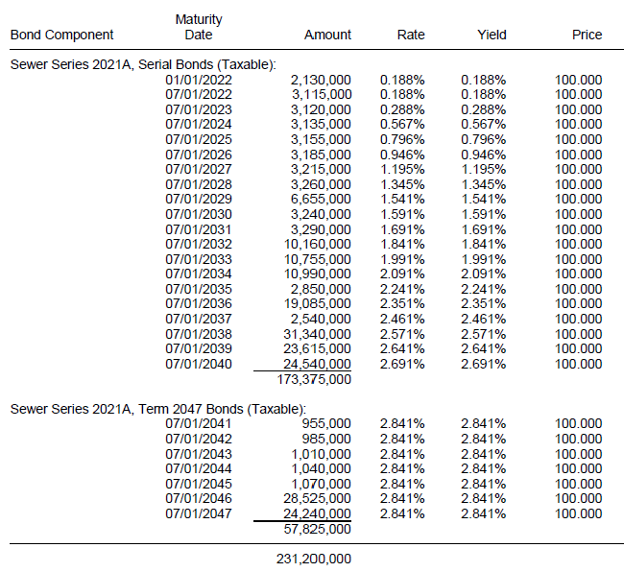

(e) Optional Redemption. The 2021A Bonds are subject to redemption prior to their stated maturities at the option of the County in whole or in part, at any time before July 1, 2031, at the “Make-Whole Redemption Price.” The 2021A Bonds maturing on and after July 1, 2032, are subject to redemption prior to their stated maturities at the option of the County in whole or in part, at any time on or after July 1, 2031, at the price of par plus accrued interest, if any, to the date fixed for redemption.

If the 2021A Bonds are registered in book-entry only form and so long as DTC or a successor securities depository is the sole registered owner of the 2021A Bonds, if fewer than all of a maturity of a series of 2021A Bonds are to be redeemed prior to maturity, the particular 2021A Bonds or portions thereof to be redeemed shall be selected on a “Pro Rata Pass-Through Distribution of Principal” basis in accordance with DTC procedures, provided that, so long as the 2021A Bonds are held in book-entry form, the selection for redemption of such 2021A Bonds shall be made in accordance with the operational arrangements of DTC then in effect that currently provide for adjustment of the principal by a factor provided by the Registrar pursuant to DTC operational arrangements. If the Registrar does not provide the necessary information and identify the redemption as on a Pro Rata Pass-Through Distribution of Principal basis, the 2021A Bonds will be selected for redemption in accordance with DTC procedures by lot within a maturity.

If the 2021A Bonds are not registered in book-entry only form, the 2021A Bonds will be assigned certificate numbers. Any redemptions of less than all of a maturity of a series of the 2021A Bonds shall be effected by the Fiscal Agent by designating such 2021A Bonds for optional redemption within a maturity in the order of the assigned certificate numbers.

(f) Mandatory Sinking Fund Redemption of Term Bonds.

The County will redeem the 2021A Bonds maturing on July 1, 2047 (the “Term Bonds”), if not optionally redeemed as described above or purchased under the provisions described in the Ordinance, at par plus accrued interest on July 1 in the years and amounts as follows:

Years | Amounts
2041 | $ 955,000
2042 | 985,000
2043 | 1,010,000
2044 | 1,040,000
2045 | 1,070,000
2046 | 28,525,000
2047* | 24,240,000
* Maturity

If the County redeems Term Bonds under the optional redemption provisions described above or purchases for cancellation or defeases Term Bonds, the Term Bonds so redeemed, purchased, or defeased (irrespective of their redemption or purchase prices) will be credited against one or more scheduled mandatory redemption amounts for those Term Bonds. The County will determine the manner in which the credit is to be allocated.

Attachment B-2

Description of the 2021A LTGO (Sewer) Bonds
(a) Principal Amount: $239,585,000.00
(b) Purchase Price: $292,350,592.38, representing the stated principal amount of the 2021A LTGO (Sewer) Bonds, plus a premium of $53,289,926.20, minus an underwriter’s discount of $524,333.82.

(c) Interest Payment Dates: January 1 and July 1, beginning January 1, 2022.

(d) Maturity and Interest Rates*: The 2021A LTGO (Sewer) Bonds shall mature on the dates and bear interest at the rates (computed on the basis of a 360-day year of twelve 30-day months), as follows:

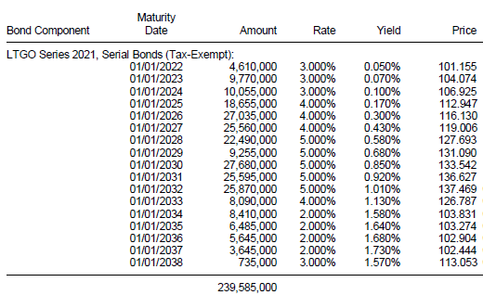

* For 2021A LTGO (Sewer) Bonds maturing on and after January 1, 2032, price is calculated to the first par call date of July 1, 2031.
(e) Optional Redemption. The 2021A LTGO (Sewer) Bonds maturing prior to July 1, 2031, are not subject to optional redemption prior to maturity. The 2021A LTGO (Sewer) Bonds maturing on and after January 1, 2032, are subject to redemption prior to their stated maturities at the option of the County in whole or in part, at any time on or after July 1, 2031, at the price of par plus accrued interest, if any, to the date fixed for redemption.

Whenever less than all of the 2021A LTGO (Sewer) Bonds of a single maturity of a Series are to be redeemed, the Securities Depository will select the 2021A LTGO (Sewer) Bonds registered in the name of the Securities Depository to be redeemed in accordance with the Letter of Representations, and the Registrar will select all other 2021A LTGO (Sewer) Bonds to be redeemed randomly, or in such other manner as the Registrar determines.

Attachment B-3

Description of the 2021B LTGO (Sewer) Bonds
(a) Principal Amount: $94,510,000.00
(b) Purchase Price: $94,303,164.08, representing the stated principal amount of the 2021B LTGO (Sewer) Bonds minus an underwriter’s discount of $206,835.92.

(c) Interest Payment Dates: January 1 and July 1, beginning January 1, 2022.

(d) Maturity and Interest Rates: The 2021B LTGO (Sewer) Bonds shall mature on the dates and bear interest at the rates (computed on the basis of a 360-day year of twelve 30-day months), as follows:

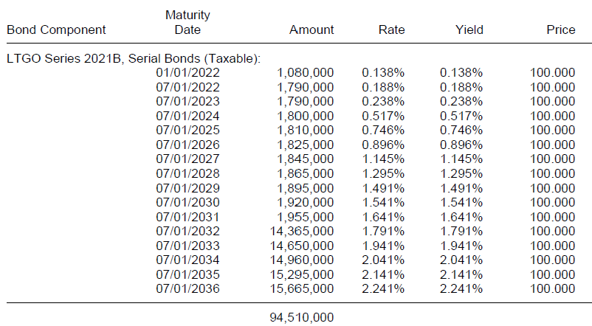

(e) Optional Redemption. The 2021B LTGO (Sewer) Bonds are subject to redemption prior to their stated maturities at the option of the County in whole or in part, at any time before July 1, 2031, at the “Make-Whole Redemption Price.” The 2021B LTGO (Sewer) Bonds maturing on and after July 1, 2032, are subject to redemption prior to their stated maturities at the option of the County in whole or in part, at any time on or after July 1, 2031, at the price of par plus accrued interest, if any, to the date fixed for redemption.

If the 2021B LTGO (Sewer) Bonds are registered in book-entry only form and so long as DTC or a successor securities depository is the sole registered owner of the 2021B LTGO (Sewer) Bonds, if fewer than all of a maturity of a series of 2021B LTGO (Sewer) Bonds are to be redeemed prior to maturity, the particular 2021B LTGO (Sewer) Bonds or portions thereof to be redeemed shall be selected on a “Pro Rata Pass-Through Distribution of Principal” basis in accordance with DTC procedures, provided that, so long as the 2021B LTGO (Sewer) Bonds are held in book-entry form, the selection for redemption of such 2021B LTGO (Sewer) Bonds shall be made in accordance with the operational arrangements of DTC then in effect that currently provide for adjustment of the principal by a factor provided by the Registrar pursuant to DTC operational arrangements. If the Registrar does not provide the necessary information and identify the redemption as on a Pro Rata Pass-Through Distribution of Principal basis, the 2021B LTGO (Sewer) Bonds will be selected for redemption in accordance with DTC procedures by lot within a maturity.

If the 2021B LTGO (Sewer) Bonds are not registered in book-entry only form, the 2021B LTGO (Sewer) Bonds will be assigned certificate numbers. Any redemptions of less than all of a maturity of a series of the 2021B LTGO (Sewer) Bonds shall be effected by the Fiscal Agent by designating such 2021B LTGO (Sewer) Bonds for optional redemption within a maturity in the order of the assigned certificate numbers.

