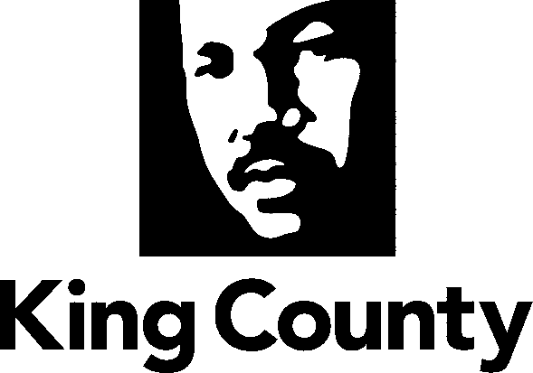

Checklist and Summary of Changes for the attached
Collective Bargaining Agreement

Name of Agreement
Professional and Technical Employees, Local 17 (Supervisors - Departments: Executive Services (Facilities Management Division), Natural Resources and Parks, Transportation)

Labor Negotiator
James J. Johnson

Prosecuting Attorney’s Review | Yes
Legislative Review Form; Motion or Ordinance | Yes
Executive Letter | Yes
Fiscal Note | Yes
Six Point Summary | Yes
King County Council Adopted Labor Policies Consistency | Yes
Ordinance | Yes
Original Signed Agreement(s) | Yes
Does transmittal include MOU/MOA? | N/A

Six Point Summary of changes to the attached agreement:
1. Changes to effective dates.

2. Changes that reflect the terms of the “Total Compensation” Coalition memorandum of agreement, ratified by King County Council Ordinance 17916.

3.

4.

5.

6.

