Lease Property Summary
Property Photo

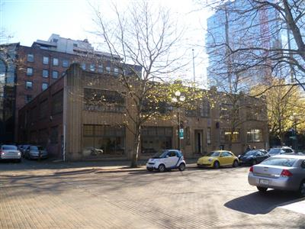
Property Owner: Beebe Realty, Inc.
Address: 416 Occidental Avenue
Cost Per Sq. Ft.: $27/sf
Operational Costs: $4.71/sf
Term: Ten years with option for two five-year extensions
Square Footage: 22,000 sf
Council District: Eight
Funding Source: Long term lease fund
Previous Location: Renewal of existing space, excluding the basement
Offer Expiration: Current lease expired on June 30, 2019. The proposed lease modification includes an initial 90 day approved holdover period for Council action at the same base rent as the month of June 2019. The initial 90 day approved holdover period ends September 28, 2019.

Lease Synopsis:
The Graybar Building (which includes two stories plus a basement level) houses Transit Fare Enforcement, the Print Shop, and Records Administration Analyst Staff for Records, Archives and Licensing Services (RALS). The lease modification scales back County’s overall footprint in this building by excluding the basement level.

Context

Rationale for transaction: The FMD inventory function was relocated from the Graybar building in June of 2019 and the basement garage space, which was being used for facilities inventory and supplies was no longer needed. FMD negotiated a new agreement that would provide for increased space for Transit Fare Enforcement and continue to provide space for Records Administration Analyst Staff and the Print Shop. One portion of the building is not yet allocated to a specific department. There are multiple options for the 2,664 vacant square feet of space remaining.

Transit Fare Enforcement and Records Administration Analyst Staff are located on the second floor of the building. The Print Shop and the unallocated vacant space are located on the first floor. Transit Fare Enforcement desires a location close to the Third Avenue bus corridor and close to King Street Center, and its footprint in the building is increasing by thirty staff members. Records Administration staff will maintain their footprint in the building and the Print Shop has reduced its footprint by consolidating on the first floor of Graybar. Additionally, both Transit Fare Enforcement and the Print Shop have extended operating hours, and locating these extended-hours businesses together is typically more energy efficient and creates less wear and tear on HVAC equipment.

Policy considerations: The Facilities Management Division (FMD) negotiated a very favorable rate, obtained a tenant improvement allowance, reduced its footprint costs, and eliminated potential moving costs for the three agency programs located in the building.

Political considerations: None

Community considerations or partnerships: This location allows Transit Fare Enforcement quick access to the Third Avenue bus corridor and to King Street Center. Quicker access allows for faster dispatch and response times.

Fiscal considerations: The cost is $27 per square foot for Years One and Two with an increase of 5% every two years thereafter. The negotiated rental rate is a fair market rate and includes a one-time Landlord contribution of $15 per square foot as a Tenant Improvement allowance, or $330,000. Operating costs are anticipated to be $4 per square foot annually, which excludes custodial services to be provided by FMD. The lease has a ten year term with the option for two additional five year extensions.

Other considerations: The Graybar Building meets the different program requirement needs of the tenant agencies including, without limitation, flooring weight requirements for pallet deliveries and print shop equipment and proximity to customer base.

CIP/operational impacts: N/A

King County Strategic Plan impact: Leasing this property furthers the King County Strategic Plan guiding principle of Financial Sustainability by co-locating multiple extended-hours agency services in a building suitable for extended hours.

Equity and Social Justice impact: FMD and the Department of Transportation and Records and Licensing staff reviewed this legislation for Equity and Social Justice (ESJ) impacts in accordance with Real Property Asset Management Plan (RAMP) Strategy 2.0 and 24.0. The Graybar Building is located in the Pioneer Square neighborhood of Seattle and is well situated to serve the downtown Seattle area. It allows convenient access to freeway, transit services and service partners. This location has a Walkability score of 95. This is a continuing location for these agency programs. These agency programs are not expected to negatively impact low income communities, communities of color or limited English proficient communities by continuing at this location.

Energy Efficiency impact: As mentioned previously, locating two of our extended-hours programs (Transit Fare Enforcement and the Print Shop) at this location eliminates the need to provide separate whole building HVAC systems for each program and is consistent with RAMP policies.

Lease Alternatives Analysis
Summary: The County owned locations and leased spaces were evaluated and rejected due to the distance from the downtown corridor and the costs involved in upgrading these facilities to meet program needs.

Vicinity View Map
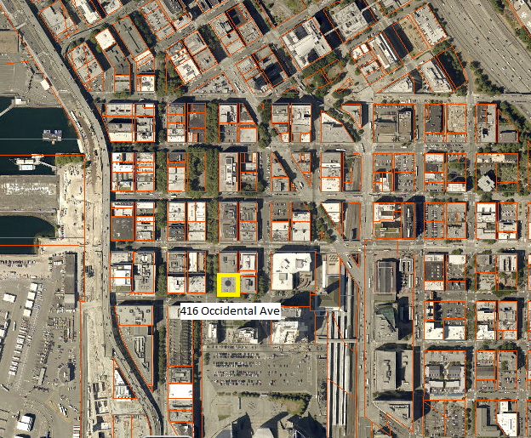

Parcel Map
