Legislative Review Form
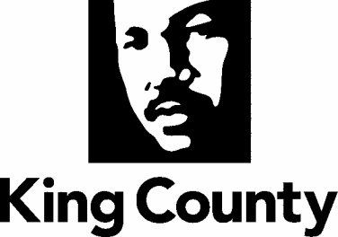

Agency: DNRP/ Contact person Phone 206-

Ordinance Motion Proviso Report Other

Civil Division Prosecuting Attorney Review

Name Raul Martinez Version Final Date 9/27/21

Dept. Director or Designee Review

Name Katherine Taylor Version Final Date 9/27/21

Performance Strategy & Budget Office Review

Name Elka Peterson Horner Version Final Date 9/28/21

Technical Form/Code Reviser Review – Confirm adherence to legislative format

Name Bruce Ritzen Version Final Date 9/28/21

Executive Office Review & Transmittal Approval

Name Karan Gill Version Final Date 10/6/21

ENTRANCE CRITERIA REVIEW
EXEC OFFICE (initials) KCC CLERK
Fiscal note? Y NA Y NA
KC Strategic Plan reference in letter? Y NA Y NA
Proof read for spelling and grammar? Y NA Y NA
All pertinent attachments listed/labeled? Y NA Y NA
Costs identified/described in letter Y NA Y NA
Regulatory Note Required and Complete? Y NA Y NA
Formatted/Delivered in word-searchable doc format? Y NA Y NA
Potential Annexation Area (PAA) impacts identified? Y NA Y NA
Advertising required? if yes, cite all pertinent code/laws. Y NA Y NA
Any special circumstances affecting processing time? Y NA Y NA

