STAFF REPORT

Agenda Item: | 7 and 8 | Name: | Jenny Giambattista
Proposed No.: | 2016-0532  2016-0531 | Date: | November 30, 2016

SUBJECT
PO 2016-0532 would authorize the Executive to execute a Fourth Amendment to the current lease at the Sabey Data Center LLC.

PO 2016-0531 This companion legislation is an appropriation ordinance that would pay for the tenant improvements required under the lease amendment authorized by PO 2016-0532.

SUMMARY

PO 2016-0532 would authorize the Executive to execute a Fourth Amendment to the County’s current lease for space located at the Sabey Data Center. The Fourth Amendment would reduce the amount of space currently leased, extend the lease term by another five years, and eliminate most of the “triple net” additional rent obligations in favor of a loaded basic rent monthly charge. (Triple Net or NNN is a leasing term to describe a lease in which the tenant pays a share of real estate taxes, building insurance and operation/maintenance costs —the three “nets”.) According to Executive staff, a significant benefit of the proposed amendment is that with the triple net additional rent obligations removed, the County will no longer be at risk to share in the cost if necessary major cost infrastructure improvements at the data center increase the additional rent charges. Additionally, because of the reduction in spaced leased, the lease amendment will result in biennial savings of $522,612 when compared to the current terms. The King County Information Technology (KCIT) budget for 2017-2018 reflects these savings and assumes this legislation will be adopted in 2016. (This cost savings excludes the one-time costs of $484,500 requested in Proposed Ordinance 2016-0531 and discussed in this staff report.)

While the proposed lease amendment includes beneficial terms to the County, it also obligates the County to a rental rate for 10 years, five years beyond the current obligation. Neither the current lease nor the amendment contain a reopener section that would allow the County to unilaterally reduce its square footage (and therefore rent) (“contraction provision”) if the market price for data space significantly declines and/or changes in technology decreases the County’s physical data capacity needs.

According to Executive staff, the proposed amendment to the lease is the result of a protracted negotiation that required extensive conversations between Sabey, KCIT, and the Facilities Management Division (FMD) because of the County’s very limited leverage position.

PO 2016-0531 is the appropriation legislation, which authorizes the funding to pay Sabey to perform restoration work to the “give back space” that will return the space the County is giving back to Sabey to its prelease condition and reconfigure the new, smaller space for KCIT’s intended use. The one-time payment is a term of the amendment.

The landlord has placed a condition on this offer to amend the lease. If the amendment is not executed by the end of 2016, it the offer to amend the lease will be revoked (Section 16 of Proposed Fourth Amendment). Thus, Executive staff have requested that the Council approve this amendment by the December 12th Council meeting.

The amendment has been reviewed by the Prosecuting Attorney’s Office.

BACKGROUND

The original Sabey data center lease (Ordinances 16213, 16214) was approved in 2008. The ordinance authorized $18,079,398 for the relocation of the data center from the Seattle Municipal Tower to the Sabey Data Center and the building out of the Sabey Data center to meet the County’s specifications. King County moved to the Sabey Data Center in May 2009. In August, 2009 the Council approved $1,387,018 for the final phase of the Data Center project.

The Sabey lease has been amended three times. (The original lease and all three prior amendments are included as Attachment 7 to this staff report.) During the current lease period, King County’s need for data center space has decreased because technology has dramatically reduced the physical space required for data storage and computing.

KCIT did attempt to sublease the unused space to other jurisdictions. This effort was largely unsuccessful.

ANALYSIS

The Fourth Amendment is Attachment A to Proposed Ordinance 2016-0532. The changes to the lease set forth in the Fourth Amendment are summarized in the table below and discussed in the analysis which follows.

Terms & Conditions | Current | Proposed
Lease Term | Initial Term 12 years (Council approved up to 30 year total term), which expires 4/30/2021 | 10 Year Term and expires 12/31/2026
Extension Terms  Lease Expiration | Lease will automatically renew for two 5 year and two 4 year extensions unless tenant gives written notice 12 months in advance of expiration of initial term (4/30/2020). | Two 5 year extension options
Square Feet | 7492 | 3344
Rate | Base Rent $4.42/NNN $.88/$20.55 per KW | $130 PER KILOWATT
Annual Rate Escalation | 3% | 2.5%
Capacity (Allotted KW) | 1050 | 350
Early Termination | At the end of 12th year upon 12 months’ notice | None
Contraction Language | None | None

Length of Lease Terms

Current Lease: The current lease has a 12 year term (Section 1.10), which expires April 30, 2021. The lease will automatically renew for two additional five year periods and two additional four -year extensions (Section 3.3) unless tenant gives written notice 12 months in advance of the initial term. If the County extends the lease, the base rent increases by 3 percent each year (Section 3.4).

Proposed Fourth Amendment: The proposed Fourth Amendment extends the County’s obligation for data center space in Sabey five years beyond the current obligation. The proposed lease provision is for 10 years with an expiration of December 31, 2026 with two additional periods of five years each (Section 2.1). Under the proposed Fourth Amendment, if the County decides to extend there is a process for determining the future rent based on a market analysis. However, regardless of the market analysis, the minimum rent in the extension term would not be lower than the rent the County was paying at the end of its term. After that the rent could increase by 2.5 percent each year (Section 5.2).

Space:

As discussed below, the proposed amendment includes significant reductions to the amount of leased space.

Current Lease: The Current lease is for 7,492 SF. The current lease contains, in addition to data center space, an equipment build room, print room, office space, break room and a secure storage cage on the first floor of the building (Section 1.1. of Amendment One.)

Proposed Fourth Amendment: The proposed Fourth Amendment is for 3,344 SF of rentable space (Section 1.4), a reduction of 4,148 SF. Under the proposed Fourth Amendment, the County will only rent the data center space and storage space on the first floor of the building.

Illustration of Current and Proposed Space
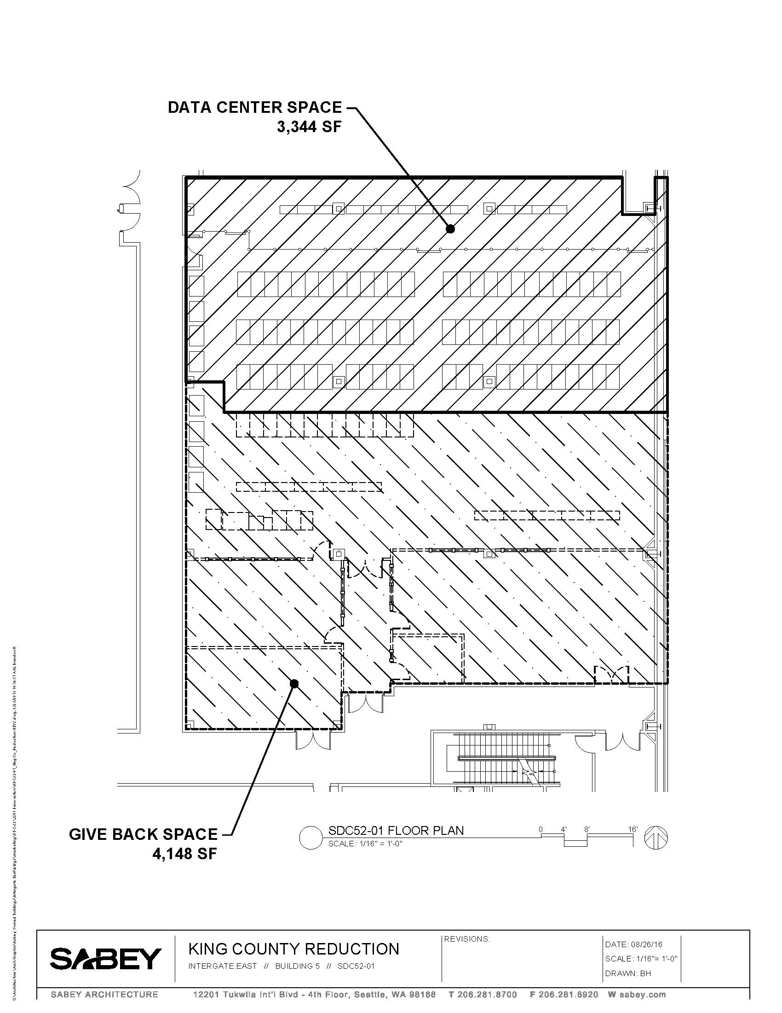

The Fourth Amendment will continue to allow King County access and use of all common area spaces (attachment H to Exhibit C of original lease) such as lobby, break room, loading dock and parking as well as common services such as custodial and security personnel 24/7.

KCIT reports the County does not need the 4,148 square feet of space it currently has because King County is able to store more data in less space as technology evolves. Given the significant downward trend in the County’s needs for data center space, Council staff asked the Chief Information Officer, Bill Kehoe, whether the County will even need the square footage proposed in the Fourth Amendment over the next ten years. Mr. Kehoe’s response is below:

We will never be out of the data center business. We have customers that do not want to put their data in the public cloud or a vendor managed service for security reasons or the services that they are running are not conducive to running in the cloud. Also, we do have separately elect customers that want to run their own server environment and cannot or are not interested in joining the King County private cloud that will require separate racks in the data center. There are some applications that require separate servers either because the system vendor requires individual servers or the performance of the system is a concern and the system needs to be isolated with physical servers. Physical servers take more space due to the need for data center rack space. We also have network equipment that is not going away and is taking a large portion of the 3344 sq. ft. Several key network nodes reside at Sabey for I-NET and other major King County and external customer services. As technology advances and as King County further matures and adopts the advanced compute and storage environment, some of the racks may be consolidated but we can always offer the space to other government cities in the region. This strategy was not successful to fill up the current empty space but we do have some small external customers from regional jurisdictions today and the possibility for other small jurisdictions is a possibility in the future.

Rental rates changes from triple net to a more inclusive price model

Comparison of 2016 Lease Costs (Excluding Electricity)
Existing Lease versus Proposed Amendment

 | Existing | Proposed Fourth Amendment
Monthly base rent | $33,186 | $40,250
Triple net charges | $27,298 | none*
Total Annual | $736,447 | $483,000
*except for electricity, which is discussed below

Current Lease:
In the current triple net lease, King County pays:

- Base rent of $33,186 per month based on a charge of $4.42 per SF
- Triple net charges of approximately $27,298, $.88 per SF and $20.55 for an allotted kilowatt hours (kWh) capacity of 1050 kWh regardless of how much is used. (King County has never used more than 275 kWh.) In addition, King County pays Sabey for the County’s direct energy usage and a share of the facility energy usage. Electricity usage is discussed under “Electricity” below

The current rental formula results in an annual cost of $736,447. The current lease includes a three percent inflator.

Proposed Fourth Amendment: The rent formula in the proposed Fourth Amendment is a fully loaded rate of $130 per kilowatt hour for a required maximum allotment of 350 kWh regardless of whether that amount is used (Section 3.1). Under this proposed formula, King County will not have to pay for any of the triple net “additional rent charges” (excluding electricity). While not specifically stated in the proposed Fourth Lease Amendment, these costs (for taxes, insurance and operation/maintenance) .are likely already included in the monthly rate. According to Executive staff, a significant benefit of the proposed amendment is that with the triple net additional rent obligations removed, the County will no longer be at risk to share in the cost if a major building component (such as the chillers) needs to be replaced and this is considered a significant risk reduction for the County.

Given that the highest amount of electricity King County has ever used is 275 kWh, Council staff asked whether the County had requested as part of the lease negotiations a lower maximum allotment of kWh. According to KCIT, Sabey determined the 350kWh and was not willing to reduce it.

The proposed Fourth Amendment results in monthly charges of $40,250 and an annual cost of $483,000 excluding electricity beginning in 2017. The proposed Fourth Amendment includes a 2.5 percent annual inflator (Section 3.1).

Electricity charges
Current Lease: Under the current lease (Section 8.1.5), King County is responsible for paying the landlord for the electricity the County directly uses and a share of the facility’s energy use. The formula for determining how much King County pays for its shared usage is the ratio of King County’s separate energy usage to the overall shared infrastructure energy usage as applied to the total shared infrastructure electricity bill. In practice, King County currently pays about $16,000 monthly to Sabey for the electricity used to power the King County equipment and for its portion of the shared electricity.

As specified in Section 8.1.5 of the current lease, at the start of each year, the landlord estimates King County’s electricity charges and King County is required to pay that amount each month. Sections 8.1.5 and 8.3 also specify that at the end of the calendar year, the landlord is required to compare actuals with estimates and credit or debit King County for the difference. In practice, Sabey has been providing a monthly reconciliation to King County. The monthly invoices provide information on the kWh used at peak and standard times but do not distinguish between shared and direct usage. The actual annual reconciliations sent to King County do not include any of these details on energy usage.

Section 8.4 of the current lease authorizes King County, at its expense, to inspect the landlord’s records one time in any calendar year with respect to any of the triple net component costs (taxes, insurance and operation/maintenance, which includes electricity) shown on Landlord’s annual reconciliation statement provided to Tenant.

Proposed Fourth Amendment: Electricity charges for the County’s electricity and shared electricity are not anticipated to change under the proposed Fourth Amendment (Section 8.1) and King County will continue to be obligated to pay for both its own electricity and shared usage using the same formula as is in the current lease.

In the proposed Fourth Amendment (Section 8.1) the landlord agrees to provide electrical use reconciliation every quarter and credit or debit any difference between estimated and actual use by tenant quarterly, rather than annual reconciliation as under the current lease.

As with the current lease, there is no requirement in the Fourth Amendment for the reconciliation to break out shared or direct usage. Section 8.1 of the Fourth Amendment states that the landlord will not provide annual reconciliation of tenant’s power usage. Given that the annual reconciliation included minimal information on electrical use, the loss of the annual reconciliation may not be problematic. Additionally, the Fourth Amendment does not specify that the quarterly reconciliation be sent to the County. Although based on the landlord’s past practice under the current lease, Executive staff expect that this will be shared with the County.

The Fourth Amendment also eliminates the County’s right under the current lease to inspect the landlord’s records related to the annual reconciliation; thus there is no specific authorization for reviewing the landlord’s electricity records. This right to inspect was eliminated as part of eliminating the triple net lease terms. . During a phone call between Executive, Council, and Sabey staff on November 28, 2016 Sabey staff reported the County’s right to audit the electrical usage will not change under the Proposed Fourth Amendment. Sabey has agreed to send King County a right to audit letter consistent with this phone conversation.

Dark Fiber
Dark fiber is cabling and infrastructure that is in place, but not currently being used. It is desirable if there is need for additional capacity because the capacity could be achieved without installing new cabling. This was put in place as part of the original build out to allow King County the growth potential for larger bandwidth.

Current Lease: The terms of the current lease (Sections 1.4.2 and 1.12.2), allows for month to month to rent for dark fiber and termination by either party. As King County has not needed the dark fiber, it has not been paying rent for it.

Proposed Fourth Amendment: Section 1.4 of the proposed Fourth Amendment to the lease deletes the section of the lease related to dark fiber because according to KCIT, there is no anticipated for additional fiber in the future.

First right of refusal
Current Lease: At the time of the original lease, King County believed it may need additional space in the future. Section 2.3 of the current lease provides the County with the right to match any competing offer to lease 3,114 square feet of space adjacent to the County’s premises. Over the course of the lease, King County has not exercised this right as King County has not needed additional space.

Proposed Fourth Amendment: The proposed Fourth Amendment deletes the first right of refusal in Section 2.3. KCIT reports it is does not anticipate needing additional space.

Expiration of Offer
The landlord has placed a condition on this offer to amend the lease. If the amendment is not executed by the end of 2016, it the offer to amend the lease will be revoked (Section 16 of Proposed Fourth Amendment). Thus, Executive staff have requested that the Council approve this amendment by the December 12th Council meeting.

Analysis of Different Scenarios
As shown in Attachment 8, FMD and KCIT compared four different scenarios in order to determine that the proposed lease amendment was the best option. Scenario D is the preferred Scenario and is consistent with the Fourth Amendment.

Scenario A, Current Lease with 5 year extension
This scenario assumes King County would continue in its current lease until the lease expires in 2021. At that point, King County would exercise its option for additional terms. This scenario assumes the triple net terms applied to a reduced space of 3344 and a three percent annual escalator. The scenario also assumes the same lower required kilowatt capacity (350 kWh) as is in the proposed Scenario D.

The assumed triple net rent rates are much lower than in the triple net model proposed in Scenario C (staying with a triple model, but reducing square footage) because FMD expects to have leverage to negotiate lower prices and a reduced square footage with the expiration of the original lease. This scenario assumes the County would be required to be pay the same amount ($450,000) for the tenant improvements (TI) to reduce the space in 2021.

The net present value (“NPV”) of this scenario is $4,672,353, $407,372 greater than the Fourth Amendment’s NPV of $4,264,981.

Scenario B, Relocate to a New Location in 2021
This scenario estimates the costs of relocating to a new space in 2021 upon the expiration of the current term. Of the four scenarios presented, this scenario has the most uncertainty regarding assumptions because it is difficult to predict data center market rates or the County’s data center needs in 2021. For purposes of this scenario, FMD estimated a move cost of $13.6 million, based on estimated needs and market prices.

The net present value of this scenario is $15,169,582 which is about $10.5 million greater than the NPV of the Fourth Amendment.

Scenario C—Current Lease terms with reduced space
Scenario C is based on a proposal from Sabey during the most recent lease amendment negotiation. Under this scenario, the square footage is reduced in 2017, but the triple net model is maintained while significantly increasing the price per square foot. KCIT preferred Scenario D (no triple net) over Option C because Option C maintains the financial obligation of the County to pay a share of the repair and replacement of shared infrastructure.

Over the course of the lease, the NPV of Scenario C is $4,394,000 only slightly ($129,019) more than the NPV of the Fourth Amendment.

Scenario D—Proposed Amendment. Reduced space, eliminates triple net terms
This is the Executive’s preferred option. The Fourth Amendment would reduce the amount of space currently leased, extend the lease term by another five years, and eliminate most of the “triple net” additional rent obligations in favor of a loaded basic rent monthly charge.

Scenario D results in a NPV of $4,264,981 over the course of the lease. This scenario assumes the one-time tenant improvement costs of $484,500 required by the landlord.

Companion Legislation 2016-0531
Section 1.12.5 in the Fourth Amendment requires the County to pay $484,500 to the landlord in order to restore the “Give Back” space to its original condition as required by the proposed Fourth Amendment.
.
The $484,500 includes $452,000 for work to be completed by Sabey and $32,500 for FMD project management cost.

The 2015-2016 KCIT budget actions are shown below:

KCIT Services $484,500
2015-2015 Adopted Budget $176,761,000
Supplemental Appropriations: $702,591
Cumulative Total Appropriation to Date $177,463,591

Fiscal effect of 2016-0532 and 2016-0531
The proposed lease amendment authorized by 2016-0532 is anticipated to cost $1,521,842 annually, including the County’s electrical usage. The proposed lease amendment which would represent approximately $522,612 in biennial savings and is assumed in the adopted 2017-2018 budget for KCIT.

Proposed Ordinance 2016-0531 is for a supplemental appropriation to the 2015-2016 budget for $484,500 in order to restore the space to its original condition as required by the lease.

AMENDMENTS
None

ATTACHMENTS

- Proposed Ordinance 2016-0532 (and its attachments)
- Transmittal Letter for 2016-0532
- Fiscal Note for 2016-0532
- Proposed Ordinance 2016-0531
- Transmittal Letter for 2016-0531
- Fiscal Note for 2016-0531
- Sabey Lease
- Comparison of Scenarios prepared by FMD

INVITED

- Bill Kehoe, Chief Information Officer, King County Information Technology
- Julie Porter, Real Property Agent IV, Facilities Management Division
- Sid Bender, Budget Manager, Office of Performance Strategy and Budget

In November 2008 the lease was first amended to allow King County to lease dark fiber, which could be used if needed as additional capacity as the County was building out its space. The second amendment in 2009 reduced the County lease space by 3,982 square feet and the rent was reduced according the reduction in square footage. In 2013, the third amendment required the County to pay rent for the connectivity room in the data center building for the purpose of establishing a connection to the telecom providers.
For example, the mainframe was roughly 6.5ft by 5ft by 6ft (180 cubic feet) and now all that data is stored using 2.75 cubic feet of the space. There were also mainframe tape machines and tape racks previously housed at the data center that took up 1500 of cubic feet of space. These are now obsolete and that space is not needed. Additionally, the County also now uses private “cloud” services where feasible, eliminating the need for many servers because data is stored at those providers’ locations. Cloud storage refers to private, off-site storage offered by companies such Amazon.
Exhibit B of Fourth Amendment of Data Center Lease Agreement

