Attachment A

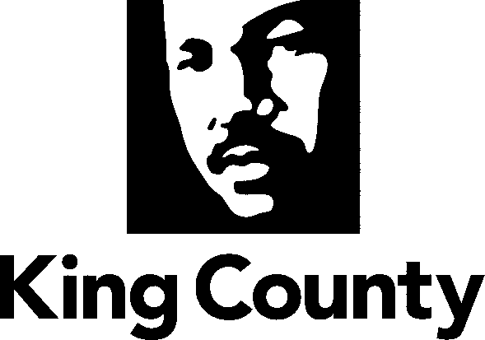

Metropolitan King County Council

Regional Policy Committee 2022 Work Program

I. Subject matters for mandatory referral of legislation:

- Solid Waste

2. Veterans Seniors and Human Services Levy (VSHSL)

3. Homelessness including Regional Homeless Authority and Health through Housing

4. Mental Illness and Drug Dependency (MIDD)

5. Regional Transportation (not including transit)

6. Affordable Housing

7. Best Starts for Kids (BSK) Levy

8. Cultural Resources and Access

9. New proposed levies to be imposed countywide

lI. Briefings on subject matters that would benefit from interjurisdictional discussion

- RPC Acting in its capacity as the Solid Waste Interlocal Forum
  - Potential briefings - Planning, Recycling, Composting, Collection, Disposal, Transfer, Finance

- Veterans Seniors and Human Services Levy (VSHSL)
VSHSL Annual Reports

- Land Conservation
- Parks and Recreation
- Implementation of the Puget Sound Emergency Radio Network (PSERN)
- Homelessness
- Regional Affordable Housing Strategies

- Mental Illness and Drug Dependency (MIDD)
- MIDD Annual Report

- Best Starts for Kids (BSK)
- BSK Annual Report

- Regional Transportation
  - Briefings on county-wide road needs: conditions, bridges, funding and traffic

- Elections

- Natural Disasters
  - Briefing from Emergency Management on preparations for natural or man-made disasters

- Flood Control
  - Briefing from the King County Flood Control District

- 2020 King County Census Results
- King County International Airport Expansion and Regional Airport Needs
- State of Agriculture in King County
- Regional Approach to Public Safety
a. Briefing on Restorative Community Pathways
- Economic Recovery and Pandemic Assistance
- COVID-19 Response
- King County’s Clean Water Plan
- Public Health Response to the Opioid Crisis

For the purpose of determining a subject matter for mandatory referral pursuant to the King County Charter Section 270 and KCC 1.24.065, the numbered topics should be liberally construed.
RPC acting in its capacity as the Solid Waste Interlocal Forum
Legislation relative to the lettered topics included in this Section II shall not be subject to mandatory referral.

