Legislative Review Form
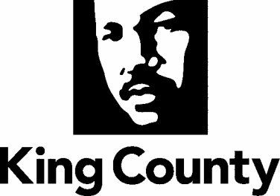

Agency: _DLS Roads__ Contact person _Rick Brater_ Phone _206-477-3601___

Ordinance Motion Proviso Report Other

Civil Division Prosecuting Attorney Review

Name John Briggs Version Final Date 07/01/2020

Dept. Director or Designee Review

Name Rick Brater Version Final Date 7/31/20

Performance Strategy & Budget Office Review

Name: Anna Markee Version: Final Date: 08/12/20

Technical Form/Code Reviser Review – Confirm adherence to legislative format

Name Bruce Ritzen Version Final Date 07/01/2020

Executive Office Review & Transmittal Approval

Name: Karan Gill Versio: Final Date: 08/31/2020

ENTRANCE CRITERIA REVIEW
EXEC OFFICE (initials) KCC CLERK
Fiscal note? Y NA BB Y NA
KC Strategic Plan reference in letter? Y NA BB Y NA
Proof read for spelling and grammar? Y NA BB Y NA
All pertinent attachments listed/labeled? Y NA BB Y NA
Costs identified/described in letter Y NA BB Y NA
Regulatory Note Required and Complete? Y NA BB Y NA
Formatted/Delivered in word-searchable doc format? Y NA BB Y NA
Potential Annexation Area (PAA) impacts identified? Y NA BB Y NA
Advertising required? if yes, cite all pertinent code/laws. Y NA BB Y NA
Any special circumstances affecting processing time? Y NA BB Y NA

