Intergovernmental Land Transfer Property Summary
Photo of Property to be received
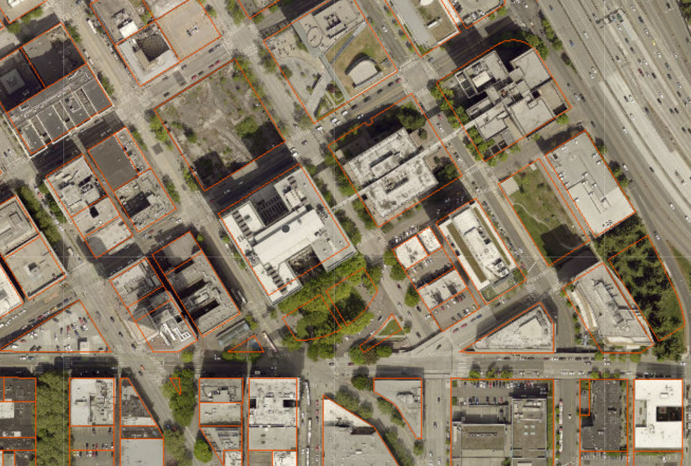

Address Roads Property: 1239 S Rose Street, KCPN 218500-0895
Wastewater Property: Cesar Chavez Park: 700 S Cloverdale St, KCPN 788360-3130
Metro Property: 1403 NW 54th Street, KCPN 276830-0455
Tax Title and Facilities Properties:
Cesar Chavez Fragment 8401 7th Ave S, KCPN 788360-2915
Sunset Hill Viewpoint Park, KCPN 047200-1460
Inverness Ravine, KCPN342604-9188
W Duwamish GB – SW Othello, KCPN 211520-0100
E Duwamish GB – S Massachusetts, KCPN 539260-0080
Cheasty Green Space – S Columbian Way, KCPN 417460-0014
E Duwamish GB – 10th Ave S, KCPN 395940-1891
Burke-Gilman Greenway – N, KCPN 882090-2280
Burke-Gilman Greenway – S, KCPN 735220-0730
Duwamish Head GB – SW Walker St, 915160-0735

Sale Price Land transfer with City of Seattle
Council District One, Two, Four, Eight
Funding Source N/A
Template Status: N/A
Offer Expiration:

Property Information
Properties included in this land transfer agreement between King County and the City of Seattle include the following:

The City of Seattle is the owner of real property located at 400 Third Avenue, Seattle, commonly known as City Hall Park. The city also holds the right of way interests in Dilling Way and a portion of Jefferson Street between Third Avenue and Fourth Avenue.

King County is the owner of real property located at 1239 S Rose Street, commonly referred to as the Roads Property.

King County is the successor in interest to the Municipality of Metropolitan Seattle for real property commonly known as:
- Metro Property (also known as Greg’s P-Patch) located at 1401 NW 54th Street. King County operates and maintains a trolley line substation on a portion of this property, access to and use of which will be retained by the County via an easement.
- Wastewater Property (also known as Cesar Chavez Park) located at 700 S Cloverdale Street. King County operates and maintains a sewer utility line under a portion of this property, access to which will be retained by the County via an easement.

King County is the fee owner of additional real properties included in this land transfer and collectively referred to in the land transfer agreement as the Tax Title and Facilities Properties.

Context
King County desires to own, operate and maintain the City Hall Park for public benefit. The City of Seattle desires to own, operation and maintain parks, open space, recreation and community facilities and programs, and other municipal programs, facilities and property inside its boundaries. The City Hall Park constitutes .56 acres of land and the County Properties collectively total 1.35 acres. The County Properties are located entirely within the boundaries of the City, except for the Roads Parcel, located at 1239 S Rose Street, which lies in unincorporated King County.

Rationale for transaction: This intergovernmental land transfer agreement supports ongoing efforts to enhance the downtown courthouse complex vicinity.

Policy considerations : This land transfer aligns with King County policies related to support services for unsheltered, homeless individuals.

Political considerations: Councilmembers have expressed interest and support for this proposed land transfer with the City of Seattle.

Community considerations
or partnerships: The properties included in this land transfer agreement shall continue to be used as public open space, park, or recreation facility purposes or other equivalent facilities within the City.

Fiscal considerations: N/A, no money is exchanged. This land transfer agreement is a transfer of property rights and ownership between the City of Seattle and King County.

Other considerations: N/A

CIP/operational impacts: N/A

Change in property use: N/A

SEPA Review Required yes/no: No

King County Strategic Plan impact: This transfer furthers the King County Strategic Plan goal of efficient, accountable regional and local government through partnering with the City of Seattle to enhance the downtown courthouse complex vicinity.

Equity and Social Justice impact: In accordance with Real Property Asset Management Plan (RAMP) policy, the Facilities Management Division reviewed this legislation for Equity and Social Justice (ESJ) impacts. This proposed land transfer furthers the King County Equity and Social Justice Strategic Plan by supporting ongoing efforts to enhance the downtown courthouse complex vicinity.

Parcel Maps
Roads Property: 1239 S Rose Street, KCPN 218500-0895
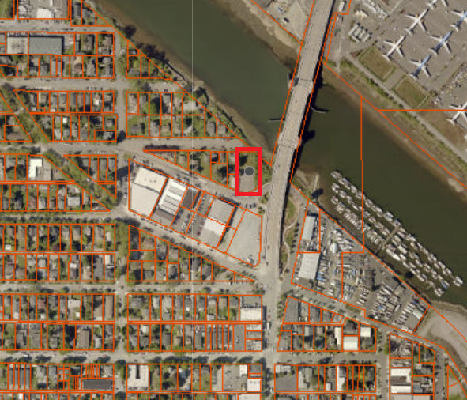

Wastewater Property: Cesar Chavez Park: 700 S Cloverdale St, KCPN 788360-3130
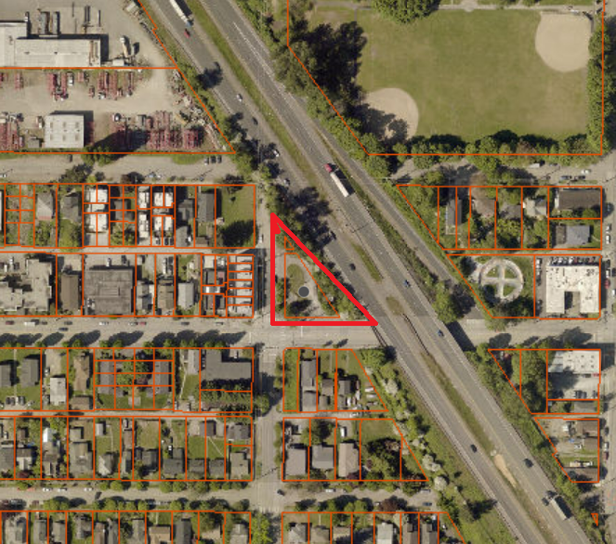

Metro Property: 1403 NW 54th Street, KCPN 276830-0455
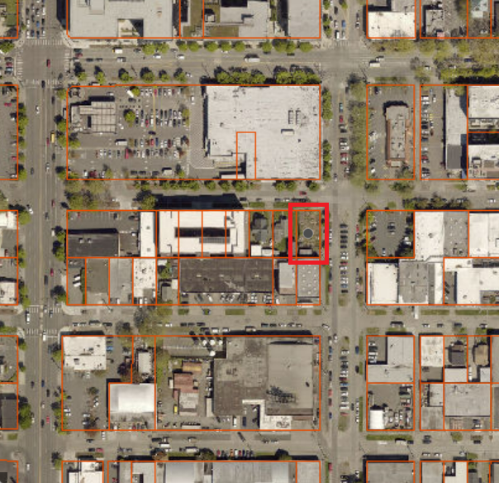

Tax Title and Facilities Properties:
Cesar Chavez Fragment 8401 7th Ave S, KCPN 788360-2915
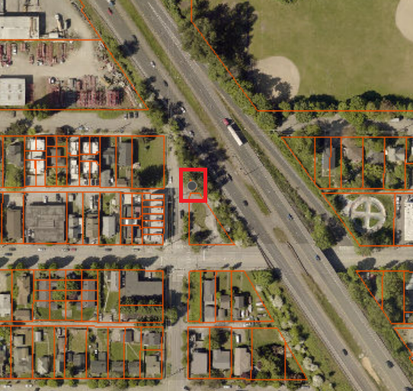

Sunset Hill Viewpoint Park, KCPN 047200-1460
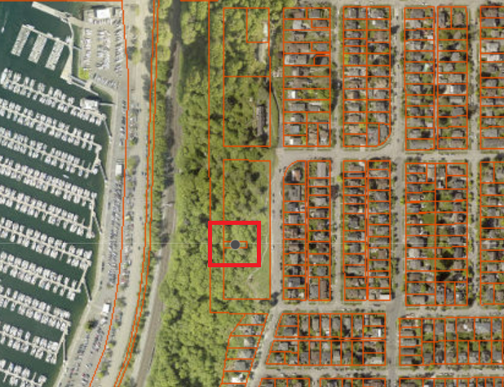

Inverness Ravine, KCPN342604-9188
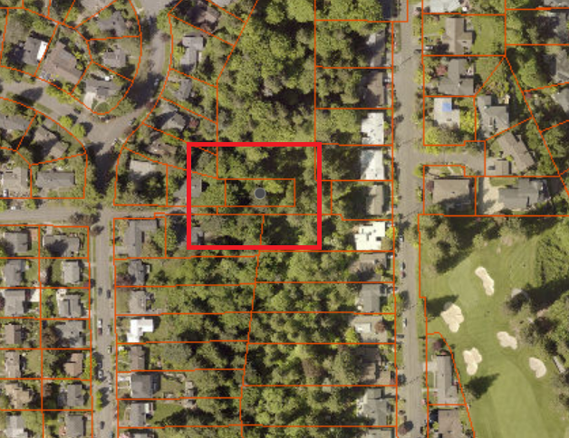

W Duwamish GB – SW Othello, KCPN 211520-0100
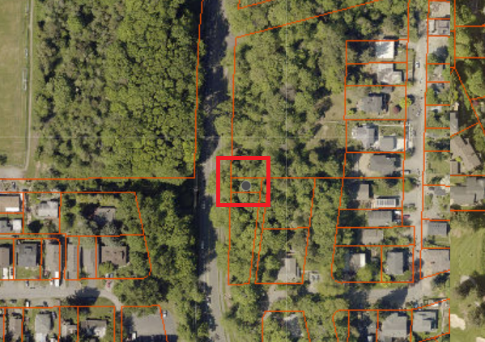

E Duwamish GB – S Massachusetts, KCPN 539260-0080
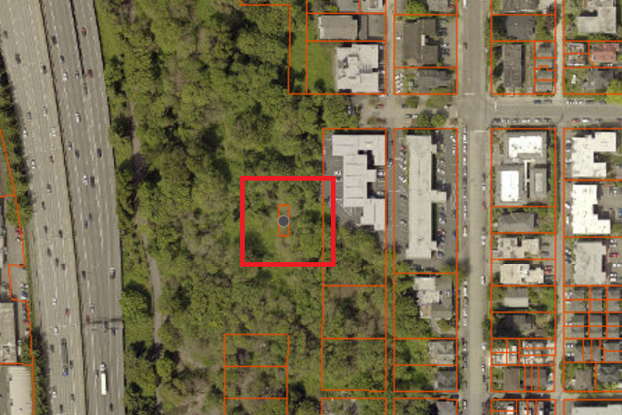
Cheasty Green Space – S Columbian Way, KCPN 417460-0014
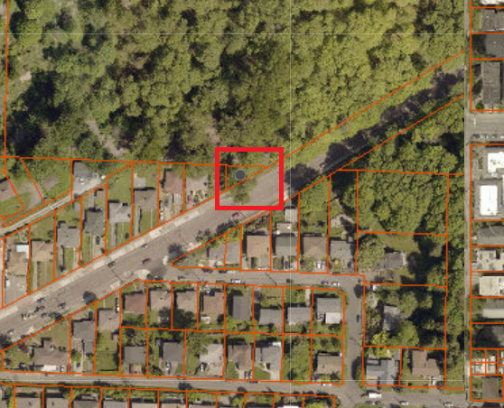

E Duwamish GB – 10th Ave S, KCPN 395940-1891
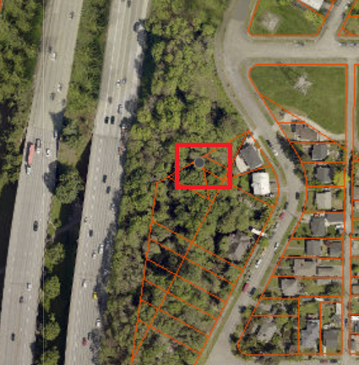

Burke-Gilman Greenway – N, KCPN 882090-2280
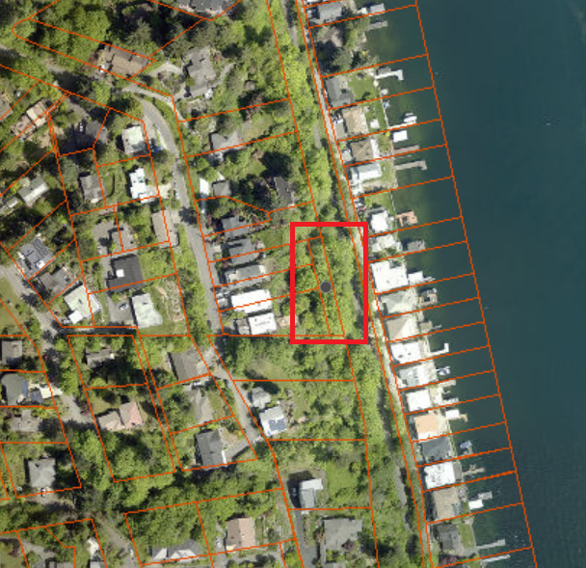

Burke-Gilman Greenway – S, KCPN 735220-0730
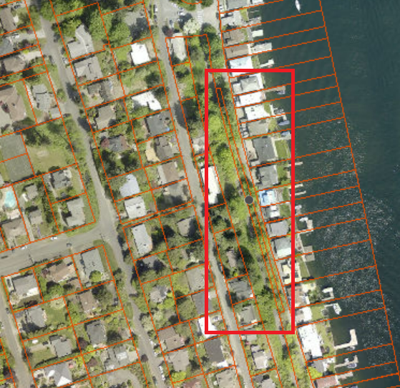

Duwamish Head GB – SW Walker St, 915160-0735
