Sale Property Summary
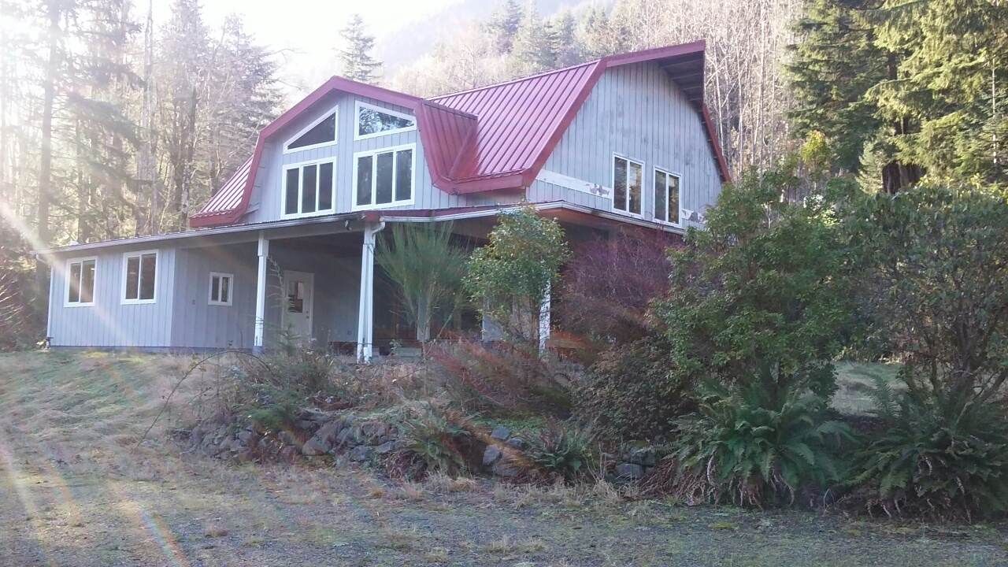
Photo of Property

Address 14524 415th Ave SE, North Bend, WA
Sale Price $107,771
Sale Area 5.2 acres + improvements
Assessor's Parcel 212308-9023
Zoning RA-10
Council District Council District Three
Funding Source Risk Management
Declared Surplus September 22, 2017
Template Status: County template with PAO approved changes
Offer Expiration: The Purchase and Sale Agreement (PSA) was executed on December 13, 2017. The ordinance approving the sale must be effective on or before 120 days or April 12, 2018. The County has the right to extend the Council Approval Contingency for an additional 90 days or July 11, 2018.

Property Information
The property consists of a 5.2 acre tract of land with a three bedroom two bath residence that was converted from an existing barn/shop. The conversion was done without permits. It is not known if permits could be obtained due to critical areas and lot limitations. The property is served by a private well (currently not operational) and septic system. The property has been vacant since acquisition by DNRP-Parks in 2012. Stream and erosion hazards are noted on the property as well as power transmission lines along the southeast portion of the property. Clough Creek (which has its headwaters in Rattlesnake Ridge) runs through the center of the property. Additionally, there is also an outbuilding in the NW corner of the parcel. There is a boundary dispute with regards to the NW area and purchase by the buyer would resolve this issue.

Context
Rationale for transaction: The County acquired the property in June of 2012 to settle a lawsuit filed by the previous owners, Leroy and Laurie Bergstrom. The lawsuit alleged the County was liable for a debris and mud flow that took place on or about January 7, 2009 causing damage and loss of real and personal property. A Settlement Agreement and Release was executed by the parties on May 15,, 2012. DNRP has since determined there is no long term need for this property and requested it be surplussed.

The property was first marketed for sale with a minimum bid of $150,000. The County received one bid in the amount of $226,500. A purchase and sale agreement was executed on October 2, 2017. During buyer due diligence, the buyer exercised her right of rescission and terminated the transaction on October 19, 2017.

The sealed bid sale was conducted again with a new minimum bid of $105,000. One bid in the amount of $107,771 was received and accepted by the County. The winning bidder is the adjacent western neighbor at 14536-415th Ave SE (Mohan Cedar Park Assembly of God Trust).

Policy considerations: Information regarding the settlement of the Bergstrom claim was transmitted to Council as part of the “2012 Quarterly Report of Closed Claims with and Indemnity Payment of One Hundred Thousand Dollars or More” (2012-RPT0189). Parks assumed custodianship of this parcel due to the proximity of other nearby properties.

Political considerations: none noted.

Community considerationsor partnerships: none noted.

Fiscal considerations: The sale proceeds will be returned to DNRP-Parks Capital Fund. Sale of this parcel reduces maintenance costs and any risk associated with the property. The County paid $272.13 in forest patrol, drainage, noxious weed and conservation taxes associated with this parcel. If assessed at the purchase price of $107,771, the property will add $1,416.82 to the annual tax base.

Other considerations: The easements and reservations of mineral rights associated with this parcel will remain in effect after the sale.

CIP/operational impacts: None noted

Change in property use: The property will be returned to private ownership. The purchaser will only be allowed to use the property in accordance with County zoning and land use codes.

SEPA Review Required yes/no: No, because the property is not subject to an authorized public use.

King County Strategic Plan impact: Sale of this property furthers the King County Strategic Plan guiding principle of Financial Sustainability and goals of Economic Vitality and Healthy Environment.

Equity and Social Justice impact: In accordance with Real Property Asset Management Plan (RAMP) Strategy 2.0 and 24.0, FMD and WLRD reviewed this legislation for Equity and Social Justice (ESJ) impacts. This property is located in unincorporated King County, east of the Harman Heights neighborhood, and is consistent with nearby uses. Proceeds from the sale will be prioritized and used for additional open space opportunities.

Surplus Process
Interest from other county agencies? No
Property suitable for affordable housing? No
Property determined to be surplus? Surplus to DNRP-Parks November 8, 2016 Declared Surplus by FMD September 22, 2017

Marketing and Sale
Indicate whether the property was marketed or not, and if so, how it was marketed:
MLS
Commercial Broker
County Website (number of website views:_______________)
Internet
Onsite Signage
Not Marketed (briefly explain)

Appraisal Process

Date of valuation: April 6, 2017
Appraised by: Keven Russell, MAI, Kidder Mathews Valuation Advisory Services. Reviewed May 12, 2017-Kurt Engstrom, MAI and Senior Review Appraiser.
Appraisal factors: The appraisal used three hypothetical scenarios based upon the ability to obtain permits. Per staff research, discussion with DPER and market input, permitting the existing structure would be unlikely due to the proximity of a stream and steep slopes. These features have already produced a damaging debris slide and it is unlikely that the County would allow the existing residence to remain.
Comps analysis: The Sales Comparison Approach of land values with development challenges.
Estimated FMV: $105,000

Appraisal Summary Chart

SUMMARY OF LAND SALE COMPARISONS

No. Address/Parcel Numb Sale Date |  |  |  |  |  | Site  Size | Sale  Price | $/Ac | Zoning |  | Environmental | Buyer/  Seller
1 |  | 4302 309th Ave. SE |  | Mar-17 |  | 354,142 | sf $105,000 | $12,915 | RA5 |  | W | Troy & Sandra Ballestrasses
 |  | West of Fall City |  |  |  | 8.13 | ac |  |  |  | Difficult CAAE | Neighborhood Ground Services Inc.
 |  | 162407-9066
2 |  | 36731 SE 94th St. |  | Jan-17 |  | 217,800 | sf $170,000 | $34,000 | RA5 |  | E, L, SS, W | Terry Lahman
 |  | East of Snoqualmie |  |  |  | 5.00 | ac $40,000 | Demo |  |  | Limited-to-CAAE | William Mahoney
 |  | 362407-9069 |  |  |  |  | $210,000 | $42,000
3 |  | 433XX SE 152nd Pl. |  | Aug-16 |  | 326,700 | sf $175,000 | $23,333 | RA5SO |  | St, SS, W | Jeffrey Griswold
 |  | South of North Bend |  |  |  | 7.50 | ac |  |  |  | Likely CAAE | Bret Joines
 |  | 222308-9069
4 |  | 273XX SE 162nd Pl. |  | Jul-16 |  | 317,552 | sf $100,000 | $13,717 | RA5 |  | E, SS, W | Kyle & Mandy O'Malley
 |  | South of Issaquah 252306-9029 |  |  |  | 7.29 | ac |  |  |  | Difficult CAAE | Woodland Properties Inc.
5 |  | 28140 SE 63rd St. |  | Apr-16 |  | 309,276 | sf $89,419 | $12,594 | RA5P |  | E, SS, W | Playhouse Development, LLC
 |  | East of Issaquah 192407-9042 |  |  |  | 7.10 | ac |  |  |  | Difficult CAAE | Kellie Williams
 | 14524 415th Ave. SE  S of North Bend |  | Appraisal |  | 226,512 sf $125,000 $24,038 RA10  5.20 ac ($20,000) Less Demolition |  |  |  |  | St, E & SS  CAAE |  | NA  King County
 | 212308-9023 |  |  |  | $105,000 $20,192

Parcel View Map
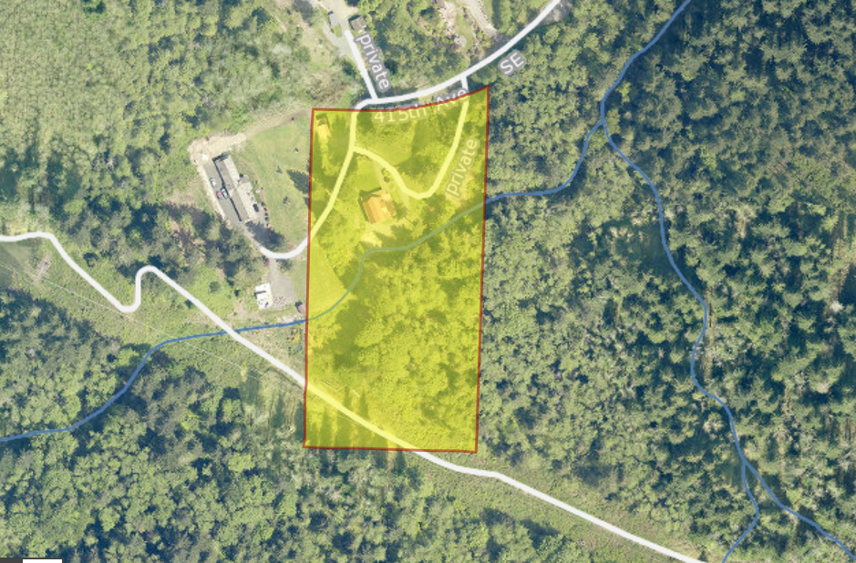

Vicinity View Map

