INTRODUCTION SLIP

DATE: August 20, 2020
TO: CLERK OF THE COUNCIL

PROPOSED MOTION NO. 2020-0284

A MOTION appointing Michael Ramos to the King County Regional Homelessness Authority's Implementation Board as a King County council appointee for a five-year term expiring December 31, 2024.

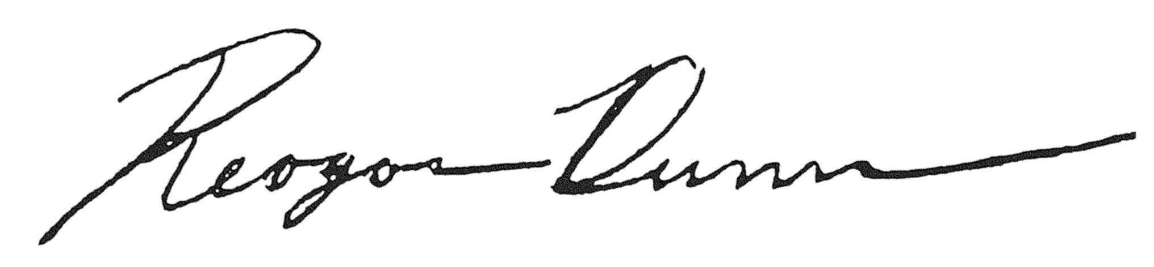

Reagan Dunn, Councilmember

