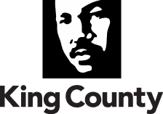

Office of Labor Relations
King County Executive Office
500 Fourth Avenue, Room 450
Seattle, WA 98104
Fax: 206-205-1395
TTY Relay: 711
www.kingcounty.gov

DATE: March 7, 2022

TO: |  | Dow Constantine, King County Executive
FM: |  | Megan Pedersen, Director, Office of Labor Relations
RE: |  | Labor Relations Legislative Transmittal Package

Attached, you will find a collective bargaining agreement for:

Union: | Uniformed Command Association (Corrections Jail Captains - Department of Adult and Juvenile Detention) (380/V1)
Contract: | Department of Adult and Juvenile Detention, Juvenile Division
Agreement: | 2021-2024 Collective Bargaining Agreement
Negotiator: | Diana Joy
Document Codes: | 380C0122

If you have any questions please contact me at 263-2898.

Approved:
 | Megan Pedersen  Director, Office of Labor Relations |  | Date

