Lease Property Summary

Photo of Property
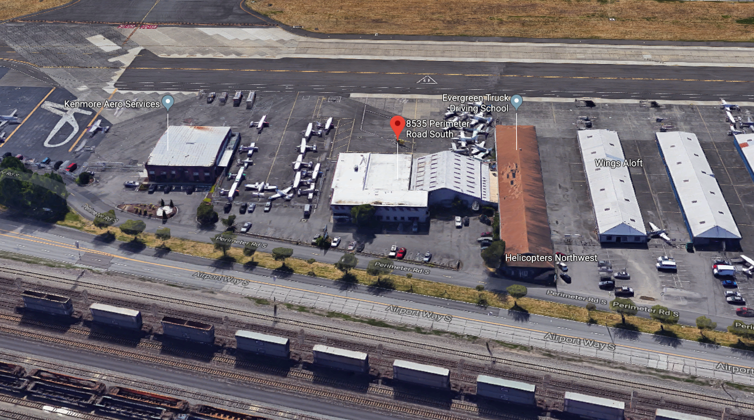

Property Owner: King County
Address: 8535, 8555 and 8600 Perimeter Road South, King County International Airport
Rental: $82,698.00 per month plus LET of $10,618.49
Term: 35 years
Square Footage: 415,568
Council District: Eight

Lease Synopsis:
As a Fixed Base Operator (FBO), Kenmore Aero Services, LLC is an aeronautical business that maintains facilities at King County International Airport (KCIA) for the purpose of conducting the retail sale of aviation fuels, lubricants, other aeronautical products, and provides line services such as maintenance and repair of propeller and jet aircraft, parking of aircraft, flight instruction, ground services and the promotion of aviation in King County. Kenmore Aero Services (KAS) is the third FBO currently operating at KCIA. This new lease will provide space for a significant expansion to their business, which will be commensurate with the facilities and services provided by the other two current FBOs.

In September 2016, the County invited five interested FBOs into a multi-lateral dialogue about a lease and development opportunity at KCIA. During the discussions, the County compared each party’s vision and business model with the County’s policy and business goals:
• Serving piston and jet powered aircraft with equal attention
• Attracting destination travel by air and producing local aviation events
• Reaching out to the community to share the adventure of flight and sharing the rewarding prospects for a career in aviation and aerospace
• Using available space at the airport to creatively maximize value and operations

Kenmore Aero’s vision and business model was the most aligned with the County’s policy preferences for KCIA. The executive authorized the Facilities Management Division to engage in direct negotiations with KAS for a thirty-five year lease at KCIA.

Kenmore Air has been a family-owned local airline since 1946. Kenmore Air subsequently established KAS (a separate limited liability company) as an FBO at KCIA initially to guarantee fueling service for the Kenmore Air airline. KAS is seeking to expand into a competitive, full service FBO by leasing additional space under a long term lease agreement. KAS also places emphasis on its commitment to serving the light general aviation community at KCIA, which aligns with policy goal of the county. The lease provides an area dedicated to serving light general aviation (piston propeller aircraft), which will directly benefit a segment of the flying public which is being rapidly priced out of KCIA due to its limited size and heavy demand for hangar space for corporate aviation.

Context
Rationale for transaction: By combining three contiguous parcels at KCIA, including the creation of a new parcel which was previously unused space, the airport was able to accommodate a third FBO, which benefits the aviation community and adds a significant amenity to the airport. KAS is going to pay for and demolish all existing facilities on the parcel and construct and invest in improvements valued at a minimum of $14.8M. Pursuant to King County Code 4.56.180 (A)(3), the code requirement for the investment value of improvements to qualify for a long term lease (longer than 10 years and up to 35 years) on this parcel is $11.3M.

Policy considerations: KCIA is required by the Federal Aviation Administration, through grant assurances tied to the Airport Improvement Program, to lease available space to qualified FBOs and other commercial aeronautical users based on demand for such space.

Political considerations: The lease requires KAS to maintain parking, self-serve fueling and services to the light general aviation (i.e., piston propeller aircraft) community, which benefits a broad constituency of flyers.

Community considerations or partnerships: KAS distinguishes itself through community involvement, outreach and charitable giving. KAS held a Fly-in and Open House on May 7, 2016, to celebrate their existing business at King County Boeing Field and to welcome light general aviation to their leasehold.

KAS has pledged $15,000 to Garden Ridge High School in Puyallup, including purchase of Van’s Aircraft empennage kit to allow students to assemble an airplane. KAS also made an unrestricted $10,000 donation to Raisbeck Aviation High School, which is in view of its current King County Airport leasehold.

Fiscal considerations: The KAS lease will provide $82,698.50 in monthly rental income to KCIA.

Other considerations: The prospective lessee was vetted according to the criteria provided in KCC 4.56.160.C.1 (commonly known as the “Responsibility Ordinance”), as required by KCC 4.56.160.B. Both Kenmore Air and KAS are existing lessee’s at KCIA with unblemished records. The entities have complied with all lease terms to date. KAS and Kenmore Air reported no negative compliance issues with regard to human trafficking laws or worker safety laws/regulations. In June 2015, the U. S. Environmental Protection Agency expedited settlement agreement and final order was executed regarding KAS joint venture partner, Kenmore Air Harbor (KAH) regarding storage of waste pursuant to Section 3008 of the Resource Conservation and Recovery Act (RCRA) and 40 CFR 22.13(b). A civil penalty of $4,000 was paid as part of this expedited settlement. In July 2017, KAS joint venture Partner, Kenmore Air Harbor, Inc., received a notice of penalty from the Washington State Department of Ecology alleging record keeping and storage violations under state hazardous materials regulations, WAC Ch. 173-303. Both matters were settled based on payment of a modest monetary penalty. No improper discharge of pollutants occurred. KAH has made significant progress in its storage of waste since this time period.

CIP/operational impacts: N/A

King County Strategic Plan impact: This transaction supports the King County Strategic Plan guiding principle of Financial Sustainability and goal of delivering a seamless network of transportation options to get people where they need to go when they need to get there.

Equity and Social Justice Impact: In accordance with Real Property Asset Management Plan (RAMP) Strategy 2.0 and 24.0, FMD and KCIA reviewed this legislation for Equity and Social Justice (ESJ) impacts. KCIA is located in the Georgetown neighborhood of Seattle and provides private and public airport services. There are similar tenants and services located in the vicinity of this parcel and no new ESJ impacts are anticipated from this lease.

Energy Efficiency impact: N/A

Lease Alternatives Analysis
Summary: N/A

Vicinity View Map
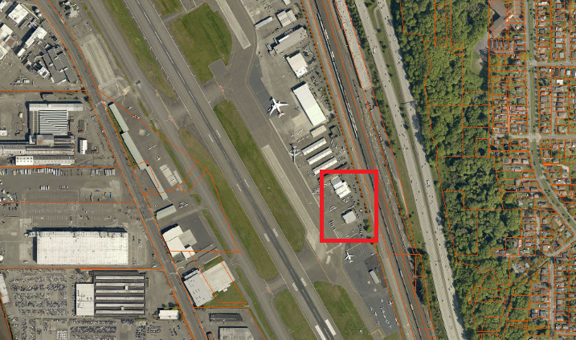

Parcel Map

