Lease Property Summary
Photos of Property
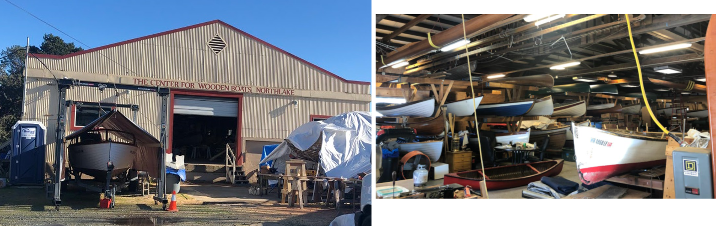

Property Owner: King County Metro Transit Department
Address: 1445 N Northlake Place, Seattle WA 98103
Rent: $4,250/month NNN
Term: Initial 5-year term with (2) additional 5-year options to extend
Square Footage: 56,397 square feet waterfront lot (approximately 25,672 sq. ft. of the lot is not submerged and approx. 20,627 sq ft of the property is lease area and has 5,000 sq. ft. storage/warehouse building and 12,000 sq. ft. of outdoor storage. (approx. 30,725 sq ft of the lot is submerged land in Lake Union)
Council District: Four
Funding Source: Center for Wooden Boats
Offer Expiration: Council approval by November 19, 2021 requested to meet requirements set out in the lease agreement.

Lease Synopsis:

The property is located on Lake Union and within 100’ of Gas Works Park and Seattle Department of Parks and Recreation property. Other adjacent uses include a shipyard and the Seattle Police Harbor Patrol. The Center for Wooden Boats (CWB) is the current tenant and has leased this property from King County since 2011. Center for Wooden Boats is a non-profit organization that uses the warehouse and yard for the storage and repair of boats. There are approximately 80 boats on the property. The existing storage building is 5,000 sq. ft. and was built in 1925. CWB has made many improvements to the building during its tenancy such as installing insulation, re-decking the south porch, enhancing interior lighting and replacement of exterior lighting with LED lighting.

Special Environmental Considerations:

The site is the location of a former bulk fuel storage and distribution facility, operation of which resulted in the presence of petroleum hydrocarbons, volatile organic compounds, and metals in the soil and groundwater. A 1999 Consent Decree between Washington Department of Ecology (Ecology), Chevron Products Company (Chevron), and King County required parties to provide remedial action. King County and Chevron have performed the cleanup and are monitoring and submitting quarterly soil samples to Ecology. No further action is presently required to meet the existing consent decree. However, no one can excavate any portion of the site (including installing water and sewer lines for a restroom) unless Ecology consents to the activity. The 1999 Consent Decree concerns only the upland portion of the site. To date, there has been no known site disturbance work to install underground utilities to the existing warehouse building.
As for the submerged portion of the site, which is the subject of a separate environmental clean-up action between the City of Seattle, Puget Sound Energy and Ecology, King County has taken the precautionary measure to prohibit access to the submerged portion of the site pending disposition of the environmental remediation for Lake Union. As access to the water is fenced-off, the market rent of $4,250/month has been appraised as an upland property.
CWB would like to rent canoes and kayaks to the public once they are granted permission from the City of Seattle and the State of Washington to access and launch the boats from the adjacent Waterway 20 property that is owned by the state and managed by the Washington State Department of Natural Resources.

As a condition of Waterway Permit 20-08998 from Washington State Department of Natural Resources (DNR) for Seattle Police Harbor Patrols use of Waterway 20, the City of Seattle’s Department of Finance and Administrative Services, (FAS) meet with the Wallingford Community Council and the Center for Wooden Boats on a monthly basis to create a future conceptual plan for use of Waterway 20 which meets the interests of both the City of Seattle and the Wallingford Community Council. The term of the permit is two years and additional sequential permits are required to be obtained from DNR per Seattle City Ordinance #126181 (approved and filed October 2, 2020).
City legislation places some restrictions on public access over Waterway 20, although members of Washington Tribes will continue to have access to Waterway 20. Other public access to Lake Union is available at Gas Works Park which is adjacent to Waterway 20 property. It is the County’s understanding that the City will continue to work with the Wallingford Community Council and the Center for Wooden Boats for water access.

Context

Rationale for transaction: The Center for Wooden Boats is a registered 501(c)(3) nonprofit museum whose mission is to promote northwest maritime heritage through education, interpretation, and hands-on experience in building, maintaining, and using historic small craft. (Source: The Center for Wooden Boats (cwb.org) Mission, Vision, & Values The site is critical to the operations and serves as a logistics hub for the CWB’s activities. Materials and donations are stored at the site. The site is unique and useful to the CWB’s mission. The CWB has informed the County that there is no other land or building site available in the area.

Separate from the use of this site for boat storage, they hold classes and boat tours at their other two sites one in the South Lake Union campus in Lake Union Park and The Center for Wooden Boats at Cama Beach State Park on Camano Island.

Policy considerations: The continued leasing of this location to the Center for Wooden Boats will keep an active tenant on the property keeping the site from mis-use and disrepair until such time as the environmental contamination issues are resolved and a long term plan for the parcel is established.

Political considerations: Continued leasing to the Center for Wooden Boats benefits the county by having an active tenant on the property to keep from misuse and disrepair until such time as the litigation around the contamination issue is resolved with various parties including City of Seattle, Chevron and Puget Sound Energy. The Center for Wooden Boats has been responsible tenants and to Metro’s knowledge have not breached King County or Department of Ecology policies.

Community considerations
or partnerships: The use of the property is limited to CWB storage and repair of boats. Storage and repair of the boats is needed to support CWB’s public activities of the center and provide recreational and educational benefit to the community. There is a possible future use of providing kayaks to the public to launch from the adjacent property owned by the state if/when public access is granted in the future. Access to the waterfront and dock from within the property is prohibited because of the litigation. CWB “collaborates with partner organizations to provide rewarding learning experiences and to enhance the community.” (source: Mission, Vision, & Values — The Center for Wooden Boats (cwb.org) Community partners and annual sponsors of CWB include Amazon, Fisheries Supply, 4Culture and The Seattle Office of Arts & Culture.

Fiscal considerations: The rent for the initial five years by CWB for the property’s 20,627 sq. ft. lease area is $4,250/month NNN triple net ($51,000/ year $2.40/sf/year) The Center for Wooden Boats will receive rent offsets for installing site improvements for the first two years of rent and there will be no rent offsets after the first two years have expired and full rent will be required.

Other Considerations: N/A

King County Strategic Plan impact: This lease supports King County Strategic Plan’s Goal of Efficient, Accountable Regional and Local Government by aligning goals of King County government with community priorities by supporting public recreation.

Equity and Social Justice Impact: In accordance with Real Property Asset Management Plan (RAMP) Strategy policy, FMD and Transit reviewed this legislation for Equity and Social Justice (ESJ) impacts. This ordinance furthers the King County Equity and Social Justice Strategic Plan by investing in community partnerships. “The Center for Wooden Boats is a thriving community that creates equitable access to empowering maritime experiences…”. One of their values is “We believe the joy of being on the water in boats should be available to all without economic or cultural barriers.” “We promote a safe and friendly environment where people of all ages, races, genders, ethnicity and incomes can connect with each other and our maritime heritage. This location is in the urban mixed-use Northlake neighborhood of Seattle. The Northlake neighborhood area is bounded to the northwest by Fremont; northeast by Wallingford and Lake Union to the south. No negative impacts are anticipated from this lease.

Energy Efficiency impact: CWB installed insulation to conserve energy and replaced exterior lighting with LED lighting.

Lease Alternatives Analysis
Summary: N/A

Vicinity View Map
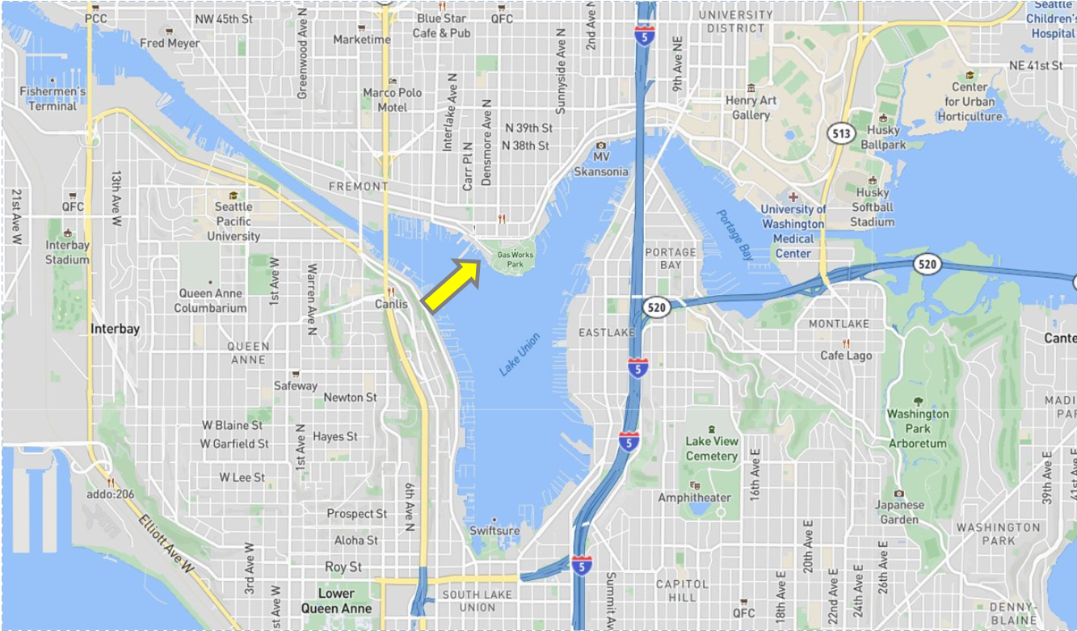

Parcel Map
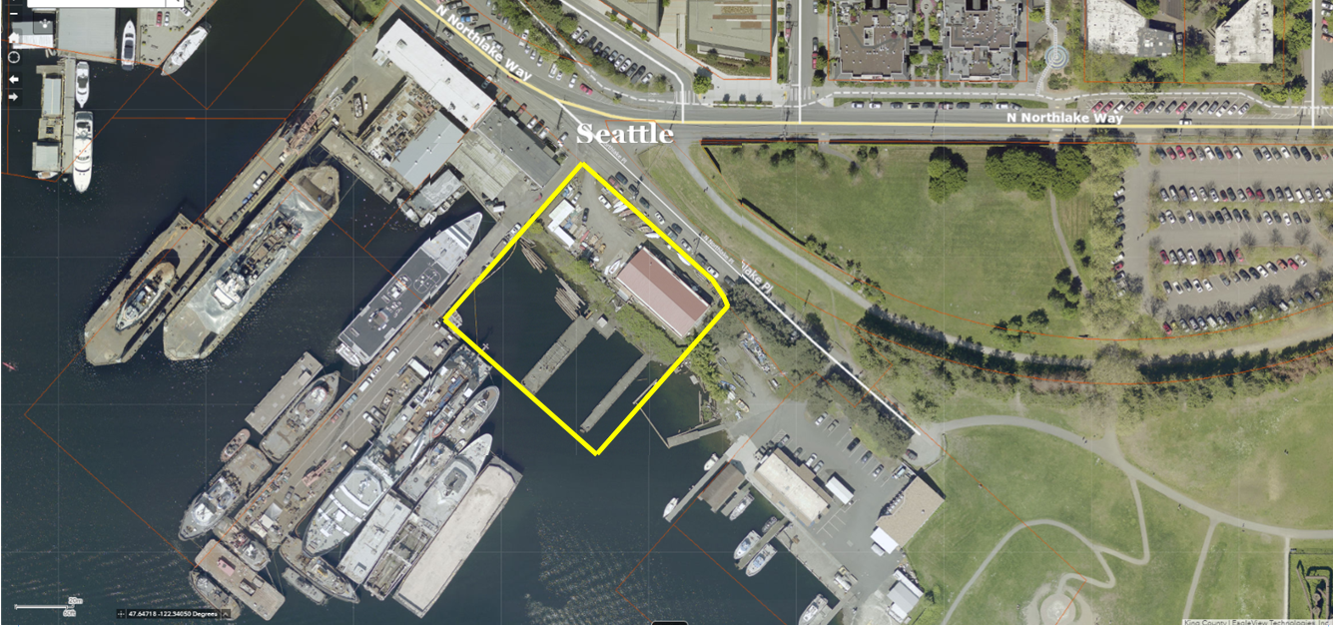

Source: CWB Vision Statement

