STAFF REPORT

Agenda Item: | 7 | Name: | Mike Reed
Proposed No.: | 2017-0188 | Date: | May 24, 2017

SUBJECT:

Proposed Ordinance 2017-0188 would set the sewer rate and capacity charge for 2018.

SUMMARY:

King County's sewer rates are set for the following year by June 30 of each year, pursuant to the county’s contract with participating utilities. Proposed Ordinance 2017-0188 would:

- Retain the monthly sewer rate at $44.22 for 2018 per residential customer equivalent (RCE) per month, which is the same as the approved 2017 rate.
- Set the monthly capacity charge for new connections to the regional system occurring in 2018 at $62.60, which is a 3.0 percent increase over the 2017 rate of $60.80.
- Provide revenue sufficient to continue the increased cash funding of capital projects, increase debt service coverage ratios, and extend funding for the rate stabilization fund.

BACKGROUND

Monthly Sewer Rate
King County provides wastewater treatment services for 17 municipalities and 17 sewer districts (including the Muckleshoot Tribe) in King County, southern Snohomish County and the northern tip of Pierce County. The county provides sewer interceptor lines that receive wastewater collected from residences and businesses by the cities and sewer districts, who bill their customers directly for both county and local utility charges. The sewer rate is charged by the county to the utilities to deliver, treat and discharge wastewater.

The monthly sewer rate collected by the county goes towards all Wastewater Treatment Division (WTD) expenses, including operating costs, debt service, and capital expenses. The monthly sewer rate for both residential and commercial customers is calculated on the basis of Residential Customer Equivalents (“RCEs”).

Table 1. Sewer Rates (2009-2017 Actual; 2018-2023 Projected)
Year | Rate  ($/RCE/Month) | %  Increase
2009 – 2010 | 31.90 | 14.1%
2011 – 2012 | 36.10 | 13.2%
2013 – 2014 | 39.79 | 10.4%
2015 – 2016 | 42.03 | 5.6%
2017 | 44.22 | 5.2%
2018 | 44.22 | 0%
2019 | 45.85 | 3.7%
2020 | 45.85 | 0%
2021 | 46.64 | 1.7%
2022 | 47.79 | 2.5%
2023 | 48.71 | 1.9%

Table 1 above depicts the anticipated sewer rates through 2023. Increases in 2019 are projected at 3.7% for the first year of the projected two-year rate; that is a decline from the 5.2% increase in 2017-2018. Similarly, in 2021, the projected increase of 1.7%, declines from the 2019 increase of 3.7%. The projected biennial increases through 2021 are each lower than the annual increases witnessed between 2009 and 2016. Increases are also lower than projected during last year’s rate discussion, when the Executive projected 2019 rates increase at 5.2% rather than 3.7%; and the 2021 increase at 2.6% rather than 1.7%.

Of particular note is that cost for the restoration of the West Point plant to full operations is being sought through insurance carried by the agency; the total restoration cost or timing and amount of insurance reimbursement is not yet known. It is also important to note that the current independent review of the plant, and the anticipated half-century evaluation, may identify additional needs that drive further costs; those are also not currently known.

The Division does retain in reserve $129 million that had been held in escrow, related to the “Brightwater Settlement.” Litigation between the County and a tunneling contractor, following termination of a contract for tunneling the Brightwater conveyance line, was initially determined in favor of the County in 2013, resulting in an award of $144 million. That award amount was placed in escrow, pending the outcome of appeals. In September 2016, the Washington Supreme Court declined review, allowing release of that $129 million of the $144 million (legal costs, potentially amounting to $15 million, are still being determined). The Division is recommending retaining this funding for costs not otherwise covered related to the West Point system failure.

The larger pattern is one of rate stability, and modest projected rate increases over time. As noted, future rate increases are less than has been previously projected.

This rate stability is attributed to several factors:

- In 2016, WTD refinanced $770 million of outstanding bonds resulting in $104 million in debt service savings over the remaining life of the bonds;
- Strong 2016 RCE growth, up 2.3 percent from 2015, broadening the customer base for coming years;
- Strong revenue collections, allowing rate stabilization fund balance to remain at $46.3 million through 2023;
- Proceeds from the favorable Brightwater judgment, remain in fund balance pending outcome of West Point restoration. Once restoration costs are determined, the utilization of remaining settlement proceeds will be determined.

Key fiscal management recommendations that were initiated in the 2017 rate, are being continued in the current 2018 rate proposal:

- The 40 percent cash funding practice for capital projects, resulting in less reliance on debt than earlier fiscal management approaches.
- Begin amortization of the principal on variable rate bonds.
- This rate proposes extension of funding levels in the Rate Stabilization Reserve rather than spending the account down.

Capacity Charge
New connections to the regional wastewater system are assessed a capacity charge, based on the policy of “growth pays for growth.” Every three years, the data supporting the calculation of the capacity charge is updated. This data addresses the costs of growth, or increasing system capacity, accommodating new users. That recalculation was made last year for the 2017 capacity charge, resulting in a 3.6 percent increase in the capacity charge for 2017 compared to 2016.

For 2018, the proposed capacity charge is $62.60, a 3.0 percent increase over the 2017 rate of $60.80.

Payment of the capacity charge may be made in a lump sum or paid over a 15-year period. Table 2 presents the proposed charge as the monthly payment over 15 years.

Table 2. Capacity Charge (2010-2016 Actual; 2017-2022 Projected)
Year | Rate/Month/RCE  15-yr. duration | % Increase
2010 | 49.07 | 3.0%
2011 | 50.45 | 2.8%
2012 | 51.95 | 3.0%
2013 | 53.50 | 3.0%
2014 | 55.35 | 3.5%
2015 | 57.00 | 3.0%
2016 | 58.72 | 3.0%
2017 | 60.80 | 3.6%
2018 | 62.60 | 3.0%
2019 | 64.48 | 3.0%
2020 | 66.41 | 3.0%
2021 | 68.40 | 3.0%
2022 | 70.46 | 3.0%

Consistent with the Regional Wastewater Services Plan policies, the capacity charge is based on the estimated costs of the 30-year Regional Wastewater Services Plan (RWSP). The capacity charge is set at a level to recover the designated, growth-related costs that are not covered by the monthly rate payments of newly connecting customers. Over the planning period of Regional Wastewater Services Plan (2003 – 2030), the capacity charge and monthly rate payments of newly connecting customers will cover 95% of growth-related costs.

Unlike the monthly sewer rate, the capacity charge is directly billed by and paid to King County. Based on information provided by the cities and sewer districts, King County notifies new connecting customers of the option to pay over time (15 years) or in a lump sum. Customers also have the option to pay off the account at any time with a discount.

The cumulative amount of the capacity charge as proposed for 2018 at $62.60 per month would amount to $11,268 if paid over the full term of 15 years. An up-front payment, discounted at approximately 2.8% compounded over the 15 years, would reduce the payment to $9,171 in 2018, if paid as a lump sum. In practice, many people choose to pay this as a lump sum and have the amount rolled into mortgage payments.

ANALYSIS

As the regional wastewater system has taken on recent and ongoing major capital undertakings, it has funded these projects primarily through bonded indebtedness, consistent with RWSP policy. The Brightwater Treatment Plant, completed in 2012, ongoing conveyance system projects, and the Combined Sewer Overflow capital projects, mandated by a consent decree with the state Department of Ecology and federal Environmental Protection Agency, represent the primary project expenditures supported by the growth in capital debt. Chart 2 below shows the total 2017 debt by project era.

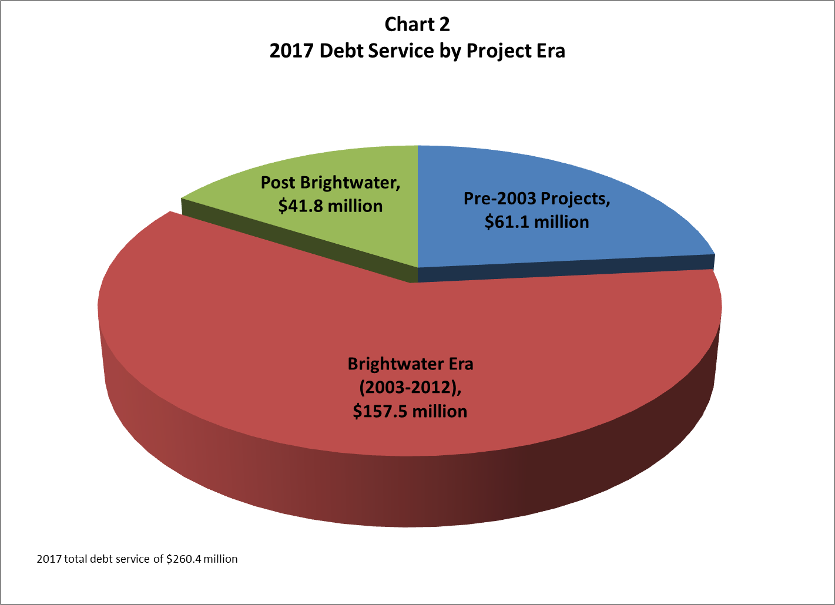

Much of the operating revenue (52 percent) goes towards debt service payments, as shown in Chart 3 below.

Chart 3. Revenue Utilization, 2018 Proposed Sewer Rate

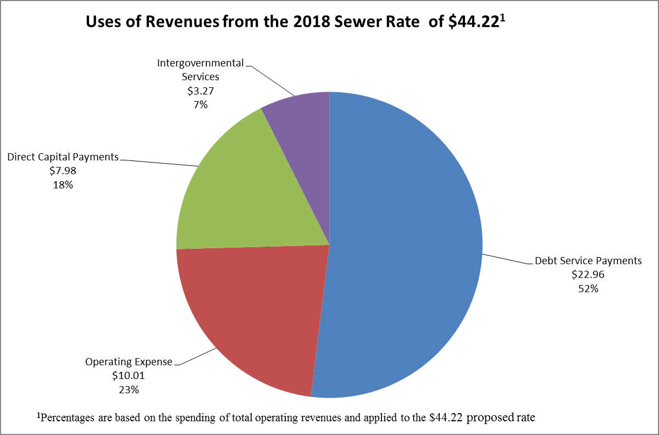

Cash Funding for Capital Projects
As noted, this rate continues the practice of 40 percent cash funding of capital projects, reducing the amount that must be raised through debt. Chart 4 below demonstrates the results, over time, of this cash funding strategy. Projected debt would be $234 million less than under previous practices by 2023. While debt issuance would continue to rise, due primarily to required Combined Sewer Overflow projects, debt levels would not rise as rapidly.

Chart 4. Future Debt Impact of 40% Cash Funding

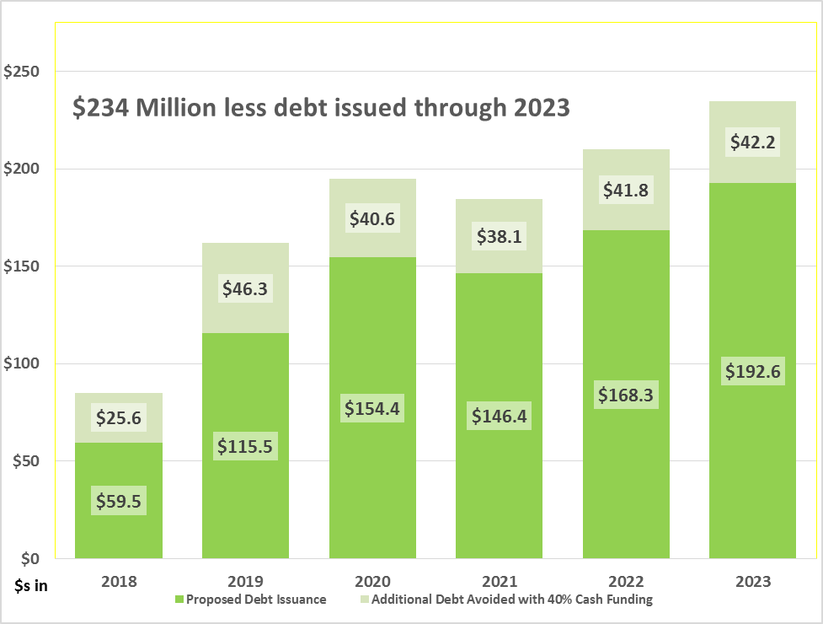

Debt Payment Coverage Ratio
WTD has historically structured rate proposals to provide debt payment coverage ratios of at least 1.15. That is, for each $1 needed to make annual payments on all bonded indebtedness, $1.15 is raised in revenue. This debt coverage ratio is a commonly-used metric by bond rating agencies and bond purchasers, as a signal of the security of bond repayment capacity.

Several factors have acted to strengthen the agency’s financial position in 2017, including:

- Refunding bonds in September 2016, generating $10.8 million in debt service savings in 2016, 2017 and 2018.
- Strong growth in the customer base generated an additional $12.3 million in sewer rate and capacity charge revenue in 2016.
- Operating fund under-expenditures of $4.9 million in 2016.
- New practice of funding 40 percent of the capital program with cash, as discussed during deliberations last year on the 2017 wastewater rate.

As a result, the debt service coverage ratio, at year-end 2016, was 1.40, well above the 1.15 historic level.

Additionally, this strong financial position has enabled the WTD to adjust its debt issuance profile. In the Financial Plan presented by the agency last year, a $60 million parity bond sale was projected for 2018. This year’s financial plan eliminates that sale, while retaining plans for 2018 issuance of $43.4 million in variable rate debt, as well as $16.1 million of state revolving fund loans.

Rate Stabilization Reserve
Beginning in 2005, WTD has deposited funds in a “rate stabilization reserve” as a tool to help manage rate increases by deferring available operating revenues into future years; funds were withdrawn as required, to moderate rates. As part of the 2017 rate proposal, the Executive had proposed to draw the reserve down to $12.0 million, by 2023.

The current rate proposal, however, retains level funding in the reserve on a continuing basis. The current balance of $46.3 million would be maintained through 2023; if contingencies present the agency with significant unanticipated expenses, the Rate Stabilization Reserve would be drawn upon to stabilize future rate levels. This strategy addresses the interests of rating agencies with maintaining adequate liquidity.

Table 4. Rate Stabilization Reserve, 2015-2021 (millions of dollars)

 |  |  | 2016 | 2017 |  | 2018 |  | 2019 |  | 2020 |  | 2021 |  | 2022 | 2023
Beginning balance |  |  | $46.3 | $46.3 |  | $46.3 |  | $46.3 |  | $46.3 |  | $46.3 |  | $46.3 | $46.3
Additions |  |  | $0.0 | $0.0 |  | $0.0 |  | $0.0 |  | $0.0 |  | $0.0 |  | $0.0 | $0.0
Reductions |  |  | $0.0 | $0.0 |  | $0.0 |  | $0.0 |  | $0.0 |  | $0.0 |  | $0.0 | $0.0
Ending balance |  |  | $46.3 | $46.3 |  | $46.3 |  | $46.3 |  | $46.3 |  | $46.3 |  | $46.3 | $46.3
Expenses and Revenues
The Executive reports that operating expenses for 2018 are projected to be $155.2 million, a 2.2 percent increase over the 2017 adopted budget. The key elements driving this increase are identified as a projected increase in WTD’s insurance rate. In response to inquiry as to whether insurance increase projections are related to the February 9th, 2017 West Point system failure event, the Executive indicates that the County is in discussions with insurance carriers regarding policies for the regional system, not specific to individual facilities.

Operating revenues are projected at $499 million for 2018. This is 1.8 percent higher than the forecast for 2017 revenues. The net increase of $26.4 million in operating revenues is generated from increases in both sewer rate revenue and capacity charge revenue, as shown in Table 5 below.

Table 5. Revenues Supporting Wastewater Operations and Capital

 | 2017 Forecast | 2018 Forecast | Change | % Change | 2019 Forecast | Change | % Change
Sewer Rate | $402.0 | $404.4 | $2.4 | 0.6% | $421.6 | $17.2 | 4.3%
Capacity Charge | $70.4 | $75.6 | $5.3 | 7.5% | $81.2 | $5.2 | 1.0%
Other Income | $13.0 | $13.4 | $0.3 | 2.5% | $13.8 | $0.4 | 3.0%
Investment Income | $5.0 | $5.6 | $0.6 | 11.9% | $7.4 | $1.7 | 30.8%
Totals | $490.5 | $499.0 | $8.6 | 1.8% | $524.0 | $24.9 | 5.0%

RCE Forecasts
Table 6 below illustrates the projected rate of growth of Residential Customer Equivalents in coming years. 2018 RCE’s—which had been expected to increase by 0.50 percent in the 2017 rate forecast—are now expected to increase at 0.60 percent, in light of a substantial increase in growth in recent years.

Table 6. Current Residential Customer Equivalents Forecast
 | 2016 | 2017 | 2018 | 2019 | 2020
2018 Rate Proposal | 752,674 | 757,610 | 762,156 | 766,348 | 771,099
Percent Change Between Years | 2.25% | 0.66% | 0.60% | 0.55% | 0.62%
2017 Adopted Sewer Rate | 740,502 | 744,945 | 748,670 | 752,787 | 757,455
Percent Change Between Years | 0.60% | 0.60% | 0.50% | 0.55% | 0.62%
Change between 2018 Rate Proposal and 2017 Adopted Rate | 12,172 | 12,665 | 13,486 | 13,560 | 13,644

Table 7 below depicts the growth in new connections to the system through 2023, comparing the expected growth in new connections as of the 2017 sewer rate versus the 2018 rate proposal. New connections are the basis on which the capacity charge is billed. The 2018 rate proposal continues to assume 10,500 new connections for 2018, declining to 10,000 in 2019. This forecast takes into consideration historical growth rates and regional economic forecasts. The Executive notes that the March 2017 Conway-Pedersen economic outlook forecasts a deceleration in employment growth, declining to 1.4 percent growth in 2018, down from 3.0 percent in 2015 and 2016.

Table 7. Projected New Sewer Connections by Year of Connection
 | 2016 | 2017 | 2018 | 2019 | 2020 | 2021 | 2022 | 2023
2018 Rate Proposal | 10,742 | 11,000 | 10,500 | 10,000 | 10,000 | 10,000 | 10,000 | 10,000
2017 Sewer Rate | 12,000 | 11,000 | 10,500 | 10,000 | 10,000 | 10,000 | 10,000 | 10,000
Change | (1,258) | - | - | - | - | - | - | -

WTD Capital Projects
Table 8 below shows the differences in WTD's proposed Capital Spending Plan compared to the capital spending projections made in the 2017-2018 Budget forecast.

Table 8. WTD Capital Spending Plan, 2017-2022 (in $ millions)

 | 2017 | 2018 | 2019 | 2020 | 2021 | 2022
2018 Rate Forecast | $183.8 | $192.4 | $221.3 | $232.7 | $226.3 | $240.3
2017-2018 Budget Forecast | $168.3 | $206.4 | $226.8 | $228.9 | $222.2 | $239.1
Difference | ($15.5) | $14.0 | $5.5 | ($3.8) | ($4.1) | ($1.2)

Major Capital Projects Incorporated into the 2018 Rate
As reported by the Executive, key projects that are underway or were added through the budget process that represent a significant portion of the six-year capital planning horizon include the following:

- Chelan Ave CSO ($118.7M)
This consent-decree-driven project will design and construct a combined sewer overflow control facility to handle four million to five million gallons of mixed storm and wastewater. The project estimate reflects work for design, construction, and property acquisition as the project team evaluate a tank alternative and a tunnel alternative. The current project schedule for substantial construction completion is June 2022.

- CSO Control & Improvements – Magnolia ($53.8M)
This estimate reflects an increase of $4.7 million to fund the repair of a 30-inch diameter pipe that has failed and prevents CSO flows from entering the facility storage tank. Repair is scheduled for completion at the end of July 2017 (July 2016 previous construction completion date). The contractor and its insurer have been put on notice that they are responsible for the repair of the damaged pipeline.

- North Creek Interceptor ($84.5M)
This project provides a vital public benefit because it increases the capacity of the regional sewer system to address sanitary sewer overflows that impact public health and water quality and accommodates planned growth. On January 19, 2017, the County Executive signed a determination of emergency and waiver from competitive procurement. The determination of emergency was necessary because the construction work was not being completed in accordance with the specifications and time period of the contract. The emergency declaration allows the Wastewater Treatment Division to hire a qualified follow-on contractor regarding the cost and schedule for completion of the remaining work. WTD signed a contract with J.W. Fowler Co. to complete the project.

- West Duwamish CSO Control ($57.3M)
This project provides for the design, construction and property acquisition to control combined sewer overflows as mandated by the consent decree issued by the U.S. Department of Justice and the Environmental Protection Agency (EPA). Construction completion is currently scheduled for January 2025.

- SP Biogas and Heat Systems Improvements ($67M)
This project provides for the design and construction to replace the South Plant heating and gas scrubbing system that has reached the end of its useful life and become increasingly costly to maintain and operate. The system replacement is an opportunity to install an energy efficient system and comply with the higher quality standard for scrubbed biogas set by Puget Sound Energy. Complying with the higher quality standard allows the scrubbed gas to be sold to an expanded market. The project is scheduled to reach substantial completion in February 2021.

- Jameson/Arcweld Buildings Replacement ($23.4M)
The Jameson and Arcweld buildings are beyond their useful life, cramped, and inefficient. The project involves design, construction, and property acquisition activities to address the organizational business needs and requirements for housing the West Division maintenance and Construction Management staff. The project is scheduled to reach substantial completion in March 2022.

Metropolitan Water Pollution Abatement Advisory Committee Comments
The Metropolitan Water Pollution Abatement Advisory Committee, or MWPAAC, advises the King County Council and Executive on matters related to water pollution abatement. It was created by state law (Revised Code of Washington 35.58.210) and consists of representatives from cities and local sewer utilities that operate sewer systems within King County’s sewer service area. Most of these cities and sewer utilities deliver their sewage to King County for treatment and disposal.

MWPAAC has indicated its support for the Executive’s 2018 rate recommendation in a letter forwarded to the Council. The letter, dated April 26, 2017, indicates as follows:

“…the proposed rate serves to continue reducing outstanding debt through 2030 by instituting increased cash funding and moderate rate increases, which is in line with the MWPAAC debt review committee recommendation. Based on that review, we support the proposed 2018 rate of $44.22, which represents no change from 2017’s rate. We encourage you to support this proposed rate, which responds to many of MWPAAC’s previously voiced concerns and proposals.”

TIMING

The wastewater contracts with participating cities and sewer districts specify that the sewer rate be effective by July 1 of each year. As such, the last regular meeting of the Full Council, with minimum processing, that would allow the county to take action and meet the contract requirement would be the meeting on June 19, 2017. With maximum processing time, the Council will have to take action on June 5, 2017.

ATTACHMENTS

- Proposed Ordinance 2017-0188, and its attachment
- Executive’s Transmittal Letter
- King County Executive 2018 Monthly Sewer Rate and Capacity Charge Proposal, dated April 27, 2017
- MWPAAC Letter to Council Chair, dated April 26, 2017

INVITED

- Tim Aratani, Manager, Finance and Administrative Services, Wastewater Treatment Division, Department of Natural Resources and Parks
- Tom Lienesch, Economist, Wastewater Treatment Division, Department of Natural Resources and Parks

The County has a contractual relationship with cities and utility districts to collect wastewater from them and convey it to County treatment plants for treatment and discharge. The component agencies that provide direct services to the ratepayers and use the County conveyance and treatment facilities are charged for the customers within their districts. The utility providers, as direct service providers, set their own rates to recoup the payments required by use of County services plus their own “local” cost of service.
A single family residence is one RCE. Commercial and industrial customers are charged based on the amount of wastewater they generate, calculated using the quantity of water consumed. For commercial and multi-family residences, the calculation is then converted into RCEs. One RCE (750 cubic feet of wastewater) represents the average amount of wastewater a single family residence would generate in a month.
K.C.C. 28.86.160 (FP-15) sets the charge via the following calculation: Capacity charge = (total system costs – rate revenue from existing customers) – rate revenue from new customers number of new customers
The RWSP financial policies, established in county code, require the capacity charge to be a uniform charge, approved annually, and the charge is not to exceed the cost of capital facilities necessary to serve customers establishing new connections to the sewer system.

