Norway Hill
Lease Property Summary
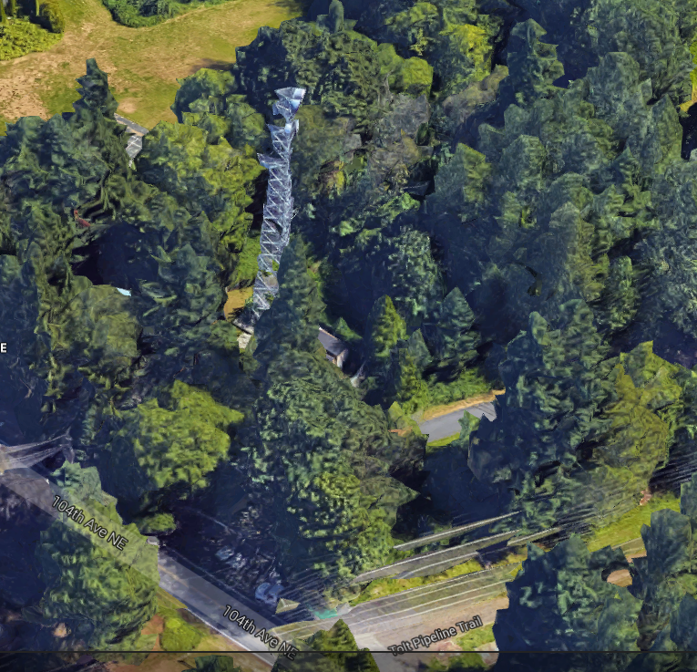

Property Owner: City of Bothell
Address: 16206 104th Avenue NE, Bothell, WA 98011 - Parcel 5690500065
Cost Per Month: $0
Operational Costs: $7,000 annually
Term: Twenty-five (25) year initial term with three, five-year extension options
Square Footage: Approximately 2500 square feet of land and space on the tower
Council District: One
Funding Source: Puget Sound Emergency Radio Network Capital Fund, Number 3361
Previous Location: N/A

Lease Synopsis:

This lease provides for a site and communications facilities for the new Puget Sound Emergency Radio Network (PSERN). Construction and operation of the PSERN supports the Strategic Plan goal of providing for safe communities. PSERN will be used to dispatch police, fire, and medical services to emergency locations where they are needed and will allow responders to communicate at those locations. It will also be used to coordinate the activities of water, sewer, and electricity utilities in restoring service after natural disasters.
At this site, the PSERN Project (Project) will construct a shelter to hold electronic equipment and erect a new tower for antennas. The radio tower will be located on the north side of parcel. There is an existing tower at the current 1.76 acre site, however it is unable to support the additional communications equipment required for PSERN, even with reinforcement. A new tower at this location is needed for PSERN. The Project will fund and construct a tower and transfer ownership to the City of Bothell when completed, as a part of the lease agreement. PSERN will not be charged rent for the Project’s use of the City’s land for the shelter or the tower during the term of this lease and all subsequent renewal periods.

Context

Rationale for transaction: This site is critical for emergency radio coverage in Bothell and the surrounding areas. Our contract requires the PSERN system vendor to meet specific performance criteria, including coverage and signal strength. The PSERN vendor identified the site as part of its system design as required in the contract for designing the radio communication system. Sites are placed in specific locations for the PSERN to meet these critical requirements.

Policy considerations: Council approved the PSERN project: Ordinances 17993, 18074, 18075; and PSERN capital fund 3361. There is urgency in completing the PSERN. The current emergency radio system is aging and the vendor will stop supporting the system at the end of 2018. PSERN staff reviewed the radio communication needs for this area and determined that leasing the existing communications system location would be more timely and cost-effective than leasing, permitting and developing a new site in this area.

Political considerations: The PSERN Levy, in 2015, was supported by 65% of voters, and will improve public safety communications. The acting City of Bothell Attorney and Director of Public Works have approved the lease language and it is expected the City Council will approve it in due course. The new tower replaces an existing tower of the same dimensions causing no change in visual impact. The City of Bothell is supportive of the new communications network. The City has noted the additional geographic coverage -- including the portion of the City in Snohomish County as well as the portion in King County -- will enable seamless communications with other police and fire departments providing mutual aid.

Community considerations or partnerships: PSERN is replacing an existing tower that is at structural capacity with a new tower at the same height. There could be concerns in the community with construction of a new tower. As part of the permitting process, the PSERN project will be required to perform public outreach to ensure that all public concerns are properly addressed to the satisfaction of the City of Bothell. However, the net visual impact will be near zero. Current tenants on the tower include KC Metro, NORCOM (North East King County Regional Public Safety Communication Agency), and EPSCA (Eastside Public Safety Communications Agency). PSERN is coordinating closely with Bothell Public Works and there will be no impact to the adjacent water tower or operations thereof.

Fiscal considerations: The Project’s improvement at the site will total approximately $540,000 consisting of the following components: 130’ Lattice tower - $125,000; Shelter & back-up Emergency Generator - $110,000; and Construction – $305,000. The funding for these improvements has previously been appropriated by Council. Operating expenses are expected to be $7,000 annually. There will be no annual rental charge at this site.

Other considerations: This lease will be taken in the County’s name and the improvements described above will be completed by the County. When the subsequent non-profit is formed to manage and operate the new radio system, this lease will be assigned to that organization.

CIP/operational impacts: The construction costs associated with the tower at this location were approved as part of Ordinances 17993, 18074, 18075; PSERN capital fund 3361. The operational issues of the site include the current radio tower and a water tower which will continue to be owned, operated, and maintained by the City of Bothell. PSERN plans for the current radio tower to remain in operation through 2016. PSERN’s new tower and shelter will be completed early in 2017. No loss of service is planned as part of the cutover to the new tower. Construction of the proposed tower will not impact water operations at the site. The PSERN project assists Bothell in their antennae upgrade effort.

King County Strategic Plan impact: Lease of this property furthers the goals of the King County Strategic Plan by supporting safe communities, exercising good financial stewardship, planning for the long-term sustainability of County services, and empowering County employees including the Sheriff, Medic One, and public works.

Equity and Social Justice impact: In accordance with Real Property Asset Management Plan (RAMP) Strategy 2.0 and 24.0, Facilities Management Division (FMD) and PSERN staff evaluated this location for Equity and Social Justice (ESJ) considerations. PSERN is an emergency radio network and will serve a larger share of the County than the current network which was completed nineteen years ago. The Norway Hill area of Bothell location is co-located with water towers on this and the adjacent parcel. Property records indicate the current radio tower has been located here since 1979. PSERN and the City of Bothell are proposing a new radio tower at this site which will allow the program to continue without significant ESJ impact.

Energy Efficiency impact: Most of the electronic components in today’s network are twenty years old; the equipment PSERN is buying is significantly more energy efficient. In addition, the shelters being installed for the Project must meet the State’s Labor & Industries Gold Seal certification and, therefore, will be much more energy efficient than those used today.

Lease Alternatives Analysis

Summary: This location was identified by the County’s vendor who has responsibility for designing the new emergency radio communications system. The County’s contract makes a single vendor responsible for the communications system design, sites and equipment. Norway Hill was chosen because it was an existing site that provides coverage for the intended area. The Snohomish County Emergency Radio System (SERS) Site on 228th, near FEMA, was evaluated but it did not provide the coverage in Bothell that was required. Building a new site in the area was also an alternative considered, but zoning and permitting restrictions make this infeasible for both timing and economic reasons.

Vicinity View Map

Parcel Map
