Legislative Review Form
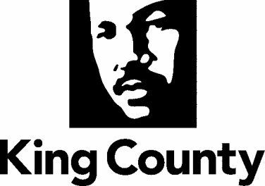

Agency: EXEC Office Contact person Rick Ybarra Phone 206-263-9651

Ordinance Motion Proviso Report Other

Civil Division Prosecuting Attorney Review

Name John Gerberding Version Final Date 12/17/2020 @ 7:31am

Dept. Director or Designee Review

Name Rachel Smith Version Final Date 12/16/2020 @ 12:30pm

Performance Strategy & Budget Office Review

Name Version Date

Technical Form/Code Reviser Review – Confirm adherence to legislative format

Name Angel Allende, Deputy Clerk Version Final Date 12/17/2020 @ 2:06pm

Executive Office Review & Transmittal Approval

Name Shannon Braddock Version Final Date 12/16/2020 @ 12:30pm

ENTRANCE CRITERIA REVIEW
EXEC OFFICE (initials) KCC CLERK
Fiscal note? Y NA BB Y NA
KC Strategic Plan reference in letter? Y NA BB Y NA
Proof read for spelling and grammar? Y NA BB Y NA
All pertinent attachments listed/labeled? Y NA BB Y NA
Costs identified/described in letter Y NA BB Y NO
Regulatory Note Required and Complete? Y NA BB Y NO
Formatted/Delivered in word-searchable doc format? Y NA BB Y NA
Potential Annexation Area (PAA) impacts identified? Y NA BB Y NO
Advertising required? if yes, cite all pertinent code/laws. Y NA BB Y NO
Any special circumstances affecting processing time? Y NA BB Y NO

