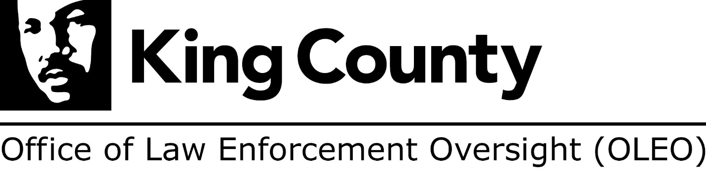

Transmittal Date: September 01, 2021
To: clerk.council@kingcounty.gov; melani.pedroza@kingcounty.gov
CC: rod.dembowski@kingcounty.gov; Girmay.Zahilay@kingcounty.gov; kathy.lambert@kingcounty.gov; jeanne.kohl-welles@kingcounty.gov; Dave.Upthegrove@kingcounty.gov; claudia.balducci@kingcounty.gov; Pete.vonReichbauer@kingcounty.gov; joe.mcdermott@kingcounty.gov; reagan.dunn@kingcounty.gov

Dear Metropolitan King County Councilmembers and Clerk of the Council,

On behalf of the Office of Law Enforcement Oversight (OLEO) staff and the King County communities we serve, I am pleased to transmit the OLEO 2020 Annual Report. OLEO’s goal is to represent the interests of the public in its efforts to hold the Sheriff’s Office accountable for providing fair and just police services. One way we do that is by providing actionable and unbiased analysis and recommendations that can help improve the integrity of Sheriff’s Office operations and the effectiveness and professionalism of its employees.

Each year, OLEO’s ordinance requires the Office provide an extensive year-in-review accounting regarding oversight of the King County Sheriff’s Office (Sheriff’s Office). This report focuses on providing analyses, recommendations and conclusions relating to all phases of the sheriff’s complaint process, common allegations of misconduct, related findings, and complaint dispositions. The Annual Report also provides a summary of critical incidents, completed systemic reviews, completed policy recommendations, and work to engage and empower the community and other stakeholders.

I want to thank the Council for its support over the past year, which was monumental both in understanding the gravity of community need and interest for effective oversight, but also for transition within OLEO. I look forward to briefing the Council on this report in the coming months, and also want to thank the OLEO staff for an excellent job producing this annual report.

Thank you again and best regards,
Adrienne Wat, OLEO Interim Director

