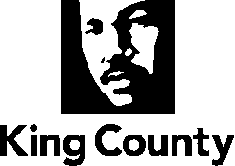

Skyway-West Hill Land Use Strategy
Phase 1 of the Skyway-West Hill Community Service Area
Subarea Plan

July 20, 2020

page intentionally left blank

Skyway-West Hill Land Use Strategy

Phase 1 of the skyway-west hill

Subarea Plan

King County Comprehensive Plan

Table of Contents
Introduction…………………………………………………………………………………………... 1
Community Outreach…………………………………………………………………………… 6
Community Outreach Process……………………………………………………………..… 6
Outreach Methods…………………………………………………………………….……….… 6
Messages We Heard…………………………………………………………………………..… 9
Community Context…………………………………………………………….………………… 11
Residential Neighborhoods……………………………………………………………...…… 19
Residential Neighborhoods Policies……………………………………………………...… 23
Commercial Areas……………………………………………………………………………….… 24
Commercial Policies………………..…………………………………………………………… 26
Community Character…………………………………………………………………………… 28
Community Character Policies…..………………………………………………………… 30
Implementation and Next Steps…………………………………………………………… 32
SWH Action 1 –Skyway-West Hill Subarea Plan………………………………………. 32
SWH Action 2 – Performance Monitoring and Evaluation…………………………. 32
SWH Action 3 – Equitable Housing Development Strategy………………………… 33
SWH Action 4 – Public Outreach in the Permit Review Process………………...… 34
SWH Action 5 – Community Design Standards………………………………………… 34
SWH Action 6 – Small-Scale Commercial Incentive Program…………..…………. 35
SWH Action 7 – Community Amenity Incentive Program…………………..……….35

Appendices
- Appendices to the Skyway-West Hill Land Use Strategy, Phase 1 of the Skyway-West Hill Subarea Plan can be found in Attachment G to Ordinance 19146

Appendix A – Community Outreach
Appendix B – Skyway-West Hill Land Use Subarea Plan Equity Impact Analysis
Appendix C – Community Center Feasibility Study
Appendix D – Service Delivery and Facilities Provided by King County in the Five Potential Annexation Areas

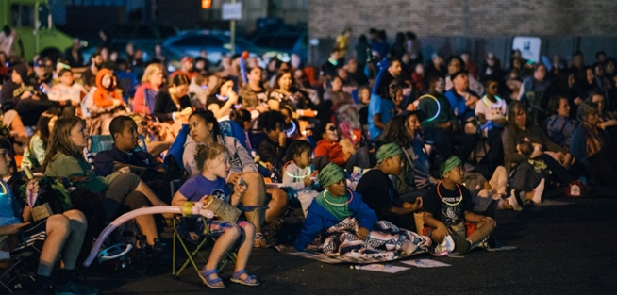
Caroline Walker Evans Photography of Skyway Outdoor Cinema 2018

Chapter 1

Introduction

Why We Plan
A neighborhood’s built environment – the location and variety of places to live, work, shop, learn, recreate, and gather as a community – shapes the lives of the people who live there. Our built environment and communities inform a distinctive sense of place and contributes to community identity, and has a significant influence on our physical and mental well-being and future success. Within King County, communities are not all built equally and health outcomes such as life expectancy, smoking rates, mental distress, and more vary disproportionately by community and census tract. Inequitable access to services, safe and affordable housing, transportation options, and jobs unequally affect some communities more than others.

Land use decisions made today shape a community for generations to come. Skyway-West Hill is an established area with opportunities for redevelopment. Although redevelopment can bring benefits to the community, it is important to recognize that this growth may leave some residents behind and push others out. The land use policies in this Land Use Strategy recognize the need to ensure that Skyway-West Hill's most vulnerable residents are protected from the impacts of change.

Land use planning is a key factor in equity and social justice, affecting residents’ ability to access the resources they need to succeed. Past land use decisions have contributed to economic and social disparities, which have been felt in communities like Skyway-West Hill. King County’s Determinants of Equity Report states that "identifying how the built environment supports residents in improving quality of life, accessing jobs and housing is critical for promoting a healthy environment for all residents."

The ultimate goal of the phased Skyway-West Hill Community Service Area Subarea Plan (Skyway-West Hill Subarea Plan) is to make real, equitable improvements to the quality of life of residents of Skyway-West Hill.

Subarea Planning
Land use in unincorporated areas of King County, such as Skyway-West Hill, is governed by the King County Comprehensive Plan and adopted subarea plans. The Comprehensive Plan sets broad, countywide policies about unincorporated area land use and designates unincorporated land for particular uses through the adopted Land Use Map. Subarea plans, which are a part of the Comprehensive Plan, address smaller geographies and establish policies specific to the needs of those communities. Policies in the Comprehensive Plan and subarea plans are implemented through the King County Code, which includes development regulations and road standards, and other service-oriented plans and the County budget.

After a two decade pause, King County decided to reinstate its long-range planning program for its unincorporated communities in 2015 and launched a Community Service Area subarea planning program. The subarea planning process for Skyway-West Hill began in 2018, focused specifically on evaluating current land uses and zoning and building on the community’s priorities to establish a community vision and supporting policies for the following 20 years. This document is the product of this effort and addresses specific land use and zoning needs for the Skyway-West Hill subarea.

As part of the County's 2020 midpoint update to the King County Comprehensive Plan, the County reconsidered the scope of the subarea planning process in light of a land use only focus that did not fully capture the community's priorities. This revision recognized an unmet need for community-focused plans and policies for a number of services and topics where King County serves as the community's local government. The County envisions that the subarea plans will provide a vehicle for residents to collaborate with King County on the future of their communities, including Skyway-West Hill.

This document is a Land Use Strategy and serves as the first part of the Skyway-West Hill Subarea Plan, focusing on policies surrounding land use, planning, and the built environment for the community. to the County intends to complete the second phase that captures the community's priorities and needs. As proposed, the second phase of this subarea plan will be adopted in 2022.

Planning History

1994 West Hill Community Plan
Skyway-West Hill's local community plan is the 1994 West Hill Community Plan. The West Hill Community Plan established a vision for Skyway-West Hill's residential neighborhoods and the Skyway Business District. The plan envisioned building a strong community identity through aesthetics and character of the built environment, support for senior residents, revitalized commercial businesses, and improved pedestrian facilities. The plan addressed a broad range of issues such as community services, infill development, affordable housing, and beautification of the business district. Except for zoning updates to implement the Growth Management Act in the 1990s, this plan was has not been updated or amended since the plan's adoption.

2008-2009 Planning Efforts
Between 2008 and 2009, community volunteers and local nonprofit groups undertook several visioning and goal-setting exercises related to neighborhood and commercial revitalization. These efforts were led by Skyway Solutions and the Pomegranate Center with support from King County's Community Enhancement Initiative. Community planning documents that resulted from these grassroots efforts included the Skyway Park Community Vision (2008) and the Community Agenda for Revitalization (2009).

Skyway Park Community Vision (2008). This report identified several community enhancement goals, including: providing a safe environment for recreation and exercise; demonstrating sound environmental practices, such as wetland and forest restoration; being sensitive to concerns surrounding gentrification and equitably serving a culturally and economically diverse community; and leveraging the park's central location to improve neighborhood walkability and connectivity. Concepts for Skyway Park included a central plaza, amphitheater, off-leash dog park, children's play areas, playfields and athletic fields, community gardens and trails through wooded areas.

Community Agenda for Revitalization (2009). This document created a vision for a positive and equitable Skyway with 6 key goals and a menu of actions to support each goal. The community agenda was a result of the efforts of over 100 Skyway residents. The document was envisioned as a future for Skyway, where the community is rich in pride with strong ethics and participation, where all people feel safe, with a positive identity with distinction and local character, with a vibrant business district with strong local representation, known for its commitment to young people and creativity, and where people have access to safe parks, walking trails, and connections to healthy food. This plan identified 33 associated actions, each with individual work plans, to implement this vision.

Community Center Visioning Process and Report (2014)
A community center has been long desired in Skyway-West Hill as a place for residents and nearby youth to recreate and connect. The Community Center Visioning Report, built from resident input during three community workshops, created a building program that included spaces such as play areas, learning spaces, gathering spaces, basketball court, swimming pool and more. The report estimated a cost of $10 million for site work and construction of such a community center.

2016 Skyway-West Hill Action Plan
In 2014 and 2015, King County Motions 14221 and 14351 called for a comprehensive update of the 1994 West Hill Community Plan. Around this time, the County was providing technical assistance to a community planning effort led by Skyway Solutions to update elements of the West Hill Community Plan. This planning effort resulted in the development of a local action plan called the Skyway-West Hill Action Plan (SWAP). The SWAP was initially proposed to be included as an addendum to the West Hill Community Plan as part of the 2016 King County Comprehensive Plan. With the creation of the County’s subarea planning program in 2015 and an identified need to comprehensively update the 1994 West Hill Community Plan, the County ultimately did not adopt the Skyway-West Hill Action Plan. Instead, the 2016 King County Comprehensive Plan directed the County to work with the community to review the Skyway-West Hill Action Plan and to update the West Hill Community Plan within the context of the new subarea planning program. The result of which is this Land Use Strategy, which constitutes Phase 1 of the Skyway-West Hill Subarea Plan.

Community Vision Statement and Guiding Principles
The Community Vision and Guiding Principles were developed based on the collective input from the community, which was gathered during multiple focus groups, one-on-one interviews, forums, and other public outreach events.

Community Vision Statement
Skyway-West Hill’s residential neighborhoods and commercial centers are vibrant and walkable places where people from diverse backgrounds can live, work, play, and thrive.

Guiding Principles
- Encourage equitable development by promoting access to a variety
of housing choices, incentivizing the creation of public amenities, addressing displacement, encouraging economic opportunity, and cultivating neighborhood character.
- Protect existing affordable housing and create new affordable or workforce housing that focuses on preventing displacement and providing options and opportunities for Skyway-West Hill residents to remain in their community.
- Equity and social justice inform policymaking, regulations, and actions that affect Skyway-West Hill.
- Protect and enhance the existing character of the community’s residential neighborhoods and enhance connections between these areas and business districts.
- Support community health by providing opportunities to access fresh foods as well as routes and trails for walking and bicycling.
- Encourage new residential development along major corridors, on transit routes, and near commercial centers.
- Promote the development of community-desired amenities and enrich the community’s diverse physical and cultural assets.
- Create sustainable, vibrant, and walkable business districts that provide opportunities for local businesses to succeed.

Chapter 2

Community Outreach

Community Outreach Process
This Phase 1 Subarea Plan is the outcome of 18 months of community engagement that was intended to gather input on community values, aspirations, and vision. The County engaged in interviews with stakeholders to gain a shared understanding of the opportunities, challenges, and existing conditions in Skyway-West Hill. Outreach from this effort built the vision for the community, resulting in policies, and a framework for future planning efforts including establishing a community needs list. A complete write-up of the outreach process can be found in Appendix A.

In October 2018, the County held a community open house to begin to gather input from the community. Based on feedback at that meeting, the public engagement process was restructured and extended to ensure the participation of the most diverse cross-section of the community possible. The public outreach process included 22 stakeholder interviews, 4 focus groups, an online survey, 2 additional community forums, and attendance at multiple community group meetings.

Outreach Methods
King County provided opportunities throughout the planning process to garner public and stakeholder feedback. Public comment and input shaped the direction of the plan.

Focus Groups/Briefings. King County conducted four focus groups with segments of the Skyway-West Hill community.
- West Hill Community Association Board Meeting, February 13, 2019. Department of Local Services staff met with the West Hill Community Association Board and provided them with an overview of the overall approach for the focus groups and solicited input from the Board.
- Scenic View Focus Group, February 20, 2019. This meeting was held at Bryn Mawr United Methodist Church, and was attended by 12 residents concerned about the preservation of private views, with members of both the Skyway Solutions and West Hill Community Association boards represented.
- Commercial District Focus Group, March 12, 2019. This meeting was held at the Fire District 20 Administration Building and was attended by 13 local business owners and members of the community interested in revitalizing the commercial districts within Skyway-West Hill.
- Martin Luther King Jr. Way South Corridor Focus Group, March 28, 2019. This meeting was held at the Creston Point Apartments Community Room and attended by 16 residents of Creston Point and surrounding mobile home parks. This group had significant participation from youth at Creston Point, and from members of the Somali community. Translation services were provided, and one member of the group relied on the translator to participate.

Public Meetings
- First Community Open House – October 30, 2018. The first open house was held at the Albert Talley High School in Skyway and attended by 53 residents. In order to ensure that attendees who spoke English as a second language could participate in the forum, Department of Local Services advertised the event in Vietnamese, Somali and Spanish and had interpreters for those languages on site.

Attendees were able to circulate through several stations that highlighted geographic portions of the community that were likely to be addressed as part of the Phase 1 subarea planning effort. The format of the meeting allowed for an overview of the planning process, followed by a question and answer section with County staff.

- Second Community Forum – June 1, 2019. A second community forum was held at Dimmitt Middle School. The timing of the meeting was set to receive feedback in the development of the public review draft that was released on July 1, as part of the 2020 Comprehensive Plan Update. The goal of the meeting was to share and receive feedback on: proposed land use and zoning map changes, the proposed community vision and guiding principles, public comments received up to this point, and potential strategies to address the risk of displacement.

The format of the forum allowed participants to visit stations where the proposed land use and zoning amendments were grouped by geographic area and materials were shared about the changes. Participants were encouraged to share their thoughts on the proposed changes. Another station was also available that presented the draft vision and guiding principles, along with a list of potential anti-displacement measures. Participants reflected on the vision and guiding principles and added dots to the anti-displacement measures as a means of expressing their support or opposition.

- Third Community Forum – August 8, 2019. A third community forum was held at the Skyway Library to present the changes that were made to the draft of the Skyway-West Hill Land Use Strategy, following the Public Review Draft comment period in July 2019. Approximately 35 members of the community attended the forum. The community members in attendance expressed general support for the changes made in the plan, such as: removing a proposal to amend the land use and zoning in the residential area in the northeast corner of the subarea; increasing the inclusionary zoning and affordable housing requirements for two proposed residential density upzones; and increasing the allowable residential density of the properties along Renton Ave S, between the nodes of the Skyway Business District.

The community asked questions about action items and how community members might be able to be involved. Additionally, there was discussion about the proposed limitations on marijuana retail uses and what that may mean for the existing businesses operating on Rainier Ave S and Martin Luther King Jr. Way S. There was also discussion about how land use and zoning interconnects with other services, such as King County Roads and Metro Transit.

Surveys. Two surveys were conducted from September 18 through November 30, 2018 and January 15 to February 5, 2019. The surveys garnered 97 individual respondents. The questions posed in the surveys are as follows:
- In the next 10 to 15 years, what pressures to change do you think the residential neighborhoods and commercial districts of Skyway-West Hill will experience? (Examples: lot sizes, types of housing, roads, walkability, lighting, building types)
- What 1 or 2 improvements—or different types of commerce—would help make the Skyway Business District a more attractive “downtown” for this community (both businesses and residents)?
- Do you have an opinion about how much and what type of affordable housing is needed in Skyway-West Hill? What are the pros and cons for you?
- A recent King County survey showed a high level of concern that current residents and businesses might be displaced by future growth and investment in Skyway-West Hill. Do you know of any specific people or businesses that have had to leave due to development? Should King County require developers to help us prevent this?
- Is there anything you would like to add related to land use and development in Skyway-West Hill?

The answers to these questions are included in the section below on "Messages We Heard."

Website/Project Page. The Department of Local Services established a project page with frequent updates during the planning process. Posted information included background history, adoption timelines, draft plan documents, meeting information, contact information for key planning staff, and an opportunity to submit comments directly through the webpage.

Messages We Heard
Several common themes emerged through these conversations with the community. These themes were incorporated into the Community Vision Statement and the Guiding Principles, which, in turn, informed policies, community needs list items and a framework for future planning work. Participants shared their concerns and ideas for Skyway-West Hill related to land use as well as county services, quality of life, infrastructure, and more.

Community Concerns. Numerous comments made by the community during the public outreach process included topics and issues outside of the intended land use scope of this planning effort. The community noted issues and concerns specific to transit stops and connectivity, sidewalk and crosswalk facilities, infrastructure improvements, economic development, public safety, and more. These issues and concerns were cataloged as part of the public outreach effort for consideration in the second phase of the subarea plan.

Gentrification and Displacement. As pressure for real estate and redevelopment rise, established communities can experience displacement. This has been an issue in many communities of King County, where historically minority or low-income communities have been pushed out. Skyway-West Hill residents identified displacement risk as a primary concern in their community and considered implementation of anti-displacement measures, such as no net loss of housing, inclusionary zoning, right-to-return policies, preservation of the existing mobile home parks, and more.

Affordable Housing. Multiple concerns were raised during the public outreach process on the provision of affordable housing in Skyway-West Hill. Some residents identified the provision of affordable housing as a tool to combat displacement. Others expressed concerns about the effect of new large-scale affordable housing developments that may displace less costly market-rate housing and loss of tax revenues resulting from affordable units. Generally speaking, strategies that supported no net loss of affordable units, inclusionary zoning, right-to-return policies, and community benefit agreements were received positively.

Access to Services. Access to services is challenging for individuals without personal vehicles in this community. Many residents rely on commercial areas in Renton and Seattle to access retail and services. Residents identified additional services that would benefit the community, including public health facilities or clinics, gathering spaces for youth, childcare and daycare facilities, pharmacies, grocery stores, and coffee shops. Residents also voiced concerns over the number of marijuana businesses in Skyway's commercial areas.

Economic Development. The community supported efforts to revitalize and reinvest in Skyway's commercial areas, particularly the Skyway Business District. The presence of the Skyway Library and the Sheriff storefront have been improvements to the area. The community identified a number of existing barriers, including a perception of crime, absentee property owners, and a lack of County investment. The community identified flexibility in zoning, mixed-use development with ground floor retail, and better infrastructure, such as lighting and sidewalks, as potentially beneficial to the commercial areas.

Limited Transportation Choices. Past infrastructure improvements along major streets within Skyway-West Hill have focused mainly on automobile movement. In addition, the relatively low-density land use pattern does not lend itself well to high transit ridership. The lack of transportation options is apparent by the travel characteristics of Skyway-West Hill commuters, where 82.3% of residents commute by automobile, compared to 71.7% countywide. Residents also identified a need for sidewalks, crosswalks, lighting, and other pedestrian facilities in residential neighborhoods and business districts.

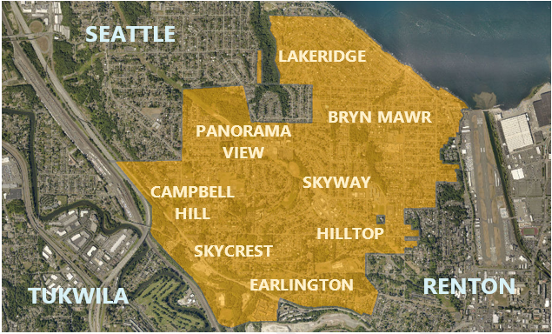
Chapter 3

Community Context

Skyway-West Hill is an unincorporated area located within the urban growth area of King County. Skyway-West Hill is situated at the south end of Lake Washington and is bordered by the City of Seattle to the north, the City of Renton to the south and east, and the City of Tukwila to the west. The area is approximately 3.2 square miles in size with a population of 18,365 people, making it the County’s fourth most populous urban unincorporated area, after Fairwood, East Federal Way, and North Highline. Skyway-West Hill is comprised of the neighborhoods of Bryn Mawr, Campbell Hill, Earlington, Hill Top, Lakeridge, Panorama View, Skycrest, and Skyway.

Community History
The commonly used names of "Skyway," “West Hill,” and “Bryn Mawr” (Welsh for “big hill”) are likely derived from the area's position on a prominent ridge west of Lake Washington and the City of Renton. The Skyway-West Hill area was settled in the 1870s as farmland, pastures, orchards, and ranches, and in the 1880s a community began to develop around Taylor Mill and other sawmills using the area’s advantageous location on Lake Washington. The arrival of the Seattle and Rainier Beach Railway streetcar line made the Bryn Mawr area increasingly accessible to prospective residents and spurred additional residential development.

However, the area did not begin to develop into a full-fledged residential community until the 1940s, when local land developers began platting and building modest single-family homes attractive to employees of Boeing’s aircraft plant in Renton. Development increased at a rapid pace after World War II when an influx of soldiers and their families returned to the area. According to U.S. Census estimates, approximately 3,500 housing units were constructed between 1940 and 1970. The available supply of modest, affordable homes and land, as well as its convenient location to Seattle and Lake Washington, made it a desirable place for soldiers and others to settle.

Population
Demographics at a Glance

 | 2000 | 2014-18
Total Population | 13,977 | 18,347
Change from 2000-2018 |  | 31%
Age Characteristics
Under 18 years | 22.8% | 22.8%
65 years and over | 13.9% | 13.5%
Median Age | 38.0 | 38.4
Race and Ethnicity
Black or African American | 25.3% | 26.3%
American Indian/  Alaska Native | 0.8% | 0.4%
Asian | 21.8% | 32.3%
Native Hawaiian / Pacific Islander | 0.5% | 0.5%
White | 44.2% | 27.7%
Other race | 2.2% | 6.4%
Two or more races | 5.1% | 6.2%
Hispanic or Latino (of any race) | 4.5% | 8.6%
Language Spoke at Home
English Only | 77.5% | 54.2%
Other than English | 22.5% | 45.8%
Median Monthly Housing Costs
Gross Rent | $742 | $1,369
Owner with Mortgage | $1,254 | $2,147
Household Income
Median Household | $47,385 | $68,782

Source: 2014-2018 ACS survey 5-year estimate and 2000 Census for the Bryn Mawr-Skyway CDP
Between 2000 and 2018, Skyway-West Hill experienced significant growth. In that time, the total population of the subarea increased by 31 percent to 18,347 residents. Skyway-West Hill is one of three communities in King County in which people of color constitute a majority of the population, along with the cities of SeaTac and Tukwila. Skyway-West Hill has the fourth-highest proportion of Asian residents (32%, the majority of whom are Vietnamese) of any community in Washington. White residents represent 28% of the community (the lowest percentage of any community in King County), Black and African-Americans represent 26% (the highest percentage of any community in Washington), and Hispanic/Latino residents represent 9%.

Skyway-West Hill has the highest percentage of people who speak an Asian language at home (28%) and among the lowest rates of only English spoken at home (54%) of any community in the state. In 2018, approximately 46% of the community spoke a language other than English at home. The predominant languages spoken in Skyway-West Hill today are Vietnamese, Tagalog, Spanish, Chinese, and Russian, in addition to English.

The median household income in Skyway-West Hill is $68,782, which is 23% lower than the countywide median of $89,418. An estimated 2,840 individuals (11.7%) in Skyway-West Hill lived below the poverty line in 2018. With children and youth under 18 living below the poverty level, this statistic nearly doubles to 21.7% compared to 11.3% countywide.

Existing Land Uses
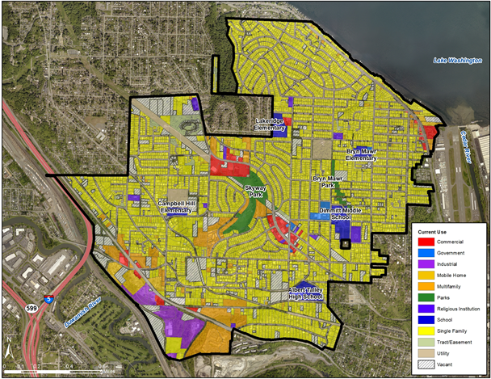
Skyway-West Hill is predominately zoned and developed as single-family residential. Single-family residential lots comprise 64% of the total land area of Skyway-West Hill and multifamily development comprises 7% of the total land area. There are three primary commercial areas, including the Skyway Business District on Renton Ave S, and business districts on Rainier Ave S and Martin Luther King Jr. Way S. Approximately 11% of Skyway-West Hill's total land area is vacant or undeveloped, dispersed throughout the subarea with a concentration south of Martin Luther King Jr. Way S.
Figure 1. Current Uses in Skyway-West Hill

Government Services
King County serves as the local government for Skyway-West Hill and administers a range of services and programs for residents. These include direct service programs such as road services, surface water management, animal control, code enforcement, building permits; and regional services such as public transit and parks. King County also develops functional plans, capital improvement plans, and the County budget that are countywide in scope, but affect the Skyway-West Hill subarea.

Roads
Skyway-West Hill has nearly 57 miles of road, 53.5 of which are owned and maintained by the King County Department of Local Services, Road Services Division, 1.8 miles by WSDOT, and 1.6 miles owned and maintained by private property owners. King County’s Arterial Functional Classification Map identifies two principal arterials, Martin Luther King Jr. Way S and Rainier Ave S; a minor arterial, Renton Ave S; and multiple collector arterials in Skyway-West Hill.

Martin Luther King Jr. Way S, also State Route 900, borders the west boundary of Skyway-West Hill connecting Interstate 5 to the City of Renton. Martin Luther King Jr. Way S is a four-lane road with shoulders and no sidewalks. The speed limit on this road ranges between 35 and 50 miles per hour in Skyway-West Hill.

Rainier Ave S is a three-lane arterial bordering Lake Washington on the east side of Skyway-West Hill connecting Rainier Beach to downtown Renton. Rainier Ave S has designated bike lanes, parking, and sidewalks.

Renton Ave S is a minor three-lane arterial serving both through and local traffic. It functions as a main street for the Skyway Business District. Sidewalks are constructed along most of the road’s length in Skyway-West Hill and bicycle lanes are present on portions of Renton Ave S within the Skyway Business District.

Water and Sewer
Seattle Public Utilities, Skyway Water and Sewer District, and King County Water District #125 provide public water to a majority of the area. A small portion of the area is served by private water supply (such as wells) and the City of Renton. Sewer service for most of Skyway-West Hill is served by Skyway Water and Sewer District. Small pockets in the northwest and southeast parts of Skyway-West Hill are located in the sewer service area of Seattle Public Utilities and the City of Renton, respectively. Parcels with on-site septic systems are clustered in the south and southeast sections of Skyway-West Hill. Public Health - Seattle & King County is the agency that provides oversight for on-site septic systems. As redevelopment occurs in privately watered and sewered areas, connections to public services are anticipated.

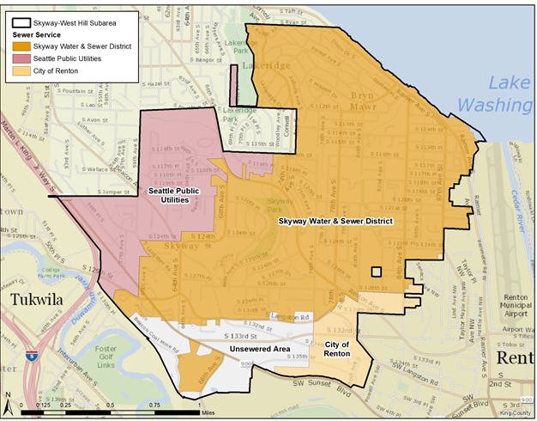
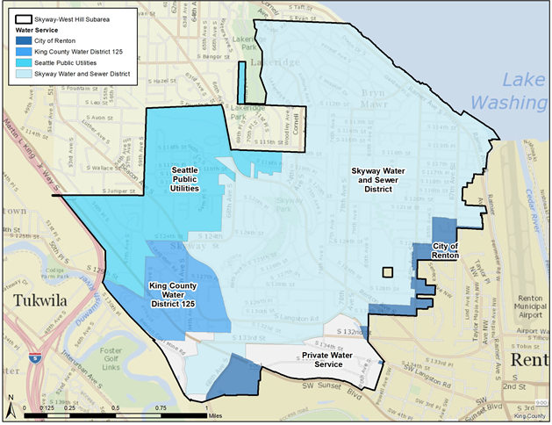
Figures 2 and 3. Water and Sewer Service in Skyway-West Hill

Transit
Skyway-West Hill is currently served by four transit routes: King County Metro Routes 101, 102, 106, and 107. These routes generally provide 15-30 minute service during peak daytime hours connecting Skyway-West Hill to downtown Seattle, Beacon Hill, and Renton (Table 1). These transit destinations provide connections to other major transit centers, Link light rail, and RapidRide lines.

Table 1 Transit Service in Skyway-West Hill
Route # | Route | Weekday Average Headways | Weekend Average Headways
101 | Renton Transit Center to Downtown Seattle  via Martin Luther King Jr. Way S | AM Peak: 15 minutes  Midday: 15 minutes  PM Peak: 10-15 minutes  Evening: 30 minutes | Daytime: 30 minutes  Evening: 60 minutes
102 | Fairwood to Downtown  Seattle – peak only  via Martin Luther King Jr. Way S | AM Peak: 10-20 minutes  PM Peak: 10-20 minutes | No Weekend Service
106 | Renton Transit Center to Downtown Seattle  via Renton Avenue | AM Peak: 15 minutes  Midday: 15 minutes  PM Peak: 15 minutes  Evening: 30 minutes | Daytime: 15 minutes  Evening: 30 minutes  Night: 60 minutes
107 | Renton Transit Center to Beacon Hill  via 87th Ave S, S 114th St, Renton Ave S, and Beacon Ave S | AM Peak: 15 minutes  Midday: 30 minutes  PM Peak: 15 minutes  Evening: 30 minutes | Daytime: 30 minutes  Evening: 30-60 minutes
King County Metro transit service in February 2020. AM Peak is typically 5am to 9am and PM Peak is typically 3pm to 7pm and can vary by route.

Within Skyway-West Hill, Routes 101 and 102 makes stops along Martin Luther King Jr. Way S at 68th Ave S and S 129th St, within the Martin Luther King Jr. Way S Business District. The routes then run limited-stop express to downtown Seattle going northbound terminating at the Washington State Convention Center, or running local southbound terminating at the Renton transit Center (Route 101) or Fairwood Center (Route 102).

Running northbound from its terminus at Renton Transit Center, Route 106 makes numerous stops along Renton Ave S, serving the southern portion of the Skyway Business District, including the Skyway Library, and connecting riders to the Rainier Beach, Othello, Columbia City, and Mount Baker Link Light Rail stations before terminating at the International District/Chinatown station.

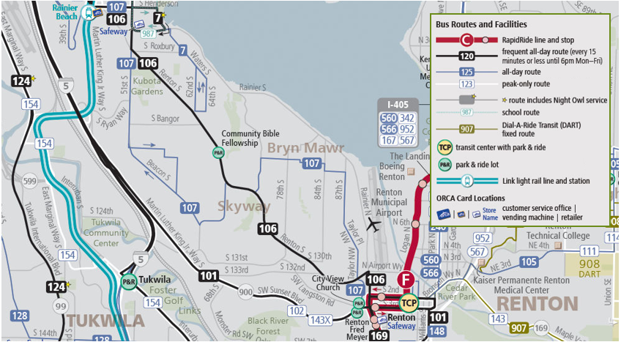
Figure 4. Transit Service in Skyway-West Hill
From Renton Transit Center, Route 107 runs north along 87th Ave S, two blocks to the west of the Rainer Ave S Business District. From there, the route runs west and south to Renton Ave S, serving the northern portion of the Renton Ave S Business District, south on 68th Ave S, and north again on Beacon Ave S before leaving Skyway-West Hill and connecting riders with the Rainier Beach and Beacon Hill Link Light Rail stations.

METRO CONNECTS, King County Metro’s long-range plan, envisions increased transit service along the major corridors currently used for transit service in Skyway-West Hill. The plan includes consideration for frequent service along existing Route 107, express service along Martin Luther King Jr. Way S (existing Route 101 and Route 102), a RapidRide line traveling along Renton Ave S through the middle of the Skyway-West Hill, and new local service along Rainier Ave S.

Schools
Skyway-West Hill is located entirely in the Renton School District. The area is served by Campbell Hill Elementary, Bryn Mawr Elementary and Lakeridge Elementary, Dimmitt Middle School, and Albert Talley High School.

Annexation
Washington’s Growth Management Act identifies cities as the most appropriate local government to provide urban services. Additionally, King County’s Countywide Planning Policies encourage the annexation of unincorporated lands that are already urbanized. Skyway-West Hill is one of the largest of the more than 60 unincorporated urban areas, called Potential Annexation Areas, which are affiliated with 19 different cities in King County. These are areas inside the Urban Growth Area, where most of unincorporated King County’s population and employment growth is expected to locate. King County serves as the regional government working with cities to facilitate the eventual annexation of Potential Annexation Areas, as well as the local government providing essential programs and services to residents in unincorporated areas.

The Skyway-West Hill area has been a part of the City of Renton’s Potential Annexation Area since 2005. The 2031 growth targets for Renton’s Potential Annexation Areas, which include Skyway-West Hill and other unincorporated areas, anticipate 3,895 new housing units and 470 new jobs. King County’s and the City of Renton’s comprehensive plans each contain maps that designate the Potential Annexation Area boundary and outline various policies related to growth, annexations, and intergovernmental cooperation.

The most recent question of annexation came up for a public vote in November 2012, when 56% of the Skyway-West Hill community voted not to annex to the City of Renton, leaving the area in unincorporated King County for the foreseeable future. As of 2019, the City of Renton has not adopted a timeline for annexation of the Skyway-West Hill Potential Annexation Area and has no immediate plans to move forward with annexation. The area will remain in unincorporated King County until future annexation, and King County will continue to serve as Skyway-West Hill's local government. As part of land use planning within Skyway-West Hill, compatibility with adjacent neighborhoods in Renton should be taken into consideration. Zoning in the City of Renton bordering Skyway-West Hill is predominately R-8 (8 dwelling units per acre), with R-10 and R-14 along Renton Ave S and CA (Commercial Arterial) along Rainier Ave S across from the Renton Municipal Airport.

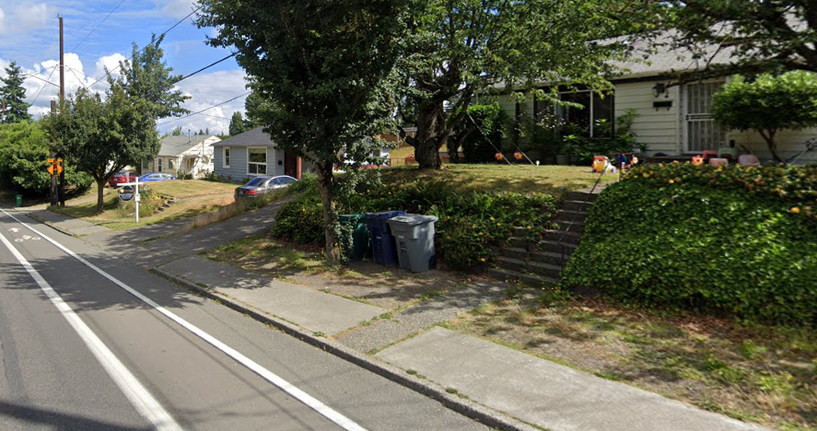

Chapter 4

Residential Neighborhoods

Existing Residential Uses in Skyway-West Hill
Thoughtful land use decisions have the power to create strong residential neighborhoods that support connected multigenerational and diverse communities. The Comprehensive Plan predominantly designates Skyway-West Hill for medium-density (4 to 12 dwelling units per acre) to high-density (12 or more dwelling units per acre) residential development, which covers over 91% of the total area of the subarea. The predominant land use pattern in Skyway-West Hill’s neighborhoods is detached single-family residential, with pockets of townhomes and low-rise multifamily development.
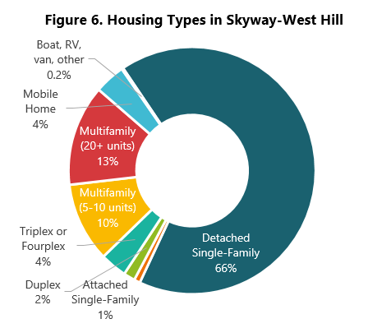
There are approximately 7,000 housing units in Skyway-West Hill. Over two-thirds of residents live in detached single-family houses. Approximately 27% of the housing units in the community are higher density, including apartments and townhouses. These developments are found throughout the subarea, with the majority concentrated along Martin Luther King Jr. Way S, Renton Ave S, and near Skyway Park. The blending of commercial and residential uses, when done strategically, can give residents better and more convenient access to shops and services. These areas have capacity for additional growth under existing zoning, and they provide a variety of housing choices.
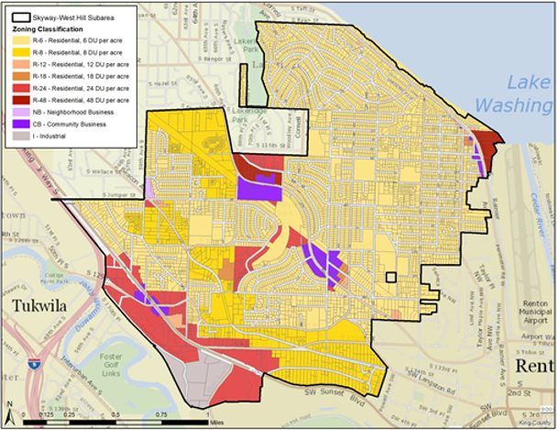
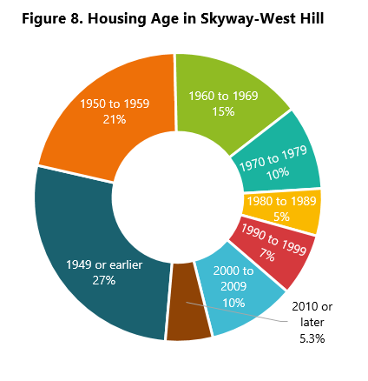
Figure 7. Existing Zoning in Skyway-West Hill
The housing stock in Skyway-West Hill is generally older than King County as a whole, with nearly 75% of units at least 40 years old. Mobile homes make up a higher percentage of housing in this area than countywide, and traditionally provide a more affordable source of housing.

The median sale price for homes in Skyway-West Hill are below countywide levels, with average home sale prices in 2019 at $485,100, more than $137,000 lower than the countywide average. However, the housing costs are not spread across Skyway-West Hill equally. In the Bryn Mawr and Lakeridge neighborhoods, sales for single-family homes averaged $567,000, compared to $414,000 in the remainder of Skyway in 2019, illustrating significant differences within the same subarea.

Housing Affordability
Access to safe and affordable housing improves residents' ability to achieve economic well-being, a high quality of life, good health, and future success. Skyway-West Hill and King County as a whole has experienced pressure for more housing as the population of the Puget Sound region has continued to grow. The County faces an unprecedented demand for affordable housing, with an identified need of nearly 244,000 more housing units countywide between 2019 and 2040 for residents at or below 80% AMI.

Between 2000 and 2018, Skyway-West Hill residents saw an increase in housing costs for both renters and owners. In 2010, gross rents averaged $963 per month. In 2018, gross rents averaged $1,369, a 42% increase in an 8 year period. In this same period, average housing costs to owners with mortgages grew 9% from $1,970 to $2,147.

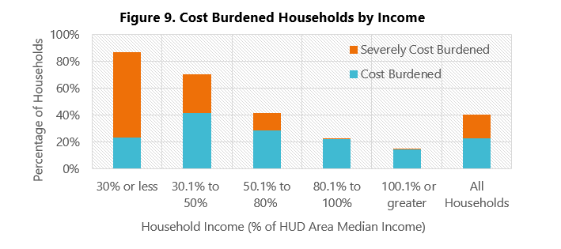
Currently, nearly 40% of all households in Skyway-West Hill are cost burdened, meaning they pay more than 30% of their income for housing. For low-income renter households at or below 80% AMI, cost burden increase to over 70% of households. Those that are severely cost burdened, paying more than 50% of their income for housing, account for nearly 20% of all households. A higher percentage of cost burdened households indicates that more residents struggling with basic needs and may be more vulnerable to evictions and displacement.

Income Restricted Units
There are 590 units of rental housing affordable to income-qualified households in Skyway-West Hill.

Table 2. Income-Restricted Units in Skyway-West Hill
Property | Address | Units | Population Served | Eligible Income  (Family of 4)
Arbor Woods | 6230 S 129th St | 27 | 50% AMI | $55,156
Aspen Ridge | 12601 68th Ave S | 87 | 80% AMI | $88,250
Creston Point | 13445 Martin Luther King Jr Way S | 476 | 60% AMI | $66,187

Community Priorities and Plan Approach
Equitable development is a key issue identified by Skyway-West Hill residents, which includes preventing displacement of existing residents and creating more housing that is affordable to the community. Many residents consider the area’s stock of affordable housing to be an asset and were supportive of the protection and creation of affordable housing.

As development pressure and housing costs in King County push the population out of the urban core, areas like Skyway-West Hill have seen large increases in rents and existing residents pushed out to other communities. This displacement of households in a neighborhood erodes the social fabric of a community over time. The community identified a need to put in place protections for residential displacement to slow housing instability. These protections may consist of programs or regulatory requirements that consider preservation of existing "naturally affordable" housing, provision of new subsidized affordable units, and community protections for residents.

More affordable housing options are needed throughout Skyway-West Hill. In surveys and community meetings, residents were strongly in favor of programs that ensured no net loss of affordable units, inclusionary zoning requirements, land trusts, right-to-return programs, and community benefit agreements. Programs that did not directly result in affordable housing, such as in-lieu fee programs, were less favored.

Residential Neighborhoods Policies
SWH-1 Focus residential density near business districts and major corridors to provide convenient access to shops, services and amenities, and transit options.

SWH-2 Maintain existing land use patterns in residential neighborhoods and ensure new development in residential neighborhoods is compatible with existing community character.

SWH-3 Provide for a wide range of residential zones, densities and housing types to continue to promote access to diverse housing choices for residents at every income level, age, household size, and lifestyle.

SWH-4 Prioritize achieving equitable development outcomes that serve the needs of all Skyway-West Hill residents through tools and strategies that support the creation of new affordable housing and preservation of existing units, and prevent residential and cultural displacement.

SWH-5 Address residential displacement risks associated with new development through strategies that slow or prevent the loss of affordable housing, particularly for low- and moderate-income families.

SWH-6 Preserve existing mobile home parks and require that any proposal to redevelop an existing mobile home park include evaluation and mitigation of residential displacement impacts.

SWH-7 Promote the efficient use of land by providing the necessary urban utilities and services through a coordinated and logical approach, including coordination with the City of Renton for planned annexation.

SWH-8 Promote safe and healthy homes through strategies, programs, and regulations that can address dilapidated or unsafe properties in the community.

Chapter 5

Commercial Areas

Existing Commercial and Industrial Uses within Skyway-West Hill
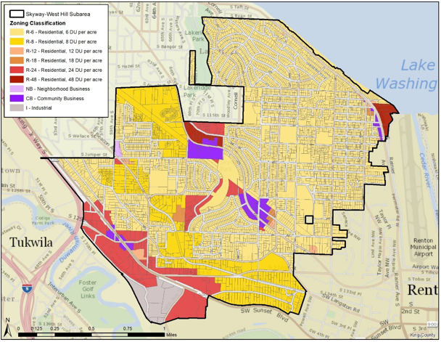
Skyway-West Hill has four areas with commercial land uses, which have the opportunity to provide services, entertainment, and employment opportunities. These areas are the Skyway Business District along Renton Ave, two smaller centers on Martin Luther King Jr. Way S and Rainier Ave S, and industrially zoned properties south of Martin Luther King Jr. Way S and west of 68th Ave S. In total, commercial areas comprise a small portion of Skyway-West Hill, just 5.5% of the land area, and provide approximately 1,700 jobs.
Figure 10. Existing Zoning in Skyway-West Hill

Skyway Business District
The Skyway Business District is the largest commercial area in the community, spanning 37 acres. The Skyway Business District is comprised of a northern node and a southern node split by Skyway Park and residential housing. The northern node includes restaurants, a grocery store, a bowling alley, a casino, retail establishments, a self-storage facility, a gas station, and automotive services. The southern node includes the Skyway Library, restaurants, convenience stores, religious institutions, a post office, a fire station, and personal services and retail establishments.

There is significant potential for commercial and mixed-use infill development and redevelopment within the Skyway Business District. Public investments such as the King County library on Renton Ave S and a future bus rapid transit route will continue to make the Skyway Business District a prime location for increased commercial development. The Skyway Business District has a land use designation of Community Business Center (“cb”) and is zoned Community Business (CB), which is intended to provide convenient retail and personal services for the local area. There is one development condition within Skyway-West Hill that applies to the Skyway Business District, SO-050, which requires pedestrian-oriented development.

Martin Luther King Jr. Way S and Rainier Ave S Business Districts
There are two other concentrations of business activity in this community, both designated as Neighborhood Business Centers in the Comprehensive Plan. These districts both have land use designations of Commercial Outside of Centers (“co”) and are zoned Community Business (CB). The first is on Martin Luther King Jr. Way S between 60th Ave S and 64th Ave S, and the second is on Rainier Ave S between S 114th and S 117th Street. These areas include some small-scale businesses such as restaurants, hair salons, a gas station, convenience stores and other retail.

Industrial Areas
The area of industrial land located south of Martin Luther King Jr. Way S and west of 68th Ave S is home to several small to medium-sized manufacturing firms. As the sole Industrial-zoned area in Skyway-West Hill where manufacturing, warehousing, and related land uses can be sited, this group of parcels serves as an asset to local economic sectors. Existing industrial uses include an engineering company, equipment rental company, concrete recycler, transfer station, and fencing company.

Community Priorities and Plan Approach
Residents of Skyway-West Hill overwhelmingly want to see new development in Skyway’s business districts. Residents must leave Skyway-West Hill for nearby commercial areas in Renton and Seattle to access retail and services, indicating an unmet need for a wide range of businesses. Residents indicated an interest in supporting and incentivizing small, locally owned, and independent stores to locate in Skyway-West Hill's business districts.

There is also a need to protect or provide measures to existing Skyway-West Hill businesses that may experience displacement risk due to economic or development pressure. Residents identified a need to revitalize the business districts while protecting existing businesses. The community saw revitalization occurring through encouraging development of vacant parcels and improving the aesthetic quality of the area, and expressed a desire to see new businesses such as restaurants, grocery stores, a pharmacy, retail, and heath care providers locate in the area. Residents also noted the poor pedestrian infrastructure in the community and expressed a desire for more and better-quality sidewalks in business districts.

Lastly, the community conveyed a sentiment that the number and density of marijuana-related businesses within Skyway-West Hill was out of proportion with the population and the community’s desired vision for their commercial areas.

Commercial Areas Policies

SWH-9 Work with the community to support and develop the individual identities of Skyway's business districts through street treatments, gateway landmarks, murals and other defining features.

SWH-10 Improve and strengthen Skyway's business districts by strengthening development standards, providing support to business owners, and supporting establishment of an action group, association, or chamber.

SWH-11 Encourage, incentivize and reduce barriers to smaller-scale commercial development that provide residents with convenient access to a range of services and amenities, that support local business ownership, that provide opportunities for local employment through job training and recruiting offices, and prevent displacement of existing businesses.

SWH-12 Limit marijuana businesses and address impacts associated with those uses.

Skyway Business District

SWH-13 Maintain the Community Business Center designation for the Skyway Business District to protect opportunities for commercial activity and encourage siting of new businesses.

SWH-14 Evaluate properties adjacent to the Skyway Business District for reclassification to Community Business Center in order to increase commercial capacity and create a more vibrant business district.

SWH-15 Support development in the Skyway Business District that can provide residents and visitors an opportunity to walk, gather and meet through an emphasis on the pedestrian environment.

SWH-16 Establish a Skyway Business District identity, including consideration of urban design standards, mixed-use buildings with ground floor retail, siting buildings adjacent to sidewalks, and high quality landscaping and public spaces.

SWH-17 Prioritize pedestrian corridors in the Skyway Business District by incentivizing development that establishes connections between commercial lots, establishing connections to Skyway Park, and locating parking facilities on the rear or side of buildings with screening.

Martin Luther King Jr. Way S and Rainier Ave S Business Districts

SWH-18 Maintain the Neighborhood Business Centers designation for the Martin Luther King Jr. Way S and Rainier Ave S commercial areas.

SWH-19 Support the redevelopment of the Martin Luther King Jr. Way S and Rainer Ave S Business Districts into an attractive pedestrian-friendly environment as new commercial development occurs.

Industrial Areas

SWH-20 Support and maintain employment opportunities and local economic activity in existing industrial areas through zoning and other regulatory tools.
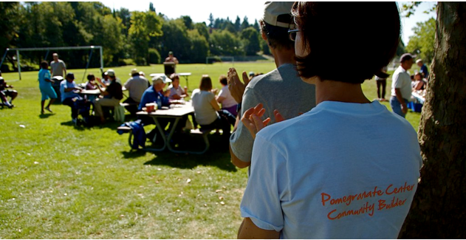
King County Parks
Chapter 5

Community Character

When planned well, neighborhoods can embody a community's identity and contribute to its distinctive sense of place and livability. A community's character can be seen through buildings and plazas, or felt through events and social interactions. Land use decisions impact how a community functions and how it is experienced by both residents and visitors. Land use policies should recognize and celebrate the unique character of different neighborhoods and the residents that live there.

Public institutions, such as parks, libraries, and community centers, are one of the ways community character is reflected. The community's priorities can be found in the way they are utilized by residents, such as what events are held, what classes are offered, and what books are checked out. Other public and private spaces like religious institutions and locally significant businesses also give a community a special sense of place.

Social and cultural connections that are not necessarily tied to a single location also contribute to community character: daily social interactions with neighbors, events and festivals, and public art also make people feel connected to their neighborhood. Land use can support the preservation and promotion of these different aspects of community character.

Parks and Open Space
Skyway-West Hill contains approximately 27 acres of public parkland within its boundaries. Of this, 23 acres are developed as Skyway Park, spanning Skyway Business District, and 4 acres are undeveloped open space known as Bryn Mawr Park.

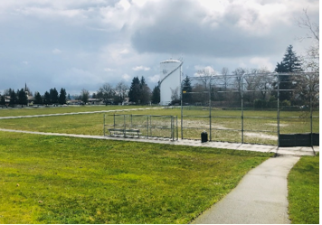
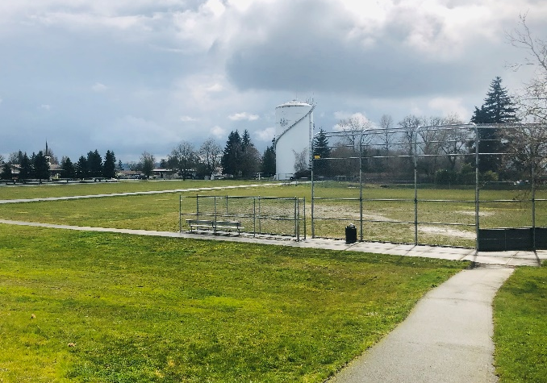
The 2008 Skyway Park Community Vision identified Skyway Park as a key asset for overall community revitalization. Currently, Skyway Park hosts Little League and youth football games as well as community events like the Skyway Community Festival. As of 2020, the County is implementing a capital project in Skyway Park to improve recreation and sports facilities. Proposed park improvements include adding an outdoor mini soccer arena, a sand volleyball court, an enhanced and expanded playground, adult fitness equipment, upgraded fencing and lighting, improvements to pathways, a new pedestrian entryway, and other improvements.

Other nearby parks provide open space, playfields, and other recreational opportunities for Skyway-West Hill residents. These include Lakeridge Park and Deadhorse Canyon in Seattle, Fort Dent Park in Tukwila, and Gene Coulon Park in Renton. Bryn Mawr, Campbell Hill, and Lakeridge Elementary Schools and Dimmitt Middle School also offer sports fields, playgrounds, and facilities used by residents, but are not classified as public parks.

Privately owned and semipublic recreation and open space are also important contributors to the area’s green space network, offering amenities like plazas, playgrounds, picnic tables, dog-walking areas, and swimming pools to residents. Many churches and religious organizations also provide similar amenities and gathering spaces on their properties.

Library
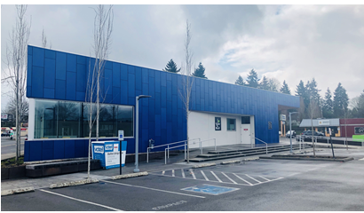
Skyway-West Hill has been served by the King County Library System (KCLS) since 1953, when the Skyway Branch Library Board and its 2,000 volumes opened to the public in the back room of a local bakery on Renton Ave S. In 1970, a 5,200 square foot Skyway Library opened with space to double the volumes available and included a meeting room. As part of a successful $172 million KCLS bond measure, a new Skyway Library opened in in 2016. The $8.3 million, 8,000 square foot facility includes eco-friendly building features, a plaza that is used for community events and farmers markets, and a table made from an airplane wing in a nod to the community’s historical connection with the aviation industry. Skyway Library has collections in Chinese, Somali, Spanish, and Vietnamese. The Library is an important gathering place in the Skyway Business District.

Community Priorities and Plan Approach
Residents of Skyway-West Hill consistently expressed a desire for more community amenities. The desired amenities generally fell into three categories:
- Public infrastructure such as sidewalks, streetlights, public meeting spaces, plazas, and parks, open space, and trails from which to enjoy the community’s superior views;
- Community assets, which provide value to residents and may be provided by the public, private, or non-profit sectors, such as a community center, childcare facilities, healthcare providers, and business incubators; and
- Cultural assets, which may include public art, cultural facilities, or events such as festivals or publicly celebrated holidays. Residents also expressed concern that development pressure would put the community’s cultural assets at risk.

Community Character Policies
SWH-21 Encourage the development of community-identified amenities near commercial centers, frequent transit corridors, and parks and trails through incentives or development requirements.

SWH-22 Seek to preserve and enhance community-identified cultural assets during development review and, when necessary, work with the community and developers to mitigate the loss of cultural assets.

SWH-23 Prioritize safe and inviting walking and bicycling connections throughout Skyway-West Hill to transit, business districts, and major destinations.

SWH-24 Prioritize and support access to healthy, affordable, and culturally relevant foods for all residents by encouraging grocery stores, small markets, weekly farmers markets, urban farms, and community gardens.

SWH-25 Highlight Skyway Park as a major community amenity through enhanced physical connections and views to the park.

Appendices

Appendices to the Skyway-West Hill Land Use Strategy, Phase 1 of the Skyway-West Hill Subarea Plan can be found in Attachment G to Ordinance 19146

Appendix A – Community Outreach
Appendix B – Skyway-West Hill Land Use Subarea Plan Equity Impact Analysis
Appendix C – Community Center Feasibility Study
Appendix D – Service Delivery and Facilities Provided by King County in the Five Potential Annexation Areas

King County, Equity and Social Justice Strategic Plan, page 30, https://aqua.kingcounty.gov/dnrp/library/dnrp-directors-office/equity-social-justice/201609-ESJ-SP-FULL.pdf
King County, Determinants of Equity Report, https://kingcounty.gov/elected/executive/equity-social-justice.aspx
Adopted by Ordinance 11166, https://aqua.kingcounty.gov/Council/Clerk/OldOrdsMotions/Ordinance%2011166.pdf
King County Metro, METRO CONNECTS Long Range Plan, 2017, http://www.kcmetrovision.org/
Zillow, Median sale price for January 31, 2019 through January 31, 2020, https://www.zillow.com/bryn-mawr-skyway-wa/home-values/ and https://www.zillow.com/king-county-wa/home-values/
King County Assessor's Office, Localscape, data accessed February 25, 2020
Regional Affordable Housing Task Force, Final Report and Recommendations for King County, WA, 2018, page 11, https://kingcounty.gov/~/media/initiatives/affordablehousing/documents/report/RAH_Report_Print_File_ Updated_10,-d-,28,-d-,19.ashx?la=en
US Census, 2006-2010 ACS 5-Year Estimate and 2013-2018 ACS 5-Year Estimate
Department of Housing and Urban Development, 2012-2016 Comprehensive Housing Affordability Strategy, https://www.huduser.gov/portal/datasets/cp.html
Regional Affordable Housing Task Force, Final Report and Recommendations for King County, WA, 2018, page 16
In 2018, Area Median Income in King County for a family of four was $110,313 (King County Housing Authority)

