Legislative Review Form
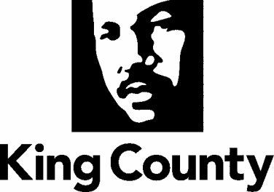

Agency: _DLS Roads__ Contact person _Tricia Davis_ Phone _206-263-9690___

Ordinance Motion Proviso Report Other

Civil Division Prosecuting Attorney Review

Name John Briggs Version Final Date 03/16/2021

Dept. Director or Designee Review

Name Tricia Davis & John Taylor Version Final Date 04/23/2021

Performance Strategy & Budget Office Review

Name: Jillian Scheibek Version Final Date: 5/14

Technical Form/Code Reviser Review – Confirm adherence to legislative format

Name Bruce Ritzen Version Final Date 03/16/2021

Executive Office Review & Transmittal Approval

Name: Karan Gill Version: Final Date: 5/26

ENTRANCE CRITERIA REVIEW
Do not check off boxes but ensure elements have been met. EXEC OFFICE (initials) KCC CLERK
Fiscal note? Y NA BB Y NA
KC Strategic Plan reference in letter? Y NA BB Y NA
Proof read for spelling and grammar? Y NA BB Y NA
All pertinent attachments listed/labeled? Y NA BB Y NA
Costs identified/described in letter Y NA BB Y NO
Regulatory Note Required and Complete? Y NA BB Y NO
Formatted/Delivered in word-searchable doc format? Y NA BB Y NA
Potential Annexation Area (PAA) impacts identified? Y NA BB Y NO
Advertising required? if yes, cite all pertinent code/laws. Y NA BB Y NO
Any special circumstances affecting processing time? Y NA BB Y NO

