Lease Property Summary

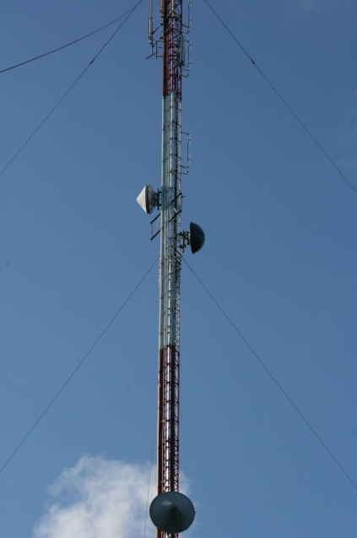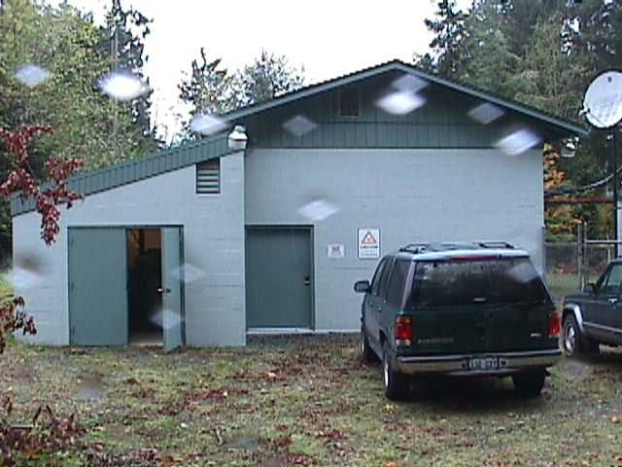
Property Owner: GTP Towers I, LLC
Address: 8869 Southeast View Park Road, Port Orchard, WA 98447
Cost : $4,758.09 base rent per month
Operational Costs: $450. Electrical payment per month
Term: Five year initial term with two, five-year, renewal options
Square Footage: The premises include space for the antenna on the tower and 143 square feet of support infrastructure in the building.
Council District: Kitsap County
Funding Source: Radio Communications Operating Fund
Previous Location: Lease extension at existing location

Lease Synopsis:
King County has leased this wireless facility in Kitsap County, which provides essential radio coverage to western King County and Vashon Island, since 1999. The premises consist of space on the landlord’s tower and in an equipment room for King County emergency radio equipment. Base rent is $4,758.09 per month and operational costs are $450 for electrical per month.

Context
Rationale for transaction:
The View Park site is one of eight tower sites that comprise the King County/Valley Communications Simulcast signal. This signal provides primary radio service for the KC 800 MHz Emergency Radio System serving the citizens in King County. There are more than 8,000 primary First Responder, Emergency Operations, Utilities, Hospitals, Schools and General Governments operating on the system. Additionally, thousands of other users rely on this signal in overlapping coverage areas to support their primary and mutual aid operations.
The Puget Sound Emergency Radio Network (PSERN) Project, is planning a new system to replace the current analog KC 800 MHz Emergency Radio System with a new state of the art, standards-based digital radio system. The new system is expected to reuse many of the current sites, such as View Park, which is favorably located to provide service in the Vashon Island area, as well as western coastal areas extending from the south end of King County to north Seattle. The term of this lease is compatible with current PSERN plans.

Policy considerations: This lease is necessary to support the King County simulcast emergency communication network signal. This network is the primary service for the KC 800MHz emergency radio system serving the citizens of King County.

Political considerations: This lease is necessary as a piece of the larger King County radio communications network. This location is critical to providing radio service in western King County and is important to jurisdictions that use the radio system in that area.

Community considerations
or partnerships: This lease is an extension of an existing lease and supports the King County emergency radio communication network. Continuing our presence on this existing tower saves King County relocation costs. Colocation on existing towers reduces tower proliferation.

Fiscal considerations: The rent for this lease is $4,758.09 per month or $57,097.08 annually. The operating expenses are $450 per month or $5,400 annually. There is a 3.5% escalation clause. The term of the lease is five years with the option of two additional five year extensions. The square footage price addresses the equipment in the building. Radio equipment mounted on the tower is detailed in the original agreement. The lease amendment term commences October 1, 2014. King County is not being charged holdover at this time. The rent for the existing facility is paid for by King County radio communication services, office of information and resource management.

Other considerations: n/a

CIP/operational impacts: This location provides easy access for radio communication services.

King County Strategic Plan impact: This transaction supports the strategic plan goals of exercising sound financial management, planning for the long-term sustainability of county services, and supporting safe communities.

Equity and Social Justice impact: No ESJ impacts are anticipated as the County is continuing operation at this location.

Energy Efficiency impact: n/a

Lease Alternatives Analysis
Summary: This is an amendment and extension of an existing lease. The particular location fulfills specific engineering requirements for radio system coverage. Additional sites were not considered for that reason. This agreement provides a preferred alternative, avoids relocation costs and contains competitive terms.

Vicinity View Map
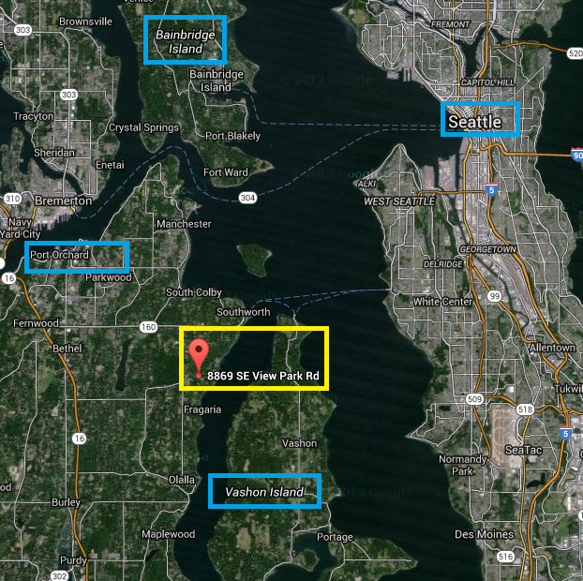
Parcel View Map
