September 2020 Public Transportation Service Changes

Title VI Service Analysis

February 2020

KCLogo-Black

Introduction

Federal Transit Administration (FTA) Circular 4702.1B, Chapter V, Section 7 requires transit agencies serving large urbanized areas to evaluate major service changes and to determine whether proposed changes would have a discriminatory impact as defined in the United States Department of Transportation’s Title VI regulations.

In accordance with these FTA regulations, this report summarizes Metro’s service analysis of changes proposed for the September 2020 service change submitted to the King County Council for approval. As part of the ordinance, Metro is proposing to revise routes that currently serve South King County. This report details the results of the Title VI analysis of these changes, known as the Renton-Kent-Auburn Area Mobility Plan, which impact Algona, Auburn, Burien, Covington, Kent, Maple Valley, Pacific, Renton, SeaTac, Seattle, Tukwila, and unincorporated King County.

Metro’s 2019 System Evaluation Report identifies corridors that are currently below their target transit service levels and identifies and prioritizes the additional hours needed on routes in these corridors to meet the service level targets based on Metro Service Guidelines (also referred to as Priority 3 service investment needs). Replacing inefficient routes with poor reliability and ridership with a more frequent, more direct network of service, the project reallocates existing resources to increase span of service, improve frequency and add important connectivity within the region. Metro’s adopted 2019/2020 budget includes an additional 10,000 service hours for this project.[1]

Service Guidelines Overview

The 2015 update to King County Metro’s *Strategic Plan for Public Transportation, 2011-2021* and related service guidelines outline the methodology Metro uses to evaluate service changes, consistent with FTA Title VI requirements (FTA Circular 4702.1B). The most relevant excerpts from the service guidelines are included below.

Implementation

Metro revises service twice a year—in spring and fall. Major and minor service revisions occur during the spring and fall service changes. In rare cases of emergency or time-critical construction projects, Metro may make changes at times other than the two regularly scheduled service changes. However, such situations are kept to a minimum because of the high level of disruption and difficulty they create. Many alternative service projects can be implemented at any time and do not need to follow the same schedule as fixed-route service.

Proposed route changes are subject to approval by the Metropolitan King County Council except as follows (per King County code 28.94.020):

* Any single change or cumulative changes in a service schedule which affect the established weekly service hours for a route by 25 percent or less.
* Any change in route location which does not move the location of any route stop by more than one-half mile.
* Any changes in route numbers.

Each year, Metro publishes a System Evaluation report, based on Metro’s Service Guidelines, that outlines the analysis of target service levels and route performance management. The annual report will include a comprehensive list of the prior years’ service changes and will identify and discuss service changes that address performance-related issues. Metro works to provide transparency in Metro’s process and help jurisdictions plan for the future by conducting regular outreach throughout the county about the results of the System Evaluation Report.

Adverse Effect of a Major Service Change

An adverse effect of a major service change is defined as a reduction of 25 percent or more of the transit trips serving a census tract, in accordance with King County code 28.94.020. Title VI of the Civil Rights Act of 1964 requires all transit agencies to evaluate major service change impacts on minority and low-income populations.

Disparate Impact Threshold

A disparate impact occurs when a major service change results in adverse effects that are significantly greater for minority populations than for non-minority populations. Metro’s threshold for determining adverse effects is when the percentage of routes or tracts adversely affected by a major service change and classified as minority is 10 or more percentage points higher than the percentage of routes or tracts classified as minority in the system as a whole. Should Metro find a disparate impact, consideration will be given to modifying the proposed changes in order to avoid, minimize or mitigate the disparate impacts of the proposed changes.

Metro will measure disparate impacts by comparing changes in the number of trips serving minority or non-minority census tracts, or by comparing changes in the number of service hours on minority or non-minority routes. Metro defines a minority census tract as one in which the minority population percentage is greater than that of the county as a whole. For regular fixed-route service, Metro defines a minority route as one for which the percentage of inbound weekday boardings in minority census tracts is greater than the average percentage of inbound weekday boardings in minority census tracts for all Metro routes.

Disproportionate Burden Threshold

A disproportionate burden occurs when a major service change results in adverse effects that are significantly greater for low-income populations than for non-low-income populations. Metro’s threshold for determining adverse effects is when the percentage of routes or tracts adversely affected by a major service change and classified as low-income is 10 or more percentage points higher than the percentage of routes or tracts classified as low-income in the system as a whole. Should Metro find a disproportionate burden, consideration will be given to modifying the proposed changes in order to avoid, minimize or mitigate the disproportionate burden of the proposed changes.

Metro will measure disproportionate burden by comparing changes in the number of trips serving low-income or non-low-income census tracts, or by comparing changes in the number of service hours on low-income or non-low-income routes. Metro defines a low-income census tract as one in which the percentage of low-income population is greater than that of the county as a whole. For regular fixed-route service, Metro defines a low-income route as one for which the percentage of inbound weekday boardings in low-income census tracts is greater than the average percentage of inbound weekday boardings in low-income census tracts for all Metro routes.

I. Service Change Area and Routes

*Affected Areas*

The proposed changes will affect 99 census tracts with a total population of about 543,837 residents.

*Affected Routes*

The affected routes in this project include Routes 105, 148, 157, 158, 159, 164, 166, 168, 169, 180, 192, 906, 908, 910, 913, 914, 916, 917.

Affected Routes 158, 159, 164, 166, 169, 180, 192, 908, 910, 913, and 916, would be replaced with Routes 160, 161, 162, 165, and 184 and expand service on Routes 105, 906, and 917.

II. Threshold 1: Is this a Major Service Change? YES

For the purposes of complying with FTA Circular 4702.1B, Chapter IV, Metro defines any change in service as “major” if King County Council approval of the change is required pursuant to KCC 28.94.020.

The proposed changes meet all criteria for a major service change by Metro and FTA definitions. Appendix A lists the specific routes being changed in September 2020.

III. Threshold 2: Are Minority or Low-Income Census Tracts Affected? YES

*Classifying minority and low-income census tracts*

For the Title VI analysis, Metro classifies census tracts as minority tracts if the percentage of the population that is minority within a tract is greater than the percentage for King County as a whole. Based on the American Community Survey five-year average for 2013-2017 data, 36.5 percent of the population is classified as minority within the county as a whole. Similarly, Metro classifies census tracts as low-income tracts if the percentage of the population classified as low-income (based on the population below 200% of federal poverty line) within a tract is greater than the percentage for King County as a whole.

In line with recommendations made by the Service Guidelines Task Force, Metro recently changed the definition of “low-income” that is used to determine census tract designations from 100% to 200% of the federal poverty line, which aligns with the threshold of other programs, including ORCA LIFT. Based on the American Community Survey five-year average for 2013-2017, 21.8 percent of the population is classified as low-income within the county as a whole.

The proposed service changes addressed in this report will affect the level of service provided to 99 King County census tracts currently served by Metro. The low-income and minority characteristics of affected census tracts are provided in Table 1 below and figures 1 and 2 on the following pages.

Table 1. Low-Income and Minority Characteristics of Affected Census Tracts

|  |  |  |  |  |
| --- | --- | --- | --- | --- |
|  | Census Tract Classification | | | |
| Total Census Tracts Affected | Minority & Low-income | Minority ONLY | Low-income ONLY | Neither Minority nor Low-income |
| 99 | 52 | 16 | 11 | 20 |

IV. Threshold 3: Is there a Disproportionate Burden on Low-Income Populations or a Disparate Impact on Minority Populations? YES

For the Title VI analysis, the determination as to whether the proposed changes resulting in a reduction in service would have a disparate impact on minority populations was made by comparing changes in the number of Metro bus trips serving minority or non-minority census tracts. Similarly, the determination as to whether the proposed changes resulting in a reduction in service would have a disproportionate burden on low-income populations was made by comparing changes in the number of Metro bus trips serving low-income and non-low-income census tracts. The September 2019 service change was used as the baseline for calculating the change in trips.

The proposed changes together affect 99 census tracts, including 16 minority-only census tracts, 11 low-income only census tracts, and 52 tracts which are both minority and low-income. There are two tracts experiencing a reduction in trips greater than 25%, they are both minority and low-income tracts. Therefore, the analysis indicates that the proposed changes would place a disproportionate burden on low-income populations and have a disparate impact on minority populations.

A detailed description of the impacts to residents in these two tracts are provided in Section V, along with the alternatives available to riders.

Notes for Tables 2 and 3

1. An adverse effect is defined as a reduction of 25 percent or more in trips per week.

Tracts are classified as low-income or minority when the percentage of low-income or minority persons in the tract is greater than the percentage of low-income or minority persons in the county as a whole.

A disproportionate burden occurs when the percentage of low-income tracts with adverse effects is more than 10 percentage points greater than the county-wide percentage of low-income tracts.

1. A disparate impact occurs when the percentage of minority tracts with adverse effects is more than 10 percentage points greater than the county-wide percentage of minority tracts.

Title VI Analysis Results for Proposed Changes for September 2020

Table 2. September 2020 Service Change Title VI Analysis - Low-Income Populations

|  |  |  |  |  |  |
| --- | --- | --- | --- | --- | --- |
| Category2 | Tracts with Adverse Effects1 | % of tracts adversely affected | % of tracts system-wide | Difference | Disproportionate Burden3? |
| Low-Income | 2 | 100% | 41% | 59% | YES |
| Non-Low-Income | 0 | N/A | 59% |  |  |
| Total | 2 | 100% | 100% |  |  |

Table 3. September 2020 Service Change Title VI Analysis - Minority Populations

|  |  |  |  |  |  |
| --- | --- | --- | --- | --- | --- |
| Category2 | Tracts with Adverse Effects1 | % of tracts adversely affected | % of tracts system-wide | Difference | Disparate Impact4? |
| Minority | 2 | 100% | 43% | 57% | YES |
| Non-Minority | 0 | N/A | 57% |  |  |
| Total | 2 | 100% | 100% |  |  |

Figure 1. Impact of proposed changes on minority census tracts.

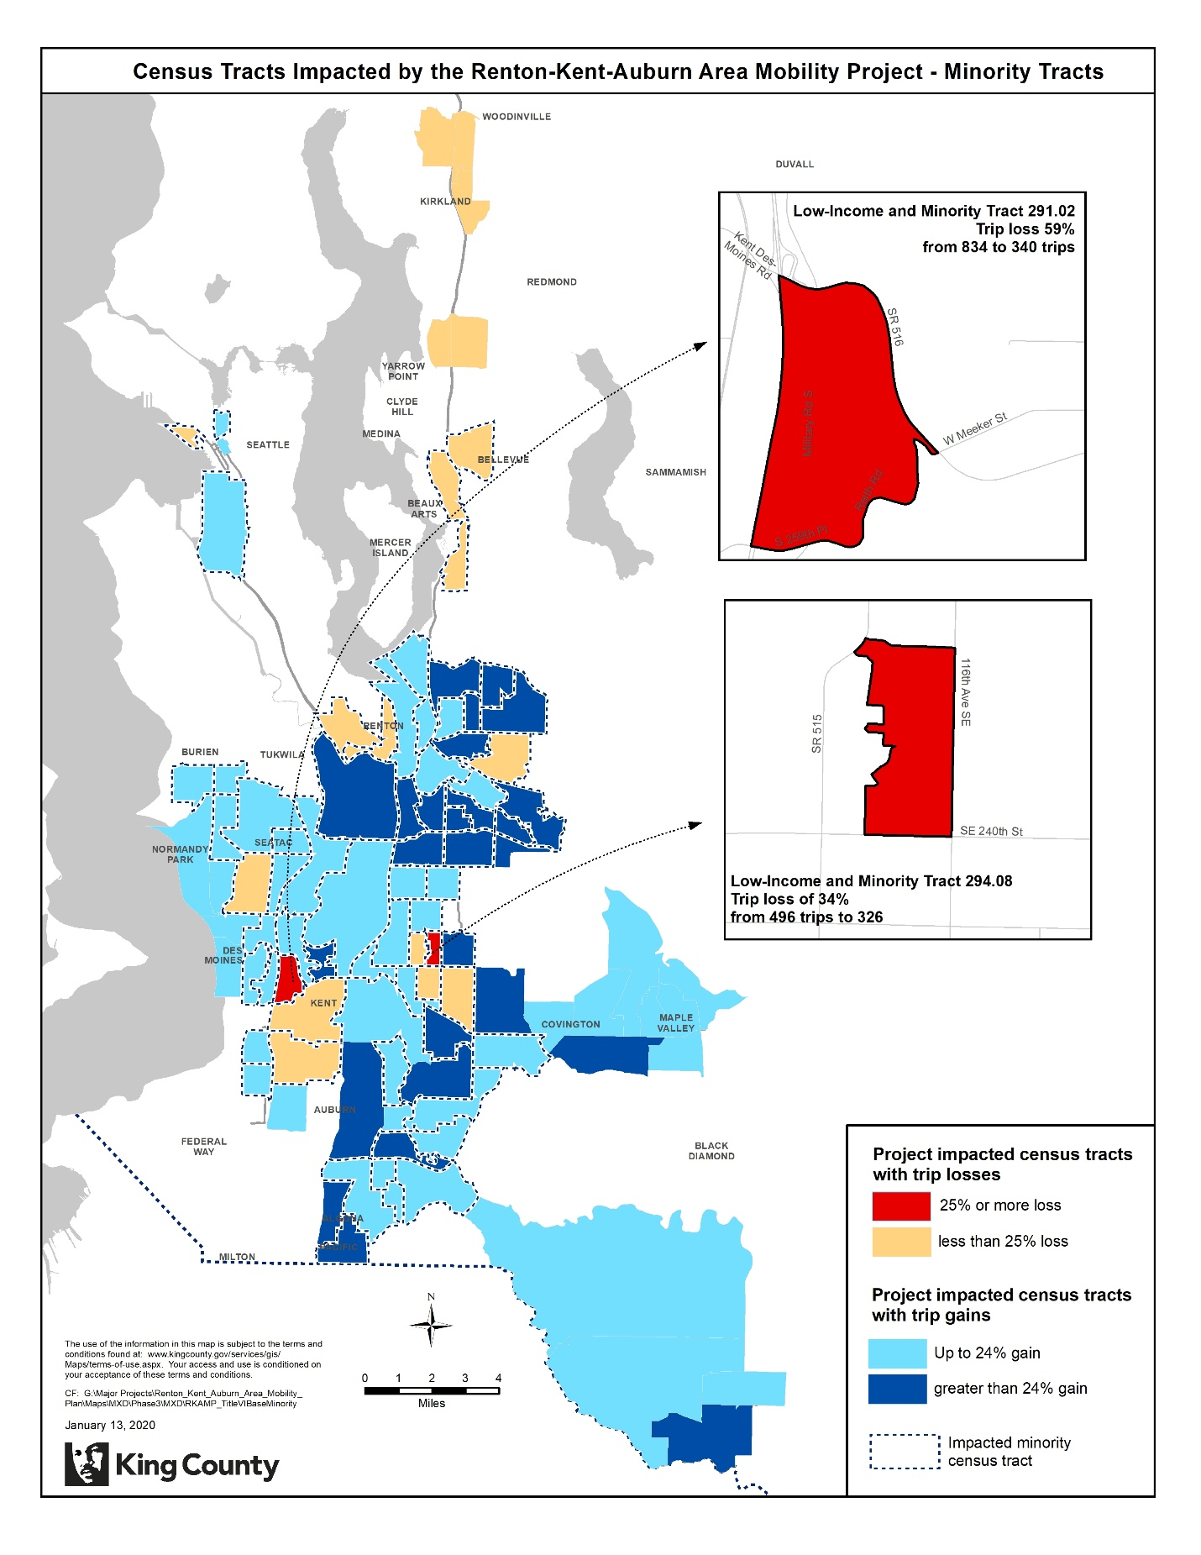

Figure 2. Impact of proposed changes on low-income census tracts.

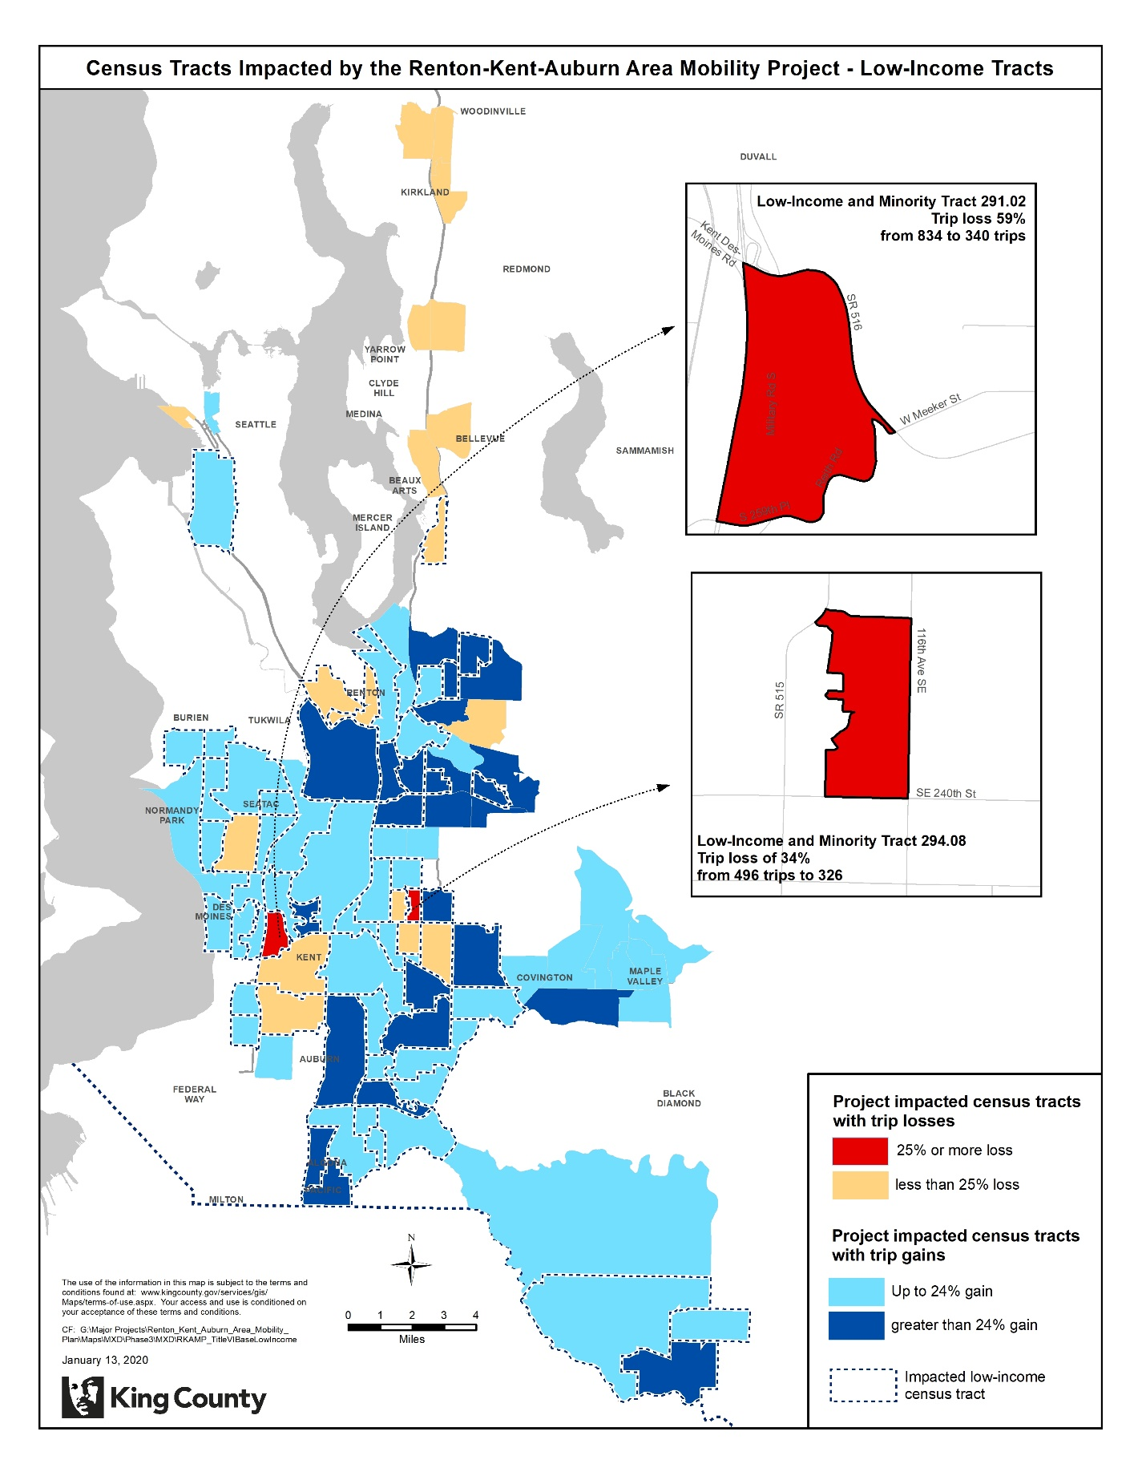

V. Threshold 4: Alternatives and Mitigation

As stated in Section IV, there are adverse effects as defined by the Title VI regulations in 2 census tracts, for the proposed service changes in South King County in September 2020. As shown in Figures 1 and 2, low-income and minority Tracts 291.02 and 294.08 are impacted. Overall, the proposed changes will result in an estimated reduction in trips by 59% and 34%, respectively.

Tract 291.02, Kent West Hill – Military Road

As shown in Figure 3, this tract is currently served by Routes 158, 159, 166, 183, and 192. With the proposed changes the tract is served by revised Route 183 and new Route 162, which replaces Routes 158 and 159. The trips serving this tract will be reduced by 59%.

Route 192 is a low-performing, peak-only route that is serves Star Lake Park & Ride, stops along Military Road, and Kent Des Moines Park & Ride before heading to downtown Seattle on I-5. The proposed changes for September 2020 include deleting Route 192. Riders near Star Lake Park & Ride and at Kent Des Moines Park & Ride will continue to be served by revised Route 190 and new Route 162. However, riders at stops along Military Road will no longer have direct service to downtown Seattle. There are an average of 20 daily riders on this route segment. We have found through our rider surveys that the riders of these peak commuter services tend to be higher-income, white, and English-speaking riders. Metro is proposing to make this change to allow for re-investment in more all-day and weekend service that would provide better transit access for equity priority populations, as recommended by the advisory board (Mobility Board) formed to advise Metro throughout the Renton-Kent-Auburn project.

Route 166 is an all-day route that connects Burien, Des Moines, and Kent. The proposed changes for September 2020 include replacing Route 164 and 166 service with Route 165 to provide a one-seat ride connection between Burien, Des Moines, Kent, and Green River College in Auburn. In this tract, Route 166 currently serves Military Road. There are currently 90 boardings on Route 166 in this segment. The new Route 165 would not operate on Military Road, but would instead operate through the Lakes Community and on S 231st Way. This change was made to provide all-day service to Tract 292.05 – also classified as low-income and minority - which is receiving a 54% increase in service. This change will also provide access to an additional 1,800 housing units that will be within a ¼-mile walkshed of service. In the Renton-Kent-Auburn Area Mobility Plan process, Metro identified equity priority tracts based on the King County Equity Score. This score measures the proportion of low-income, minority, and limited English-proficient populations compared to the King County average and scores tracts on a scale from one to five, with a score of five representing the highest concentrations of priority populations. Priority tracts for this project are those with a four or five score. According to this measure, Tract 292.05 is a priority tract and Tract 291.02 is not.

Figure 3. Impact of proposed changes on Tract 291.02.

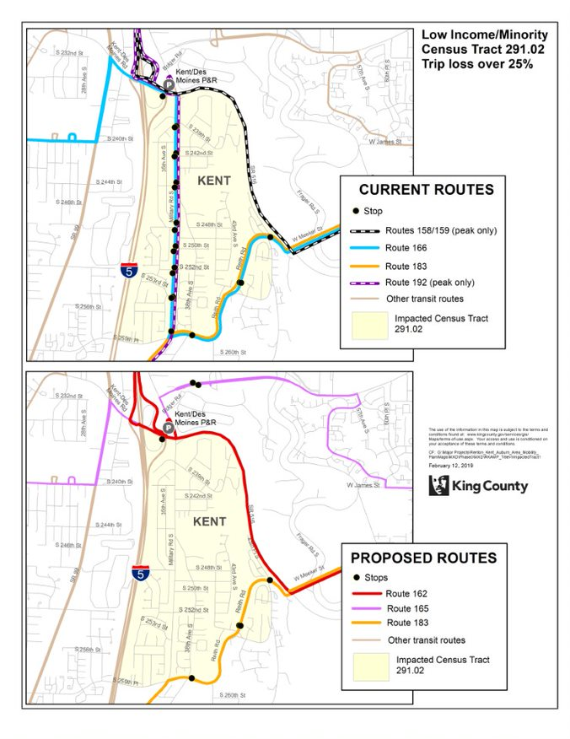

Tract 294.08, Kent East Hill – 116th Aves SE and SE 240th St

As shown in Figure 4, this tract is currently served by Routes 164, 169, 914, and 916. With the proposed changes the tract is served by new Route 160, which replaces Route 169; new Route 165, which replaces Route 164; and revised Route 914, which replaces portions of Route 916. The trips serving this tract will be reduced by 34%. The changes affecting this tract are to Routes 914 and 916. Route 916 will be deleted and this service will be combined with Route 914 to increase service from every 60 minutes to every 30 minutes on the Kent East Hill. This proposed change received significant support through outreach to Route 914 and 916 riders and was made to provide better service to senior housing and key community assets on the Kent East Hill. In this tract, the pathway along 112th Ave SE and SE 237th Pl will no longer be served, and the revised pathway does not include stops in this tract. The stops on this pathway have an average of one weekday boarding. However, the DART deviation area for Route 914 overlaps with this tract, so demand-responsive service will be available to residents in this area.

Figure 4. Impact of proposed changes on Tract 294.08.

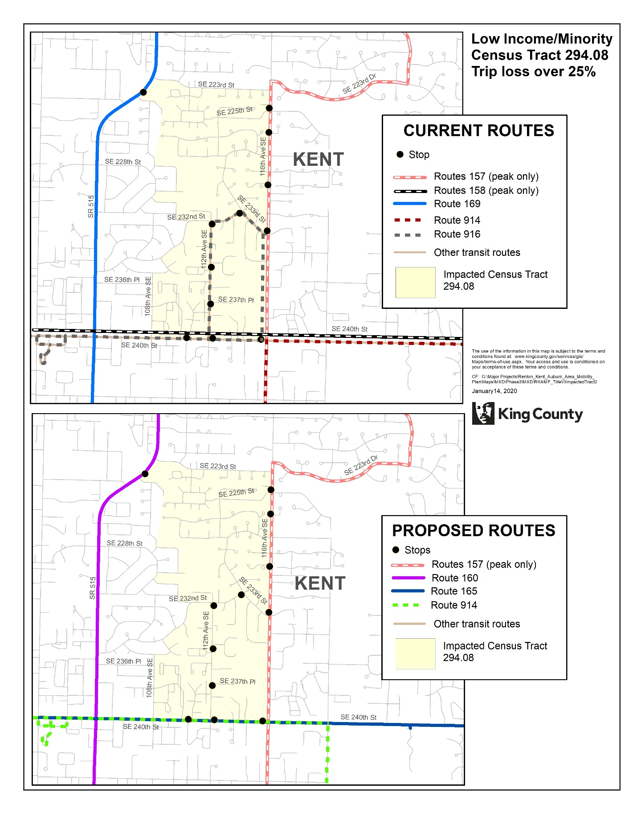

Benefits

All together, the recommended changes will better meet community-identified needs, including increased evening and weekend service, service to priority community destinations, improved east-west connectivity, and a more integrated regional transit network. The majority of the project area tracts (80%) are classified as low-income tracts, minority tracts, or both. Of these tracts, 80% are receiving increases in the number of trips serving that tract and 26% are receiving trip increases of greater than 25% with the proposed September 2020 service changes.

The proposed transit service changes feature creation of Route 160, a new frequent route that is proposed to travel between Renton, Kent, and Auburn and be upgraded to the RapidRide I Line in 2023. The proposed improvements will connect south King County riders to this new, high capacity frequent route as well as the existing high speed, high capacity Sounder rail service that connects riders in Auburn, Kent, and Tukwila to downtown Seattle and Tacoma during peak periods. The proposed changes also improve access to future Link light rail stations south of Angle Lake and set the stage for further service integration efforts prior to the opening of the Federal Way Link Extension in 2024.

APPENDIX A: Affected Routes and Rider Alternatives

| Route | Action | Alternatives |
| --- | --- | --- |
| 148 | Modify the routing of Route 148 to better serve community assets, including a new community center (to open in 2020), and housing along 116th​ Ave SE. | N/A |
| 157 | Restructure Route 157 to serve 132nd Ave SE and SE 256th St and not SE Kent Kangley Rd to avoid duplication with new Route 162. | Riders along SE Kent-Kangley will be served by Route 162. |
| 158 | Delete Route 158 to reduce duplicative and low-performing service. | Alternative service will be provided by new Route 162, connecting Lake Meridian Park and Ride to Downtown Seattle via SE Kent Kangley Rd and Kent Station, and local Route 164 which will receive increased service and will be realigned to cover 132nd Ave SE and SE 240th St. |
| 159 | Delete Route 159 to reduce duplicative and low-performing service. | Alternative service will be provided by new Route 162 connecting Lake Meridian Park and Ride to Downtown Seattle via SE Kent Kangley Rd and Kent Station, and local Route 168 which will receive increased service. |
| 164 | Delete Route 164 and replace with new Route 165 to provide a one-seat ride between Green River College, Kent, Highline College, Des Moines, and Burien. | The Route 164 corridor will be served by new Route 165, with increased frequency, span of service, and new Sunday service. |
| 166 | Delete Route 166 and replace with new Route 165 to provide a one-seat ride between Green River College, Kent, Highline College, Des Moines, and Burien. | The Route 166 corridor will be served by new Route 165, with increased frequency and span of service. However, Route 165 will not serve Military Road and will instead route along Veteran’s Drive and through the Lakes Community. |
| 168 | Route 168 will be revised to serve SE Kent Kangley Dr and Canyon Dr SE and not 132nd Ave SE, SE 256th St, 104th Ave SE, and SE 240th. | Alternative service will be provided along 132nd Ave SE, SE 256th St, 104th Ave SE, and SE 240th by Routes 165, 160, and 914. |
| 169 | Delete Route 169 to reduce duplicative service. | Alternative service will be provided by the new Route 160 service between Renton and Kent. |
| 180 | Delete Route 180 to reduce duplicative service. | Alternative service will be provided by service on new Route 160 between Auburn Station and Kent Station, new Route 161 between Kent Station and Burien Transit Center, and new Route 184 between South Auburn and Auburn Station. |
| 906 | Add additional service and revise route pathway to stay on SE Petrovitsky Road rather than deviating to serve SE 168th Street. | Alternative service will be provided by the Route 148 pathway to serve 116th Ave SE and 168th St. |
| 908 | Delete Route 908 due to low performance. | Alternative service will be provided by expanded service on Route 105 providing additional frequency. |
| 910 | Delete Route 910 due to low performance. | Alternative service will be provided by new frequent Route 160 service between Auburn Station and North Auburn and increased service on Route 917 between Auburn Station and the Outlet Collection. |
| 913 | Delete Route 913 due to low performance. | Alternative service to Route 913 will be provided by new Route 165 along S 231st Way and through the Lakes community. |
| 914 | Delete Route 916 to reduce duplicative service and provide simplified route and service design. | Alternative service will be provided by revised Route 914 with improved frequency. |
| 917 | Revise Route 917 to remove low ridership White River Junction stop and GSA deviation area to improve travel time and reliability. | N/A |

1. In addition, 7,700 annual hours associated with Expenditure Restriction ER9 in the 2019-20 budget will be invested in routes associated with this project.