

Internship Policies and Procedures Manual

**King County Guide for Employing Interns**

###### DEPARTMENT OF EXECUTIVE SERVICES

###### HUMAN RESOURCES DIVISION

Nancy Buonanno Grennan, Director

April 2013

**TABLE OF CONTENTS**

Overview – Employing Interns……………...………………………………….…..4

Part I: Administrative Intern – Student Intern……………………………….….…5

1. Purpose…………………………………………………………….……..5
2. Establishing A Paid Administrative Internship for Students………….…5
3. Agency’s Responsibilities Upon Hire – Student Hire……………………6
4. Compensation…………………………………………………………….8
5. Student Intern Position Monitoring………………………………………8
6. Termination………………………………………………………………8
7. Reference Documents……………………………………………………8
8. Student Intern Appointment Letter Template………………...….10
9. Student Internship Development Worksheet…………………….12
10. Exit Survey for Student Interns – Sample……………….……….13

Part II: Administrative Intern – Veteran Intern…………………………………..15

1. Purpose………………………………………………………………….15
2. Establishing A Paid Administrative Internship for Veterans……….…..15
3. Agency’s Responsibilities Upon Hire – Veteran Internships…………..17
4. Compensation……………………………………………………….…..18
5. Veteran Intern Position Monitoring…………………………….………18
6. Program Completion or Termination……………………….…………..18
7. Reference Documents…………………………………………….…….18
8. Department Request for Veteran Intern…………………………19
9. Veteran Intern Appointment Letter Template…………………..21
10. Exit Survey for Veteran Interns………………………………... 23

Part III: Volunteer Interns………………………………………………………..27

1. Purpose………………………………………………………………….27
2. Establishing A Volunteer Intern…………….……………………….….28
3. Student Affiliation Agreements………………………………………..28
4. Onboarding The Volunteer Intern………………………………………28
5. Volunteer Intern Position Monitoring…………………………………..28
6. Termination……………………………………………………………..29
7. Reference Documents…………………………………………………..29
8. Volunteer Intern Appointment Letter Template…………………30
9. Volunteer Intern Waiver and Release……………………………32

Part IV: Work Study Students……………………………………………………33

1. Purpose………………………………………………………………….33
2. Establishing A Work Study Program…………………………………...33
3. Upon Hire……………………………………………………………….34
4. Compensation…………………………………………………………...35
5. Work Study Student Position Monitoring………………………………36
6. Reference Documents…………………………………………………..36
7. Comprehensive List of All Washington State Work Study

Eligible Schools……………………………………………….....36

1. Washington State HECB Employer Contract and Profile Form…43
2. Work Study Appointment Letter………………………………...44

Appendix A……………………………………………………………………….46

**Overview- Employing Interns**

This policy and procedure manual is a resource guide for managers, supervisors, and human resources professionals. It provides guidance in hiring interns. Interns include administrative interns (students and veterans), volunteer interns, and work study students.

Contingent workers provide needed staffing assistance but may only be used to provide work of a temporary nature. King County Code 3.12A.010 provides:

…both operational efficiency and fair and equitable employment practices are advanced by the use of regular, career service employees where appropriate. Therefore, it is the policy of King County to have ongoing, relatively stable, and predictable bodies of work necessary to the provision of services to the public performed by career service employees, and to minimize its use of part-time and temporary employees.

It is the responsibility of executive agencies to ensure the appropriate use and approval of contingent workers. In partnership with executive agencies, the Department of Executive Services (DES), Human Resources Division (HRD) performs periodic audits of the use of contingent worker requests to ensure the appropriate use of contingent workers and to verify code compliance. To ensure appropriate designation of its workforce, the county establishes policies and guidelines for the administration of its contingent workforce as set forth in the contingent worker manual. This manual provides specific guidance on hiring interns.

1. **EFFECT OF Intern Policy**

The provisions of the Internship Policies and Procedures Manual confer no new privilege, right of appeal, right of position, transfer, demotion, promotion, recall, reinstatement nor any other employment right or benefit for any individual. This manual does not constitute an express or implied contract. It provides general guidance that cannot form the basis of a private right of action. The principles and procedures set forth in this manual are subject to change and may be modified, suspended or revoked without notice in whole or in part.

1. **DEFINITIONS**

Terms appearing throughout the Internship Policies and Procedures Manual are defined in Appendix A: Definitions.

1. **RESOURCES FOR ADMINISTERING CONTINGENT WORKER PROCESSES**

The Human Resources Operations and Consulting Services (HROCS) team oversees the contingent worker process. For additional information and guidance on how to administer contingent workers, contact HROCS team members at [CCQA@kingcounty.gov](mailto:CCQA@kingcounty.gov).

The Contingent Worker Manual is available online in the Outlook Public Folders/Human Resources/Policies & Guidelines/Contingent Workers and on the intranet at <http://hrd.metrokc.gov/policy.htm>.

**Part I**

**ADMINISTRATIVE INTERN – STUDENT INTERN**

1. **PURPOSE**

King County supports internship programs that provide growth and learning opportunities to students in high school, college and trade schools. This section provides the policy and processes for aiding executive agencies in hiring and managing their paid student internship programs.

Student interns are involved in education or training programs designed to provide students with professional experience in the furtherance of their education and training and are academically oriented for their benefit. Internships assist students in reaching their educational goals by giving them the opportunity to augment classroom instruction with exposure to a real world employment setting.

The County may employ student interns to perform work which will not:

1. Result in the displacement of regular employees or impair existing contracts for service;

2. Fill a vacant position;

3. Be used as a supplemental workforce to enhance or expand the delivery of King County service; or

4. Be primarily clerical in nature.

Work performed by a student intern bears a relationship to his or her formal academic program or career interest.

During the annual body of work review, particular attention is paid to the use of interns to ensure they are not being used to supplant or displace regular employees.

Student interns are exempt from the career service system and are at-will employees. The hiring authority or the student intern may terminate the employment relationship without cause or prior notice.

1. **ESTABLISHING A PAID ADMINISTRATIVE INTERN****SHIP FOR STUDENTS**

An internship is a planned program to provide a student with a meaningful learning experience applicable to the student’s field of study. This requires structured assignments coupled with appropriate supervision, evaluation, and feedback. Learning objectives will be developed when considering a student internship opportunity. It is beneficial to have clear job duties that identify the learning objectives or a defined project scope that demonstrates how the learning objectives for each individual will be met.

The procedure for establishing a student internship is as follows:

1. **Define the Work Program.** Prior to requesting a position for the intern, the hiring authority should define a work program for the intern designed to provide meaningful experience applicable to the student’s field of study. The Student Internship Development Worksheet can assist in identifying appropriate work for interns within the agency.
2. **Contact the Office of Labor Relations.** Prior to establishing a new internship, the hiring authority should contact the Office of Labor Relations to discuss any potential labor relations issues.
3. **Enter the Position Request into PeopleSoft.** The hiring authority enters the appropriate information into PeopleSoft to initiate the position request.
4. **Agency Human Resources Service Delivery Manager (“HRSDM”) Approval of Request.** After entry of the position request, the agency HRSDM will review the position request. If approved, the request is routed to HRD for review.
5. **HRD Review of Request.** HRD reviews the request for approval/denial. HRD may contact the hiring authority for additional information, if necessary. HRD will approve/deny the request for a term of up to one year. Following approval of the position request, HRD will submit the request to Central Position Data Management.
6. **Notify Agency of Approval/Denial.** The individual who initiated the request is notified of the intern approval/denial via PeopleSoft. Upon receipt of approval notification, the agency may initiate the hiring process.
7. **Creation of the Position.** Central Position Data Management will review the request. If all necessary information is present, it will approve the position creation.
8. **Identify the Candidate**. The hiring authority identifies the candidate and inputs the name of the student into PeopleSoft.
9. **Complete the Hire.** Once the candidate has been identified and hours worked verified, the agency may proceed with hiring the employee.
10. **AGENCY’S RESPONSIBILITIES UPON HIRE – STUDENT INTERN**
11. **Review Enrollment Criteria.** To qualify as a student intern, students must meet one of the three following enrollment criteria:
    1. The student is currently enrolled as a full-time student as defined by the school, organization, or institution.
       1. The student must provide proof of enrollment upon hire.
       2. Proof of continued enrollment must be provided each quarter or semester during the regular school year.
    2. The student has been accepted into an educational institution which meets the above requirement, when between institutions (*e.g.,* from high school to college); or
    3. The student is not currently enrolled but is qualified to work during the summer break. The student must provide proof of continued future enrollment (e.g. full-time enrollment in the fall will qualify).
12. **Input Enrollment Information into PeopleSoft.**
13. **Determine Retirement Eligibility.** Human resources staff completes the [Position Eligibility Worksheet](http://www.kingcounty.gov/employees/benefits/~/media/employees/benefits/documents/PEW0609.ashx) and sends it to Benefits, Payroll and Retirement Operations to determine whether a position is eligible for participation in the Washington State retirement system.
14. **Complete Initial Hire or Promotion Pay Request Form**. The agency completes an Initial Hire or Promotion Pay Request Form if requesting pay above step 1. The county administrative officer must approve the hiring of an employee above Step 5.
15. **Send Appointment Letter to HRD.** The agency provides the intern an appointment letter[1] and forwards a copy of the letter and new hire paperwork to HRD.
16. **Enter the employee into PeopleSoft.** The new employee must be entered into PeopleSoft on or before the employee’s first day of work.
17. **Attend New Employee Orientation.** All new employees must attend the Benefits, Payroll and Retirement Operations NEO, or the equivalent, within seven days.
18. **Attend Training.** All new employees must attend the Workplace Harassment and Acceptable Use trainings.
19. **Complete General On-Boarding.** Complete any additional paperwork and processes associated with on-boarding a new hire (Form I-9, W-4, direct deposit, etc.).
20. **COMPENSATION**

Student intern compensation is determined by their academic program which will fall within one of the four following established pay ranges:

| **Student Intern Compensation** | | |
| --- | --- | --- |
| **Intern Classification** | **Pay Range** | **Academic Status** |
| Intern 1 | 11 | High School Student |
| Intern 2 | 21 | Undergraduate |
| Intern 3 | 31 | Graduate |
| Intern 4 | 41 | Post-Graduate/Fellowship |

Generally, student interns begin at Step 1 of their pay range. Above step one pay rates may be offered in certain circumstances based upon the intern’s program of study, previous experience, class standing, or competing offer(s). Paid student interns are eligible for cost of living adjustments. They may receive a one-step within range increase after each 12-month increment of continuous service in a position provided that the student continues to meet the eligibility criteria and is performing appropriate internship work. Step increases are not required, but may be given at the hiring authority’s discretion. Initial pay above step one requires meeting specific criteria, in accordance with King County Code 3.15.120 (Pay on initial employment).

Student interns are hourly employees under the Fair Labor Standards Act (FLSA) regardless of their classification and are, therefore, overtime eligible. Student interns are ineligible for benefits but do receive a transit pass.

1. **STUDENT INTERN POSITION MONITORING**

The agency must regularly review the duties performed by student interns to ensure that they are engaged in meeting their learning objectives. It is recommended that the student intern provide a presentation at the end of the internship or at appropriate intervals to demonstrate how the learning objectives were met. Though tracked in PeopleSoft, student interns are not restricted on the number of hours that they may work. However, an analysis will be provided to the CSRC BOW for student interns who work more than 800 hours a year to determine if the assignments are appropriate.

1. **TERMINATION**

Student interns are at will employees and the employment relationship may be terminated by either party at any time without cause or prior notice. Upon termination of the internship, the agency is encouraged to work with the student intern to determine whether the objectives of the agency’s internship program are being met. To facilitate that determination, a sample exit interview form for student interns follows in the Reference Documents section below.

1. **REFERENCE DOCUMENTS**
2. Student Intern Appointment Letter Template
3. Student Internship Development Worksheet
4. Exit Survey for Student Intern – Sample

**Student Intern Appointment Letter Template**

DATE

NAME

ADDRESS

ADDRESS

Dear NAME:

Welcome to King County division or section. The purpose of this letter is to confirm your appointment to the position of Student Intern I, II, III or IV in the division of the King County agency. The effective date of your hire is DATE.

This position reports to supervisor, title. Your primary work location will be in the division offices located at address.

This position’s standard workweek is 35/40 hours and normal work hours are 8:00 am to 5:00 pm, Monday through Friday. You may discuss your specific schedule with your supervisor.

In this position you will summary of duties. Specific job duties will be discussed with you upon commencement of your employment.

You will be compensated at $rate hourly, which is Step X of Range X (King County FLSA Non-Exempt Squared Annual Salary Table). You will be paid on a biweekly/ semi-monthly basis in the PeopleSoft payroll system, with the first pay date for the new position occurring date. This position is an hourly position governed by the overtime provisions of the federal Fair Labor Standards Act and/or the Washington State Minimum Wage Act and is eligible for overtime pay or compensatory time accrual. However, you must receive prior approval from your supervisor before working any necessary overtime hours to meet your position responsibilities. Refer to PER 8-2-2 (AEP) 8“Overtime Pay, Holiday Pay and Compensatory Time in Lieu of Overtime Pay for Hourly Employees as Defined by the Fair Labor Standards Act and the Washington Minimum Wage Act” (June 1, 2008) for more information on the executive policy for hourly employees.

You are required to comply with federal government work authorization requirements. Within the first three days of employment you must present document(s) that identify both your identity and ability to work in the United States. On your first day of work, you will meet with a human resources/payroll staff person who will provide more information.

You are scheduled to attend a New Employee Orientation at time on date, in Room 121 of the Chinook Building, at the corner of Fifth Avenue and Jefferson Street. Your supervisor will arrange additional training for you including the mandatory Anti-Harassment classroom and web-based Workplace Harassment training.

Student internships are programs that provide students with exposure to workplace activities which are related to the intern’s field of study. As a student intern, you are an at-will temporary employee and serve at the pleasure of the hiring authority; either you or the county may terminate your employment at any time with or without cause or prior notice. Student interns are not members of the county’s career service system and are not covered by provisions governing the career service system.

The following items are important for you to know:

1. You are ineligible for King County benefits but are eligible for a transit pass.
2. You may be separated from employment prior to the completion of the assignment without cause or prior notice.
3. You do not attain any rights toward career service or regular employment.
4. You are not represented by a labor union.
5. To be eligible for hire into a career service position you must first compete in a formal selection process.

To qualify as a Student Intern, the following criteria must be met:

* You must be enrolled as a full-time student in a school, organization or institution.
* You must provide proof of full-time enrollment upon hire and throughout employment on a recurring schedule for the regular school year (e.g. quarterly or on a semester basis) in advance of the commencement of the next period of enrollment.
* You must provide proof of continued full-time enrollment to qualify for work during summer break (e.g. proof of enrollment in the fall term will qualify).

Please understand that the provisions of this letter do not constitute an expressed or implied contract but rather a statement of a number of matters important to you. If you have any questions about your position or any information in this letter, please contact name, title, at phone.

Congratulations on your appointment, and again, welcome to division.

Sincerely,

HIRING AUTHORITY

Attachment

cc: SUPERVISOR

OTHER

Personnel/Payroll file

**Student**

**Internship development**

**Worksheet**



**Name:**

**School:**

**Education Track or Program of Study:**

**Learning Objectives of Internship Associated with Program of Study:**

**_1. _______________________________________________________________________**

**_2. _______________________________________________________________________**

**_3._______________________________________________________________________**



Exit Survey for Student Interns - Sample

We hope you enjoyed your learning experience with King County. So that we may learn from your experiences with us, we would appreciate your completing this exit survey. Survey responses provide valuable information the county can use for improving the learning experience of student interns.

**Name:** ______________________________ **Supervisor/Mentor:** _______________________

**Department/Division:** _________________ **Employee PeopleSoft Id:**___________________

**Area of Study/Major:** _________________ **Dates of Internship:**_______________________

**School Level (circle one):** High School, Undergraduate, Graduate, Post-graduate/Fellowship

|  |  |  |  |
| --- | --- | --- | --- |
| **Were the following reasons important in your decision to intern with King County** | **Yes** | **Somewhat** | **No** |
| Desire to work in the public/government sector after graduation |  |  |  |
| King County’s reputation as a good learning environment for interns |  |  |  |
| School credit or meeting an educational requirement from your internship |  |  |  |
|  | | | |
| **Please describe your internship experience at King County including projects on which you participated and a description of typical daily activities performed** | | | |
|  | | | |

|  |  |  |  |  |
| --- | --- | --- | --- | --- |
| **Please tell us about your experience at King County** | **Strongly agree** | **Agree** | **Disagree** | **Strongly  disagree** |
| I was able to develop skills related to my area of educational study |  |  |  |  |
| I understood the learning objectives of my internship |  |  |  |  |
| I received feedback on progress toward meeting my learning objectives |  |  |  |  |

|  |  |  |  |  |
| --- | --- | --- | --- | --- |
| **Please describe how this internship complimented your educational learning objectives** | | | | |
|  | | | | |
|  | | | | |
| **Please tell us about your experiences with your supervisor/mentor** | **Strongly agree** | **Agree** | **Disagree** | **Strongly  disagree** |
| My supervisor/mentor was accessible and approachable |  |  |  |  |
| My supervisor/mentor exhibited genuine interest in my development |  |  |  |  |
| My supervisor/mentor provided learning opportunities |  |  |  |  |
|  | | | | |

**Thank you for completing the survey. Your responses are valued and appreciated.**

**Please send completed surveys to: King County Human Resources Division  
M.S. ADM-ES-0450  
500 Fourth Avenue, Room 450  
Seattle, WA 98104**

**Part II**

**ADMINISTRATIVE INTERN – VETERAN INTERN**

1. **PURPOSE**

King County has established a Veterans’ Internship Program called the Heroes Employment Reintegration Opportunity or HERO program. The HERO Program is designed to afford veterans with on-the-job training and work experience to enable them to more effectively compete for civilian jobs and to provide them with the support needed to successfully make the transition from military to civilian employment.

This section provides the policy and processes for aiding executive agencies in participating in the HERO Program by hosting veteran interns. A comprehensive manual for the implementation of the HERO Program is accessible by request to HRD’s Employment Services.

The HERO Program is designed for unemployed individuals that have served a minimum of 180 days active duty or mobilized reserve duty in a branch of the U.S. Military, including Army, Navy, Air Force, Marines, Coast Guard or National Guard/Reserve, or fulfilled the military service obligation of at least 6 or 8 years for National Guard/Reserve, and received one of the following characters of discharge: honorable, medical, general, or under honorable conditions; or, a National Guard/Reserve or Service Member currently called up for duty (Article 10 or 32), in process for activation, activated for duty or returning from duty. Individuals with less than 180 days active duty with a medical discharge also qualify under this definition.

The County may employ veteran interns to perform work which will not:

1. Result in the displacement of regular employees or impair existing contracts for service;
2. Fill a vacant position;
3. Be used as a supplemental workforce to enhance or expand the delivery of King County service; or

Work performed by a veteran intern bears a relationship to his or her job skills and/or career interests.

During the annual body of work review, particular attention is paid to the use of interns to ensure they are not being used to supplant or displace regular employees.

Veteran interns are exempt from the career service system and are at-will employees. The hiring authority or the veteran intern may terminate the employment relationship without cause or prior notice.

1. **ESTABLISHING A PAID ADMINISTRATIVE INTERNSHIP FOR VETERANS**

The HERO Program is facilitated by a coordinator in HRD who is responsible for the overall oversight of the program. The coordinator will work with departments and agencies to develop veteran internship positions that meet the requirements of the program.

Interns work 30 hours per week for a total of six months. The less than full-time schedule allows for the veteran to engage in services such as medical care and counseling as well as dedicate time to job search activities.

The program runs two sessions per year; January-June and July- December. Veteran interns will participate in the program as part of a cohort of interns and receive: comprehensive support services; an assigned veteran mentor on staff; one-on-one supervision from the site supervisor and the coordinator; and job search assistance.

Departments host the veteran intern as an employee, and offer an experience in the spirit of training. The veteran’s internship duties are to assist and support the work that is performed in the department. While the veteran may well have all the skills required to perform the job, the experience is designed to provide them with a supported “transition” to civilian work which may require some extra support and training beyond a job specialty skill.

Departments interested in hosting a veteran intern may complete the Department Request for Veteran Intern form and return it to the coordinator. The Department Request for Veteran Intern follows in the Reference Documents section below.

The procedure for establishing a veteran internship is as follows:

1. **Define Work.** The hiring authority should work with the coordinator to define a work program for a veteran intern designed to provide a meaningful experience and exposure to King County government. Veteran interns may not be responsible for decisions about or performance of major tasks, assignments or projects. The duties of the intern may not

* Result in the displacement of regular employees or impair existing contracts for service;
* Fill a vacant position;
* Be used as a supplemental workforce to enhance or expand the delivery of King County service; or be clerical in nature.

The position should offer

* On-the-job training,
* Opportunity to identify transferable skills,
* Build confidence,
* Experience in the civilian work environment, and
* Development of skills to more effectively compete for regular positions throughout King County government.

### Request Intern. Departments, divisions or supervisors interested in hosting an intern can initiate the process by completing a *Department Request for HERO Program Veteran Intern* form and submit it to the coordinator. Once the form is submitted, the coordinator will work with the department to develop the internship.

1. An Employment Services recruiter will post a job announcement for all veteran internship positions.
2. The recruiter will monitor and screen applications for all veteran internship positions.
3. The recruiter will forward all appropriate qualified applications to the department hiring authority for further review and interviewing.
4. The hiring department will inform the HERO Program coordinator of the final candidate and initiate the hiring process.
5. The HERO coordinator will match the selected intern with a King County employee mentor.
6. **AGENCY’S RESPONSIBILITIES UPON HIRE – Veteran Internships**
7. **Notify the HERO coordinator of selection.**
8. **Input Enrollment Information into PeopleSoft.**
9. **Determine Retirement Eligibility.** Human resources staff completes the [Position Eligibility Worksheet](http://www.kingcounty.gov/employees/benefits/~/media/employees/benefits/documents/PEW0609.ashx) and sends it to Benefits, Payroll and Retirement Operations to determine whether a position is eligible for participation in the Washington State retirement system. Complete Initial Hire or Promotion Pay Request Form. The agency completes an Initial Hire or Promotion Pay Request Form if requesting pay above step 1. The county administrative officer must approve the hiring of an employee above Step 5.
10. **Send Appointment Letter to HRD.** The agency provides the veteran intern an appointment letter and forwards a copy of the letter and new hire paperwork to HRD.
11. **Enter the employee into PeopleSoft.** The new employee must be entered into PeopleSoft on or before the employee’s first day of work.
12. **Register for New Employee Orientation.** All new employees must attend the Benefits, Payroll and Retirement Operations NEO, or the equivalent, within seven days.
13. **Register for Training.** All new employees must attend the Workplace Anti-Harassment and Acceptable Use trainings. Veteran interns will be encouraged to attend other training opportunities that may be offered to county employees generally.
14. **Complete General Onboarding.** Complete any additional paperwork and processes associated with on-boarding a new hire (Form I-9, W-4, direct deposit, etc.).
15. **COMPENSATION**

Veteraninterns in the HERO Program will be paid at Range 21 of the King County Hourly Squared Table. Dependent upon the agency’s agreement for hosting a veteran intern, 50% of the veteran intern’s wage may be paid through the Veterans and Human Services (VHS) Levy and reimbursed to the agency upon completion of the six month program.

Generally, veteran interns begin at Step 1 of their pay range. Above step one pay rates may be offered in certain circumstances based upon previous experience or prior wages in the military. Veteran interns are eligible for cost of living adjustments. Because they serve for only six months, interns are not eligible for step increases. Initial pay above step one requires meeting specific criteria, in accordance with King County Code 3.15.120 (Pay on initial employment).

Veteran interns are hourly employees under the Fair Labor Standards Act (FLSA) regardless of their classification and are, therefore, overtime eligible. Veteran interns are ineligible for benefits other than a transit pass.

Based on an agreement between HRD and the Department Community and Human Services, fiduciary of Veterans and Human Services (VHS) Levy funds, departments will be expected to pay the veteran intern’s full wages for the duration of the six-month placement and receive reimbursement of the VHS Levy eligible hours at the end of the internship.

The HERO coordinator will inform the department’s human resources staff of the protocols and required paperwork needed for the department to receive reimbursement.

1. **VETERAN INTERN POSITION MONITORING**

The veteran intern’s performance and progress will be regularly reviewed by the HERO coordinator and the site supervisor. The HERO coordinator will maintain regular contact with the site supervisor and the mentor to monitor the intern’s work as well as ensure that the veteran intern is receiving the support services he or she requires. The site supervisor will be provided evaluation forms to be completed at months three and six.

1. **PROGRAM COMPLETION OR TERMINATION**

Veteran interns are at will employees and the employment relationship may be terminated by either party at any time without cause or prior notice. Upon termination or completion of the program the veteran intern is encouraged to complete an exit survey to determine whether the objectives of the HERO Program are being met. The Exit Survey for Veteran Interns follows in the Reference Documents section below.

1. **REFERENCE DOCUMENTS**
2. Department Request for Veteran Intern
3. Veteran Intern Appointment Letter Template
4. Exit Survey for Veteran Interns



Department Request for Veteran Intern

Department:

Division:

Work Site Location:

Manager/Supervisor:

Veteran Intern Job Title:

Who would the intern be directly reporting to on a daily basis?

Please include a one page job description with this form (template provided below). If you’d like to elaborate further on projects the intern will be working on, or provide any additional information beyond that contained in the job description please include that here.

Please note the following expectations of managers who decide to host an Intern:

1. Be able to provide the work space and equipment required to do the job.
2. Meet with the intern on a regular basis to communicate expectations and provide feedback. If you are not in the office regularly please assign a lead or journey level staff to fill this function.
3. Meet with the HERO Program coordinator for check-ins.
4. Complete performance monitoring forms.
5. Supervise the intern throughout the duration of the internship. Interns should not be rotated through different teams unless approved by the Hero Coordinator.
6. Allow the Intern time to attend various internship meetings, trainings, mentor check-ins and activities set up by the HERO Program coordinator.
7. Allow time for the intern to job shadow in another department for a day or so if identified as part of their career preparation with the coordinator.
8. Include interns in as many team meetings and staff trainings as possible.
9. Encourage Interns to get involved with projects that interest them if time permits.
10. Interns SHOULD NOT do administrative work all the time unless the internship is designed to learn administrative work. Our internships are meant to be primarily beneficial to the veteran and should focus on becoming job-ready.

Department Request for Veteran Intern Continued

Veteran Internship Description

**Job Title:**

**Opportunity Type:** Veteran Internship

**Employer Division:**

**JOB STATUS:** Part-time 30 hours per week

**Compensation Type:** Range 21, Step 1 of Hourly Squared Table

**Manager / Supervisor of Intern:**

**Interns will gain knowledge through experiencing the following areas of learning:**

**Have an Interest in** (list relevant attributes, *e.g.,* prefers working outdoors, enjoys helping the public, etc.)**:**

**Work Environment** (indoor/outdoor, work with public, work on team, independent, how many staff, offices, cubicles, daylight/no daylight, quiet/loud, active or sedentary, etc.):

**QUALIFICATIONS** (Please list any required qualifications first and indicate that they are required in each line – examples below are required for every job description):

* Must be a veteran meeting the following criteria: served a minimum of 180 days active duty or mobilized reserve duty in a branch of the U.S. Military, including Army, Navy, Air Force, Marines, Coast Guard or National Guard/Reserve, or fulfilled the military service obligation of at least 6 or 8 years for National Guard/Reserve, and received one of the following characters of discharge: honorable, medical, general, or under honorable conditions. Individuals with less than 180 days active duty with a medical discharge also qualify under this definition. A National Guard/Reserve or Service Member currently called up for duty (Article 10 or 32), in process for activation, activated for duty or returning from duty also qualifies.
* Must be at least 18 years old
* Must be unemployed
* Must be authorized to work in the U.S.
* Have an interest in:

**Veteran Intern Appointment Letter Template**

DATE

NAME

ADDRESS

ADDRESS

Dear NAME:

Welcome to King County Heroes Employment Reintegration Opportunity (HERO) Program. The purpose of this letter is to confirm your appointment to the position of Veteran Intern in the division of the King County agency. The effective date of your hire is DATE.

This position reports to supervisor, title. Your primary work location will be in the division offices located at address.

This position’s standard workweek is 30 hours and normal work hours are [Set out 30 hour workweek hours here], Monday through Friday. You may discuss your specific schedule with your supervisor.

In this position you will summary of duties. Specific job duties will be discussed with you upon commencement of your employment.

You will be compensated at $rate hourly, which is Step X of Range 21 (King County FLSA Non-Exempt Squared Annual Salary Table). You will be paid on a biweekly/ semi-monthly basis in the PeopleSoft payroll system, with the first pay date for the new position occurring date. This position is an hourly position governed by the overtime provisions of the federal Fair Labor Standards Act and/or the Washington State Minimum Wage Act and is eligible for overtime pay or compensatory time accrual. However, you must receive approval from your supervisor before working any necessary overtime hours to meet your position responsibilities. Refer to PER 8-2-2 (AEP) 8“Overtime Pay, Holiday Pay and Compensatory Time in Lieu of Overtime Pay for Hourly Employees as Defined by the Fair Labor Standards Act and the Washington Minimum Wage Act” (June 1, 2008) for more information on the executive policy for hourly employees.

You are required to comply with federal government work authorization requirements. Within the first three days of employment you must present document(s) that identify both your identity and ability to work in the United States. On your first day of work, you will meet with a human resources/payroll staff person who will provide more information.

You are scheduled to attend a New Employee Orientation at time on date, in Room 121 of the Chinook Building, at the corner of Fifth Avenue and Jefferson Street. Your supervisor will arrange additional training for you including the mandatory Anti-Harassment classroom and web-based Workplace Harassment training.

The HERO Program is designed to afford veterans with on-the-job training and work experience to enable them to more effectively compete for civilian jobs. As a veteran intern, you are an at-will temporary employee and serve at the pleasure of the hiring authority; either you or the county may terminate your employment at any time with or without cause or prior notice. Veteran interns are not members of the county’s career service system and are not covered by provisions governing the career service system.

The following items are important for you to know:

1. You are ineligible for King County benefits but are eligible for a transit pass.
2. You may be separated from employment prior to the completion of the assignment without cause or prior notice.
3. You do not attain any rights toward career service or regular employment.
4. You are not represented by a labor union.

Please understand that the provisions of this letter do not constitute an expressed or implied contract but rather a statement of a number of matters important to you. If you have any questions about your position or any information in this letter, please contact name, title, at phone.

Congratulations on your appointment, and again, welcome to division.

Sincerely,

HIRING AUTHORITY

Attachment

cc: SUPERVISOR

OTHER

Personnel/Payroll file

Exit Survey for Veteran Interns



We hope you enjoyed your internship experience with King County. So that we may learn from your experiences with us, we would appreciate your completing this exit survey. Survey responses provide valuable information the county can use for improving the HERO Program and its participants.

**Name:**

**Supervisor:**

**Department & Division:**

**Job Title**

**Area of Career Interest:**

**HERO Mentor:**

**Dates of HERO internship:**

|  |  |  |  |  |  |  |
| --- | --- | --- | --- | --- | --- | --- |
| **Were the following reasons important in your decision to intern with King County** | **Yes** | | **Somewhat** | | **No** | |
| **Desire to work in the public/government sector** |  | |  | |  | |
| **Unable to find employment on my own** |  | |  | |  | |
| **When employed I struggled to maintain the job** |  | |  | |  | |
|  | | | | | | |
| **Please tell us about your experience at your work site** | **Strongly agree** | **Agree** | | **Disagree** | | **Strongly  disagree** |
| **An adequate orientation to the job was provided** |  |  | |  | |  |
| **I had the resources I needed to fulfill my job duties** |  |  | |  | |  |
| **My co-workers understood my role/duties** |  |  | |  | |  |
| **My co-workers were accepting and helpful** |  |  | |  | |  |

|  |  |  |  |  |
| --- | --- | --- | --- | --- |
| **Please tell us about your internship experience with the HERO Program** | **Strongly agree** | **Agree** | **Disagree** | **Strongly  disagree** |
| **The orientation to the HERO Program and King County government was helpful to my success as an intern** |  |  |  |  |
| **It was helpful to be a part of a group of HERO interns** |  |  |  |  |
| **The program provided the extra support I needed to deal with issues that can arise from transitioning from military to civilian employment** |  |  |  |  |
| **The resume and job search assistance was useful and will benefit me in future** |  |  |  |  |
| **As a result of this experience I have learned more about the career field I am interested in** |  |  |  |  |
| **As a result of this internship I am better able to identify my transferable military skills** |  |  |  |  |
| **I understood the learning objectives of my internship** |  |  |  |  |
| **I received useful feedback on my progress toward meeting my learning objectives** |  |  |  |  |
| **I learned new skills I can use in future employment** |  |  |  |  |
| **I have a better understanding of King County government and services as a result of this experience** |  |  |  |  |
| **I have a better understanding of job opportunities with King County as a result of this experience** |  |  |  |  |
| **I know where to find and how to apply for King County jobs** |  |  |  |  |
| **Because of my HERO Program experience I feel better prepared to find civilian employment** |  |  |  |  |

|  |  |  |  |  |
| --- | --- | --- | --- | --- |
| **Please describe how this internship will or will not help you in pursuing future employment** | | | | |
|  | | | | |
|  | | | | |
| **Please tell us about your experiences with your supervisor** | **Strongly agree** | **Agree** | **Disagree** | **Strongly  disagree** |
| **My supervisor was accessible and approachable** |  |  |  |  |
| **My supervisor exhibited genuine interest in my development** |  |  |  |  |
| **My supervisor provided learning opportunities** |  |  |  |  |
| **My supervisor had enough knowledge about veterans and the military to make me feel supported** |  |  |  |  |
|  | | | | |
| **Please tell us about your experiences with your HERO Mentor** | **Strongly agree** | **Agree** | **Disagree** | **Strongly  disagree** |
| **My mentor was accessible and approachable** |  |  |  |  |
| **My mentor exhibited genuine interest in my development** |  |  |  |  |
| **My mentor provided support that was helpful to my success** |  |  |  |  |
| **My mentor was always professional and appropriate in their role** |  |  |  |  |
| **My mentor played an important role in my experience** |  |  |  |  |

|  |  |  |
| --- | --- | --- |
| **Please tell us about your opinions** | **Yes** | **No** |
| **I would work for this supervisor again.** |  |  |
| **I would work for this organization again.** |  |  |
| **I would recommend this mentor for other participants.** |  |  |
| **I would recommend this program to other veterans.** |  |  |

|  |
| --- |
| **What would make the HERO Program better?** |
|  |

|  |
| --- |
| **What worked well for you in the HERO Program?** |
|  |

**Thank you for completing the survey. Your responses are valued and appreciated.**

**Please send completed surveys to:**

**King County Human Resources Division  
M.S. ADM-ES-0450  
500 Fourth Avenue, Room 450  
Seattle, WA 98104**

**Or Email to** [**candicestephens@king.county.gov**](mailto:candicestephens@king.county.gov)

**PART III**

**VOLUNTEER INTERNS**

1. **PURPOSE**

King County supports volunteer (unpaid) internship programs that provide growth and learning opportunities to high school, college, and students in trade schools. This section provides the policy and processes for aiding executive agencies in hiring and managing their volunteer internship programs.

Volunteer internships receive scholastic credit or scholastic recognition for participating in the internship. Volunteer internships assist the students in reaching their educational goals by giving students the opportunity to augment classroom instruction with exposure to a real world government setting.

The County may utilize volunteer interns to perform work which will not:

1. Result in the displacement of regular employees or impair existing contracts for service;

2. Fill a vacant position;

3. Be used as a supplemental workforce to enhance or expand the delivery of King County service; or

4. Be primarily clerical in nature.

Work performed by a volunteer intern bears a relationship to his or her formal academic program or career interest.

Volunteer interns are not King County employees. King County or the intern may terminate the volunteer internship without cause or prior notice.

1. **ESTABLISHING A VOLUNTEER INTERN**

A volunteer internship is a planned program to provide a student with meaningful learning experience. As voluntary interns are unpaid, the creation of a position is unnecessary. However, before establishing a volunteer intern, the hiring authority should contact the Office of Labor Relations to discuss any potential labor relations issue.

1. **STUDENT AFFILIATION AGREEMENTS (Volunteer Interns in the Department of Public Health)**

When using interns in the Department of Public Health, a student affiliation agreement is usually signed by the school. Consult with Department of Public Health Human Resources and the Public Health Risk Manager about the need for such an agreement, and how to procure it.

1. **ONBOARDING THE VOLUNTEER INTERN**
2. **Identify a Candidate.**
3. **Student Affiliation Agreement.** If the volunteer intern will be working for the Department of Public Health, inquire with Department of Public Health Human Resources as to whether a Student Affiliation Agreement is in place. If not in place, discuss if one is necessary.
4. **Review Enrollment Criteria.** To qualify as a student intern, students must meet one of the three following enrollment criteria:
   1. The individual is currently enrolled as a full-time student as determined by the school, organization, or institution.
      1. The student must provide proof of full-time enrollment.
      2. Proof of continued enrollment must be provided each quarter or semester during the regular school year.
   2. The student has been accepted into an educational institution which will meet the above requirement, when between institutions (*e.g.,* from high school to college); or
   3. The student is not currently enrolled but is qualified to work during the summer break. The student must provide proof of continuing full-time enrollment (e.g. full-time enrollment in the upcoming fall term will qualify).
5. **Send Appointment Letter to HRD.** The agency provides the volunteer intern an appointment letter and forwards a copy of the letter and Volunteer Services Waiver and Release to HRD HROCS.
6. **Transit Pass Eligibility.** While volunteer interns are unpaid, they are eligible for a transitpass.
7. **VOLUNTEER INTERN POSITION MONITORING**

The agency must regularly review the duties performed by interns to ensure that they are engaged in meeting their learning objectives.

1. **TERMINATION**

Volunteer internships may be terminated by either party at any time without cause or prior notice.

1. **REFERENCE DOCUMENTS**

1. Volunteer Intern Appointment Letter Template

2. Volunteer Services Waiver and Release

**Volunteer Intern**



**Appointment Letter Template**

DATE

NAME

ADDRESS

ADDRESS

Dear NAME:

Welcome to King County division or section. The purpose of this letter is to confirm your volunteer internship in the division of the King County agency. The effective date of your internship is DATE.

You report to supervisor, title, who will supervise your learning objectives. Your primary volunteering location will be in the division offices located at address.

Your internship standard week is 35/40 hours and normal hours are 8:00 am to 5:00 pm, Monday through Friday. You may discuss your specific schedule with your mentor.

In this internship you will summary of learning objectives. Specific duties will be discussed with you upon commencement of your internship.

As a volunteer intern, you will be performing hours of service for a public agency for civic, charitable, educational, or humanitarian reasons, without promise, expectation or receipt of compensation for services rendered. Thus, you will not receive compensation for your contribution. You will be required to sign and submit a waiver of liability which is included at the end of this letter.

The following items are important for you to know:

1. You are ineligible for King County benefits but are eligible to receive a transit pass.
2. Either you or the county may terminate the internship prior to the completion of the assignment without cause or prior notice.
3. You do not attain any rights toward career service or regular employment.
4. You are not represented by a labor union.
5. To be eligible for hire into a career service position you must first compete in a formal selection process.
6. You are ineligible for enrollment in the Public Employees' Retirement System (PERS).

To qualify as a Volunteer Intern, the following criteria must be met:

* You must be enrolled as a full-time student in a school, organization or institution.
* You must provide proof of full-time enrollment upon appointment and throughout your internship.
* You must provide proof of continued full-time enrollment to qualify for an internship during summer break.

Please understand that the provisions of this letter do not constitute an express or implied agreement. If you have any questions about your internship or any information in this letter, please contact name, title, at phone.

Congratulations on your internship, and again, welcome to division.

Sincerely,

HIRING AUTHORITY

Attachment

cc: SUPERVISOR

OTHER

I understand and accept the conditions of this internship.

______________________________________ _______________________

Student Signature Date

**VOLUNTEER INTERN**

**WAIVER AND RELEASE**

The undersigned, on behalf of themselves and their estate, hereby waives any right of recovery and releases King County, its officers, officials, employees and agents, from liability arising from any injury to Undersigned, arising from or out of the Undersigned’s activities and participation in the volunteer internship at King County

The Undersigned further acknowledges and agrees that King County does not assume any responsibility whatsoever for any property of the Undersigned and the Undersigned shall not hold the county liable for any loss or damage to same.  The Undersigned hereby gives permission to be photographed and have their image used in King County publications.

Signature: __________________________________________ Date: ____________

**For youth under 18 years of age**: ______________________________________ (print) has my permission to accept a volunteer unpaid internship for King County. Signature of Guardian: __________________ _________Date: ______

**PART IV**

**WORK STUDY STUDENTS**

1. **PURPOSE**

King County supports employing college-level students who qualify for work study. Work study is a program administered by the state that provides funding for employers to employ qualified students. Students gain work experience and financial assistance while employers gain subsidized workers. This section provides the policy and processes for ensuring that executive agencies manage their work study student employees.

Per the county’s contract with the State of Washington Work Study Program, the county must, “Ensure that the work performed by the State Work Study student will bear relationship to the student’s academic program and/or career interest.” The County may utilize work study students to perform work which will not:

1. Result in the displacement of regular employees or impair existing contracts for service;

2. Fill a vacant position;

3. Be used as a supplemental workforce to enhance or expand the delivery of King County service; or

4. Be primarily clerical in nature.

Work performed by work study students may include administrative work, peak workload, short-term needs, project related or seasonal work. Assignments for a work study employee should be appropriate for an entry-level employee.

Work study students are exempt from the career service system and are at-will employees. Either the agency or the student may terminate the employment relationship at any time with or without cause or prior notice.

1. **ESTABLISHING A WORK STUDY PROGRAM**

Each executive agency is responsible for signing up and receiving approval from the Washington State Higher Education Coordinating Board (HECB) to participate in the Work Study Program.

Following is a list of steps explaining the hiring process:

1. **Annual Registration with HECB**. Annually, participating agenciesmust submit Washington State HECB Employer Contract and Profile Form to participating schools and the HECB. The state contacts agencies with a renewal form between May 1 and September 30 of each year. Registration must be current for the agency to participate in the work study program.
2. **Determine Need**. Assignment for the work study position must be defined prior to posting the position at participating schools.
3. **Enter Data into PeopleSoft.** The hiring authority enters the appropriate information into **PeopleSoft** to initiate review of the request for a new position by HRD.
4. **HRD Review of Request**. HRD reviews the request for approval/denial to ensure compliance with HECB requirements.
5. **Notification of Approval/Denial**. PeopleSoft will notify the hiring authority of the work study student approval/denial via PeopleSoft workflow.
6. **Creation of the Position.** Upon submittal by the agency, the Position Control will review the request and the position will be created.Once the position has been created, the agency may proceed with the hiring process.
7. **Identify Target Schools.** The agency must determine where the work study position will be advertised. This decision may depend on location as well as any particular academic programs present at the institution.
8. **HECB Job Description Form.** For each work study position, the agency must submit an HECB Job Description Form and receive approval from any schools at which the position will be advertised. The form provides general information about the position and defines the minimum requirements. The participating school will post the position to its students.
9. **Selecting a Candidate**. The agency interviews applicants to select a candidate for the position. Before interviewing, the agency may request verification of program eligibility (*e.g.*, a Financial Aid Award Letter or referral letter from the school signed by a school officer listing work study award amount and applicable terms).
10. **UPON HIRE**

The following must occur upon hiring a work study student:

1. **Determine Retirement Eligibility.** Human resources staff completes the [Position Eligibility Worksheet](http://www.kingcounty.gov/employees/benefits/~/media/employees/benefits/documents/PEW0609.ashx) and sends it to Benefits, Payroll and Retirement Operations to determine whether a position is eligible for participation in the Washington State retirement system.
2. **Complete Initial Hire or Promotion Pay Request Form.** The agency completes an Initial Hire or Promotion Pay Request Form if requesting pay above step 1. The county administrative officer must approve the hiring of an employee above Step 5.
3. **Send Appointment Letter to HRD.** The agency provides the employee an appointment letter and forwards a copy of the letter and new hire paperwork to HRD.
4. **Enter Employee into PeopleSoft.** The new employee must be entered into PeopleSoft on or before the employee’s first day of work.
5. **Attend New Employee Orientation (NEO).** All new employees must attend the Benefits, Payroll and Retirement Operations Benefits, Payroll and Retirement Operations NEO, or the equivalent, within seven days.
6. **Attend Training.** All new employees must attend the Workplace Anti-Harassment and Acceptable Use trainings, or the equivalent.
7. **Complete General On-Boarding.** Complete any additional paperwork and processes associated with on-boarding a new hire (Form I-9, W-4, direct deposit, etc.).
8. **Notify Schools.** Upon hiring awork study student, agencies notify the school. Each school may have its own process and paperwork to complete at this point.
9. **COMPENSATION**

Work study students are exempt from the career service system and are at-will, hourly employees. They must certify hours by recording hours and signing a Work Study Off-Campus Timesheet provided by their school. Agencies verify the hours worked and satisfactory performance by signing the timesheet. The completed timesheet is returned to the appropriate school for processing. Agencies pay the work study student for hours worked directly and Washington State issues a reimbursement check within three to six weeks.

Work study students receive compensation in one of three established pay ranges:

|  |  |  |
| --- | --- | --- |
| **Work Study Student Compensation** | | |
| **Work Study Classification** | **Pay Range** | **Academic Status** |
| Work Study 1 | 21 | Undergraduate |
| Work Study 2 | 31 | Graduate |
| Work Study 3 | 41 | Post-Graduate/Fellowship |

Generally, work study students begin at Step 1 of their pay range. Above step one pay rates may only be offered in certain circumstances based upon the student’s program of study, previous experience, class standing, or competing offer(s). Work study students are eligible for cost of living adjustments. They may receive a one-step within range increase after each 12-month increment of continuous service in a position. Step increases are not required, but may be provided at the hiring authority’s discretion. Initial pay above step one requires meeting specific criteria, in accordance with King County Code 3.15.120 (Pay on initial employment). Work study students are hourly employees under the FLSA regardless of their classifications and, are therefore, overtime eligible. Work study students are ineligible for benefits but do receive a transit pass.

1. **WORK STUDY STUDENT POSITION MONITORING**

A student’s financial aid award letter sets the maximum amount the work study program will reimburse. The county receives 65% reimbursement of the student’s wages; therefore it is important to monitor the number of hours worked and associated costs. The HECB will not reimburse the county for work exceeding the award amount. Work study students may not remain in a work study classification after they exceed the maximum amount of reimbursement from the work study program.

Based upon their financial aid award, students may work full-time during winter, spring and summer breaks and part-time during the normal school year. Though tracked in PeopleSoft, work study students are not restricted on the number of hours that they may work but the HECB will only reimburse the agency up to the amount of the award.

1. **REFERENCE DOCUMENTS**
2. Comprehensive List of All Washington State Work Study Eligible Schools
3. Washington State HECB Employer Contract and Profile Form
4. Work Study Appointment Letter

| **School** | **City** | **Telephone** |
| --- | --- | --- |
| Antioch University | Seattle | 206.441.5352 |
| Bastyr University | Kenmore | 425.823.1300 |
| Bates Technical College | Tacoma | 253.680.7000 |
| Bellevue Community College | Bellevue | 425.564.1000 |
| Bellingham Technical College | Bellingham | 360.738.0221 |
| Big Bend Community College | Moses Lake | 509.793.2222 |
| Cascadia Community College | Bothell | 425.352.8000 |
| Central Washington University | Des Moines | 206.439.3800 |
| Central Washington University | Ellensburg | 509.963.1111 |
| Central Washington University | Everett | 425.259.8900 |
| Central Washington University | Kent | 253.856.9595 |
| Central Washington University | Lakewood | 253.964.6636 |
| Central Washington University | Lynnwood | 425.640.1574 |
| Central Washington University | Moses Lake | 509.793.2384 |
| Central Washington University | Wenatchee | 509.665.2600 |
| Central Washington University | Yakima | 509.574.6894 |
| Centralia Community College | Centralia | 360.736.9391 |
| Clark Community College | Vancouver | 360.699.6398 |
| Clover Park Technical College | Lakewood | 253.589.5800 |
| Columbia Basin College | Pasco | 509.547.0511 |
| Cornish College of the Arts | Seattle | 206.726.5151 |
| Eastern Washington University | Cheney | 509.359.6200 |
| Edmonds Community College | Lynnwood | 425.640.1459 |
| Everett Community College | Everett | 425.388.9100 |
| Gonzaga University | Spokane | 509.328.4220 |
| Grays Harbor Comm. College | Aberdeen | 360.532.9020 |
| Green River Community College | Auburn | 253.833.9111 |
| Heritage University | Toppenish | 509.865.8500 |
| Highline Community College | Des Moines | 206.878.3710 |
| Lake Wash. Inst. Of Technology | Kirkland | 425.739.8100 |
| Lower Columbia College | Longview | 360.442.2311 |
| North Seattle Comm. College | Seattle | 206.527.3600 |
| Northwest University | Kirkland | 425.822.8266 |
| Northwest Indian College | Bellingham | 360.676.2772 |
| Olympic Community College | Bremerton | 360.792.6050 |
| Pacific Lutheran University | Tacoma | 253.531.6900 |
| Peninsula College | Port Angeles | 360.452.9277 |
| Pierce College | Lakewood | 253.964.6500 |
| Renton Technical College | Renton | 425.235.2352 |
| Saint Martin's University | Lacey | 360.491.4700 |
| Seattle Central Comm. College | Seattle | 206.587.3800 |
| Seattle Pacific University | Seattle | 206.281.2000 |
| Seattle University | Seattle | 206.296.6000 |
| Seattle University Law School | Seattle | 206.398.4000 |
| Seattle Vocational Institute | Seattle | 206.587.4950 |
| Shoreline Community College | Seattle | 206.546.4101 |
| Skagit Valley College | Mt. Vernon | 360.416.7600 |
| So. Puget Sound Com. College | Olympia | 360.754.7711 |
| So. Seattle Community College | Seattle | 206.764.5300 |
| Spokane Community College | Spokane | 509.533.7000 |
| Spokane Falls Comm. College | Spokane | 509.533.3500 |
| Tacoma Community College | Tacoma | 253.566.5000 |
| The Evergreen State College | Olympia | 360.867.6000 |
| Trinity Lutheran College | Everett | 425.249.4777 |
| University of Puget Sound | Tacoma | 253.879.3100 |
| University of Washington | Bothell | 425.352.5000 |
| University of Washington | Seattle | 206.543.2100 |
| University of Washington | Tacoma | 253.692.4000 |
| Walla Walla University | College Place | 509.527.2615 |
| Walla Walla Community College | Walla Walla | 509.522.2500 |
| Washington State University | Pullman | 509.335.3564 |
| Washington State University | Spokane | 509.358.7500 |
| Washington State University | Richland | 509.372.7000 |
| Washington State University | Vancouver | 360.546.9788 |
| Wenatchee Valley Comm. College | Wenatchee | 509.682.6800 |
| Western Washington University | Bellingham | 360.650.3158 |
| Whatcom Community College | Bellingham | 360.383.3000 |
| Whitman College | Walla Walla | 509.527.5111 |
| Whitworth University | Spokane | 509.777.1000 |
| Yakima Valley Comm. College | Yakima | 509.574.4600 |

**Employer Contract and Business Profile**

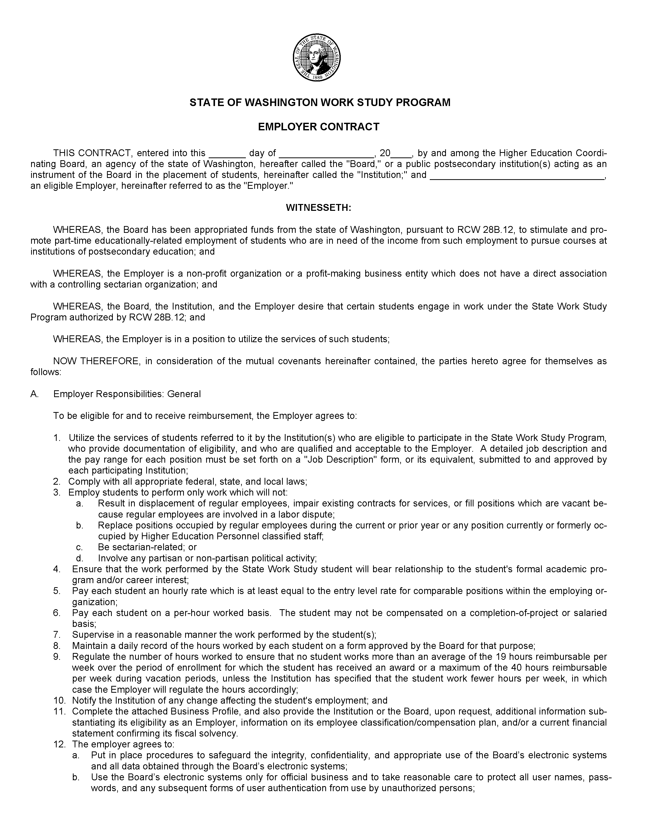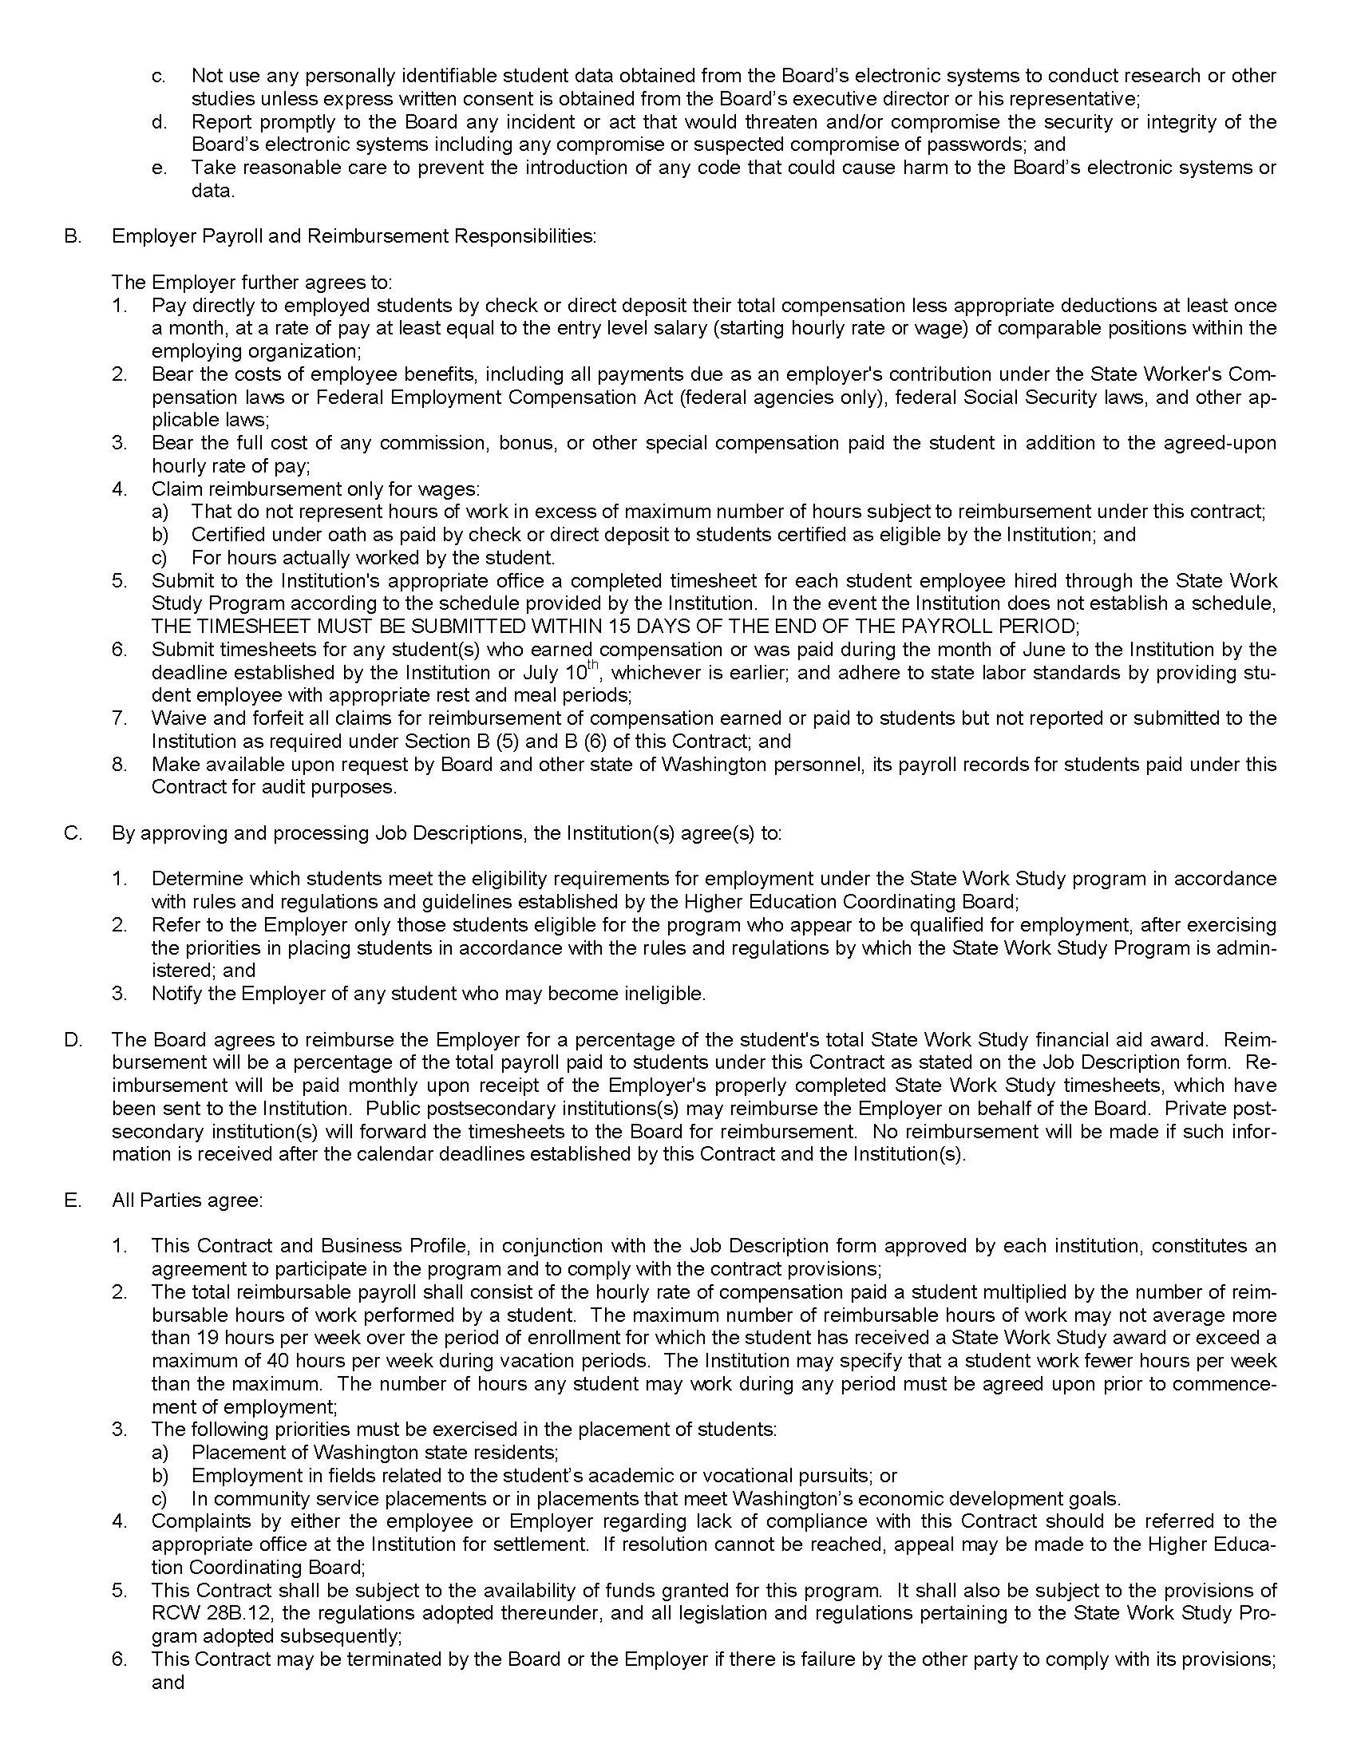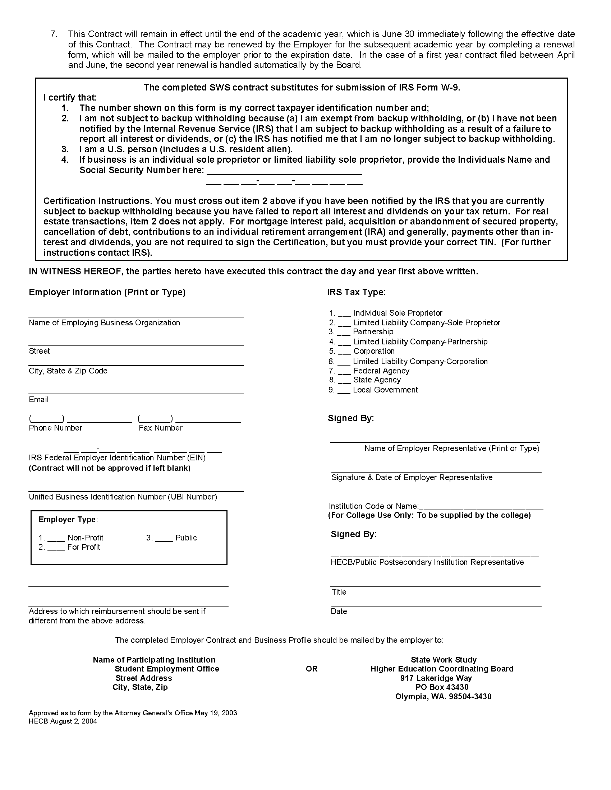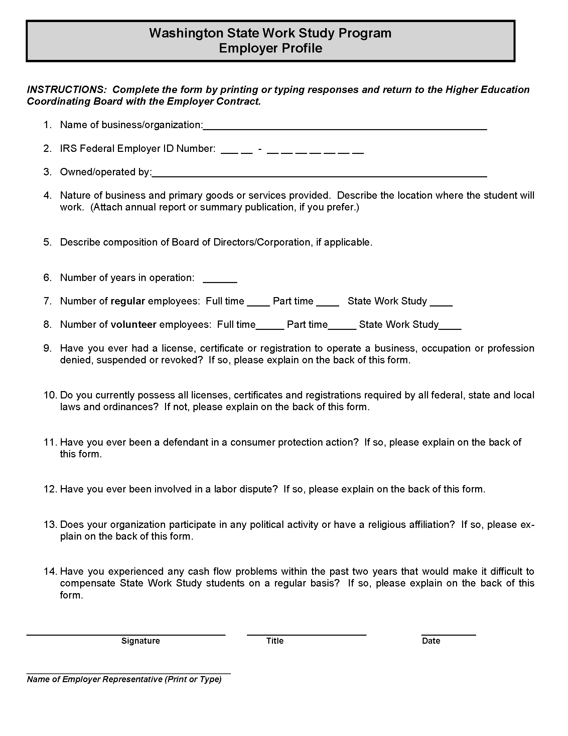

**Work Study Appointment Letter Template**

DATE

NAME

ADDRESS

ADDRESS

Dear NAME:

Welcome to King County division or section. The purpose of this letter is to confirm your appointment to the position of Work Study I, II, or III in the division of the King County agency. The effective date of your hire is DATE.

This position reports to supervisor, title. Your primary work location will be in the division offices located at address.

This position’s standard workweek is 35/40 hours and normal work hours are 8:00 am to 5:00 pm, Monday through Friday. You may discuss your specific schedule with your supervisor.

In this position you will summary of duties. Specific job duties will be discussed with you upon commencement of your employment.

You will be compensated at $rate hourly, which is Step X of Range X (King County FLSA Non-Exempt Squared Annual Salary Table). You will be paid on a biweekly/ semi-monthly basis in the PeopleSoft/MSA payroll system, with the first pay date for the new position occurring date. This position is an hourly position governed by the overtime provisions of the federal Fair Labor Standards Act and/or the Washington State Minimum Wage Act and is eligible for overtime pay or compensatory time accrual. However, you must receive prior approval from your supervisor before working any necessary overtime hours to meet your position responsibilities. Refer to PER 8-2-2 (AEP) 8“Overtime Pay, Holiday Pay and Compensatory Time in Lieu of Overtime Pay for Hourly Employees as Defined by the Fair Labor Standards Act and the Washington Minimum Wage Act” (June 1, 2008) for more information on the executive policy for hourly employees.

You are required to comply with federal government work authorization requirements. Within the first three days of employment you must present document(s) that identify both your identity and ability to work in the United States. On your first day of work, you will meet with a human resources/payroll staff person who will provide more information.

You are scheduled to attend a New Employee Orientation at time on date, in Room 121 of the Chinook Building, at the corner of Fifth Avenue and Jefferson Street/ or the equivalent. Your supervisor will arrange additional training for you including the mandatory Anti-Harassment classroom and web-based Workplace Anti-Harassment training.

Work study is a program that provides students with exposure to workplace activities which are related to the intern’s field of study. As a work study student, you are an at-will temporary employee and serve at the pleasure of the hiring authority; either you or the county may terminate your employment at any time with or without cause or prior notice. Work study students are not members of the county’s career service system and are not covered by provisions governing the career service system.

The following items are important for you to know:

* You are ineligible for King County benefits but are eligible for a transit pass.

1. You may be separated from employment prior to the completion of the projected work schedule without cause or prior notice.
2. You do not attain any rights toward career service or regular employment.
3. You are not represented by a labor union.
4. You are ineligible for hire into a career service position unless you have competed in a formal selection process.

To qualify as a Work Study student, you must be enrolled as a student as defined by the school, organization or institution (King County will accept each individual institution’s definition of full-time); you must provide proof of full-time enrollment upon hire and throughout employment on a recurring schedule for the regular school year (*e.g.*, quarterly or semester basis) in advance of the commencement of the next recurring schedule; and your work with the county may not exceed your financial aid award.

Please understand that the provisions of this letter do not constitute an expressed or implied contract but rather a statement of a number of matters important to you. If you have any questions about your position or any information in this letter, please contact name, title, at phone.

Congratulations on your appointment, and again, welcome to division.

Sincerely,

HIRING AUTHORITY

Attachment

cc: SUPERVISOR

OTHER

Personnel/Payroll file

**APPENDICES**

**APPENDIX A: Definitions**

**Administrative Interns:**

A.1. "Administrative interns" means employees who are :

a. ~~e~~nrolled full-time during the regular school year in a program of education, internship or apprenticeship; or

b. veterans temporarily working to gain practical workforce experience.

2. All administrative internships in executive departments shall be approved by the manager. Administrative interns are exempt from the career service under Section 550 of the charter.

(KCC 3.12.010 (A))

**Annual Body of Work (BOW) Review:**

(t)he executive shall conduct an annual review as described herein. By March 1 of each year, beginning March 1, 1999, each executive agency and administrative office shall prepare and submit to the committee a comprehensive report documenting its use of part-time and temporary employees, other than probationary and provisional employees, in the preceding calendar year. Within 60 days of submission of the above reports, the committee shall make a factual determination as to whether an ongoing, relatively stable and predictable body of work on an annualized basis has been identified. If the committee determines that such a body of work exists, the committee may recommend: (1) the creation of any new part-time or full-time regular career service position(s); or (2) the filling of an existing vacant career service position in which the work is being performed by a temporary or part-time employee(s); or (3) the creation of a term-limited temporary employee position; or (4) the cessation of the work. If the committee identifies such a body of work, but the committee does not make any of the recommendations described above, the agency must discontinue the use of part-time or temporary employees to perform that work. If the committee recommends creation of a regular career service position, but the executive does not recommend or the council does not create such a position, the agency shall discontinue performance of the pertinent body of work by temporary or part-time employees. Any regular career service position created as a result of this process will be filled by a competitive hiring process. The reports of each agency and of the committee and the records of their proceedings shall be considered disclosable public records and shall also be made available to the council upon request.

(KCC 3.12A.030)

**Benefits-Eligible:** Full-time regular, part-time regular, provisional, probationary and term-limited temporary employees shall receive leave benefits as referenced in K.C.C 3.12.040. Full-time regular, part-time regular, provisional, probationary and term-limited temporary employees shall be eligible for medical, dental, life, disability, and vision benefits, except in those instances where contrary provisions have been agreed to in the collective bargaining process and to the extent such benefits are available through insurers selected by the county.

**Career Service Position:**

all positions in the county service except for those designated otherwise by Section 550 of the King County Charter, as follows:

…all positions in the county service except for those which are designated by Section 550 of the charter as follows: All elected officers; the county auditor, the clerk and all other employees of the county council; the county administrative officer; the chief officer of each executive department and administrative office; the members of all boards and commissions; administrative assistants for the executive and one administrative assistant each for the county administrative officer, the county auditor, the county assessor, the chief officer of each executive department and administrative office and for each board and commission; a chief deputy for the county assessor; one confidential secretary each for the executive, the chief officer of each executive department and administrative office, and for each administrative assistant specified herein; all employees of those officers who are exempted from the provisions of this chapter by the state constitution; persons employed in a professional or scientific capacity to conduct a special inquiry, investigation or examination; part-time and temporary employees; administrative interns; election precinct officials; all persons serving the county without compensation; physicians; surgeons; dentists; medical interns; and student nurses and inmates employed by county hospitals, tuberculosis sanitariums and health departments of the county.

Divisions in executive departments and administrative offices as determined by the county council shall be considered to be executive departments for the purpose of determining the applicability of Section 550 of the charter.

All part-time employees shall be exempted from career service membership except, all part-time employees employed at least half time or more, as defined by ordinance, shall be members of the career service.

(KCC 3.12.010(G))

**Career Service Review Committee (CSRC)**:

…the career service review committee which shall consist of the following three permanent members: the county executive or his or her designee; the chief officer of the office of budget or successor organizational unit, or his or her designee; and the manager of the human resources management division or successor organizational unit, or his or her designee; and one member representing the agency whose body of work and/or employees are then under review.

(KCC 3.12A.020)

**Contingent Worker:** a temporary worker who is not a regular, provisional, probationary or appointed King County employee. King County has six types of contingent workers:

* Term-Limited Temporary Employees
* Short-Term Temporary Employees
* Contract Workers Non-Employees
* Administrative Interns Employees
* Volunteer Interns
* Work Study Students

**Regular Position:**

a position established in the county budget and identified within a budgetary unit’s authorized full time equivalent (FTE) level as set out in the budget detail report.

(KCC 3.12.010(BBB))

**Volunteer Interns:**

volunteers whoare also enrolled full-time during the regular school year in a program of education, internship or apprenticeship who are receiving scholastic credit or scholastic recognition for participation in the internship.

(KCC 3.12.010 (KKK))

**Work Study Students:**

a student enrolled or accepted for enrollment at a post-secondary institution who, according to a system of need analysis is approved by the higher education coordinating board, demonstrates a financial inability, either parental, familial or personal, to bear the total cost of education for any semester or quarter.

(KCC 3.12.010 (LLL))

1. An Administrative Intern Appointment Letter Template is located at the end of this section.