**Responses to Council staff questions**

1. Do any of the dates on the timeline on page 6 need to be updated since the September transmittal date?

Response:

*Yes. There has been a 2 month slide in the overall training plan caused by the time required for the shared EBS and BI hardware installation. FBOD leadership recommended that EBS migrate to the new hardware as the priority due to critical tasks associated with the financial year end process. In addition, the Shared Services Hardware Support team requested a 2 week lag between EBS Go-Live on the new hardware and the BI Go-Live. The 2 week lag would allow the Hardware Support team to troubleshoot any unplanned issues that may arise post production of the new hardware. The Basic ‘BI Consumer’ training will now be delivered, online, via Skillsoft. The online training videos provide the ability to reach agency users more efficiently. The Initial Skillsoft training videos are targeted to become available to the 40 “Pilot” users by January 23, 2017. See Revised Plan graph below for additional key target dates:*

***Revised Plan:*** 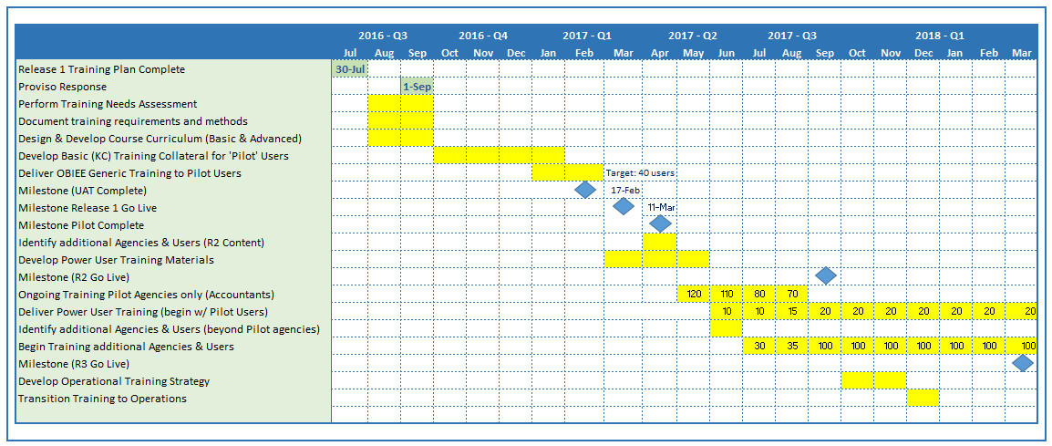

**Follow-up questions Jan 13, 2017**

1. **Is the BI product a web solution? In other words, is the product loaded onto end users machines or do they simply access a website?**

**Response:** Yes, Oracle BI runs in a browser. No software installations required.

1. **Please provide a copy of the Basic Training Collateral for “Pilot Users” referenced in the table above.**

**Response:**  These are online videos (see sample Lesson 1, attached)

1. **I am confused by the row title in the 10th row of the above table “Identify additional Agencies and Users (R2)”. Why that happening before R2 is go live? I am thinking that Row 10 should be referencing R1?**

**Response:** This is only to identify the users who will receive training next.

1. **I am trying to understand the timing of the training for R1 for the pilot users. Sounds like once R1 is deployed to pilot users or they have access to it, the training videos will be concurrently available to pilot users by Jan 23? Please correct or clarify if this is not accurate. Will the Pilot users be getting video training only for R1?**

**Response:** No, as we release new dashboards, we will continue to develop new video content. Each dashboard will have its own (brief) video walkthrough explaining its purpose and how to use it.

1. **Is there an automatic feedback survey that will pop-up after the training for pilot users? And for subsequent users?**

**Response:** No, the survey is not embedded in the training video (although there are knowledge check questions there). A survey (using Survey Monkey) will be sent to every user who receives a Certificate of Completion.

1. **Do you anticipate modifying the training after the pilot users complete it?**

**Response:** Hopefully, not, but the purpose of the Pilot is to gather feedback regarding the application and training materials. We will modify training materials, if needed, based on their feedback.

1. **Given the central and unique role of PSB in budget analysis and fund management, why isn’t PSB part of the pilot group on page 7?**

**Response:** PSB is involved in the Pilot. Two late additions were BRC and PSB. Kate Davis and Aaron Rubardt are on the list of users to be trained. See attached list of Pilot Users.

1. The timeline on page 6 shows a needs assessment being completed in 3Q 2016. Please provide a copy and describe how the needs assessment was completed.

Response:

*See attached documents: ‘BI Insights TNA’ and ‘TNA Questionnaire’*

**Follow-up Question Jan 13, 2017**

1. **I read the brief attached document. I had assumed a needs assessment would survey users to find out their training needs. Why were the interviews limited to BRC?**

“A Training Needs Assessment (TNA) was administered by our contractor, AST Corporation. **Utilizing a detailed questionnaire, and interviews with the Business Resource Center (BRC), we were able to identify the essential training needs of the user community.** During these initial interviews with the BRC it was determined that the user community, already had the baseline computer and analytical skills necessary to learn the new BI applications.

1. **Please explain this statement from the TNA…I thought training would be Skill soft training videos**

* BI consumers, located outside the downtown area, will receive ‘Live’ Instructor-led Webinar training.

**Response:** A typical training needs assessment is designed to identify the technical capabilities, hardware needs and skills of the users to be trained. Because we are targeting existing Discoverer users who have advanced Excel, and computer skills, we did not feel that a traditional TNA would provide any new information. The interviews with trainers within the BRC provided all the information we needed. The last sentence should have been removed. It was left over from an earlier version, prior to the decision to use training videos.

1. Same question as above for “document training requirements and methods” and “Design and Develop Course Curriculum”

Response:

*See attached – these are summarized in the BI Insights TNA document*

1. Is the “pilot” group made of power users AND BI consumers?

Response:

*No, the “pilot” group will take BI Consumer Training only. Power User Training will be provided to a subset of BI users once they have had time to master BI Consumer activities. The BI Point of Contact for each Agency will determine who they would like to take Power User Training. Currently the goal is to have a Power User Training Curriculum available in May, 2017. See Revised Plan graph in response to question 1 above.*

1. As I understand the training plan, different capabilities are released in Release 1, 2, and 3 (see page 13). **Will all agencies be part of Release 1, 2, and 3, or just those listed on page 7? If not, how and when will they be trained?**

Response:

*Only the agencies listed on page 7 are involved in Release 1 (see revised plan). We plan to begin training Power Users (from the Pilot group) and, start offering BI Consumer training to the remaining agencies in June 2017.*

**Follow-up Question Jan 13,, 2017**

1. **Same question as above, will all agencies listed on Page 7 be part of roll-out for R 2 and R3?**

**Response to Follow-up:**

**All of the “Pilot” agencies will provide named users who will be the first to be trained and provide UAT testing on new R1, R2 and R3 content before the materials are opened up to the wider King County Agency population. This approach will be used during the scope of the approved project duration. Once Pilot feedback has been provided and contents have been updated, all additional King County users will be granted access to the content. In other words, all content developed for the scope of the BI Insights project will be available to all Agencies based on their EBS, PeopleSoft and Hyperion Roles & Responsibilities.**

1. I can’t tell from the chart on page 6 when training will be delivered for R1, R2, and R3 for non-pilot agencies. (I am assuming the milestone date is when the technology goes live)

Response:

*The milestone dates refer to the release of new content (data) in the data warehouse. Per revised plan (above), we expect to begin training the non-pilot agencies in June 2017.*

**Follow-up Question Jan 13,, 2017**

1. **My assumption is that in addition to more data with R 2 and R3, there are more dashboards, thus I am assuming there is a need for more training on how to use the additional data/dashboards. Please correct these assumptions as needed.**

Response: You are correct. For each new dashboard there will be training materials developed.

1. **Page 7 of the original report says “In each subsequent release, we will be guided by the BI Project Rollout Strategy to determine agencies and users to be trained. What does that mean? I am not familiar with the BI Project Rollout Strategy.**

Response: The Project Rollout Strategy has been updated and is attached. The plan is to target Accountants and Financial Analysts in the 9 Pilot agencies, first, then begin offering training to all agencies.

1. **Please explain the graphic in the middle of page 7. Is this a power user training schedule?**

**Response:** The Proposed Training Deployment Plan graphic shows conceptually how we will develop the training of all new content. The content is planned to be primarily video training for Consumers and primarily instructor led training for Power Users.

1. **The table above is not clear to me with regards to the roll-out timing for R2 and R3. I see the R 2 and R3 go-live dates (May 2017 and Sept 2017). Will those implementation dates only be for the agencies on page 7?**

**Response:** During the BI Insights Project we will first utilize named Pilot Users from now the 9 agencies (PSB and BRC – new agency additions) to first test the training materials and perform User Acceptance Testing on the new content before releasing the content and training materials to the rest of all county agencies.

1. **What training will users receive for R2 and R3? Is the training for R2 or R3 already developed? If so, please provide the names of training videos. Feel free to reference Question #7 below as relevant.**

**Response:** No, there has not been any training materials developed. The R2 and R3 Dashboard development is a prerequisite for training materials.

1. Please explain pages 11 and 12. Are you assuming BI Consumers will take all sessions on page 11? How long will each session be and how will the training be delivered? Live, video, web cast, etc.?

Response:

*BI Consumer training will be delivered via Skillsoft (video); Power User training will be live, or webcast. Optional training workshops will be offered throughout the implementation (so users can receive training support, if needed). There has been a change to what is outlined on Page 11. Here is the revised curriculum:*

**Follow-up Question Jan 13, 2017**

1. **Will any of these be REQUIRED or just offered?**

**Response: BI Consumer Training videos are required to be granted access to BI.**

1. **How long is each one?**

**Response: The Consumer Training videos required for BI access take approximately 1 hour to complete.**

1. **Why does the last sentence say…this course is broken? fixed**

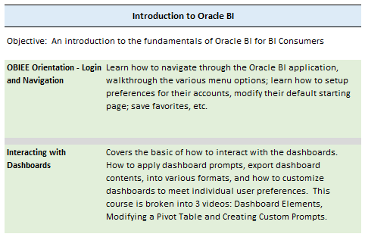

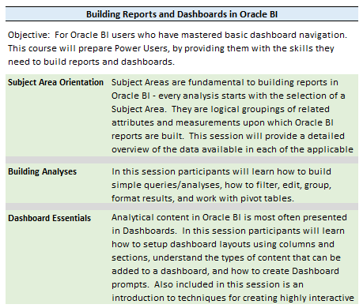

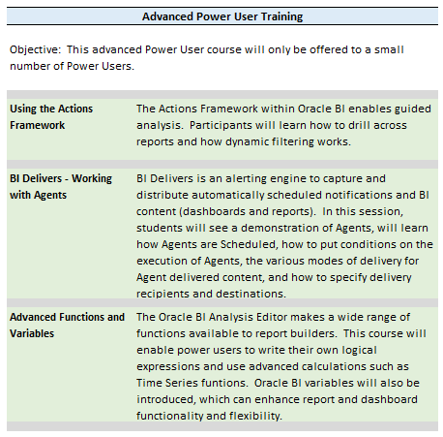

1. How much training (in hours) will BI Consumers and BI power users need/required to take?

Response:

*BI Consumer training consists of a 1 hour ‘Introduction to Oracle BI’ video. This covers basic navigation within the Oracle BI application. There will be subsequent optional training videos developed that will provide users with an overview of each specific dashboard. We expect power user training to be a 2 or 3 day Instructor-led class (14-18 hours).*

**Follow-up Question Jan 13, 2017**

1. **Same follow-up question as #9. Who developed the videos and how are they customized for King County.**

**Response:** The BI Project Team developed the videos. Each video uses King County developed dashboards as the examples in the videos. See attached sample video.

1. **What are the training requirements for R2 and R3?**

**Response:** All new users will have to take Introduction to Oracle BI on-line video trainings. Training materials for R2 and R3 will be developed based on the prioritized dashboard content determined at the start of each release by the BI Evaluation Team and the Data Governance Teams.

Instructor led training will be required for Power Users. Currently, Power User Training will be delivered early/mid Release 2 timeframe (targeting early Q3 2017).

1. How much of the training is from Oracle? I am asking because I am hoping we didn’t to have to recreate what already exists.

Response:

*We received training materials from our contractor, AST Corporation, but these materials will need to be customized for King County. Each BI implementation is unique so we must develop our own training materials.*

**Follow-up question 1-13-17**

**I am not understanding who developed the training materials. Earlier you referenced SkillSoft training videos. I assume those are an off the shelf product, so I am not sure how they were modified. Please provide more information on the development of the training materials and describe the extent they are customized to meet KC needs.**

**Response:** The Skillsoft product is a platform for hosting the training videos. The videos are developed using the Camtasia product which is used in the creation of the videos. (Allows you to record voice and screen capture).

The BI Project Team will be utilizing some previously developed Power User training materials for our Power User course development. All of the Consumer training materials were 100% customized using King County developed dashboards.

1. What’s going on with the BICC? Please provide an update on its status and activities.

Response:

*The BI Competency Center (BICC) is a set of organizational constructs that ssupport the BI Program with People, Processes & Quality Data to ensure BI Program benefits are realized. It seeks to remove the organizational separation of business and IT for those engaged in BI work. It is comprised of:*

* *Executive and Program level management with representatives from business and IT*
* *Has a technical component for development of an integrated, certified data warehouse and BI presentations*
* *Has strong Data Governance, Training, Change Management, Communications and Support functions*

*BI Insights project has a BI Insights Executive Steering Committee, and a BI Insights Evaluation Team. These executive and program level management groups meet regularly and are comprised of business and IT representatives;*

*The BRC BI Insight team is in the process of implementing Oracle’s BI applications for the creation of a certified financial and HR analytics data warehouse and developing King County dashboards with the assistance of subject matter experts (SME’s) from the initial 7 agencies.*

*A formal Data Governance program is in progress. The Data Governance Release 1 participants have been meeting bi-monthly since July and includes BRC IT representatives and business representatives from the initial 7 agencies.*

*A formal Training program is in progress and described in this Proviso.*

*BI Insights communications have been initiated via a monthly Newsletter and a devoted BI Insights section on the new BRC SharePoint website. Post Release 1 production, this site will be updated with additional information. In addition, BI Insights presentations are conducted at County-wide Finance Manager Meetings and Discoverer User group (RUG) meetings.*

*Specific Business Process Improvement (BPI) Change Management sessions will be scheduled and conducted post Release 1 production with the initial 9 agencies to help the agencies explore Discoverer replacement alternatives using BI Insights dashboards and information.*

*BRC BI Insights specific support processes are being developed to provide fast and flexible assistance to BI Insights users post Release 1 production.*

1. Are you planning on including Council analysts in the BI consumer training? If so, when?

Response:

*Yes. Council Analysts will be included in the same way as any other agency user. The Council agency will have a training point of contact who will identify the analysts eligible for training. Only the agencies listed on page 7 are involved in Release 1 (see revised plan). We should begin offering Basic training to the remaining agencies by June 2017).*

1. How will agencies and their staff learn about the trainings?

Response:

*Agency Directors are appointing a training coordinators (point of contact) who will identify and prioritize the list of trainees for their respective agency.*

1. To what extent will there be training on how to do analysis of data, ask new questions, and dig deeper, etc. in effort to capture the “business intelligence” capacity of the system? In other words, during our previous discussions the benefits of this project I heard, “we don’t know what we don’t know because we haven’t had access to this data”--what type of training will be offered to help staff to learn to use this information for new levels of analysis?

Response:

*Knowledge transfer, enhancement of analytic skills, coaching and training are central to the mandate of the BICC. As we interact with users, especially Power Users, our goal will be to guide and promote more analysis at King County. Whereas, the current process is to extract large amounts of data, load it into a spreadsheet, then, analyze i.e. ‘Query, then Analyze’. In BI the goal is to ‘Analyze, then Query’, the data is already summarized, so you begin with the analysis; looking for outliers, or exceptions. The system is designed to quickly allow users to drill down to the detailed transactions that will explain exceptions. This paradigm shift in approach will be communicated throughout the organization.*

**Follow-up 1-13-17**

*As we interact with users, especially Power Users, our goal will be to guide and promote more analysis at King County.*

**I need to better understand how this will be done.**

**Response:** Today users are looking at all of the data available in EBS, Peoplesoft and Hyperion. The goal is to have users review information for exception and outliers. As Users evaluate the exceptions, they will either get their question answered or ask additional questions based on the information displayed in the result of the dashboard.

Training materials and workshops will be offered to help users shift from evaluating all data to reviewing exceptions and then asking the next question of “Why” the exception occurs. The focus needs to shift asking the right questions associated with the exception data vs all data to provide a recommendation for a business decision.

**KC Black 2**

**BI Analytic Project**

BICC Rollout Strategy

Author: Pat Deasy

Creation Date: June 20, 2016

Last Updated: Jan 16, 2017

| Role (A= Approver; R = Reviewer) | Name | Signature |
| --- | --- | --- |
| R | Rita Popp |  |
| R |  |  |
| R |  |  |
| A | Carmel Call |  |

**Document Control**

**Change Record:**

| Date | Author | Version | Change Reference |
| --- | --- | --- | --- |
| June 20, 2016 | Pat Deasy | 1.0 | Original Document |
| Jan 16, 2017 | Pat Deasy | 1.1 | Added rollout timeline |

Contents

Overview 4

BI Insights Project Rollout Strategy 5

Options for BI Insights Program Rollout: 6

Selected Option for Release 1 Rollout 8

Latest Project Timeline Summary: 9

User On-Boarding – Suggested Process 10

## Overview

For King County to realize the long-term benefits of the BI Insights Program, its usage needs to become pervasive and persistent within all business units. To ensure successful adoption of the BI Program, the introduction of BI training and usage into the organization should follow best practices and “start small” and gradually add business units and users.

## BI Insights Project Rollout Strategy

The BI Insights project identified and collected financial and HR information requirements from the KC central services groups: FBOD, PSB and HRD and from 22 autonomous agencies. The majority of the information requirements are standard across all organizational entities but there are differences and departmental specific information requirements across the 22 agencies. The estimated number of potential County-wide BI business users is 1200.

One of the major objectives of the BI Insights Program is self-service BI. Industry definition:

* Self-service business intelligence consists of the facilities within the BI environment that enable BI users to become more self-reliant and less dependent on the IT organization
* Self-service BI does not equal BI self-sufficiency

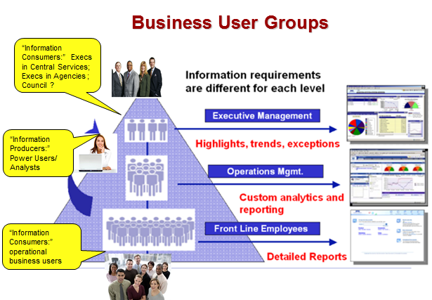

In general, a “Big Bang” rollout approach is seldom successful. Best practices suggest an incremental approach especially if the BI program is new to the organization.

## Options for BI Insights Program Rollout:

The following rollout options were considered:

**Option I. Organizationally Focused**

* Target initial rollout to Central Services financial groups FBOD and PSB.
* Rollout to participants (information consumers/analysts/potential power users) for these organizational entities.
* Focus Data Governance on data required to support reports/dashboards for FBOD and PSB
* Focus training to participants in those entities

|  |  |
| --- | --- |
| Pros | Cons |
| Controlled Introduction: BI is introduced to a limited number of each user segment. Data Governance is targeted to central financial content with limited participants; Change Management begins with central financial group – maybe Discoverer replacement process options | Delays usage by larger KC consumer user base and delays wider Power User program. |
| Training is tested on limited number of users |  |
| Mitigates technical start-up risk. Managed service environment validation and testing; data problems |  |

**Option II. Organizational / User Segment Focused**

1. **Information Consumer Focused** - The Information Consumer group could be a focus.
2. Business users who consume BI to support day-to-day operations
3. Gather information to increase knowledge and make decisions, but don’t have time, experience or inclination to create needed inputs
4. At King County these are the executives and the operational business users
5. Largest audience for BI
6. Usually underserved in most BI environments

**Organizational / Information Consumer Focused Rollout**

* Release 1 financial dashboards and reports delivered to selected information consumers in selected departments
* OBIEE training targeted to selected users
* Provide pre-built reports and guided drill through dashboards with comprehensive financial information and selection filters.
* Change Management targeted to day-to- day information usage. Discover report information replacement.

|  |  |
| --- | --- |
| Pros | Cons |
| Visible : high benefit in the near term to Information Consumers across King County | May delay power user program training |
| Fast: realizes Discoverer information replacement and the promise of possible incremental process improvements sooner |  |

## Selected Option for Rollout

Options were presented and discussed with BI program management and Evaluation and Core Team. A variation of Option II was selected as the Release 1 Rollout Strategy - *Deliver Release 1 to a limited set of users from a limited set of organizational units.* (Note: Training plan is synchronized with this option)

Target Release 1 rollout to:

* Central Services financial group FBOD
* A limited number of agencies: DOT, DNRP, DPH, DPD, KSO, KCIT, PSB & BRC.
* A limited number of “Pilot” participants from each agency
* Focus Data Governance membership from these organizational entities
* Focus initial training to selected participants from these organizational entities

|  |  |
| --- | --- |
| Pros | Cons |
| Controlled Introduction. Adheres to best practices to start small with a representative group and scale with successive content and participants. Takes advantage of “lessons learned” for future release planning (Release 2 & Release 3) | Delays usage by remaining agencies until late into Release 1 |
| Training is tested on limited number of users which allows for refinement and enhancements for subsequent releases. Introduces the “train the trainer” concept and power user concept. | Larger community business user training scaled during Releases |
| Mitigates technical start-up risk of the late introduction of the technical production environment and the required validation and testing. |  |

* Rollout and the associated training plan were approved by the Evaluation Team and then presented and approved by the Steering Committee.
* Release 1 Data Governance members and department SME’s (Subject Matter Experts) who assist in dashboard development were selected from these departments.
* Training contacts were identified for each department and these contacts identified the “Pilot” users from their departments for training; UAT participation and a 4 week production Pilot usage period.
* Accountants and Financial Analysts from ALL remaining agencies will be trained following the “Pilot” period at the rate of 120/month based on the priority of each agencies Training Point of Contact representative.

## Latest Project Timeline Summary:

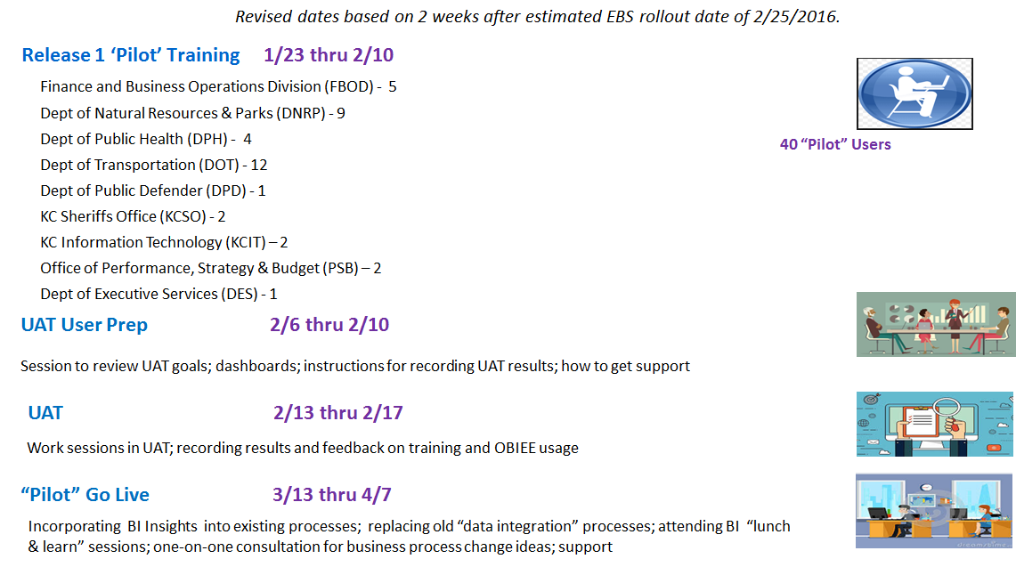

## User On-Boarding – Suggested Process

