# **Proposed 2022 Sewer Rate and Capacity Charge**

# **and 2022-2031 Sewer Rate Plan**

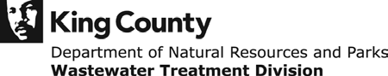

### Table of Contents

King County Wastewater Treatment Division 1

Local Sewer Agencies (LSAs) 3

System-Wide Planning 5

Sewer Rate Plan Development and Stakeholder Engagement 5

Six and Ten-Year Sewer Rate Plan Forecast 6

2020 Wastewater Treatment Division Financial Performance 8

Revenue 8

Expenditures 9

Debt 9

Cash Funding and Defeasance 9

Net Cash Flow 9

Proposed 2022 Sewer Rate and 2022-2031 Rate Plan Forecast 10

Primary Rate Drivers 10

Revenue Forecast 11

Sewer Rate 12

Capacity Charge 15

Other Revenue 20

Operating Expenditures 21

Savings 2020 21

Adopted 2021-2022 Budget 21

Operating Forecast 21

Incremental Forecasted Expenditures 22

Green Where We Work 22

Capital Improvement Plan 22

Portfolio Management 22

2020 Performance and Accomplishment Rate 23

2021-2022 Capital Budget 23

Proposed Capital Improvement Program (CIP) 24

Emerging Priorities and Key Issues 26

West Point Treatment Plant Power Quality and Reliability 26

Capital Funding Plan 28

Cash Funding 28

Debt Financing 28

2021 Planned Financing Activity and Strategies 30

Revenue Requirement 31

Cash Test 31

Debt Service Coverage Test 32

COVID-19 Net Impact Forecast Summary 33

Reserves Management 34

Water Quality Operating Fund 4611 35

Water Quality Construction Fund 3611 36

Debt Reserves 8921 and 8922 36

Reference 36

History of 40 percent Cash-Funding Approach: 36

Supplemental WTD Debt Information 37

## King County Wastewater Treatment Division

Distributed over a 424-square-mile service area, the King County (County) sewer system collects and treats an average of 175 million gallons a day of sewage from approximately two million residents. The Wastewater Treatment Division (WTD) of the King County Department of Natural Resources and Parks (DNRP) is the provider of wholesale wastewater treatment in the region. King County’s WTD is responsible for the construction, operation, and maintenance of the regional wastewater conveyance and treatment system, which includes three major secondary treatment plants (West Point in Seattle, South Plant in Renton, and Brightwater in south Snohomish County), 397 miles of conveyance lines, 48 pump stations, and 25 regulator stations. Other WTD facilities include four combined sewer overflow (CSO) treatment plants, four CSO storage facilities, 39 CSO outfall locations, and secondary treatment plants on Vashon Island and in Carnation. [1]



### Local Sewer Agencies (LSAs)

The Local Sewer Agencies (LSAs) served by the County include 17 cities and 16 sewer districts in King County, south Snohomish County, and northern Pierce County, and the Muckleshoot Tribe. The sewage disposal contracts with the LSAs specify that the following year’s sewer rate must be determined before July 1of the current year. This provides time for the LSAs to include the WTD rate in preparing budgets and proposing local sewer collection rates for the following year.

WTD contracts directly with the LSAs; outside of the capacity charge program, WTD does not have a direct relationship with the individual ratepayers. Engagement with the LSAs is accomplished through the Metropolitan Water Pollution Abatement Advisory Committee (MWPAAC) and the County Council’s Regional Water Quality Committee (RWQC).

The LSA contracts define the two customer classes for billing the agencies – single family residential and Residential Customer Equivalents (RCEs). RCEs include all other customers, such as commercial, multi-family, and industrial. An RCE is determined by converting reported flows based on an equivalency that defines one RCE as 750 cubic feet per month. An industrial waste high strength surcharge is added to qualifying high strength flows. [2]

A list of the LSAs and their year-end 2020 reported RCEs is provided in Table 1.

**Table 1. 2020 Reported Customers by Local Sewer Agency**



### System-Wide Planning

Work is underway to update to WTD’s systemwide comprehensive plan that was last updated in 2006. [The Clean Water Plan](https://www.kingcounty.gov/depts/dnrp/wtd/capital-projects/system-planning/clean-water-plan.aspx) will guide King County’s clean water investments for the next 40 years.[3] The Clean Water Plan and implementing legislation is anticipated for delivery to the County Council in late 2021 or early 2022. It will provide guidance on the significant investments necessary to address the next era of complex challenges, including aging infrastructure, current and emerging regulatory directives, regional growth, ratepayer affordability, resilience to natural disasters, and climate change. WTD will prepare the sewer rate forecast and related affordability impacts for a variety of Clean Water Plan strategies so that stakeholders can evaluate alternatives through a financial and affordability lens. The preferred Clean Water Plan strategy will form the basis for the 2023 sewer rate proposal.

#### Financial Capability Assessment and Household Affordability

Considering the magnitude of anticipated investments being assessed in the Clean Water Plan, WTD engaged Raftelis Financial Consultants to perform a sewer rate affordability study. The study has already produced an affordability assessment tool that applies the most current industry approaches to differentiate between Clean Water Plan alternatives under consideration. This tool will also be used to support ongoing negotiations of the [CSO Consent Decree](https://www.kingcounty.gov/~/media/services/environment/wastewater/cso/docs/130703_KingCountyCSOConsentDecree.ashx?la=en) with the U.S. Environmental Protection Agency (EPA) and the Washington Department of Ecology (Ecology).

### Sewer Rate Plan Development and Stakeholder Engagement

#### Background on the 2021 Sewer Rate and 2021-2030 Strategy (adopted in 2020)

The 2021-2030 King County sewer rate plan (“the adopted rate plan”) developed in early 2020, is shown in Table 2below. The rate plan reflects a one-year, 4.5 percent rate increase for 2021 and a placeholder no rate increase in 2022. The initial early March 2020 WTD rate proposal presented to the King County Executive was a 9.5 percent sewer rate increase for 2021, with a smoothed rate plan of biennial rate increases to enable the County to begin addressing a backlog of critical asset management projects. The 2021 proposal was the first that incorporated a strategy to complete catchup on a backlog of unfunded critical asset management projects that had been catalogued over the previous year.

COVID-19 became an emerging issue during the development of the initial proposed 9.5 percent rate increase for 2021. The combination of the pandemic in March 2020 and stakeholder response to the asset management funding impact led the Executive to propose a reduced rate increase of 4.5 percent. [4] The proposed 2021 4.5 percent rate increase stipulated that asset management needs remain and a rate increase would need to be considered in 2022, pending COVID-19 impacts and feedback from stakeholder engagement sessions on the asset management catch-up strategy. This stipulation was communicated to stakeholders and included in the rate proposal submitted to the Council.

MWPAAC and the RWQC received a series of briefings in 2020 and early 2021 on the asset management backlog. In addition, MWPAAC’s Rates and Finance Subcommittee received briefings from WTD Finance staff on rate development in advance of the 2022 proposal.

**Table 2. Adopted 2021-2030 Rate Plan**

### Six and Ten-Year Sewer Rate Plan Forecast

Utility enterprise funds, such as the County’s Water Quality Operating Fund, are self-supporting and therefore must set user fees to recover costs of providing service. [5] The total cost that must be generated by utility revenue sources in any given year is referred to as a utility’s revenue requirement[6]. The requirement that the fund is self-supporting necessitates that the sewer rate is set so that total utility revenue is sufficient to support total utility costs, including operating expenditures, debt repayment, and financial policies, such as cash funding of the capital program and debt service coverage.

WTD’s annual sewer rate-setting process includes the development of a six-year financial plan (currently 2022-2027) and a 10-year forecast (currently through 2031). The proposed 2022 sewer rate is prepared in the context of the revenue needs of the utility over the forecast period, which includes long-term staffing, operations and maintenance, asset management, and further projected costs of running the system. WTD looks beyond just near-term funding needs because of the long useful life of many of the utility’s assets. The sewer rate is adopted annually, but the funding needs and revenues generated are viewed as part of a 10-year financial plan. Table 3 provides an example of a single-year revenue requirement (2021) and the incremental rate increase needed for revenue sufficiency in that year which is shown in red as a “Deficiency”.

**Table 3. Revenue Requirement – 2021 Balanced Revenue and Expenditures with Rate Increase**



## 2020 Wastewater Treatment Division Financial Performance[7]

**Table 4. Wastewater Treatment 2020 Forecast vs. Preliminary 2020 Actuals**



### Revenue

Approximately 55 percent of sewer rate revenues in 2020 were from single-family residential customers whose fees are not based on consumption. Consumption-based RCEs reported reduced flows beginning with second quarter (Q2) billings in 2020, though due to the lags in the billing cycle and the rolling average basis for consumption-based RCE billing, there was minimal impact. Table 4 shows that total RCEs were 0.3 percent lower than projected and related sewer rate revenues were 0.2 percent lower.

Capacity charge revenues are $0.8 million lower than previously forecast, due to a reduction in elective early payoff activity.

Investment income was lower by $1.7 million due to lower interest rates from the King County Investment Pool (1.25 percent, compared with 2.25 percent in 2019), but offset by the higher average cash balances associated with proceeds from the 2019 and 2020 bond sales.

COVID-19 had minimal impact on 2020 sewer rate revenue performance compared to the forecast in the adopted rate plan.

### Expenditures

Operating expenditure savings of $7 million below budget are largely due to the reduced demand for some chemicals, lower use of maintenance parts and materials, and lower than projected cost of diesel fuel and electricity. Restrictions due to COVID-19 mandated business closures led to delays in associated expenditures.

### Debt

Debt service is $10 million lower than projected due to the sale of low-interest revenue bonds and actual variable interest expense being lower than projected. Details include:

The County issued $366 million of long-term (30 year) sewer revenue bonds.[8] The 2020 Series A Tax-Exempt Bonds ($179.5 million) have a true interest cost of 2.64 percent and will provide $181.6 million for WTD’s capital program in 2020 and 2021. The Series A Bonds also refunded $24 million of 2010 revenue bonds and will provide $15.3 million of debt service savings through 2033. The 2020 Series B Taxable Bonds ($186.7 million) have a true interest cost of 1.93 percent. This issue advance refunded $167 million of previously issued sewer revenue bonds and will reduce debt service payments by $43.7 million through 2039.

The County also issued two series of short-term sewer revenue bonds[9] for $100.3 million each, at interest rates of 0.625 percent and 0.875 percent, that must be redeemed on January 1, 2024 and January 1, 2026. These issues refunded 2001 and 2011 variable rate bonds. This transaction is part of the regular renewal of WTD’s variable rate debt portfolio and diversification of its short-term debt maturities.

WTD used $76.1 million of cash to defease outstanding sewer revenue bonds, which will reduce principal and interest payments by $188 million through 2051.[10]/[11] WTD contributed $12.2 million of cash to redeem high-interest debt maturing in 2022 and 2023. The early redemption of these bonds is expected to save WTD $0.5 million.

State Loan funding decreased by $14.7 million over what was projected last year, reflecting delayed draws on those loans.

### Cash Funding and Defeasance

Operating revenue dedicated to capital program funding can alternatively be used to remove outstanding high interest rate debt from the books through defeasance[12]. A 2020 $95 million defeasance was planned for based on outstanding loans with interest rates high enough to expect savings if they were replaced in 2020 with lower interest rate bonds. A slightly lower $88.3 million defeasance was executed to maintain adequate reserves in the fund as WTD was estimating potential COVID-19 impacts and related reliance on reserves in 2021.

### Net Cash Flow

The $37 million net cash flow reflects both cost savings in 2020 and the conservative cash strategies related to planning for unknown pandemic impacts.

## Proposed 2022 Sewer Rate and 2022-2031 Rate Plan Forecast

The proposed 2022 sewer rate, maintaining the 2021 $47.37, and 2022-2031 rate plan (proposed rate plan), are shown in Table 5, followed by a description of the five primary rate drivers and sections detailing the assumptions for each of the revenue requirement components.

The proposed rate plan is prepared with the goal of smoothing the rate increases to mitigate the impact of potential large increases. MWPAAC supports an annual rate increase rather than a biennial rate increase as a stable rate path that will assist agencies in avoiding rate spikes that are difficult for rate payers and utilities to manage. Table 5 shows a 4 percent 2022 proposed rate increase and forecasted annual increases that rise gradually to 7.5 percent in the final year to meet a steep increase in capital costs. The approach to a smoothed rate plan allows over - and under - revenue balancing in any given year, although revenue must be sufficient to balance expenditures in the final year.

The table includes outputs such as debt service coverage, an important measure considered by bond rating agencies; the projected Capital Improvement Plan (CIP) spend; and the estimated range of jobs supported by the total WTD capital investments in each year (based on the [Washington State Input Output](https://ofm.wa.gov/washington-data-research/economy-and-labor-force/washington-input-output-model) economic multipliers).

**Table 5. Proposed** Rate Plan



### Primary Rate Drivers

#### COVID-19 impacts are delayed due to WTD billing structure and offset by record-low interest rates in the bond market.

While a six percent ($21.7 million) reduction in sewer rate revenue is estimated for 2021, the reduction will be offset by savings realized through the 2020 bond issuance and refinancing of outstanding debt at record-low interest rates.

#### West Point Treatment Plant power quality and reliability investments begin in 2021.

The King County Executive issued a [Declaration of Emergency](https://www.kingcounty.gov/elected/executive/constantine/news/release/2021/February/25-west-point-declaration.aspx) on February 25, 2021, requiring that immediate steps be taken to improve power reliability at the West Point Treatment Plant (WPTP). Under the Executive’s Declaration of Emergency, the WTD will begin work to modify the cogeneration system at WPTP to allow critical equipment to withstand voltage sags or power disruptions. In addition, WTD is evaluating alternatives that include installing a battery energy storage system to address near-term power reliability at WPTP. In coordination with Seattle City Light, WTD will also analyze and develop a schedule and cost estimate for a new, dedicated transmission line or power feed to serve the WPTP.

#### Consent Decree CSO cost updates available to include in the forecast; schedule considerations evaluated.

At the time of the 2021 sewer rate proposal, updated CSO costs were in progress but not yet complete, so the 10-year rate plan (2021-2030) reflected cost estimates last prepared in 2017. In a 2019 letter to the EPA and Washington State Department of Ecology (Ecology), WTD asked to reopen negotiations on the CSO Consent Decree that requires completion of the County’s CSO projects by December 31, 2030. Those discussions are currently underway. The proposed 2022 sewer rate includes updated CSO costs and the 10-year rate plan currently extends CSO costs out to 2040 pending a change to the CSO Consent Decree.

#### Critical asset management catch-up plan initiated in 2022 and completion timeline extended three years (2033).

The work outlined in the 10-year sewer rate plan accompanying the 2022 sewer rate proposal begins the process of catching up on WTD’s critical asset-management backlog, with completion of all but three projects by 2030 and all by 2033. WTD plans to phase in an Asset Management Strike Team[13] to work on these projects starting in mid-2021.

#### The 2021 sewer rate proposal did not include system improvements related to nutrient removal. The preliminary draft permit was released for comment in January 2021. Conditions in the draft permit are not well defined and are subject to feedback and revision. Estimating cost impacts subject to substantial changes based on future decisions by the regulators, and therefore the 2022 sewer rate proposal does not include costs related to the draft permit.

#### Additional Key Assumptions:

* The forecast in the adopted rate plan included a proposed project to replace the Jameson ArcWeld Building. It was subsequently excluded from the 2021-2022 budget, as new alternatives were in development, and a lower cost building lease option is in negotiation.
* The County recently committed to resume work on Phase 1 of the Sammamish Plateau Diversion Project in 2021 and 2022.
* Project delivery staff resources are currently shifting to meet very near-term accelerated priorities (West Point Power Reliability and Phase 1 of the Sammamish Plateau Diversion Project). Lower priority projects that will potentially experience delays will be identified as project assignments shift to meet near-term prioritization changes. This limited capacity for additional projects with existing staff is forecasted to extend into at least 2023

It is noteworthy that the proposed rate plan forecast includes a doubling of the capital program by 2027andwill in turn require additional staff resources to deliver. The Planning and Project Delivery Section of WTD is conducting a series of strategic workforce and resource management workshops starting in early 2021 to develop staffing plans with recommendations for performing work already identified in the adopted rate plan.

## Revenue Forecast

The sewer rate and capacity charge together make up 95 percent of total operating revenues. Table 6 shows WTD’s revenue components by size.

**Table 6. Operating Revenue Components Sorted by Size**

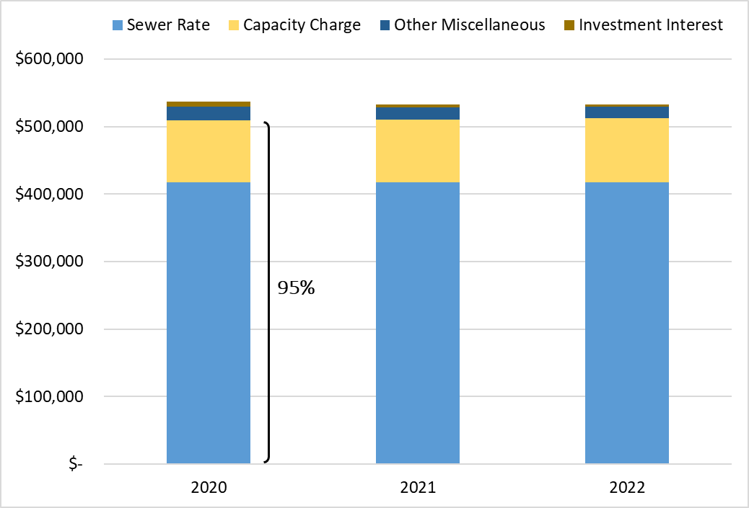

### Sewer Rate

Sewer rate revenue is the largest component of WTD operating revenues, representing 78 percent of total operating revenue. Single Family Residential (SFR) customers make up 55 percent of the sewer rate customer base and are billed one unit per household regardless of water use. The remaining 45 percent of RCEs are comprised of Commercial and Multi-Family customers in a combined rate class. An RCE is a unit used for billing purposes that converts reported water use (as a proxy for sewage flows) to the approximate equivalent of one SFR. As defined in the LSA contracts and County code, one RCE is equal to 750 cubic feet of water usage.

#### Billing Structure

In contrast to the retail agencies that read meters and bill customers either monthly or bimonthly, RCE reporting and billing are on a quarterly cycle.

As shown in Table 7, billings for the SFR class in a given quarter are based on RCEs reported in the quarter before the previous one (e.g., Q2 billing is based on Q4 reported).

The Commercial and Multi-Family billing structure includes additional delay. Billings are based on a four-quarter rolling average of RCEs with the intent to minimize variability of billings to the agencies.

**Table 7. RCE Reporting to Sewer Rate Billing Lag**



RCEs based on customer accounts and usage during Q4 2020 will be reported to WTD by the LSAs in Q1 2021 and billed in Q2 2021. This structure results in COVID-19 impacts to sewer rate revenue from Q2 reductions in commercial water use, impacting the rate as only one of four quarters in Q4 2020. The 2020 reduction in reported water use due to COVID-19, first reported with Q2 use, is expected to have the greatest impact in 2021. Table 8 shows the makeup of each quarter for the flow-based RCE billing based on water use.

**Table 8. Billing Basis for Each Quarter**



Due to COVID-19, commercial activity has significantly decreased in the King County service area. As people stayed home and water demand increased per household, there was no expected reduction to residential classes who pay this fixed charge per household.

In fall 2020, COVID-19 revenue impact estimates assumed Commercial/Multifamily consumption reductions would recover to 2019 levels (pre-COVID-19) by the end of 2021. Due to the extended impact of COVID-19, limitations of vaccine supply and distribution and the lingering economic impact of mandated restrictions, the projected recovery of reported flow-based RCEs to pre-COVID-19 levels has been extended to the end of 2022.

Table 9 shows the percent decline in flow-based RCEs compared with 2019 levels. The zero percent reduction indicates a return to 2019 levels; a positive number is a return to growth after recovery. Reduced commercial sewer rate revenue is estimated to total $46 million through the biennium (from a biennial sewer revenue baseline of $880 million) and the delayed impact of the 2022 reduction results in an estimated $16 million of additional revenue loss in 2023 (from an annual sewer revenue baseline of $490 million).

**Table 9.** Commercial and Multi-Family RCE Percent Change from 2019**[14]**



While the forecast returns to the long-term growth assumption of 0.52 percent annual RCE growth in 2024, future years are impacted by the loss of customer-base growth between 2019 and 2023 as 2019 levels are reset.

#### Historical Sewer Rate Increases

To provide context for the historical rate of growth to the revenue needs of the utility, rate increases going back to 1990 are provided in Table 10. The average biennial rate increase is 9.1 percent going back to 1990.

**Table 10.** Historical Sewer Rate Increases (1990-2020)



### Capacity Charge

Since 1990, King County has levied a [capacity charge](https://kingcounty.gov/services/environment/wastewater/capacity-charge.aspx) on structures with new connections to the sanitary sewer system. This charge is paid in addition to the monthly sewer bill assessed by the local sewer collection agency. Newly connecting customers are directly billed by King County for the capacity charge. The capacity charge is set annually by the King County Council and is currently $68.34 per month for 2021.

In 1992, voters approved an amendment to the County's charter that authorized the merger of King County with the Municipality of Metropolitan Seattle (Metro), with the phased merger effective in 1994.[15] As successor to Metro, the County assumed Metro’s rights and obligations, including authority to impose the capacity charge.[16]

The Revised Code of Washington (RCW) [35.58.570](https://app.leg.wa.gov/RCW/default.aspx?cite=35.58.570) authorizing the capacity charge states:

“(1) A metropolitan municipal corporation that is engaged in the transmission, treatment, and disposal of sewage may impose a capacity charge on users of the metropolitan municipal corporation's sewage facilities when the user connects, reconnects, or establishes a new service to sewer facilities of a city, county, or special district that discharges into the metropolitan facilities. The capacity charge shall be based upon the cost of the sewage facilities' excess capacity that is necessary to provide sewerage treatment for new users to the system.

(2) The capacity charge is a *monthly charge* reviewed and approved annually by the metropolitan council.”

Currently, RCW does not allow the County to require upfront payment of the capacity charge, which is the most common industry approach to new development charges such as impact fees and utility connection charges. [17] The monthly charge reference is unique to the authorizing language for metropolitan municipal corporations and is not included in RCW authority for city and special purpose district connection charges that share much of the same language.[18]

King County Code [28.86.160](https://kingcounty.gov/council/legislation/kc_code/38_Title_28.aspx) Financial Policies state, “The capacity charge may be paid by new customers in a single payment or as a monthly charge at the rate established by the council…”

Customers may elect to pay the capacity charge in one lump sum or be billed quarterly based on the monthly rate for 15 years. The charge is linked with the property, meaning that unless a developer elects the lump sum payment at the time of connection, it will be paid by the property owner(s) over the first 15 years connected to the system.

While capacity charge prepayment is currently elective, [King County Code 28.86.160 B F-15 3 c](https://kingcounty.gov/council/legislation/kc_code/38_Title_28.aspx) states that “King County shall pursue changes in state law to enable the county to require payment of the capacity charge in a single payment.”

This change would enable the County to require payment of the capacity charge in a single payment. It would assign payment responsibility to the developer, rather than the eventual homeowner or commercial building owner. This change would be consistent with similar developer charges for infrastructure capacity, such as impact fees for transportation, school, fire, and parks and other utility connection charges. [19] Capacity charge payments impact households for the 15-year payment period.

#### Capacity Charge Updates

Regular updates to the underlying assumptions are guided by the [King County Code](https://kingcounty.gov/council/legislation/kc_code/38_Title_28.aspx) which states, “Customer growth and projected costs, including inflation, shall be updated every three years beginning in 2003.

The county should periodically review the capacity charge to ensure that the actual costs of system expansion to serve new customers are reflected in the charge.”

The three-year update for the 2023 charge, which examines actual costs compared to projections, will be undertaken in early 2022. The 2023 update is expected to be a transition from the [County’s Regional Wastewater Service Plan](https://www.kingcounty.gov/depts/dnrp/wtd/capital-projects/system-planning/regional-wastewater-services-plan.aspx) (RWSP) to an updated comprehensive plan, the Clean Water Plan, as the basis for customers, projects, and financial assumptions. This transition will depend on Clean Water Plan progress as of the end of 2021.

The charge is inflated at three percent in interim years, consistent with WTD capital cost inflation assumptions. Table 11 provides the 2022 proposed capacity charge based on the three percent adjustment at $70.39 and projects the charge and related lump sum elective payment option for the forecast period using the three percent interim increase.

**Table 11.** Capacity Charge 2022 Proposed Rate and 2022-2030 Forecast



The capacity charge has undergone review and enhancement through various studies in recent years. Below is a summary of new programs, results of studies completed, and status of the study in progress.

##### Payment Relief Program

In April 2020, WTD began offering additional payment options for capacity charge customers who have been financially impacted by the COVID-19 outbreak. These include:

* Deferral of one capacity charge invoice for up to one year
* Flexible payment plan offerings, including due-date extensions with no interest or late fee penalties
* Suspension of “Intent to File Lien” notifications to delinquent customers

##### Capacity Charge Rate Structure

In 2020, the County Council approved [updates](https://kingcounty.gov/services/environment/wastewater/capacity-charge/review-studies.aspx) to the rate structure of the capacity charge. As of January 1, 2021, the County uses average persons per household as the new basis of the capacity charge for residential structures. This change to the capacity charge residential rate structure will tie the amount that is charged to the average number of people per household by housing type, which is based on data from the U.S. Census Bureau.

For single family homes, the updates mean that small homes will pay a lower capacity charge and large homes will pay a higher charge beginning in 2021. The RCE assigned to single family homes will be based on size: small (<1,500 sq. ft. = 0.81 RCE), medium (1,500 – 2,999 sq. ft. = 1 RCE), and large (>3,000 sq. ft. = 1.16 RCE).

Using persons per household data also resulted in small changes to RCEs assigned to multi-family units. The Council established a permanent classification for accessory dwelling units, such as backyard cottages and basement apartments, and set a 0.59 RCE for those units.[20] Previously, these units were charged as single detached units or duplexes. The Council-approved changes are designed to be revenue-neutral so as not to increase the overall amount that the County collects from the capacity charge.

Since the capacity charge program began in 1990, the county has experienced significant growth and change. Emerging trends include micro-housing, small efficiency dwelling units, accessory dwelling units, detached accessory dwelling units, group housing, adult care homes, and the installation of low-flow plumbing fixtures. The purpose of updating the rate structure is to ensure that the capacity charge better reflect the amount of wastewater a home is likely to send to the sewer. Using average persons per household allows the County to update the basis for the capacity charge as demographics and housing trends evolve.

A list of the historical capacity charge in each year going back to 2003 is provided inTable 12**.**

**Table 12.** Historical Capacity Charge Increases (2003-2021)



##### Consultant Review

In 2016, the County Council Auditor published capacity charge audit findings titled “[Wastewater Capacity Charge: Unclear Whether Growth Pays for Growth](https://www.kingcounty.gov/~/media/depts/auditor/new-web-docs/2016/wtd-rates-2016/wtd-final-2016.ashx?la=en).” The audit focused on whether the methodology and calculation established in 2003, and intended to be maintained and reconciled through 2030, would produce a charge that accomplishes the County’s policy that growth pays for growth through the capacity charge.

The seven recommendations outlined in the audit findings include significant and complex modeling changes and engagement with MWPAAC. Progress has been made over the three years following the audit (2017-2019) and stalled in 2020 with the onset of the pandemic. Recommendation 2 states that WTD “should have an independent party review the validity of the model’s methodology and calculations on a regularly scheduled basis.” WTD retained Raftelis Financial Consultants in January 2021 to respond to Recommendation 2 and provide expertise and resources to complete the remaining outstanding audit responses. The first phase of a two-phase scope of work is anticipated to be complete by the end of June 2021.

The timing of engaging the subject matter expert will serve two additional critical review purposes for the capacity charge. New customer connection charges, such as the County capacity charge, are based on the County’s comprehensive sewer planning document that forecasts future demands on the system and the cost of investments to provide any expanded capacity driven by growth or climate change. The current capacity charge approach was developed with the RWSP in the early 1990s and per [King County Code 28.86.160](https://kingcounty.gov/council/legislation/kc_code/38_Title_28.aspx) Financial Policies, stating, “The capacity charge shall be based upon the costs, customer growth and related financial assumptions used for the Regional Wastewater Services Plan adopted by Ordinance 13680 as such assumptions may be updated.”

As described in the System-Wide Planning section of this document, creation of the Clean Water Plan is underway to provide an updated comprehensive plan for the next 40 years. As it has been more than 20 years since the last major plan update, it is important to review the capacity charge to ensure that it still accomplishes the County’s policy goals while reflecting regional changes in housing, and that it meets the capacity needs identified in the Clean Water Plan. MWPAAC has formed a work group to provide input to WTD on the consultant’s review of the capacity charge.

Given the need for a timely response to the outstanding Auditor criteria and incorporation of the selected Clean Water Plan preferred strategy by year end, the study will be done in two phases. The consultant has been engaged to conduct Phase 1 as described below, while Phase 2 will use the cost and capacity findings in the Clean Water Plan to update the charge inputs when available.

Key objectives of the Phase 1 work plan are:

* Achieve *transparency* in both the model tool to calculate and update the charge, and in the guiding methodology.
* Evaluate an equitable and defensible, *growth-pays-for-growth methodology*, rooted in applied concepts that can be understood by non-technical stakeholders.
* Produce *revised financial policies* in line with the proposed capacity charge methodology and using terminology and language that are accessible to non-technical stakeholders.
* Utilize consultant experience and expertise to produce focused and industry-supported alternatives to encourage *collaborative engagement with component agencies* and ultimately achieve broad consensus on selection of an alternative.

The MWPAAC work group met for the first time on March 31, 2021, and the project is scheduled for completion by the end of June 2021.

#### Capacity Charge Revenue Forecast

About 85 percent of capacity charge revenue comes from customers using the 15-year payment plans with 15 percent coming from elective prepayments. Ongoing payments are stable, while prepayments vary significantly year to year and are difficult to forecast.

Table 13 shows the 2017-2019 average of prepayment activity) at $25.5 million total, compared with the 2020 actual of $18.3 million.

**Table 13. Capacity Charge** Prepayment 2020 Performance Against Three-Year Average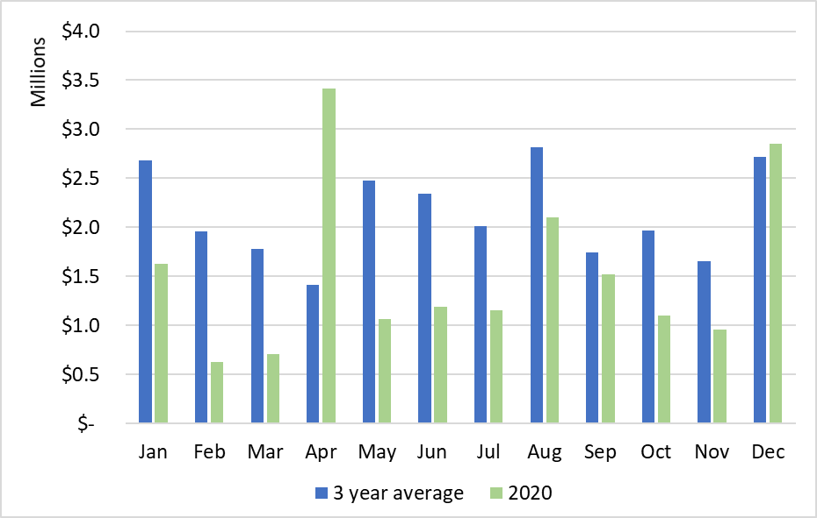

With the exception of a single large capacity charge prepayment in April 2020, prepayments were down compared with the three-year average in 2017-2019, with December 2020 rebounding to higher than the three-year average. Overall, in 2020 there was a 28 percent reduction over the three-year average. Of note, prepayments were down in Q1 2020 ahead of the mandatory closures for COVID-19, indicating that 2020 was potentially going to be one of the lower prepayment years to begin with for this highly variable revenue source.

Revenue from 15-year payment plans has historically been escalated based on a conservative four percent year over year growth. The revenue forecast was reduced to three percent year over year growth. While the commercial real estate sector has been negatively impacted by the pandemic, residential real estate has continued to benefit from increased demand for new construction. The reduced new connections forecast is based on an assumed reduction to new commercial sector connections. Table 14 reflects the updated assumptions used to forecast capacity charge revenue through 2023. The 2023 sewer rate proposal (to be prepared in Q1 2022) will reflect any observed trends in recovery based on 2021 vaccine roll out and reductions to COVID restrictions.

**Table 14. Capacity Charge** Forecast Assumptions



### Other Revenue

#### Interest earnings

Interest earnings, also known as investment income, is the revenue that WTD obtains from investing its cash balances in the King County Investment Pool (pool). The pool pursues a low-risk investment strategy that prioritizes the availability of funds for its participating agencies to meet daily cash flow requirements. In 2020, WTD cash balances averaged approximately $540 million throughout the year, including which includes cash balances for all WTD reserve accounts.

Interest rate forecasts for the pool come from King County’s Office of Economic and Financial Analysis and are estimated at 0.60 percent for 2021[21]. The economic impacts from COVID-19 have resulted in a sharp decrease in interest rates and a commitment from the Federal Reserve to maintain interest rates low as long as needed to sustain the economic recovery[22]. The impact of lower interest rates on WTD’s revenues is limited since interest earnings represent one percent of WTD’s total revenues, and any earnings reduction is significantly offset by savings coming from a lower cost of debt.

#### Industrial, Septage, Resource Recovery

Other WTD income comes from 38 separate revenue sources, the largest of which are industrial surcharges, septic hauler fees and sales of methane, electricity, and Renewable Identification Numbers[23] (RINs). Projections are based on the RINs financial plan ($2.3 million, 2020; $3.1 million, 2021; and $1.5 million in 2022) and three percent growth for most other revenue components beginning in 2021.

The forecast includes the loss of electricity sales from cogeneration[24] at the West Point Treatment Plant beginning in 2022. The West Point Power Quality and Reliability projects include modification at the plant to fully utilize the electricity produced at the plant rather than sell a portion of it. Electricity sales have averaged $1.4 million annually.

## Operating Expenditures

The 2021-2022 operating budget provides the basis for forecasting operating costs for future years. The 2021 Rate Plan adopted by the King County Council in May 2020 estimated operating expenditures at $173.1 million in 2021 and $181.9 million in 2022. The adopted budget for 2021 is $171.8 million and $173.9 million in 2022, which reflects the hold put on new programs and cost increases due to the pandemic.

Table 15 shows the 2020 Revised Budget, 2020 Unaudited Actuals, and the 2021 and 2022 budget with percent change year over year.

**Table 15. Unaudited 2020 Operating Expense Budget and 2021-2022 Adopted Budget**



### Savings 2020

Expenditures estimated at $161.6 million are under the 2020 budget of $168.9 million by $7.3 million due to reduced demand for some chemicals, lower usage of maintenance parts/materials, lower than projected cost for diesel fuel and electricity, and delays in contracted services due to COVID-19.

### Adopted 2021-2022 Budget

The Salaries and Benefits budget category increased by one percent in 2021 over 2020. Modest assumptions regarding salary increases were applied, including no wage increase in 2021 and a two percent wage increase in 2022. Labor negotiations are underway with several unions and potential wage impacts are unknown.

Four new FTEs are funded by the existing budget and one FTE transferred to the Department of Local Services. Three temporary positions were converted to FTEs (Sediment Management Program position, Energy Engineer, Sustainability Specialist) and WTD added a Business and Finance Officer to work on audit compliance and debt accounting.

The Supplies and Services budget categories did not increase in 2021.

Intragovernmental fees increased by six percent, including $400,000 for Lab and Science services, $1.4 million for internal service fund charges related primarily to increasing insurance premiums and equipment rental, and a $243,000 increase in General Fund overhead. There may be reductions to internal service fund rates for COVID-19 changes that are not reflected at the time budget adoption.

### Operating Forecast

Historically, annual growth in operating expenditures has averaged about four percent as a composite of inflation and maintaining an aging and growing system. Table 16 shows the annual growth in operating expenditures going back to 2009.

**Table 16. Historical Annual Increase in Operating Expenditures**

**(inflation plus new and growing system costs)**



### Incremental Forecasted Expenditures

The initial quote for the Jameson improvements and annual lease cost is included in the proposed rate plan. Improvements would be capitalized[25] and funded out of the construction fund, while the ongoing lease payments are forecast as an allocation between the construction fund and the operating fund. The operating allocation represents about $830,000 in 2022, increasing to $1.1 million in 2031.

The operating impact of staffing to meet the asset management investment buildup goes from about $500,000 per year to about $700,000 by the end of the forecast.

The Joint Ship Canal project closeout costs that are not eligible to be capitalized represent about $5 million over 2024 and 2025. A placeholder of about $4 million is included in the forecast in the years following for unknown additional operating costs that will be shared based on an allocation defined in the project agreement with the City of Seattle.

Incremental operating costs are forecast based on inflation at three percent, excluding the assumed additional one percent to recognize the growth in operating costs.

### Green Where We Work

The WTD moved 350 employees to permanent telework as part of DNRP’s [GreenWhereWeWork](https://www.kingcounty.gov/depts/dnrp/about/green-where-we-work.aspx) (GWWW) project. DNRP vacated two and a half floors of office space in downtown Seattle, retaining the Fifth Floor of King Street Center to be used as a collaboration hub and meeting space. Home-based employees are encouraged to engage with the communities served by going to the places where work is performed, such as operations facilities, parks, and community centers.

The GWWW project will have transitional costs associated with upgrading technology, training employees, and learning to collaborate in a virtual environment. DNRP anticipates significant long-term cost savings including an estimated savings of $6 million in office space costs alone. DNRP also anticipates a decrease in its environmental footprint and more accessible customer service.

## Capital Improvement Plan

### Portfolio Management

Beginning in 2017, WTD focused on developing a more comprehensive and structured approach to managing its capital program with the goal of aligning the mix of projects in WTD’s capital improvement plan (CIP) with its strategic initiatives and overall mission. A pilot of this prioritization approach informed the 2019 sewer rate development and since then has been used to inform rate and budget-setting processes.

Projects are organized and prioritized within the following categories:

Table 17. Capital Portfolio Category Descriptions

### 2020 Performance and Accomplishment Rate

The capital accomplishment rate is the amount of actual or forecasted capital spending that occurs in the year compared with the amount of capital spending planned. WTD’s capital program accomplishment target of 85 percent is evaluated against the actual spend performance of recent years to ensure it remains a valid assumption. Using an accomplishment rate in the financial plan allows WTD to adjust the capital program’s funding plan to reflect the reality of delays in the execution of capital projects that thus delay spending. In 2020, the accomplishment rate for the capital program was 81 percent, compared with 85 percent used to forecast funding needs in the rate plan. This difference represents approximately $11 million less capital spending in 2020 than total capital expenditures forecast in the financial plan for that year. Table 18 presents the historical accomplishment rate.

Table 18. Historical Accomplishment Rates for the Capital Program ($ in millions)



### 2021-2022 Capital Budget

The forecast uses an assumed 85 percent accomplishment rate for all projects except the Georgetown Wet Weather Treatment Station and the Joint Ship Canal CSO project. Based on the progress of these two projects and the remaining costs being primarily for contracted construction, the plan assumes Georgetown will achieve all of its remaining $81 million planned spending and that the Joint Ship Canal will achieve its $80 million planned spending within the six-year planning period, which would be a 100 percent accomplishment rate.

WTD critically reviewed project scopes, risks, cash-flow projections, and schedules to update spending forecasts for the existing capital program. Highlights of planned accomplishments within the current program are summarized in Table 19.

Table 19. WTD Capital Portfolio Category Expected 2021-2022 Accomplishments



### Proposed Capital Improvement Program (CIP)

Table 20 compares the 2022 proposed and 2021 Adopted 2021-2026 CIP spending plan by portfolio category.

Table 20. WTD 2022 Proposed and Adopted 2021-2026 Spending Plan

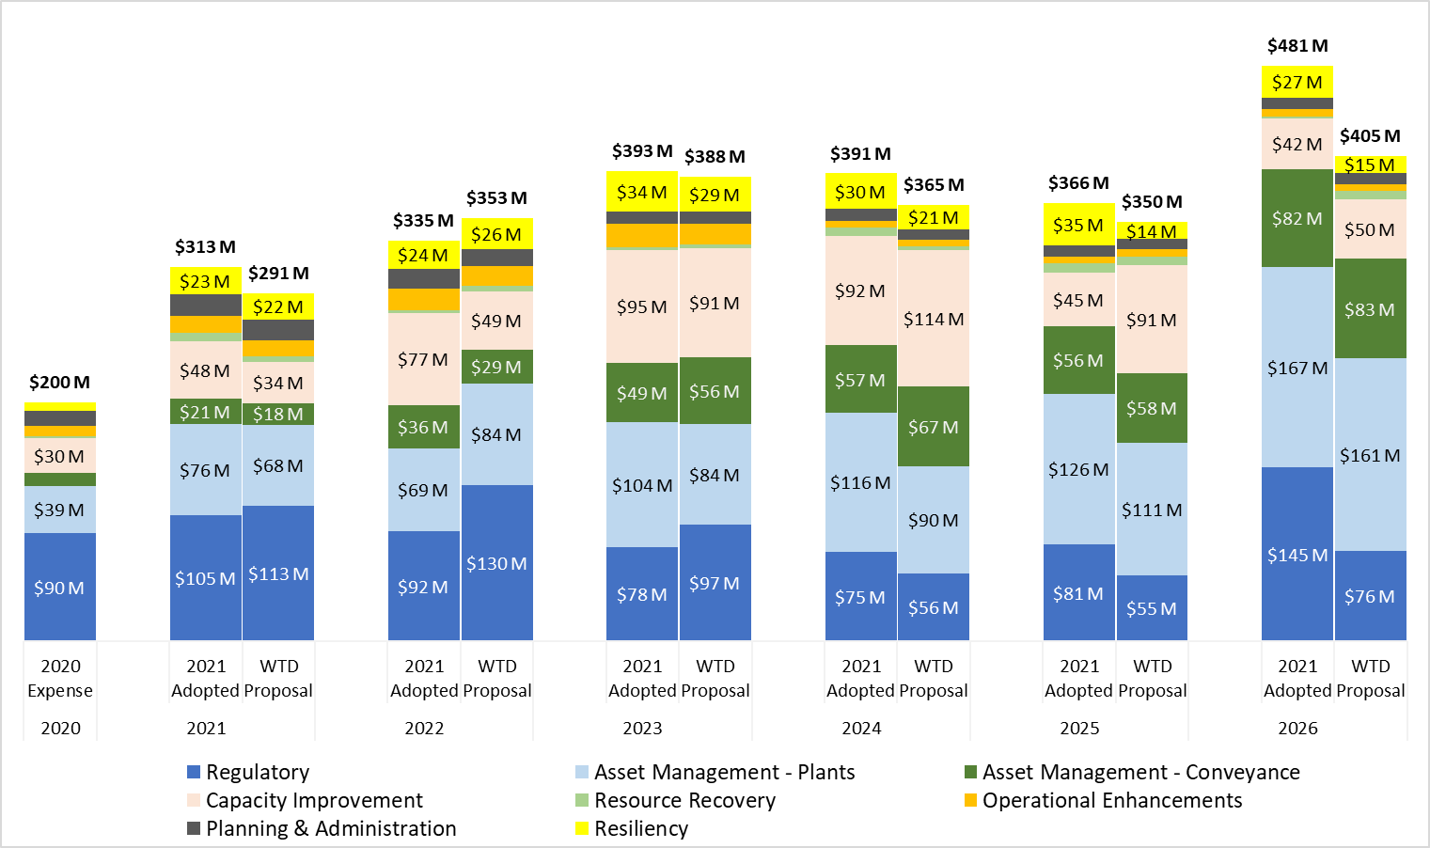

The following five projects are the largest individual components of WTD’s capital expenditures for 2021-2022:

#### Joint Ship Canal Water Quality

The [Ship Canal Water Quality Project](https://www.seattle.gov/utilities/neighborhood-projects/ship-canal) is a joint project with the City of Seattle. The 2.7-mile tunnel project is mandated through separate consent decrees the County and City have with the EPA and Ecology. The project is expected to prevent an average of 75 million gallons of uncontrolled sewage overflows annually and currently is in construction with an anticipated completion date of 2025.

#### Georgetown Wet Weather Treatment Station

The [Georgetown Wet Weather Treatment Station](https://www.kingcounty.gov/depts/dnrp/wtd/capital-projects/active/georgetown.aspx) project is also driven by consent decree. It includes the construction of a CSO wet weather treatment station between the Brandon Street and South Michigan Street Regulator Stations; related pipes; and a new outfall structure to release the treated water into the Duwamish River. When constructed, the station will treat up to 70 million gallons a day of combined rainwater and wastewater that would otherwise have discharged directly to the Duwamish without treatment during storm events. This project is expected to finish construction in 2022.

#### West Point Power Quality Improvements

On February 25, 2021, the County Executive transmitted legislation to the County Council and signed a [Declaration of Emergency](https://www.kingcounty.gov/elected/executive/constantine/news/release/2021/February/25-west-point-declaration.aspx) to provide the West Point Treatment Plant with more reliable power in response to increasing power disruptions. The project will either modify on-site power cogeneration at West Point, install a large battery system to help buffer the power supply, or both, which will enable plant equipment to continue operating during power disruptions. This work is expected to be completed by February 28, 2023.

#### North Mercer Island/Enatai Sewer Upgrade

This project will increase the reliability and capacity of the existing [North Mercer Island Interceptor and Enatai Interceptor](https://www.kingcounty.gov/depts/dnrp/wtd/capital-projects/active/north-mercer-island-enatai-sewer-upgrade.aspx) components of the regional wastewater system to convey the 20-year peak wastewater flows[26] projected through the year 2060. Project construction will include approximately 17,210 linear feet of new sewer pipeline and related features and will upgrade the County’s North Mercer Pump Station on Mercer Island. This project is anticipated to start construction in 2021 and extend until 2025.

#### Interbay Sewer and Odor Control Upgrade

The County will [upgrade an aging sewer pipe in Seattle’s Interbay neighborhood](https://www.kingcounty.gov/depts/dnrp/wtd/capital-projects/active/interbay-sewer-oc-upgrade.aspx). The existing pipe was built in 1967 and is nearing the end of its service life. New odor-control technology will be added to the system while the sewer pipe upgrade is underway. When complete, the sewer will provide reliable service for another 50 years or more. Construction is anticipated to be complete by 2024.

## Emerging Priorities and Key Issues

### West Point Treatment Plant Power Quality and Reliability

#### Administrative order actions and report on plan from flood event

[Administrative Order #19477](https://ecology.wa.gov/About-us/Get-to-know-us/News/2021/Feb-3-King-County-Wastewater-Treatment-Plant-Enfor), issued by Ecology, requires King County to address power reliability issues at the West Point Treatment Plant. WTD has reallocated staff resources to prioritize this coordinated effort with Seattle City Light. The proposed rate plan includes the recommended investments to address power reliability.

Table 21 shows the strategy used in the proposed rate plan to fund and deliver the prioritized asset management investments and respond to the Administrative Order.

Table 21. Strategy to Fund West Point Power Reliability and Maintain Critical Asset Management Catch-Up

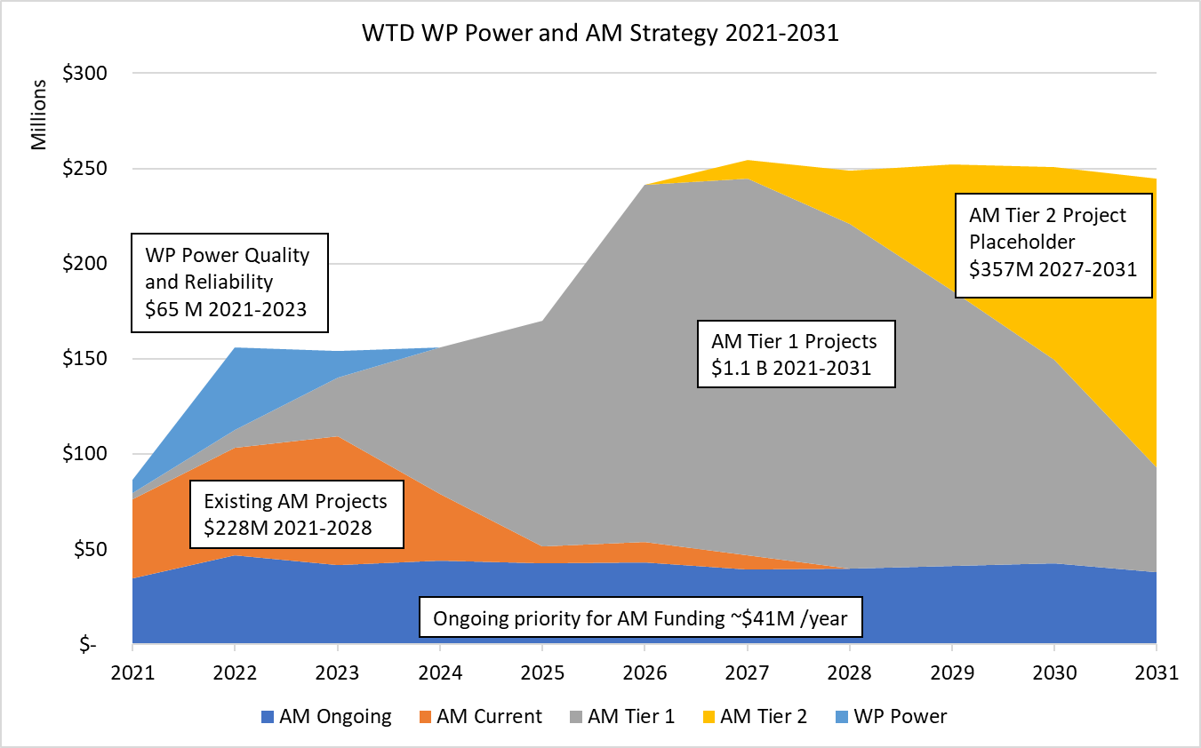

**Ongoing (Dark Blue):** High-priority minor (low cost) asset replacements or refurbishments.

**Existing (Orange):** Highest-priority large asset replacements or refurbishments that are currently appropriated and in project delivery.

**West Point Power (Light Blue):** Costs to provide the West Point Treatment Plant with more reliable power in response to increasing power disruptions. The project will either modify on-site power cogeneration at West Point, install a large battery system to help buffer the power supply, or both, which will enable plant equipment to continue operating during power disruptions. This work is expected to be completed by February 28, 2023

**Tier 1 (Gray):** Equipment or pipeline that is currently in poor condition, unserviceable, or for which spare parts cannot be found. Consequences of failure include sewage overflows, other operating permit violations, or operational disruptions for which there would be no easy workarounds. Because wear and tear and corrosion are progressive, every year of delay means that the risk of failure increases.

**Tier 2 (Yellow):** Equipment or pipeline that is old, showing wear, or has corrosion that indicates it will fail in the future. In the case of equipment, the equipment is currently doing its job, but due to its age will likely perform poorly or fail in the near future. Tier 2 failure has the same consequences as Tier 1 but is less likely to occur now. Tier 2 also includes equipment that may be in worse condition but is not located in a critical process—i.e., equipment may be more likely to fail, but the consequences would not be as severe. The risk of delay is the same as Tier 1.

Combining the strategy to address unfunded asset management and West Point power priorities, the placeholder 2040 CSO completion schedule (covered in the Primary Rate-Drivers section), and the adopted six-year CIP, Table 22 shows the annual capital investments included in the rate plan in their respective Portfolio categories. As discussed in the Primary Rate-Drivers section, this capital program does not include investments related to the Draft Preliminary Ecology Nutrients permit.

Table 22. Proposed Capital Investments by Portfolio Category for Ten-Year Forecast



## Capital Funding Plan

The capital program is funded by two primary sources - cash generated from the sewer rate and capacity charge revenues and by debt financing from revenue bonds or low-interest state and federal loan programs.

### Cash Funding

The sewer rate is set at a level to ensure 40 percent of the capital spending plan is generated from revenues. The informal policy is to accomplish the target on a six-year, rolling-average basis. This allows year to year fluctuations in setting a smoothed rate increase plan.

Since the target cash funding is accumulated over the course of the year, a single, year-end transfer to the construction fund from the operating fund makes the cash available for funding capital projects in the following year.

### Debt Financing

Debt financing[27] is used either when there is a state or federal loan secured for a project, or when revenue bonds are issued to balance the total annual funding needs after use of cash and secured loans.

While bonds have typically been issued annually, in order to secure record-low interest rates available in 2020, WTD issued bonds intended to balance capital funding needs through the 2021-2022 biennium. The Debt Proceeds column in Table 23 shows use of proceeds in 2021 and 2022 that represent some of the bond proceeds from the 2020 revenue bond issuance.

Table 23. Capital Funding Plan



Table 24 shows the capital funding plan and the use of various debt instruments secured to fund the capital program.

Table 24. Capital Funding Plan Funding Sources

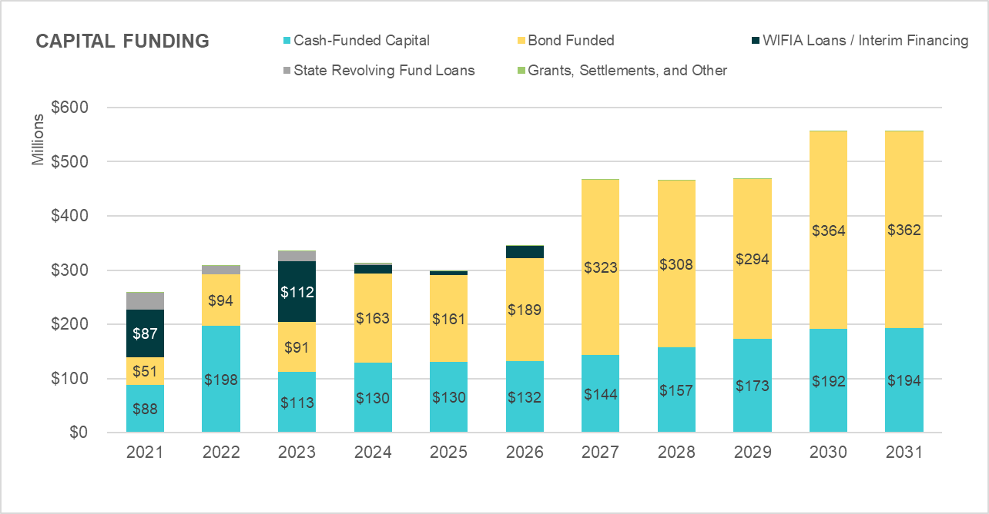

Table 25 illustrates the impact to the balance of total outstanding debt resulting from the financing activities necessary to deliver the capital program. The balances in this chart reflect the annual reduction in debt balances from debt service repayment.

Table 25. Existing and New Debt Balances

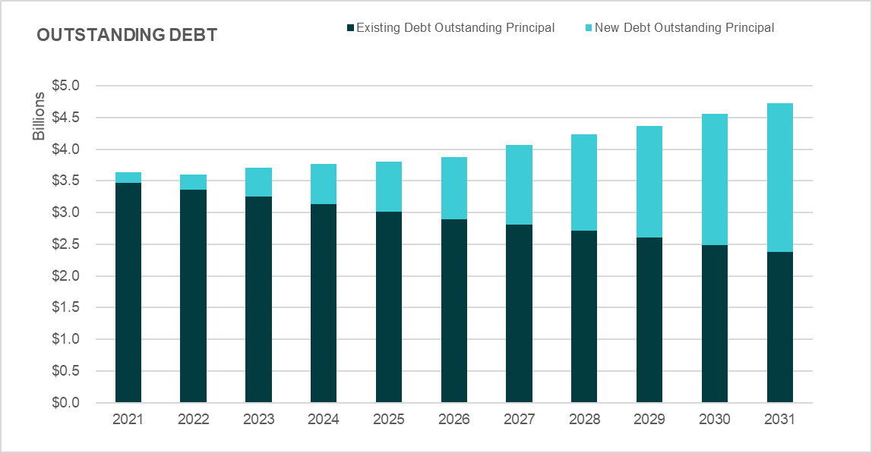

### 2021 Planned Financing Activity and Strategies

#### State Revolving Fund Loan Refunding

WTD is evaluating refunding [State Revolving Fund](https://ecology.wa.gov/About-us/How-we-operate/Grants-loans/Find-a-grant-or-loan/Water-Quality-grants-and-loans) (SRF) loans that could provide at least five percent present-value savings consistent with the County’s Debt Policy. SRF refunding is targeted for early Q3 2021 to coincide with other planned financing activity. Refunding candidates will depend on interest rates at that time.

#### Proposed Legislation to Restore Tax-Exempt Advanced Refunding

Tax-exempt bonds have traditionally been issued by state and local governmental for public infrastructure. WTD uses tax-exempt bond financing as its primary source of long-term financing for the capital program. Investors who purchase these bonds are exempt from paying federal income tax on interest earnings, so they are willing to buy the bonds at a lower interest rate than conventional bonds, which becomes lower-cost debt to the borrower. Prior to the [2017 Tax Cuts and Jobs Act](https://www.congress.gov/115/bills/hr1/BILLS-115hr1enr.pdf) (TCJA), tax-exempt advanced refunding bonds could be issued to refund outstanding tax-exempt debt with higher than current market interest rates. The TCJA eliminated tax-exempt refunding bonds.

In February 2021, [legislation](https://www.wicker.senate.gov/public/_cache/files/16a3a96d-4dc9-4db8-81cf-c10bcb729887/localinfrastructureact-onepager117th.pdf) was introduced in the U.S. Congress that would amend the federal tax code to restore state and local governments’ ability to use advanced refunding to manage bond debt and reduce borrowing costs for public projects. WTD is tracking the status of this proposed legislation and has prepared a list of potential candidates for advanced refunding to pursue should the legislation be enacted.

WTD continues to pursue available alternatives to take advantage of the current interest-rate environment, including evaluating SRF loan refunding and potential defeasance activities. The current restriction on issuing tax- exempt refunding bonds does not limit the use of cash for advanced refunding. In comparison with issuing tax-exempt advanced refunding bonds, the ability to take high interest rate debt off the books through defeasance is limited by the utility’s ability to generate cash from ongoing revenue sources.

#### Defeasance

Cash generated from the 40 percent funding policy can be used to directly fund capital spending or to pay down higher-interest outstanding debt. This accomplishes the same debt-balance outcome as directly cash-funding the CIP while replacing high interest rate debt with lower interest rate new debt in the current market.

Table 26 demonstrates how use of the cash collected from sewer rate revenue for CIP funding can be used for defeasance and accomplish the same debt balance management goal.

In the “No Defeasance” scenario, new bonds are issued and added to the debt balance at 60 percent of the annual CIP and 40 percent is cash-funded. The sample ending debt balance is $800.

In the “Defeasance” scenario, additional debt is issued to cover the full CIP (rather than 60 percent), which frees the cash from rates to pay down outstanding higher interest rate debt. There is an effective exchange of higher interest rate debt on the books for lower interest rate debt available at current market conditions. The sample ending debt balance is the same $800.

Table 26. Sample Defeasance



## Revenue Requirement

There are two tests that guide rate setting and determine a utility’s annual revenue requirement - the cash test and the debt service coverage test.

### Cash Test

The utility must ensure first that it can support its cash obligations, including operating expenditures, debt service repayment, and any financial policy targets, such as cash to fund the capital program.

[King County Code 28.86.160](https://kingcounty.gov/council/legislation/kc_code/38_Title_28.aspx) Financial Policies state “King County shall charge its customers sewer rates and capacity charges sufficient to cover the costs of constructing and operating its wastewater system.  Revenues shall be sufficient to maintain capital assets in sound working condition, providing for maintenance and rehabilitation of facilities so that total system costs are minimized while continuing to provide reliable, high quality service and maintaining high water quality standards.”

Table 27 shows the components that build to the total annual revenue requirement compared with revenue under the existing sewer rate.

Table 27. 2022 - 2031 Sewer Rate Plan Revenue Requirement

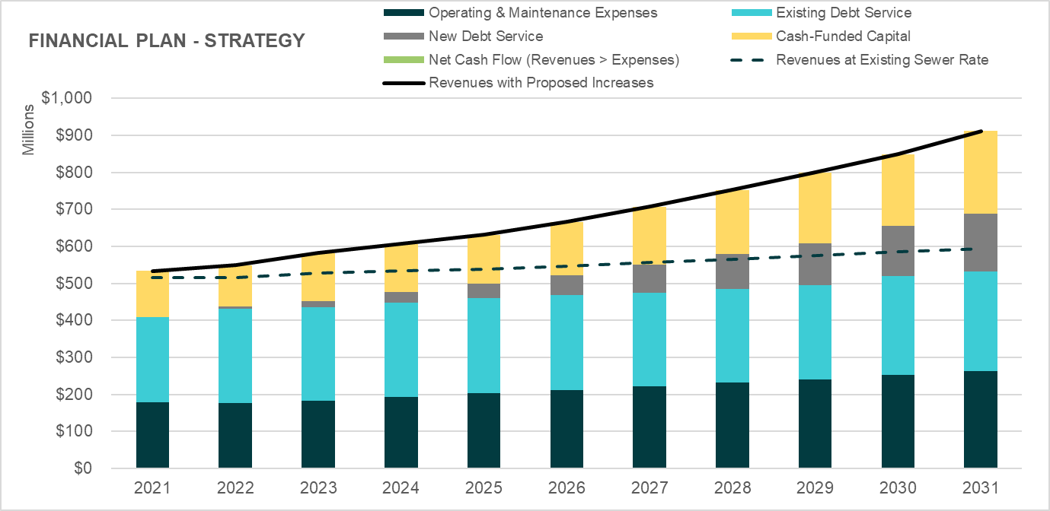

Beginning from the bottom, the first stack in the bar represents the annual Operating and Maintenance (O&M) Expenses with projected inflation and growth. The second stack shows the debt service obligation for existing outstanding WTD debt. The third stack represents new debt service repayment generated by funding the capital program in this forecast. The top stack represents the policy to cash-fund 40 percent of the capital program from revenue.

The dashed line shows the level of revenue generated if the sewer rate were to remain at the current 2021 level of $47.37 monthly for all years of the forecast, in order to demonstrate the insufficiency of the current rate level. The solid line shows the revenue meeting the annual requirement in each year based on the proposed rate plan.

[Table 5 – also available on page 7]

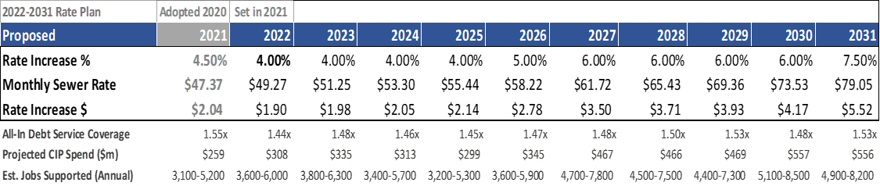

### Debt Service Coverage Test

The secondary test is the debt service coverage (DSC) test. DSC is broadly used in the industry, and a specific focus from rating agencies. Generally, it measures revenue sufficiency risk to bond holders by determining how much cushion does or does not exist in the revenue levels set by the agency. The rate proposal produces coverage ranging from 1.35x in 2022 to 1.55x in 2029. DSC measures the net revenue from the utility after paying operating and maintenance expenses as a factor of how many times that net revenue could cover the debt service in a single year. Since cash-funded capital policies are not part of the calculation, meeting the policy also accomplishes meeting coverage cushion.

An explanation of DSC produced for 2020 engagement with stakeholders is included in Table 28.

Table 28. Debt Service Coverage Concepts and Performance

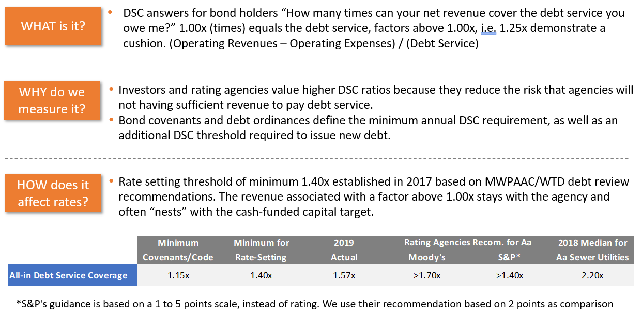

Moody’s Investor Service’s median DSC tracking for water and sewer agencies shown in Table 29 represents about 30 percent of an increase between 2009 and 2019 (in comparison, WTD is at about 19 percent). DSC is trending upward in the industry due in part to growing attention to the financial capacity necessary to address aging infrastructure. WTD’s historical coverage performance has exceeded 1.40x since 2016 and trended higher (e.g.,1.58x in 2019). Median DSC for Aa (high-rated) sewer utilities in the US is 2.2x (Moody’s, 2018 data).[28]

Table 29. History of WTD DSC and Ratings



### COVID-19 Net Impact Forecast Summary

Estimated impacts were shared with MWPAAC and [RWQC](https://aqua.kingcounty.gov/Council/agendas/RWQC/20201209-RWQC-additional.pdf) in 2020 and are shown in the Fall Forecast column of Table 30 for comparison. The total projected net shortfall through 2022 has been reduced from $27.8m to $0.5m as capacity charge revenue in 2020 outperformed mid-year COVID-19 impact estimates and debt service savings were higher than estimated at that time.

The key takeaway is that the estimated revenue loss is almost fully offset by debt service savings from record-low bond market interest rates and operating expenditure savings, as shown in Table 30.

**Table 30. Estimated Net Impacts of COVID-19[29]**



#### Fall 2020 estimated impacts from COVID19:

* Reduced revenue forecast:
  + Sewer rate - lower projected flow-based RCEs
  + Capacity charge - lower projected prepayments and reduced growth assumptions
  + Investment income - lower interest rates
* Shortfall offset by:
  + Savings from operating expenditures in 2020 (2021-2022 budget was not finalized so no change included)
  + Savings from record-low interest rates on the 2020 bond issuance and refundings

#### February 2021 revised estimated impacts:

* + Slowed the projected recovery of flow-based RCEs
  + Higher than estimated 2020 capacity charge revenue
  + Lower operating expenditures in the 2021-2022 adopted budget
  + Early redemption of near-term higher interest rate debt

## Reserves Management

WTD maintains financial reserves that address minimums required by debt covenants (contracts), working capital targets, management of loan proceeds and other capital resources, rate increase smoothing, and mitigation of revenue risk.

While WTD historically has managed its reserves according to these functional uses, there are limited formal policies directing minimum or target levels and allowed use. The WTD Finance 2021 work plan includes research and benchmarking to develop and propose formal policies for these utility reserves that align with industry best practice and WTD financial structure. This section describes the reserves and the reserve levels targeted in rate plan development.

**Table 31. Summary of WTD Reserves**



### Water Quality Operating Fund 4611

#### Liquidity Reserve

The Liquidity Reserve is targeted to provide sufficient cash balances for variance of revenue and expenditures cycles throughout the year. The working capital target is established as 10 percent of operating expenditures in any given year. As a result, a reserve increase must be funded each year as operating expenditures increase.

#### Rate Stabilization Reserve

A rate stabilization reserve is unique in that bond covenants (contracts) are written to allow that in any given year use of this reserve can be recognized as revenue eligible for inclusion in the bond coverage calculation. In years that WTD contributes to this reserve, that portion of revenue is deducted from the revenue basis for calculating bond coverage. This allows WTD to use reserves to manage rate levels without compromising the ability to meet annual bond coverage targets. Funds in the Rate Stabilization Reserve also enhance the liquidity metrics[30] used by the rating agencies when they evaluate WTD’s credit quality.

Careful consideration is given to use of reserve balances. Use of reserves represents a one-time resource and excess reserves should be applied to one-time expenditures. Without plans to replenish the reserve, it is only a short-term, buy-down resource and will not contribute to long-term rate management. Most formal reserve policies define the period over which replenishment of the reserve to its minimum level must occur after a draw. The proposed rate plan does not project uses or contribution to this reserve.

The current balance represents approximately 11 percent of 2020 sewer rate revenue, which becomes 6.2 percent by 2031 as revenues increase and the balance does not. A rate stabilization reserve often includes some cushion related to revenue risk from unexpected under-collection of revenue for reasons such as economic or weather-related changes in commercial water-consumption-based RCEs. The 2021 reserve analysis will evaluate and recommend a formal policy on target and minimum balances and parameters for how the reserve is utilized.

#### Unrestricted Operating Balances

Funds in excess of the minimum reserves levels that remain in the Operating Fund at year-end are evaluated for optimal use including potential transfer to the Construction Fund or to contribute to defeasance transactions.

### Water Quality Construction Fund 3611

#### Unrestricted Construction Fund Balances

WTD’s Water Quality Construction Fund is where capital project costs are charged; loan proceeds are reserved and spent; transfers are received for cash-funded capital from the Operating Fund; and capital reserves, such as the Asset Management Reserve, are maintained. Accumulated reserves above the policy-minimum are used to fund projects.

The Construction Fund balance is projected to end at the $5 million liquidity reserve target in each year of the rate plan beginning in 2023, after the balance of bond reserves from the 2020 issuance has been fully expended. The capital reserves will be evaluated with the 2021 reserve analysis.

Asset Management Reserve

The Asset Management Reserve is maintained as an emergency reserve and as such, is not forecast to deviate from the $15 million balance. This reserve could be an important resource if an asset failure should occur during a period of significant revenue constraint.

### Debt Reserves 8921 and 8922

WTD debt reserve minimums are established as a requirement in bond covenants or by the loan-granting agency. The County’s bond ordinance requires that a reserve be maintained in an amount equal to maximum annual debt service on outstanding Parity Bonds.[31] The requirement is currently $158 million. Ecology had a similar requirement, although the agency eliminated this provision for loans awarded after 2018. Reserves for pre-2018 Ecology loans total $13.5 million.

## Reference

### History of 40 percent Cash-Funding Approach:

The 2017 sewer rate proposal included, for the first time, a cash-funding target equal to 40 percent of the current year CIP to reduce growth in WTD debt balance. Previous rates had been set to meet an annual 1.15x DSC minimum. The new policy was in response to recommendations from a MWPAAC Debt Review Committee that proposed WTD target 1.40x debt service coverage as a minimum for setting the sewer rate. The 1.40x coverage target is used as a secondary rate-setting threshold to the 40 percent cash target.

The August 2019 Ratings Median Data Report[32] issued by S&P Global Ratings indicates WTD is highly leveraged in the industry:

* + King County WTD Debt-to-Capitalization Ratio 2018: 98 percent
  + Northwest Utilities: 30 percent
  + National “Very Large” Utilities: 47 percent

A key related ratio is the free cash flow to depreciation measure. This is a common investor and industry measure of the annual financial capacity to maintain utility plant facilities at current levels of service, which assumes that such assets will allow continuation of service and the ability to generate revenue without a significant rate adjustment for unfunded infrastructure needs. Projected cash funding at 40 percent (2021 projected $110 million) is less than annual depreciation ($179.5 million 2019 audited), which suggests that WTD should maintain at a minimum the current policy target.

### Supplemental WTD Debt Information

Table 32 2020 Year-End Outstanding Debt Balances[33]



Table 33 Sewer Rate Model Debt Assumptions for 2022 Rate Plan



#### Types of WTD Financing

##### Bonds - Sewer Revenue bonds are secured by a pledge of revenue of the sewer system subject to payment of all operating and maintenance expenses of the sewer system[34]. When revenue bonds are additionally backed by a pledge of the [full faith and credit](https://www.investopedia.com/terms/f/full-faith-credit.asp) of the issuer (meaning the County’s General Fund revenue and taxing power) the bonds are referred to as limited tax general obligation (LTGO) bonds.

State loans - WTD has received loans from Ecology under the Water Pollution Control SRF Loan Program and the [Washington Public Works Trust Fund](https://www.commerce.wa.gov/building-infrastructure/pwb-home-page/) administered by the Washington State Department of Commerce. The loans require either semi-annual or annual payments of principal and interest from 2021 through 2053 and bear interest at stated rates from 0.0 percent to 3.1 percent. As of December 31, 2020, the balance due on all state loans is $245.5 million. State loans are secured by a subordinate lien[35] on the net revenues of the system.

WIFIA Loans - [The Water Infrastructure Finance and Innovation Act of 2014](https://www.epa.gov/wifia) (WIFIA) established the WIFIA program, a federal credit program administered by EPA for eligible water and wastewater infrastructure projects. The WIFIA program accelerates investment in the nation's water infrastructure by providing long-term, low-cost supplemental loans for regionally and nationally significant projects at below market rates. The WIFIA loans, after draws are made, are secured by a pledge of revenue from the sewer system subject to payment of all operating and maintenance expenses of the sewer system. WTD has successfully qualified for and received two federal WIFIA loans to date, totaling $231.3 million.

##### Commercial Paper

The Commercial Paper[36] (CP) program provides low-cost, flexible, short-term financing for WTD capital projects. CP can be used to provide interim financing to pay for capital projects pending permanent financing from state and federal loans and from long-term fixed or variable-rate debt.

The initial purpose of the CP program is to pay the Georgetown Wet Weather Treatment Station and Ship Canal Water Quality project costs prior to receiving reimbursement and permanent fixed-rate financing from the SRF and WIFIA loans secured for these projects. CP costs are expected to be lower than WIFIA and SRF loan rates. By issuing CP and delaying WIFIA and SRF draws, WTD will incur lower-interest costs over the extended construction periods for these projects. CP can also be issued to provide interim financing for the cash-funded portion of WTD’s CIP.

##### Variable Rate Debt

WTD’s debt policy limits the utility’s variable rate debt exposure to a maximum amount equal to 20 percent of all outstanding debt; currently, a target of 15 percent is used in the forecast. WTD’s initial variable rate issuance was its $100 million commercial paper program in 1996. Over the next 25 years, WTD has expanded its variable rate portfolio to a total of approximately $550 million. Variable rate debt allows WTD to achieve a borrowing cost that historically has been much lower than traditional fixed rate debt. Typically, an investor can sell variable rate bonds back with just a week’s notice and this type of investment warrants the lowest borrowing cost in any given interest rate environment.

1. Secondary treatment includes aeration, settling, disinfection, and discharge through an outfall. Secondary treatment in conjunction with primary treatment removes about 85 to 90 percent of suspended solids in wastewater.
2. “High-strength” refers to more concentrated waste and this surcharge covers the additional cost of treating this waste at the treatment plant.
3. <https://www.kingcounty.gov/depts/dnrp/wtd/capital-projects/system-planning/clean-water-plan.aspx>
4. Asset Management is the coordinated activity of an organization to realize the value from its assets. King County manages over 60,000 WTD assets valued at almost $5 billion, including equipment like pumps and motors, infrastructure like pipelines and tanks, buildings, vehicles and technology, and software and databases.
5. <https://ofm.wa.gov/sites/default/files/public/legacy/policy/80.20.htm>
6. <https://www.awwa.org/portals/0/files/publications/documents/m1lookinside.pdf>
7. Audited 2020 financial information will be available in May of 2021. Preliminary (unaudited) year-end financial data is presented for comparison to the 2020 forecast from the adopted (2021-2030) rate plan.
8. Bonds par amounts (the principal to be repaid) are lower than actual bonds proceeds because tax-exempt municipal bonds are usually sold at a premium, meaning that coupon rates offered to investors (interest payments) are higher than the prevailing market rate, but proceeds are higher than principal owed.
9. WTD long-term bonds currently are issued with 30-year terms and short-term bonds usually have two to three-year fixed rate terms but can be up to five years.
10. Defeasance is an alternative way to achieve tax-exempt bond savings: Operating cash is used to “prepay” high interest debt while new bonds are issued at lower cost to finance the capital program.
11. An additional $8 million was contributed towards the defeasance from the debt service reserve fund. This release of excess reserves was permitted after the reduction of future debt service through recent refundings and defeasance transactions.
12. Defeasance is a provision in a contract that voids a bond or loan on a balance sheet when the borrower sets aside cash or bonds sufficient to service the debt.
13. The WTD proposed 2022 rate plan assumes 6 Full-time Equivalents (FTEs) are added in 2021, 6 FTEs in 2022 and 1 FTE proposed in 2023 as an Asset Management Strike Team to support catching up on the backlog of projects to repair or replace aging equipment. No new projects can realistically progress in 2022 unless resources are added, or existing projects are deferred.
14. Forecast from February 2021 included a 0% sewer rate increase in 2022 and a 10.5% increase in 2023.
15. <https://www.kingcounty.gov/depts/dnrp/wtd/about/history.aspx>
16. Revised Code of Washington [35.58.360](https://app.leg.wa.gov/RCW/default.aspx?cite=35.58.350)
17. A 2015 internal WTD survey of utility connection charges for 18 comparable agencies nationwide included data on when the charge is assessed to new connections for 13 of the 18 agencies. Of the 13, 100 percent required payment at the time of permitting or service application. Only WTD did not require payment as a condition of development through the permitting/service application process.
18. <https://app.leg.wa.gov/RCW/default.aspx?cite=35.92.025> Cities and Towns

    <https://app.leg.wa.gov/RCW/default.aspx?cite=57.08.005> Districts
19. Impact fees are one-time charges assessed by a local government against a new development project to help pay for new or expanded public facilities that will directly address the increased demand for services created by that development. <http://mrsc.org/Home/Explore-Topics/Finance/Revenues/Impact-Fees.aspx>
20. King County Code 28.84.050 O.3.
21. The March 2021 forecast is available at <https://www.kingcounty.gov/~/media/business/Forecasting/documents/March2021_pdf.ashx?la=en>
22. https://apnews.com/article/fed-low-rates-coronavirus-economy-a142da0b3bac10860247732cdc2a7acf
23. A RIN is a is a serial number assigned to a batch of [biofuel](https://en.wikipedia.org/wiki/Biofuel) for the purpose of tracking its production, use, and trading.
24. Cogeneration refers to electricity produced from methane burnt during the wastewater treatment process.
25. To capitalize is to record a cost but delay full recognition of the expense. This is beneficial in acquiring new assets with long-term lifespans that can depreciate the costs.
26. A “peak” flow is a sudden and/or sustained increase in the flow.
27. Debt financing occurs when a money is raised by selling debt.
28. Information available by subscription only at <https://www.moodys.com/>
29. Net impacts were estimated based on the adopted 2021-2030 rate plan.
30. Liquidity Metrics measure the agency’s ability to meeting financial obligations.
31. Parity Bonds are based on sewer revenue.
32. Information available via subscription access on S&P Global.
33. Excludes principal payments from January 1, 2021 that had already been transferred to the debt service fund in December 2020
34. This website provides more information on bonds <https://www.investopedia.com/ask/answers/09/bond-rating.asp>
35. "Subordinate" liens are those that can only be paid after more senior liens are released
36. Commercial Paper is a commonly used type of unsecured, short-term debt typically used for short-term liabilities. Maturities on commercial paper typically last several days, and rarely range longer than 270 days.It is usually issued [at a discount](https://www.investopedia.com/terms/a/at-a-discount.asp) from face value and reflects prevailing market interest rates.