Best Starts for Kids Youth and Family Homelessness Prevention Initiative *2018 Outcomes and Independent Evaluation Report*

\\dchs-shares01\home\raspeth\My Pictures\KClogo_h_bw_m.tiff

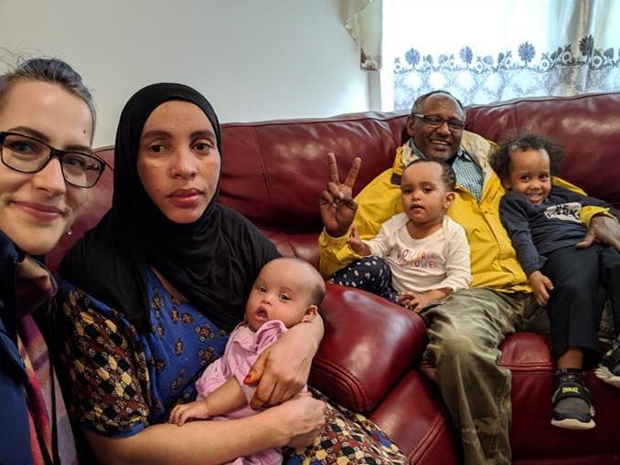

**Department of Community and Human Services**Housing and Community Development

# Table of Contents

|  |  |  |  |
| --- | --- | --- | --- |
| Introduction………………………………………………………………….…..... |  | 3 |  |
| 2018 Key Accomplishments…………………………………………………….. |  | 3 |  |
| Learning Circles Making the Difference …………………………………........ |  | 3-5 |  |
| Technical Assistance …………….…….…………………………….…………. |  | 6-7 |  |
| Targeting Households at Imminent Risk ……………………………………… |  | 8 |  |
| Client Stories ……………………………………………...................................  Advancing Equity through YFHPI ………………………………………….….. |  | 9-12  13 |  |
| Equity for All ……………………………………………………………….…….. |  | 13-14 |  |
| Leaders in Prevention ……………………………………………….………….. |  | 15 |  |
| Program Performance and Outcomes: Preliminary Data.............................. |  | 16-19 |  |
| Evaluation – Year One Design to Implementation........................................ |  | 19-27 |  |
| Conclusion …………………………………………………………………..…… |  | 27 |  |



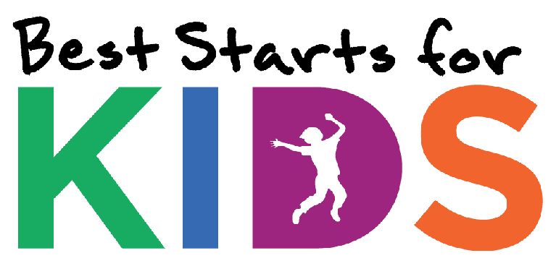

Introduction

Best Starts for Kids (BSK) Youth and Family Homelessness Prevention Initiative (YFHPI) is entering its third year. With the YFHPI, King County has assumed a leadership role in homelessness prevention. YFHPI’s model serves households that, without assistance, are at extreme risk of becoming homeless. Through a combination of intensive case management services and flexible financial assistance, households at imminent risk of homelessness are able to stay in their homes and avoid entering the homeless system.

As required in the YFHPI implementation plan, this report shares information on program outcomes and strategies. This report also details the work to ensure an independent evaluation of the initiative.

2018 Key Accomplishments

In 2018, more youth and young adults and households with children were able to avoid an episode of homelessness, thanks to the dedicated work of YFHPI case managers. Since the program began, YFHPI has supported 7,134 people. Nine out of ten households exiting YFHPI remained outside the homelessness system, and 21 percent were able to resolve their housing crisis without financial assistance. Staff received higher levels of training, resulting in households attaining higher levels of stabilization. Another key accomplishment was the development of a randomized control trial of YFHPI with external evaluators from Notre Dame, described in detail in this report.

Learning Circles – Making the Difference

In 2018, monthly learning circles continued to be the pillar upon which YFHPI provided training. Morning learning circles offer case managers one-on-one technical assistance from County staff, while also providing a space to network and team-build. Afternoon learning circles brought in consultants to facilitate enhanced learning in how to work with communities disproportionately represented in the homeless system. Professional development opportunities were expanded in 2018 with the addition of consultant Ken Kraybill, renowned Motivational Interviewing Trainer, working with case managers in guiding clients to empower themselves to reach higher levels of housing stability.

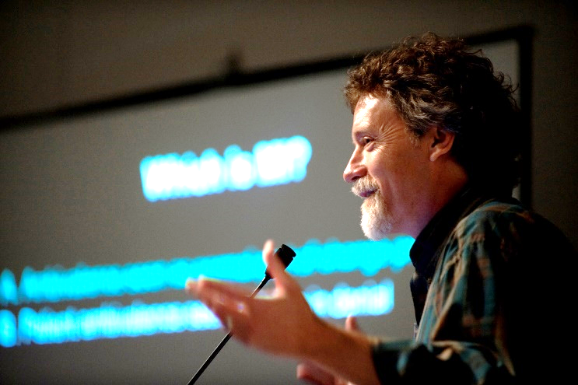

**Case managers share the value of monthly learning circles:**

*“It’s the one place that everyone already understands the stresses that come with the job. I get so many encouragements and support – it feels like home. I’ve never experienced the cohesiveness of this team anywhere else –* Liletha Williams, Atlantic Street Center

*“The value of this monthly learning circle is the best thing in this field. It’s best thing best because you can learn new things and how to do case management efficiently.”* – John Deng Duot, Iraqi Community Center of Washington

*“The value is that it continues to keep the team together in a forum to be able to ask questions so that we are all on the same page, especially when it relates to clients.”* – Tanya Robertson, Therapeutic Health Services

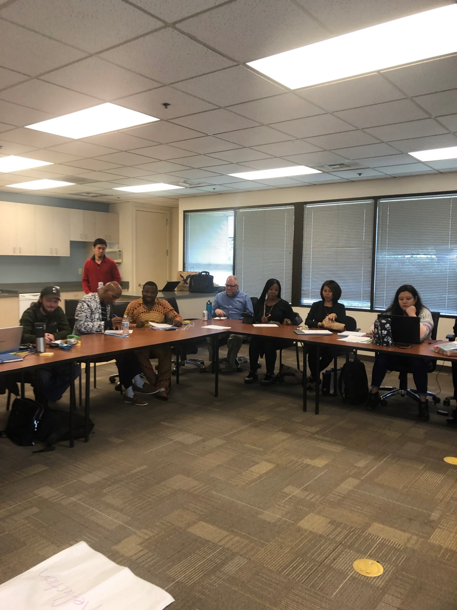

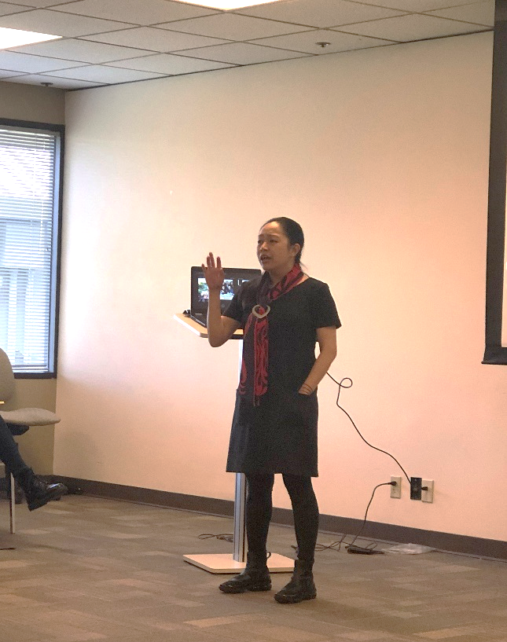

*“I love to bounce ideas off the other case managers. Many times I have found solutions to issues by just asking a question to the group.”* – Akia Forward, Multi-Service Center

*“The learning circles have helped me learn, grow and expand my knowledge to provide better services to our clients. I’m grateful to be a part of this wonderful team which always share ideas and resources. I’m also grateful to the YFHPI Prevention and Diversion Program Manager, for providing never ending support, especially when PIE lost our Executive Director in December, Amina Ahmed.”* – Rother Rashid, Partner in Employment

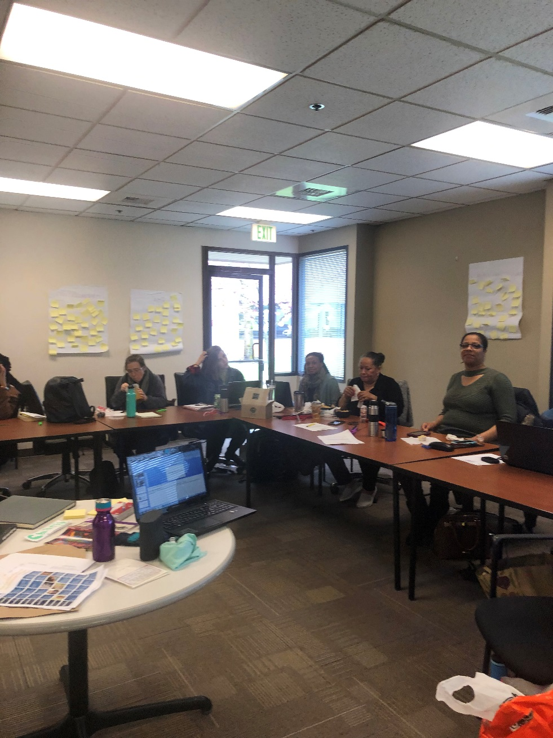

# Technical Assistance

In 2018, the YFHPI staffing grew, allowing for more individualized training and technical assistance. Case managers gained the opportunity to talk over individual client cases with County staff, with consultants, and with their peers. They gained a sounding board as they worked to determine “imminent risk” of homelessness and service planning. Additionally, case managers received assistance in the use of the prevention database.

To address case manager turnover, King County offers the YFHPI model, evaluation and database training to each new case manager.

Case managers voiced strong support for the assistance and training:

*“You just have to ask. Both YFHPI staff and Bitfocus are ready and able to help whenever there is a question.”* – Agueda Dudley-Berrios, YouthCare

*“I get prompt responses and solid support”* –Lee Durfy, Kent Youth and Family Services

*“I know without a doubt that any problem I encounter; there is someone on our YFHPI team willing and able to assist so it’s easy to ask for help.”* –Liletha Williams, Atlantic Street Center

*“From the very small request to the larger help I need, I have felt very supported. Any question or technical support I need is handled with kindness and is always prompt and relevant.” –* Cindy Obtinario, Friends of Youth

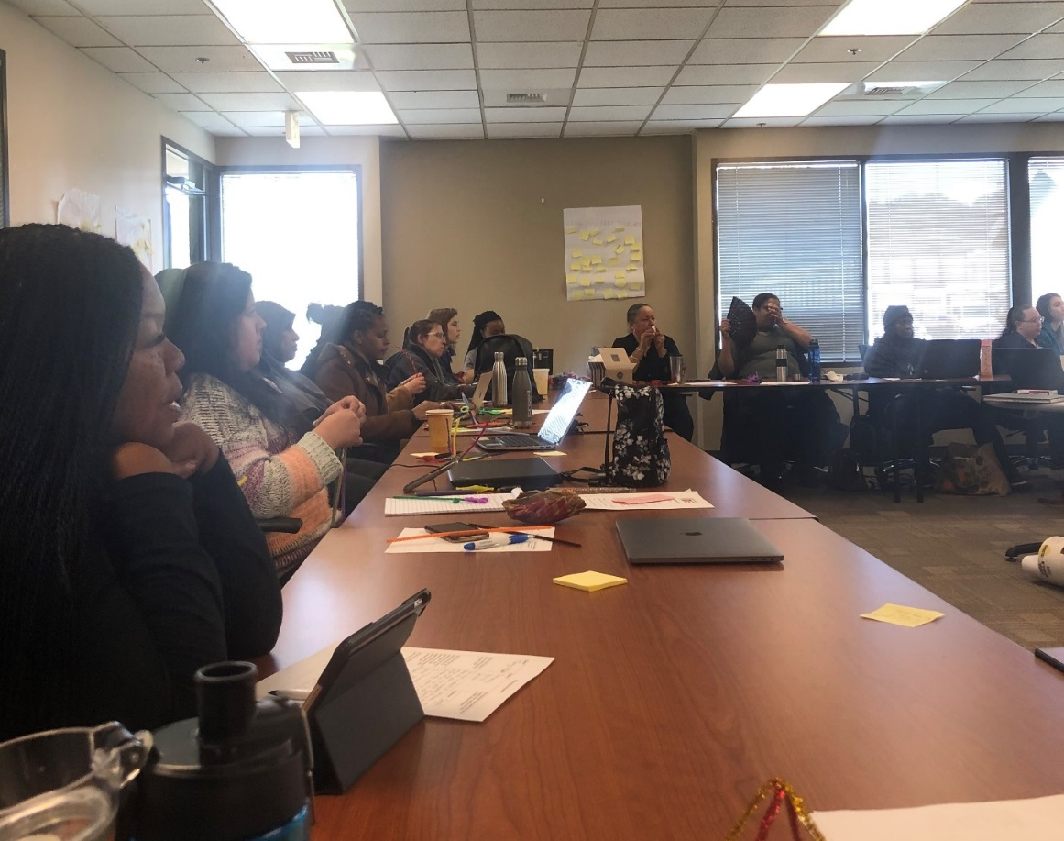

Monthly case manager trainings in 2018 covered the following topics:

|  |  |
| --- | --- |
| **Month/Year** | **Presentation / Presenters** |
| January 2018 | Budgeting 101 – Greg Hollmann  Regional Access Points – Stan Brownlow  Evaluation and Randomization – Kim Dodds |
| February 2018 | Implicit/Explicit Bias Training – All Home  Vulnerability Tool Training – Kim Dodds |
| March 2018 | Evaluation Training – Kim Dodds  LGBTQ Cultural Competency - Revelry Media |
| April 2018 | Evaluation Training – LEO (2 sessions) |
| May 2018 | Follow-up to Evaluation Training – Notre Dame  YFHPI and System Concerns – Hedda McLendon |
| June 2018 | LGBTQ Cultural Competency – Revelry Media |
| July 2018 | Case Manager Self Care  (Movie – *Homeless to Harvard*) – Kim Dodds |
| August 2018 | Motivational Interviewing – Ken Kraybill |
| September 2018 | AM: Legal clinic  PM: LGBTQ Cultural Competency – Revelry Media |
| October 2018 | Motivational Interviewing – Ken Kraybill |
| November 2018 | LGBTQ Cultural Competency – Revelry Media |
| December 2018 | Holiday Celebration – Team Building |

Targeting Households at Imminent Risk

In 2018, King County aligned with the City of Seattle to use the Seattle/King County Homelessness Prevention Vulnerability Tool. This tool looks at several factors to determine risk for homelessness.

The predictive factors include:

* Single parent household (more risk if parent is under the age of 25)
* Current household income
* Prior rental evictions
* History of homelessness
* Number of children in the household
* Sudden adverse change in circumstances (income, employment, hospitalization).

The first step for a perspective client is meeting with an YFHPI case manager to identify the level of assistance needed. If the case manager identifies imminent risk of housing loss, they use the Seattle/King County Homelessness Prevention Vulnerability Tool to qualify the household for YFHPI services. Clients scoring 15 or above on the tool are at risk; those at the higher end of the range (29 and above) are identified at highest risk.

Clients at highest risk immediately receive case management and are eligible for flexible funds.

Case management is a core strength in prevention services, but another key to achieving housing stability is flexible funding. While 21 percent did not need any financial assistance, the majority of YFHPI participants needed some level of flexible funding to achieve stability.

In May 2018, King County implemented a funding limit for households of $2,300 per year. A funding limit was introduced in tandem with the randomized control trial, in an effort to reduce the impacts for agencies whose clients would be randomized to receive flexible funds only. King County originally set $1,700 as the funding limit per year, but after inviting case manager and agency input, the County raised the limit to $2,300**.**

**In 2018, actual average household assistance across all households receiving financial assistance was approximately $1,900.**

Client Stories

Intensive training has prepared YFHPI case managers to work with individuals and families and truly make a difference in the lives of youth and families identified as at imminent risk of homelessness. Meet just a few of the youth and families helped in 2018.

**Therapeutic** **Health** **Services**



“Preventing someone from becoming homeless is one of the greatest gifts the community can provide to a family. Growing up, I was homeless several times. As an adult, I faced becoming homeless again, but now with my children. After starting a new job, I was laid off. Behind in rent, and no family support, I didn’t know what to do.

Tanya with Therapeutic Health Services helped me find a job and assisted with my past-due rent. She helped me with my resume and actually gave me a list of employers that were hiring. I was depressed, but with her help, she guided me back into the work force! I am now employed fulltime! We have a roof over our head and I am able to provide for my family.”

**Friends** **of** **Youth**

Jackson came to Seattle to build a life after his family kicked him out of his home for being gay. Jackson briefly lived with an aunt while looking for a job and a place to live. Jackson’s first job did not work out. Facing a job loss, he also faced eviction. Jackson came to Friends of Youth (FOY) for help.

FOY provided employment assistance and rent support. He gained new employment, but then suffered a stroke. Newly employed, he had insurance, but no paid time off. FOY continued to support Jackson to avoid a housing loss.

Today, employed, stably housed, and connected to the Seattle community, Jackson is thriving. Without YFHPI support, his story would be very different.

.

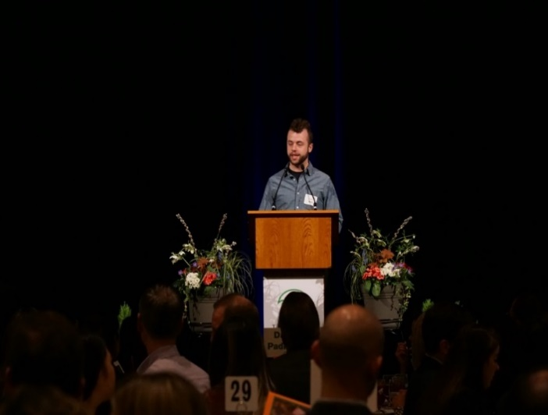 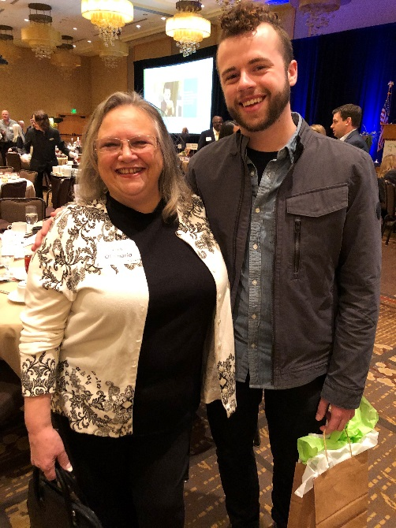

Jackson (above) as a presenter at the Friends of Youth *Celebration of Youth 2019*

**The** **Arc** **of** **King** **County**

~~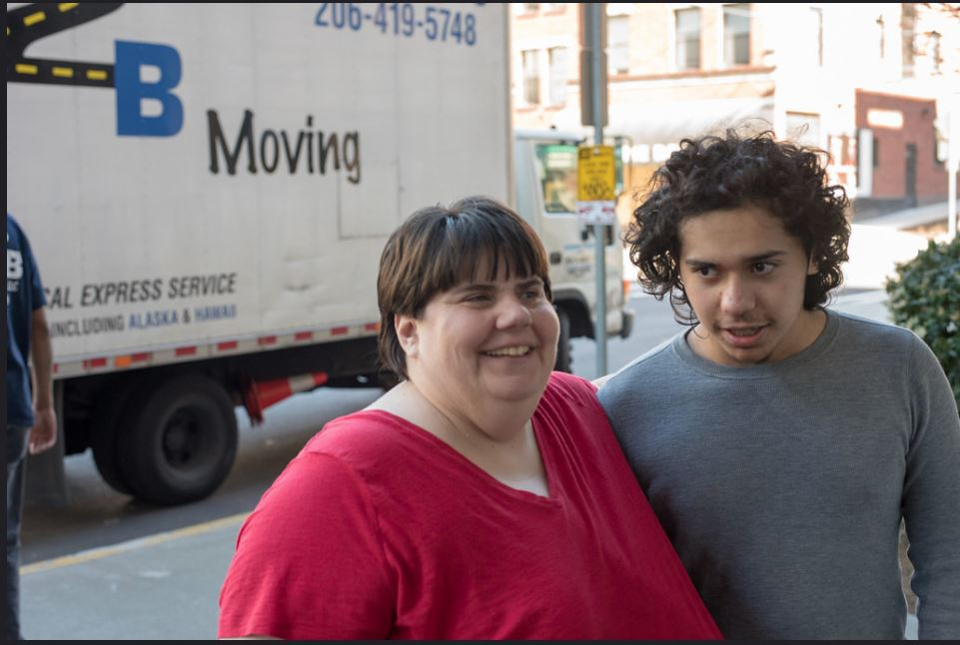~~

Terry and his son enrolled with the Arc of King County, which specializes in serving people with intellectual or physical disabilities. Social Security is their sole source of income, and Terry has worked hard to live frugally and make smart use of their available funds. In March 2017, however, the family experienced the imminent risk of homelessness after a long-term roommate moved out. An Arc of King County YFHPI case manager stepped in to help, offering case management services and flexible funding. The case manager worked closely with the landlord, who allowed flexibility with rental payments while they search for a new roommate.

Their hard-won stability faltered when, after a year, the new roommate left and once again, the family was at risk. With a limited income, affordable housing was the primary barrier to stability.

YFHPI staff searched every low-income housing opportunity and met with several landlords in an effort to find stable and secure housing. Concurrently, staff assisted the family to apply for other community resources such as utility assistance and food stamps. YFHPI program staff provided countless hours of encouragement, helping the family remain hopeful for a true housing solution.

In February 2019, hope became reality. The YFHPI team helped Terry secure a subsidized affordable housing unit in Seattle. Terry signed the lease and got the keys in March. The family moved in – their first truly stable home in nearly two years.

**Open Doors for Multicultural Families**

~~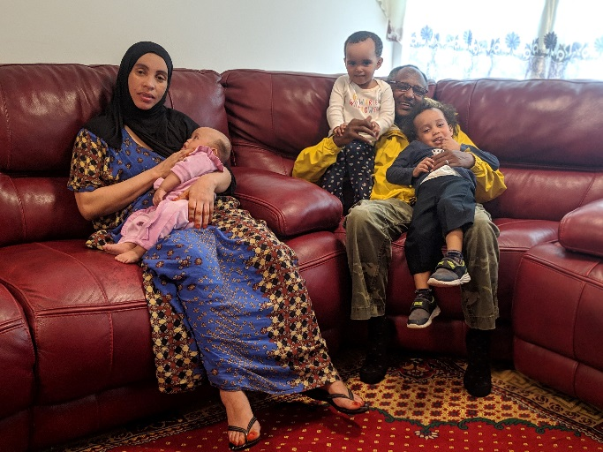~~This family lived in a one-bedroom apartment in the North Seattle area. Barely making ends meet financially, a one-bedroom unit was all they could afford and even then, they were rent-burdened. After the mother gave birth to their newborn, the landlord gave the now family of five notice to vacate based on family size. The family could not afford a larger apartment in the complex. With no money to pay for a move and no money for deposits, the family found themselves at a very high risk of becoming homeless.

Open Doors assisted the family with moving costs for an affordable two-bedroom apartment. Their YFHPI case manager worked hard to connect the family to SNAP and disability services, including Social Security disability for the baby. With assistance, mom is now planning on going to school and getting a part-time job to help support the family. The entire family is now in a much better situation.

**Therapeutic Health Services**

“As a teen, I experienced homelessness. After having my daughter, I didn’t want her to ever have to experience the trauma I experienced being homeless. I ran into a tough spot and she almost had to.

Because of the help I received through this program, we were able to avoid becoming homeless. I was able to get connected to community supports and I am now working full-time. Due to the case management I received, my daughter and I are now stably housed.”

Advancing Equity through YFHPI

YFHPI brought about the hiring of 25 case managers that represent various communities disproportionately impacted by homelessness, some who also bring the voice of lived experience. These talented staff greatly enrich the efforts of YFHPI. The initiative has relied on these “field experts” to provide the foundation to take a huge step forward in tackling one of the largest challenges in our community: homelessness.

In the fall of 2018, YFHPI staff met with community consultants in an effort to assemble a team that would move the community forward in learning how to reduce disproportionality for blacks and African American’s in the homeless system. With no curriculum or best practice available to direct this work, the goal was to bring in a team that would engage with and learn from the 25 YFHPI field experts. Talitha Consultants, LLC joined YFHPI in December 2018 to begin this effort. The 2019 BSK annual report will share more about the design, implementation, and early learnings of this project.

**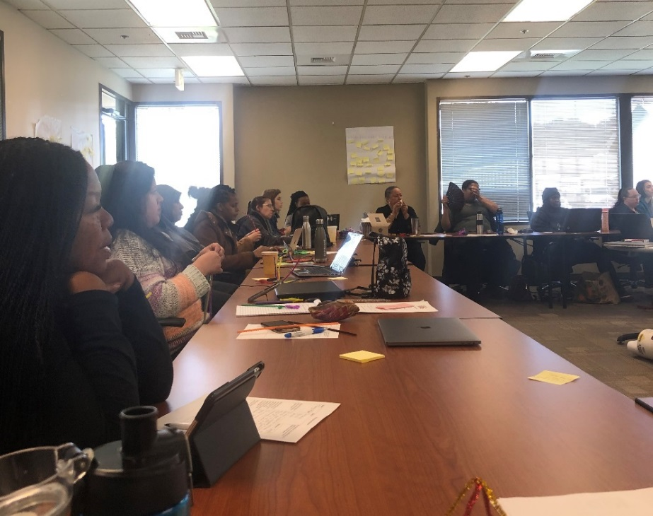**

EQUITY FOR ALL

YFHPI provided leadership in designing a homelessness prevention system that would target communities disproportionately represented in the homeless system. Funding agencies with access to youth and families identified in these communities has been critical to YFHPI’s overall success. Clients are more successful addressing their housing barriers when they are working with someone who can also break through cultural and language barriers. Two client stories capture why this cultural connection is so important.

**Vicky’s Story**: “My name is Vicky, I am from Congo. I lived in Nigeria as a refugee before I moved to the United States with my two children in November 2013. The life in America is not easy, you must be able to fight for yourself to become stable.

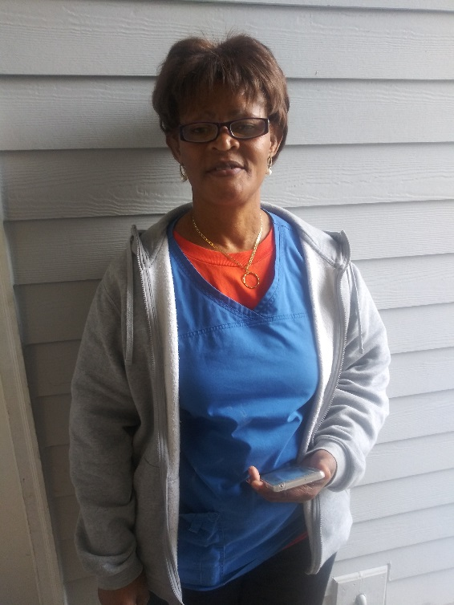“With no family to help me, it was not easy. I struggled to pay rent even though I was working. As a single mom with two kids in school, all of the bills fell to me and I couldn’t afford to pay everything. I borrowed money and wasn’t able to pay it back. I got notices to leave my apartment if I couldn’t pay all of the rent I owed. I was scared and felt so alone. A friend told me about Mother Africa. From the first time, they were always so helpful and friendly to me. I felt welcomed there. They understand me coming from my country and they have people there that speak my first language (French).

I was helped to secure my accommodation where I currently live. They helped me to pay past-due rent and then work on ways to get stabilized. I was helped with going to driving school and getting a license. Mother Africa also helped me find my current job, which pays more and is close to home. This month I celebrate a year anniversary at my job!”

**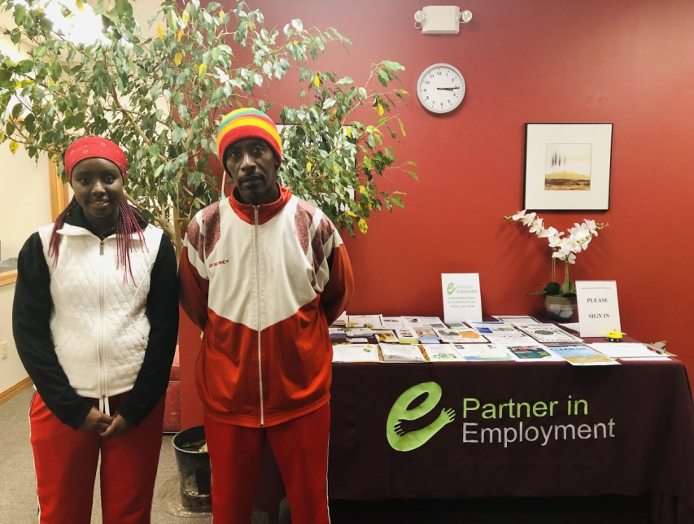Ermias’ Story:** “I am a single father. Last year my daughter came from Ethiopia to live with me, but I had lost my job and was struggling to pay rent. For a while, I had no income at all, and we were almost homeless.

As a parent, I was scared because I didn’t know how we were going to survive, but luckily, my community helped me get in contact with a case manager at Partner in Employment who could speak my language.

PIE paid my rent for two months, and also got me enrolled in an aerospace manufacturing program which I just completed, and now they’re helping me with my resume so that I can get a job to support my family. PIE also enrolled my daughter in their youth mentorship program so that she will continue to be successful in school and get life success mentorship from someone who understands our culture and speaks our language. I am so thankful for the great help and security that I've received from PIE - it has been a turning point for the success of my family.”

Leaders in Prevention



In June 2018, United Way of King County (UWKC) reached out to the YFHPI program to provide prevention services at the UWKC Family Resource Exchange (FRE), an event held quarterly in King County. FRE’s primary focus is assisting households struggling with homelessness; however, the first event saw many people who were not yet homeless.

YFHPI partners participated in the first FRE in August 2018 and have since collaborated in three more. FRE amplified the need for system-wide prevention services. YFHPI’s focus on serving youth and families at the highest need of prevention services also meant that single adults and families who needed rental assistance or eviction prevention services alone had no access to services at the FRE. King County began engaging with other funders to look at ways all needs in prevention could be available at future FREs.

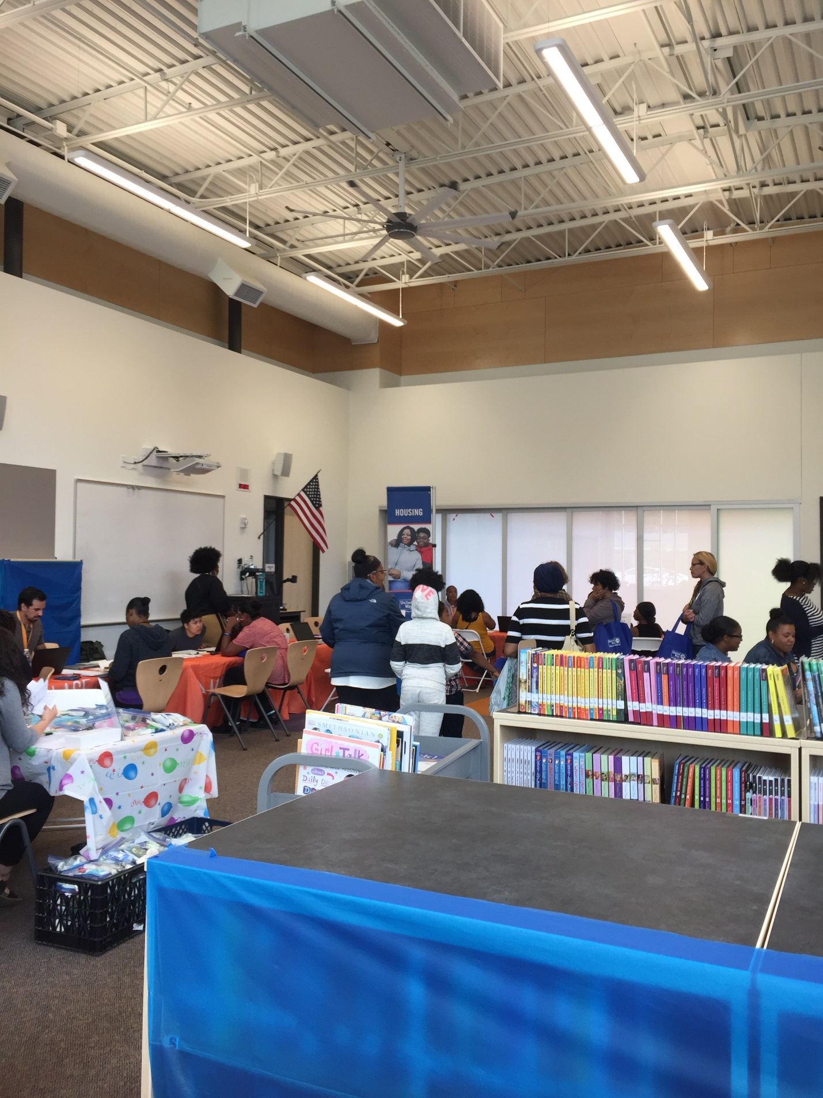

The response from prevention funders led to the creation of the **Homelessness Prevention and Shallow Rent Subsidy Leadership** team. Facilitated by King County, the team meets monthly to create a prevention system to meet the needs of the majority of households for whom homelessness could be avoided. The first pilot of a system-wide approach to prevention occurred at the UWKC Community Resource Exchange on March 13, 2019. Details and updates on this system design work will be included in the 2019 BSK Annual Report.

Program Performance and Outcomes: 2018 Data

The Department of Community and Human Services (DCHS) Performance Measurement and Evaluation team (PME) conducts data analysis to monitor program performance and client outcomes for the YFHPI. Demographic information and financial assistance numbers for those enrolled in the program during 2018 are shown, as well as the cumulative performance of the program from 2017 through 2018.

**Demographic Characteristics of the Clients**

The YFHPI served **1,571 families and 352 unaccompanied youth in 2018**, comprising more than 5,700 people all together. More than **60 percent were people of color**, consistent with data in the Homeless Management Information System (HMIS) that show people of color are at disproportionate risk of experiencing homelessness.

**Race**

The chart below shows the number of individuals of all ages who were served by YFHPI in 2018 by race. The second chart shows the race of youth ages 24 and under. Racial composition of children and youth was very similar to all clients served.

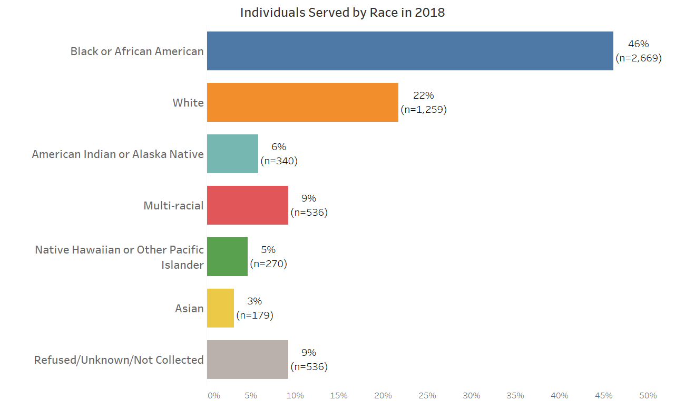

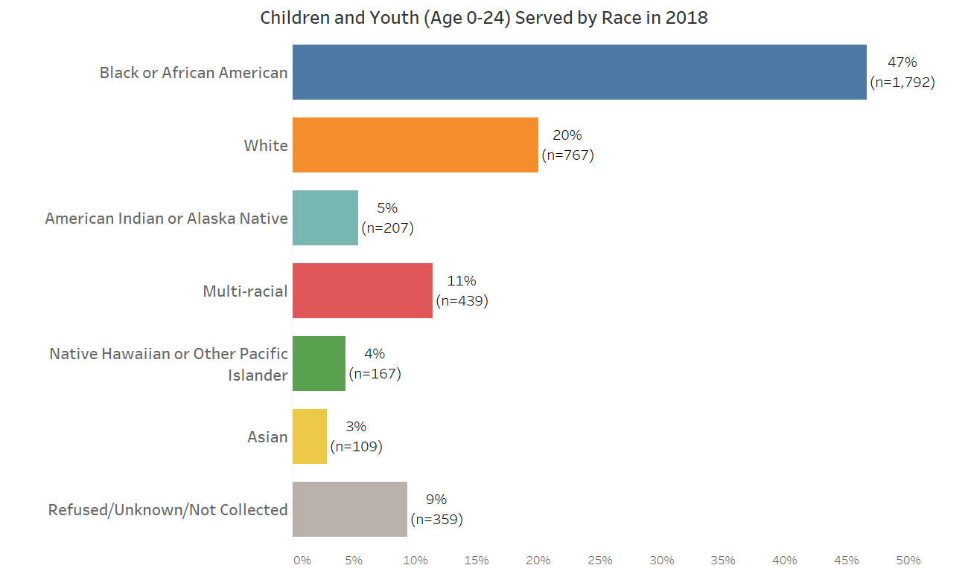

**Age and Household Type**

More than half of the clients served in 2018 were children under the age of 18 (N=3,330). The majority of youth under age 18 were children in families. There were 134 unaccompanied youth ages 18 to 24, and 134 families headed by young adults ages 18 to 24.

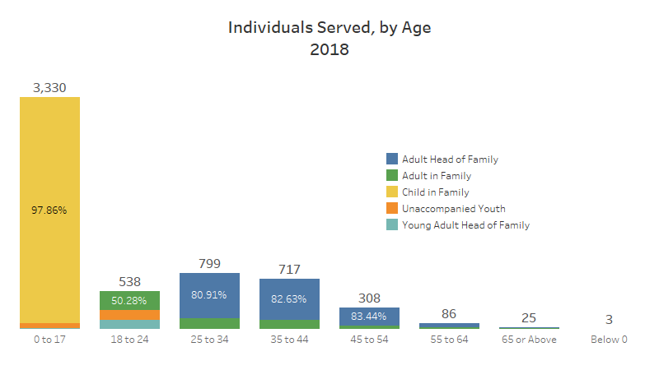

**Gender**

Sixty percent of clients served in YFHPI in 2018 identified as female and 40 percent identified as male; less than one percent identified as transgender. Among children in families, gender was evenly split, with 50 percent male and 49 percent female. However, the majority of young adults ages 18-24 were female, whether unaccompanied (54% female) or young parents (84% female). Most families had a female head of household (81%). Three percent of unaccompanied young adults and less than one percent of other adults identified as transgender.

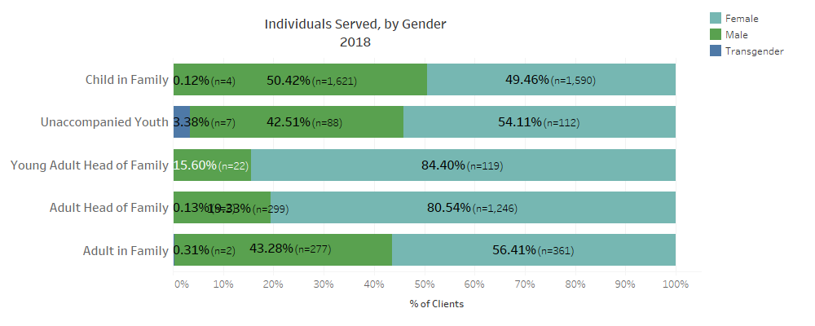

**Flexible Financial Assistance**

YFHPI providers used **$1.7M in flexible funds in 2018** to maintain stable housing and prevent homelessness. The average amount of financial assistance provided was about $1,900 per household. Past due rent and rent assistance were the most common types of financial assistance, accounting for almost three-quarters of all financial assistance as shown below.

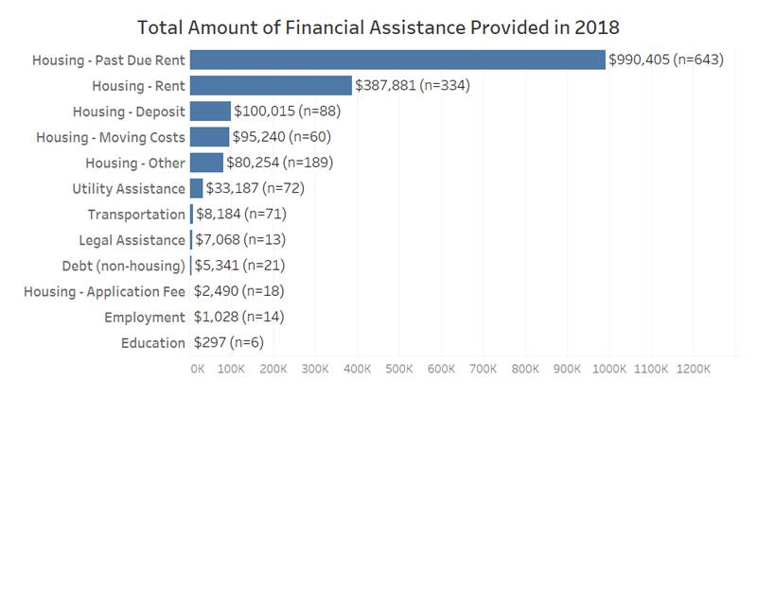

**Twenty-one** **percent of households did not need any financial assistance**, but rather were able to work with their case manager to resolve their housing crisis through other means.

**Ninety-four percent** of the households that exited YFHPI to any exit destination during 2017-2018 avoided becoming literally homeless.

The data shows that YFHPI is positively affecting the lives of thousands of people and preventing homelessness for vulnerable youth and families with children.

Evaluation – Year One: Design to Implementation

YFHPI has been extremely fortunate to collaborate with the [Wilson Sheehan Lab for Economic Opportunities](https://leo.nd.edu/) (LEO), a collaborative research center in the Department of Economics at the University of Notre Dame in Indiana (<https://leo.nd.edu>).

Not only have they collaborated with the County to design an evaluation that is meaningful and relevant to homelessness prevention efforts in King County, but they have repeatedly stepped up to work directly with the YFHPI case managers to ensure they feel equipped with the knowledge and resources they need to be part of such a complex evaluation process.

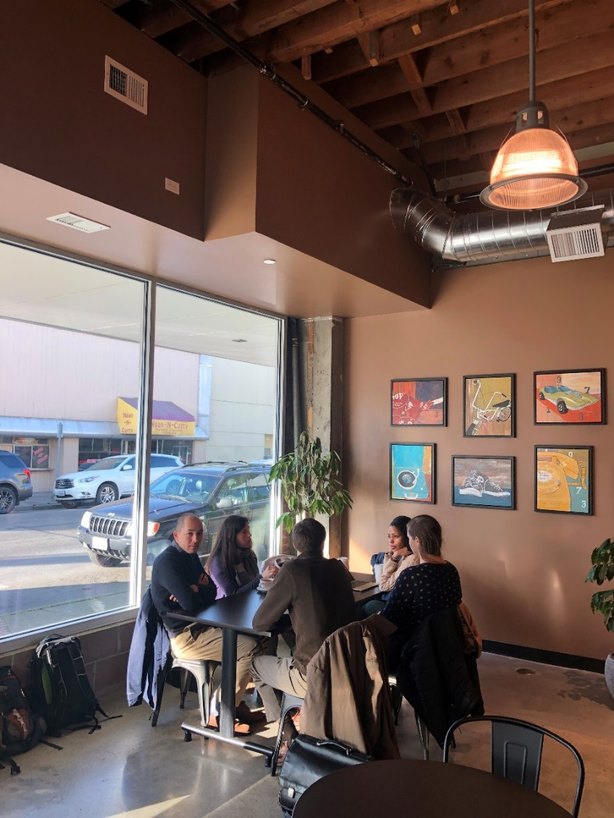

**Overview**

King County joined with Wilson Sheehan LEO to design a rigorous evaluation of the YFHPI. Using a randomized-controlled trial (RCT), the evaluation will compare the effectiveness of two different approaches to homelessness prevention to determine whether a model that includes case management and access to flexible funding yields better outcomes than financial assistance alone in prevention programs.

The study design allows testing of the hypothesis that the case management aspect of the YFHPI program is key to preventing homelessness and promoting long-term stability. YFHPI was designed under the belief that families at imminent risk of homelessness face a complicated set of barriers to housing stability that will not be adequately addressed by financial assistance alone. The study design allows testing that the combined program of financial assistance and case management has a significantly better impact on client outcomes as compared to financial assistance alone.

The two study groups are as follows:

1. **Case Management Plus Access to Flexible Funds**(standard YFHPI services): Half the participants will receive access to the usual YFHPI services as provided since the program’s implementation, i.e., a combined program of progressive case management and flexible financial assistance. With assignment to this group, participants will establish a relationship with their case manager and begin working with them to stabilize their housing situation. Regular case management activities include navigating interactions with landlords, identifying suitable housing, and other housing-specific activities, as well as broader activities related to budgeting, employment, dependent care, etc., that can support housing stability. Per the standard YFHPI model, case managers can directly provide financial assistance through flexible funds at their discretion – for example, if a case manager finds a client’s current rent to be unsustainably high, they may decline to use flexible funds to pay for a client’s current rent in favor of locating and putting a deposit on a more sustainable unit; and
2. **Flexible Funds Only**: The other half of participants will receive flexible financial assistance to address an immediate housing-related need, with the minimal case management needed to verify the financial need and process funding. Participants assigned to this group must provide verification of their need, and are guaranteed quick financial assistance once need has been verified. If need is not verified, they will not receive funds. Funding can be used to cover the same expenses that funding could be used for in the standard YFHPI intervention. As with the other group, the most common use of funds is for back rent.

Enrollment into the RCT began in May 2018 and is on track to conclude with 600 participants at the end of October 2019. There are currently 394 participants enrolled in the study, with their baseline characteristics shown in Table 2 of this section. Baseline characteristics across the two groups are balanced and indicate that the randomization process is working as intended.

Data is also being collected on the financial assistance and case management services provided to both study groups, as presented in Table 3. The data in Table 3 shows that while both groups are receiving similar amounts of financial assistance, the treatment group is receiving significantly more case management compared to the control group.

Primary outcomes will be measures of housing stability; secondary outcomes will include family welfare, criminal justice and employment. LEO will measure the extent to which clients who have access to case management will have a lower usage of homelessness services as well as better economic, health, criminal justice and other stability-related outcomes.

**Need for Rigorous Evaluation**

King County and the LEO research team chose this study design because of the current lack of rigorous research in the area of homelessness prevention. The current literature on homelessness primarily focuses on study participants that are already homeless, rather than samples that are at imminent risk of homelessness.

There have been few rigorous studies on preventing homelessness for families at imminent risk of becoming homeless. Evans, Sullivan and Wallskog (2016) found that those who called the Homelessness Prevention Call Center in Chicago when funding was available were 76 percent less likely to enter a homeless shelter within the next six months. Rolston et al. (2013) conducted an RCT to examine the impact of the New York Homebase Community Prevention program, a unique intervention aimed at keeping an at-risk population in their homes via case management services, referrals to other services, and limited financial assistance. The study showed that families with children assigned to the treatment group were significantly less likely to enter a shelter and that there was a mild level of cost savings to the program, though the study does not have statistical power to detect effects for outcomes beyond housing stability. Homebase is an evidence-based model for homelessness prevention, but there is no rigorous evidence as to how much the individually tailored but expensive case management element of the program mattered.

King County’s YFHPI study will be the first to compare financial assistance to a program that combines financial assistance with a comprehensive case management element. It will provide evidence on how to design the most effective package of homelessness prevention services. The study will also be the largest randomized homelessness prevention evaluation to date. Previous studies rely on either an approximation of random assignment or small samples.

Additionally, King County is working with the Research and Data Analysis (RDA) Division of the Washington State Department of Social and Health Services to expand the scope to study the programs’ impacts on arrests and incarcerations; behavioral health outcomes; use of emergency and hospital services; and child welfare outcomes. Behavioral health (i.e. mental health and substance use) and child welfare outcomes in particular have not been studied yet in well-powered, rigorous impact evaluations of homelessness prevention. The results of this study will not only inform decisions about how to best design homelessness prevention efforts in King County, but will be informative to policymakers in other regions looking to build prevention programs, and will contribute to the body of evidence surrounding effective design and targeting of homelessness prevention programs.

**Research Design**

The evaluation as designed is a randomized controlled trial. Approximately 600 participants will be enrolled in the study, with 300 in each arm of the intervention. Enrollment should be complete by the end of October 2019 and data will be collected for 12 months before final analysis begins.

Participants are randomly assigned to one of the two interventions: (1) Progressive case management plus access to flexible funds (standard YFHPI services); or (2) Flexible funds only, where clients receive access to flexible funding but do not establish a long-term relationship with a case manager. The study has been reviewed and approved by the Institutional Review Board (IRB) for the University of Notre Dame, which is responsible for ensuring that all studies by researchers from the University are designed and conducted in an ethical manner. Input and feedback from YFHPI case managers and supervisors informed the design of the interventions and the setting of eligibility requirements for the study.

The Seattle/King County Homelessness Prevention Vulnerability Tool, described earlier in this report, assigns clients with a risk score based on answers to a series of questions about previous experiences. According to the tool, prevention services are not a good fit for clients with a risk score under 15. Perspective clients must score at least a 15 to be eligible for YFHPI services and for participation in the study. Based on the experience of providers in King County and data on the distribution of risk scores in the City of Seattle, ethical considerations dictated that clients with a risk score above 28 be considered too high-risk to be offered a funds-only option. These clients are automatically enrolled in standard YFHPI services (case management plus access to flexible funds) and are not invited to participate in the study. All clients with a risk score within the “moderate risk” range (15-28) are invited to participate in the study, with the exception of domestic violence survivors and households headed by clients under the age of 18, who are de-identified in the YFHPI database by law.

Participation in the study is not required in order to receive services from YFHPI; clients in the moderate risk range may always choose to be directly enrolled in standard YFHPI services without participating in the lottery. Thus, the evaluation includes only clients who have some interest in a funds-only option.

Figure 1 on the following page illustrates the flow of clients into the study.

**Figure 1: Study Enrollment Process**

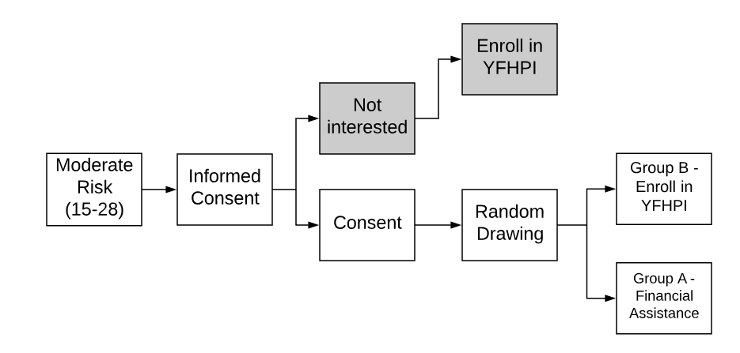

All case managers have participated in at least one of the in-person trainings provided by the research team on the study enrollment process and the elements of informed consent. Case managers have also been provided with extensive guides to reference during the study enrollment process.

**Randomized Control Trial Enrollment**

After a client receives a risk score within the eligible range, case managers explain the purpose of the study and provide eligible clients with the opportunity to consent to participate in the evaluation and the lottery in which they have some chance of immediate financial assistance without case management. Clients who choose to participate sign a consent form in their preferred language; in order to be as inclusive as possible, a translated version of the consent form is available in most of the languages commonly spoken by YFHPI clients. Participants are then randomly assigned on-the-spot into one of the two interventions, using a random assignment tool that has been coded into the existing YFHPI database.

The following table shows study enrollment as of April 2019: 394 clients chose to participate and were assigned into a group, about 32 households enrolled per month. If this rate continues, study enrollment should be complete in fall 2019.

**Table 1: Study Enrollment, May 2018-April 2019**

|  |  |
| --- | --- |
| **Group** | **Households** |
| Flexible Funds | 193 |
| Case management + Flexible Funds (Standard YFHPI Services) | 201 |
| Total Study Enrollments | 394 |

Table 2 (below), compares the characteristics of those assigned to each intervention. If the randomization is working correctly, there should be few statistically significant differences between the two groups. Table 2 shows that the two groups appear balanced; there are few significant differences between the two groups in the proportion of clients matching each characteristic listed in the table.

The table shows that over half the heads of household in the sample identified as Black or African American, a quarter as white, and the remaining quarter as multi-racial, Asian, Native Hawaiian, Pacific Islander, American Indian or Alaskan Native (note that the numbers on race do not add up to 100 percent because some clients did not provide this information). Additionally, approximately 10 percent of participants identified as Hispanic. Women head up about 80 percent of the households. The majority of households have experienced homelessness in the past, and a majority earn less than 30 percent of the area median income for their household size.

A test was conducted to determine the difference between the means for the flexible funds group, as compared to the case management group, for each characteristic. Generally, a p-value above 0.05 is considered a positive result on this test and indicates there is no significant difference between the two groups. Most of the characteristics below pass this test, providing overall confidence that the sample is well balanced. Similarly, an F-test does not reject the hypothesis that all the listed characteristics are balanced across the two groups (F=0.8; p = 0.68).

**Table 2: Balance Test - Characteristics of the Study Population at Baseline**

|  |  |  |  |
| --- | --- | --- | --- |
|  | Flexible Funds | Case Management + Flexible Funds | P-Value of Test of Difference in Means |
| Black or African American | 59% | 56% | 0.64 |
| White | 25% | 26% | 0.82 |
| Asian, Native Hawaiian or Pacific Islander | 6.7% | 7.5% | 0.78 |
| American Indian or Alaska Native | 2.1% | 3.0% | 0.57 |
| Multi-racial | 4.7% | 4.0% | 0.74 |
| Head of Household Age | 36.8 | 36.6 | 0.91 |
| Hispanic | 10% | 13% | 0.43 |
| Head of Household is Female | 81% | 78% | 0.43 |
| Any Household Member Has Disability | 26% | 28% | 0.66 |
| Housing Loss Expected in Less Than 3 Days | 33% | 33% | 0.98 |
| History of Homelessness | 62% | 49% | 0.01 |
| Less than 30% of Area Median Income (AMI) for household size | 79% | 78% | 0.78 |
| Number of Household Children | 2.0 | 2.1 | 0.48 |
| N | 178 | 192 |  |

**Interventions**

After consenting to participate, the study randomly assigns each household to one of the two groups. Table 3 below shows data on services that the providers have collected since the initial grant proposal. The table includes everyone enrolled in the study with at least eight weeks of follow-up data, excluding a handful of agencies for which data has been tracked, but not entered electronically.

**Table 3: Comparison of Services**

|  |  |  |
| --- | --- | --- |
|  | Flexible Funds | Case Management + Flexible Funds |
| Risk Score | 21.6 | 21.2 |
| Financial Assistance Amount | $1,373 | $1,238 |
| Any Financial Assistance Received | 88% | 80% |
| Number of Meetings | 3.5 | 7.8 |
| Total Time of Meetings | 5.6 | 11.3 |
| Time Spent on Intake | 2.7 | 3.0 |
| Time After Intake | 2.8 | 8.1 |
| N | 135 | 152 |

In practice, average financial assistance is fairly similar between the two groups. As shown in the table, the ‘financial assistance only’ group averages $1,373 per family and the ‘case management + financial assistance’ group averages $1,238. These turned out to be nearly equal for several reasons. First, while members of the ‘financial assistance only’ group are more likely than those in ‘case management + financial assistance’ to receive any financial assistance (88% vs. 80%), some do not receive assistance because they do not provide sufficient documentation. Second, the ‘case management + financial assistance’ group has a deeper connection to the program, which seems to lead to slightly larger payments, conditional on any payment. In the end, while there are differences in financial assistance, the actual payments provided are similar.

Thus, the primary difference between the services provided to the two groups is the level of case management. Both groups receive some staff time to complete the enrollment process, arrange for payment, and verify documents. Thus, meeting time spent on intake is similar, 2-3 hours for both groups. The ‘case management + financial assistance’ group, however, receives more case management after intake. To date, this group has received 8.1 additional hours of case management compared to 2.8 hours for the financial assistance only group. Note that these values are underestimates since group B may continue to receive case management for many weeks after enrollment. To date, the case management group has received roughly triple the in-person time after intake.

**Outcomes**

A primary outcome will look at usage of emergency housing services. Information on entrance to emergency shelters, enrollment in rapid re-housing programs, and other housing assistance programs is available through the King County HMIS. King County already has access to these records and a data sharing agreement signed to facilitate the use of these records for the evaluation.

Another primary outcome will address stability as measured using consumer reference data. These address data will come from Infutor, a consumer reference data company that aggregates records from various sources (e.g. utility bills) to construct address histories for most people in the United States. Similar address history data has been used, for example, to longitudinally follow residents affected by rent control in San Francisco (Diamond et al. 2018). Compared to shelter entry, the existence of a formal address in such data is a more comprehensive measure of homelessness and its absence more likely to capture unsheltered homeless families. This data can measure housing stability using the end date of a given housing spell and moves from one location to another. LEO has a signed data use agreement with Infutor allowing access to this data for this study.

Secondary outcomes will include behavioral health, criminal justice, healthcare, employment, public benefit, and child welfare outcomes. King County DCHS hosts both the YFHPI program and behavioral health programming, making it straightforward to record behavioral health service usage and outcomes. A clear process exists for linking to additional outcomes through the DSHS Research and Data Analysis section. They have internal data on many means-tested programs such as Temporary Assistance for Needy Families (TANF), SNAP, and subsidized healthcare. Child protection and foster care data are also internal to DSHS. For their own purposes, DSHS has linked these data to other datasets: arrests (State Patrol), inpatient and emergency department visits (hospitals), and earnings. King County is working with RDA to obtain permission to access these records from the Washington State Institutional Review board, as well as from each agency that created the records.

It is important to note that the study will only analyze and publish results on outcomes in aggregate. The study will measure the average differences between those enrolled in the two interventions, but will not analyze or publish individual results.

**Timeline & Next Steps**

The YFHPI and research team will continue to support the case managers with training and technical assistance as study enrollment continues. The research team visited King County in March 2019 to provide a refresher on study enrollment. YFHPI Program Managers will provide one-on-one technical assistance to individual case managers through enrollment observations in the coming months toward completing enrollment in fall 2019.

Over the next six months, the research team will continue to work with RDA to obtain approval from the Washington State IRB as well as from the agencies holding administrative records on behavioral health, criminal justice, healthcare, employment, public benefit, and child welfare outcomes.

The study will look at outcomes at six, 12 and 24 months following study enrollment. The lag on updating the administrative databases will determine how quickly outcomes are accessed and analyzed. A final report at the conclusion of the study will include all outcomes through 24 months of follow-up.

Conclusion

YFHPI experienced a year of growth in 2018. Case managers continued to advance their skills in identifying households at imminent risk of homelessness and began implementing a true homelessness prevention model that effectively targets families at imminent risk. Training prepared case managers to work effectively with an external evaluator in the randomized controlled trial. YFHPI partners took their professional skills out into the community, providing leadership at Community Resource Exchange events and assistance to people in need. Looking ahead, the YFHPI case managers plan to continue to improve motivational interviewing skills to help clients better determine their own path to housing stability. Case managers will also play a critical role in working to learn why homelessness continues to impact black and African American households at a greater rate than any other racial group and to develop better interventions to assist those households. Finally, work will continue toward achieving full enrollment and proceeding with the independent evaluation.