## STAFF REPORT

|  |  |  |  |
| --- | --- | --- | --- |
| **Agenda Item:** | 6 and 7 | **Name:** | Mike Reed |
| **Proposed No**.: | 2021-0187  2021-0190 | **Date:** | May 18, 2021 |

**SUBJECT:**

The Executive Proposed 2022 Sewer Rate and Capacity Charge and related wastewater supplemental budget ordinance.

**SUMMARY:**

King County's sewer rates are set for the following year by June 30 of each year, pursuant to contract with participating utilities. The Executive has transmitted Proposed Ordinance 2021-0187 setting the sewer rate and capacity charge for 2022. The Proposed Ordinance would:

* Increase the **monthly sewer rate** effective in 2022 by 4.0% to **$49.27** per residential customer equivalent (RCE) per month; and
* Set the **monthly capacity charge** for new connections to the regional system occurring in 2022 at **$70.39** per RCE per month, which is a 3.0% increase over the 2021 rate of $68.34;

By contract with partner cities and sewer districts, the county is to complete its consideration and action on the sewer rate to provide for an effective date for the legislation on or before June 30, 2021. (*Note: partner city and sewer districts act after the county sets the sewer rate to establish their local rates, all of which go into effect on January 1, 2022*)

The Executive has also transmitted Proposed Ordinance 2021-0190, which is a supplemental appropriation ordinance that would authorize expenditures to initiate project work on backlogged Asset Management projects and to fund costs for lease of space to house agency employees. The proposed ordinance setting the sewer rate and capacity charge for 2022 would provide the revenue base for these Asset Management and lease projects.

**BACKGROUND**

**Monthly Sewer Rate.**King County provides wastewater treatment services for 17 municipalities and 17 sewer districts (including the Muckleshoot Tribe) in King County, southern Snohomish County, and the northern tip of Pierce County. The county provides sewer interceptor lines that receive wastewater collected from residences and businesses by the cities and sewer districts, who bill their customers directly for both county and local utility charges. The sewer rate is charged by the county to the utilities to deliver, treat and discharge wastewater.[1]

The monthly sewer rate collected by the county goes to support all Wastewater Treatment Division (WTD) expenses, including operating costs, debt service, and capital expenses. The monthly sewer rate for both residential and commercial customers is calculated on the basis of Residential Customer Equivalents (“RCEs”).[2]

**Table 1.**

**Sewer Rate (2009-2021 Actual; 2022 Proposed; 2023-2025 Projected)**

| **Year(s)** | **Rate**  **($/RCE/ Month)** | **% Increase** |
| --- | --- | --- |
| 2009 – 2010 | $31.90 | 14.1% |
| 2011 – 2012 | $36.10 | 13.2% |
| 2013 – 2014 | $39.79 | 10.4% |
| 2015 – 2016 | $42.03 | 5.6% |
| 2017 | $44.22 | 5.2% |
| 2018 | $44.22 | 0.0% |
| 2019 | $45.33 | 2.5% |
| 2020 | $45.33 | 0.0% |
| 2021 | $47.37 | 4.5% |
| **2022** | **$49.27** | **4.0%** |
| 2023 | $51.25 | 4.0% |
| 2024 | $53.30 | 4.0% |
| 2025 | $55.44 | 4.0% |

Table 1 above depicts the anticipated sewer rates through 2025 according to the transmittal. Increases have historically been structured effectively as biennial rates, with rate adjustments in alternating years. Rates going forward are projected to increase annually, rather than biennially. This recommendation comes after extensive engagement with the Metropolitan Water Pollution Abatement Advisory Committee (MWPAAC).

The Executive transmittal has referenced a number of rate drivers that impact this 2022 proposal (Attachment 6 to the Staff Report):

* *West Point Treatment Plant power reliability investments.* Council approved legislation in February 2021 continuing an Emergency Declaration to respond to a Department of Ecology administrative order requiring an undertaking to address the reliability of the power supply at West Point Treatment Plant. WTD is beginning work to address “voltage sags” that have historically impacted operations at the plant during storm-driven wind and rain events.
* *Combined Sewer Overflow (CSO) cost estimates.* Newly-available estimates for the cost of completing CSO projects are incorporated into the proposed rate; negotiations are currently underway with the Environmental Protection Agency and the Department of Ecology to extend the required completion date for those projects from 2030 to 2040. The proposed rate extends those costs to 2040, on the assumption of a favorable outcome to negotiations.
* *Asset Management Catch-Up.* The physical plant, including many of the conveyance pipelines as well as the West Point and South treatment plants, are over 50 years old, and are experiencing significant upgrade, repair or replacement needs. The Council was briefed during the 2021-2022 budget process regarding a backlog of asset management projects that, if unaddressed, can affect the performance of the system. This rate proposal provides for a “catch-up” process which would complete all the asset management projects by 2033. It includes an asset management “strike team” to support progress on the asset management catch-up. (Proposed Ordinance 2021-0190, summarized at the end of this staff report, would provide expenditure authority to support the early phase-in of this “strike team” as well as for a number of priority Asset Management projects delayed from last year’s rate consideration.)
* *Covid-19 impacts.* The agency anticipates a reduction in sewer rate revenue for 2021 associated with the COVID-19 economic slowdown; that reduction will impact 2022 revenues due to the billing structure of the agency, which bills for current services in future quarters. The revenue reductions are expected to be offset by savings from record-low interest rates impacting the cost of new borrowing and refinancing of existing debt.

***Capacity Charge***

New connections to the regional wastewater system are assessed a capacity charge, based on the policy of “growth pays for growth”[3]. Payment may be made in a lump sum or paid over a 15 year period. Table 2 presents the proposed charge as the monthly payment over 15 years.

**Table 2.**

**Capacity Charge (2012-2020 Actual; 2021 Proposed; 2022-2025 Projected)**

|  |  |  |
| --- | --- | --- |
| **Year** | **Rate/Month/RCE**  **15-yr. duration** | **% Increase** |
| 2012 | $51.95 | 3.0% |
| 2013 | $53.50 | 3.0% |
| 2014 | $55.35 | 3.5% |
| 2015 | $57.00 | 3.0% |
| 2016 | $58.72 | 3.0% |
| 2017 | $60.80 | 3.6% |
| 2018 | $62.60 | 3.0% |
| 2019 | $64.50 | 3.0% |
| 2020 | $66.35 | 2.9% |
| 2021 | $68.34 | 3.0% |
| **2022** | **$70.39** | **3.0%** |
| 2023 | $72.50 | 3.0% |
| 2024 | $74.68 | 3.0% |
| 2025 | $76.92 | 3.0% |

Consistent with the Regional Wastewater Services Plan policies, the capacity charge is based on the estimated costs of the 30-year Regional Wastewater Services Plan (RWSP).[4] The capacity charge is set at a level to recover the designated, growth-related costs that are not covered by the monthly rate payments of newly connecting customers. Over the planning period of RWSP (2003 – 2030), the capacity charge and monthly rate payments of newly connecting customers will cover 95% of growth-related costs.

Unlike the monthly sewer rate, the capacity charge is directly billed by and paid to King County. Based on information provided by the cities and sewer districts, King County notifies new connecting customers of the option to pay over time (15 years) or in a lump sum. The lump sum payment is less than the total dollar value of the 15 year option since the cost of financing the long-term payment is deducted.

The Council approved revisions to the capacity charge rate structure in 2020, in recognition of emerging housing options like Accessory Dwelling Units and microhousing; and in acknowledgement of the imbalance of a charge that assessed the same amount for small and large single family dwellings. The revisions are tied to the average number of persons per household by housing type. Smaller single family homes—under 1500 square feet (s.f.) are assessed at 0.81 RCE; mid-sized homes—1,500 s.f. to 2,999 s.f.-- are assessed at 1.00 RCE; and large homes, over 3,000 s.f., are assessed at 1.16 RCE. Accessory Dwelling Units are assessed at 0.59 RCE, and there were small changes to the rates charged for multifamily units.

**Local Jurisdiction Sewer Rates.**As noted, cities and sewer districts are responsible for collecting wastewater from homes and businesses within their jurisdictions; they assess a separate charge in addition to the county sewer rate and capacity charge described here. To provide a sense of the total wastewater charges a residential ratepayer might pay, staff has reviewed the rates of several jurisdictions to identify the sewer charge they assess[5]. Local charges vary substantially; some are fixed rates monthly, while some are variable based on water consumption. Most do not include a local separate connection charge tied to local system growth costs, though one of the selected jurisdictions below does (Bellevue assesses a Capital Recovery Charge of $22.83/mo. for 10 years—not included in the example below). Some local jurisdictions may also provide a discount to low-income ratepayers—those discounts are not addressed in this summary.

The five jurisdictions referenced in Table 3 below are randomly selected, and may or may not be representative of the 34 city and sewer district jurisdictions that partner with the Wastewater Treatment Division in delivery of wastewater services. These are 2021 rates. 2022 rates will be established following the county’s determination of its rate through Proposed Ordinance 2021-0187.

**Table 3.**

**2020 Sewer Rate (per month) — Selected Local Partner Jurisdictions**

|  |  |  |  |  |
| --- | --- | --- | --- | --- |
| **Northshore Utility District** | **Renton** | **Bellevue (variable)** | **Sammamish Plateau WSD** | **Soos Creek WSD** |
| $14.59 | $31.12 | $36.97 | $37.96 | $19.13 |

A given ratepayer, depending on jurisdiction, water usage, application or non-application of a local connection charge, may pay a local sewer rate that varies substantially from case to case. For illustrative purposes, if the $31.12 Renton local charge identified above were added to the county’s 2021 rate of $47.37, the ratepayer would be paying $78.49/mo. (collected by the city; county’s portion is passed through to the county). In addition, if that ratepayer had connected to the system in 2021, and selected to pay the monthly rate rather than the full up-front cost of the capacity charge, that ratepayer would be paying an additional $68.34/mo. for the capacity charge which would be paid directly to the county. The total cost for the Renton ratepayer would be $146.83/mo. for both the sewer rate and capacity charge.

**ANALYSIS**

**Operating Revenues.**According to the Technical Memo accompanying the transmittal (Attachment 5), 2022 operating revenues are projected at $549.3 million, $16.2 million (3.0%) more than 2021 operating revenues. Increases in sewer rate revenue of $16.3 million are associated with the proposed 2022 sewer rate increase of 4.0%, and with RCE forecasts. Table 4 provides a summary of all revenues to support Wastewater operations and capital.

**Table 4.**

**Revenues Supporting Wastewater Operations and Capital (in $ millions)**

|  |  |  |  |  |  |  |
| --- | --- | --- | --- | --- | --- | --- |
|  | **2021 Forecast** | **2022 Forecast** | **Difference** | **% Change** | **2023 Forecast** | **% Change** |
| **Sewer Rate** | $417.3 | $433.6 | $16.3 | 3.9% | $464.1 | 7.0% |
| **Capacity Charge** | $92.9 | $96.0 | $3.1 | 3.4% | $98.9 | 3.0% |
| **Investment Income** | $4.5 | $3.2 | ($1.3) | -28.1% | $2.6 | -18.6% |
| **Other Income** | $18.5 | $16.5 | ($2.0) | -10.7% | $16.6 | 0.6% |
| **Rate Stabilization** | - | - | - | 0.0% | - | 0.0% |
| **Totals** | **$ 533.1** | **$ 549.3** | **$ 16.2** | **3.0%** | **$ 582.2** | **6.0%** |

Operating revenues reflect both the rate charged, and the numbers of residential and commercial accounts and their flow volumes—translated into Residential Customer Equivalents (the sewer rate and capacity charge rate are assessed per monthly RCE). As RCE’s increase or decrease based on population growth and economic conditions, corresponding changes are reflected in total operating revenues. RCE counts have been impacted by the economic slowdown associated with the COVID-19 pandemic, as businesses and industrial plants have reduced operations or closed. The table below depicts the projected impacts of these RCE reductions on revenues, in terms of proportionate reductions in RCE counts and associated revenue impacts.

**Table 5.**

**Impact of COVID-19 Economic Slowdown on RCEs and Revenues**

|  |  |  |  |  |  |
| --- | --- | --- | --- | --- | --- |
|  | **Quarter 1** | **Quarter 2** | **Quarter 3** | **Quarter 4** | **Total Shortfall** |
| **2020** | 1.9% | (15.1%) | (13.5%) | (10.0%) | ($649,056) |
| **2021** | (15.0%) | (15.0%) | (10.0%) | (10.0%) | ($21,682,191) |
| **2022** | (10.0%) | (15.0%) | (5.0%) | (5.0%) | ($24,340,266) |
| **2023** | 0.0% | 0.0% | 0.0% | 0.0% | ($16,067,252) |
| **Total** | | | | | **($62,738,765)** |

Information provided by the agency at the end of 2021 described a number of offsetting impacts to COVID-19 related revenue shortfalls. Historically low interest rates resulted in a reduced cost of borrowing for the agency, which relies heavily on bond sales and federal and state loans to support capital budgets. In addition, there were savings realized in agency operations; together, these reduced costs and savings largely offset the impacts of the economic slowdown to the WTD budget.

**Operating Expenses.** For 2021 and 2022, operating expenses are projected at $175.8 million and $177.1 million respectively. Table 6 compares the forecast of operating expenses from the 2022 Proposed Rate to the 2021 Adopted Rate.

**Table 6.**

**Operating Expenses — 2022 Proposed Rate, 2021 Adopted Forecast (in millions)**

|  |  |  |  |  |  |  |
| --- | --- | --- | --- | --- | --- | --- |
|  | **2021** | **2022** | **2023** | **2024** | **2025** | **2026** |
| **2022 Proposed Rate Forecast** | ($175.8) | ($177.1) | ($182.8) | ($192.2) | ($202.7) | ($211.4) |
| **2021 Adopted Rate Forecast** | ($173.1) | ($181.9) | ($191.6) | ($203.1) | ($213.4) | ($221.8) |
| **Difference** | **$2.7** | **($4.8)** | **($8.8)** | **($11.0)** | **($10.7)** | **($10.4)** |

**Capital Revenue.** Revenue support for capital expenditures is derived from both rate-supported cash transfers to capital accounts, and from borrowing, including bond sales, state and federal loans and other debt instruments. Cash transfers are intended to provide 40% of the cost of capital projects in cash, over time. This cash-funded capital helps to assure sufficient “debt coverage”—the amount of revenue available to pay regular debt obligations, described as, for example, “1.5x” (one-and-a-half times the amount of revenue available compared to that needed to pay debt payments due). Table 7 below illustrates the various standards for debt coverage, and the wastewater system’s debt coverage level for 2019.

**Table 7.**

**Debt Coverage Standards**

|  |  |  |  |  |  |
| --- | --- | --- | --- | --- | --- |
| **Minimum Requirements of Debt Covenants and Code** | **Minimum for Rate Setting—Debt Review Recommendations** | **2019 Actual** | **Moody’s Recc. for Aa Rating** | **S&P Recc. for Aa Rating** | **2018 Median for Aa Sewer Utilities** |
| **1.15x** | **1.40x** | **1.57x** | **1.70x** | **1.40x** | **2.20x** |

Table 8 below describes the recent debt rating history of WTD debt instruments, and the debt coverage ratio history.

**Table 8.**

**WTD Debt Coverage Ratios and Rating History**

|  |  |  |  |  |  |  |  |  |  |  |  |  |
| --- | --- | --- | --- | --- | --- | --- | --- | --- | --- | --- | --- | --- |
|  | **2008** | **2009** | **2010** | **2011** | **2012** | **2013** | **2014** | **2015** | **2016** | **2017** | **2018** | **2019** |
| WTD Debt Ratio | 1.24x | 1.33x | 1.30x | 1.32x | 1.28x | 1.33x | 1.33x | 1.36x | 1.41x | 1.51x | 1.49x | 1.58x |
| S&P Rating | AA+ | AA+ | AA+ | AA+ | AA+ | AA+ | AA+ | AA+ | AA+ | AA+ | AA+ | AA+ |
| Moody’s Rating | Aa3 | Aa3 | Aa2 | Aa2 | Aa2 | Aa2 | Aa2 | Aa2 | Aa2 | Aa1 | Aa1 | Aa1 |

Bond sales and loans result in outstanding debt that is repaid by regular debt payments, supported by the sewer rate. Chart 1 below illustrates the declining amount of overall existing debt principal, from approximately $3.4 billion currently to approximately $2.4 billion in 2031. That decline, however, is expected to be offset by increasing amounts of new debt, amounting to more than $2 billion in principal by 2031.

**Chart 1.**

**Outstanding Debt – Existing and New**

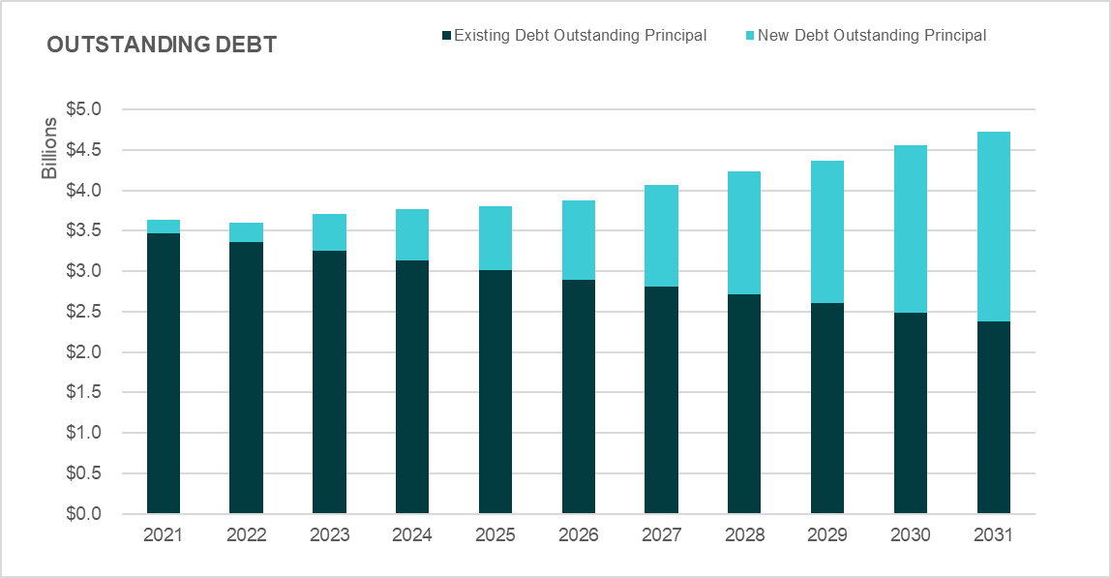

**Capital Expenditures.** Table 9 below shows the differences in WTD's proposed Capital Spending Plan compared to the capital spending projections made in the adopted 2021 rate. Projections for 2022 anticipate significantly higher expenditure levels for capital projects than had been forecast in the 2021 rate forecast.

**Table 9.**

**WTD Capital Spending Plan (in $ millions)**

|  |  |  |  |  |  |  |  |
| --- | --- | --- | --- | --- | --- | --- | --- |
|  | **2021** | **2022** | **2023** | **2024** | **2025** | **2026** | **2027** |
| **2022 Proposed Rate Forecast** | ($258.8) | ($307.9) | ($334.6) | ($312.6) | ($299.0) | ($344.7) | ($467.0) |
| **Rate of Increase from previous year** |  | 19.0% | 8.7% | -6.6% | -4.3% | 15.3% | 35.5% |
| **2021 Adopted Rate Forecast** | ($271.8) | ($298.5) | ($338.7) | ($331.4) | ($305.9) | ($408.9) | ($560.5) |
| **Rate of Increase from previous year** |  | 9.8% | 13.5% | -2.2% | -7.7% | 33.7% | 37.1% |

As a means of illustrating the purposes that the capital budget supports, the agency has categorized its capital expenditures according to major functional areas, or “portfolios”. The portfolios include:

* Regulatory – Projects and programs that respond to regulatory, permit, or consent decree legal deadlines
* Asset Management: Plants and Conveyance – Rehabilitation or replacement of critical assets at treatment plants or in wastewater conveyance network
* Resiliency – Improve the survivability and operability of core assets against natural disasters by addressing known deficiencies
* Operational Enhancements – Reduce operating costs at treatment plants through projects that create efficiencies
* Capacity Improvement – Increase capacity at WTD facilities to accommodate growth
* Resource Recovery – Projects that reduce energy use or recover resources with value from wastewater such as methane gas or reclaimed water

Chart 2 below depicts the anticipated proportional growth in expenditures in the portfolios, as well as substantial growth in projected total capital expenditures. Asset management at treatment plants, responding to the aging of the system, and regulatory projects required by federal or state regulatory entities, show the greatest expenditure growth through 2031, with projects to increase the capacity of treatment plants and pipelines, associated with population growth, also showing major increases.

**Chart 2.**

**Capital Expenditure Growth by Portfolio**



As noted above, upgrades the wastewater conveyance system is one of the major capital expenditures required to manage the system. Chart 3 below illustrates the age range of interceptor conveyance lines throughout the system.

**Chart 3.**

**Interceptors By Age**

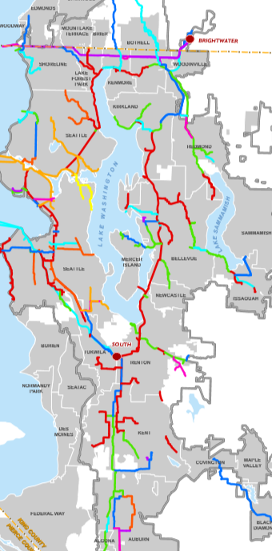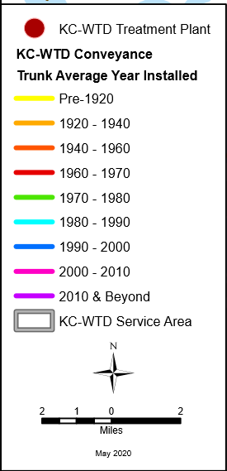

The map above illustrates that a large proportion of the system was built before 1970 and is at or nearing 50 years of service life. In addition to the physical condition of conveyance lines, their age may raise capacity issues. The Division’s Conveyance System Improvement project is intended to assure that the system is capable of conveying wastewater volumes expected for peak 20 year storms. As regional population growth continues, the agency is pressed to address these emerging capacity needs.

As noted, the asset management needs are not confined to the conveyance system; the treatment plants—two of which are over 50 years old—also are the focus of asset management evaluation. The agency indicates that, for the system as a whole, they have identified a priority asset management inventory of $1.18 billion in projects, as depicted in Chart 4 below. Also depicted is the West Point Power Quality/Reliability project, approved by Council in February 2021.

Chart 4 illustrates the additional Asset Management project costs that the agency anticipates in coming years. This $1.18 billion in priority projects was initially described as part of last year’s rate cycle.

**Chart 4.**

**Asset Management Inventory**

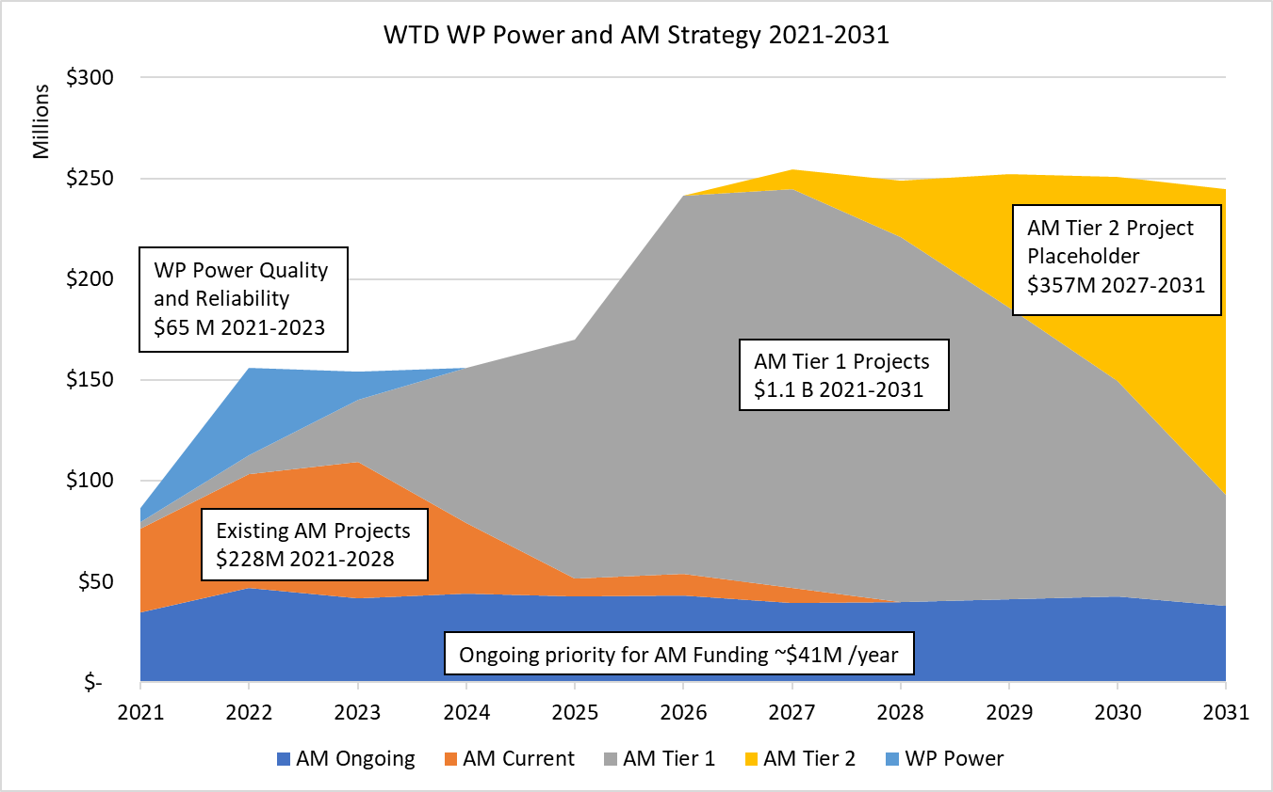

The historic mid-century project to restore the water quality of Lake Washington, which was the original undertaking of Metro government, is often cited as a major regional accomplishment. That project was begun in the late 1950s, with construction of wastewater facilities—plants and interceptor pipelines—getting underway in the 1960s. The extensive construction of that period is now reaching the end its service life, much of it at about the same time, placing intensified asset management pressure on the wastewater capital program.

The capital program also supports the Combined Sewer Overflow program. The agency is required by a Consent Decree to complete a total of 14 Combined Sewer Overflow projects by 2030; negotiations are underway with the Environmental Protection Agency and the Washington Department of Ecology to extend that deadline until 2040. The transmitted rate assumes the success of those negotiations; revenues to support remaining projects are not included in projected revenues through 2030. A number of projects are currently underway—including the Joint Ship Canal project, and the Georgetown Wet Weather Treatment Plant. Four earlier projects have been completed. Remaining projects (some of these are combined projects) include the Hanford/Lander/Kingdome/King Street (HLKK) Wet Weather Treatment Station, the Montlake Storage Tank/Green Stormwater Infrastructure, and the University Storage Tank/Green Stormwater Infrastructure.

**Metropolitan Water Pollution Abatement Advisory Committee Comments.** The Metropolitan Water Pollution Abatement Advisory Committee (MWPAAC) advises the King County Council and Executive on matters related to water pollution abatement. It was created by state law (RCW 35.58.210) and consists of representatives from cities and local sewer utilities that operate sewer systems within King County’s sewer service area. These cities and sewer utilities deliver their sewage to King County for treatment and disposal.

MWPAAC has forwarded an advisory letter, Attachment 4, which is included in the transmittal. MWPAAC’s comments come in the context of revisions to the proposed 2021 rate package. The initial recommendation by WTD to the Executive was for a 0.0% rate increase for 2022, in light of continuing COVID-19 revenue and cost challenges to partner agencies--with large increases in the outyears on a biennial schedule. MWPAAC had expressed an interest in a more steady, gradual and predictable pattern of increases, beginning with a 4.0% increase for 2022. The transmitted rate proposal includes the recommended 4.0% 2022 rate, with annual rate increases rather than larger biennial projected increases.

The MWPAAC letter indicates:

* Confirmation that MWPAAC supports the Executive-Proposed 4.0% rate increase for 2022;
* A request for annualized rate increases going forward, rather than rate increases on a biennial schedule;
* Request for clarification of anticipated asset management cost projections over coming decades;
* Request for preliminary estimate of the impact of the Nutrients rule changes on sewer rates;
* Emphasis on the need for MWPAAC input on the Clean Water Plan, and cost estimates associated with possible changes resulting from the planning process;
* Concern about the assumption in the rate proposal of the shift of the bulk of combined sewer overflow costs to the 2030-2040 decade, in the context of discussions with the Environmental Protection Agency regarding modification of deadlines for completion of required combined sewer overflow projects.
* The need for more time for MWPAAC to review proposed rates prior to transmittal;
* The scope, nexus to wastewater programs, and rate implications associated with the Executive’s “Clean Water, Healthy Habitats” program;
* Concern regarding increases in cumulative system debt as capital costs continue to grow; and
* A desire for reliable construction time schedules, and an appeals process to review any changes in prioritization, to allow for consideration of impacts on local agencies.

**Proposed Ordinance 2021-0190.** During the 2021 sewer rate discussion that occurred in Spring of 2020, the Executive identified a number of high-priority asset management projects that were deferred pending a full discussion of the asset management backlog. The Wastewater Treatment Division, during Fall of 2020 and Spring of 2021, engaged with the Metropolitan Water Pollution Abatement Advisory Committee, and with the Regional Water Quality Committee, to describe the nature and extent of the asset management backlog, and the risks involved in not addressing the identified projects.

In the 2022 rate proposal, the Executive has included revenue for an Asset Management “Strike Team”, which would be responsible for moving forward expeditiously with priority asset management projects, including projects initially identified in the 2021 rate, but delayed to accommodate the engagement process. Expenditure authority for these projects was not included in the 2021-2022 budget. The Executive indicates that revenue from the 2021 rate is available to support the initial phase-in of the Strike Team, including 6.0 FTE’s in mid-2021; 6.0 FTE’s in 2022 would be supported by the 2022 proposed rate. Proposed Ordinance 2021-0190 would provide expenditure authority for $1,435,000 for the 2021--2022 biennium to support this early phase-in and begin work on these backlogged projects.

In addition, the proposed appropriation would provide expenditure authority for a long-term lease for employees currently housed in the Jameson and ArcWeld buildings, both of which have housed construction management staff for many years, and are beyond their useful service lives, showing conditions of wear and deterioration.. An opportunity for a long-term lease in an existing building has emerged, however, avoiding the need to construct replacements for these two structures. This would be a 20-year lease; the agency plans to pay tenant improvement costs to the property owner in a lump sum, to achieve savings in monthly rent payments.

The supplemental appropriation ordinance would also authorize expenditures of capital funding from the Water Quality Account in support of the priority Asset Management backlog. Projects include:

* Refurbishment of the M Street Trunk Line ($1,126,528)
* Improvement of the electrical system at West Point ($3,555,281)
* Refurbishment of the influent and effluent pumps at West Point ($5,212,620)
* Upgrade of the Lakeland Hills Pump Station ($1,101,000)
* Improvements to the South Plant Dewatering System ($554,706)

**TIMING**

The wastewater contracts with participating cities and sewer districts specify that the sewer rate be in place by June 30th of each year (partner city and sewer districts act after the county sets the sewer rate to establish their local rates, all of which go into effect on January 1, 2021). In addition, sewer rates are required by state statute to advertise a public hearing notice 10 days prior to the public hearing date.

To meet the above requirements, following consideration by the Budget and Fiscal Management Committee, a public hearing is planned for full Council on June 1, 2021, with Council action to follow.

**INVITED**

* Christie True, Director, Department of Natural Resources and Parks
* Kamuron Gurol, Director, Wastewater Treatment Division
* Hiedi Popochock, Financial Services Manager, Wastewater Treatment Division
* Courtney Black, Rates, Capital and Debt Management Supervisor, Wastewater Treatment Division

**ATTACHMENTS**

1. Proposed Ordinance 2021-0187 (and its attachment)
2. PO 2021-0187 Transmittal Letter
3. PO 2021-0187 Fiscal Note
4. PO 2021-0187 MWPAAC Letter with rate recommendation
5. PO 2021-0187 Technical Memo
6. PO 2021-0187 WTD Sewer Rate Proposal
7. Proposed Ordinance 2021-0190 (and its attachment)
8. PO 2021-0190 Transmittal Letter
9. PO 2021-0190 Fiscal Note--Capital
10. PO 2021-0190 Fiscal Note--Operating

1. The County has a contractual relationship with cities and utility districts to collect wastewater from them and convey it to County treatment plants for treatment and discharge. The component agencies that provide direct services to the ratepayers and use the County conveyance and treatment facilities are charged for the customers within their districts. The utility providers, as direct service providers, set their own rates to recoup the payments required by use of County services plus their own “local” cost of service.
2. A single family residence is one RCE. Commercial and industrial customers are charged based on the amount of wastewater they generate, calculated using the quantity of water consumed. For commercial and multi-family residences, the calculation is then converted into RCEs. One RCE (750 cubic feet of wastewater) represents the average amount of wastewater a single family residence would generate in a month.
3. K.C.C. 28.86.160 (FP-15) sets the charge via the following calculation:

   Capacity charge = (total system costs – rate revenue from existing customers) – rate revenue from new customers

   *number of new customers*
4. The RWSP financial policies, established in county code, require the capacity charge to be a uniform charge, approved annually, and the charge is not to exceed the cost of capital facilities necessary to serve customers establishing new connections to the sewer system.
5. **NorthShore –** Bimonthly rate including King County is 123.93.; monthly rate $61.96 minus $47.37 (KC rate) =$14.59

   Source [http://www.nud.net/about-us/departments/finance/service-rates](http://www.nud.net/about-us/departments/finance/service-rates%20%20) .

   **Renton** – $31.12 fixed Source: <https://www.rentonwa.gov/cms/one.aspx?portalId=7922741&pageId=17174716>

   **Bellevue**

   Bellevue passes WTDs $47.37 through directly, and adds its own rate of $4.93/ccf  (charging bimonthly), -- to make it monthly -- using 7.5 per month (KC conversion rate) would be 15 ccf per 2 months multiplied by $4.93 = $73.95 2 month bill / 2 = $36.97 month. Source: <https://bellevuewa.gov/sites/default/files/media/pdf_document/2021/Utility%20Rate%20Flier_2021updated_Revised.pdf>

   **Sammamish Plateau Water/Sewer District** – $37.96 Source: <https://spwater.org/384/Single-Family-Residential-Water-and-Sewe>.

   **Soos Creek Water Sewer District** – $19.13 Source: <https://www.sooscreek.com/static/7/utility-rates>.