KING COUNTY FAIR SUMMARY REPORT (2000 – 2015)
Per Ordinance 18110, Section 35, Proviso P2

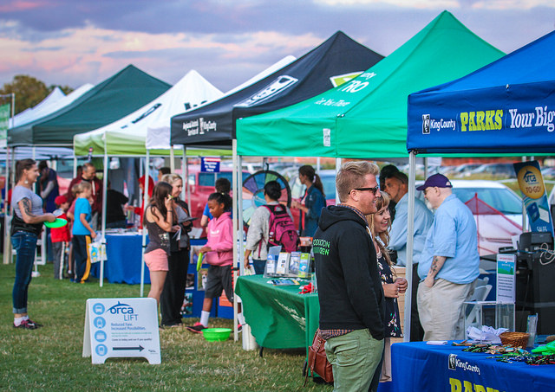

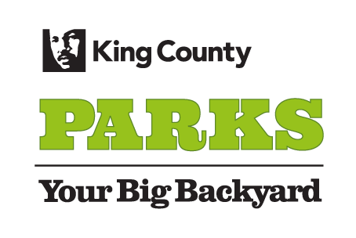

Parks and Recreation Division
Department of Natural Resources and Parks

The following report and accompanying motion are in response to Ordinance 18110, Section 35, Proviso P2. This report summarizes the financial and operational timeline of the King County Fair from 2000 – 2015 and identifies revenues for ongoing financial support to ensure that the King County Fair continues to be provided for County residents in the future.

A. A historical summary of King County's financial support for the fair from 2000 through 2015, including actions resulting from Ordinance 15634 and Ordinance 16369

The following chart summarizes the history of King County financial support of the King County Fair and the underlying Fairground facilities. Funding falls into three categories described below.

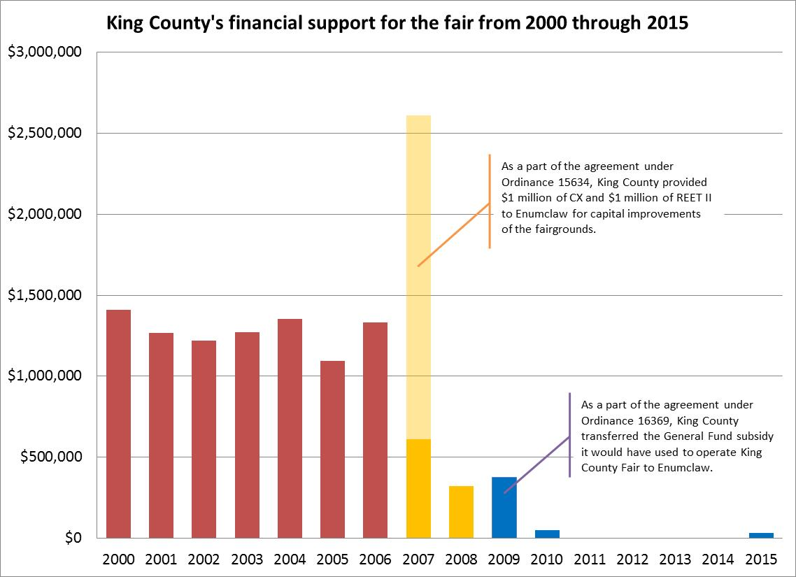

King County owns both the Fair and the Fairgrounds: Until 2007, King County owned and operated the King County Fair and the Fairground facilities, spending between $1 million and $1.5 million annually to support its operation.

Enumclaw assumes ownership of the Fairgrounds: As a result of Ordinance 15634, King County transferred the Fairground facilities to the City of Enumclaw. As a part of the transfer agreement, King County provided Enumclaw with $1 million of Real Estate Excise Tax (REET) II funds and $1 million from the General Fund for capital improvements to the property and operating and maintenance expenses. King County continued to operate and manage the King County Fair through an annual sixteen-day lease during the summer with the City of Enumclaw.

Enumclaw takes over operations of the King County Fair: As a result of Ordinance 16369, the City of Enumclaw agreed to operate and manage the 2009 King County Fair in exchange for $311,203 of one-time support from the King County General Fund. In 2010, King County provided $50,000 to Enumclaw for operation of the Fair. King County did not provide any funding to the Fair between 2011 and 2014. In 2015, through Ordinance 18088, King County provided $35,000 to Enumclaw for the operation of the Fair.

Actions resulting from Ordinance 15634 and Ordinance 16369:

On November 3, 2006, King County enacted Ordinance 15634, which transferred the Fairground facilities and related properties to the City.

Under the agreement, the City would take ownership and responsibility for maintenance and capital improvements on the property, and the County would enter a ten-year lease for use of the Fairgrounds for the King County Fair or similar events to promote agriculture and activities for youth.

The County had not been able to generate enough revenue to cover the cost of operating (or repairing) the Fairgrounds, and Enumclaw was interested in acquiring and improving the Fairgrounds as part of a broader plan to market the City as an equestrian destination.

As part of the Fairgrounds transfer, the County provided Enumclaw with $2 million for capital improvements to the property ($1 million in REET II funds) and capital improvements or operating and maintenance expenses ($1 million from the King County General Fund).

On March 4, 2009, King County enacted Ordinance 16369, which allowed the City of Enumclaw to operate and manage the 2009 King County Fair in exchange for $311,203 of one-time support from the King County General Fund.

The City of Enumclaw would bear sole responsibility for the Fair’s decision making, planning, operations and management for 2009. Enumclaw agreed to provide “suitable competitions for 4-H and Future Farmers of America (“FFA”), sufficient to allow 4-H and FFA participants to compete in State competitions at the Puyallup Fair.” Enumclaw also agreed to refer to the Fair as “The King County Fair, produced by the City of Enumclaw.”

B. Summary of the current management of the King County Fair by the City of Enumclaw and the plans for the management of the King County Fair during the remainder of the biennium

In 2007, the City of Enumclaw took ownership of the Fairgrounds, now operated as the Enumclaw Expo Center. The City operated the facility from January 2007 through June 2015. As of July 1, 2015 the Enumclaw Expo Center is operated under a lease agreement by Enumclaw Expo & Events Association (EEEA), a 501c(3) non-profit organization. EEEA is governed by a board of directors with a broad spectrum of experience with government, event management, non-profit management and youth activities. For example, Kevin Wright, who is the King County Director of WSU Extension which oversees the 4-H Youth Development Program that participates in the Fair, is a board member of the EEEA.

The lease agreement requires EEEA to put on the King County Fair and the City to assist EEEA in obtaining any funding for operating the Fair or to complete capital improvements to the facility. Funds from King County for the King County Fair must go directly to the City.

From 2011 - 2014, the Fairgrounds were leased to Universal Fairs, a for-profit corporation, to put on the Fair. For the first part of 2015, the City operated the fair with employees performing the planning and management, and those staff then transitioned to EEEA employment as of July 1. EEEA is currently working with the state to begin the steps necessary to receive state funding for the King County Fair to offer 4-H premiums and increase 4-H participation.

Going forward, EEEA is seeking to include greater representation from County agencies at future fairs, including booths highlighting regional County services provided by Metro, the King County Library System, the Regional Animal Service, and Parks and Solid Waste Division programs.

C. Identification of revenues that would provide ongoing County financial support for the King County Fair in the amount of at least $25,000 each year

The identified revenue source to provide $25,000 of financial support for the King County Fair each year is the King County Parks Levy – Parks Operating fund. The Parks Levy expires at the end of 2019, the funds will be included in the Executive’s proposed budget through 2019. All funds provided to the City of Enumclaw shall be used solely for the purpose of supporting the youth programs at the Fair.

D. A plan for how King County activities and programs could be represented at the Fair

King County agencies have successfully showcased their programs and services for our region’s residents at King County Parks’ events, including the Movies@Marymoor and CHOMP! These outreach activities are also relevant to visitors of the King County Fair and have great potential to be represented at the King County Fair for increased exposure and engagement with the public.

The following are two featured examples of County outreach programs designed to engage the public that could be presented at the King County Fair:

King County Solid Waste, Recycling and Environmental Services
Water-Aware in the Yard and Garden
This hands-on exhibit features creative ways to conserve water in the yard and garden, from rain barrels and cisterns to “watering wands” to innovative composting techniques. Water-Aware is coordinated by the King County EcoConsumer public outreach program.

King County Solid Waste
“Food Too Good to Waste”
This very interactive table affords the opportunity to generate dialogue about how to reduce food waste at home. Materials are distributed to assist residents in wasting less food. There is also an opportunity for social media engagement, allowing people to publicly acknowledge that they will reduce food waste.

Additional King County agencies and programs with outreach experience and the potential to participate in the King County Fair:

- Children and Family Justice Center
- Community Service Areas
- Easy Being Green
- Eco-Consumer
- Elections
- Flood Control District
- Office of Emergency Management
- Historic Preservation Program
- Department of Housing
- IT/Web redesign team
- Hazardous Waste Management Program
- Loop
- Master Recycler Composter
- Metro - Vanpool/Bus, ORCA Lift, ORCA 2 Go
- Noxious Weed Program
- Parks and Trails
- Regional Animal Services
- Public Health - Access & Outreach
- Sheriff's Office

Related properties include Sportsman Park, Farmers Park, and two related agricultural parcels.

