Franchise Summary

Franchisee City of Redmond (Novelty Hill franchise area)
Type of Franchise Water and sewer facilities
Description Certain portions of Sections 2-6 and 21-35, Township 25 and 26 North, Range 6 East, in unincorporated King County, Washington
Council Districts Three
Time Sensitive N/A
Template Status: County template with negotiated items
Hearing and
Public Notice Required: Yes, posting and publication per King County Code (KCC) 6.27.050 and RCW 36.55.010

Project Information

A franchise agreement approved by the King County Council is required of all public and private utilities to construct, operate, and maintain facilities within King County road rights-of-way.
The parties negotiated a tentative franchise agreement that combines and updates several franchise areas previously authorized for use of County road right-of-way for water and sewer facilities in the City of Redmond’s Novelty Hill franchise area, updates the franchise terms, and establishes franchise compensation in exchange for use of County road rights-of-way consistent with KCC 6.27.080.

Context
Rationale for approval: This tentative franchise agreement meets the criteria for approval under K.C.C. 6.27.060.A-C and prescribes the terms and conditions for Franchisee’s use of road rights-of-way in unincorporated King County.
Policy considerations: In addition to the criteria required by K.C.C. 6.27.060.A-C, this tentative franchise agreement also authorizes the County Risk Manager to review and adjust insurance requirements with each amendment and each five years.
The annual franchise compensation amount includes a credit for the direct costs incurred by the City for fire suppression facilities and services (KCC 6.27.060.C.2) and an adjustment under the Financial Impact Limiting Factor provision of the Public Rule for Determining Franchise Compensation under KCC 6.27.080 (RPM 9-2).
The initial term of this franchise is 10 years. The FMD Director may approve an extension for up to 15 additional years, subject to Franchisee maintaining substantial compliance with the franchise terms and conditions.
The tentative franchise agreement also includes a reservation of the right to impose a utility tax.
Political considerations: The Redmond City Council approved the terms and conditions contained in the franchise agreement on March 1, 2022.
Community considerations: Ensures continuing water and sewer service to the residents served by Franchisee.
Other considerations: None.
Budget considerations: The City paid a franchise application fee of $1,000 at the time it submitted its initial application to update its franchise areas. The application fee is credited against franchise compensation. KCC 6.27.054.F.
This tentative franchise agreement includes annual franchise compensation in the amount of $22,515 per year, beginning in 2021. The annual amount will be adjusted annually and reevaluated every 5th year beginning in 2025. The annual amount includes a credit for direct costs incurred by the City for fire suppression facilities and services (KCC 6.27.060.C.2) and adjustment for the Financial Impact Limiting Factor under the Public Rule for Determining Franchise Compensation under KCC 6.27.080 (RPM 9-2). Upon execution of the franchise, the City will also pay a lump sum amount for use of the County road rights-of-way between 2018 through 2020.
CIP/operational impacts: No impacts anticipated.
Change in property use: The Facilities Management Division Director may approve changes to the franchise area, such as excluding road right-of-way in unincorporated King County that becomes vacated, incorporated, or annexed.
KC Strategic Plan impact: Approval of this right-of-way franchise furthers the King County Strategic Plan objective of exercising sound financial and risk management by managing the County’s risk through insurance and bond requirements and establishing franchise compensation in exchange for use of County road rights-of-way.
Equity/Social Justice impact: In accordance with Real Property Asset Management Plan (RAMP) policy, FMD reviewed this legislation for Equity and Social Justice (ESJ) impacts. This franchise covers areas of unincorporated King County near the City of Redmond and allows the city to continue providing water and sewer services to those residents. No ESJ impacts are anticipated with this transaction.

Franchise Area Map
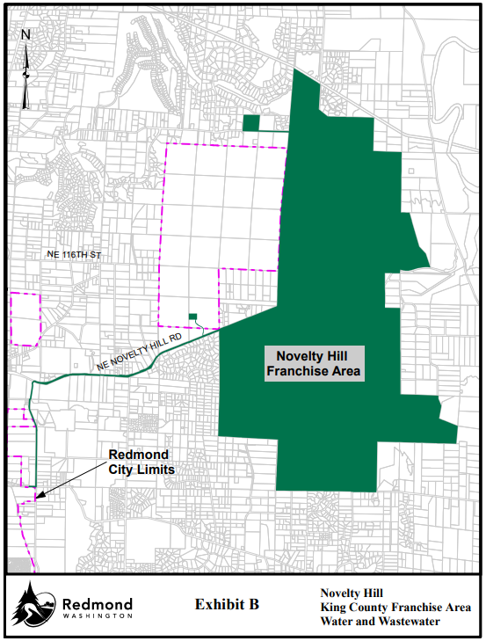

Description of county roads by reference to section, township, and range in which the county roads or portions thereof are physically located (RCW 36.55.040):
King County right-of-way located within any of the following locations:

- Section 2, T.25N., R.6E
- Section 3, T.25N., R.6E
- Section 4, T.25N., R.6E
- Section 5, T.25N., R.6E
- Section 6, T.25N., R.6E

- Section 21, T.26N., R.6E
- Section 22, T.26N., R.6E
- Section 26, T.26N., R.6E
- Section 27, T.26N., R.6E
- Section 32, T.26N., R.6E
- Section 33, T.26N., R.6E
- Section 34, T.26N., R.6E
- Section 35, T.26N., R.6E

