Lease Property Summary

Proposed UPS Facility at KCIA
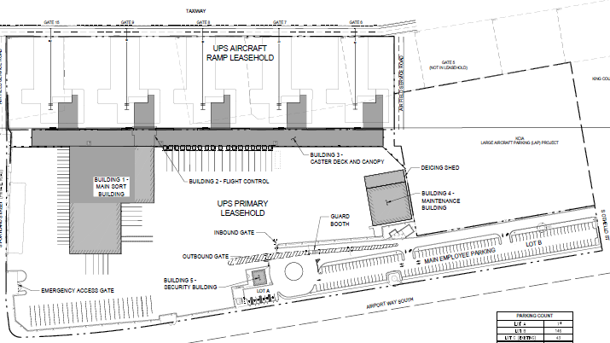

Property Owner: King County International Airport
Address: Perimeter Road South, Seattle, WA 98108
Cost Per Sq. Ft.: $1.90/SF/Year (Ground Lease) for the first 3 years with annual 2.5% increase, then $3.07/SF/Year for Year 4, and market rent based on appraisals thereafter
Term: 20 years, with three 5-year options
Square Footage: 564,000 SF
Rental: $89,300 per month, $1,071,600 annually
Council District: Eight
Funding Source: KCIA Airport Fund
Previous Location: United Parcel Service (UPS) has been occupying this space since 1996. They originally sublet the space and are currently on a one-year lease.
Offer Expiration: The current, one-year agreement, expires in July 2021 or upon execution of this long-term agreement. This long-term agreement includes a rental rate increase beginning four years from execution.

Lease Synopsis

United Parcel Service (UPS) is an American multinational package delivery and supply chain management company. UPS has been occupying space at the King County International Airport (KCIA) since 1996, originally subletting the space and currently on a one-year lease. The new lease (Lease) proposes a long-term 20-year initial term with extension options, totaling 35 years. Within four years, UPS is required to satisfy the capital investment requirement of King County Code 4.56.180.A.2 by demolishing the current improvements, construct a permanent cargo handling facility valued at no less than $37 million, and an improved ramp area (i.e., aircraft parking area) worth an additional $1.8 million. At the end of the Lease, the leasehold and improvements revert to the ownership of King County. As an airline, UPS will also pay additional landing, fuel, and aircraft parking fees on a monthly basis.

Context

Rationale for transaction: This transaction engages UPS in a long-term lease requiring capital investments to build a permanent cargo handling facility approximately worth at least ~$37 million. Locally, UPS employs 5,000 employees and 500,000 worldwide. As e-commerce growth continues and shipping demand increases, parcel delivery and logistics services are projected to become essential to the overall economy.

Policy considerations: This lease is consistent with the 2019 Real Property Asset Management Plan (RAMP) and is in line with KCIA’s master plan to support the modernization or expansion of the airport and provide the framework needed to guide future development in a cost effective and sustainable manner. The master plan accounts for the fact that several leased parcels at KCIA have terms nearing expiration and could be considered for redevelopment to the most appropriate use. Air cargo operations are forecasted to increase within the next 15 years. The new facility will help ensure that the airport is better prepared to handle the increase in air cargo operations.

Political considerations: The proposed UPS facility will contribute to King County’s economy and western Washington’s role as a major national and international trading region. King County supports efforts to plan and create a fast, reliable freight transportation system in the region. To maintain the region’s competitive edge, transportation infrastructure must provide for the efficient movement of goods and freight to and from ports, airports, and industrial areas balanced with the needs of general purpose and high occupancy vehicle traffic. Total air cargo tonnage through KCIA was projected to increase twofold by 2025 in the PSRC study, with KCIA maintaining roughly the same statewide market share (25 percent). A long-term lease will help secure UPS as a permanent tenant at KCIA.

Community considerations
or partnerships: UPS is used by Amazon and other local businesses to transport goods. A permanent facility at KCIA will help the airport’s total positive economic impact within the Puget Sound Region and Washington State as it will contribute to more than $3.5 billion in direct and indirect economic activity, wages and benefits, sale of goods and services, and tax revenues.

Fiscal considerations: In addition to the capital improvements of the proposed facility, the lease will also generate $89,300 of monthly rent with annual increases of 2.5% and five year market rent adjustments based on appraisals. Air Cargo is a large sector for KCIA and represents a relatively high value market because an air cargo carrier operating out of KCIA translates to lease revenue, landing fees, fueling fees, and aircraft parking fees. The anticipated lease and fee revenue will contribute to the long-term economic self-sustainability of KCIA.

Other considerations: The existing UPS lease and adjacent area to be added to the leasehold represent an 18-acre redevelopment parcel which can be used for long-term air cargo and/or combination air cargo/general aviation uses. It is a desirable area; no other parcel on the east side of the airfield offers comparable parcel depth and distance from the main runway, allowing parking positions. The proposed facility intends to have a five-building campus including a main sorting building, a flight control building, a caster deck and canopy building, a maintenance building, and a security building and parking for up to five widebody jet aircraft.

The 7300 Building, constructed in 1938 with 18,910 SF of gross building area, is currently solely occupied by UPS. It is part of the Historic Society Resource Inventory, ID number 3032. It was last surveyed in 2010, however, this interim-use of the building is not the highest and best use for this property and should be demolished to support a state-of-the-art package and sorting facility resulting in the highest and best use of the property. Should the 7300 Building demolition not be approved by the Historic Society and subsequently permitted, UPS has an option to remove that portion from the lease.

CIP/operational impacts: The UPS lease would generate positive revenue for KCIA with no cost to the County.

King County Strategic Plan impact: This transaction supports the King County Strategic Plan guiding principle of Financial Sustainability, by providing land improvements and revenue to the KCIA, and the goal of mobility by increasing freight transportation in the region.

Equity and Social Justice impact: In accordance with Real Property Asset Management Plan (RAMP) policy, the Facilities Management Division reviewed this legislation for Equity and Social Justice (ESJ) impacts. UPS is a large employer with a diverse workforce paying competitive wages and benefits. The planned leasehold locates this major employer in the South Park-Georgetown neighborhood. In addition to its regular workforce, UPS also expands its workforce seasonally in response to increased parcel deliver demand.

Energy Efficiency impact: The buildings have been designed in accordance with the requirements of the State of Washington Energy Code. Site and building lighting is 100% LED lighting, conveyor systems incorporate Variable Frequency Drives and other energy-reducing technologies. Infrastructure for electric vehicle charging will be provided in the employee parking lot.

Lease Alternatives Analysis
Due to limited and geographically challenged space at KCIA and leaseholds, the proposed space is the only one suitable for this lease. UPS has occupied the current leasehold since 1996 and has been gradually centering its logistics around KCIA. Given KCIA’s business orientation favoring air cargo and sortation, the proposed UPS air cargo facility is the highest and best use of the property, adding value to KCIA and providing the northwest with a major shipping facility.

Vicinity View Map
