Property Summary
Project Background
The Lake Hills and Northwest Lake Sammamish sewer pipe has served Redmond and Bellevue for 50 years. The Wastewater Treatment Division (WTD) of the Department of Natural Resources and Parks launched its Lake Hills Trunk and Northwest Lake Sammamish Interceptor Upgrade Project (Lake Hills Project) to upgrade 4.5 miles of this sewer pipe in order to address capacity needs and meet planned growth projections in the City of Redmond.

The route of the new pipe will almost entirely follow the route of the existing pipe and will be located under roads, parks, trails, and private property in the City of Redmond. Almost all of the route will be constructed using open trench technology (i.e., excavating a trench and manually installing the pipeline) with two tunneling segments under the Sammamish River and at Marymoor Park. Construction is expected to begin in 2022 and take three years to complete.

Property Acquisition Detail
As of August 2020, WTD had acquired 35 of 36 (97 percent) of the necessary easements that are mostly for permanent and/or temporary construction purposes. Construction of the Lake Hills Project requires acquisition of the remaining easement on the property described below in more detail.

Bijan Nikfard Property
The property is a 2,400 square foot home in a residential subdivision that was built in 1990. It is necessary to acquire a permanent easement of 760 square feet through a portion of this property for construction equipment, materials, and workers to access and construct the new conveyance line, and to provide a bypass during construction.
The easement area is on 12 feet of this property that is separated from the home by a ravine, a stream, and a native growth protection easement. Construction equipment will gain access through the easement and will not require access to other parts of this property outside of the easement area.

The property owner has concerns with the impacts the easement will have on the property and wants a change in route to avoid the need for an easement on the property. There is not an alternative route that would avoid the need for an easement on this property. As of July 2020, the property owner has continued to reject the terms for the easement.

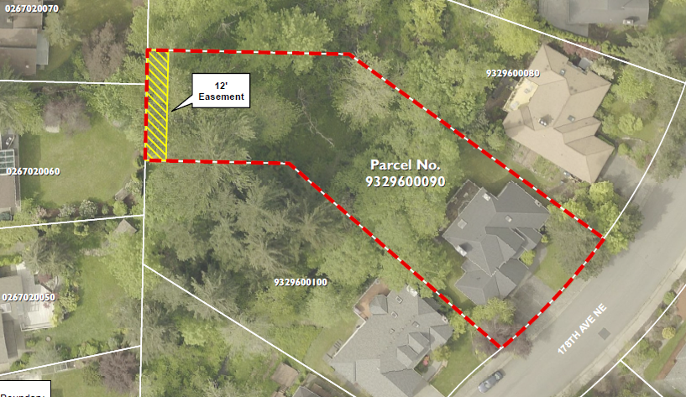
Map of Nikfard Property. Easement area in yellow.

