STAFF REPORT

Proposed No.: | 2019-0413 | Name: | Erin Auzins  Andy Micklow  Jenny Ngo  Jake Tracy

SUBJECT

Proposed Ordinance 2019-0413 would adopt the 2020 King County Comprehensive Plan update, which includes the Skyway-West Hill Community Service Area Subarea Plan.

SUMMARY

The 2020 King County Comprehensive Plan (KCCP) update is a midpoint update under the County's Comprehensive Planning structure. As transmitted by the Executive, changes to the KCCP are those identified in the scope of work adopted by the Council in February 2019. At previous meetings, Executive staff briefed the Executive's proposed Skyway-West Hill Community Service Area (CSA) Subarea Plan, and the 2020 KCCP update; Council staff also provided a "key issues" briefing that covered the entirety of the Executive's transmitted Plan, and our identified key issues. At the January 22 Committee meeting, Council staff provided a written staff report on a number of Committee-identified topics. At the February 12 Committee meeting, Council staff provided additional analysis for the changes related to Mineral Resources and Fossil Fuel Facilities.

At the July 21st full Council meeting, the Council will hold a continued public hearing to hear additional public testimony. Council staff will be available to brief any new amendments. The Council is scheduled to vote on the legislation at this meeting.

BACKGROUND

Comprehensive Plan Midpoint Update

The King County Comprehensive Plan (KCCP) is the guiding policy document for land use and development regulations in unincorporated King County. In 2018, the Council approved a change to the County’s Comprehensive Planning structure and schedule. The restructure adopted and codified into the King County Code (K.C.C.) allows for three main types of updates to the plan: annual updates, midpoint updates, and 8-year updates. The next 8-year update to the KCCP will be transmitted to the Council in 2022, with adoption in 2023.

Because of the length of time between the last major update in 2016 and the next 8-year update in 2023, as part of the restructure ordinance, the Council included a requirement for the 2020 KCCP update, both in the K.C.C. and as a Workplan Action Item in the KCCP. The 2020 KCCP update is considered a midpoint update under K.C.C. 20.18.030.D.4. Midpoint updates allow substantive changes to the Comprehensive Plan, including changes to the urban growth area, if they are identified in the scoping motion.

In February 2019, the Council adopted the scoping motion for the 2020 KCCP update. Motion 15329 outlined the key issues that the Council and the Executive identified for specific consideration in the KCCP update. The scoping motion set the work plan for the 2020 KCCP update and unlike the 8-year update, topical areas, including land use and zoning changes and urban growth area changes, are limited to what is included in this scoping motion.

It is worth noting that while the 2020 KCCP update is considered a midpoint update, the Code and the KCCP would also allow changes allowed as part of an annual update. K.C.C. 20.18.030.B. states, in part: “Every year the Comprehensive Plan may be amended to address technical updates and corrections, to adopt community service area subarea plans and to consider amendments that do not require substantive changes to policy language or do not require changes to the urban growth area boundary….” K.C.C. 20.18.030.B. lists 16 categories that limit the kinds of changes that can be considered as part of what is referred to as the annual update in this section of code. Changes allowed as part of an annual update can be included as part of the ordinance that adopts the 2020 KCCP update.

Community Service Area Subarea Plan

As part of the 2016 KCCP, the Council included Workplan Action #1, Implementation of the Community Service Area (CSA) Subarea Planning Program. As part of this Workplan Action item, the County has started subarea planning using the geography of the six rural Community Service Areas, and for the five remaining large urban unincorporated potential annexation areas, as shown in the map in Chapter 11 and below.

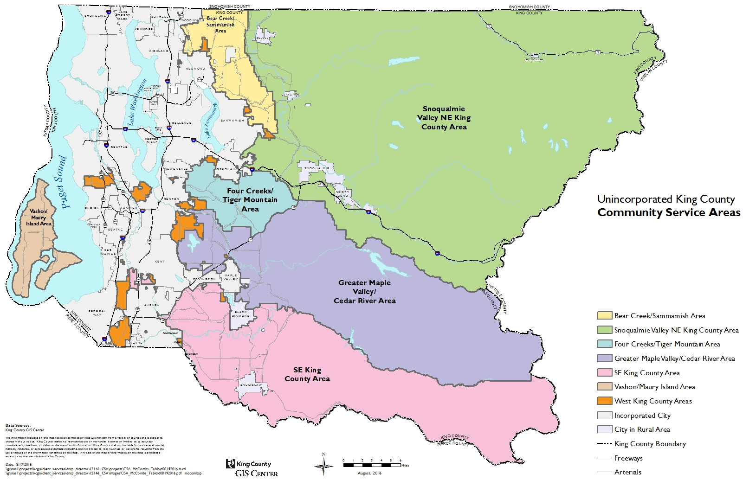

The focus of the CSA subarea plans are on land use issues in these subarea geographies, including:

[A] regular assessment of the Community Service Area's goals, population changes, new development, employment targets and similar demographic and socioeconomic indicators. These assessments are called Community Service Area Subarea Plans. To address the unique issues in each geography, Community Service Area subarea plans may also have more refined, land uses focuses on rural town centers, urban neighborhoods, or corridor approaches.

The high level review along with more detailed land use planning will be guided by a series of criteria such as community interest, social equity, funding, and new development. Equity and social justice principles will play a particularly key role during subarea plan public engagement activities. People of color, low-income residents, and populations with limited English proficiency will be informed and offered equitable and culturally-appropriate opportunities to participate in its planning process.

The schedule for the CSA Subarea Plans is also found in Chapter 11. The Council review time frame is shown in the "Adoption Year" for each CSA Subarea Plan. CSA Subarea Plans are reviewed and approved as part of an annual update to the KCCP.

Schedule of Community Service Area Subarea Plans
Planning Year | Adoption Year | Geography | Other Planning
2018-19 | 2019-20 | Skyway West Hill PAA | 2020 Comprehensive Plan
2019-20 | 2020-21 | North Highline PAA
2020-21 | 2021-22 | Snoqualmie Valley/NE King CSA
2021-22 | 2022-23 | No Subarea Plan | Eight-Year Comp. Plan Update
2022-23 | 2023-24 | Greater Maple Valley/Cedar CSA
2023-24 | 2024-25 | Fairwood PAA
2024-25 | 2025-26 | Bear Creek/Sammamish CSA
2025-26 | 2026-27 | Southeast King County CSA | Potential Midpoint Update
2026-27 | 2027-28 | Four Creeks/Tiger Mountain CSA
2027-28 | 2028-29 | East Renton PAA
2028-29 | 2029-30 | Federal Way PAA
2029-30 | 2030-31 | No Subarea Plan | Eight-Year Comp. Plan Update

Note: The planning year is a 12-month, July to June process. The adoption year is a 12-month, July to June process.

Vashon-Maury Island Subarea Plan. In 2017, the Council reviewed and adopted the first subarea plan created under the new CSA subarea planning program: the Vashon Maury-Island CSA Subarea Plan. The plan was a robust document that included adoption of many new policies across all policy areas of the KCCP: land use; rural area and natural resource lands; housing and human services; environment; parks, open space and cultural resources; transportation; and services, facilities and utilities. An implementation matrix was also included that outlined one or more “actions” for implementation of each policy in the subarea plan. The adopted plan also included a Workplan with three action items for implementation of the subarea plan.

Council review of the plan identified several areas of substantive policy issues in the transmittal, including inconsistency with the GMA, inconsistency with adopted KCCP policies, changes to current countywide and area-specific policy direction, potential for unanticipated County responsibilities, King County budget impacts, and service implications countywide and/or for other CSA geographies. It was also apparent that coordination and collaboration between DPER and PSB might not have occurred as required. Partly as a result of these issues, the Council adopted the budget provisos described below.

Skyway-West Hill SWAP and West Hill Community Plan Update. In 2014, the County adopted Motion 14221, which called for a comprehensive update to the 1994 West Hill Community Plan. Around this same time, Executive staff were also providing technical assistance to a community-led effort to update some elements of the Community Plan. This community-led effort resulted in the development of a series of proposed local implementation actions called the Skyway-West Hill Action Plan (SWAP). The SWAP was proposed to be adopted as an addendum to the existing 1994 Community Plan during the 2016 update of the KCCP. No policy changes to the Community Plan were included in the proposed SWAP.

The SWAP was a community-developed document, and was drafted prior to the adoption of the new subarea planning program framework in the 2016 KCCP. The SWAP process did not include comprehensive review and/or updates to the underlying Community Plan, as called for by Motion 14221 or the underlying subarea planning program goals. Additionally, a variety of policy issues, such as substantive budgetary impacts, were identified during Council review of the transmitted SWAP. As a result, the 2016 KCCP directed the Executive to work with the community to review the proposed SWAP and to comprehensively update the Community Plan within the context of the subarea planning program. The 2016 KCCP included a March 1, 2018 deadline for transmittal of the subarea plan. However, due to the adoption of the budget provisos discussed below, Executive work on development of the Skyway-West Hill subarea plan was put on hold while that work was completed.

2017-18 King County subarea planning budget provisos. Following Council review of the proposed 2016 SWAP and the transmitted 2017 Vashon-Maury Island CSA Subarea Plan, the Council identified the need for the Executive to reassess the subarea planning program, including the program’s structure and schedule, the elements of subarea plans, and interdepartmental roles in the development of subarea plans. As a result, Proviso P2 of Section 5 and Proviso P3 of Section 47 of Ordinance 18602, a supplemental 2017-2018 King County Budget ordinance, were adopted in November 2017.

The two provisos restricted $200,000 each from DPER’s and PSB’s budgets, and directed that no funds could be expended on subarea planning activities, unless and until the Council acts on the motion to approve the proviso response. The key elements of the subarea planning program restructure plan called for in the provisos are as follows.

- Consistency. Methods to ensure subarea plans will be consistent with existing laws, policies, and adopted budget direction.
- DPER and PSB coordination. Recommendations for coordination and collaboration between DPER and PSB’s Regional Planning Unit in the development of subarea plans.
- Departmental consultation. Methods to ensure subarea plans will be developed in consultation with and with concurrence by other County departments.
- Schedule. Evaluation of potential changes to the subarea planning schedule to ensure sufficient time to complete plan development and adoption, including considering whether subarea plans should be developed and/or adopted at the same time as major KCCP updates are developed and/or adopted.

In May 2018, the Council adopted Motion 15142, which approved the Executive's plan to restructure the Community Service Area subarea planning program. The restructure was largely implemented through Ordinance 18810 in October 2018 as part of the 2018 KCCP update. The changes to the subarea planning structure in Ordinance 18810 include:

- Modifying the Comprehensive Plan from a 4-year update cycle to an 8-year cycle.
- Modifying the Council review time frame from a 9-month March to December review, to a 12-month July to June review. It also set a deadline for Council adoption of the KCCP at the end of each June.
- Modifying the CSA Subarea planning structure to make the approach for subarea plan development and adoption in a manner that is similar to the current KCCP process. Each subarea plan is proposed to have a two-year process, where Executive development of a proposed plan would take one year, and Council review and adoption would take one year. Development of a subarea plan would be led by the Permitting Division, in coordination with PSB and other County departments through an interdepartmental team. Similar to the KCCP, the Plan proposes to include the following process for development of subarea plans.
  - Internal scoping with County departments, Councilmembers, and Council staff
  - External scoping with the community
  - Development of a Public Review Draft
  - A public comment period
  - Development of an Executive recommended plan
  - Transmittal to the Council for review and possible action

- Pausing the development of CSA subarea plans during the development of the 8-year KCCP updates.
- Narrowing the scope of the CSA subarea plans to focus on land use issues, such as review of land use designations, zoning classifications, Special District Overlays (SDOs), and property-specific (P-Suffix) development conditions. Other “built environment” topics are also proposed to be addressed, but would be done so in the context of existing functional plans, such as the Transportation Needs Report (TNR) and Regional Trail Needs Report (RTNR). Additionally, the plans are proposed to “generally rely” on the adopted policies of the KCCP; potential for new, subarea-specific policies would be limited.
- Including an implementation matrix to reflect community-identified priorities, similar to the matrix in the Vashon-Maury Island CSA Subarea Plan. Development of the “actions” in the matrix is proposed to be informed by the adopted County budget, including review of existing and planned programmatic work and funded, planned, and unfunded capital plans and projects for the subarea. The Plan states that this proposed process would have communities prioritize their interests, which would then be considered as part of future biennial budgets.
- Including monitoring the implementation of the subarea plans and using performance measures is proposed, which is expected to result in a reduction or elimination of “the need for workplan items” when adopting subarea plans.
- Modifying the schedule and geography (as described earlier in this staff report) to reflect these changes.
- Better coordination between the Permitting Division and the Regional Planning Unit in PSB, using an interdepartmental staff team, and “documenting leadership support” for proposed policies and actions within their respective departments. The Council also approved two additional FTEs as part of the 2019-2020 budget for subarea planning to implement the restructure.

Skyway-West Hill SWAP and West Hill Community Plan Update. The Skyway-West Hill CSA Subarea Plan is included in the Executive's transmittal of Proposed Ordinance 2019-0413, as Attachments F and G. The Executive's proposed plan includes a Subarea Plan, proposed Map Amendments, a community center feasibility analysis, an equity analysis of service delivery, and an equity impact review of the plan.

Public Participation

K.C.C. 20.18.160 and RCW 36.70A.140 call for “early and continuous” public engagement in the development and amendment of the comprehensive plan and any implementing development regulations. As part of that process, the Executive is required to publish a Public Review Draft (PRD) of the KCCP that allows for public input on the draft changes to the plan. For the 2020 KCCP update, the Executive issued the PRD on July 1, 2019, which was open for public comment through July 31, 2019. The Executive hosted five community meetings on the PRD, in Carnation, Skyway, Maple Valley, Vashon-Maury Island, and North Highline. An additional meeting focusing on sea level rise was held on Vashon-Maury Island on July 2, 2019. For the Skyway-West Hill CSA Subarea Plan, the Executive held four focus group meetings, three community meetings, and 22 stakeholder interviews.

Following closure of the PRD comment period, the Executive considered the public feedback and finalized the proposed 2020 KCCP update. The Executive transmitted a recommended KCCP update to the Council on September 30, 2019, as required by K.C.C. 20.18.030.D.4. The Council will review and deliberate on the Executive’s proposal, with adoption expected by the end of July 2020.

ANALYSIS

Committee and Council Review Process

At two briefings in the Mobility and Environment Committee in 2019, Executive staff briefed the changes proposed by the 2020 KCCP update and the Skyway-West Hill CSA Subarea Plan. At the December 13, 2019 Committee meeting, Council staff presented initial analysis of the Executive's legislation. Additional Council staff analysis was provided at the January 22, 2020 and February 12, 2020 Committee meetings. Subsequently, an initial striking amendment S1, was issued by the Chair of the Committee that made substantive changes from the Executive's transmitted 2020 Update. A public hearing notice was issued based on this initial striking amendment, as well as a series of line amendment concepts under consideration.

On June 5, 2020, the Mobility and Environment Chair issued an updated striking amendment, S2, and that is posted to the Council's website for the 2020 update. There is a link below to the website where S2 and known line amendments are published. On June 9, the Council heard public testimony, and Council staff briefed all known amendments. On July 7, the Council held a continued public hearing, to hear additional public testimony.

On July 21st, the Council is scheduled to continue the public hearing, be briefed on all of the amendments, and hold a final vote on the 2020 update.

Attachment 3 to this staff report includes the tentative Committee and Full Council review schedule for the 2020 Update, updated as of June 29, 2020.

Growth Management Planning Council Review

On June 24, 2020, the Growth Management Planning Council (GMPC) approved Motion 20-1 which recommends that the 2016 King County Countywide Planning Policies Urban Growth Area Boundary Map and the Potential Annexation Areas Map be amended. The changes include three amendments to the Urban Growth Area adjacent to the City of Woodinville, the City of Maple Valley, and the City of Issaquah. The GMPC was also briefed on the proposed changes at its February 2020 meeting.

ATTACHMENTS

- Transmittal Letter
- Fiscal Note
- 2020 Comprehensive Plan Update Schedule, as of June 29, 2020

LINKS

All components of the transmitted 2020 update to the 2016 KCCP, as well as additional information about the Council’s review of the proposal, can be found at:

https://www.kingcounty.gov/council/CompPlan/2020compplan.aspx

Direct link to the Council amendment page:

https://www.kingcounty.gov/council/CompPlan/2020compplan/amendments.aspx

Ordinance 18810
K.C.C. 20.18.030
Attachment A to Ordinance 18623
Adopted in 1993 via Ordinance 11166. Only minor map and zoning amendments to the Community Plan have been adopted since 1993.
Included as Attachment J to the Executive’s transmitted 2016 KCCP.

