STAFF REPORT

Proposed No.: | 2020-0045 | Name: | Jake Tracy

SUBJECT

Proposed Ordinance 2020-0045 would update King County's floodplain development regulations in response to an audit by the Federal Emergency Management Agency (FEMA) and would adopt FEMA's new Flood Insurance Study and Flood Insurance Rate Maps.

SUMMARY

In order to make federal flood insurance available to property owners in King County, the County is required to participate in the National Flood Insurance Program (NFIP) administered by FEMA. FEMA requires that jurisdictions such as King County have minimum code standards for floodplain development, and that such jurisdictions adopt the most recent Flood Insurance Study (FIS) and Flood Insurance Rate Maps (FIRM). These maps were transmitted to the County on February 19, 2020 and are required to be adopted by the County no later than August 19, 2020 for property owners in the county to maintain NFIP eligibility.

Additionally, FEMA conducted an audit ("community assistance visit") of King County in 2019, which included an audit of code language and the permitting process, and a field tour of several floodplain development sites. Through the audit, FEMA identified several places in King County's code that need to be updated in order to comply with the minimum standards in the WAC and Code of Federal Regulations.

Proposed Ordinance 2020-0045 would update King County's floodplain development regulations in response to FEMA's audit and would adopt FEMA's new Flood Insurance Rate Maps. Changes include a new floodplain variance process, changes to and addition of definitions, new standards for accessory structures, new standards for areas below structures' lowest floor, additional standards for the coastal high hazard area, and additional standards for FEMA floodproofing and elevation certificates.

Additionally, since the ordinance was transmitted, FEMA has identified further code changes required to maintain NFIP eligibility.

Striking Amendment S2 attaches the FIS and FIRM to the ordinance, updates regulations to comply with FEMA guidelines, establishes process and makes changes to requirements for floodplain variances, and makes a number clarifying and technical changes. There is also a title amendment and a line amendment regarding farm pads.
BACKGROUND

In order to make federal flood insurance available to property owners in King County, the County is required to participate in the National Flood Insurance Program (NFIP) administered by FEMA. King County has participated in this program since September 1978, and as of April 2019, the NFIP had paid out 1,007 flood claims in the County in the total amount of over $21.7 million.

FEMA requires that jurisdictions such as King County have minimum code standards for floodplain development, and that such jurisdictions adopt the most recent Flood Insurance Rate Maps. These maps were transmitted to the County on February 19, 2020 and are required to be adopted by the County no later than August 19, 2020 for property owners in the county to maintain NFIP eligibility. Prior to this update, the effective Flood Insurance Study and Flood Insurance Rate Maps date to 2005.

Additionally, it is necessary for the County to have a floodplain development code meeting FEMA's minimum standards in order to maintain King County's rating as a Class 2 community in FEMA's Community Rating System, which results in a forty percent discount in flood insurance rates in King County, resulting in over $1 million in savings each year.

King County's floodplain development regulations affect four overlapping areas:
- The floodplain is the area within the county subject to a 1 percent annual chance of flooding. The 1percent-annual-chance flood is known as the base flood.
- The FEMA floodway is an area within the floodplain necessary to contain and discharge the base flood without increasing the base flood by more than one foot.
- The zero-rise floodway contains the FEMA floodway and is an area within the floodplain necessary to contain and discharge the base flood with no measurable rise in base flood elevations.
- The zero-rise flood fringe is the remainder of the floodplain that is outside of the zero-rise floodway.

Figure 1 gives an example of how these overlapping definitions apply.

Figure 1 – Components of a Floodplain
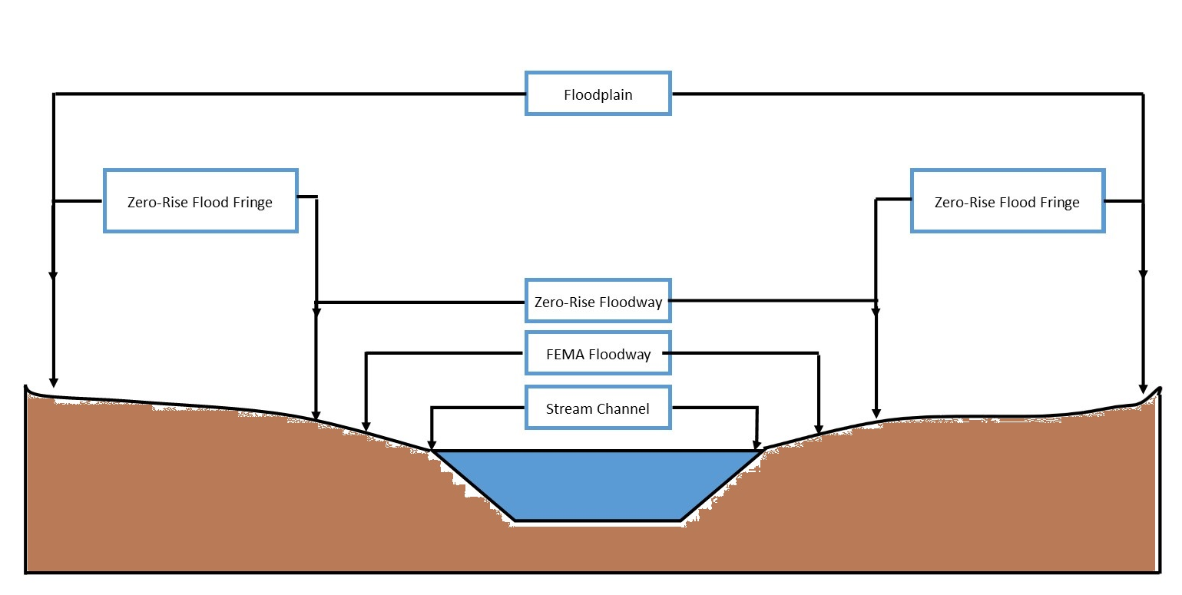

In addition to these areas, there is also the Coastal High Hazard Area, which is a flood hazard area along an open coast subject to high velocity wave action. In unincorporated
King County, Vashon-Maury Island contains a coastal high hazard area.

FEMA conducted an audit ("community assistance visit") of King County in 2019, which included an audit of code language and the permitting process, and a field tour of several floodplain development sites. Through the audit, FEMA identified several places in King County's code that need to be updated in order to comply with the minimum standards in the WAC and Code of Federal Regulations. FEMA identified the following issues in their Community Assistance Visit Narrative:

- Necessary updates to definitions to meet minimum standards;
- Necessary clarifications of development standards with the regulatory floodway;
- Necessary clarifications for coastal high hazard areas;
- Concern over compensatory flood storage standards in the zero-rise flood fringe; and
- Adoption of the new FIS and FIRM.

An annotated copy of the county's code was provided to executive staff as part of the audit. Since the community assistance visit, and after the proposed ordinance was transmitted, FEMA met with executive staff again and provided additional changes to code that are necessary in order to maintain participation in the NFIP.

On February 19, 2020, FEMA issued a Letter of Final Determination for King County, meaning that the final flood maps will be effective, and must be adopted by the County, no later than August 19, 2020.

ANALYSIS

The proposed ordinance would make a number of changes to King County Code 21A.

Updated Flood Insurance Study and Rate Maps. The proposed ordinance would adopt the new FIS and FIRM that have been provided to King County along with the Letter of Final Determination, and would update Title 21A to reference the new study and maps. Because the Letter of Final Determination had not been received at the time the ordinance was transmitted, the date of the letter is not included in the transmittal. The ordinance will therefore need to be updated with the date to comply with FEMA's rules.

Floodplain Variance Process. In the current code, if an applicant wants to take an action not allowed by the floodplain regulations, the remedy is an alteration exception, which is the process used for critical areas generally. However, FEMA refers to the process as a "variance" rather than an alteration exception, and has language in its model ordinance that reflect FEMA's desired criteria for issuing variances. The proposed ordinance would disallow alteration exceptions for flood hazard areas and would create a new variance process in their place. The variance language largely reflects FEMA's model language. In order to receive a variance, an applicant would have to demonstrate:

- Good and sufficient cause
- That failure to grant the variance would result in an exceptional hardship
- That granting a variance will not result in increased flood heights
- That granting of a variance will not result in additional threats to public safety, extraordinary public expense, create nuisances, cause fraud on or victimization of the public or conflict with existing laws or ordinances.
- That granting the variance within the FEMA floodway or the zero-rise floodway will not cause any increase in water surface elevations.
- That the variance is the minimum necessary, considering the flood, erosion or channel migration hazard, to afford relief.

Within these confines, variances would be allowed to any regulation in the floodplain code, except that no variances would be allowed to the prohibition on new or substantially improved residential structures in the FEMA floodway. The proposal would also require the director to "consider" a number of other factors, but as these are considerations, and not criteria, they would not be required to be met in order for a variance to be issued.

Additionally, it should be noted that the proposed variance language includes a provision that states that "generally, variances may be approved for new construction and substantial improvements to be erected on a lot of one-half acre or less in size contiguous to and surrounded by lots with existing structures constructed below the flood protection elevation, but only if the other elements of this section have been fully considered." Because the other variance criteria must only be "fully considered," rather than "met," this would allow for a variance to be granted that does not meet any of the code criteria mentioned above, as long as it is on a lot of one-half acre or less.

Updated and New Definitions. The proposal includes an update to a number of existing definitions, and addition of new definitions. Many of these changes are technical or clarifying in nature, and have been identified by FEMA as necessary to maintain compliance with the NFIP standards.

One substantive change is to the definition of "floodplain development." The proposed changes are to remove maintenance and repair of an existing structure, above-ground utility, or flood protection facility from the list of things that do not constitute floodplain development. These are things that FEMA considers to be development and thus are proposed for removal from the exemptions.

Updated Standards for Areas Below the Lowest Floor. For new and substantially Improved residential and nonresidential structures, the proposal would adopt new standards for fully enclosed areas that are below the lowest floor of the building and below the flood protection elevation (three feet above base flood level). Such areas could only be used for parking, building access, or limited storage of readily removable items, and would have to comply with a number of standards to automatically allow the entry and exit of floodwaters. These standards would apply throughout the entire floodplain – the zero-rise flood fringe, zero-rise floodway, and FEMA floodway.

Accessory Structures. The proposal allows accessory structures to have their lowest floor located below the flood protection elevation in the zero-rise flood fringe, zero-rise floodway, and FEMA floodway, if the accessory structure:

- Is less than 400 square feet;
- Has flood openings;
- Is anchored;
- Is used only for parking or storage of materials; and
- Has no utilities except electrical fixtures elevated above or floodproofed to the flood protection elevation.

These changes are reflective of what is contained in the FEMA model ordinance, except that the four hundred square foot restriction is not contained in the FEMA ordinance. These regulations would therefore be more restrictive than FEMA guidance.

A previously existing exception for nonresidential agricultural accessory structures is proposed to be retained in the executive's proposal, but would be moved to a new section and additional information on the requirements for such structures would be added. This would require that new, substantially improved, or converted nonresidential accessory structures with an assessed value greater than or equal to $65,000 must be elevated to at least one foot above the base flood elevation, and that nonresidential agricultural accessory structures with an assessed value less than that could be constructed to have the lowest floor below one foot above the base flood elevation, if engineering and design criteria are met. These standards would apply in the zero-rise flood fringe, zero-rise floodway, and FEMA floodway.

This exception for agricultural buildings is not in line with FEMA guidance, and retention of this proposed language would result in King County losing flood insurance. Executive staff is in the process of applying for a communitywide exception from FEMA to allow this agricultural exception, but FEMA has stated that a decision is unlikely to be made within the timeframe for this update. The executive has therefore prepared replacement language for the striker that is in line with FEMA's guidance, with the intent of adding this exception through future legislation if the communitywide exception is granted.

Water Wells. The proposal would require that new water wells within the floodplain be located outside of the FEMA floodway and outside of areas subject to ponding. Wells would be required to be protected to the flood protection elevation and from any surface or subsurface drainage capable of impairing the quality of the groundwater supply. The proposal does not contain guidance on acceptable forms of protection.

Alteration of Watercourses. The proposal includes new standards for alteration of a watercourse, as required by the Code of Federal Regulations. These requirements include notification to the Department of Ecology and adjacent communities, submission of proof of this notice to FEMA, and a requirement that flood-carrying capacity is maintained in any alteration. All critical area, shoreline, and other regulations would still apply.

New Standards for the Coastal High Hazard Area. The proposed ordinance would prohibit the use of breakaway walls in coastal high hazard areas. Executive staff states that the existing code's silence on the topic de facto prohibits breakaway walls, but that this would codify the prohibition.

Additionally, the proposal would prohibit alteration of sand dunes. This is something that is required by the Code of Federal Regulations.

FEMA Floodproofing and Elevation Certificates. The proposed ordinance gives new criteria for FEMA floodproofing certificates and FEMA elevation certificates. The executive states that the requirements are already part of existing practice and are required by FEMA, so these changes codify existing practice.

Other Changes. In addition to the changes discussed above, the proposed ordinance makes a number of technical and clarifying changes to the floodplain code. Some of the clarifying changes give additional guidance in conformance with the executive's intent and/or existing practices, so this additional guidance would constitute new policy in the code, even if not new policy in practice.

As noted, FEMA has requested more code changes since the transmission of the proposed ordinance in order to conform to the Federal Code of Regulations and other
FEMA guidance.

AMENDMENT

Striking Amendment S2 would make a number of changes to the proposed ordinance. These include:

- Adding the Flood Insurance Study and Flood Insurance Rate Maps as attachments to the ordinance, and updating references to the documents within the ordinance.
- Removing the exception for agricultural buildings that was not in line with FEMA guidance, and replacing it with a wet floodproofing agricultural building variance process that aligns with FEMA guidance. If the building is worth $65k or more, it would need to meet the agricultural building variance criteria as well as the general floodplain variance criteria.
- Establishing variances to floodplain development regulations as Type 2 decisions and agricultural building variances for buildings less than $65k as Type 1 decisions.
- Requiring lots less than one-half acre to meet floodplain variance criteria in order to receive a floodplain variance.
- Clarifying that zoning variances and critical area alteration exceptions may not be used for variances/exceptions to the floodplain code.
- Changes for consistent use of terminology and clarification of definitions.
- Changes requested by FEMA after transmittal of the ordinance.
- Technical and clarifying changes to match executive intent and/or existing practice.
Amendment 1 would modify regulations for farm pads, stating that, if there are multiple locations on a property meeting all other farm pad siting criteria, the farm pad should be located as far as practical from interior property lines.

Title Amendment T1 conforms the title to S2.

ATTACHMENTS

- Transmittal Letter
- Fiscal Note
- FEMA Community Assistance Visit Narrative
- FEMA Letter of Final Determination
- Plain Language Summary
- Regulatory Note

According to FEMA's Community Assistance Visit Narrative, June 2019.
Substantial improvements are improvements greater than 50% of the value of the structure.
In the regulatory floodway, a critical areas report is required to show that there will be no increase in base flood elevation. New accessory structures are not allowed in the FEMA floodway, but these regulations would apply to substantial improvements to existing accessory structures.
In the regulatory floodway, a critical areas report is required to show that there will be no increase in base flood elevation.

