Eastside Rail Corridor

Rail Removal Plan

Purpose

Ordinance 17503 (December 2012) contains prerequisites in order for the King County Executive to proceed with any rail track removal on the Eastside Rail Corridor (ERC). One of those prerequisites is that the Executive shall submit a rail removal plan along with a motion to the Council. This Rail Removal Plan (Plan) is intended to fulfill that requirement. This Plan explains background conditions and reasons for rail removal; proposes a phased approach to rail removal and associated timing by location; and outlines the anticipated schedule and funding source.

Reasons for Rail Removal

When King County acquired portions of the ERC from the Port of Seattle in 2013, it acquired all of the rail infrastructure located there, including rails, ties, ballast, drainage structures, and other structures and equipment that formerly supported rail uses of the ERC that had been discontinued by 2008. During the latter years of Burlington Northern-Santa Fe’s (BNSF) ownership, as its operations ceased in the corridor, BNSF reduced or eliminated its maintenance activities, and vegetation became overgrown, trestles aged, and surface and ground water found new pathways, leading to deterioration of the rail bed and track system. As explained further below, in many areas the rail infrastructure was already in poor condition in 2008 and is in worse condition today. The poor condition of the rail infrastructure has affected the efficiency of and added costs to King County’s maintenance of the property, and affected other uses of the property that comport with railbanking and the multiple-purpose vision for the ERC. Each of the primary reasons supporting rail removal is explained below, generally falling under four categories: Improved Operational Efficiency and Safety; No Anticipated Use of Existing Rail Infrastructure; Improving the Corridor’s Recreational Function and Value; and Alignment with Policy Guidance Related to Corridor Development

- Improved Operational Efficiency and Safety

Removal of the rail infrastructure will improve access, efficiency and safety for maintenance and operations while ensuring effective use of public funds.

Since acquiring portions of the corridor, the Parks and Recreation Division of the Department of Natural Resources and Parks (Parks) has worked to clear invasive and hazardous vegetation, clean culverts, and address graffiti problems. However, the rails and ties in place along the County-controlled segments of the railbanked ERC prevent Parks’ regular maintenance equipment from accessing all areas of the corridor. As a result, in 2013 Parks purchased a high-rail truck to operate on the existing rails and provide a form of access to crews in order to perform some of the ongoing operations and maintenance requirements. Because Parks staff is forced to perform maintenance of the ERC from rail-based vehicles, they are limited in terms of the equipment available to them, and the work they are able to perform. Further, the rails limit the places where Parks may access the ERC from adjoining roads or other properties. Using rail-based vehicles also results in yet more wear-and-tear on the aging rails, ties, and associated rail infrastructure.
The condition of the rails in many places is failing. Removal of rails and rail equipment in the ERC will address a variety of maintenance-related issues:
- Performing basic corridor maintenance from the rails not only requires specialized equipment, but also imposes the need for additional work to maintain the rail infrastructure itself. Removal of the rails, ties, and related equipment would allow Parks to use its regular trail maintenance equipment and reduce the time and effort needed to perform ongoing maintenance.
- Limited corridor access requires longer travel times to project locations. Removal of the rails would expand the access points available to Parks and reduce travel time and costs.
- Parks lacks the funds needed to undertake replacement of existing failed sections of rail infrastructure and other deferred maintenance required to continue using the high-rail vehicle. Longer term, far more rail infrastructure replacement would be required, including replacing roughly 23,500 failed ties, at a cost of approximately $390,000/mile (approximately $6M for the King County ownership area).
- Several culverts along the rail corridor are failing, and must be repaired to avoid impacts on-site and to neighboring properties, which will require removal of rails in order to access the culverts. Removing the rails from all the County’s segments of the ERC will eliminate the need to replace the rails after culvert repairs, which will eliminate those additional project costs.

- No Active or Currently Anticipated Use of Existing Rail Infrastructure

No portion of the mainline between Woodinville and Renton or the Redmond Spur south of milepost 1.0 – the northerly limit for proposed removal activities on the Spur – is being used for rail-based uses at this time. There are no pending proposals for reactivation of freight service, and King County expects that the costs of any future freight reactivation proposal (including the cost to rehabilitate or upgrade track structures) will be borne by the party proposing reactivation. At this time there are no active or licensed excursion service operations or active proposals to reestablish excursion service or any other rail use on the corridor.

Although the entirety of the corridor is intended for multiple uses, encompassing nonmotorized and transit uses, there are currently no known transit uses for the existing rail infrastructure, whether for high-capacity transportation uses like light rail or otherwise, . For its part, Sound Transit will be removing the existing rails from the “Sound Transit Mile” in Bellevue to facilitate construction of Wilburton Station, the Operations and Maintenance Satellite Facility (OMSF), and related elements of the East Link light rail system. Furthermore, Sound Transit officials have confirmed that the existing rail infrastructure is of no use to them in implementing their High Capacity Transit Easement over the remainder of the ERC outside of Redmond. Sound Transit has written a letter to this effect, a copy of which will be submitted with this Plan in connection with the proposed motion to authorize rail removal as required under Ordinance 17503.

- Improving the Corridor’s Recreational Function and Value

The existing track and ties impede the implementation of other uses, including recreational uses, in the County-controlled segments of the ERC.

Removing the rails and ties would facilitate recreational functions and values over both the near term and the long term. In the near term, removing the rails and ties would reduce the risks to corridor users that are currently traversing the railbed, both on foot and on bikes, and would facilitate the access of public safety vehicles to the corridor in emergency situations. In the longer term, and subject to the County’s ongoing ERC Master Planning process, removal of rails and ties from the rail bed would facilitate the most cost-effective, timely construction of an interim trail use of the corridor as it would make the rail bed available for an existing, contiguous, and Americans With Disabilities Act-graded pathway of generally sufficient width to support bike and pedestrian uses. If the rails and ties remain in place then the rail bed almost certainly would not be a practical option for future trail improvements.

- Alignment with Policy Guidance Related to Corridor Development

Rail removal is in alignment with policy direction established for the development of the corridor. Rail removal is consistent with railbanking regulations and does not affect the availability of the corridor for reactivation of freight service. Rail removal is consistent with the Regional Advisory Council’s vision for the corridor, including by helping foster multi-modal connections between neighborhoods and economic centers through dual use of the corridor for both nonmotorized and transit facilities, supporting utility maintenance and development, and expanding the recreational trail network. Actions enabled by rail removal support King County Comprehensive Plan objectives including creating sustainable neighborhoods, directing development toward existing communities, and providing transportation choices.

Rail Removal Phasing (Timing & Locations)

Parks will employ a two-phase approach to removing the existing tracks and ties from the County-controlled segments of the ERC.

Upon approval of this rail removal plan by motion of the King County Council, Parks would implement removal of the rails in two phases over the geographical areas shown in Figure 1. Phase 1 will address all King County-owned areas of the railbanked ERC south of the Kirkland-King County ERC property boundary near 108th Avenue NE in Bellevue, and extending southerly to Coulon Park in Renton where King County’s ERC ownership ends. Design and permitting of rail removal will be initiated in early 2016 with Phase 1 rail removal to be completed by mid- 2017, or as soon as practicable.

Anticipated Schedule for Rail Removal
 | 2016 |  |  |  | 2017 |  |  |  | 2018
 | Q1 | Q2 | Q3 | Q4 | Q1 | Q2 | Q3 | Q4 | Q1 | Q2 | Q3 | Q4
Phase 1 |  |  |  |  | Q42016: Council consideration of approval of Trail Master Plan
Site Plan Development
Permitting
Bid and Award Construction Contract
Rail Removal Construction
Phase 2- TBD Dependent on Excursion Rail RFP
Site Plan Development
Permitting
Issuance of RFP for Excursion Service
Bid and Award Construction Contract |  |  |  |  |  | Tentative
Rail Removal Construction |  |  |  |  |  |  |  | Tentative

Phase 2 will address all King County-owned areas of the railbanked ERC north of the ownership areas of the City of Kirkland and the City of Redmond, except the area from milepost 0.0 to 1.0 of the Redmond Spur, where the rail would be left in place in observance of the existing license for head and tail freight operations there. In Phase 2, on completion of the Trail Master Plan and on adoption by the County Council of the preferred alternative for trail development in the corridor, Parks will solicit proposals for excursion or other rail-based service on any and all portions of the corridor north of the ownership areas of the City of Kirkland and the City of Redmond. If no feasible proposal for rail-based service be submitted within 90 days of the issuance of the Request for Proposal (RFP), then Phase 2 removal activities will start on the mainline portion of the ERC and then move to the Redmond Spur. For purposes of the RFP, a feasible proposal must include a business case supported by operators with proven success in operating excursion services, financial commitments for all necessary capital investment required to recondition or refurbish the railbed for such service and proof of operating funds available to support the business case through profitability.

Rail removal is not being driven by considerations regarding Parks’ implementation of the long term ERC trail. Parks’ ERC Trail Master Plan process will determine the location of the long term ERC trail. Removal of rails and ties is currently anticipated to begin later than Council approval of the ERC Trail Master Plan. Phase 1 site plan development, permitting and bid and award activities shall begin as soon as practicable after approval of this plan; Phase 2 site plan development and permitting activities may occur concurrent with those for Phase 1. Phase 2 bid and award activities will occur only after issuance of the Request for Proposals for excursion or other rail based service north of the ownership areas of the City of Kirkland and the City of Redmond, and only if no feasible proposals have been received within the time allotted. Council approval of the ERC Trail Master Plan is currently anticipated to be under Council consideration in the fourth quarter of 2016.

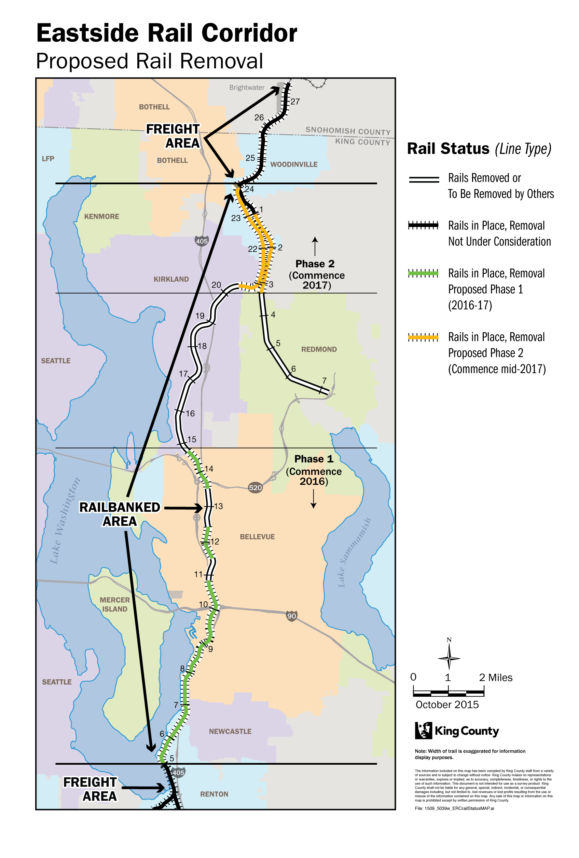
Figure 1: Eastside Rail Corridor Proposed Rail Removal by Phase

Planning Activities to Coincide with Rail Removal

As noted above, rail removal is currently anticipated to begin later than Council approval of the ERC Trail Master Plan. Planning activities should include consideration of some impacts and opportunities arising from rail removal

- In preparation for preserving the historic legacy of railroad usage and future vision for transit in the corridor after rail removal, the Trail Master Plan will include planning for physical indicators to denote these historic and future uses along the length of the corridor.

- During rail removal design, Parks will identify areas along the corridor where development adjacent to the corridor that occurred after construction of the rail bed has resulted in narrow street widths and where the Trail Master Plan could offer opportunities for improvement.

Funding Source

It appears that rail salvage could generate modest revenue in excess of removal costs, which with other funding sources developed in collaboration with co-owners and stakeholder groups could be used in support of projects and activities in the corridor.

However, at present it is intended that removal of rails and ties would be primarily funded through the Regional Trails Reserve Fund in the Parks budget. These funds are a reserve balance of previously uncommitted funds in the Regional Trails Fund, sourced from the Parks Levy through a mid-biennium supplemental budget request being transmitted to the Council concurrent with this transmittal for review and approval. The mid-biennium supplemental request includes a request for budget authority to expend funds toward rail removal. At present, $1,550,000 is requested toward the engineering design and rail removal construction costs. This rail removal plan is subject to any and all of the terms and conditions of that separate budget appropriation.

Based on costs identified in the Missouri Rail Plan 1995 Update, adjusted for inflation and confirmed by recent local estimates of cost per mile for rail construction.

