TRANSIT SERVICE FUNDING AGREEMENT
BY AND BETWEEN
KING COUNTY
AND
THE CITY OF SEATTLE

THIS TRANSIT SERVICE FUNDING AGREEMENT (the "Agreement") is made by and between King County, a political subdivision of the State of Washington and home rule charter county with broad powers to provide public transportation within the County's geographic boundaries, by and through the King County Department of Transportation, Metro Transit Division (the “County" or "Metro Transit") and the City of Seattle, a Washington municipal corporation (the “City”), both of which entities may be referred to hereinafter individually as "Party" or collectively as the "Parties."

WHEREAS, the City and County have existing agreements for purchasing transit service hours that will remain in place, including a December 2008 Transit Service Speed and Reliability Partnership agreement and an August 2013Transit Service Financial agreement; and

WHEREAS, the City has identified additional City funds that can be used to purchase service hours from the County, and;

WHEREAS, the City has identified specific routes and times where it desires additional service hours to be applied to attain transit service goals in the Seattle Transit Master Plan; and

WHEREAS, Strategies 3.1.1 and 6.3.1 of the King County Metro Transit Strategic Plan for Public Transportation 2011-2021, adopted in August 2013, identify partnerships with local jurisdictions and businesses as a potential source of the revenue necessary to provide transit service in support of a strong, sustainable economy;

NOW, THEREFORE, IN CONSIDERATION OF THE MUTUAL PROMISES, COVENANTS AND AGREEMENTS SET FORTH HEREIN, AND FOR OTHER GOOD AND VALUABLE CONSIDERATION, THE RECEIPT AND SUFFICIENCY OF WHICH ARE HEREBY ACKNOWLEDGED BY THE PARTIES, THE PARTIES HEREBY AGREE AS FOLLOWS:

1. PURPOSE OF AGREEMENT

The purpose of this Agreement is to set forth the terms and conditions under which City-funded transit service will be operated on specified routes as outlined in Exhibits A and B, which are incorporated herein and made a part of this Agreement by this reference.

2. COUNTY’S RESPONSIBILITIES

2.1 The County will provide transit service in accordance with the service specifications set forth in Exhibits A and B, pursuant to which the City will pay the fully allocated cost of the service hours.

2.2 The County will manage the service in accordance with its regular procedures and as may be further specified in this Agreement. The Parties understand and agree that the transit service referenced herein will be open to the general public.

2.3 The County will include the transit service provided for under this Agreement in its annual route performance monitoring that will include the following two standard indicators:

- Rides per platform hour;
- Passenger miles per platform mile.

3. CITY’S RESPONSIBILITIES

3.1 Service Funding. The City will pay, via payment of billings from the County twice per year, as specified in Section 5.1 of this Agreement, one hundred percent (100%) of the fully allocated cost of the service described in Exhibit A. Fully allocated costs include the cost of fuel, maintenance, driver wages, service supervision, infrastructure maintenance, revenue collection, scheduling, rider information, data analysis, and administrative and management costs.

3.2 Payment Timeline. The City shall pay the amount indicated in Section 3.1 beginning with the first payment in January 2015 to the final payment in February 2016.

4. TERM OF AGREEMENT

This Agreement shall commence upon signing by the Parties. Services will begin as specified in Exhibit A and continue until February 2016, unless extended or earlier terminated pursuant to the terms of this Agreement.

5. INVOICES/PAYMENT PROCEDURES

5.1 The County will invoice the City twice each year for the cost, as specified in Section 3.1 of this Agreement, of the transit service provided for herein. The City will receive two (2) billings each calendar year for the costs incurred by the County to operate the service based on Metro’s fully allocated hourly rate for that service type and billed “as scheduled” at the time the service was operated.

5.2 The total service costs based on scheduled service hours is shown in Exhibit C, which is incorporated herein and made a part of this Agreement by this reference. This fully allocated hourly rate will be adjusted in January each year, based on the per mile and per hour costs for that year. This adjustment will be provided to the City.

5.3 The City shall make payment within forty-five (45) days after receipt of an invoice. Should the City fail to pay the County the amount due within forty-five (45) days of receipt of a billing invoice from the County, a late payment assessment shall be applied to any outstanding balance due for that invoice. The late payment assessment shall be fixed at the maximum rate allowable under Washington state law.

6. INDEMNIFICATION AND LEGAL RELATIONS

6.1 It is understood and agreed that this Agreement is solely for the benefit of the Parties hereto and gives no right to any other person or entity. No joint venture or partnership is formed as a result of this Agreement. No employees or agents of one Party or its contractors or subcontractors shall be deemed, or represent themselves to be, employees, agents, contractors or subcontractors of the other Party.

6.2 Each Party shall comply, and shall ensure that its contractors and subcontractors, if any, comply with all federal, state and local laws, regulations, and ordinances applicable to the work and services to be performed under this Agreement.

6.3 Each Party shall protect, defend, indemnify and save harmless the other Party, its elected officials, officers, officials, employees and agents while acting within the scope of their employment as such, from any and all costs, claims, judgments, and/or awards of damages, arising out of or in any way resulting from each Party’s own negligent acts or omissions. Each Party agrees that it is fully responsible for the acts and omissions of its own subcontractors, their employees and agents, acting within the scope of their employment as such, as it is for the acts and omissions of its own employees and agents. Each Party agrees that its obligations under this provision extend to any claim, demand, and/or cause of action brought by or on behalf of any of its employees or agents. The foregoing indemnity is specifically and expressly intended to constitute a waiver of each Party’s immunity under Washington’s Industrial Insurance Act, RCW Title 51, as respects the other Party only, and only to the extent necessary to provide the indemnified Party with a full and complete indemnity of claims made by the indemnitor’s employees. The Parties acknowledge that these provisions were specifically negotiated and agreed upon by them.

6.4 Each Party’s rights and remedies in this Agreement are in addition to any other rights and remedies provided by law.

6.5 This Agreement shall be interpreted in accordance with the laws of the State of Washington. The Superior Court of King County, Washington, located in Seattle, Washington, shall have exclusive jurisdiction and venue over any legal action arising under this Agreement.

6.6 The provisions of this Section 6 shall survive any termination of this Agreement.

7. CHANGES AND MODIFICATIONS

This Agreement may be amended or modified only by prior written agreement signed by the Parties hereto. Amendments and modifications consistent with the intent and purpose of this Agreement may be executed by the General Manager of the County's Transit Division and the Director of Seattle Department of Transportation.

8. TERMINATION OF AGREEMENT

8.1 Either Party may terminate this Agreement in writing if the other Party substantially fails to fulfill any or all of its obligations under this Agreement through no fault of the other; provided, however, that, insofar as practicable, the Party terminating the Agreement will give not less than 135 calendar days prior to the County’s February, June or September service change, by written notice delivered by certified mail, return receipt requested, of intent to terminate.

8.2 In addition to termination under Subsection 8.1 of this Agreement, either Party may terminate this Agreement for its convenience, provided that the other Party will be given not less than 135 calendar days prior to the County’s February, June or September service change, by written notice delivered by certified mail, return receipt requested, of intent to terminate.

8.3 Performance of any tasks undertaken by the County pursuant to this Agreement beyond the County’s current appropriation year is conditional upon the appropriation by the County Council of sufficient funds to support the work provided for in this Agreement. Should such an appropriation not be approved, the Agreement shall terminate at the close of the current appropriation year. The appropriation year ends on December 31st of each year.

8.4 If either Party terminates, the City will pay the County a pro-rated amount for services performed in accordance with the Agreement to the date of termination.

9. FORCE MAJEURE

Either Party shall be excused from performing its obligations under this Agreement during the time and to the extent that it is prevented from performing by a cause beyond its control, including, but not limited to: any incidence of fire, flood, earthquake or acts of nature; strikes or labor actions; commandeering material, products, or facilities by the federal, state or local government; and/or national fuel shortage; when satisfactory evidence of such cause is presented to the other Party, and provided further that such non-performance is beyond the control and is not due to the fault or negligence of the Party not performing. In no event, however, shall this provision eliminate the obligation to make payment to the County for work performed in accordance with this Agreement.

10. WAIVER OF DEFAULT

Waiver of any default shall not be deemed to be a waiver of any subsequent default. Waiver of breach of any provision of this Agreement shall not be deemed to be a waiver of any other or subsequent breach and shall not be construed to be a modification of the terms of this Agreement unless stated to be such in writing, signed by authorized Parties and attached to the original Agreement.

11. ASSIGNMENT

This Agreement shall be binding upon the Parties, their successors, and assigns; provided, however, that neither Party shall assign or transfer in any manner any interest, obligation or benefit of this Agreement without the other’s prior written consent.

12. NO THIRD PARTY BENEFICIARIES

Nothing in this Agreement, express or implied, is intended to confer on any person or entity other than the Parties hereto and their respective successors and assigns any rights or remedies under or by virtue of this Agreement.

13. MUTUAL NEGOTIATION AND CONSTRUCTION

This Agreement and each of the terms and provisions hereof shall be deemed to have been explicitly negotiated between, and mutually drafted by, the Parties, and the language in all parts of this Agreement shall, in all cases, be construed according to its fair meaning and not strictly for or against either Party.

14. ALL TERMS AND CONDITIONS

This Agreement merges and supersedes all prior negotiations, representations and agreements between the Parties related to the subject matter hereof, contains all the terms and conditions agreed upon by the Parties, and constitutes the entire agreement between the Parties. No other understandings, oral or otherwise, regarding the subject matter of this Agreement shall be deemed to exist or to bind the Parties hereto.

15. CONTACT PERSONS

The County and the City shall designate a contact person for purposes of sending inquiries and notices regarding the execution and fulfillment of this Agreement.

 | City of Seattle
Contact Name | Bill Bryant
Department | Seattle Department of Transportation – Policy and Planning
Title | Transit Programs Manager
Address | SMT, 700 Fifth Ave Suite 3866 Seattle WA 98124-4996
Telephone | 206-684-5470
Fax | 206-684-5180
E-Mail | Bill.Bryant@Seattle.Gov

 | King County
Contact Name | Victor Obeso
Title | Manager, Service Development, King County Department of Transportation
Address | 201 S. Jackson St. KSC-TR-0426, Seattle, WA 98104
Telephone | 206-263-3109
Fax | 206-684-1860
E-Mail | Victor.obeso@kingcounty.gov

16. EXECUTION OF AGREEMENT – COUNTERPARTS

This Agreement may be executed in two (2) counterparts, either of which shall be regarded for all purposes as an original.

17. EFFECTIVE DATE

This Agreement shall take effect when it is signed by both Parties.

IN WITNESS WHEREOF the Parties hereto have executed this Agreement on the ______ day of ___________________, 2014.

KING COUNTY  By: _________________________________  Title: ________________________________  Date: ________________________________ | CITY OF SEATTLE  By: _________________________________  Title: ________________________________  Date: ________________________________
EXHIBIT A

SERVICE DESCRIPTION

Pursuant to the terms and conditions of this Agreement, transit service on the routes identified in this Exhibit A and in the route map in Exhibit B will be operated as follows:

Route 82:
Operate two late night trips on Route 82 to Queen Anne, Green Lake and Greenwood at 2:15 a.m. and 3:30 a.m.

Route 83:
Operate two late night trips on Route 83 to University District, Maple Leaf and Ravenna at 2:15 a.m. and 3:30 a.m.

Route 84:
Operate two late night trips on Route 84 to Madison Park and Madrona at 2:00 a.m. and 3:15 a.m.
EXHIBIT B: Map of Routes 82, 83, and 84

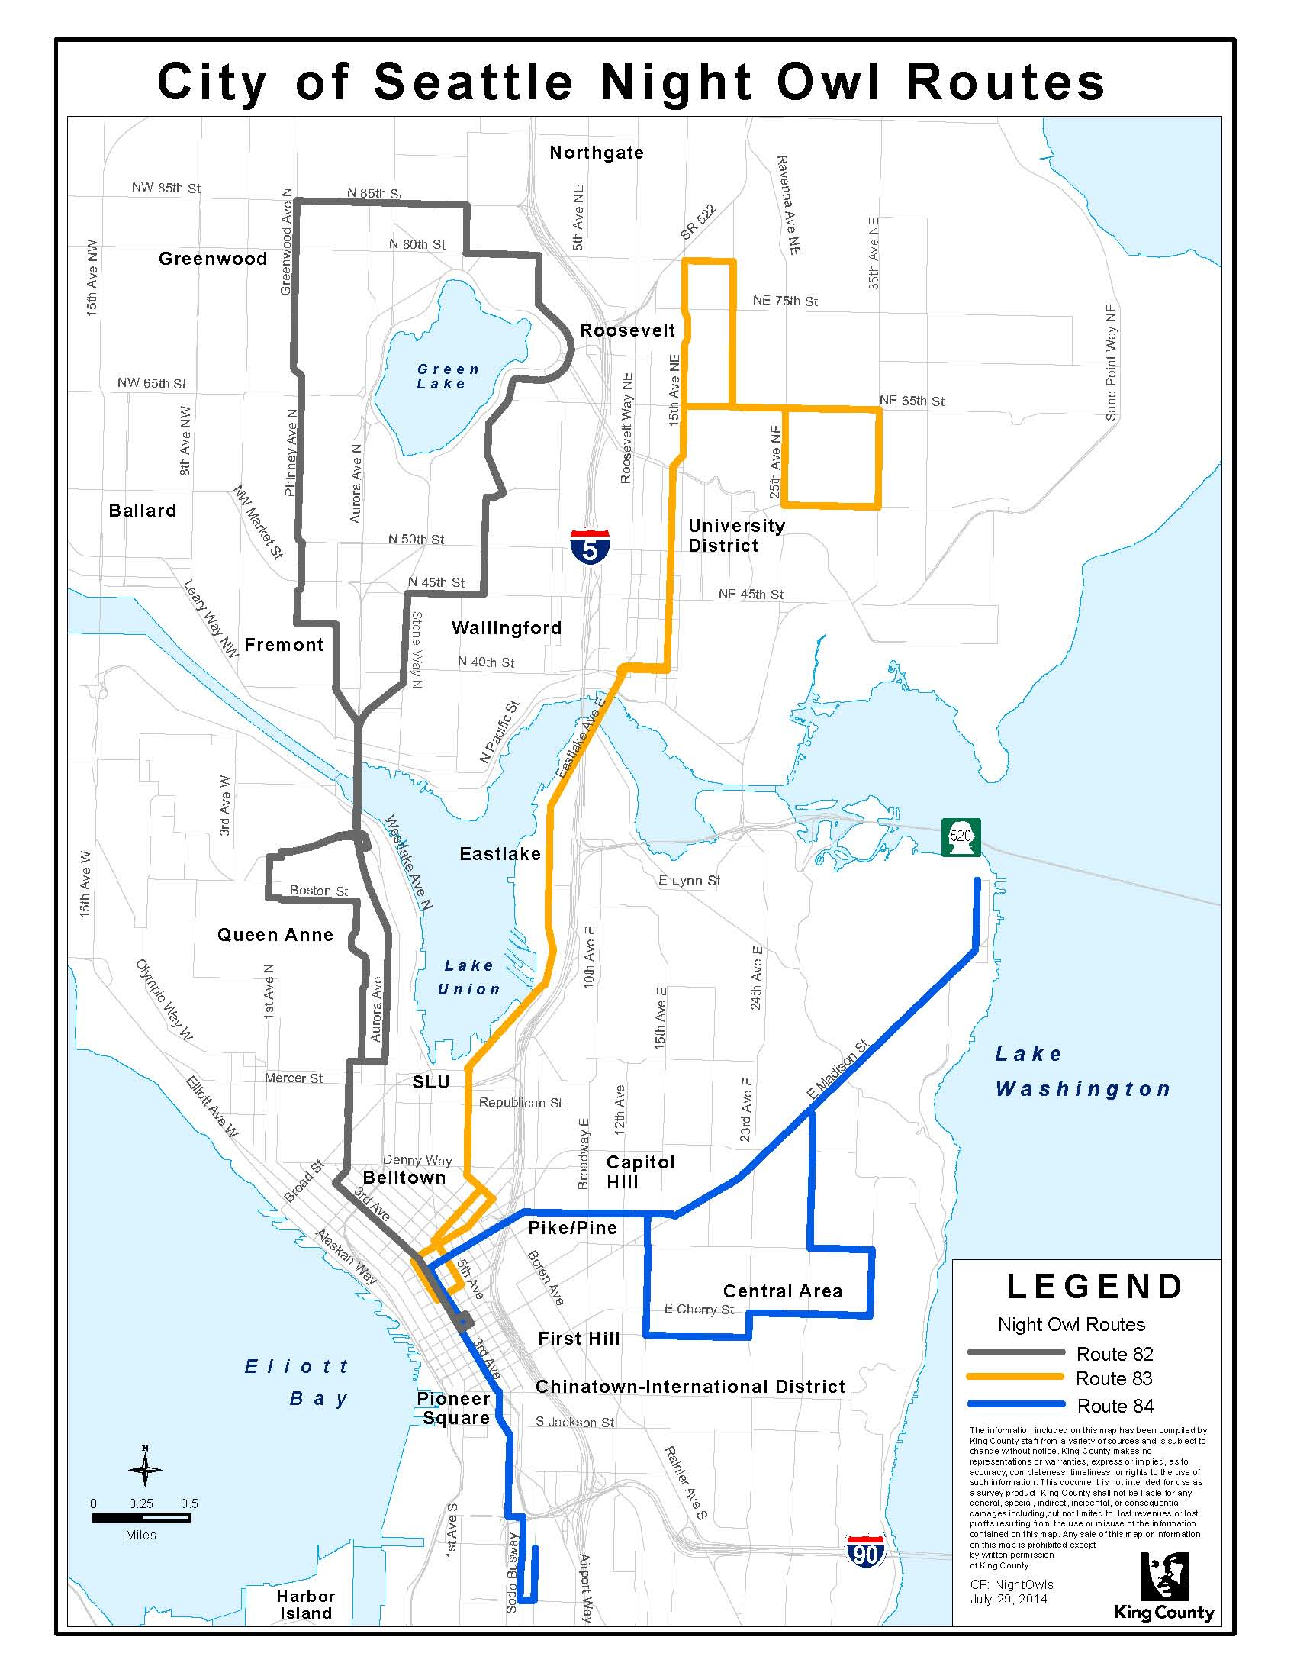

EXHIBIT C: 2014 Service Cost

Route | Day | Time | Description | Est. Ann. Service Hrs | Coach Type | 2014 Hourly Rate | Annual Cost Estimate
82 | All | 2:15 a.m., 3:30 a.m. | Operate two late night trips | 1,270 | 60’ Diesel/Hybrid | $153.07 | $194,398.90
83 | All | 2:15 a.m., 3:30 a.m. | Operate two late night trips | 1,286 | 40’ Diesel/Hybrid | $139.91 | $179,924.26
84 | All | 2:00 a.m., 3:15 a.m. | Operate two late night trips | 1,277 | 40’ Diesel/Hybrid | $139.91 | $178,665.07
 |  |  | TOTAL |  |  |  | $552,988.23

