REVISED STAFF REPORT

Agenda Item: |  | Name: | Andrew Kim
Proposed No.: | 2022-0178 | Date:

COMMITTEE ACTION

Proposed Substitute Motion 2022-0178.2 to adopt county priorities for the 2023-2024 Biennial Budget, passed out of committee on May 11, 2022, with a “Do Pass” recommendation. The Motion was amended in committee with Amendment 1 to replace the draft version of the priorities document with the final version.

SUBJECT

A proposed motion setting the county's priorities for the 2023-2024 Biennial Budget.

SUMMARY

As set forth in Section 410 of the King County Charter, at least 95 days prior to the end of each fiscal year, the executive is required to present to the council a biennial budget proposal every two years. Moreover, as set forth in Section 420 of the King County Charter, at least 150 days prior to the end of the fiscal year, all county agencies are required to submit to the executive a budget proposal for consideration. In anticipation of the 2023-2024 biennial fiscal period, the executive has begun the 2023-2024 biennial budget planning process. The chart below provides major steps of the budget process.

The proposed motion would adopt the council’s priorities for the 2023-2024 biennial budget, as outlined in Attachment A, to provide input to county agencies and the executive as they develop the proposed biennial budget.
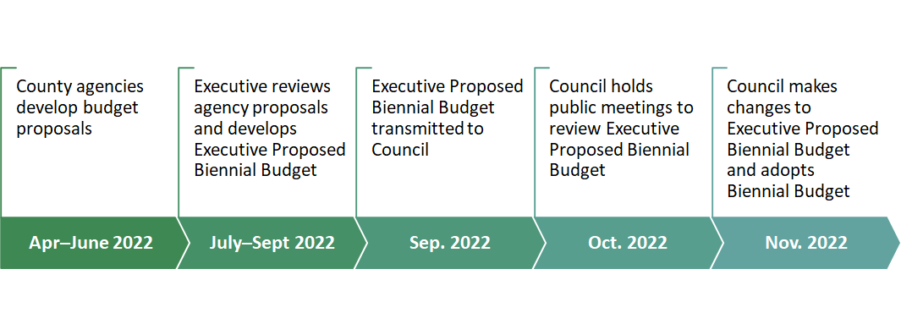

AMENDMENT

Attachment A of the proposed motion includes a draft version of the council priorities that was shared by the Budget and Fiscal Management Committee (BFM) Chair at the April 27, 2022 committee meeting. Council staff is working with the BFM Chair to prepare Amendment 1, which would replace the draft version with a final version to be considered for action. Amendment 1 will be distributed to committee members prior to the meeting.

