Attachment A - 13998

Real Estate Services
Roads Surplus Sales, Eastside Rail Corridor and Environmental Initiatives
Proviso Response

Ordinance 17476
King County 2013 Budget
Section 28 — Proviso 1

Table of Contents

I. Executive Summary 1
II. 2013 Real Estate Services Budget Proviso 4
III. RES Staff Support for the Sale of RSD Surplus Property 5
IV. Eastside Rail Corridor 9
V. Environmental Initiatives 11
VI. RES Revenue and Staffing Plan Update 13
VII. Summary 17

Executive Summary

This report responds to Proviso 1 in Section 28 of King County Ordinance 17476. Progress made in four specific areas between January 1 and July 31, 2013, as well as other time frames, is presented in terms of cost, revenue, staffing levels, and schedule. In addition, the overall five-year staffing plan for the Real Estate Services (RES) Section in the Facilities Management Division (FMD) is updated and summarized.

Support for the Sale of Road Services Division Surplus Property

Since 2012, RES staff have either sold or have a sale closing pending for 39 of the 138 Road Services Division (RSD) surplus properties. Those properties represent 48% of the total acreage in the portfolio. About $5 million in revenue is anticipated to be received by the County for these parcels in 2013 (including $2.9 million for the Bruggers Bog property which closed in July 2013) and an additional $5.3 million in 2014, for a total of $10.3 million by the end of 2014. It is estimated that these sales will have required the equivalent of less than 5 full-time employees (FTE) of RES staff time, for an estimated cost of about $1 million.

Up to seven additional FTEs of staff time will be required between now and 2017 to sell the remainder of the RSD surplus properties, although a portion of the remaining properties are expected to not be marketable. RES will review staffing needs once due diligence activities are complete and marketability is determined for the remaining parcels.

The remaining parcels in the RSD surplus portfolio are estimated to be worth approximately $4.8 million based on adjusted assessed value. Of the parcels remaining to be sold, 36 will be transferred to other jurisdictions that have annexed or will annex the area in which the parcels are located. No revenue is anticipated from those parcels. About 90 hours of RES staff time per parcel will be required to complete the transfers.

Eastside Rail Corridor

In February 2013, King County purchased 15.6 miles of a former Burlington Northern Santa Fe (BNSF) rail corridor on the eastside of Lake Washington, with the intention of managing it as a multi-use corridor that will include a recreational trail. Parks is the custodial agency for that property. RES staff involvement in the purchase of the corridor in the first half of 2013 included due diligence activities, coordination with the Port of Seattle regarding the transition of ownership and property management activities, and coordination with Parks to develop policies and strategies for converting existing permits to King County permits. That preliminary work, funded through the General Fund, is nearly complete.

Over 300 permits issued by BNSF are associated with the new property. Many of the existing permits are outdated, incomplete and unclear as to terms and conditions. Based on field reconnaissance, it is likely that there are many more unpermitted uses of the property. RES and Parks intend to issue County permits to replace the existing permits, so that all users of County property in the corridor comply with insurance, bonding, indemnification and other requirements of County permits. Most of the cost associated with the issuance of those permits would be covered through permit fees. Work on the permits began in 2013 and will continue through the end of 2014. It is estimated 1.35 FTEs will be required between 2013 and 2015 for this work.

Additional work associated with encroachments and enforcement may be identified during the permit transfer process.

Environmental Initiatives

In 2012 and 2013, RES staff supported the development of a storm water management inspection and compliance program for over 800 County-owned parcels, under the National Pollutant Discharge Elimination System (NPDES). The first audit of the program in July 2013 by state and federal inspectors has met with initial praise from the inspectors as to program status, quality and completeness. Final audit results are not available to include in this report. One-quarter of a FTE in RES will be required to maintain the ongoing requirement of this program.

Also in 2012 and the first half of 2013, RES staff conducted research and provided information to the Environmental Protection Agency (EPA) about County-owned properties in the Lower Duwamish Superfund Clean-Up study area. Future work will support the County’s efforts to ensure that responsibility for the $330 million clean-up plan is allocated fairly between the County and other liable parties. An estimated .25 FTE of RES staff time, in addition to term-limited temporary (TLT) and other resources, will be required in 2014 and 2015.

2013 RES Staffing Plan Update

In 2012, RES developed a staffing plan that responded to declining revenues and the subsequent lower anticipated future workloads from the RSD. The plan also addressed the need to maximize overall revenue to RSD through the sale of surplus properties. The plan provided for repurposing real estate staff, who previously conducted acquisition work on RSD capital improvement program (CIP) projects, to address the emphasis on maximizing revenue through surplus property sales. The plan also reduced the overall number of FTE employees by one supervisor and one real property agent in 2013 and by an additional real property agent in 2014.

In August 2012, RES reevaluated its staffing forecast based on additional reductions in RSD CIP spending levels for 2013. Following the reevaluation RES decided to reduce staff levels by two FTEs in 2014 instead of the one reduction originally anticipated.

The 2013 staff reductions anticipated in the 2012 budget proviso response has been implemented on schedule. Two positions were eliminated in 2013. No layoffs occurred because the reductions were addressed through retirements.

In 2013 RES reorganized, reducing three units to two, thereby eliminating one supervisor position. The Permit and Franchise Unit was combined with the Acquisition Unit. Real property agents throughout the section were provided with training and resources needed to market for sale the RSD surplus properties. The Sales and Leasing Unit remained intact, but the Unit carried out significant cross-training and reassignment of job duties to implement the transition plan and to carry out the RES section’s redefined work emphases.

In anticipation of 2014 reductions, one position is being held vacant starting mid-year 2013 in order to avoid a layoff in 2014. A total of three FTEs, including the held vacancy will need to be eliminated in the RES section in 2014 due to further declines in the RSD CIP and other work areas. Further reductions may be required in the five-year planning horizon if workload projections are accurate.

2013 Real Estate Services Budget Proviso

Historically, a significant portion of the RES property acquisition work has been conducted in support of the Roads Capital Improvement Program (CIP). With substantial reductions to the Road Fund, and resultant cuts to the Roads CIP, the King County Council has been particularly interested in related impacts to RES workload, staffing, and revenue forecasts. Included in both the 2012 and 2013 budgets were provisos requiring the Executive to provide Council an assessment of RES program impacts, and forecasts for the future.

This report responds to the 2013 Budget proviso (Ordinance 17476, Section 28, Proviso 1), which follows:

Of this appropriation, $250,000 shall not be expended or encumbered until the executive transmits a report and a motion that acknowledges receipt of the report and the motion is passed by the council. The motion shall reference the proviso's ordinance, ordinance section, proviso number and subject matter in both the title and body of the motion.

The executive must file the report and motion required by this proviso by August 22, 2013, in the form of a paper original and an electronic copy with the clerk of the council, who shall retain the original and provide an electronic copy to all councilmembers, the council chief of staff and the lead staff for the government accountability, oversight and financial performance committee or its successor.

The report shall provide an analysis that is based on the quantity, timeliness and financial results for the period from January 1, 2013, through July 31, 2013, of the real estate services staffing for:

- Property sales support provided to the roads services division that categorizes properties in the due diligence, surplus, appraisal, marketed, and completed stages of the sales process;

- Water quality inspections in response to the national pollutant discharge elimination system ("NPDES") permitting requirements based on the quantity and complexity of NPDES permitting;

- Utility easement requests for right-of-way on the eastside rail corridor based on the quantity and complexity of permitting and easements; and

D. Environmental protection work for the lower Duwamish clean up.

Further, narrative descriptions of the benefits of dedicated staffing for the bodies of work should be included, as well as anticipated needs in the second year of the biennium to analyze 2014 staffing levels.

While the Council’s particular interest has been the ripple effects of Road Fund reductions on RES staffing levels, a number of other program areas affect RES staffing levels, all of which are addressed in the RES workload, staffing, and revenue forecasts contained in this report. In addition to RSD work, forecasts include the following subject areas:

- non-Roads acquisitions,
- non-Roads sales,
- leasing,
- permitting,
- franchising,
- property management, and
- environmental compliance.

Forecasts are also included for the Eastside Rail Corridor and special environmental initiatives cited in the budget proviso.

RES Staff Support for the Sale of RSD Surplus Property

Scope of Work and Approach

Once a custodial agency determines that a property is surplus to their needs, it can be sold according to a process established in King County Code Section 4.56. That process has many complex steps. Although the time required to sell individual properties varies widely, a mathematical average was calculated for staffing projection purposes. In 2012, it was estimated that a typical property could take an average of 150 hours of staff time to sell. The averages for properties that have not yet sold have been increased because it is anticipated that they will be more difficult to sell. Details are provided below.

The steps required to sell a property include a formal polling of County agencies to determine that a property is fully surplus to the County’s needs; due diligence activities, including researching title, potential use and marketability and appraisals; sale marketing, including advertising, coordination with the Northwest Multiple Listing Service and working with real estate brokers; working with a potential buyer to negotiate sale terms and conditions and documentation through a purchase and sale agreement; preparation of sale approval legislation for Council review, and interface with council staff and attending the council hearing to explain the proposed sale and answer questions. For planning purposes, the projections assume that due diligence typically requires almost half of the estimated time to complete each sale. The projections assume that marketing could take about one-fifth of the total time and the sales activities would take the remainder, or about one-third of the total time.

The length of time it may take to sell a property depends on a number of factors, such as the strength of the market, current demand, competition with similar properties, and the quality and condition of the property. Each property could take from several months to many years to sell. For the purposes of the five-year staffing forecast, it is assumed that the RSD surplus parcels will take an average of two years to sell.

The 2012 RES budget proviso response indicated that 138 properties could be declared surplus to RSD needs. Nine parcels were removed from that list by RSD in 2013. RES staff did further analysis of those properties and prioritized them into five categories. These categories have been used to develop the sales component of the RES five-year revenue and staffing plan presented below.

Sales Process Improvements

In order to quickly and efficiently market the surplus RSD properties, RES has expanded and accelerated its sales marketing program by re-assigning staff resources, applying innovative marketing techniques, and improving the quality and frequency of communication with potential buyers.

Communication improvements include an online marketing system using both the King County website and Twitter. From August 1, 2012, to July 31, 2013, we've had over 4,400 pageviews on the RES property sales web site. For Twitter, we made a conscious effort to drive traffic to both the web page and individual property pages last summer and fall, when we had about 14,500 followers of @KCNews (we have 16,600 now). On the days that we tweeted listings, pageviews on the RES property sales website doubled or tripled.

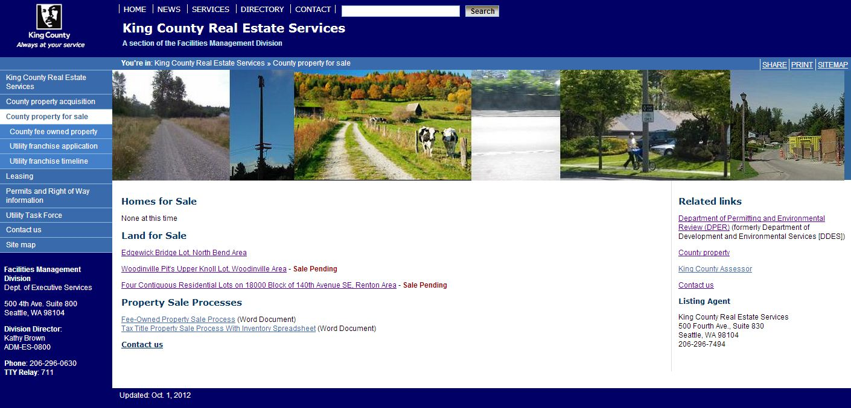

RES staff have also ensured that aggressive pricing of surplus properties, based on appraised fair market value, maximizes revenue to RSD while ensuring that the property is competitive with similar properties on the market.

FMD continues to pursue additional steps to expedite the sale approval process. The goal is to streamline the sale process in order to save time and money. A Lean review is currently being planned to identify and develop a strategy to address process improvements. The review may result in proposed code revisions in 2014. The goal is to identify measures that may reduce the overall time required to accomplish the sale of RSD surplus property. Efficiencies will be regularly evaluated after the process improvements are implemented. If significant time savings are realized, RES staffing levels for future years will be adjusted accordingly.

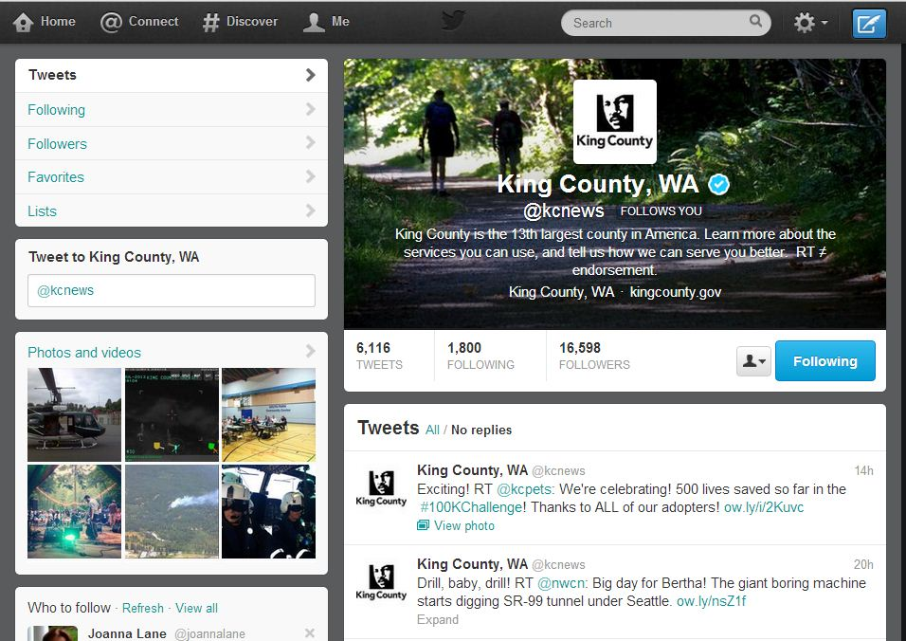

Accomplishments

The first and second categories (Categories 1 and 2) of surplus parcels generally contain the highest quality parcels in terms of size, condition, and marketability. These properties were determined to be the most saleable. There are 39 parcels in Category 1 and Category 2. About $5 million in revenue (including $2.9 million for Bruggers Bog which closed in July 2013) is anticipated to be received by the County for these parcels in 2013 and an additional $5.3 million in 2014, for a total of $10.3 million by the end of 2014. It is estimated that these sales have required less than 5 FTEs of RES staff time (583 total hours between January 1 and July 31, 2013), for an estimated cost of about $1 million. Part of the staff time spent in that period would involve due diligence work for properties that would be marketed and possibly sold in 2015.

Additional work to be completed by RES property agents in 2012 and through the end of 2013 includes working with RSD to identify all surplus properties and establishing a web-based database containing an inventory of all surplus properties. Standardized status reports are generated from this system to help both RSD and FMD managers keep track of program accomplishments.

Sales in Progress and Planned Work

Category 3 includes 28 parcels. These are generally properties that are likely to sell but some have site limitations, use restrictions, or other development or marketing limitations that may require more staff time and longer marketing exposure than Category 1 and 2 parcels to sell. In the staffing projections, it is assumed that one-quarter of these properties will not advance beyond due diligence due to marketing limitations. It is estimated that it will take about 200 hours of RES staff time to sell Category 3 parcels.

The total potential value of Category 3 parcels, based on appraisals and assessments, is about $3.8 million. A majority of that revenue is expected to be received in 2014, with about $1 million anticipated in 2015. About 2 FTEs will be needed for work on Category 3 sales in 2014, tapering down to .5 FTE of RES staff time in 2015. The total estimated cost of this staff time would be approximately $500,000. Given the conservative estimate of $4.2 million in revenue, versus the staff time costs, FMD recommends moving forward with the Category 3 sales.

There are 22 parcels in Category 4. These are properties that have site limitations, use restrictions, or other development or marketing limitations that will require more staff effort and possibly longer marketing exposure to sell compared to Category 1, 2 and 3 parcels. Since these parcels will likely be the most difficult properties to sell, an estimate of 250 staff hours per parcel was used in the staffing projections. However, all of these properties will require due diligence work prior to evaluating whether or not to put them on the market. The due diligence work on these parcels would occur in 2015 and require about 2 FTEs of RES staff time. Once the due diligence is complete, staffing levels for 2016 and 2017 will be reevaluated if some of the parcels are not suitable for marketing. At this time, 2 FTEs of RES staff time total is forecast for marketing and sale of Category 4 parcels in 2016 and 2017. That estimate assumes that 25% of these parcels will not go to market.

Another factor in determining whether or not to move Category 4 parcels to market is their total potential value. Estimating a rough potential sale value for these parcels, using assessed values in the absence of appraisals, results in a total value of about $500,000. It may be determined, once appraisals are in hand, that it may cost more to market these parcels than they are worth. For now, the staffing projections include work on Category 4 parcels through 2017. Staffing projections assume that all work on Category 4 parcels would occur between 2015 and 2017. No staffing for Category 4 is projected for 2014.

In Category 5 there are 36 parcels. These are properties identified by the County for possible conveyance to cities due to annexation or incorporation. No revenue would be expected from the transfer of these parcels. About 2.5 FTEs of RES staff time is expected to be distributed evenly over the period between 2013 and 2016. That equals about 90 hours per parcel for RES staff.

RES experience gained over the past year in RSD surplus sales has provided greater understanding of the issues related to marketing the less valuable parcels. Staffing projections in the out years are extremely hypothetical with actual staffing time likely to vary greatly from parcel to parcel. Staffing projections will be carefully evaluated each year to determine the viability and advisability of parcel sales.

Eastside Rail Corridor
Project Overview

In February 2013, King County acquired ownership rights to 15.6 miles of BNSF rail corridor (the Eastside Rail Corridor (ERC)) on the eastside of Lake Washington, passing through the cities of Woodinville, Redmond, Kirkland, Bellevue and Renton. The County paid more than $15 million for those ownership rights.

With the purchase of the corridor, the County became the Interim Trail User for rail banking purposes under the federal Rails-to-Trails Act, 16 U.S.C. §1247(d). Rail banking preserves disused portions of interstate rail lines by allowing them to be used for trails for an indefinite but interim period. The basic premise of the Act is that rail-banked property may be restored to active service (“reactivated”) upon demand of a bona fide interstate freight rail operator.

As the Interim Trail User, the County is subject to legal obligations imposed by the Rails-to-Trails Act. One of those requirements is to actively manage the corridor in such a way that the corridor could be reactivated for freight rail service. The County intends to manage the ERC in a manner consistent with rail banking requirements and all of our real estate management practices, including the Special Use Permit (SUP) process for private or non-County use of County public lands. By authorizing uses with SUPs, the County will build an accurate record of uses in the corridor that will be beneficial when considering future multiple public uses. The process will also ensure that all users of the corridor have agreed to the standard indemnification, bonding, insurance and other conditions, including special conditions related to rail banking, required for the use of County land.

Accomplishments

In the 2012 proviso response, RES listed a number of activities associated with the acquisition of the ERC including due diligence for the sale transaction, development of a County management program, ownership transition, and staffing the future permit program.

Over 210hours of work (.14 FTE) were recorded by RES staff between January 1 and July 31, 2013, on activities related to the Eastside Rail Corridor. During that period, RES staff conducted appraisal reviews and other due diligence activities. In addition, permitting staff attended several meetings with Port of Seattle staff to discuss management of the inventory of over 300 permits and approvals that were transferring with the sale. RES also organized and facilitated several coordination meetings with Parks, to develop a process to convert BNSF permits to County permits. The result was an agreed-upon process between RES and Parks for processing the permit transfers.

Work In Progress

Work during the remainder of 2013 and into 2014 will include the development of a fast and efficient process to coordinate with Puget Sound Energy (PSE) and Sound Transit regarding issuance of permits by the County in areas in which they hold easements.

The permit transfer process will begin in 2013 in the southern portion of the ERC, within the City of Renton. The first round of transfer requests will be for permits owned by the City of Renton. There are approximately eight (8) known permits owned by the City. The City may identify additional uses that would require a permit from the County. Renton has offered to collaborate with the County on the development of the process that will be used to request and process transfers with citizens and companies in need of permits in the rest of the corridor.

RES permit staff will send requests to permit holders in small batches of 10 to 20 permits at a time. The requests will be sent generally from the south to the north. RES staff will attempt to work with entire neighborhoods at once, to avoid confusion among neighbors. It is anticipated that unpermitted uses will be identified during the permit transfer process. Efforts will be made to permit activity such as parking and landscaping along with permits issued for crossings of the corridor.

It is anticipated that about 400 permits will be issued for non-County uses of the ERC between August 2013 and the end of 2014. Each of these permits will be assessed the standard permit fee for a Special Use Permit, currently $500. FMD will submit a proposal in 2013 to increase that fee to $550 beginning in 2014.

Some users of the ERC may either refuse to apply for a SUP when requested, or the County may not discover all unpermitted uses. RES plans to coordinate with Parks to develop and jointly implement an encroachment identification and enforcement process in 2013 and 2014.

Planned Work

A majority of staff time required from RES will be associated with the transfer of the BNSF permits to County permits. Assuming that 400 permits will be issued for existing uses of the corridor (known uses plus additional currently unpermitted uses), 1.35 FTEs will be required between 2013 and 2015 for this work.

Environmental Initiatives

NPDES Compliance

Project Overview

The County-held federal municipal storm water permit under the National Pollutant Discharge Elimination System (NPDES) requires the County to ensure that properties it owns and operates do not generate pollutants. For RES, that includes 16parcels leased to private businesses and more than 864 Tax Title Properties and dedicated greenbelts.

In early 2013, FMD and Water and Land Resources Division (WLRD) staff developed an inspection and compliance program to conform to permit requirements. As a result, every property will be inspected once every five years unless the property contains constructed on-site drainage facilities, in which case the storm water permit requires an annual inspection.

Corrective actions that may be identified as necessary after inspections include litter and waste material removal. The RSD is contracted to perform maintenance of drainage facilities or to assist with major debris dumps deemed a potential water quality violation. The inspection program has also disclosed instances of minor and major trespass and orphaned greenbelts that should have been transferred to cities during early annexations and incorporations, but were not.

Accomplishments

RES staff recorded 616 hours (.42 FTE) of work between January 1 and July 31, 2013, on NPDES permit implementation. Additional time was spent in 2012 prior to implementation of a timekeeping system that tracks hours worked by project.

In 2012 RES staff processed 81 parcel inspections performed by WLRD and confirmed six (6) instances of trespass. Twelve (12) parcels were identified that will need to be transferred to an incorporated jurisdiction. Four (4) parcels were cleaned up by the Solid Waste Division (SWD) and RES staff coordinated Roads Division’s corrective maintenance work at two sites.

WLRD normally performs all of the field inspections, but none were performed during the first six-month period of 2013, pending Council approval of a supplemental budget request for 2013. Almost half of the original inspection budget was diverted to pay for function-critical repairs to constructed drainage systems that were discovered in late-2012. Repairs had to be completed by June 30 to meet permit standards or a notice of permit violation would have been forwarded to Washington State Department of Ecology. FMD plans to complete the 2013 inspection work program during the second half of the year.

The storm water-focused property inspection program has resulted in better management of the overall portfolio of properties. Besides being a better neighbor to adjacent private property owners, the interests of County taxpayers are being protected, the environment including both terrestrial and aquatic habitat are protected, and compliance with federal law is achieved.

Work In Progress

The County has just recently gone through a compliance audit performed by an enforcement team comprised of representatives from the federal Environmental Protection Agency (EPA) and the Washington State Department of Ecology. The FMD property management program and compliance database were highlighted for recognition during the audit, showcasing the system developed by FMD to ensure that storm water pollutants are not generated on County properties. The auditors described the property management program as “excellent and impressive” during their verbal closing comments. The formal written audit findings will not be available for several months and it is not known at this time if any corrective actions or program enhancements will be required.

The program is in the third year of a five-year revolving cycle. Costs for WLRD inspection services in years four and five are expected to climb slowly and only as a result of increased unit staff costs. The program has been designed so the number of sites inspected in each of the first five years is relatively constant. Starting in the sixth year the number of tax title lots will grow by an average of 60 per year, based on past experience. Since the program will also still be visiting sites for the first time every year, predicting corrective costs on the parcels will be difficult and past experiences may only loosely inform future projections. Research performed by RES staff after WLRD inspections reveals discrepancies in ownership and jurisdiction. It will be necessary to prioritize sufficient staff time to tighten the RES database, which in the long-term will increase RES efficiency in processing all inspected parcels.

Planned Work

The size of the real estate portfolio that RES staff are required to inspect on a regular basis, coordination required with WLRD and other County agencies to correct problems that are discovered during inspections, and resolution of encroachment and property transfers will require the same level of effort in future years as planned for in 2013.

In 2014 and future years, .25 FTE will be required per year to comply with NPDES property management responsibilities. FMD now has the ability to track actual staff time spent on this work and will make adjustments in future years based on the first full year of data collection.

Lower Duwamish Clean-Up

Project Overview

King County owns, operates, and leases a number of properties in the Lower Duwamish Waterway Superfund Clean Up Project Area, including a regional wastewater treatment system, the King County International Airport, and property leased to small businesses and industries. These facilities may have contributed to the historical pollution of the Lower Duwamish Waterway.

Before the Superfund listing of the site in 2001, King County joined with the City of Seattle, the Port of Seattle and Boeing, to form the Lower Duwamish Waterway Group (LDWG). The LDWG has been proactively working with the EPA and the Washington State Department of Ecology to get the cleanup started.

The EPA has indicated a preference for a clean-up alternative with an estimated cost of approximately $330 million. That cost will be distributed between responsible parties, including the County. LDWG has developed a proposal to distribute those costs through a voluntary allocation process in lieu of litigation.

Accomplishments

Under federal Superfund laws, clean-up costs are paid for by businesses, individuals and public agencies found to be responsible for the historical pollution. The EPA uses the 104E process to assist in identification of properties within the study area that may have contributed to the contamination. RES staff conducted extensive review of current and historical property records in 2012 and 2013 to identify such properties. This work involved reviewing property files, scanning lease agreements and other documents, and conducting research on corporate history of tenants on County property.

The share of the clean-up costs that each responsible party is required to pay will be determined through an allocation process that will begin in 2013 and take approximately two years to complete. King County, including RES staff, have been assisting the Prosecuting Attorney’s Office (PAO) in the development of the allocation process. Continued assistance to the PAO by RES staff in presenting the County’s case in the allocation process is necessary. By the end of 2013 RES staff may be requested to assist the PAO with responses to requests for information from the allocator and in developing the County’s case in allocation. After that, during 2014, RES may be requested to assist in the development of responses to others who have made cases against the County.

RES staff recorded 377 hours (.25 FTE) between January 1, 2013 and July 31, 2013, on work related to the Lower Duwamish Clean-Up project.

Planned Work

Approximately .25 FTE will be required in 2013, 2014, and 2015 to conduct work related to the allocation process.

RES Revenue and Staffing Plan Update

The RES section is the entity charged with overall management of King County’s real estate portfolio. As such, RES is the sole agency vested with the responsibility for property leases, easements, and other permissions for property use. RES is also tasked with real property inventory functions, and disposal of King County-owned properties that are no longer needed for King County business. RES is responsible for nearly all property acquisitions, as well as managing almost all of the real property owned by King County. The Department of Natural Resources and Parks (DNRP) and the Department of Transportation (DOT) also have some property management responsibilities.

RES seeks to ensure that: 1) the opportunity cost of financial resources in land and buildings is minimized, and that 2) the capital and revenue expended on the County’s real estate portfolio are efficiently and effectively directed to provide the greatest value to the County’s business strategies and service delivery requirements.

RES reduced staff levels by two (2) FTEs in 2013, in accordance with plans submitted in the 2012 proviso response. One of those positions was a supervisor position, eliminated when the Permitting Unit was combined with the Acquisition Unit. Real property agents throughout the section received training and resources needed to sell the RSD-surplus properties. The Sales and Leasing Unit remained intact, but the Unit carried out significant cross-training and reassignment of job duties to implement the transition plan and to carry out the RES section’s duties and responsibilities.

RES anticipates reducing staffing in 2014 by three (3) FTEs compared to 2013 levels. Staffing levels are also expected to decrease further within the five-year forecast period. However, it is difficult to forecast precise staffing levels with little information on the long term capital projects of other County agencies that may require assistance from RES. Staffing levels may be adjusted in future years as new information becomes available about factors affecting the overall workload. RES anticipates a continued focus on retraining and cross-training to ensure that existing staff are able to respond to the changing nature of the RES workload.

The FTE count in the following summary chart does not include the RES Section Manager and two administrative staff. Those positions would continue to be required during the five-year staff plan timeframe presented in this document. The 2016 and 2017 staffing levels are partial as no information is available about future CIP work from various County agencies that may require RES support. Staffing forecasts will be evaluated and adjusted annually and rely on the best information available from partner agencies within the County.

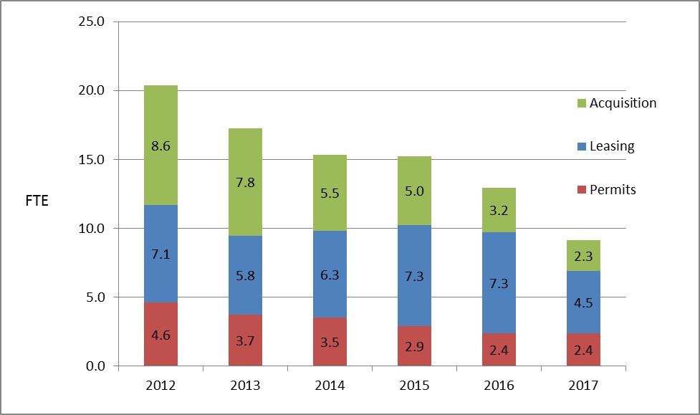
Note: This staffing level forecast takes into consideration that fact that one position has been held vacant after a June 2013 retirement to avoid a layoff in 2014.

The level of staffing required by RES depends on a number of factors, including the CIP plans of other County agencies, the volume and rate of sale of surplus properties, and work required on special projects such as the Eastside Rail Corridor and environmental initiatives. The detailed staffing plan representing all of the work the RES is responsible for is in Appendix A. An explanation of staffing assumptions for RSD surplus sales, the Eastside Rail Corridor, and environmental initiatives is provided above. Descriptions of other factors affecting the RES staff planning including the RSD CIP, permitting, and franchises are provided below:

RSD CIP

One of the RES Section’s primary customers is the Road Services Division (RSD). Services include: 1) property and right-of-way acquisition in support of the RSD CIP; 2) the sale of surplus properties; 3) permitting of non-County work within the County right-of-way (ROW), and 4) negotiation of franchise agreements with utilities.

RES bills RSD for work related to acquisitions. RES sales work is funded through the General Fund. However, revenues from the sales of the surplus properties more than compensate for the funds needed to cover the transaction costs. Costs associated with permitting and the issuance of franchises are generally covered through administrative fees to applicants.

In the 2012 proviso response, RES anticipated a 42% reduction in the RSD CIP to $242 million for the period between 2012-2017. In August 2013, the CIP funding levels dropped again requiring an additional FTE reduction to the RES staff level in 2014.

The equivalent of 2.4 FTEs worked on RSD CIP projects in 2012. By the end of 2013, it is anticipated that 1.5 FTEs will have worked on RSD CIP projects. Although last year it was anticipated that the 2014 RSD CIP would include 10 projects, requiring approximately 1.1FTEs, that number has recently changed to three (3) projects that will require approximately 0.4 FTE of RES time. That number may increase slightly to about 0.5 FTE if new acquisition work planned by RSD materializes in 2014.

Between mid-2013 and 2017, the RSD CIP is expected to continue to decline, with minimal work anticipated for RES staff in the foreseeable future.

 | 2012 | 2013 | 2014 | 2015 | 2016
# of Projects | 19 | 14 | 3 | 0 | 1
Charges | $436,516 | $300,000 | $80,000 | 0 | $50,000
Hours | 3,492 | 2,222 | 593 | 0 | 370
FTEs | 2.4 | 1.5 | .4 | 0 | .25

Permitting

The RES permitting unit is responsible for granting permission for non-County use of County property. Permits that they issue include right-of-way construction (ROWC) permits for use of County roads, special use permits (SUP) for proposed uses on non-roads property, and franchise agreements that cover the terms and conditions for on-going use of County right-of-way by utility providers.

RES is also currently responsible for issuing permits for use of County roadways to transport loads larger than legal limits in terms of size and weight. In response to a request from the King County Department of Transportation (DOT), RES intends to transfer responsibility for issuance of that permit to DOT. This transfer of responsibility is consistent with King County Code. Between 300 and 400 over-legal permits are required per year, which takes about .25 FTE of staff-time to process. The revenue from these permits does not cover the administrative costs to issue them.

In 2012 and 2013, RES has been working with stakeholders to simplify and clarify the fee structure for ROWC permits. Proposed legislation will be submitted along with the 2014 budget to accomplish this goal. Although the fee structure will be simplified, it is anticipated that the total revenue will remain the same compared with the existing fee structure and that revenue will cover the costs to issue the permits. Approximately 1,500 of these permits are issued per year, requiring about 1.33 FTEs to process.

The legislation that RES intends to submit with the 2014 budget will also include proposed changes to the SUP permit process. In 2012, RES, DOT and Parks co-sponsored a Lean process that clarified the workflow within RES and between RES and custodial agencies. The legislation will propose an increase in the inspection fee that the County is allowed to charge, as well as an increase in the SUP fee from $500 to $550 per permit. The increase would compensate custodial agencies for review of permit applications. Therefore, this increase would have no effect on the overall revenue forecast for RES. Fees for SUPs generally cover RES’s administrative cost to issue the permits. About 140 of these permits have been issued per year in recent years, requiring about.5 FTE. The permits associated with the ERC discussed above would be SUPs. RES has anticipated approximately 400 permits on the ERC, associated with the transition of the property to County ownership. Those permits will require a one-time increase of 1.35 FTEs between 2013 and 2014.

Appendix A contains detailed information about the level of effort anticipated over the next five years to issue all permits. Appendix 3 contains information about the anticipated revenue expected from the permit program.

Encroachments

During the 2012 Lean process on the SUP permit, participants identified the need to be more systematic with the identification and resolution of unpermitted uses on County land. FMD is in the early stages of working with custodial agencies and the Office of Performance Strategy and Budget to design a process to address this issue. Additional RES staff-time may be required in future years once a new process to resolve encroachments is identified.

Franchises

The permitting unit in RES manages the negotiation of franchise agreements with utilities (water, sewer, power, gas, and wireless communications). There is currently a backlog of franchise work that has accumulated over several years. The current work plan anticipated short-term temporary assistance in 2013 and 2014 to help eliminate the backlog. In addition, almost two (2) FTEs of RES staff time will be required in 2013 and 2014 to eliminate the backlog. RES will require about .25 FTE on an ongoing basis to manage the standard franchise workload.

Summary

The 2012 proviso response from RES charted a course for the section that included staff reductions, reassignment and retraining to accommodate the new sales workload, and significant attention to important environmental initiatives.

All of those planned activities occurred as indicated in the 2012 report. One supervisor and one addition position were eliminated in 2013. All staff in the Acquisition Unit and the Sales and Leasing Unit were provided training to increase and enhance their skill sets so that they could be reassigned to surplus sales work.

The immediate attention and resources focused on the sale of RSD surplus properties resulted in the sale of 49% of the total acreage in the portfolio. Revenue from these sales will be about $5 million by the end of 2013 with an additional $5 million expected by the end of 2014.

In 2012 RES anticipated reducing 2014 staffing levels by 2 FTEs compared to 2013 levels. Based on a new analysis of workload for 2014, staff reductions will increase to 3 FTEs in 2014. The workload for RES will be monitored carefully and additional staffing adjustments will be made as needed in future years.

Appendices

- Five-Year Workload Forecast

Note: This table does not include the director and 2 administrative staff.

- RES Work Plan for RSD Surplus Properties

- Revenue Forecast (2014 Budget Submittal)

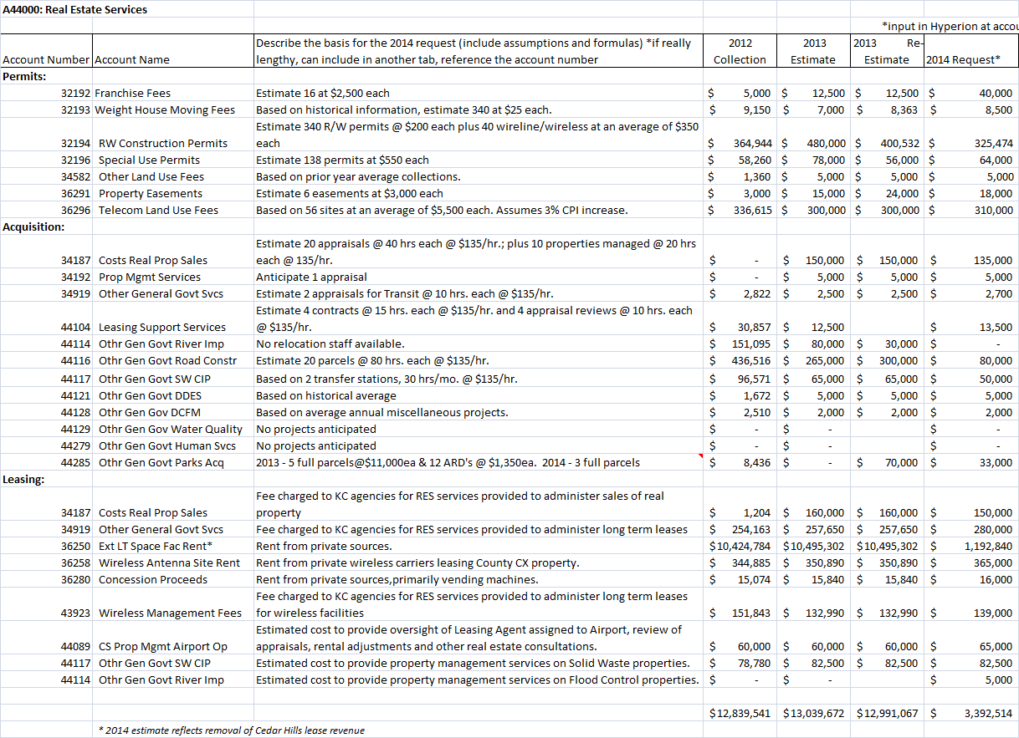

- Summary Property Sales Report
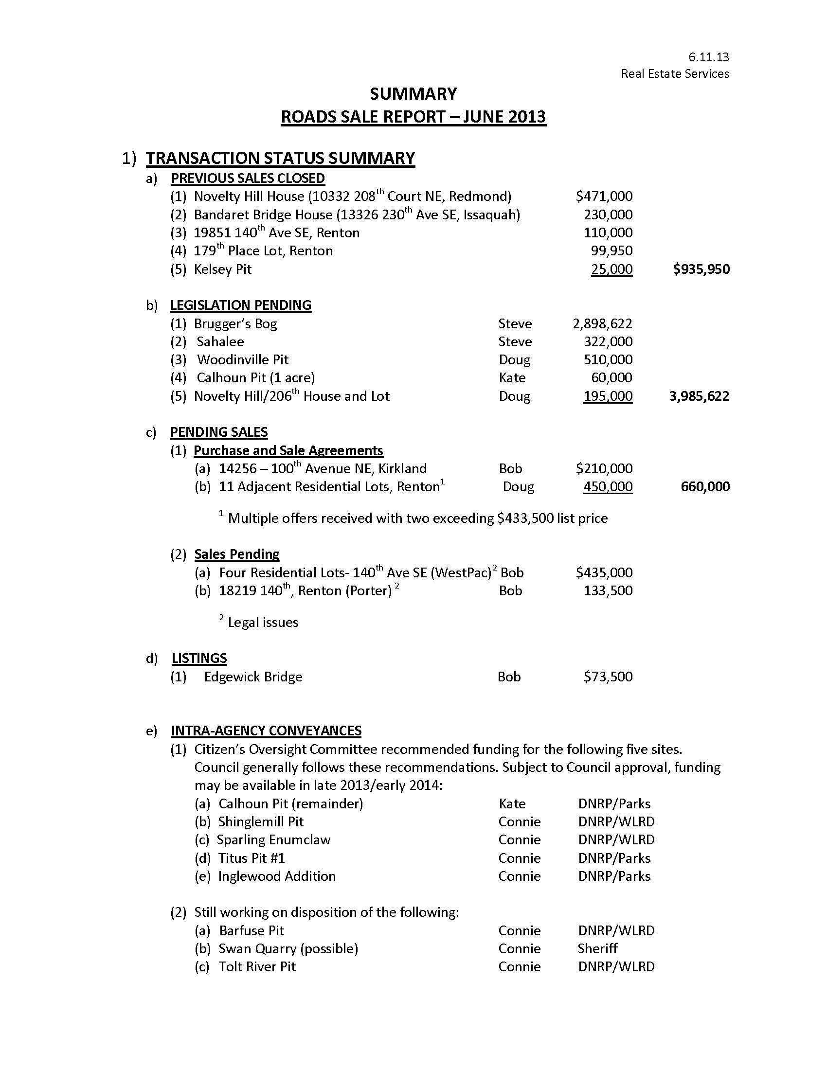

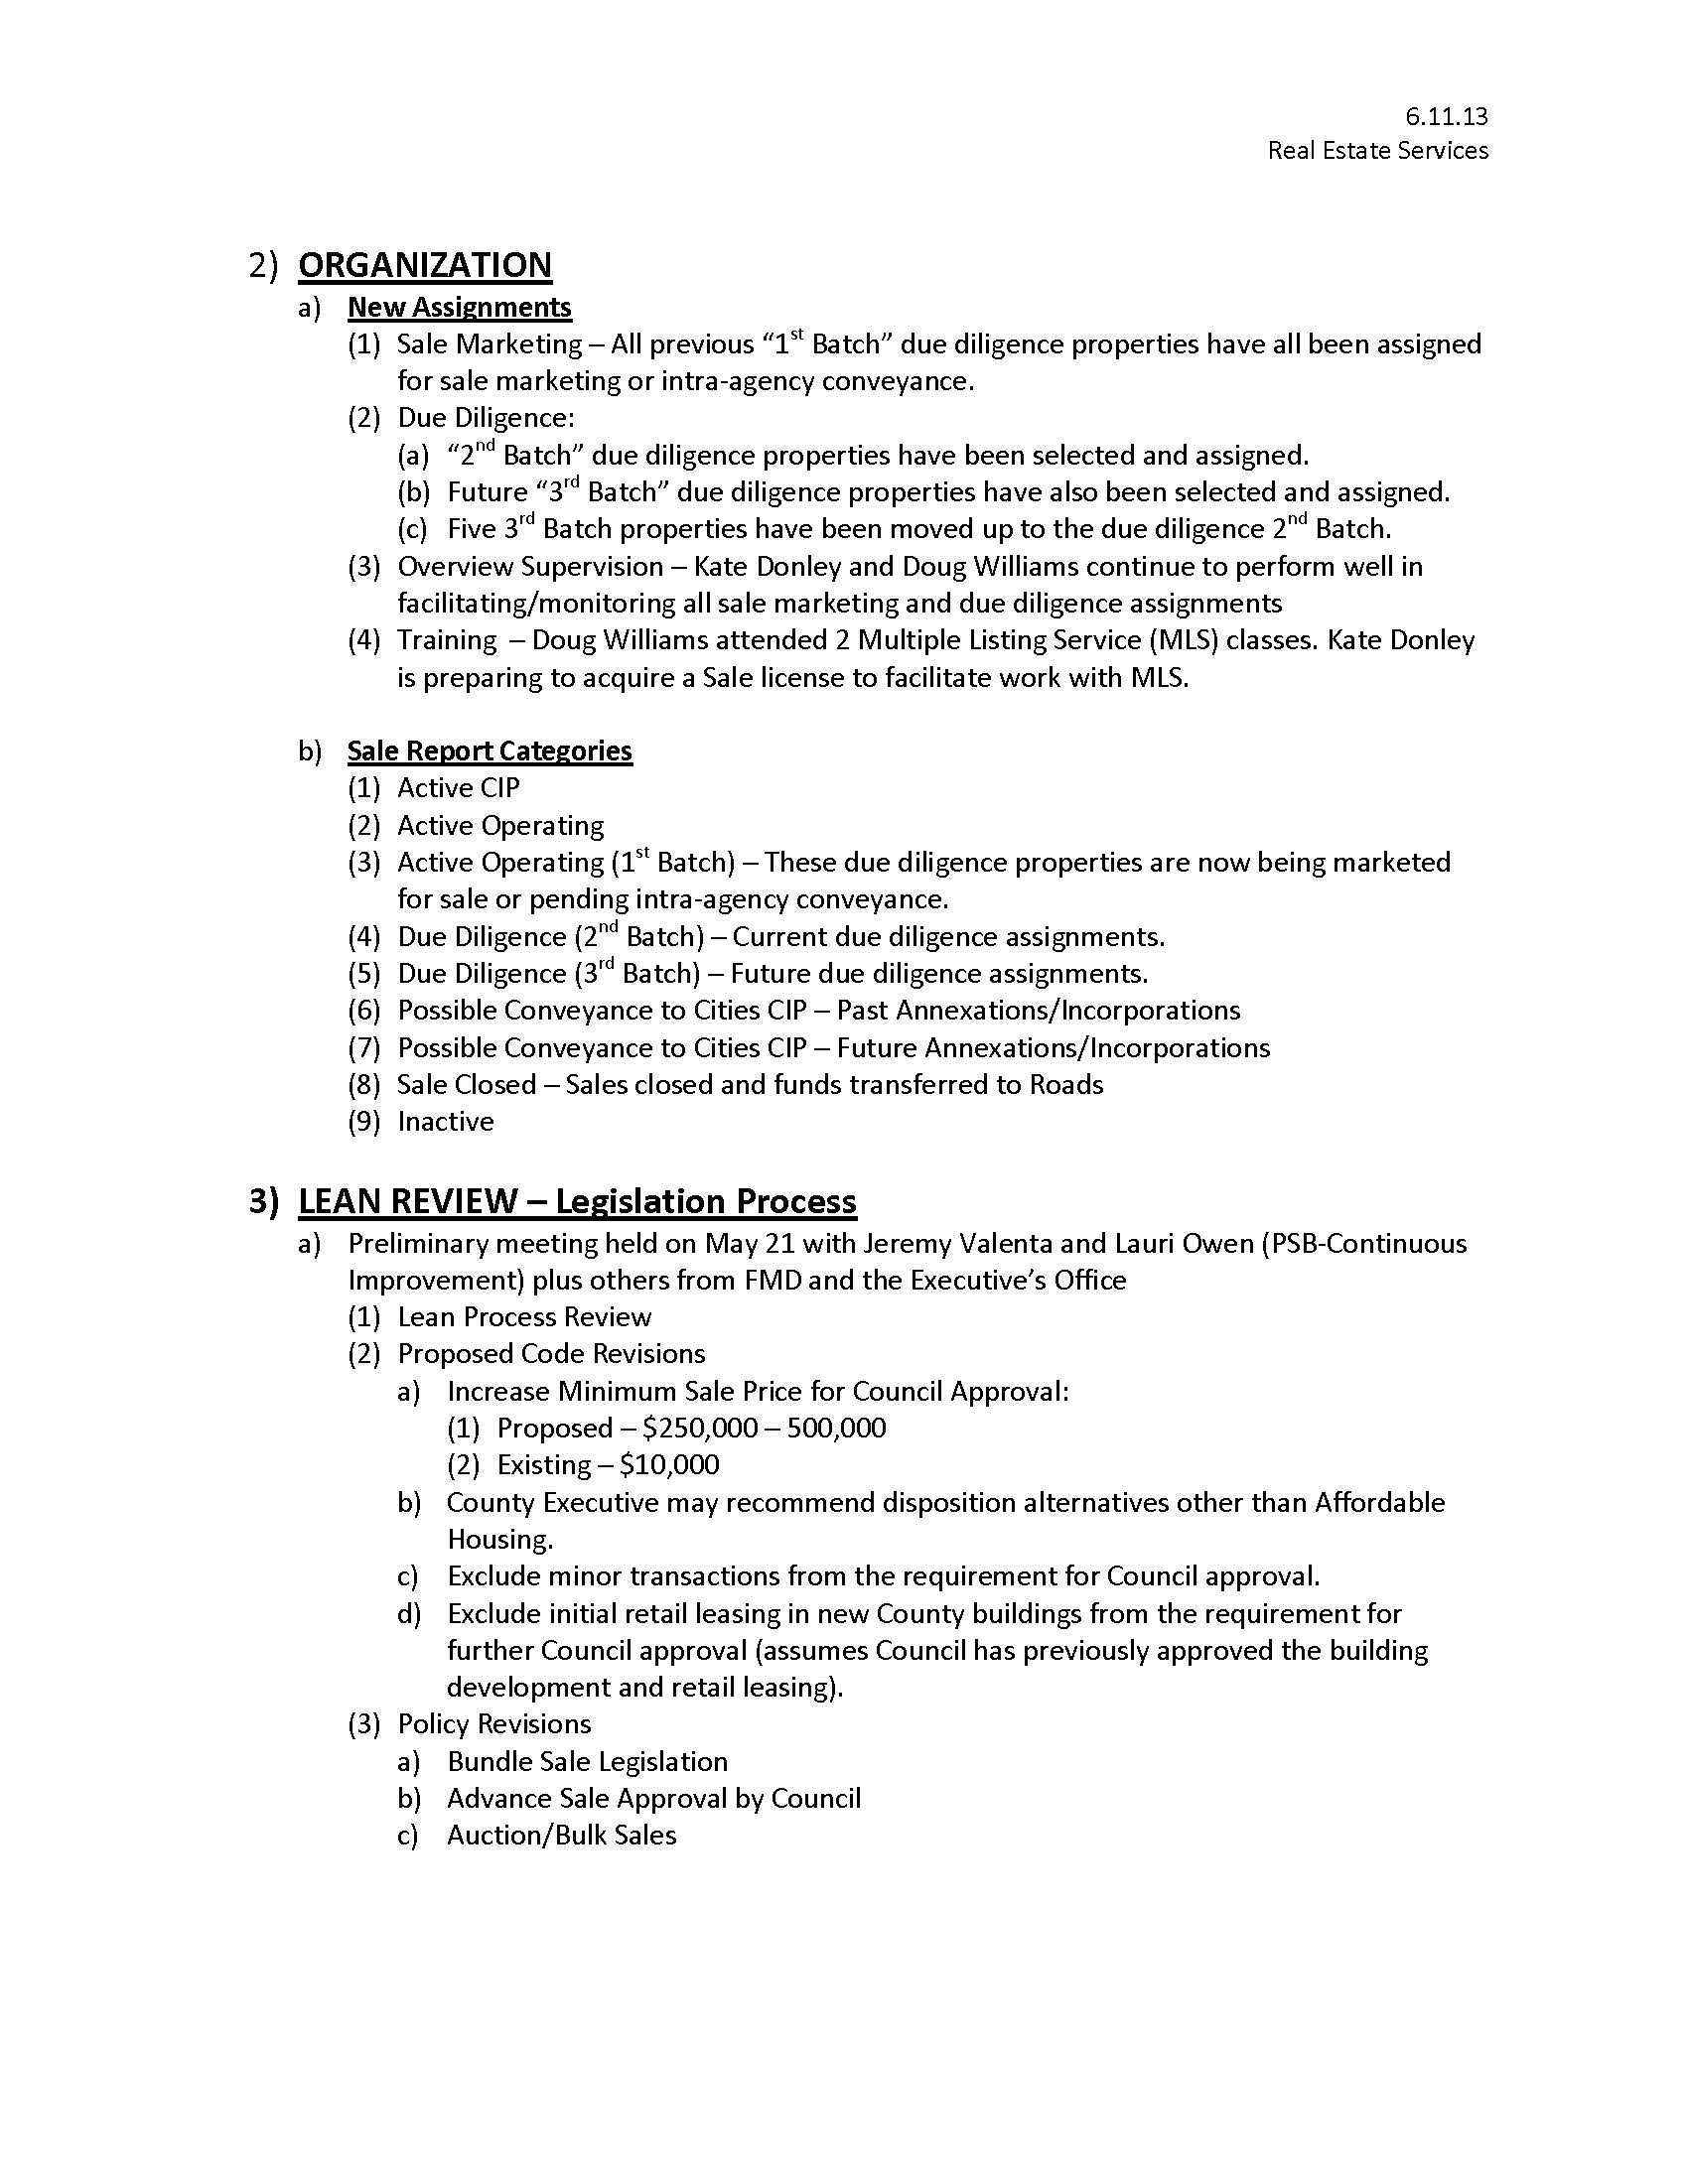

Actual from 2013 budget submittal
From 2013 budget submittal, re-estimate column
$125 per hour in 2012. $135 per hour in 2013 and beyond.
1480 productive hours per FTE

