Sale Property Summary
Photo of Property
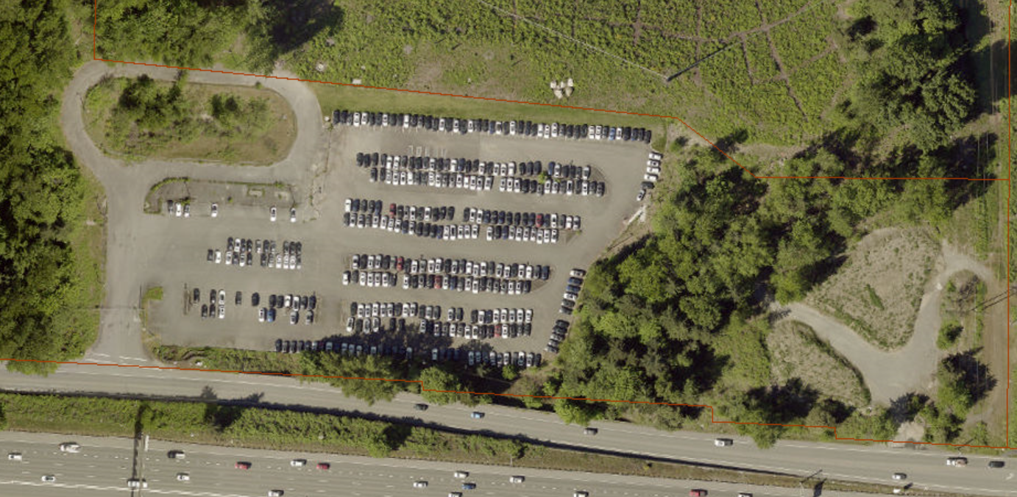

Address 13620 SE Eastgate Way, Bellevue
Sale Price $18,885,000.00
Sale Area 9.81 Acres
Assessor's Parcel 102405-9101
Zoning OLB2, Office and Limited Business 2
Council District Six
Funding Source Solid Waste Fund
Declared Surplus September 4, 2019
Template Status: County template with changes
Offer Expiration: Approval by July 15, 2021 to maintain funding for project.

Property Information
The site was purchased in 1993 by the Solid Waste Division as a site for construction of a new transfer station, which was not built on the site for financial reasons. The site has never been improved beyond paving portions to provide for temporary parking/staging during and after construction of the transfer station on adjacent sites. The Solid Waste Division notified FMD in January 22, 2018 they have no further need for the site. The proposed purchasers are Polaris at Eastgate, LLC, an affiliate of the Inland Group, Horizon Housing Alliance, a California non-profit public benefit corporation and Congregations for the Homeless, a Washington non-profit corporation.

Context
This surplus property will be developed to contain a permanent 80-100 bed men’s shelter, an additional 80 units of housing for persons transitioning out of homelessness and approximately 265 units of affordable housing serving families with an income of 60% area median income or lower.

Rationale for transaction: The property is surplus to King County’s current and likely future needs and sale of the property will not only reduce operating costs and liabilities but will also provide one-time revenues to support other one-time expenditures.

Policy considerations : While it is King County policy to own facilities it needs for operations purposes, given current and future anticipated operations, this facility is no longer needed to support Solid Waste Division or other King County operations and holding on to the facility results in additional liability and costs. In addition, sale to the potential purchasers aligns with King County policies related to support for affordable housing and providing facilities and services for unsheltered, homeless individuals.

Political considerations: Councilmember Balducci has an interest in this transaction, as it relates to the long-standing need to provide a permanent homeless shelter to serve the Eastside and the City of Bellevue.

Community considerations or partnerships: Congregations for the Homeless is a faith-based, community organization that operates shelters on the Eastside and is the originator of this proposed sale. This sale will provide the first permanent shelter on the eastside of King County and Congregations for the Homeless has successfully advocated for changes in Bellevue’s land use codes that would authorize, for the first time, permanent shelters in the City.

Fiscal considerations: The purchase price of $18,885,000 is equal to the amount of the appraised fair market value, as determined by appraisal dated October 16, 2020, of $21,435,000 less $2,550,000, the amount of the estimated cost to remediate the environmental contamination of the property to meet current regulatory cleanup criteria and provide King County protection from future claims.

Other considerations: None Known

CIP/operational impacts: No CIP or Operational impacts

Change in property use: If sold to the prospective buyers, the property will be developed to contain a permanent 80-100 bed men’s shelter, an additional 80 units of housing for persons transitioning out of homelessness and approximately 265 units of affordable housing serving families with an income of 60% area median income or lower.

SEPA Review Required yes/no: No

King County Strategic Plan impact: This proposed sale furthers the King County’s Strategic Plan goal of accessible, affordable housing by increasing access to quality housing that is affordable to all, specifically providing affordable housing resources to communities and individuals that meet their specific needs, increasing housing stability for low-income families, and seeking innovative partnerships to expand the supply and funding of affordable housing.

Equity and Social Justice impact: In accordance with Real Property Asset Management Plan (RAMP) policy, the Facilities Management Division reviewed this legislation for Equity and Social Justice (ESJ) impacts. This proposed sale furthers the King County Equity and Social Justice Strategic Plan by investing in community partnerships to create affordable housing in the Eastgate neighborhood of Bellevue. The proposed development to create a men’s shelter, housing for persons transitioning out of homelessness, and affordable housing serving families with an income of 60% are median income or lower and is expected to positively affect low income communities.

Surplus Process
Interest from other county agencies? None that would interfere with the proposed sale.
Property suitable for affordable housing? Yes
Property determined to be surplus? Yes

Marketing and Sale
Indicate whether the property was marketed or not, and if so, how it was marketed:
MLS
Commercial Broker
County Website (number of website views:_______________)
Social Media
Onsite Signage
Not Marketed (briefly explain) unique circumstances make the sale in the best interests of the public, and the use of a portion of the surplus property will be restricted to the provision of social or health purposes.

Appraisal Process
Summary
Date of valuation: October 16, 2020
Appraised by: Integra Realty, reviewed by ABS Valuation
Appraisal factors: Sales Comparison and Land Residual Approaches
Comps analysis: Analyzed 8 sales, which after adjustment resulted in a value of $21,360,000. A second approach, identified as a Land Residual Approach, based on a theoretical development consistent with highest and best use, resulted in a value of $21,435,000.
Estimated FMV: As reconciled, $21,435,000. This value was validated by a review appraisal dated March 16, 2021, completed by S. Murray Brackett, MAI.

Appraisal Summary Chart
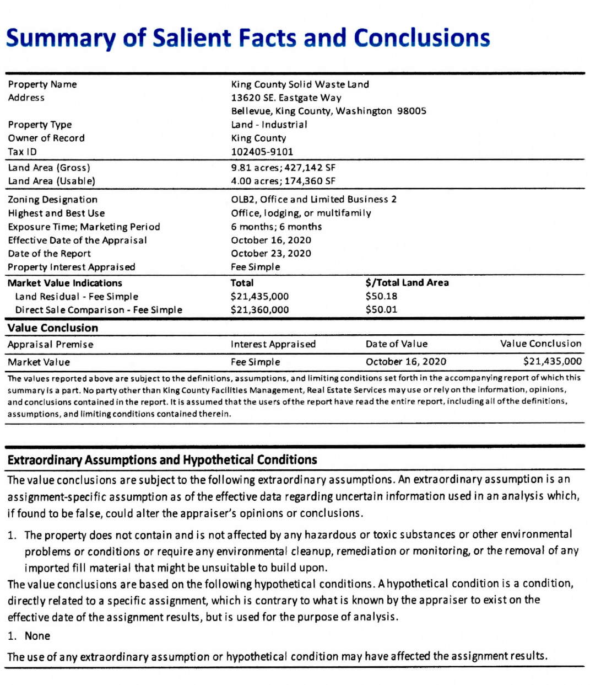

Vicinity View Map
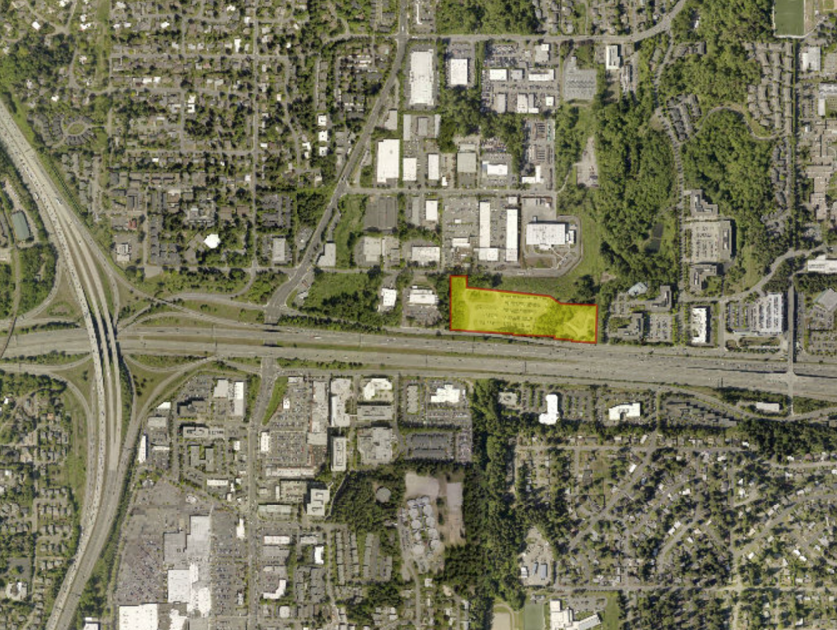

Parcel Map
