Champion/sponsor | Linda De Boldt
project manager | Birol Shaha
Date | 1/10/2023 updated (originally approved in 2016)
project name | Factoria Boulevard Storm Conveyance Improvements Project
CIP/JDE Number | JDE # 333690001
dept / division | Utilities / Engineering
CIP No. | D-114

Project Background
The City of Bellevue experiences recurrent flooding in the City’s Factoria-Richards Creek drainage basin during high-intensity storm events. In 2014, a heavy storm event on August 12-13 inundated a portion of Factoria Boulevard, south of SE 36th Street with nearly 4 feet of water (Figure 1). Businesses were flooded, streets were inaccessible, and the community was significantly disrupted. Flooding along Factoria Boulevard has been reported on numerous other occasions, including October 20, 2003, November 2, 2006, December 2, 2007, June 20, 2013, and May 4, 2017.
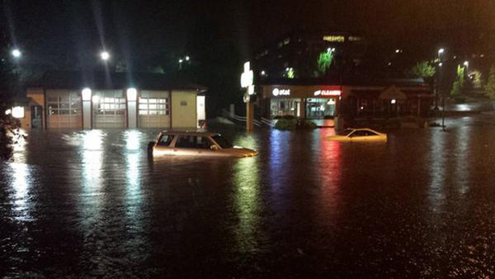
Figure 1. Flooding during the August 12-13, 2014 storm
In order to determine the cause of the flooding, and options available to address the issue in this area, the City completed several engineering studies that identified segments of the storm conveyance system between SW 38th Street and the discharge at Richards Creek as having constrained capacity to convey stormwater runoff generated during high intensity storm events.
Storm system improvements alternatives were evaluated, and recommended improvements were approved by the Utilities Capital Improvement Program (CIP) Cabinet in December 2018 to proceed to the design phase. The recommended solution includes replacement of the existing storm drain conveyance pipe with a larger capacity storm conveyance conduit, the installation of new drain pipes across Factoria Boulevard and new inlets located north of SE 38th Street along Factoria Boulevard SE.
Subsequently a comprehensive preliminary design including topographic survey and utility locates, geotechnical exploration, initiation of State and Federal environmental and land use permit acquisition, early stakeholders/public coordination and outreach was completed. Findings from preliminary design and baseline scope, schedule, project cost estimates were reviewed and approved by the Utilities CIP Cabinet in December 2020 to proceed to the Final Design phase.
This Charter has been, thereafter, updated to include Final Design phase of the project.

Problem Statement
- Street flooding is occurring between SW 38th Street to the discharge at Richards Creek during high intensity storm events.
- The flooding is a result of the peak flows during heavy rain events exceeding the capacity of the existing storm drainage system and upper Richards Creek Inlet Channel.
- These kinds of storm events have increased in frequency in the last decade and may continue to increase as a result of climate change.
- If stormwater infrastructure improvements are not made, during high intensity storm events, flooding of Factoria Boulevard would significantly disrupt the flow of traffic in the region, causing economic disruption to the many businesses in this commercial area, including access to the T-Mobile headquarter (>6,000 employees).

Goal Statement
The purpose of Factoria Boulevard Storm Conveyance Improvements Project is to design and construct storm system improvements to increase storm system conveyance capacity and reduce the risk of flooding along Factoria Blvd between SE 38th St and Richards Creek inlet channel such that no street flooding occurs during large storm events (design storm is 100-year, 24-hour storm event) by 2024.
The outcome of this project will be that the public storm water drainage system along Factoria Boulevard will have adequate capacity to collect and convey rainfall induced storm runoff effectively such that mobility through this major transportation corridor within the City of Bellevue will not be disrupted by flooding during high intensity storm events.

High Level Scope
The project replaces a segment of existing 3.3’x5.5’ stormwater pipe with a larger capacity conveyance system along the north bound lanes of Factoria Boulevard SE that will outfall into the Richards Creek Inlet channel adjacent to the Factoria Village commercial area.
The project is located just south of the intersection of interstate-90 and Factoria Boulevard, in the upper Richards Creek basin, a major tributary to Kelsey Creek, the largest creek in the City of Bellevue. The stormwater conveyance improvements that include 500 feet of 9-foot-wide by 4-foot-high concrete box conveyance, 250 feet long 49-inch by 33-inch pipe, and other associated drainage improvements will be located north of SE 38th Street along Factoria Boulevard SE as shown in Figure 2.
A City water line and PSE gas line need to be relocated due to conflicts with the proposed improvements in the project area.
- Conveyance Improvements
  - Replace existing 5.3 feet x 3.3 feet CMP pipe w/ 9-feet x 4 feet concrete box conveyance
  - New 24” dia. pipes across Factoria Blvd
  - 19 new inlets to reduce gutter flow
  - Replacement of Stormwater Outfall in the open channel inlet to Richards Creek
- Utilities Relocation - City’s water line, PSE’s gas and power line, other telecommunication lines
- Downstream Open Channel Improvements - Enhance Fish Habitat and Upland Vegetation (Mitigation)

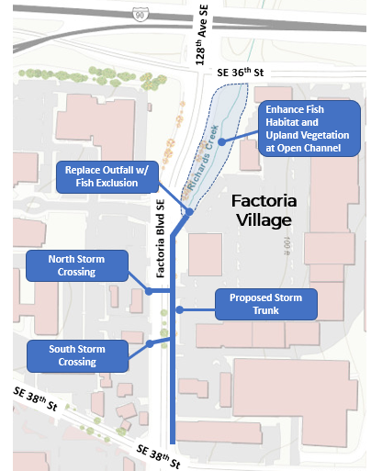
Figure 2. Project map showing proposed improvements.
The project is being completed in three phases. Phase 1 (Alternatives Evaluation, now completed) reviewed alternative improvements options and identified the preferred solution to proceed to design phase. Phase 2 (Design - ongoing) will complete engineering designs and permits for the preferred solution. Phase 3 will be construction.
Alternatives Evaluation Phase 1 (Completed Dec 2018) -
- Data Gathering and Review
- Condition Assessment
- Hydrologic/Hydraulic Modeling and Analysis
- Alternatives Analysis
Preliminary Design Phase 2 (Completed, 2019-2020) -
- Preliminary Design (30%)
- Surveying and Utility Locates
- Geotechnical Exploration
- Coordinating with City, State (WDFW) and Federal (USACE) Permitting agencies including Tribes and preparing permit applications (HPA, JARPA, Land Use Permits)
- Environmental compliance review and preparing Critical Areas Report
- Constructability Review
- Risk Analysis
- Utilities Relocation Plan
- Franchise Utilities Coordination
- Stakeholders and Public Coordination and Outreach
- Traffic Control Concept plans
- Traffic Impact Analysis and Lane Closure Configuration
- Supplemental Business Case Analysis
- Independent Cost and Design Review
- Project cost estimates (baseline cost) and implementation schedule
Final Design Phase 3 (ongoing, 2021-2022) -
- Final Design (60%, 90% and 100%)
- Permit acquisition
- Constructability
- Agencies and Franchise Utilities Coordination
- Stakeholders Outreach and Coordination
- Easement Acquisition
- Plans, specification and Engineers Estimates (PS&E)
Construction Phase 4 (2023-2024) –
- Public Bidding and Contract Award
- Construction activities by Contractor
- Construction management support including inspections, review, and coordination for RFIs, submittals, and change orders
- Agencies, Stakeholders Coordination
- Franchise Utilities Coordination

Out of Scope –
Relocation of gas line, power line and any telecommunication infrastructure that will need to be relocated by respective franchise utilities.
Primary deliverables include:
- Alternatives Analysis Report (identifies the Preferred Alternative), completed by December 2018)
- 30-Percent Design Submittal (Preliminary Design Report, 30% Plans, Implementation Schedule, Class 3 Cost Estimate), completed by December 2020)
- Final Design Submittal (Bid-ready Construction Plans, Schedule, Class 1 Cost Estimate), completed by March 2023)
- Construction Substantial Completion by Dec 2024.

Project Schedule
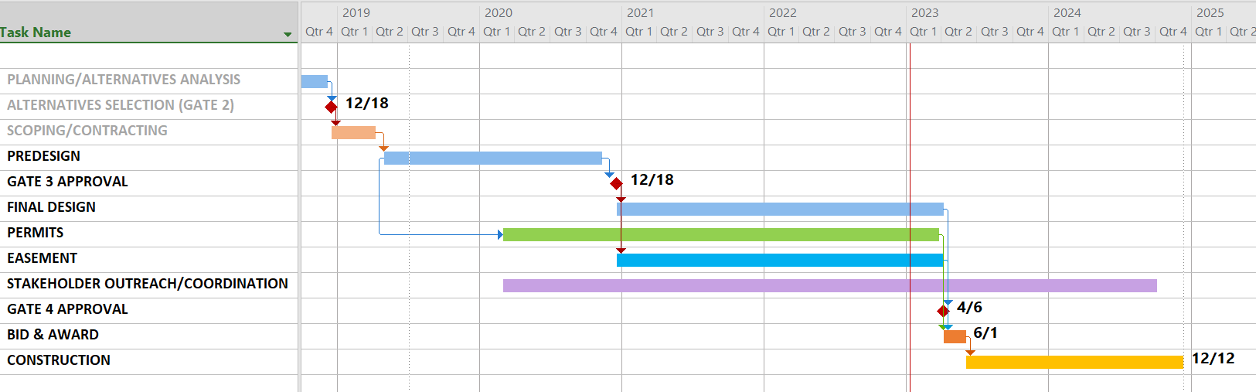

Project is currently initiating final design phase. Construction is projected to start in summer of 2023 and complete final restoration in 2024.

Project Cost
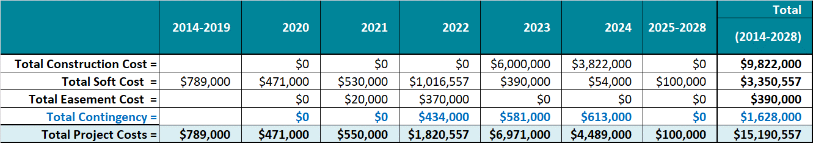
Estimate based on 95% Design
King County Flood Control District (KCFCD) has approved CIP Project Grant of $6,814,000. The project also obtained $716,716 from the KCFCD Sub-Regional Opportunity Fund.

PROJECT TEAM
Name | ROLEs & Responsibility
City Team Members:
Maria Peraki | City Project Manager
Linda De Boldt | Project Sponsor, Assistant Director
Debbie Harris | Project Management Section Manager
Jerry Shuster | Utilities Planning - Storm water Sr. Engineer
Christa Heller | Environmental Scientist/ Watershed Management Specialist
Doug Lane | Planning Manager
Birol Shaha | CIP Portfolio Manager
Casey Peterson | O&M - Storm Water Superintendent
Richard Peckler | O&M – Sewer SET (Sr. Tech)
Nathan Rauscher | O&M – Water SET (Sr. Tech)
Rich Ford | Sr. Construction Inspector
Ryan Shelton | Utilities Construction Manager
Michaelene Fowler | Utilities Public Information Officer
Mike Murray | City Real Property (Easement Acquisition)
Design Consultants Team Members:
Ginette Lalonde (Louis Berger/WSP) | Consultant Project Manager
Ralph Nelson (Louis Berger/WSP) | Senior Civil Engr, /Hydraulics & Hydrology
Jay Cammermeyer (Louis Berger/WSP) | Project Engineer, Lead
Dan Roscoe (WSP) | Environmental and Permitting Lead
Brian Kellogg (WSP) | Traffic Control
Jerry Scheller (Tetra Tech) | Prime Consultant QA
Kevin Dour (Tetra Tech) | Large On-Call Contract Manager
Geo Engineers | Geotechnical (predesign phase)
Aspect | Geotechnical (final design phase)
Rachel Aronson (Triangle) | Public Outreach
Mark Fuglevand (KBA) | Constructability
Parametrix | Surveying
APS | Utilities locating

KEY STAKEHOLDERS
Name (Organization) | Interest
Utilities O&M | Owns and operates the storm water system
Development Services Dept. | Review/Issue City permits including Critical Areas Land Use Permit, SEPA and Clear and Grade Permit
Transportation - ROW | Review/Issue City ROW permit
Transportation - Traffic | Traffic Control and Signals
Franchise Utilities (OPL, SPU, PSE, Century Link, Comcast etc.) | Utility Interferences / Relocates
Factoria Village (property owner) | Key Stakeholder, obtain temporary construction easements
Factoria Village (commercial businesses) & Gas Station | Primarily stakeholders Impacted by construction activities
Local adjacent business (e.g. T-Mobile headquarter, Formula Fast Lube, Taco Bell, AT&T, Cleaners, QFC, Romio’s, Factoria Mall, etc.) | Impacted by construction activities
Residents Factoria Neighborhood | Impacted by construction activities
Traveling Public | Impacted by construction activities
Washington Department of Fish and Wildlife (WDFW) | Issue Hydraulic Project Approval (HPA) permit
US Army Corps of Engineering | Federal Permits (JARPA)
Tribes | Stakeholder (Fish habitat)
Ecology | State permit
Metro Bus | Construction Impacts to Bus Routes, Relocation of bus stop
WSDOT | I-90 access/exit, potential staging area near project site
Police, Fire, Waste Collection | Stakeholder, coordination during construction
Permitting
This project triggers several federal, state and local permits that have long review timeline and requires early consultation with the permit agencies.
Replacement of existing storm water outfall at the open channel inlet to Richards Creek triggers permit from -
- U.S. Army Corps of Engineers (USACE) - CWA Section 404 & Section 401, Endangered Species Act (ESA)
- Washington Dept. of Fish and Wildlife (WDFW) - Hydraulic Project Approval (HPA)
- City of Bellevue - State Environmental Policy Act (SEPA) and Critical Areas Land Use permit (CALUP)
During preliminary design phase, project completed early consultation with WDFW, USACE, and the Muckleshoot Tribes and developed a conceptual mitigation plan which was submitted to the Tribes and to USACE along with the Joint Aquatic Resource Permit Application (JARPA). Applicable environmental documentation such as Biological Assessment and Critical Area Report were also prepared and submitted with the application for City’s Critical Areas Land Use Permit and SEPA determination.
In the final design phase, further coordination with these permit agencies will continue as design team submits responses to the agencies initial permit review comments along with finalizing mitigation report and other revisions to the permit application and associated design adjustments.
The project also completed consultation with the City Transportation Right-of-way (ROW) to develop traffic control concepts and completed traffic impact analysis that identified preferred lane closure configuration and confirmed approach towards traffic management during construction.

Stakeholder outreach and coordination
An early coordination and outreach to the key stakeholders was completed in the predesign phase. Below is brief summary of the outreach plan that is ongoing through the design phase.
Key Stakeholders
- Businesses: Factoria Village, Marketplace Factoria, Brown Bear Car Wash, Formula 1 Fast Lube
- Commuters, Pedestrians, Residents, Shoppers
- School Districts, Church, Medical Facilities, T-Mobile
- Fire, Police, Metro, Waste Collection,
- State & Federal Agencies (WDFW, Ecology, USACE, WSDOT)
- Other City departments
On-going Outreach
- Planning phase – inform, early engagement, buy-in
- Design – updates and detail coordination
- Pre-Construction – advance notification, prepare for construction
- Construction – traffic alert, signage, ongoing coordination
Outreach Tools
- Postcards mailer, project website, email correspondences, 1:1 meetings, open house, presentation and Q/A, letters, traffic alerts, signage, text blasts, press release.
Stakeholder Outreach and Coordination Plan identified and outlined outreach methods for each of the key stakeholder. An example is included below for a key stakeholder – Factoria Village.

ASsumptions, Constraints, and Risks
- The design level of service (LOS) has come under question as a result of the initial findings. The design LOS criteria for this project is to provide 100-year level of protection, based on the City standards for pipe systems. Much of the existing system being evaluated have been originally designed to provide a 25-year stom LOS. Designing to a higher LOS (e.g. 100-year) tends to force the solution to cover an expanded area that is currently served by a system designed to a lesser LOS.
- Factoria Blvd is heavily congested with utilities including Olympic Pipeline, and SPU’s Cedar Eastside Supply Line (CESSL). For now, it is assumed that -
  - Conveyance improvements will not require to relocate or shut down the Olympic Pipeline which runs along the north bound lane of Factoria Blvd.
  - Conveyance improvements will not require to relocate or shut down SPU’s CESSL, which runs along the north bound lane of Factoria Blvd and supplies Bellevue’s Richards Road Inlet.
  - SPU’s Mercer Island Pipeline, which runs from CESSL west along SE 38th Street and supplies all of Mercer Island’s water plus Bellevue’s Inlet #11 (Factoria area) will be unaffected, even if a local shutdown of the CESSL at the project site became necessary (isolation valve at SE 38th Street assumed to be functional).
- Construction requires closure of both northbound lanes of Factoria Boulevard that carries 38,000 vehicles a day –obtained approval of optimum lane closure configurations through traffic impact analysis and early coordination with COB Transportation ROW.
- Need to acquire temporary construction easements along commercial properties along the Factoria Blvd – project team has initiated coordination with the property owner of Factoria Village.
- Franchise Utility Interferences - need to relocate PSE’s 4” high pressure gas line – early coordination with franchise utilities, initiated in predesign phase. PSE to complete relocation ahead of City’s project.
- Work beyond ordinary high-water mark (for outfall replacement) at the Inlet of Richards Creek will need to be performed within fish window.
- Complex heavy civil construction in tight workspace with shoring, through along/across Olympic Pipeline, SPU’s fragile 36” transmission water line and numerous other utilities, dewatering and storm bypass system is a construction challenge.
- Complex construction sequence with extensive traffic control to maintain access to business/pedestrian maintained through construction and relocating 12-inch water line will be required – early constructability review identified possible construction sequence and other requirements, and associated traffic control concepts have been developed.

Project governance/ APPROVAL PROCESS
The following process defines who evaluates and decides on project continuance, success, and provides final sign-off of project completion. The process for the project will use the City of Bellevue Utilities project governance model (approvers and applicable approval dates are listed in parenthesis).
- Gate 1 – Project Charter Approval (approved by Utilities Assistant Director, 2016)
- Gate 2 – CIP Cabinet Approves Recommended Alternative (Utilities CIP Cabinet, approved December 19, 2018)
- Gate 3 – Approval of Preliminary Design and Authorization to Proceed to Final Design (CIP Cabinet, December 18, 2020)
- King County Flood Control District (KCFCD) approval of Project Charter, which in included in the Interlocal Agreement between the City and the District.
- Gate 4 – Approval to Proceed with Bid Advertisement (Engineering Section Manager, CIP Cabinet)
- Gate 5 – Approval to Proceed with Construction Contract Award (Utilities Assistant Director and/or CIP Cabinet)
- Gate 6 – Approval of Construction Contract Completion and Acceptance and, authorization to proceed with Project Closeout (Construction Manager)
- Gate 7 – Approval of Project Closeout (Engineering Section Manager)

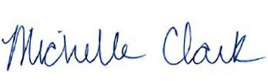 3/9/2023
Michelle Clark, Executive Director Date
King County Flood Control District

