STAFF REPORT

Agenda Item: | 7 | Name: | Hiedi Popochock
Proposed No.: | 2017-B0131 | Date: | June 27, 2017

SUBJECT

A briefing by the King County Department of Elections to discuss the passage of the Washington State legislature’s Substitute Senate Bill 5472 regarding ballot drop boxes.

SUMMARY

In May 2017, the Washington State legislature passed Substitute Senate Bill (SSB) 5472 to increase the number of ballot drop boxes available for elections in Washington communities.

According to SSB 5472, the number of ballot drop boxes required for each county is formula-based. The bill requires a minimum of one ballot drop box per fifteen thousand registered voters in the county and a minimum of one ballot drop box in each city, town, and census-designated place in the county with a post office.
The King County Department of Elections (“Elections”) currently operates 43 ballot drop boxes in various locations throughout King County. The passage of SSB 5472 requires Elections to operate an additional 43 ballot drop boxes, totaling 86 ballot drop boxes, based on the formula described in the bill. The effective date of the bill is July 23, 2017.

Today’s briefing by Elections will discuss the operational and fiscal implications of implementing SSB 5472. Elections will submit a supplemental appropriation request for approximately $1.1 million in the near future to implement the state-mandated minimum ballot drop box requirement.

BACKGROUND

Ballot Drop Box Legislative History

In 2005, the Washington State legislature amended Title 29A RCW to allow counties the option of conducting elections by mail. In response, the Council authorized transitioning King County to elections by mail, but imposed a number of requirements to be met prior that transition.

Ordinance 15523: Requirements for vote-by-mail. In June 2006, the Council passed Ordinance 15523, which authorized the County to conduct elections by mail beginning on a date established by the Director of Elections, possibly as early as 2007 or 2008, provided that certain conditions were met. One of the conditions was specific to regional voting centers and ballot drop boxes and is described below.

- The Council had to approve by motion a plan with cost estimates for regional voting centers and ballot drop boxes, as well as the estimated capital and operating costs of regional voting centers or accessible voting centers and drop boxes, a map identifying their locations, and a description of the security measures that would be put in place in those locations (note that the Council addressed this requirement in several additional pieces of legislation, as described below).

Ordinance 15652: Regional voting centers and ballot drop boxes. In November 2006, the Council adopted a proviso to the 2007 budget ordinance requesting a plan and schedule for the transition to vote-by-mail and information regarding regional voting centers and ballot drop boxes.

Motion 12505: Consulting group recommendations for regional voting centers and ballot drop boxes. In April 2007, through Motion 12505, the Council created a consulting group to propose locations for regional voting centers and ballot drop boxes by July 27, 2007. The group consisted of representatives from the following groups and was to represent geographical and political party diversity:

- King County Elections staff;
- Citizens’ Elections Oversight Committee;
- Council staff;
- Elections Disability Advisory Committee; and
- Voting Rights Act Section 203 community coalition.

The consulting group recommended 17 regional voting centers located throughout the County, as well as locations for 36 ballot drop boxes. Because the consulting group’s recommendations for regional voting centers and ballot drop boxes were submitted just as the economic downturn began, the Executive and Council examined options to provide voting alternatives at a lower cost.

Motion 12820: Plan for ballot drop boxes. In July 2008, the Council approved Motion 12820, which approved a plan for three regional voting centers and 39 ballot drop boxes. The ballot drop boxes were to be located at 32 local libraries outside Seattle, as well as at six city of Seattle Neighborhood Service Centers and the King County Administration Building in downtown Seattle.

Ballot drop-off locations following Motion 12820. Although Motion 12820 authorized the number and location of ballot drop-off locations, the continued economic downturn affected the number of locations the County was actually able to implement.

From August 2008 to December 2009, Elections operated 19 drop boxes. In December 2009, Elections reduced the number of ballot drop-off locations to two in order to cut costs in anticipation of the 2010 budget deficit. Ordinance 16717, which adopted the 2010 annual budget, noted that no drop boxes would be funded during 2010, “unless the county receives additional funding options from the State Legislature.”

During the middle of 2010, in response to voter concerns about the decrease in the number of ballot drop boxes, Elections proposed a plan to deploy 11 ballot drop boxes for the November 2010 general election. Those ballot drop boxes were to be located based on “data accumulated related to usability at former locations” and the “Regional Planning Council’s ‘urban centers’ designation” and would be located at a mix of city halls, shopping centers and city and county properties.

Ordinance 16984, which adopted the 2011 annual budget, included two provisos requiring Elections to provide reports on the number of ballots deposited in each ballot drop box during:

- The 2010 general election, any special elections in 2011, and the primary election (due by September 14, 2011); and
- The 2011 general election (due by December 13, 2011).

Motion 14491: Ballot drop-off location plan. In December 2015, Council approved Motion 14491 that requested the director of Elections to develop and transmit a plan by April 30, 2016 to improve access to and convenience of ballot drop-off locations in King County.

Ordinance 18239: 2015-2016 Supplemental Budget proviso requiring location plan for ballot drop boxes. In February 2016, Council approved Elections’ supplemental budget request of $351,000 to purchase 37 new ballot drop boxes. In addition, Council included a proviso stipulating the new drop boxes were not to be installed until the director of Elections transmitted a ballot drop box location plan as requested in Motion 14491 and was approved by motion by the Council.

Motion 14634: Ballot drop box location plan approval. In May 2016, Council approved Elections’ “Ballot Drop-Off Location” plan, through Motion 14634, in order for Elections to deploy the 33 new 24-hour ballot drop boxes in King County. By the 2016 General election, Elections was operating a total of 43 24-hour ballot drop boxes.

Substitute Senate Bill 5472: Requiring ballot drop boxes in all communities. In early 2017, the Washington State legislature passed Substitute Senate Bill 5472 to require ballot drop boxes in all communities. According to SSB 5472, the number of ballot drop boxes required for each county is formula-based. The bill requires a minimum of one ballot drop box per fifteen thousand registered voters in the county and a minimum of one ballot drop box in each city, town, and census-designated place in the county with a post office. The effective date of the bill is July 23, 2017.
As noted above, Elections currently operates 43 ballot drop boxes at various locations throughout King County (Attachment 1). The passage of SSB 5472 requires Elections to operate an additional 43 ballot drop boxes, totaling 86 ballot drop boxes, based on the formula described in the bill. Elections is proposing to phase in the additional 43 ballot drop boxes over a three-year period. The proposal includes 13 ballot drop boxes that would be added for the 2017 Primary election (Attachment 1) and 15 ballot drop boxes that would be added in each of the 2018 and 2019 Primary elections.

Table 1 below illustrates the number of ballot drop boxes utilized in King County over an 11-year period including the future implementation of SSB 5472 over a three-year period.

Table 1. Historical and Future King County Ballot Drop Box Counts
(General or Primary Election)

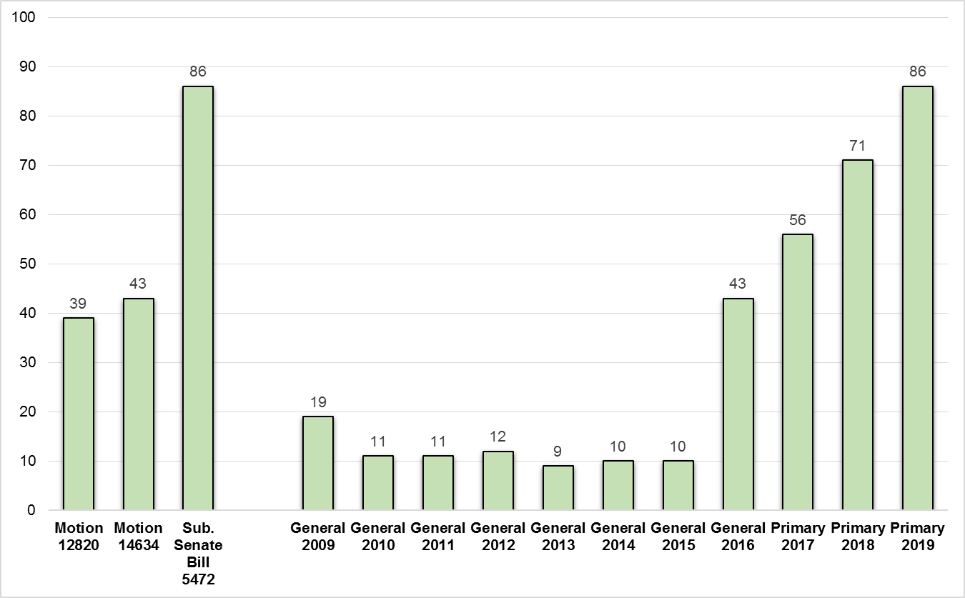

Currently, Elections estimates the implementation costs of SSB 5472 at $1.1 million ($500,000 for one-time capital expenses and $600,000 for ongoing operational expenses). Elections will submit a supplemental appropriation request in the near future to implement the state-mandated minimum ballot drop box requirement.

ATTACHMENTS

- Map and Listing of Current & 2017 Primary Election Ballot Drop Box Locations
- Elections’ Ballot Drop Box Expansion PowerPoint Presentation

INVITED

- Kendall Levan-Hodson, Chief of Staff, Department of Elections

The first election conducted completely by mail was the special election in February 2009.
Legislation adopted by the Council prior to the implementation of elections by mail refers to “regional voting centers.” However, Elections now refers to these centers as “accessible voting centers” or “AVCs”. These voting centers are regulated by RCW 29A.40.160.
Ordinance 15652
Staff report on Proposed Motion 2008-0381 to Committee of the Whole, July 21, 2008, prepared by Mike Alvine
Non-Seattle drop box locations approved by Motion 12820 were: Algona Pacific Library, Auburn Library, Black Diamond Library, Boulevard Park Library, Carnation Library, Covington Library, Des Moines Library, Duvall Library, Fairwood Library, Fall City Library, Federal Way 320th Library, Burien Library, Maple Valley Library, Bothell Library, Kingsgate Library, Lake Forest Park Library, Library Connection @ Crossroads Bellevue, Mercer Island Library, Muckleshoot Library, Newport Way Library, North Bend Library, Richmond Beach Library, Sammamish Library, Skykomish Library, Skyway Library, Valley View Library, White Center Library, Woodinville Library, Woodmont Library, Enumclaw Library, City of Kent library location TBD, City of Tukwila library location TBD. See Attachment 3 to this staff report.
Seattle Neighborhood Service Center drop box locations approved by Motion 12820 were: North/Lake City, Delridge/West Seattle, Central, Ballard, Southeast, and Northeast/University District. Ordinance 16216 authorized the Executive to enter into an interlocal agreement with the City of Seattle for the placement of these drop boxes and payment to the city of Seattle for their operations.
Elections--Ballot drop box redeployment in selected areas of the county (2010-RPT0197)
Ordinance 16717
Elections--Ballot drop box redeployment in selected areas of the county (2010-RPT0197)
Elections--Ballot drop box redeployment in selected areas of the county (2010-RPT0197)
Drop boxes for the November 2010 general election were located at: Lake Forest Park City Hall, University Heights Community Center, Issaquah City Hall, Redmond City Hall, Earlington Building (Renton), Crossroads Shopping Center (Bellevue), Federal Way City Hall, Elections Office (temporary location in Tukwila), King County Administration Building
Response provided via 2011-RPT0150
Response provided via 2011-RPT0205
Ordinance 18239--Council approved funding to replace four ballot drop boxes at existing locations and install 33 new ballot drop boxes at various locations in King County.
In the 2015 General election, Elections operated ten 24-hour drop boxes and 12 ballot drop-off vans. Due to the increase in ballot drop boxes, Elections significantly decreased its use of ballot drop-off vans.

