Lease Property Summary

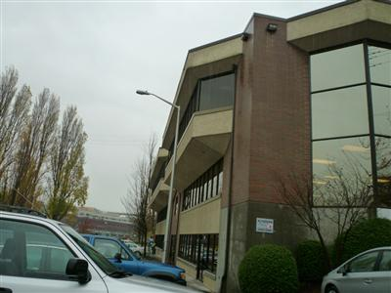
Property Owner: Magoon Enterprises, LLC
Address: 130 and 150 Nickerson Street
Cost Per Sq. Ft.: $20/sf per year for 1,236 sq. feet and $24/sf per year for 8,471 sq. feet
Operational Costs: $0 Operating Costs in 2015, base year operating expense reset to 2015.
Term: 5 years
Square Footage: 9,707 rentable square feet
Council District: 4
Funding Source: Shared Services Fund (1210)
Previous Location: Second amendment to lease at this location

Lease Synopsis:
Canal Place, located at 130 and 150 Nickerson Street, houses Water and Land Resources Division’s Local Hazardous Waste Management Program (LHWMP). The County has reduced the leased space footprint from 12,470sf to 9,707sf. This is a net reduction of 2,763 square feet due to program changes requiring an additional 1,813 sq. ft. for LHWMP and 4,576 sq ft vacated at the Nickerson Street location as the Industrial Waste Program moved to King Street Center in December 2014.

Context
The second amendment of the office lease revises the current space being leased, square footage, other lease terms and rent. The agreement is for a five-year term with the option to extend the term for two periods of 48 additional months each.

Rationale for transaction: Amending the lease for this location was needed to extend the lease, downsize and reconfigure the space due to the Industrial Waste Program relocation to King Street Center and to enable continued Local Hazardous Waste Management Program delivery, with other jurisdictions housed near, or at, this location.

Policy considerations: The continued leasing at this facility allows the County to avoid costs associated with moving and maintains a centralized location for coordination of program activities between multiple jurisdictions -- such as Seattle Public Utilities, Sound Cities and local tribal governments.

Political considerations: The Local Hazardous Waste Management Program is a multi-jurisdictional governmental agency. It is implemented through a “Management Coordination Committee” (MCC). It operates through the consensus of its five members, which are drawn from each of the Program Partners (Public Health – Seattle and King County; King County Solid Waste Division; King County Water and Land Resources Division; Seattle Public Utilities and; Sound Cities and other cities and tribes). The employees at this location are a combination of King County Water and Land and Solid Waste Division employees as well as Public Health employees and employees of Seattle Public Utilities. Funding comes out of County fund 1210 (Shared Services Fund). The LHWMP supports the downsizing, space reconfiguration and the items outlined in the second amendment to the lease.

Community considerations
or partnerships: LHWMP has been housed at this location since 1991, due to its proximity to King County’s Environmental Lab and a small staging lab on Nickerson Street. The neighborhood has been very supportive of King County’s use of this leased space.

Fiscal considerations: The proposed lease rate for Canal Place is lower than the current rate being paid by King County in its lease executed in 2010, due to a negotiated reset of base year operating expenses. The county reduced its overall footprint at the location due to Industrial Waste moving to King Street Center. The Local Hazardous Waste Management Program area increased slightly due to increased staffing and program requirements. The new lease allows LHWMP to increase its square footage by 23% (from 7,894 to 9,707) while only increasing its rental costs by 5.5% (from $216,651 to $228,663. A more detailed view of the financial details of the transaction is contained in the fiscal note. The lease also includes landlord funded-tenant improvements that are to be completed within four months of lease commencement. All the tenant improvements will be completed within the tenant improvement allowance. This second amendment includes a holdover provision that holdover, which began December 31, 2014, shall be no longer than 90 days and during this “Holdover Period” the County will pay the minimum monthly rent stated in Section 2 of the second amendment. The amendment also states that if the second amendment has not been executed by the end of the Holdover Period, rent will be increased to 150% of the agreed amount. The holdover amount would be an additional $9,607.53 per month over the base rent. It is likely that this holdover amount will need to be paid to allow the Executive and Council sufficient time to review this legislation. A Net Present Value analysis was not performed due to the decision that staying at the current location provided good value.

Other considerations: The nature of LHWMP’s work requires regular handling of hazardous waste samples for staging and analysis. Proximity to a leased staging lab space and to King County’s Environmental Lab is essential.

CIP/operational impacts: Continuing operation at this location saves moving costs and other charges associated with relocation. LHWMP has funding to cover this new lease in its 2015-16 biennial budget and in its projected future financial plan. All funding comes from the Hazardous Waste Fund.

King County Strategic Plan impact: This transaction supports the strategic plan goals of safeguarding and enhancing King County’s natural resources and environment and exercising sound financial management.

Equity and Social Justice impact: No equity and social justice impacts are anticipated as LHWMP is continuing at their current location. LHWMP is a leader within King County’s Equity and Social Justice program in its direct program support for communities throughout the county.

Energy Efficiency impact: This site is accessible by transit. Many site employees use alternative commute options (bike, walk, carpool, kayak). This transaction will not change any additional energy impacts associated with the leased space.

Lease Alternatives Analysis

Summary: Since this is an amendment to the current lease at a market rate, with the landlord funding tenant improvements for the downsizing, no other lease sites were considered. Program requirements such as proximity to the Environmental Lab and the site being centrally located for multiple jurisdictions were key factors in the decision to continue to lease program space at this location.

Vicinity View Map
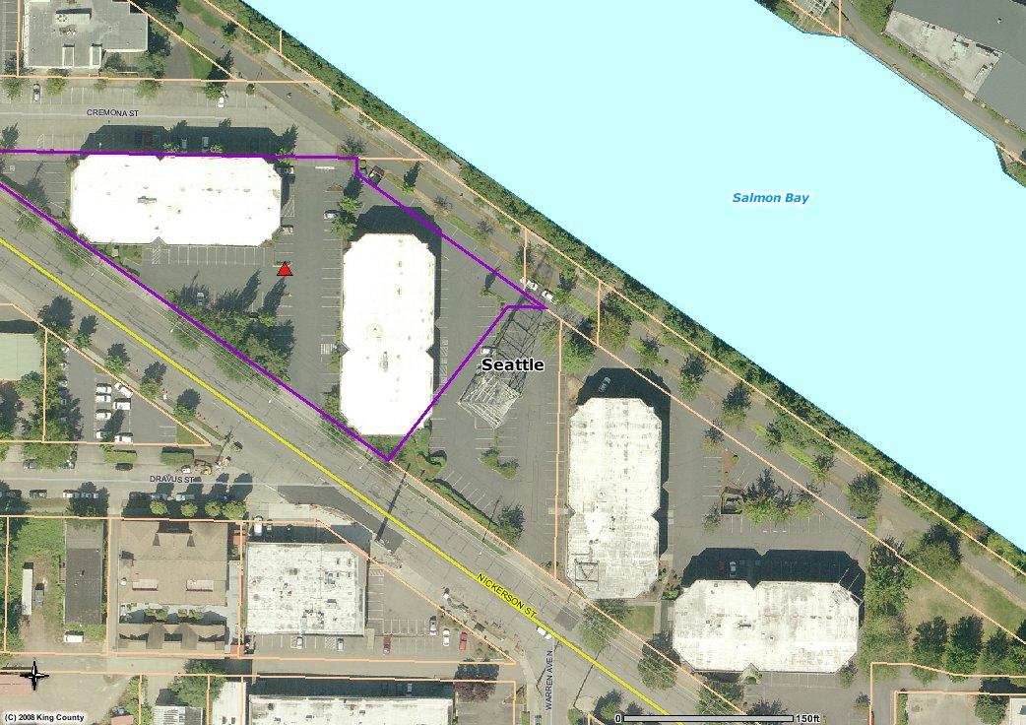

Parcel Map
