

June 13, 2022

Melani Pedroza
Clerk of the Council
King County Courthouse
516 Third Avenue, Room 1200
Seattle, WA 98107

Dear Ms. Pedroza:

Passed during the 2022 legislative session, HB 1320 enacts changes to the processing of all civil protection orders in the courts. In order to implement the legislation, effective July 1, Superior Court seeks to broaden the authority of the existing Family Law commissioners so they may hear all protection order matters encompassed by the legislation, including anti-harassment actions.

The attached proposed amended ordinance provides language to effect this change under KCC 2.69.040. Thank you for your consideration.

Sincerely,
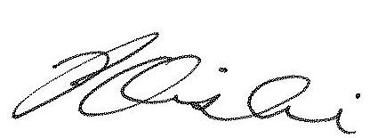

Patrick H. Oishi
Presiding Judge

/enclosure

