INTERLOCAL AGREEMENT BETWEEN KING COUNTY AND THE CITY OF BUCKLEY TO USE CITY PROPERTY TO CONSTRUCT, OPERATE, AND MAINTAIN THE FOOTHILLS TRAIL AND NON-MOTORIZED BRIDGE ACROSS THE WHITE RIVER

This Interlocal Use Agreement (“Agreement”) is entered into as of the last date signed below by and between King County, a political subdivision of the State of Washington (“King County”), through its Department of Natural Resources and Parks, Parks and Recreation Division (“Parks”) and the City of Buckley, a municipal corporation of the State of Washington (the “City”). King County and the City are collectively referred to in this Agreement as the “Parties” and individually as a “Party.”

RECITALS
- The Foothills Trail is part of King County’s Regional Trail System (“RTS”), one of the nation’s most extensive multi-use trail networks with more than 175 miles of trails for recreation and non-motorized mobility and commuting.
- King County owns certain real property which contains a portion of King County's Foothills Trail to the north of and adjacent to the White River, and Buckley owns certain real property which contains a portion of Pierce County’s Foothills Trail located south of and adjacent to the White River, each identified on Exhibit A attached hereto.
- The completed portions of King County’s Foothills Trail and the portion of Pierce County’s Foothills Trail remain separated by the White River. The lack of a safe pedestrian and cycling trail river crossing between the surrounding communities presents certain health and safety risks and limits the ability of the communities to interact using non-motorized transportation methods. Additionally, there is also a need for alternative emergency vehicle egress from Buckley to Enumclaw in the event of a SR-410 bridge closure. In order to address these issues, the Parties have determined that there is a need for construction, operation, and maintenance of a safe, non-motorized crossing of the White River, its adjacent portions of the recreational Foothills Trail, a maintenance turn-around area, and mitigation planting (the “Project”).
- King County, Enumclaw, Pierce County and Buckley conducted a feasibility study (White River Pedestrian Trail Feasibility Study Report – May 2008) which evaluated and selected a proposed alignment for the Project.
- In 2015, the Parties, along with the City of Buckley, Pierce County, and the Washington State Department of Transportation, entered into the Interlocal Agreement For Cooperative Planning Design and Construction of a Foothills Non-Motorized Bridge Across the White River.
- A section of the Foothills Trail that extends from the southern terminus of the trail in King County to the northern terminus of the trail in Pierce County is known as the White River Crossing. This section is primarily comprised of three (3) bridge spans (“Bridge Spans”), two (2) approach or transition spans (“Jump Bridges”), trail immediately south of the bridge, a maintenance turn-around area, and mitigation planting (the “Project Area”), depicted in Exhibit B.
- King County has previously secured a grant from the Washington Recreation and Conservation Office and is also using County levy moneys for the design and construction of the Project. The City will contribute eighty thousand dollars ($80,000) and Pierce County will contribute two hundred and sixty-six thousand dollars ($266,000) toward construction of the Project.
- King County is in the process of completing design, permitting, and obtaining property rights for the Project.
- The portion of the Project Area that will be within the City of Buckley will be located substantially within the following areas: the street right of way for River Avenue, Parcel number 0620344013, and the Foothills Trail Corridor within the public ROW (all areas collectively referred to herein as the “City Property”), as depicted in Exhibit B.

- King County desires the City’s permission to use the City Property for the Project.

- The City is willing to grant King County permission to use the City Property for construction, operation, and maintenance of the Project, as set forth below in this Agreement.

- As part of their Agreement, the Parties have additionally agreed to the following: After construction, the County will retain ownership of the three (3) Bridge Spans and two (2) Jump Bridges, which, the County is ready, willing and able to own, operate and maintain for the use and benefit of the general public, including both City and County residents, as a Regional Trail. The trail area immediately south of the bridge and maintenance turn-around area are required for King County maintenance vehicle access, and this area shall be maintained by the City of Buckley. The mitigation plantings will be maintained and monitored by King County for the duration of any applicable permit requirements, which are anticipated at five (5) years. These, among other, various obligations have been outlined in Exhibit C “Foothills Trail – White River Crossing Operations and Maintenance Responsibilities.” These obligations have been depicted in Exhibit D “King County Parks Maintenance Limits”. Additionally, after expiration of the required period set forth in any applicable permits, the mitigation planting area will remain with the City through a Covenant, whose form and terms the Parties agree to determine after execution of this Agreement.

- Through this Agreement, King County will be able to make Project improvements to the Foothills Trail, an invaluable asset to south King County, the City of Buckley, and Pierce County.

- This Agreement is entered into pursuant to RCW 39.34 (Interlocal Cooperation Act). The Parties represent that under state law, including but not limited to RCW 35.75, RCW 36.34.340, RCW 36.75.060, RCW 36.89.030, RCW 47.30.020, RCW 47.30.070, RCW 47.01.260 and RCW 67.20.010, they each have authority to perform the services, activities, and undertakings contemplated herein.

NOW, THEREFORE, for and in consideration of the mutual promises and covenants set forth herein, the sufficiency of which is hereby acknowledged by both Parties, the Parties agree as follows:

Grant And Permitted Use.

  - Grant. City hereby grants and conveys to King County a non-exclusive use right and license over the City Property, as described above and depicted in Exhibit B, for purposes of constructing, operating, and maintaining the Project. Said use rights include, but are not limited to, maintenance vehicle access to the trail and turn-around area and access to the mitigation planting site for the duration required by any applicable permits. The rights granted to King County herein shall extend to the areas described above in Recital I and depicted in Exhibit B. This right and license shall begin upon the Effective Date of this Agreement.

  - Permitted Use. City’s permission is granted upon the condition that King County will use the City Property solely for the construction, operation, and maintenance of the Project, required environmental mitigation, and for no other purpose whatsoever, unless agreed upon in writing by the Parties. The Parties further agree that any work or use outside of the City property necessitated by the Project shall be pursuant to a temporary construction easement, whose form and terms the Parties agree to determine after execution of this Agreement.

  - Non-Exclusive Priority Use. King County’s right to use the City Property for purposes of the Project shall be the highest priority use. The City shall retain the right to use any or all portions of the City Property, provided such City use does not conflict with King County’s Project or use rights.

  - Use by Motorized Vehicles. Motorized vehicles necessary for the construction, maintenance, operation, inspection, rehabilitation or repair of the Project, and for providing police, security, fire and emergency services, are permitted on the City Property.

Effective Date; Term; Extensions.

  - Effective Date. This Agreement will be effective on the date last signed by an authorized representative of each Party following authorization by the Metropolitan King County Council and the City of Buckley Council (“Effective Date”).

  - Term. The term of this Agreement will be twenty-five (25) years from the Effective Date, unless extended or terminated earlier by either Party pursuant to the terms herein.

  - Extensions. The City shall, at King County’s sole discretion, grant King County use of the City Property for the Project for an additional twenty-five (25) year term via an Amendment to this Agreement. King County may exercise its extension option by providing notice within a year of the expiration of the original term that it is exercising its option.

Construction of Recreational Trails.

  - General Obligation Regarding Construction. King County will be solely responsible for the construction of the Project on City Property. Said responsibility shall include all work specified in the Parties’ temporary construction easement.

  - Permit Review and Approval. King County will be responsible for procuring all necessary permits and approvals required by the Project. The City agrees that it will cooperate with King County to the extent necessary in obtaining any necessary permits.

  - Public Notice. King County will be solely responsible for ensuring that the adjacent City Property owners are appropriately notified about planned construction activities. King County will be the primary point of contact for the public for all Project-related construction.

  - Funding. King County will construct the Project at its sole cost and expense, minus the amount of alternative funding sources described in Recital G, and the City contribution set forth below in Section 3.4.1 of this Agreement.

3.4.1 The City agrees to provide funding toward construction of the Project in the amount of eighty-thousand dollars ($80,000). King County will invoice the City within thirty-days of executing this agreement and the City will have thirty-days to remit funds.

  - Compliance with Law. King County will complete all construction in compliance with all applicable federal, state, and local laws and regulations. The City will not assume responsibility for or control over the working conditions and safety practices of employees, contractors, or subcontractors hired by King County to perform any work on the City Property, and nothing in this Agreement will be construed to place a duty, express or implied, on the City to control or be responsible for such activities of King County.

Project Operation and Maintenance.

  - Maintenance. The Parties respective full maintenance obligations are set forth and outlined in Exhibit C (“Foothills Trail – White River Crossing Operations and Maintenance Responsibilities”). As indicated in Exhibit C, King County will operate and maintain the Project’s Bridge Spans at its sole cost and expense.
  - King County will be the initial point of contact for public maintenance requests and complaints associated with the Bridge Span, and will provide City a contact for referring bridge-related maintenance requests and complaints as appropriate. The City will maintain all other recreational trail and trail- related improvements within City Property. The Parties may modify the maintenance responsibilities set forth in this Agreement by executing a written amendment, pursuant to Section 16 below.
  - Vehicular Access. The performance of maintenance activities shall primarily be conducted by King County Parks Operations and Maintenance staff via maintenance vehicles. Maintenance vehicles are classed as light and medium duty pickup trucks, with occasional light duty trailers. Access for Heavy Duty vehicles or equipment such as those requiring a Commercial Driver’s License (CDL) shall be used at Parks’ discretion for significant work.

  - Signage. King County may install signage at the City Property regarding use of the facility and way-finding.

  - City Access. Consistent with Section 1.2 above, City will at all times have free access to the City Property.

  - Temporary Trail Closures. King County may, at any time, close to the public all or any part of the bridge and turn-around area for reasons of construction, maintenance, development, operation, or improvement of same. King County will be responsible for installing its own closure devices in the case of King County required trail closures. Either Party may at its discretion close all or part of the Project unilaterally should a threat to the public exist on the Project. Upon such emergency closure, the closing Party shall provide prompt notice to the non-closing Party of the basis and anticipated duration of the closure.

  - Locking Devices. Each Party shall coordinate and share with the other Party any locking devices on bollards, gates, and other features (present and future), such that each Party has access to perform its responsibilities pursuant to this Agreement.

  - Failure to Maintain. If a Party refuses or neglects to perform its repair, replacement, or maintenance responsibilities under this Agreement, the other Party shall provide the non-performing Party reasonable written notice of the need for additional repair, replacement, or maintenance actions and shall provide the non-performing Party fourteen (14) business days to respond to this notice. If the non-performing Party fails to respond to the other Party’s notice and/or initiate remedial action to conduct the needed repair, replacement or maintenance actions, the Party giving notice may make such repairs or perform such maintenance on behalf of and for the account of the non-performing Party. If the Party giving notice makes or causes any such repairs to be made or performed, as provided for herein, the non-performing Party shall pay the cost thereof (including, but not limited to, the cost of labor, material and equipment) to the Party giving notice promptly upon receipt of an invoice therefor. However, if the Parties do not agree about what repair, replacement or maintenance actions are necessary and warranted, the Parties shall attempt to resolve the dispute. If the Parties are unable to resolve the dispute, the Parties shall engage in some mutually acceptable form of Alternative Dispute Resolution, such as mediation or arbitration. The Parties agree that a good-faith attempt to resolve any dispute through ADR shall be a condition precedent for either Party to initiate any civil action or other litigation regarding this Agreement.

Default.

“Default” means the failure of either Party to perform any obligation or to comply with any term under this Agreement, and to fail to cure such non-performance or failure to comply within thirty (30) days after written notice from the other Party. However, a Party will not be in Default if the failure to perform or comply is such that it cannot reasonably be cured within thirty (30) days and the Party commences a cure within thirty days after notice and diligently pursues the cure to completion. If either City or King County disagree regarding whether non-performance or non-compliance has occurred, or if the Parties cannot agree on a cure or a reasonable time frame for implementing the cure, prior to terminating this Agreement, the disagreement will first be referred to the City of Buckley and the Director of King County Department of Natural Resources and Parks (KCDNRP) for a negotiated resolution. If the City of Buckley and KCDNRP Director cannot reach resolution, the Party claiming the other Party is in Default may choose to pursue any remedies allowable at law or equity.

Indemnification, and Hold Harmless.

  - Indemnification, and Hold Harmless. Each Party shall protect, defend, indemnify, and hold harmless the other Party and its officers, officials, employees, and/or authorized agents, while acting within the scope of their employment as such, from any and all costs, claims, judgements, and/or awards of damages (both to persons and/or property), arising out of, or in any way resulting from, negligent acts or omissions by or on behalf of the indemnifying party in the exercise of its rights and obligations pursuant to this Agreement. No Party shall be required to indemnify, defend, or hold harmless the other Party to the extent the claim, suit, or action for injuries, death, or damages (both to persons and/or property) is caused by the negligence of the other Party. Where such claims, suits, or actions result from the concurrent negligence of the Parties, their officers, officials, employees, and/or authorized agents, and/or involve those actions covered by RCW 4.24.115, the indemnity provisions provided herein shall be valid and enforceable only to the extent of the negligence of the indemnifying Party, its officers, officials, employees, and/or authorized agents. The Parties agree that their obligations under this section extend to any claim, demand, and/or cause of action brought by, or on behalf of, any of their officers, officials, employees, and/or authorized agents. For this purpose only, the Parties, by mutual negotiation, hereby waive, with respect to each other only, any immunity that would otherwise be available against such claims under the Industrial Insurance provisions of Title 51 RCW. This indemnification and waiver shall survive the termination of this Agreement.

  - Recreational Use. City is permitting the use of the City Property conditioned, in part, upon King County’s agreement to make the Recreational Trail available to the public at no cost. To the extent that the Recreational Land Use Statute, RCW 4.24.210, or other applicable law provides immunity to City and King County, the Parties do not intend the indemnity in this Section to act as a waiver of such immunity.

THE INDEMNIFICATION PROVISIONS OF THIS SECTION WERE SPECIFICALLY NEGOTIATED AND AGREED UPON BY THE PARTIES.

- Invalidity.

Any provision of this Agreement which shall prove to be invalid, void or illegal shall in no way affect, impair, or invalidate any other provision hereof and the remaining provisions hereof shall nevertheless remain in full force and effect.

Nonwaiver.

The failure of a Party to insist upon or enforce strict performance by the other Party of any of the provisions of this Agreement or to exercise any rights under this Agreement shall not be construed as a waiver or relinquishment to any extent of its right to assert or rely upon any such provisions or rights in that or any other instance; rather, the same shall be and remain in full force and effect.

Assignment, Successors and Assigns.

King County reserves the right to assign, transfer, or otherwise dispose of any of the privileges granted under this Agreement without the prior written consent of City.

Applicable Law; Venue.

This Agreement shall in all respects be interpreted, construed and enforced in accordance with the laws of the State of Washington and the sole venue for any action arising out of this Agreement shall be the Superior Court of King County, King County, Washington.

Notices.

All notices hereunder must be in writing and shall be deemed validly given if sent by electronic mail, United States mail, by personal delivery, or by overnight delivery by a nationally recognized carrier, addressed as follows (or to any other address that the party to be notified may have designated to the sender by like notice):

CONTACT INFORMATION
If to City by mail or email, to:

City of Buckley
Attn: City Administrator
933 Main Street
Buckley, WA 98321
If to King County by mail or email, to:

201 S. Jackson Street, Suite 700
Attn: Parks Capital Projects & Land Management Section Seattle, WA 98104

Headings.

The titles of sections are for convenience only and do not define or limit the contents.

Entire Agreement; Exhibits.

This Agreement, including the exhibits, sets forth the entire agreement of the Parties, and supersedes any and all prior agreements, with respect to use of the City Property. However, this Agreement shall not supersede any prior agreements with respect to any other subject matter, such as funding.

Counterparts.

This Declaration may be executed in counterparts, each of which shall be deemed an original, and all of which together shall constitute one and the same instrument.

Amendments In Writing.

Any amendment or modification of this Agreement must be in writing and executed by the Parties agreeing thereto.

IN WITNESS WHEREOF, this Interlocal Use Agreement has been executed the day and year last below written.

City of Buckley.

By: _____________________________ Date:_________________
___________, Its ______________

Approved as to Form

__________________________________

GRANTEE:

King County

By: _____________________________ Date:_________________
Christie True, Director
King County Dept. of Natural Resources and Parks

Approved as to Form

__________________________________
Raul Martinez, WSBA #31848
King County Sr. Deputy Prosecuting Attorney

STATE OF WASHINGTON )
) ss.
COUNTY OF KING )

I certify that I know or have satisfactory evidence that ____________ signed this instrument as ___________ of and on behalf of the City of Buckley, and acknowledged it to be the free and voluntary act of such company for the uses and purposes mentioned in the instrument.

Dated this _______ day of _______________________, 2022.

__________________________________
(Signature)
__________________________________
(Print Name)
Notary Public, in and for the State
of Washington, residing at____________
My Commission Expires _____________

STATE OF WASHINGTON )
) ss.
COUNTY OF KING )

I certify that I know or have satisfactory evidence that Christie True signed this instrument as the Director, Department of Natural Resources and Parks of KING COUNTY, and acknowledged it to be the free and voluntary act of such entity for the uses and purposes mentioned in the instrument.

Dated this _______ day of _______________________, 2022.

__________________________________
(Signature)
__________________________________
(Print Name)
Notary Public, in and for the State
of Washington, residing at____________
My Commission Expires _____________

EXHIBIT A – Property Map
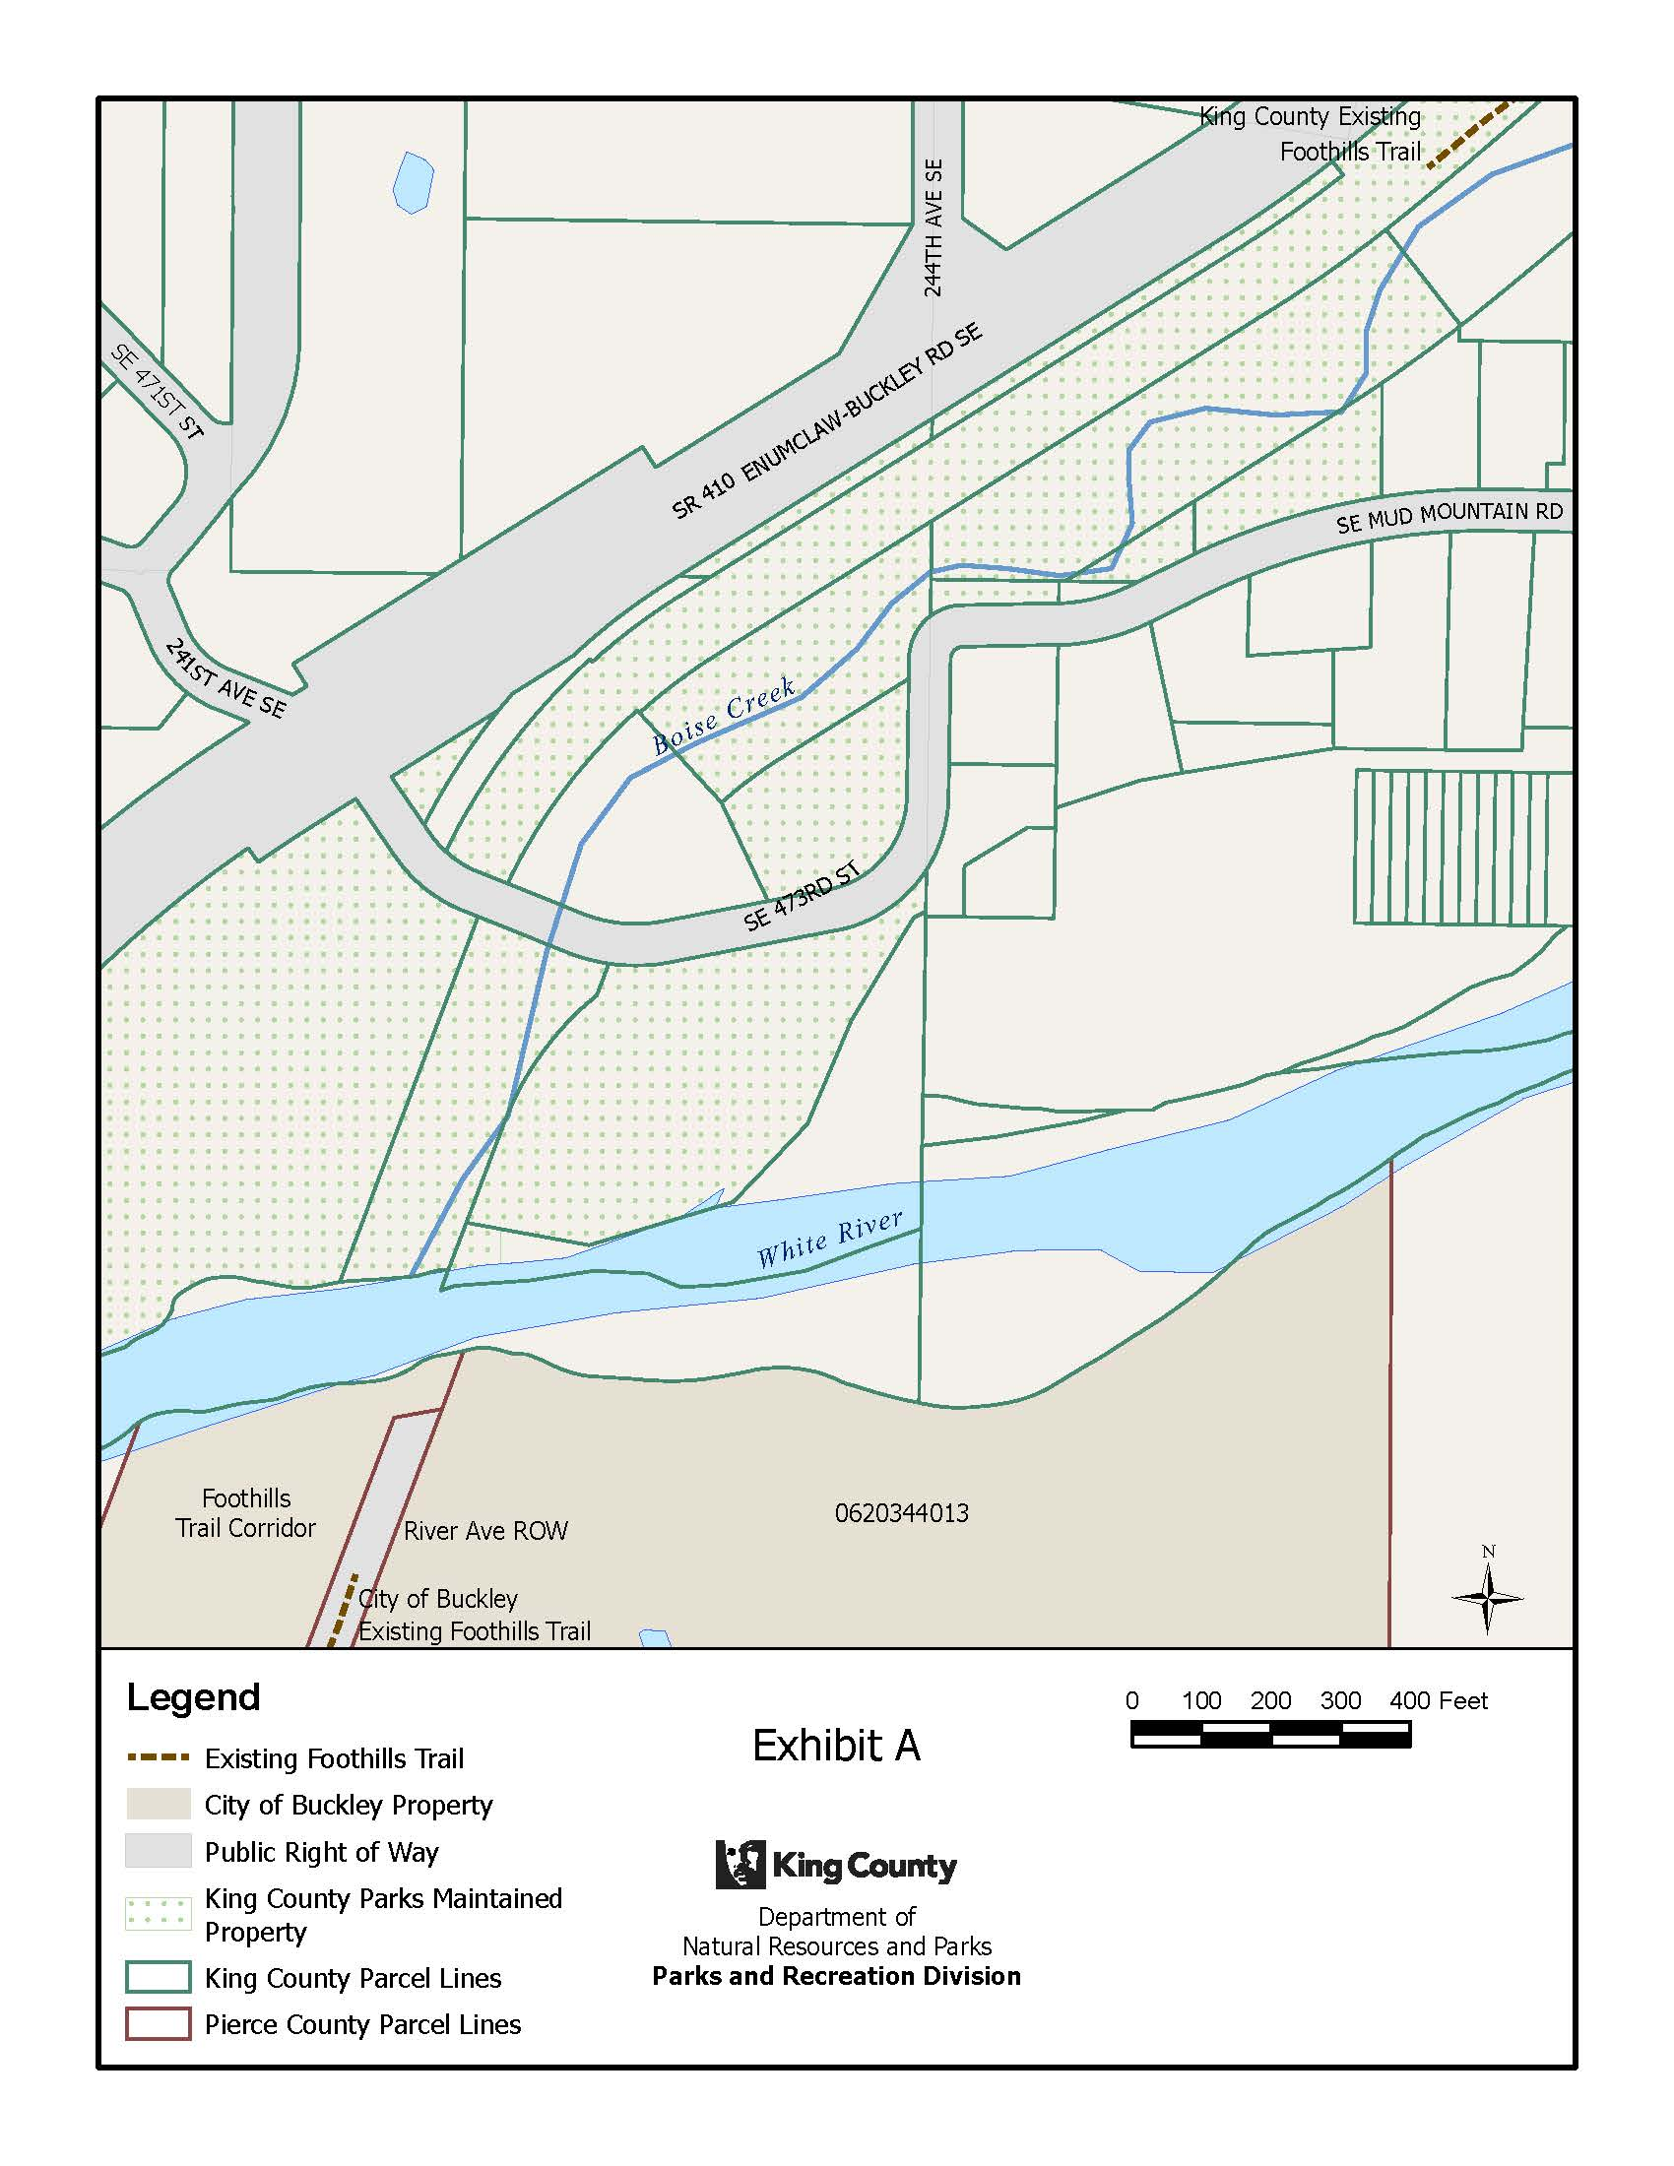

EXHIBIT B – Use Agreement Graphic Map

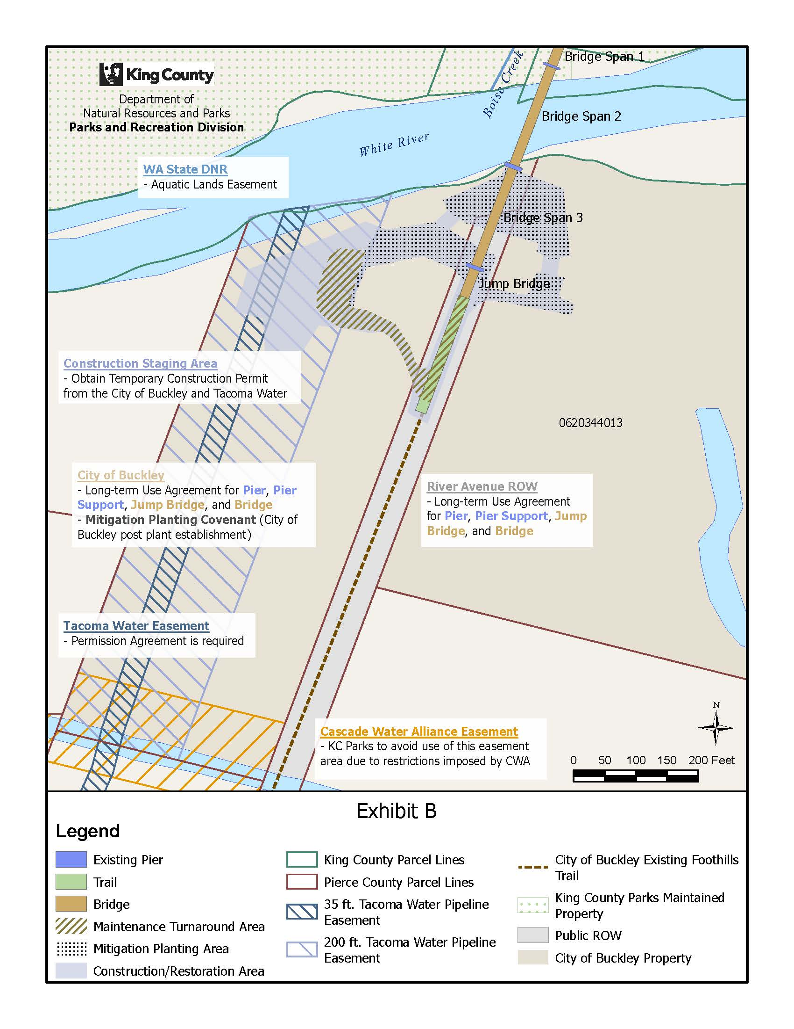
EXHIBIT C – Maintenance Responsibilities

EXHIBIT C

FOOTHILLS TRAIL – WHITE RIVER CROSSING
Operations and Maintenance Responsibilities

KING COUNTY RESPONSIBILITY
- The County shall conduct the following maintenance activities on the Bridge Spans, Jump Bridges, and Piers located on City Property:

    - Trail Maintenance. This responsibility shall consist of sweeping, blowing, and removing debris from the bridge deck and railing; removing litter from the bridge deck, as well as periodic pavement cleaning; and, repairing the deck and railing, as well as periodic spot inspections.

    - Bridge Spans, Jump Bridges and Pier Maintenance and Safety Inspections. This responsibility shall consist of – handrail, spall, and/or surface repair; and, maintenance on or immediately below the bridge deck. A County Bridge Inspection Team shall also conduct safety inspections no less than every four-years.

    - Vandalism Repair and Graffiti Removal. This responsibility shall consist of bridge infrastructure repair and graffiti removal from all bridge areas accessible from the bridge deck, including rails, deck, signs, cables and other amenities on top of or immediately below the bridge deck. The County shall not be responsible for Vandalism or Graffiti Removal on any parts of the Bridge Spans, Jump Bridges and Piers that are not accessible from the bridge deck.

    - Erosion and slope stabilization. This responsibility shall consist of maintaining and repairing any erosion control measures related to the Project’s structural foundation component’s maintenance, including seeding, erosion control blankets, and other surface best management practices.

    - Communication. This responsibility shall consist of interacting with the public to provide information and assistance.

CITY OF BUCKLEY RESPONSIBILITY
- The City shall conduct the following maintenance activities on City Property:

  - Abatement of unauthorized encampments and encroachments, as follows:
  - The City shall conduct routine patrols to locate and remove unauthorized encampments and encroachments on City Property, except within those portions designated as mitigation sites in Exhibit D.

  - Within wetland mitigation sites on City Property, as depicted in Exhibit D, the City shall remove encampments if the County notifies the City of encampments or if the City observes encampments.

  - Perform vandalism and graffiti removal on bridge elements that are accessible from the ground, including, but not limited to, the bridge pier and abutment areas for both the main and approach spans, and all areas that are accessed from the ground underneath the bridge.

    - Perform periodic debris removal from bridge abutment and piers, as well as periodic brushing in these areas.

WETLAND MITIGATION SITE

- The mitigation plantings will be maintained and monitored by King County for the duration of permit requirements, which the Parties anticipate will be five (5) years. After expiration of the permit period, the mitigation planting area will be maintained by the City, as required by a Covenant.

- During the period in which King County is required to maintain the mitigation area pursuant to permit requirements, and notwithstanding the City’s responsibility to remove unauthorized encampments, the County shall be solely responsible for any restoration of wetland mitigation sites that result from unauthorized encampments. The County agrees not to seek any recovery or compensation from the City for damage to the mitigation sites caused by the unauthorized encampments or reasonable actions taken by the City to remove the illegal encampments.

CONTACT INFORMATION

1. All correspondence related to the responsibilities outlined above, shall be through the designated contacts. The City of Buckley and King County formal point of contacts are as follows:

KING COUNTY: Nick Halverson
Parks Operations Manager
King County Parks
201 S. Jackson St. Suite 5702
Seattle, WA 98104
(206) 477-6138
Nick.halverson@kingcounty.gov

CITY OF BUCKLEY:
Emily Terrell, Director of Planning & Building,
City of Buckley, WA
(360) 761-7817
eterrell@cityofbuckley.com

2. From time to time, contact information may change. Any change or update to contact information shall be provided to the other Party by electronic mail notification. The Party in receipt of the change will confirm receipt of the change by electronic mail back to the initiating Party.

EXHIBIT D – Maintenance Limits

