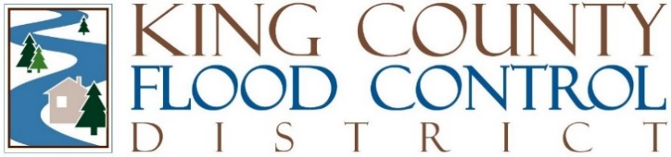

STAFF REPORT

Agenda Item: | 7 | Name: | Michelle Clark
Proposed Legislation: | FCD2025-02 | Date: | February 11, 2025

Proposed Resolution FCD2025-02: A RESOLUTION authorizing the chair to enter into a third amendment to the agreement for the Lower Green River Corridor Plan and PEIS Project Manager Services.

Proposed Resolution FCD2025-02 authorizes the chair to enter into a third amendment to the agreement with Lund Consulting for the purpose of providing project management services for the King County Flood Control District's (District) Lower Green River Corridor Flood Hazard Management Plan and Programmatic Environmental Impact Statement (LGRCFHMP PEIS) process. FCDECM2018-02 authorized the chair to enter into the original contract and FCD2024-06 was the most recent amendment to the original contract.

The District's LGRCFHMP PEIS, which was completed in 2024, represented the largest and most challenging integrated floodplain management program envisioned for the central Puget Sound area in our state's history. Now, the effort is transition from the LGRCFHMP PEIS phase into the Lower Green River Corridor Plan LGRCP (“Corridor Plan”) and Capital Investment Strategy (CIS) phase. The expected outcomes of the Corridor Plan and CIS are:

- A shared vision and goals for the river corridor related to flood risk reduction and multibenefits that reflects the engagement of tribes and people who live and work in the community.
- A Lower Green River Flood Hazard Management Plan and Capital Investment Strategy for adoption by the District Board of Supervisors.

Under the proposed contract amendment, Lund Consulting’s project management/"owner’s rep" tasks include:

- Oversee the Lower Green River Corridor Plan and CIS to ensure a transparent, accountable, and equitable process.
- Manage contract for the technical consulting team to ensure work products meet the quality standards of the District, including overseeing the technical consulting team contract to review invoices, manage budget, and keep deliverables on track.
- Coordinate with King County Rivers and Floodplain Management staff to obtain technical support as directed by Executive Director.
- Provide direction to the technical team as questions arise, following the Executive Director’s instructions, on contract tasks.
- Provide review of draft documents on behalf of the District, coordinate review by District Executive Director and oversee revisions to draft documents for final publication.
- Meet weekly with technical team and Executive Director.
- Coordinate with team to support Partner Planning Committee, and any other advisory groups requested by the Executive Director.

The amendment to the contract for project management services is for an amount not to
exceed total of $275,650 and is for a term of 25 months.

Approval of this amendment is administrative and does not change the authorized Project budget. The amendment has been reviewed by legal counsel.

