STAFF REPORT

Agenda Item: | 9 | Name: | Mike Reed
Proposed No.: | 2020-B0070 | Date: | September 2, 2020

SUBJECT

The determination by the Washington Department of Ecology to establish a General Permit restricting nutrient discharges into Puget Sound, and its related determination to provide for facility-specific caps on nutrient discharges.

SUMMARY:

The Washington Department of Ecology, after an extended process of outreach and analysis, announced a decision to develop a General Permit on nutrient discharges. That announcement was made pursuant to the agency’s responsibilities under the federal Clean Water Act for managing discharge of nutrients into Puget Sound. King County’s operation of two of the largest wastewater treatment plants discharging into Puget Sound, together with the information about the levels of nutrients in wastewater discharges, raise this as a topic of concern for the Regional Water Quality Committee, which has included the control of nutrients on its annual workplan for several years. Today’s briefing will primarily focus on preliminary King County strategies in response to the anticipated regulatory action, and possible cost implications.

BACKGROUND:

Ecology Regulatory Determinations
In August of 2019, the Washington Department of Ecology arrived at a preliminary determination to develop a general permit regarding nutrient discharges, pursuant to requirements of the federal Clean Water Act, and associated regulations. Specifically, Ecology cites 40 CFR Sect. 122.44(d)(1)(i), which establishes the regulatory threshold, as follows:
“..(Permit) limitations must control all pollutants or pollutant parameters that are or may be discharged at a level which will cause, have reasonable potential to cause, or contribute to an excursion above any state water quality standard...”

Following the preliminary determination referenced above, Ecology provided a public comment period. In January of 2020, the agency formalized its earlier preliminary decision, determining that Ecology will develop a General Permit to implement nutrient control requirements at domestic wastewater treatment plants.

Ecology has indicated that the general permit would apply to treatment plants discharging to Puget Sound; approximately 70 plants would be impacted.
Ecology indicated that it anticipates development of preliminary draft permit materials, to be followed by a formal draft permit in Quarter 4 of 2020; final permit issuance would occur in 2021.

Individual Permits
In December of 2019, the Department arrived at a related decision, that individual permits would have nutrient controls. Ecology would modify individual permits as necessary when the general permit is developed. The individual permits would establish facility-specific nutrient-related requirements; it is expected that provision would be made for:
- A Total Inorganic Nitrogen cap
- Monitoring requirements
- Assessment and optimization of the existing treatment process

Nutrient Management Plan
Ecology is developing a Nutrient Management Plan that will describe how the agency will reduce the different human sources of nutrients to Puget Sound. The goal is to restore water quality to meet dissolved oxygen standards. The agency anticipates release of a draft plan for public comment in 2022.

Context: Ecology’s Puget Sound Nutrients Source Reduction Project

The Puget Sound Nutrients Source Reduction Project was undertaken to analyze and respond to the impacts of excessive nutrient discharges on marine biota in Puget Sound. Monitoring of marine waters by Ecology led the agency to conclude that the water quality of Puget Sound is changing as the result of excessive levels of nutrients from human sources. Ecology notes that monitoring data has identified many places throughout the Sound where levels of dissolved oxygen—critical for marine biota—are constrained.

The Regional Water Quality Committee was briefed on the Puget Sound Nutrients Source Reduction Project by the Director of the Washington Department of Ecology Water Quality Program, Heather Bartlett, at its May 2, 2018 and June 5, 2019 meetings.

What are Nutrients? How do they contribute to oxygen depletion?
Nutrients are chemicals such as nitrogen and phosphorous that stimulate the growth of plant life—either on land or in the water. The presence of nitrogen in lawn fertilizer, for example, is based on its status as a stimulant for growth in green plants. This is one of the numerous sources of nitrogen and phosphorous that are present in human environments; human and animal waste are other major sources of nitrogen, as are agricultural wastes, atmospheric deposition, urban runoff, and wastewater treatment plant effluent.

In the marine environment, nitrogen encourages the growth of algae. While nitrogen is a critical element in the cycle of marine life, excessive levels can lead to uncontrolled growth, such as large algae blooms covering extensive areas of water surfaces. When this algae dies, it sinks to the bottom of the water column; there, bacteria work to decompose it, consuming available oxygen in the process, and depriving the water of oxygen needed by marine life.

The federal Clean Water Act requires that states develop a plan to address polluted waters. Washington’s Ecology Department has been delegated authority by the federal Environmental Protection Agency to implement the federal Clean Water Act in Washington.

Chesapeake Bay Nutrients Management Example: Total Maximum Daily Load

Management of nutrient impacts has been the subject of federal and state action elsewhere in the nation. In 2010, the federal Environmental Protection Agency (“EPA”) established the Chesapeake Bay Total Maximum Daily Load (“TMDL”), as tool for defining maximum pollution limits Bay-wide, and allocating pollution discharge amounts within those limits. This followed extensive restoration efforts during the prior 25 years, which failed to achieve sufficient progress towards improvements in water quality, and triggered a federal Clean Water Act mandate for the TMDL. It also responded to a Presidential Executive Order to restore and protect Chesapeake Bay.

The TMDL set watershed limits of 185.9 million pounds of nitrogen, 12.5 million pounds of phosphorous, and 6.45 billion pounds of sediment per year, across jurisdictions with discharge into Chesapeake Bay, including Delaware, Maryland, New York, Pennsylvania, Virginia, West Virginia and the District of Columbia. Watershed Implementation Plans (“WIP”) were established for the various jurisdictions defining how they would achieve the discharge reductions required for the TMDL allocations.

Wastewater facilities have been a particular point of focus in the Chesapeake Bay project. According to the EPA, upgrades and operational efficiencies at wastewater treatment plants throughout the Chesapeake Bay watershed have resulted in steep reductions in nitrogen and phosphorous pollution. From 1985 through 2015, the wastewater sector cumulatively prevented over 900 million pounds of nitrogen and phosphorous pollution from entering the Bay’s tributaries, reducing nitrogen in the Bay by 57% and phosphorous by 75%. In 2015, annual progress in the wastewater sector effectively met its 2025 nutrient pollution limits set in the Chesapeake Bay TMDL. The 472 municipal and industrial wastewater treatment plants in the Chesapeake Bay watershed were designated as significant sources by states and the EPA, and have annual nutrient pollutant limits in their NPDES permits, providing legally enforceable assurances that pollutant reductions will be achieved. Continuing investments in advanced wastewater treatment have exceeded $7 billion in the Bay watershed.

Washington Department of Ecology Study 2014: Puget Sound and the Straits Dissolved Oxygen Assessment

Attention to the control of nutrients into Puget Sound has been growing in Washington State. The Washington Department of Ecology, participating with the Pacific Northwest National Laboratory, in 2014 published a report addressing the relationship of nitrogen discharges to levels of oxygen. The “Puget Sound and the Straits Dissolved Oxygen Assessment: Impacts of Current and Future Nitrogen Sources and Climate Change through 2070”, summarizes current and future impacts of human nutrient loads, Pacific Ocean conditions, and climate change on dissolved oxygen levels in the Salish Sea. The geographic focus of the study was beyond Puget Sound specifically, and encompassed the larger Salish Sea—including Puget Sound, the Strait of Juan de Fuca, and the Strait of Georgia in British Columbia. The authors note that, while Puget Sound—defined as the waters south of Admiralty Inlet—is the area of primary interest, Puget Sound is connected to the Strait of Juan de Fuca and the Strait of Georgia, and cannot be considered in isolation—so the analysis includes all major U.S. and Canadian influences on circulation and water quality in the Salish Sea. Among the determinations of the Report:

- Human sources of nitrogen discharging into the Salish Sea—distinct from natural sources--have the greatest impacts on dissolved oxygen in South and Central Puget Sound. Between marine point sources—primarily wastewater treatment plants, with limited numbers of industrial outfalls—and watershed inflows, the marine point sources cause greater decreases of dissolved oxygen levels than watershed inflows—both of which will increase with increasing population growth.

- Strong influences on dissolved oxygen result from Pacific Ocean inflows. North Pacific dissolved oxygen concentrations have been declining for 50 years—and if those trends continue, Salish Sea dissolved oxygen would decline far more from ocean inflows than from human nutrient loads.

- Nitrogen naturally occurs in rivers and streams entering marine waters, but human activities have increased nitrogen loads above naturally occurring levels. Natural nitrogen concentrations in rivers are governed by nitrogen concentrations in rainfall and processes within forested watersheds. These baseline conditions are impacted if regional air emissions alter rainfall nitrogen concentration, or if forested areas are converted to other developed land uses. In a watershed, human contributions include point source discharges, including wastewater treatment plants. Nonpoint sources from developed lands also increase human contributions above natural levels.

- In the U.S. (excluding plants serving Vancouver, Victoria and other Canadian communities) 78 municipal wastewater treatment plants and 10 industrial facilities discharge treated effluent through outfalls to Puget Sound and the Straits. Water volumes from wastewater plants are small compared to inflows from watersheds; however, municipal wastewater treatment plant effluent contains higher concentrations of nitrogen compared to inputs from rivers and streams. Industrial plant discharges generally have lower nitrogen concentrations than municipal wastewater plants.

- The population served by the 78 municipal WWTPs serving the U.S. portion of the Salish Sea will double by 2070, from 4.2 million served currently to 7.8 – 8.8 million served by the year 2070. Compared to current flows from these 78 municipal WWTPs (320 mgd), future flows are projected to grow to 390 to 400 mgd by 2020 and 570 to 660 mgd by 2070. With this doubling of population, marine point source loads of nitrogen would increase by an additional 47,200 kg/d discharging to Puget Sound and the Straits. Land use changes would increase nitrogen loads by 31,300 kg/d by 2070 compared with current conditions due to the conversion of forested land to developed land such as residential and agricultural uses.
Chart 1: Distribution of Sources of Dissolved Inorganic Nitrogen into Salish Sea

Nitrogen Load Allocation among Puget Sound Wastewater Plants
King County operates three regional wastewater treatment facilities—the West Point Treatment Plant, the South Treatment Plant, and the Brightwater Treatment Plant. West Point and South are among the largest facilities serving the Puget Sound population. Among 69 plants reviewed by Ecology with marine discharge in the greater Puget Sound area, 10 plants serve around 80% of the total population connected to a central sewer collection system. Most of these are connected to West Point (26% of the population total) and South Plant (21% of the population total). According to Chart 2 below, West Point and South Plant generate over half (52%) of the total nitrogen load.

Chart 2: Allocation of Nitrogen Load among Puget Sound Wastewater Plants

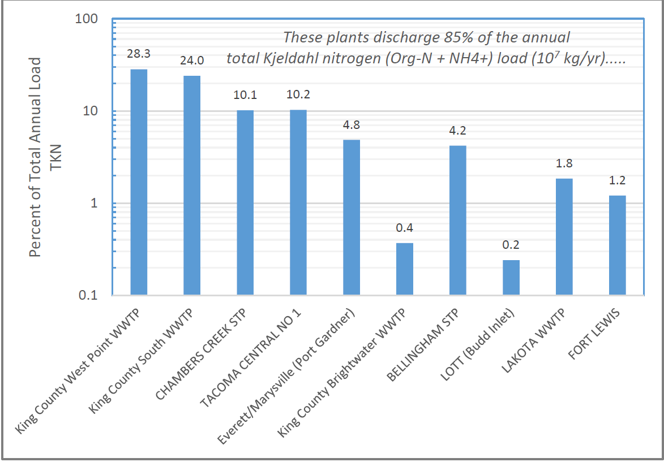

Washington Water Quality Standards—Nutrients

The water quality standards established by WDOE include provisions for the minimum concentrations of dissolved oxygen needed to protect aquatic life. The standards vary by basin. Most U.S. waters of the Salish Sea have the most protective “Extraordinary” water quality requirements to protect aquatic life with a minimum dissolved oxygen concentration of 7.0 mg/L. Several bays and inlets have a lower “Excellent” standard to protect aquatic life where dissolved oxygen must be >6.0 mg/L. Urban bays must maintain minimum concentrations above 5.0 mg/L to protect “Good” aquatic life uses. If a water body is naturally lower in oxygen than these thresholds, then the combined effects of all human activities must not cause the naturally lower oxygen to decrease by more than 0.2 mg/L.

Regulatory Agency Pressure to Act

Both the federal Environmental Protection Agency and the Washington Department of Ecology have encountered pressure to move forward with measures to control discharge of nutrients into national and state waters. In August, 2009, the U.S. Environmental Protection Agency Office of the Inspector General issued an Evaluation Report entitled “EPA Needs to Accelerate Adoption of Numeric Nutrient Water Quality Standards” The Inspector General’s Office found that
EPA’s 1998 National Strategy and Plan to promote State adoption of nutrient water quality standards (which better protect aquatic life and human health) has been ineffective. In 1998, EPA stated that a critical need existed for improved water quality standards, given the number of waters that were impaired from nutrients. In the 11 years since EPA issued its strategy, half the States still had nonnumeric nutrient standards. States have not been motivated to create these standards because implementing them is costly and often unpopular with various constituencies. EPA has not held the States accountable to committed milestones. The current approach does not assure that States will develop standards that provide adequate protection for downstream waters. Until recently, EPA has not used its Clean Water Act authority to promulgate water quality standards for States. EPA cannot rely on the States alone to ensure that numeric nutrient standards are established. EPA should prioritize States/waters significantly impacted by excess nutrients and determine if it should set the standards. EPA also needs to establish
effective monitoring and measures so that accurate program progress is reported.
This will assist EPA management in program decision-making.

We recommend that the Assistant Administrator for Water:
- Select significant waters of national value which need numeric nutrient water quality standards to meet the requirements of the Clean Water Act.
- Set numeric nutrient water quality standards for the waters identified in the first recommendation to meet the requirements of the Clean Water Act.
- Establish EPA and State accountability for adopting numeric nutrient standards for the rest of the Nation’s waters.
- Establish metrics to gauge the actual progress made by the States.

The Washington Department of Ecology has also been the subject of pressure to act. In 2017, Northwest Environmental Advocates petitioned Ecology to launch a “Total Maximum Daily Load” study immediately, and asserted that the agency should limit releases of nitrogen from sewage treatment plants that discharge into Puget Sound. Ecology denied the petition for a TMDL, indicating that it does not have sufficient information to begin the process. In the letter denying the petition, Ecology indicated,
“Although Ecology has decided to deny your petition, we share many of your concerns regarding nutrient impacts in Puget Sound. Further, Ecology agrees that Puget Sound is impaired by nutrient pollution and that a TMDL may be necessary to address this impairment.”

ANALYSIS:

The Washington Department of Ecology has, following extensive analysis of the sources of, and impacts of, nutrient discharge into Puget Sound, arrived at a determination to limit nutrient discharges from wastewater plants through the issuance of a General Permit and individual plant discharge limits. Details on exactly how these determinations will be implemented are currently being developed. The King County Wastewater Treatment Division has been active in participating with Ecology in the process leading to the determinations, and is expected to continue to play a role in the process moving forward.

While there are a number of major sources, wastewater treatment plants appear to be among the major human-driven generators, and King County’s plants appear to be among the larger generators within the community of Puget Sound wastewater plants.

Upland sources also generate significant nutrient volumes, and the Pacific Ocean contributes large volumes to the overall load of nitrogen in particular.

Other parts of the country have moved forward with efforts to control nutrient discharges into waters of national significance; jurisdictions surrounding Chesapeake Bay, for example, have made notable progress in reducing discharge of nutrients, with federal financial assistance.

Given the limited footprint of the West Point Treatment Plant, development and operation of nitrogen discharge reduction mechanisms is expected to be particularly challenging.

Today’s briefing will primarily focus on preliminary King County strategies to the anticipated regulatory action, and possible cost implications.

INVITED

- Rebecca Singer, Resource Recovery Manager and Nutrients Lead

ATTACHMENTS

- Wastewater Treatment Division’s Nutrient Management Strategy Presentation

https://www.epa.gov/chesapeake-bay-tmdl/wastewater-pollution-reduction-chesapeake-bay-watershed
https://www.epa.gov/chesapeake-bay-tmdl/wastewater-pollution-reduction-chesapeake-bay-watershed
https://www.epa.gov/sites/production/files/2016-06/documents/wastewater_progress_report_06142016.pdf
https://fortress.wa.gov/ecy/publications/SummaryPages/1403007.html
https://fortress.wa.gov/ecy/publications/documents/0610091.pdf P 19 (i) When a water body's D.O. is lower than the criteria in Table 210 (1)(d) (or within 0.2 mg/L of the criteria) and that condition is due to natural conditions, then human actions considered cumulatively may not cause the D.O. of that water body to decrease more than 0.2 mg/L.
“EPA Needs to Accelerate Adoption of Numeric Nutrient Water Quality Standards” Report No. 09-P-0223, August 26, 2009 EPA Office of Inspector General
https://www.eopugetsound.org/magazine/is/nutrients

