Lease Property Summary
Photo of Property:
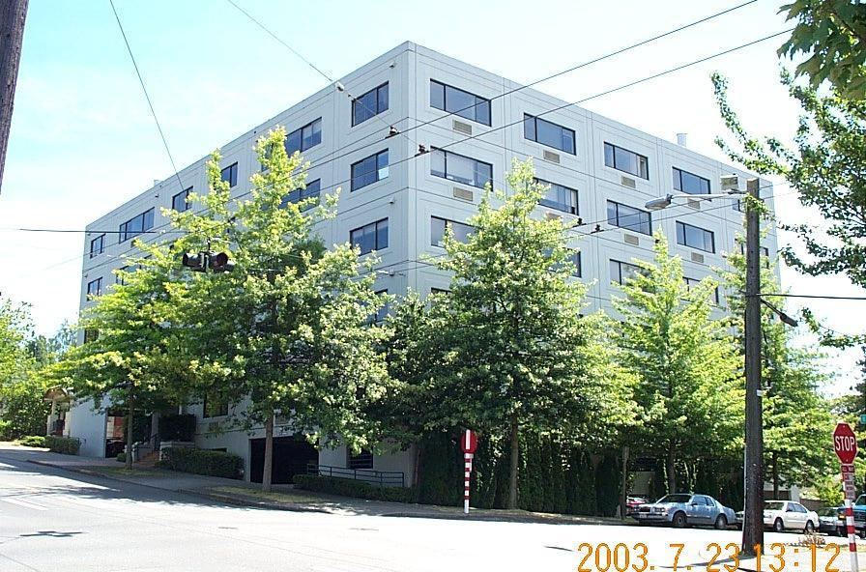

Property Owner: Jefferson House LLC
Address: 1401 East Jefferson Street, Seattle, WA 98122, Suite 400
Cost Per Sq. Ft.: $20.82 per square foot including operating expenses
Term: 75 months
Square Footage: 4,429
Council District: Two
Funding Source: Department of Public Defense Operating Fund
Previous Location: This agreement is a new King County lease but continues occupancy at the organization’s existing location.

Lease Synopsis:
The tenant of this space is one of the new Department of Public Defense divisions, The Defenders Association (TDA). The location described in this lease provides for close and convenient access to the Youth Services Complex, which is the primary work location for this division. The space is built out with offices, and serves 15 employees.

Context
Rationale for transaction: TDA was an existing tenant in the Jefferson Building when they became part of King County. The TDA employees working at this location are dedicated to providing juvenile public defense, dependency and truancy (Becca Bill) services. After a market search it was determined that the Jefferson Building was the best location, with close proximity to the Youth Services Complex and a functional floor plan. This new King County lease will allow TDA to continue occupancy in the Jefferson Building, under a new King County lease agreement. Long-term occupancy of this space is contingent upon Council approval. This lease includes an amendment containing Council recommended language used in the previous Jefferson building lease for the Department of Public Defense SCRAP division.

Policy considerations: This lease continues the policy of supporting public defense while maintaining a separation of Department of Public Defense counsel from King County Prosecuting Attorney, Superior Court, District Court and Sheriff’s offices.

Political considerations: N/A

Community considerations or partnerships: N/A

Fiscal considerations: This lease represents a very favorable rent rate for the local market.

Other considerations: Renewal of this lease maintains operations critical to the delivery of Department of Public Defense services.

CIP/operational impacts: This lease is a continuation of ongoing operating costs.

King County Strategic Plan impact: The attached lease furthers the King County Strategic Plan goal of Justice and Safety, by ensuring fair and accessible justice systems, and Financial Stewardship, by planning for the long-term sustainability of County services.

Equity and Social Justice impact: This transaction ensures King County’s commitment to a fair and equitable justice system by providing a long term location for a division of the Department of Public Defense.

Energy Efficiency impact: N/A

Lease Alternatives Analysis
Summary: King County Real Estate Services engaged the services of a commercial real estate brokerage to conduct a search in the local market and develop a list of alternative sites. It was determined that there were no other viable options within reasonable access of the Youth Services Center and negotiating a new lease with new terms in the existing building was the best course of business for TDA.

Vicinity View Map
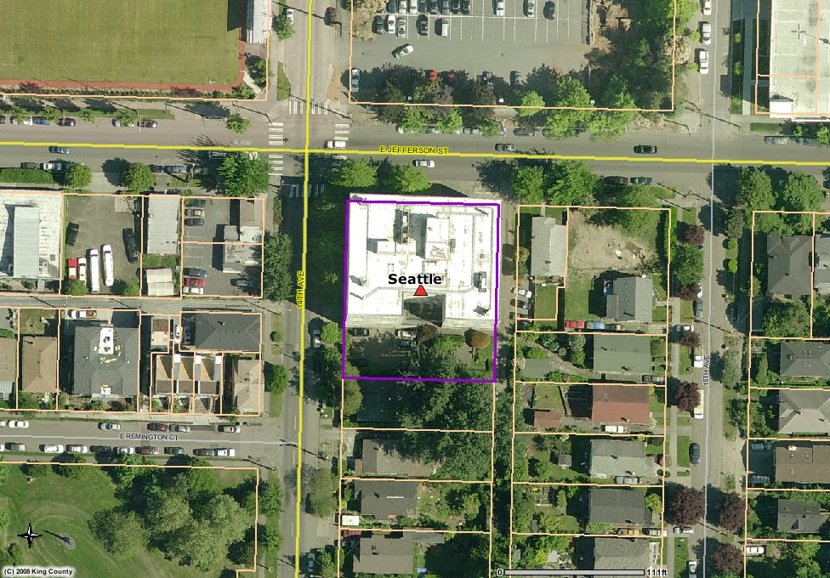

Parcel Map
