STAFF REPORT

Agenda Item: | 6 | Name: | Leah Krekel-Zoppi
Proposed No.: | 2025-0122 | Date: | May 20, 2025

SUBJECT

A proposed ordinance that would make changes to Priority Hire program requirements by changing the criteria of “economically distressed areas” as it relates to administration of the program.

SUMMARY

The Priority Hire Program helps King County increase workforce diversity and promote economic opportunities for economically disadvantaged areas through targeted priority recruitment for county public works construction jobs and contracting. The proposed ordinance would make changes to the King County code definition of “economically distressed areas” in order to reflect the county’s changing demographics and align with the City of Seattle Priority Hire Program. The proposed change would increase the number of Priority Hire ZIP Codes from 44 to 55 ZIP Codes. An analysis of the proposal found that it would significantly increase the percentage of the population of low income and unemployed people in King County who would be eligible to participate in the Priority Hire Program.

BACKGROUND

King County Priority Hire Program. The Priority Hire Program was created in 2018 to prioritize the recruitment and involvement of economically disadvantaged workers in county public works projects. The purpose of the Priority Hire Program, according to Ordinance 18672, was to “help address construction workforce shortages, diversify the construction workforce, and improve the well-being of individuals who live in geographic areas of economic distress.”

The Priority Hire Program is administered by the Finance and Business Operations Division (FBOD) through master community workforce agreements that determine the terms and conditions for Priority Hire workers for county projects with estimated construction costs of $5 million or more, including:
- The percentage of labor hours to be performed by Priority Hire workers;
- The percentage of apprentice labor hours by preferred entry candidates;
- Provisions to ensure a respectful, inclusive workplace;
- Provisions to increase access for women and minority-owned businesses, open shop contractors, and small contractors and suppliers; and
- Provisions for recruitment, retention, and mentoring of construction workers.

The Priority Hire Program uses criteria to determine ZIP Codes that fall into a designation of “economically distressed areas.” The list of ZIP Codes is determined by the Priority Hire Program Manager, in accordance with King County Code criteria, and is to be updated at least once every five years. Changes to the criteria for determining economically distressed areas must by approved by ordinance. A Priority Hire Advisory Committee has been established to advise the county on implementing, planning, administering, and reporting on the Priority Hire Program. The Priority Hire Program Manager is required to submit an annual report detailing the performance of the program.

According to the Executive, data from Priority Hire annual reports shows that the Priority Hire Program has resulted in $35 million in wages paid to local workers.

2024 Annual Apprenticeship and Priority Hire Report. In 2024, the King County Priority Hire Program resulted in $10.5 million in wages paid to priority hire workers, and 1,017 workers being hired from priority hire ZIP Codes. The report states that Priority Hire participation rates exceeded hiring goals, including:

- Apprenticeship participation: 25.7% goal 39.5% actual
- Journey Worker participation: 18.2% goal 26.3% actual
- Minority Worker particpation: 21% goal 47.3% actual
- Women Worker participation: 12% goal 15.1% actual

The report also states that in 2024, FBOD commissioned a study to update the designation of economically distressed areas. That study is the basis for Proposed Ordinance 2025-0122.

ANALYSIS

The proposed ordinance would make changes to the King County Code definition of “economically distressed area” within the Priority Hire Program. Table 1 shows a comparison between the current definition of “economically distressed area” and the proposed definition.

Table 1. Comparison of Current and Proposed Definitions of Priority Hire Economically Distressed Area
Definition | Current | Proposed
Applies to ZIP Codes | “In the top 30% of all ZIP Codes in King County” | That “include at least 60% of King County population of residents” that meet the criteria
Applies to | “Concentration of individuals” within the ZIP Code who meet at least 2 of the 3 criteria | “Population of residents in that ZIP Code that have a high absolute number, have a high share by percentage, or have a high density per acre of people” meeting at least 2 of the 3 criteria
Criteria (meets 2 of 3) | - Have income at or below 200% of federal poverty,  - Are unemployed, or  - Are at least age 25 without a college degree | - Have income at or below 200% of federal poverty,  - Are unemployed, or  - Are at least age 25 with less than a bachelor’s degree

According to the Executive, the purpose for the proposed change was to reflect the changing demographics and economic characteristics of the region and to enhance regional uniformity, since the proposed changes align with the “economically distressed areas” used by the City of Seattle Priority Hire Program.

The Priority Hire Program requires the list of ZIP Codes designated as “economically distressed areas” to be updated at a minimum of every five years. In 2024, FBOD engaged a consultant to analyze an update to the Priority Hire ZIP Code list. The resulting King County Priority Hiring Analysis (Attachment A to Proposed Ordinance 2025-0122) updated the service area and considered adjustments based on the 2024 City of Seattle Priority Hire criteria. The analysis found that the current King County “economically distressed area” methodology and the current City of Seattle methodology produced different results. The analysis included Figure 1 to depict the differences between the two methodologies (“2016 Methodology” refers to current King County Methodology).

Figure 1. Comparison of King County and Seattle Priority Hire Methodologies
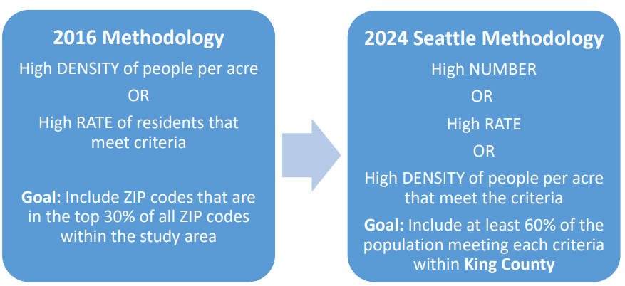

The analysis also included Figure 2, which depicts a calculation using each methodology for a sample ZIP Code.

Figure 2.
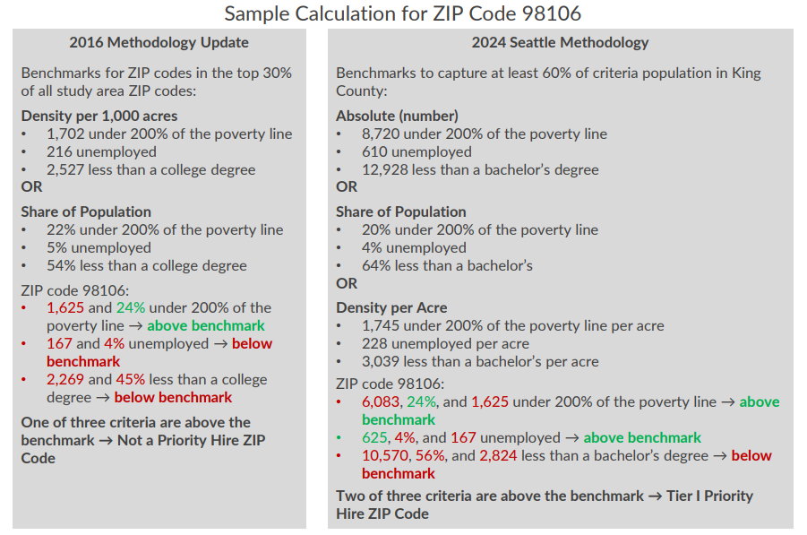

The sample comparison shows that ZIP Code 98106 meets one out of three of the current criteria and two out of the three of the proposed criteria. That means that this particular area would not currently qualify as a King County Priority Hire area but would qualify under the proposed changes and under the City of Seattle Priority Hire Program.

The analysis undertaken on behalf of FBOD found that overall, King County’s current methodology reaches 45 percent of the total population of residents who either 1) earn under 200 percent of the federal poverty rate, 2) are unemployed, or 3) have less than a bachelor’s degree. By comparison, the proposed methodology would reach 72 percent of that total population.

According to the analysis, the number of Priority Hire ZIP Codes would change from 44 ZIP Codes currently to 55 ZIP Codes under this proposal. Table 2 shows how the Priority Hire ZIP Codes would change if this proposed ordinance were to be adopted.

Table 2.
Change in Priority Hire ZIP Codes Under Proposal
Would be added under proposal but not under current method | Would be removed under current method but retained under proposal | Would be added under either method | Would be added under current method but not under proposed | Would be removed under either proposal
98012 | 98056 | 98158 | 98119 | 98007
98022 | 98092 | 98372 | 98154 | 98043
98026 | 98106 |  | 98164 | 98321
98034 | 98134 |  | 98174
98038 |  |  | 98195
98042
98052
98058
98166
98354
98390
98391

Legal Review. Council’s legal counsel completed a legal review of the proposed ordinance and did not identify any issues.

INVITED

- Ken Guy, Director, Finance and Business Operations Division

ATTACHMENTS

- Proposed Ordinance 2025-0122 (and its attachment)
- Transmittal Letter

Ordinance 18672
K.C.C.12.18A.020
K.C.C.12.18A.030
K.C.C.12.18A.040
K.C.C.12.18A.050
2025-RPT0046

