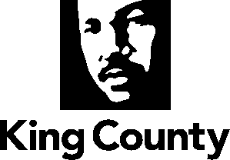
REVISED VHSL assessment report

Response to King County Motion 14743’s request for analysis and recommendations as to levy goals, strategies, programs and services
King County Department of Community and Human Services
January 19, 2017

Table of contents

I. Executive Summary and Recommendations 2
II. Assessing the Current VHSL’s Goals and Strategies 20
III. Community Engagement 34
IV. Analysis of Potential Strategy Areas 47
Unifying Themes and Community Needs 47
Veterans, Military Service Members and Families 48
Older Adults 60
Affordable Housing 87
Low-Income, Rural Residents 100
Diversion and Reentry for Criminal Justice-Involved or Incarcerated Persons 106
Survivors of Human Trafficking: Labor Trafficking and Commercially Sexually Exploited Youth 112
Domestic Violence 116
Civil Legal Services 121
Veterans Court Programs 125
V. Oversight Board Structure 130
VI. Assessing Human Services Funding Trends and Alignment Opportunities 133

Executive Summary and Recommendations

In 2005, King County faced deep cuts to human services funding that risked unraveling an already threadbare safety net. Local men and women were returning from wars in Afghanistan and Iraq, many bearing visible and invisible wounds that complicated the already difficult task of rejoining society. Too many of King County’s veterans and most vulnerable residents were struggling without help, reacting at great human and financial cost to health, housing, and financial crises instead of preventing them. King County residents needed support to reconnect with opportunity and their communities at the very moment when the resources that could help them faced elimination.

Against this backdrop, the King County Executive and the Metropolitan King County Council presented to voters a ballot measure for the first Veterans and Human Services Levy, and the voters approved it. The levy funded programs for veterans and vulnerable residents to combat homelessness, improve health, and increase self-sufficiency, filling gaps and connecting siloed efforts to keep the health and human services system working for residents. In 2011, the Executive and Council asked the voters to renew the Veterans and Human Services Levy and by a margin of nearly 69 percent, King County voters said “yes.”

The levy has provided funding and fine-tuned its programs to help veterans, the vulnerable and families in need for more than a decade. The current VHSL has served over 150,000 King County residents, including more than 25,000 veterans, since it was renewed in 2011. In a myriad of ways, it has helped county residents achieve safer, healthier and more productive lives. The current levy expires December 31, 2017. The King County Executive and Metropolitan King County Council are now considering whether and in what form a renewal levy should go to the voters.

To begin the discussion and planning process, the County Council passed a “guidance motion” on Sept. 27, 2016, requesting from the Executive two reports to inform the Council’s deliberations on a potential ballot measure to renew the King County Veterans and Human Services Levy (VHSL). This report responds to the Council’s request to analyze the existing VHSL and propose new or existing strategies that might feature in a renewed VHSL. This report includes:

- An assessment of the effectiveness of the levy-funded strategies, services and programs in meeting the established VHSL policy goals

- Analysis and recommendations on whether a renewed levy should incorporate new goals or strategies related to older adults; civil legal services; affordable housing and reduction of homelessness; enhanced reentry services for criminal justice system-involved and incarcerated persons; expansion of veterans treatment courts; and services for sexually exploited youth and victims of human trafficking, low-income residents of the rural communities, and survivors of domestic violence

- Analysis on how a renewed levy would align and coordinate with Best Starts for Kids (BSK), the Mental Illness and Drug Dependency (MIDD) sales tax, and other federal, state and local funding

- Analysis of the current levy’s citizen oversight board structure

- Options and recommendations for a renewed levy to fill gaps in the social safety net.

Community Outreach and Engagement
Community partnership is essential in every phase of the levy renewal planning process. VHSL staff from the Department of Community and Human Services undertook an extensive community engagement and partnership process during Fall 2016 to gain input from providers, board members, clients and residents on the effectiveness of the VHSL, areas for improvement, and service area gaps and needs.
The team held three rural convenings, sixteen “Community Conversations” and fifteen focus groups—including meetings hosted in Cantonese, Khmer, Korean, Mandarin, Somali, and Spanish—to meet and learn from King County residents. Two online surveys provided another way for community members and service providers to participate. In all, 742 voices shared their insights, perspectives and hopes for what a renewed VHSL could and should be. Their input informs this report and its recommendations.
Assessment of the Current Veterans and Human Services Levy
Three goals guide the Veterans and Human Services Levy (VHSL). Staff analysis and community input demonstrate that the VHSL has been effective for King County residents in all three goal areas, serving hundreds of thousands since the original VHSL’s inception in 2006:

Goal One: Prevent and Reduce Homelessness
Outreach programs have reached more than 8,800 homeless veterans, chronically homeless individuals and other homeless persons, helping to move thousands from the streets into housing. Since 2006, the VHSL has contributed capital to the creation of 2,009 units of affordable housing, including units specifically set aside for veterans. The VHSL has also played a key role in convening a team of federal, state and local agencies that housed 850 homeless veterans in 2015, developing a by-name list and case conferencing model now employed by the larger homeless housing system. While homelessness remains a significant regional issue, the VHSL’s investments have helped house thousands of veterans and vulnerable residents in King County and have set the stage for continued progress.

Goal Two: Reduce Unnecessary and Expensive Use of Emergency Rooms and Jails
The personal trauma, collateral consequences, and system cost of incarceration are immense. Incurring those costs to people’s futures and County budgets is particularly problematic when the reason for incarceration is preventable or cheaper, more effective and less destructive alternatives exist. Investments in programs that connect incarcerated persons and those reentering society after incarceration with health and human services are essential tools in helping reduce recidivism, helping families regain stability, and reducing overall system cost. A similar model applies to the value of preventive medical care before conditions deteriorate and require expensive and less effective emergency interventions. Goal Two funds a set of programs that connect people to systems and resources to break costly cycles of incarceration and emergency room use. The Veterans Incarcerated Program and Passage Point have served hundreds of veterans and families as they reenter from incarceration. The Client Care Coordination program has tracked the cost-saving effects of providing housing and supportive services to high systems utilizers, tracking more than $7 million in cost offsets.

Goal Three: Increase Self-Sufficiency for Veterans and Vulnerable Populations
Thanks to VHSL funds, the King County Veterans Program (KCVP) provides a broader and richer array of services to support veterans and their families, including case management services through an individualized service model that responds to the needs of each veteran and their family. The levy enhanced the geographic accessibility of the KCVP and made it possible to add significant employment and education services, as well as services focused on veterans of color, women veterans and National Guard and National Reserve service men and women and their families—all improvement that were not possible prior to the VHSL. In 2015, 80 percent of KCVP clients receiving case management reported increased self-sufficiency and 93 percent of veterans seeking jobs were employed.

In addition to the VHSL’s accomplishments within its goal areas, the levy has also allowed King County to lead important changes in the larger health and human services system, incubating innovative concepts that have since come to scale to effect system change.

Investing Early
The VHSL has dedicated more than $1 million every year since 2006 to programs that invest in early childhood, promote strong starts for kids, and reduce future system involvement. This focus helped build the case for early investment in children with its attention to Healthy Start programs, play and learn groups, maternal depression screening and other supports for families with young children. The lessons learned were instrumental in planning for the Best Starts for Kids initiative.

Mobile Services
Public Health-Seattle & King County’s well-known and successful Mobile Medical Van began as a VHSL program. The Mobile Medical Van has helped to bring health and behavioral health services to many who would otherwise not have received any health care or waited until needing expensive emergency services. Based on its early successes, the project now leverages two non-VHSL dollars for every dollar of VHSL investment, enjoying broad support as it reduces emergency room use and promotes health. Community engagement frequently complimented the mobile van itself, but conversations also highlighted more generally the model of expeditionary services that the van employs, meeting need where it is, as an important strategy of health and human services delivery in a potentially renewed VHSL.

While noting strong success across VHSL programs, analysis also reveals opportunities for improvement. The VHSL has continuously refined its performance measurement practices to move away from a focus simply on throughput and numbers served, moving towards a focus on outcomes and how lives have been improved. The potential renewal of the levy presents an opportunity to take the next step and increase systemization among programs and emphasize outcomes within programs to better measure and demonstrate how levy-funded activities combine to change lives and drive system change. Renewal also presents the opportunity to align more directly with the County’s Strategic Plan, incorporate fully the County’s Equity and Social Justice Strategic Plan, coordinate a service system with Best Starts for Kids and the recently renewed Mental Illness and Drug Dependency Sales Tax, align or integrate with other local initiatives like the King County Veterans Program, and provide a source of local funding that can meet changing needs based on local conditions or changes in federal and state policy and funding.

Analysis and Recommendations on Potential New Goals or Strategy Areas
The Council’s guidance motion directed an analysis of whether a renewed levy should incorporate any new strategies not specified in the current levy’s service improvement plan:

The analysis and recommendations shall specifically address: whether a renewed levy should include a strategy or strategies to serve older adults; a strategy or strategies to increase integration of civil legal services for levy-funded programs or persons served by the levy; a strategy or strategies to increase investments in affordable housing generally and reduction of homelessness specifically; a strategy or strategies to enhance reentry services for criminal justice system-involved and incarcerated persons; strategy or strategies to tailor services for particular populations whose circumstances warrant specialized approaches, including sexually exploited youth, victims of human trafficking and low-income residents living in rural communities; a strategy or strategies to provide investments in services for survivors of domestic violence and people experience domestic violence; and a strategy or strategies to expand veterans courts.

This report explores in later sections each of these areas in detail, tying together research by internal workgroups, stakeholder feedback, and input from in-person and online community engagement efforts. Across the variety of populations and issues analyzed within this report several key, cross-cutting themes emerge:

The Importance of Housing to Health and Human Services: Affordable housing was an area of discussion at every community engagement, focus group and rural meeting. It was the most frequently cited system gap in the online surveys. The issue of homelessness was a strong and recurring concern. Older adults voiced their fears they could not afford to continue living in King County. Others spoke of the housing needs of veterans and their families or of chronically homeless people with behavioral health and disabilities that make stable housing hard to find and maintain. Residents were clear that housing is the paramount source of stability on which lives are built. In the absence of that stability, other investments in human services are less effective.
System Awareness and Service Access: Residents across the county’s geographic, cultural and experiential diversity expressed frustration in the lack of clear information about the broad array of federal, state, county, and community-provided human services that are available and how to access them. Lack of centralized information, insufficient transportation options, unavailability of materials in languages other than English, program hours that match business days instead of people’s needs, complicated eligibility requirements, and rigid income thresholds were identified as access barriers that impede people from receiving services and constrain the full effectiveness of public investments in health and human services.
Isolation: King County is a prosperous county, but not everyone is able to enjoy or benefit. Isolation from families and communities appears to be increasing. Veterans are returning to a nation in which fewer and fewer of their neighbors understand their experience. Older adults watch their social networks change as their family members grow up and move on, their professional networks fade after retirement, and life-long companions move or pass away. Language and cultural barriers can keep refugees and immigrants from fully participating in community. Families caring for aging or disabled family members feel alone in their experiences. Men and women leaving incarceration are isolated by difficulties in finding housing and employment. Beyond identifying isolation as a common issue, the discussions revealed that isolation has profound community and health-harming effects. Our communities are stronger when everyone can participate.
Beyond these cross-cutting themes, areas that received the most input from the community were the needs of veterans and their families, the growing number and needs of older adults in the community, and the critical need for affordable housing countywide. These three areas feature prominently in the report and are then followed by additional analyses of populations and issues on which the Council requested information.

Veterans: King County is home to an estimated 112,556 veterans. While the total population of veterans in King County is declining, the number of veterans in poverty and the severity of their poverty have increased since 2006. Unlike other populations considered in this report, the size of the veterans population can change rapidly based on federal policies and world events.

Veterans’ military service equips them to contribute powerfully to their communities. Leadership experience, an ethos of shared sacrifice and common purpose, and exposure to people and cultures from across the country and across the globe make veterans community assets. For some veterans, however, the same experiences that equip them with the potential to contribute so much to their communities also erect barriers to unlocking that potential. Empowering veterans to leave poverty and contribute to their communities is both a moral and an economic imperative.

The significant majority of King County’s veterans are Vietnam era of service or before. There are more than 74,000 veterans over the age of 55 (60%). As these veterans age, a significant number are presenting service-related illness and disabilities that combine in complex ways with health considerations that accompany the aging process generally. Younger veterans are more economically and racially diverse than their older counterparts and present new opportunities and challenges. Over 9,200 King County veterans are 34 years of age and younger. Although small in number and proportion to the overall population, there are higher rates of disability and mental health problems as more recent veterans have increasingly served multiple tours of duty in two ongoing conflicts. Research is clear that service-related trauma takes a significant toll, not just on the returning service man or woman, but also on their families. Suicide rates are dramatic: roughly 20 veterans a day commit suicide nationwide.

Veterans of all ages are increasingly isolated within society as rates of military service decline. For veterans who experienced trauma in service, rejoining a society that does not understand their experiences can be just as traumatic. Social isolation demonstrably harms health and shortens lifespan, a theme that emerged among several other populations examined in this report.

Women now represent a growing portion of veterans, reflecting the increasing role of women in the all-volunteer military. Women veterans are on average younger than their male counterparts. While they share with all veterans the potential to contribute powerfully to communities, unlocking that potential will require a veteran’s service system that has long focused on serving primarily men to adapt to meet the needs of all veterans.

Another significant issue for many veterans is financial insecurity. Over 18,000 King County veterans are low-income (below 200 percent of poverty). The number of veterans living below poverty level grew 43 percent since 2010. About ten percent of homeless single adults are veterans. They are disproportionately veterans of color.

The King County Veterans Program has grown significantly in recent years, thanks to VHSL funding. It is better able to serve our veterans and their families, but there are still gaps in services. Executive Dow Constantine’s Regional Veterans Initiative (RVI) brought together experts, veterans service organizations and human services organizations to improve service coordination. Full implementation of the RVI’s recommendations remains an important goal. The VHSL’s continued improvement process should now focus on increased systemization of services to simplify veterans’ access to the services that can help them meet complex needs. Specific examples of areas for improved systemization include better integrating the VHSL’s programs for veterans with the King County Veterans Program, improving connections and systems among VHSL-funded providers, and meeting the community’s requests for more advocates to help veterans and families bridge the gaps and connect to the services and benefits they have earned.

Older Adults: The older adult population in King County is vulnerable on many fronts, with high rates of financial insecurity; a growing need for affordable and supportive housing; health and community-harming effects of social isolation; and high rates of disease, injury and disability.
The population is rapidly aging. By 2040, 25 percent of the residents of King County will be over the age of 60, up from 18 percent today. More than 232,000 residents in King County are 65+, and over 300 of those are centurions (age 100+). While overall longevity is increasing, significant disparities based on race and place persist. Residents in South Bellevue can expect to live ten years longer than those in South Auburn.

Older adults—especially the “older old”—experience many vulnerabilities:
- The majority of the 60+ population (78%) have one or more chronic health conditions, with significantly higher rates of poverty and disability based on race and place.
- As many as 35 percent are women living alone.
- More than 107,000 people in Washington State have Alzheimer’s disease or other dementias, and that number is expected to double in the next 25 years.
- Elder abuse is on the rise. In 2014, the Washington State Adult Protective Services reported a 48 percent increase in reports of crimes against older adults in a five-year time span, with more than 7,000 allegations of abuse and neglect in King County in 2015.
- The challenge of caring for vulnerable elders impacts all generations. Of those turning 65 today, one out of three will need long-term services and supports in the future. Unpaid family caregivers—spouses, adult children and others—provide the bulk of this care.

While the older adult population has grown, federal, state and county investments in this population have significantly declined in recent years. King County’s Area Agency on Aging (operated by the City of Seattle) reports a $3 million reduction in program dollars in the last five years while at the same time serving 12,000 additional clients. King County’s historic General Fund investments in older adults were reduced due to lack of available discretionary funds, and a federal funding to Public Health for healthy aging was discontinued. These trends are exacerbated by the divestment in the older adult population by private charities.

Financial security, stable housing, social engagement and healthy living are key determinants of healthy aging. King County has a key role to play to promote healthy aging. This report lays out a framework to guide planning, services and activities for a potentially renewed VHSL.

Affordable Housing/Homelessness: Since 2000, King County’s population has grown by over 16 percent, adding nearly 300,000 residents. As local businesses expand, this trend is expected to continue for the foreseeable future. Unfortunately, not all of King County’s residents are flourishing. In the face of a real estate and technology boom, many find themselves priced out of housing, especially those who are low and very low-income, older adults and people who are homeless. A lack of housing blunts the effectiveness of other county investments in these populations as people focus on finding a place to stay instead of recovery, their health or seeking employment.

Even for those who have homes, the situation is too often precarious. While the county’s population has grown by nearly 20 percent, incomes have increased by only about seven percent. As of 2014, King County’s area median income (AMI) was approximately $86,000. Renter households make up approximately 40 percent of all households in King County, but they represent nearly 70 percent of households earning less than 50 percent of AMI. With lower incomes and higher housing costs, renters are at higher risk of having one unexpected expense or job loss cause them to lose their housing.

This situation is compounded by the rapid rise and high level of rents. Nearly 50,000 households earning 30 percent of AMI (approximately Washington State’s minimum wage) are severely housing cost burdened (defined as paying more than 50 percent of income towards rent). An additional 14,500 households earning 50 percent of AMI are severely housing cost burdened. Seattle has the highest number of severely cost burdened households, while South King County has the highest percentage. Cost burden does not fall equally across all racial and ethnic groups. Black or African American and Hispanic households are disproportionately severely cost burdened.

Taken together, there are nearly 65,000 households that are unstably housed. With one adverse event, such as an illness, accident or reduced work hours, many of these households would be at serious risk of homelessness. A 2012 study in the Journal of Urban Affairs found that a $100 rise in rents leads to a 15 percent increase in homelessness.

Displacement is another serious issue. In a highly competitive rental market, many landlords who previously accepted voucher payments are electing to stop, displacing currently housed households. With the increasing value of land, owners of mobile home parks are selling the property to developers, displacing low-income park residents.

The populations most at risk are those with special needs. These include senior households, people who are homeless (including those who are chronically homeless), low-income veterans, persons with disabilities, and some immigrants and refugees.

Added to this is the County’s homelessness crisis. In 2016, the One Night Count of homelessness in King County revealed 4,505 individuals without shelter (a 19 percent increase from 2015). Another 6,183 individuals were in emergency shelters and transitional housing, for a total of 10,688 homeless individuals throughout the County. These figures do not represent the thousands of households that are marginally housed, living one adverse event away from homelessness. In many cases, homelessness is a result of special circumstance. An individual or household may be faced with mental illness, chemical dependency or domestic violence. Left untreated or unresolved, these issues contribute to housing instability through loss of wages and/or erratic behavior, often leading to homelessness. The lack of affordable housing then exacerbates other challenges, impeding the effectiveness of a broad array of programs and investments to assist low-income residents.

In the face of the unprecedented need, the VHSL could play a critical role in expanding current effective shelter and affordable housing solutions while supporting new, innovative approaches to creating housing and linking shelter to housing.

Rural Residents: A total of 208,406 individuals, 10.4 percent of the county’s population, live in rural areas of King County. Compared to the entire county, a greater percentage of the rural population is White (84.9 percent). The percentage of people who own their own home is higher in rural King County than the rest of the county (77.6 percent). The percent of people in rural King County who have low income is less than the county as a whole. There are 15,155 people in rural King County whose income is below the federal poverty level, a poverty level of 7.3 percent compared to 11.8 percent countywide. Indicators of wellbeing and social support from a large national survey suggest that overall, health and community support networks for people in rural areas are similar to, if not better than, the entire county.

Although rural areas in King County do not appear to have the highest concentrations of vulnerable people in the county, averages and means may mask severe need for residents of rural communities. Vulnerable populations and those with low income living in rural areas face unique challenges in accessing services due to their geographic location.

Research points to the importance of integrated rural health and human service delivery for low-income families. Community conversation participants from rural areas echoed this finding, describing the difficulty of accessing services outside of urban cores. Intersections of membership in a vulnerable population, being low-income, and living in a rural community can combine to create particular difficulty. Community participants highlighted important opportunities to transform human services delivery in rural communities through strategies that employ remote access (e.g., tele-health), mobile services, school-based services and more multigenerational approaches to care. A renewed VHSL may have an important opportunity to improve access to services that can connect rural residents with the larger county and community.

Survivors of Human Trafficking and Sexually Exploited Youth: Human trafficking is the act of compelling a person into any form of labor against their will. Human trafficking can occur in any industry, including agriculture, construction, domestic service (e.g. housekeeper, child care), restaurants, salons, commercial sex work, massage parlors and small businesses. According to the Federal Bureau of Investigation, human trafficking is the second most lucrative criminal industry worldwide, after drug trafficking, bringing in approximately $32 billion annually. The U.S. Department of State estimates that as many as 17,500 foreign nationals are trafficked into the U.S. every year, and the National Report on Domestic Minor Sex Trafficking suggests that between 100,000 and 300,000 domestic minors are trafficked within the borders of the U.S.

Victims are often controlled physically, emotionally and financially. They are afraid to approach authorities because they fear threats of harm against their families or deportation. They may not speak English, presenting a potential intersection with issues affecting immigrants and refugees. The trauma of human trafficking can be so great that many may not identify themselves as victims or ask for help, even in highly public settings.

Washington is a “hot spot” in an international human trafficking circuit between the United States, Mexico, Hawaii, Japan, Thailand and the Philippines. Three common forms of human trafficking were the focus of this report:

- Labor Trafficking: Very little is known about the issue of human labor trafficking and exploitation in this region. Advocates state that they do not have good data on the extent of this largely hidden problem.

- Commercial Sexual Exploitation of Adults: Exploitation of adults includes prostitution, street or internet-based exploitation, pornography, stripping, phone sex and other “businesses” in the sex industries that may be illegal or legal, and that involve money transactions or other exchanges for sexual activity. Because adult victims of commercial sexual exploitation were treated until recently as criminals in the justice system, there are significant gaps in understanding the scope of the survivor population and the services they need.
- Commercial Sexual Exploitation of Children: Commercial sexual exploitation of children occurs in both the county’s urban and rural areas. Approximately 300-500 youth are exploited each year in King County.
New Council Action: Addressing the lack of information about this problem, the County Council inserted a budget proviso in the recently enacted 2017-2018 Budget Ordinance, Ordinance 18409, Section 20, Proviso P1 directing the Executive to “transmit a report and a work plan on options to assess and address the systemic issue of labor trafficking and trafficking related exploitation in King County.” Potential VHSL strategies to serve victims of human trafficking should align with both the proviso-directed work and the recent report and recommendations of the One King County Sexual Exploitation Work Group.
Domestic Violence: At least 14,000 individuals experience domestic violence in King County each year. Most reported domestic violence incidents occurred in Seattle and South King County.

In 2011, 16 percent of women and one percent of men at least age 18 years old reported being injured by an intimate partner at some point in their life. In 2015 there were 54 domestic violence fatalities in Washington State; four of these occurred in King County. A total of 4,195 individuals sought domestic violence protection orders as walk-in clients in 2015.
Domestic violence is often an underlying cause of homelessness or housing instability. In 2015, 5,023 people who were experiencing homelessness and seeking housing services had experienced domestic violence; 79 percent were female. Service providers noted the immediate need for shelter and long-term housing options for survivors, and that eviction history and debt make it challenging for many of these survivors to hold a lease in their own name. A bright spot is the new Best Starts for Kids-funded Youth and Family Homelessness Prevention Initiative. Based on a successful domestic violence pilot funded by the Bill and Melinda Gates Foundation, the new program will help families, including those fleeing domestic violence, and help save children from ever experiencing the trauma of homelessness. The program launched in December 2016 and will introduce much needed capacity, but it will not eliminate the need for similar resources for survivors.
Many who have experienced domestic violence have also experienced sexual violence. These clients need to be connected to appropriate sexual assault resources as well as domestic violence services.
Civil Legal Services: Civil legal services, also called civil legal aid, are legal and law-related services that assist low-income persons and communities to avoid, resolve or mitigate the effects of non-criminal legal problems. These services help low-income persons and communities in legal proceedings and situations where they may be at risk of losing access to important statuses, services, or basic needs. These can include housing, healthcare, employment, government benefits, or the right to remain in the United States.

Seventy percent of low-income households in Washington face at least one significant civil legal need each year, 76 percent of whom do not receive civil legal services to help them address their legal problems. The result is that low-income residents of King County too often engage in legal processes that could deprive them of housing, healthcare access, income or other important parts of their lives without the advice or representation they need to ensure that laws and regulations are being enforced fairly.

Potential VHSL priority populations with pronounced civil legal needs, explored in detail within this report, include veterans, military service members, and their families; older adults; immigrants and refugees; homeless persons and those at risk of losing housing; and survivors of domestic violence and sexual assault, who experience more civil legal issues per person that any other population.

Reentry Services for Incarcerated Persons and the Shift to Diversion: The current VHSL supports important parts of a continuum of services for justice-involved veterans and families. These levy-funded programs include mental health care in the County’s Regional Veterans Court, the Veterans Incarcerated Program and Passage Point. While these programs focus on reentry and provide essential services to help veterans and families rejoin society after incarceration, community engagement discussions highlighted a clear emphasis on diversion.

The underlying idea of emphasizing diversion over reentry is that many of the traumatic effects and collateral consequences of justice-system involvement occur at the initial point of arrest and during pre-adjudicative procedures. When the criminal justice system is used to provide health, recovery and other interventions that could more effectively be provided by health and human services agencies, the result is that the person receives more expensive, less effective care that actually erects barriers to health and self-sufficiency. In cases where criminal justice system contact is more attributable to conditions of mental health, addiction or disproportionate practices of enforcement, the most effective strategy to prevent the fiscal and moral costs of using the criminal justice system to provide human services is to prioritize diversion away from the system rather than reentry to society after entering the system.

Expansion of Veterans Courts: King County’s veterans courts remain an innovative and effective tool for serving eligible and amenable justice-involved veterans. The intensive concentration of services, resources and service providers that makes the District Court’s Regional Veterans Court (RVC) so successful also makes it particularly resource intensive. Fortunately, the existing RVC has the capacity to accept referrals on charged misdemeanors from any municipality within King County. In fact, inter-jurisdictional referrals are the largest source of the RVC’s cases. Further exploration of veterans court expansion within King County is feasible by referral or even off-site convening of the court rather than attempting to replicate within new courts the concentration of dedicated staff and resources from the U.S. Department of Veterans Affairs, Washington Department of Veterans Affairs, King County Prosecutor’s Office, Department of Public Defense, King County District Court, and associated community-based programming.

Alignment Opportunities
As was the case when the original VHSL came into being, the potential renewal of the levy comes at a time when funding and support for human services is uncertain. A transition to a new federal administration creates uncertainty around federal funding for health, housing and human services. Potential federal budget cuts would in-turn cause state-level reductions as pass-through funding falls. This uncertainty elevates the importance of local fund sources to meet residents’ needs and also highlights the importance of local funding sources retaining flexibility to react to changes that endanger safety net services for King County’s most vulnerable residents.
The report identifies many of the current, pending and possible change drivers that may impact the health and human services system, including the possibility of some small or large rollbacks to the Affordable Care Act, possible changes to housing policy and funding, and the continuing divestment in funding for older adult services. The report also notes changes in the philanthropic funding landscape.
The report also explores opportunities for coordination, particularly with the newly renewed MIDD and Best Starts for Kids. Together, these three fund sources provide a substantial portion of King County’s local investments in health and human services for children, youth, families, adults and communities.
The report identifies for further study potential co-investments that may implicate prohibitions against supplantation as well as potential areas of co-investment to promote coordinated services and County priorities. Specifically identifying instances of co-investment that implicate supplantation will require finalization of implementation processes for BSK and MIDD.
Discretionary co-investment and coordination are easier to explore at this point in the planning process. There are several areas where two or more of the service plans could complement each other and make it possible to serve more individuals or serve the community better: to increase system stability through diversified funding, enhance integrated and coordinated performance measures, improve access and delivery of services, and align programs and services with the County’s strategic plan and Equity and Social Justice goals.

Examples include:
- Intergenerational Activities – Such as child care, kinship care (grandparents providing child care), housing options and social inclusion activities.
- Investments in Housing Capital and Homelessness Efforts – Continued coordination of investments to build units of housing for shared populations in need and alignment with the All Home goal of making homelessness rare, brief and one-time.
- Aligning Investments in Therapeutic Courts – Courts and veterans and human services providers can have the greatest impact working together to help individuals and families achieve stability
- Integrating Community Partnerships – BSK, MIDD, and a renewed VHSL have an important opportunity to coordinate community engagement and partnership efforts in ways that support the King County Equity and Social Justice Strategic Plan.
- Aligning Performance Measurement Frameworks – All three initiatives are working to integrate contracting, data reporting and alignment of performance management frameworks to allow for shared results and indicators across the funding sources and improve the ability to measure the combined impacts of these programs.

Citizen Oversight Boards
King County has been fortunate to attract a number of dedicated and insightful individuals who have volunteered their time and effort to serve on the two VHSL oversight boards. The current VHSL adopted without change the board structure set out in the original version of the levy.
Both boards play substantial roles in approving implementation plans for new or revised levy activities. The boards also provide advice on recommendations to the Executive and Council on new levy priorities and re-allocation of under-expended levy funds. They also serve on Request for Proposal (RFP) rating panels and community committees.
After consultation with both boards, VHSL staff believes specific recommendations as to board changes are premature until the Council determines whether and what form to seek renewal of the VHSL. Instead of recommendations, this report proposes considerations that may shape future decisions about the essential role of the citizen oversight boards once the Council decides upon issues of a renewed levy’s purpose and focus.
Recommendations
In light of the considerations summarized here and analyzed in greater detail within the body of this report, the following recommendations respond to the Council’s VHSL Renewal Planning Guidance Motion to inform deliberations about whether and in what form to renew the VHSL.
Recommendations about VHSL Goals and Existing Strategies
- A renewed VHSL should maintain strong support for veterans, military service members and their families as a key focus of a renewed veterans and human services levy. VHSL services are making a difference for King County’s veterans, helping thousands gain or maintain housing, receive mental health care that keeps them engaged with their families and communities, and continue serving their communities after the military.

- A renewed VHSL should adopt the outcomes-based framework recently employed by Best Starts for Kids (BSK) and the Mental Illness and Drug Dependency (MIDD) sales tax. This would require shifting from a Goals-Strategies-Activities framework to a Results-Indicators-Strategy Area framework. This change would mean no longer using the current VHSL’s nomenclature to describe the three goals and four strategies, although those goals and strategies could remain within the substantive content of a renewed VHSL, acting as guiding principles or parameters for planners to use in designing an outcomes-based framework. Making this structural change will allow a renewed VHSL to respond to several of the opportunities for improvement contained within this report:
- Framework alignment with BSK and MIDD will allow for common results and indicators between BSK, MIDD and VHSL, increasing the County’s ability to quantify the combined effectiveness of the three local revenue sources for human services funding and to conduct combined continuous improvement processes.
- An outcomes-based framework integrates performance measurement into the planning process instead of designing an after-the fact performance measurement process.
- An outcomes-based framework will complement efforts to increase the ability of programs within the levy to work together for common outcomes. The nature of an outcomes-based framework is that the needs it identifies and solutions that it seeks to meet those needs are naturally systematized to support shared results.

- In reviewing the current Goal One, consideration should be given to increasing emphasis and support for affordable housing (capital, operations and services) as a strategy to align with All Home’s concept of making homelessness rare, brief and one-time. A lack of affordable housing was the most frequently articulated veterans and human services system gap in all forms of community engagement. While services for persons experiencing homelessness remain in demand and the complementary relationship between housing and supportive services is clear, the most severe shortcoming of the existing system is that there are not enough units of affordable housing. Affordable housing strategies should feature as a significant investment in a renewed VHSL’s approach to keeping King County’s veterans, older adults, and vulnerable population housed or making their experience of homelessness rare, brief and one-time.

- In reviewing the current Goal One’s emphasis on preventing and reducing homelessness, consideration should be given to prioritizing populations in which the VHSL otherwise invests and prioritizing populations who fall into gaps in eligibility, services, and types of housing that larger sources of funding create through their policies and operations. The purpose of these investments would be to make targeted investments that can amplify existing County investments or that can provide access for persons within the VHSL’s priority populations who are otherwise excluded from the homeless housing system.

- In reviewing the current levy’s Goal Two accomplishments in reentry for veterans and families, consideration should be given to directing new emphasis and resources to diversion away from the criminal justice system. Criminal justice system stakeholder groups identified that diversion can avoid the costs—to people and to the system—of criminal justice system involvement, whereas reentry focuses on reducing those costs after they are incurred. A renewed levy can continue promoting less expensive, more effective interventions by appropriately diverting veterans and vulnerable populations away from the criminal justice system in the first place.

- Consideration should be given to preserving the current levy’s Goal Two focus on preventing unnecessary and expensive emergency room use. Preventing crises works better and costs less. Continuation of this principle promises benefits for several of the potential priority populations within a new levy. Older adults and their caregivers in community conversations regularly voiced support for in-home medical services that could identify and treat emerging health conditions or help manage chronic conditions. The current levy’s use of early depression screening for mothers and seniors, as well as preventive medical care for the homeless, all demonstrate the value of including preventive care within larger strategies to keep vulnerable populations healthy and in their homes.

- A renewed VHSL should affirm the value of social engagement and belonging in addition to the existing Goal Three emphasis on self-sufficiency; the levy should also affirm support for vulnerable populations for whom full self-sufficiency may not be realistic. The VHSL should cultivate and pursue the complementary values of community connection and self-reliance. Community feedback identified that self-reliance is desirable for most, but that it is unrealistic for others. Examples may include older adults whose age or health conditions make self-sufficiency unlikely or some persons with disabilities who may be able to increase independence but who are unlikely to achieve self-sufficiency. This enhancement of the current VHSL’s Goal Three would not only promote self-reliance but also the value of inclusiveness and connection. Promoting them in combination supports potential VHSL results around increasing self-reliance, reducing social isolation, and promoting belonging.

- A renewed VHSL should retain the majority of programs contained within its strategies even if it adopts a new framework that uses different nomenclature (see Recommendation 1). This recommendation does not endorse wholesale renewal of all existing activities or programs nor does it endorse or imply preference for any current programs or contractors who provide services under the current VHSL’s activities. The purpose of this recommendation is to affirm that the majority of the activities in the current VHSL’s four strategies are effective and meet the needs of King County residents, and should therefore be considered—at the activity level (as opposed to the specific providers contracted to provide the activity)—for inclusion in an renewed VHSL.

- Consideration should be given to retaining an investment in health care reform, policy, and system design and implementation (functions contained within the current Activity 3.3) to ensure that levy programming remains well positioned to adapt to changes in federal and state health and human services policies. Continuous improvement in a renewed levy period will require ongoing engagement in federal and state policy environments with which a renewed VHSL should coordinate to align where possible and avoid duplication.

- A renewed VHSL should contain robust support for evaluation. Serving residents well, continuous improvement, and stewardship of precious public resources all depend upon a clear-eyed understanding of the system in which the VHSL operates and the outcomes that the VHSL achieves. Measuring results is an essential part of effective health and human services planning, and a renewed VHSL should contain significant resources to maximize its effectiveness by measuring its effectiveness.
Recommendations about Potential New VHSL Strategies
- Consideration should be given to a major strategy area to serve older adults and promote healthy aging in King County. This strategy should also include investments in supports for caregivers of eligible older adults. Older adult issues came up frequently in the community engagement process, and comments focused on the affordable housing, healthy living, financial security, and social engagement needs of low-income older adults. These community comments correspond to the clear data that older adults will be an increasingly large share of the county’s population, even as other funding sources move away from investments in supporting older adults.

- Consideration should be given to supporting civil legal services to support desired outcomes for populations in whom a renewed VHSL invests. Civil legal aid provides essential protections and fair system access for low-income King County residents faced with problems as varied as potential home loss, inappropriate denial of earned benefits, family separation, removal from the United States, protection orders to ensure personal safety, and efforts to combat financial exploitation. Half of homeless veterans’ top ten unmet needs are civil legal issues. Older adults, survivors of domestic violence or sexual assault, and immigrants and refugees all present civil legal challenges whose resolution can amplify the effectiveness of other County investments in essential services like housing, behavioral healthcare and resources for disabilities.

- Consideration should be given to a substantially increased emphasis on helping the levy’s priority populations gain or maintain affordable housing, paying particular attention to targeted investments that can catalyze broader system effectiveness in making homelessness rare, brief and one-time for VHSL priority populations. As discussed in Recommendation 2, the most pronounced gap in the local homeless housing system is the basic lack of affordable housing. Increasing housing stock and paying particular attention to populations who are missed or who do not fit well within the existing housing system can enable the full effectiveness of other investments in services and systems. Housing is an investment that amplifies the effectiveness of other investments. Conversely, a lack of housing will blunt the effectiveness of other investments in a person’s health, recovery or ability to seek employment.

- Consideration should be given to criminal justice system diversion for all populations while preserving the current levy’s accomplishments in reentry for veterans and families (duplicate to Recommendation 5, repeated here for responsiveness).

- Consideration should be given to investments to support survivors of human trafficking, to include commercially sexually exploited youth. The Council issued a budget proviso in the recently enacted 2017-2018 Budget Ordinance, Ordinance 18409, Section 20, Proviso P1 directing the Executive to “transmit a report and a work plan on options to assess and address the systemic issue of labor trafficking and trafficking related exploitation in King County.” Potential VHSL strategies to serve victims of human trafficking should align with both the proviso-directed work group and the recent report and recommendations of the One King County Sexual Exploitation Work Group.

- Consideration should be given to supporting the unmet needs of survivors of domestic violence. Community engagement and focus groups highlighted needs and opportunities to provide shelter and short-term housing for survivors, potentially doing so outside of the larger homeless housing system for which survivors may not be a good fit. Research also highlighted the critical importance of enabling rapid access to protection orders that can support safety for survivors. As with other areas that currently receive General Fund support, further investment in this area may implicate the prohibition against supplantation.

- Consideration should be given to system access to services for low-income residents of rural communities. Input from community meetings identified as needs types of services that increase awareness and access of the health and human services system and its benefits for otherwise isolated communities. These may include mobile, remote (“tele”), transportation and other innovative services and systems that help rural communities connect with the services they need.

- In reviewing whether to expand veterans treatment court services within King County, consideration should first go to exploring how the County’s existing Regional Veterans Court may support a community’s needs. Veterans treatment courts have proven effective in advancing both therapeutic approaches that help veterans and the need to promote public safety. Part of what makes the courts so effective is that they coordinate significant resources from a variety of partners. The concentration of resources depends upon the capacity of multiple levels of government to allocate dedicated staff. Replicating that model would require the U.S. Department of Veterans Affairs, Washington Department of Veterans Affairs, King County, and local jurisdictions to allocate substantial additional resources. The existing court has the ability to receive from local jurisdictions referrals for many matters, and exploring how to expand the existing court’s coverage may address communities’ needs without creating a new court.

- Although not specifically raised as potential populations within the Guidance Motion, consideration should be given to identifying and supporting targeted investments for immigrants and refugees, persons with disabilities, and survivors of sexual assault to keep them engaged, healthy and housed within King County. In addition to the populations and issues that the VHSL Guidance Motion specified for analysis in this report, the guidance motion asks more broadly whether a renewed VHSL should include any new strategies. The community engagement process repeatedly identified immigrants and refugees, persons with disabilities, and survivors of sexual assault as populations within King County for whom significant service system gaps exist. Community conversations often surfaced these populations in the context of broader issue areas on which the Guidance Motion directed analysis:

- Immigrants and refugees: Community engagement and the July 2016 findings of King County’s Immigrant and Refugee Task Force both indicate that immigrants and refugees report gaps and challenges related to service system awareness and access, availability of civil legal services, difficulty gaining or maintaining housing, and awareness of and access to existing health and human services programs. This finding is similar to the gaps that several other communities expressed around understanding the service system and how to access it. In particular, immigrants and refugees identified language access—both in the ability to speak to potential service providers in a language other than English and in being able to receive written materials in languages other than English. Any strategy for serving immigrants and refugees within a renewed VHSL should consider aligning with the recommendations of the July 2016 report of the Immigrant and Refugee Task Force.

- Persons with disabilities and their families: Families and caregivers of persons with disabilities were frequent participants in the community engagement process. A frequently raised issue among these participants was support for caregivers, an issue also raised in the context of those caring for older adults and those caring for disabled veterans. Caregiver needs focused on short-term respite for caregivers, long-term planning assistance for caregivers (e.g., to help in directing care for a disabled child after the caregiver parent’s death), and assistance navigating complex systems required to seek and apply for services.

- Survivors of Sexual Assault: The VHSL Guidance Motion requested analysis as to whether survivors of domestic violence should be included in a renewed VHSL’s strategies. In researching domestic violence and in community engagement on the subject, the comorbidity of sexual assault surfaced repeatedly. As with potential inclusion of other human services that currently receive General Fund support, any inclusion of Sexual Assault as an issue area within a renewed VHSL may implicate supplantation.
Recommendations about BSK, MIDD, Federal and State Alignment and Integration
- A renewed VHSL, MIDD and BSK should identify where co-investments implicate the prohibition against supplantation.

- A renewed VHSL and BSK should coordinate around intergenerational strategy areas that serve children and a VHSL priority population.

- A renewed VHSL, BSK, and MIDD should continue appropriate integration of their systems of community partnership and engagement, contracting, contract monitoring, data management, and performance measurement. Future progress in this area may include adopting the Community Liaison concept proposed within King County’s Equity and Social Justice Strategic Plan.

- A renewed VHSL, BSK and MIDD should adopt common frameworks and assess whether and how to adopt common results and indicators for some of their programming (see Recommendation 1).

- Consideration should be given to supporting VHSL’s full integration of the operations of the state-mandated King County Veterans Program (KCVP) and VHSL-funded services for veterans and their families.

- A renewed VHSL should identify programming intersections with human services programs funded by the King County General Fund (civil legal services, domestic violence, sexual assault, and older adults) to determine whether those intersections implicate the prohibition against supplantation.
Recommendations about VHSL Citizen Oversight Board Structure
- This report determines that specific recommendations about changes to the citizen oversight board structure are premature until the council determines whether and in what form to seek renewal of the VHSL in light of the recommendations included in this report. This report proposes the following considerations when the council considers board structure in the future:

- Consider combining the County’s state-mandated Veterans Advisory Board and the VCOB as a way to promote programmatic alignment between the County’s state-mandated Veterans Assistance Program (the King County Veterans Program) and VHSL-funded programs that serve veterans and to strengthen and unify the voice of veterans in County policy making.

- Increase exposure and accountability to client and/or affected community perspectives, retain the current boards’ emphasis on community membership, and retain or remain close to the current boards’ size

- Ensure Veterans Citizen Oversight Board (VCOB) composition includes perspectives of major populations served by the VHSL’s veteran-specific fund in a renewed VHSL. In the current VHSL, this would include positions for veterans, military service members and their families.

- Align Regional Human Services Citizen Oversight Board (RHSCOB) composition to require perspectives of major population groups or service types served by the VHSL’s human services fund in a renewed VHSL. These may include members with expertise or experience in issues affecting older adults, homelessness, immigrants, refugees, or populations reentering society after incarceration if those populations are included as major foci in a renewed VHSL.

- Consider the addition of non-voting members representing key governmental or institutional partners in order to promote veterans and human services system awareness, alignment, and integration. Possible partners include the U.S. Department of Veterans Affairs (Hospital Administration and Benefits Administration), the U.S. Department of Housing and Urban Development, the Washington Department of Veterans Affairs, the Area Agency on Aging, or local Human Services Commissions.

Recommendations about Use of VHSL Proceeds to Fill Safety Net Gaps
- Consideration should be given to identifying how a renewed VHSL could include within its funding structure an annual portion of unprogrammed funds whose purpose is to provide rapid response that fills gaps or makes use of opportunities that result from changes in the federal or state funding landscapes for human services. Since its inception, the VHSL has served as a form of connective tissue between parts of the health and human services system to keep its services accessible to vulnerable populations. As the federal landscape presents uncertainty and local conditions continue to change rapidly, the VHSL should remain capable of adapting to changing conditions to support County priorities and values.

Assessing the Current VHSL’s Goals and Strategies

“An assessment of the effectiveness of the … veterans and human services levy-funded goals outlined in Ordinance 17236, and the effectiveness of the existing strategies, services and programs in meeting the three policy goals. The assessment report shall include an explanation of the methodology used to make the determination of effectiveness. The purpose of the review is to identify potential changes to improve the levy’s effectiveness, improve the levy’s stewardship of resources and improve the levy’s equity and social justice impact…”

Assessing the 2012-2017 Veterans and Human Services Levy:
Key Achievements and Opportunities for Improvement of the Levy’s Goals and Strategies

Introduction
King County’s Veterans and Human Services Levy (VHSL) has served more than 150,000 King County residents—more than 25,000 of whom were veterans—since it was renewed by voters with 68.9 percent of the vote in 2011. The VHSL is on track to have served more than 200,000 residents by the end of 2017, when the current VHSL will expire. Since the VHSL’s inception in 2006, it has contributed capital to the creation of 2,009 units of affordable housing, with 613 of those units coming online in the current levy period and additional units set to open before the VHSL expires.

Beyond the numbers of people the VHSL has served and number of homes it has built, the VHSL has shifted its focus towards outcomes in addition to throughput, and its activities have played an important part in transforming the local human services system that the VHSL was originally created to help stabilize. Key examples of the VHSL’s transformative focus on outcomes include:

Enhancing the King County Veterans Program
King County’s Veterans Program (KCVP) has existed for decades, and its service model prior to the VHSL consisted largely of issuing checks for emergency funds to indigent veterans. The VHSL’s investment in KCVP added a second full-time office and transformed both KCVP locations into service hubs. Veterans may first come for financial assistance, but they are then engaged by trained case managers who can assist in leveraging other VHSL-funded programs as well as state and federal resources to guide veterans in achieving their health, housing and employment goals.

Building the case for early investment in children
Every year since 2006, the VHSL has allocated at Council direction $1.5 million to fund early intervention and prevention programs to reduce crisis service system involvement. These investments guided King County’s investment in proven strategies for Best Starts for Kids. VHSL funds have supported critical early investments in programs like:
- Healthy Start: Provided 1,528 in-home visits to first-time, primarily very low-income parents and their infants, utilizing evidence-based programming to strengthen young families (2012-2015).
- Maternal Depression Reduction: Screened more than 10,100 mothers at behavioral health integrated community health centers, identifying more than 2,400 who screened positive for depression and then received follow-up treatment to promote successful parenting and child health (2012-2015).

- Play and Learn Groups: 338 Play and Learn groups regularly met across the region helping families prepare their young children for success in school and life (2012-2015). The evidenced-based program reaches families in their neighborhoods and in their home languages at weekly, facilitated play groups.

Navigating intersections of the human services, legal and criminal justice systems
Similar to the VHSL’s role in building the case to invest early in children and families, the levy has played a key role in connecting programs that work at the intersection of human services, legal services and the criminal justice system. These innovative investments prioritize people over programs and outcomes over traditional roles. Examples include:

- Passage Point: Recognizing the unique challenges that formerly incarcerated parents face and the long-term value of keeping families together, the Passage Point residential facility has provided a supportive place for an annual average of 98 reentering parents to work towards family reunification, while also navigating all of the other challenges that accompany leaving incarceration (2012-2015). Hundreds of parents and their families have benefited from the levy’s investment in supporting them so they can support their families.

- Veterans Incarcerated Program: Case managers specifically trained in veterans benefits and familiar with veteran’s culture have identified and screened 2,619 veterans incarcerated in facilities within King County. More than 1,029 of the veterans eventually enrolled in case management with the project (2012-2015). In 2015, housing referrals for veterans leaving incarceration with case management from the program were 79 percent successful, helping set the conditions for reentry success by releasing veterans to housing instead of homelessness.

Meeting clients where they are
The VHSL has been a leading force in promoting outreach and mobile services that meet veterans and vulnerable populations where they are to provide services before needs deteriorate into crisis. Example of VHSL programs that meet residents where they are include:

- Mobile Medical Van: One of the VHSL’s most widely recognized investments, the Mobile Medical Van, was originally solely funded by the VHSL. After building a record of success, the VHSL has since been able to leverage non-levy funds to maintain the community impact of the program. Every VHSL dollar invested in the program leverages two dollars in non-VHSL funds. A total of 3,198 homeless and low-income residents of King County have received medical care from the project instead of letting conditions deteriorate further and eventually seeking care in emergency rooms (2012-2015).

- Outreach Programs for Homeless Veterans, Veterans of Color and Women Veterans: Recognizing that women veterans and veterans of color face additional challenges in accessing veteran’s services, VHSL funding has invested in community partners’ ability to identify veterans who may not feel welcomed by traditional outreach strategies. Veterans outreach specialists from El Centro de La Raza and Therapeutic Health Services have sought out and screened 2,693 veterans, eventually helping 1,653 to apply for benefits or services to improve income, health, housing or self-sufficiency (2012-2015).

- PEARLS: VHSL has funded this in-home depression screening program for older adults; 294 older adults have completed the program, a 78 percent success rate of helping older adults facing the difficulties of depression later in life (2012-2015).

These programs represent the role the Veterans and Human Services Levy has played in improving the County’s human services system and improving the lives of King County residents. As this fixture of the service landscape completes its first decade of keeping residents connected to services and to their communities, this report’s evaluation of the levy’s goals presents an important opportunity to take stock of what the levy has done and suggest improvements that can help it continue serving new residents in new ways moving forward.

How This Report Assesses the VHSL’s Goals and Strategies

Should the Council and voters elect to renew the Veterans and Human Services Levy, the levy will have an opportunity to refine its goals and strategies and continue the work of transforming King County’s veterans and human services systems. Assessing the current VHSL’s goals and strategies provides an essential step in that process. This report’s assessment of the current VHSL and its goals and strategies consists of four parts:
- A review of the current VHSL’s goals-strategies-activities structure
- An explanation of this report’s methodology in assessing the goals and strategies
- An assessment of effectiveness for each goal and each strategy
- An assessment of the VHSL’s systems.

VHSL Framework History: Differences in the 2006 and 2012 Frameworks
The current VHSL utilizes a goals-strategies-activities structure to direct its expenditures to have a targeted impact. The current VHSL’s structure draws heavily upon the structure of the original VHSL. Key changes between the original and current versions of the VHSL include an articulation of individual goals, a reduction of the number of strategies, and adjustments to the activities to correspond to the refined structure. The next table depicts key changes in structure between the original and current versions of the VHSL.

Summarizing the Current Framework
VHSL’s Three Goals: The VHSL’s goals were designed to support the King County Strategic Plan and in alignment with the Framework Policies for Human Services. The three goals are to:
- Prevent and reduce homelessness
- Reduce unnecessary criminal justice and emergency medical system involvement
- Increase self-sufficiency of veterans and vulnerable populations
VHSL’s Four Strategies: Guided by the VHSL’s three goals, the Service Improvement Plan enumerates four strategies. These strategies set out broad categories of levy-funded activity directed at achieving the levy’s goals. Importantly, each of the VHSL’s four strategies contributes to more than one of the VHSL’s three goals. The current VHSL’s strategies are:
- Supporting veterans and their families to build stable lives and strong relationships
- Ending homelessness through outreach, prevention, permanent supportive housing and employment
- Improving health through the integration of medical and behavioral health services
- Strengthening families at risk.
Except for Strategy 1, the current VHSL’s strategies do not specify the particular populations to receive services and programming under each strategy. The VHSL’s Service Improvement Plan does, however, identify “target populations” to prioritize expenditures within each strategy in light of the “limited availability of levy funds.”
VHSL’s Activities: Within each of the four strategies, the VHSL funds individual programs or services that the framework calls activities. The VHSL funds 43 activities across the four strategies. The number of activities has changed year over year as particular activities may start or stop operations.
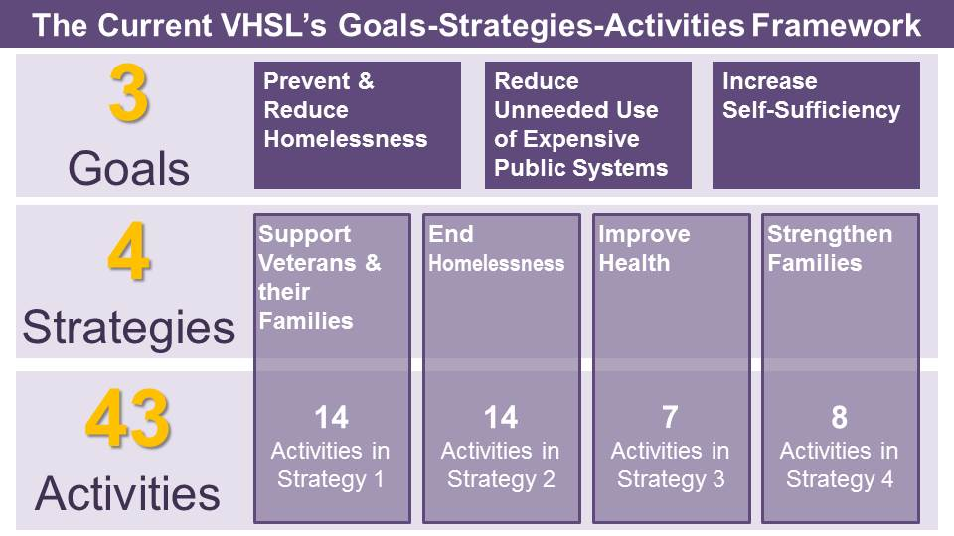
Focus on Activities. The VHSL’s current framework emphasizes the levy’s individual activities as the focus of its performance measurement concept. The three goals guide the four strategies and the strategies present broad categories of activity types that guide what the activities do to serve residents, but this structure was not designed with shared performance measures among the activities within either the goals or strategies.
Activities either can be sorted by the four strategies under which they are funded or they can be re-sorted by the three goals that they support. Under this design methodology, the current VHSL does not have goal-level or strategy-level performance measures, and total performance at the goal or strategy level is expressed as the set of activity-level accomplishments for every activity within a strategy or goal.
For example, sorted by the strategy under which activities are funded, VHSL activities align as follows:
Sorted by goal, VHSL activities align differently.
Understanding the VHSL’s current goals-strategies-activities structure and the resulting emphasis in evaluation on activities rather than goals is important when developing a methodology to assess the VHSL’s performance relative to its goals and strategies.
Assessment Methodology
In assessing the VHSL’s goals, strategies and systems, this report relies upon cumulative fiscal and performance evaluation data, community input received during community conversations, input from focus groups, meetings with key stakeholders, and the results of two online surveys and staff analysis.
Although activity-level program evaluation is outside the scope of this report, VHSL administration and evaluation staff closely monitors levy activities’ performance and fiscal status. The Executive transmits for Council review and acceptance an Annual Report and a Mid-Year Performance and Financial Update for every year of levy operations. These reports examine the performance of individual levy-funded activities against performance targets, highlight accomplishments and the VHSL’s impact in King County, and provide a detailed fiscal accounting of VHSL annual budgets and expenditures. Annual and mid-year reports for all completed years of the current VHSL are available for public review online.
In addition to annual and mid-year reporting, VHSL evaluation staff maintains two online VHSL evaluation documents. The first is the 2012-2017 Levy Evaluation Implementation Plan, a document that lays out the VHSL evaluation staff’s framework and principles for ongoing evaluation of VHSL performance. The second is the 2012-2017 Levy Evaluation Implementation Plan Addendum A (2016 Activity-Level Evaluation Templates), which provides activity descriptions, implementation details, and recent performance data for each of the activities funded by the VHSL. As discussed earlier in this section, while this report does not evaluate the VHSL’s activities individually, the VHSL’s goals-strategies-activities framework depends upon cumulative activity-level performance as the primary indicator of success within each goal and strategy.
Having established the scope of the evaluation, this report frames its evaluation of the levy’s goals and strategies around the answers to three questions:

How has the goal or strategy benefitted King County residents since 2012?
In answering this question for each goal and strategy, this report will highlight cumulative performance of the activities aligned with the goal or strategy.

Does the goal or strategy remain relevant in 2017?
In answering this question for each goal and strategy, this report will consider how community conditions, the funding landscape and other programming may have changed or stayed the same.

What opportunities exist to increase the effectiveness of the goal or strategy in a renewed VHSL?
In answering this question for each goal and strategy, this report will consider community engagement feedback, best and emerging practices observed in other County initiatives, and staff analysis to identify opportunities to improve the goal or strategy’s effectiveness, stewardship, or equity and social justice impact.

Assessing VHSL Goal One: Prevent and Reduce Homelessness
- How have VHSL activities contributed to the prevention and reduction of homelessness since 2012?
The 2016 update to the Veterans and Human Services Levy Implementation Plan identifies eleven of the VHSL’s activities as primarily aligned with Goal One as depicted in the following table:

Goal One’s ten activities have accomplished the following outcomes in serving King County residents from 2012 -2015:

- Reached more than 8,800 clients through outreach and mobile services and connected more than 7,100 of those clients to housing, medical or behavioral health services.
- Housed 3,202 clients in levy-funded programs who either remained in housing or secured a new permanent housing placement – an average of 87 percent gaining or maintaining housing annually.
- Awarded funds to developers of low-income housing to build 613 units of affordable housing during the current levy period so far. A recent example of VHSL-funded affordable housing is the William J. Wood Veterans House with 44 units for homeless veterans and their families operated by MultiService Center that opened Dec. 8, 2016.
- Housed 850 homeless veterans under a focused veterans housing initiative in 2015. While veterans homelessness remains a challenge in King County, 2015’s exceptionally high rate of housing success despite chronic unavailability of housing stock occurred when VHSL-funded staff and key partners from VHSL-funded community agencies, Supportive Services for Veteran Families (SSVF) programs, the Washington Department of Veterans Affairs (WDVA), and the U.S. Department of Veterans Affairs (VA) convened a task force to synchronize processes to identify, engage, assess, place and support homeless veterans. The resulting Veterans Operational Leadership Team (VOLT) pioneered the processes in King County of assessment and by-name-list tracking of homeless veterans and remains in action today. Both practices have gone on to standard use by the countywide Coordinated Entry system. Nearly 40 percent of the VHSL’s annual expenditures go towards capital, services, or programming intended to prevent or reduce homelessness.

- Does Goal One remain relevant in 2017?
Yes. Concerns about the lack of affordable housing were the most frequently mentioned issue in the Community Conversations on VHSL renewal. Despite VHSL’s work to house or keep housed thousands of County residents, despite the levy’s creation of hundreds of units of affordable housing, and despite promoting integration of housing and medical and behavioral health services, homelessness remains a state of emergency in King County. The region’s combination of expensive rents, high housing demand and low affordable housing stock contribute to the likelihood King County’s low-income, fixed income, and otherwise vulnerable residents will continue to face the threat of homelessness in large numbers.

- What opportunities exist to increase the effectiveness of Goal One in a renewed VHSL?
Building, preserving, or otherwise creating more affordable housing: The insufficient stock of affordable housing units is a fundamental contributor to homelessness in King County. There are hundreds of veterans in possession of Veterans Affairs Supportive Housing subsidized housing vouchers who cannot find a unit to rent. While subsidies, supportive services, and initiatives to improve screening, assessment, and placement efficiency are all important to addressing the problem of homelessness, the most fundamental within the system is the simple lack of enough units of affordable housing. The VHSL has historically dedicated a portion of its revenue for capital to build affordable housing units, and increased capital allocations could increase the effectiveness of that effort.

Full alignment with King County and All Home: Over the last three years, VHSL-funded activities within this goal have begun to move away from operation as independent programs and towards integration into the County’s larger system of preventing and reducing homelessness. More recently, VHSL-funded programs have also begun incorporating practices and standards promulgated by All Home to make homelessness in King County rare, brief and one-time. Continued integration of VHSL-funded efforts into the larger County system through the Continuum of Care is essential to making VHSL-funded programs as effective as possible.

Recognizing Opportunities to Tailor Services for Specialized Populations: The VHSL should recognize the specialized role it can play in meeting the housing needs of some populations who do not fit well within the primary homelessness system. Input from service providers made clear that populations like domestic violence survivors, youth seeking shelter, undocumented persons, and veterans who are ineligible for federal veterans services are sometimes poor fits for the larger homelessness system. The VHSL has the ability to provide small-scale, tailored housing solutions for populations like these that better meet their needs while also allowing the larger homeless housing system to focus on the larger population of homeless persons for whom it was designed.

Assessing Goal Two: Reduce Unnecessary Criminal Justice and Emergency Medical System Involvement
- How have VHSL activities contributed to reducing unnecessary use of criminal justice system and emergency medical system involvement since 2012?
The 2016 update to the Veterans and Human Services Levy Implementation Plan identifies six of the VHSL’s activities as primarily aligned with Goal Two as depicted in the following table:

Goal Two’s seven activities have accomplished the following outcomes in serving King County residents from 2012 -2015:

- VHSL reentry programs engaged more than 3,800 incarcerated or formerly incarcerated King County residents, providing case planning, supportive services, or connections to housing or healthcare to promote successful reentry and reduce the likelihood of recidivism in the criminal justice system:
  - Passage Point: The YWCA program creates a supportive residential community that helps parents facing homelessness after incarceration reunite with their children by providing a stable environment, with positive educational and social opportunities for them and their children.
  - Veterans Incarcerated Program: With the WDVA, the program designed to address the needs of veterans incarcerated in County Correctional Facilities offers alternatives to jail and referral to housing, employment services and treatment.
  - Forensic Intensive Supportive Housing (FISH): Coordinated by King County’s Behavioral Health and Recovery Division (BHRD), the FISH program provides prevention and intervention strategies for those most at-risk and need to reduce or prevent more acute illness, high-risk behaviors, incarceration and other emergency medical or crisis responses.
- The Client Care Coordination (CCC) Program, maintained a database of homeless individuals who were high utilizers of public services, tracked their use of these services one year before and one year after they were housed, and facilitated housing placements for individuals within the program. The clients’ use of services declined after they were placed in housing. The CCC calculated the cost offsets associated with this decline and found that since 2012, supportive housing placements achieved estimated cost offsets of $7 million that otherwise would have been incurred to incarcerate or hospitalize these individuals.

- Does Goal Two remain relevant in 2017?
Goals Two’s purpose of promoting housing, treatment, healthcare and service interventions to reduce more expensive use of jails and emergency room’s remains a pressing goal in King County. Nearly 80 percent of the County General Fund goes towards law and justice system costs, and emergency healthcare services are more expensive than preventive services. Important changes within King County’s funding landscape have incurred since the first VHSL, including approval and renewal of the MIDD sales tax and the community’s adoption of the Coordinated Entry system.
- What opportunities exist to increase the effectiveness of Goal Two in a renewed VHSL?

Emphasizing Diversion: VHSL activities that support Goal Two are divisible into two categories: programs that promote successful reentry when a person is within the criminal justice system (e.g., Veterans Incarcerated Program and the Emerging Programs for Justice-Involved Veterans, which funds mental health screening in the Regional Veterans Court) and diversion programs that avoid entry into the criminal justice system by resolving issues before they contribute to criminal justice system contact (e.g., Veterans Legal Assistance Program and FISH). Recent efforts within King County have further developed both reentry and diversion strategies.

Looking forward, the VHSL may improve effectiveness of Goal Two by consolidating and continuing to support the reentry programming that it has created, which focuses primarily on justice-involved veterans and families, but then shifting the emphasis of Goal Two’s efforts towards criminal justice system diversion for all residents of King County. An emphasis on diversion was a clear takeaway from the focus group meetings with the criminal justice system stakeholder group on criminal justice system issues.

The underlying idea of emphasizing diversion over reentry is that many of the traumatic effects and collateral consequences of justice-system involvement occur at the initial point of arrest and during pre-adjudicative procedures. When the criminal justice system is used to provide health, recovery and other interventions that could more effectively be provided by health and human services providers, the result is that the person receives more expensive, less effective care that actually erects barriers to eventual health and self-sufficiency. In cases where criminal justice system contact is more attributable to conditions of mental health, addiction or disproportionate practices of enforcement, the most effective strategy to prevent the fiscal and moral costs of using the criminal justice system to provide human services is to prioritize diversion away from the system rather than reentry to society after entering the system.

Assessing Goal Three: Increase Self-Sufficiency of Veterans and Vulnerable Populations
- How have VHSL activities contributed to self-sufficiency of veterans and vulnerable populations since 2012?
The 2016 update to the Veterans and Human Services Levy Implementation Plan identifies 11 of the VHSL’s activities as primarily aligned with Goal Three as depicted in the following table:

Goal Three’s 24 activities have accomplished the following outcomes in serving King County residents from 2012 -2015:
- The King County Veterans Program (KCVP) served nearly 10,000 veterans and their families. Data shows that 7,510 of those clients received case management services, 6,400 received financial assistance, and KCVP provided veterans and family members with 55,400 bed nights in local shelters to intervene in housing crises and stabilize clients to receive treatment, medical care and other interventions.
- Over 10,100 mothers were screened at behavioral health integrated community health centers, with over 2,400 screening positive for depression and receiving treatment that contributed to the healthy development of their children and ongoing successful parenting.
- A total of 913 veterans received an initial case assessment by the Northwest Justice Project’s legal assistance program with 330 of those cases successfully resolved by project attorneys and 589 cases referred for assistance by outside counsel.
- Over 338 Play and Learn groups regularly met across the region to help families prepare their young children for success in school and life. The evidenced-based program reaches families in their neighborhoods and their home languages at weekly, facilitated play groups.
- Over 1,000 clients received over 12,800 hours of individual and group PTSD counseling, helping them cope in healthy ways with the effects of their trauma. Importantly, these services were provided not only to military veterans, but also to their spouses and dependent children, helping families remain connected and healthy.

- Does Goal Three remain relevant in 2017?
Yes. As the VHSL goal with the most programs, this goal provides for a broad array of health, housing, income, and social connection-promoting programs that help meet immediate needs in ways that support long-term growth.

- What opportunities exist to increase the effectiveness of Goal Three in a renewed VHSL?
Systemization: The programs supported within this goal area provide an impressive range of services and supports, yet the majority of the programs operate independently of each other unless relationships between providers help make the connections. Moving forward, the VHSL has an opportunity to increase the systemization of its programs. One of the most frequently noted gaps from the community engagement process was that system fragmentation and complexity too often inhibit service effectiveness and client access. While those concerns can be partially addressed by improved communication about the programs available, the structure of the system itself could improve to clarify how VHSL-funded programs can work in combination and sequence to form a continuum of care for recipients, both with other VHSL programs as well as with programs funded through the County and broader community.

Systemization also holds significant opportunities to improve the standard of service by individual programs and providers. Confronted with the complexity of their clients’ needs and with uncertainty about what other resources are available and have capacity to accept referrals, many providers reported in community engagement that they felt frustrated by not being able to meet all of their clients’ needs or that they felt overwhelmed by trying to meet all of their clients’ needs. Improved systemization amongst VHSL-funded programs can address this issue.

Work force development is another potential advantage of building up the idea of the VHSL as a system of services. VHSL providers who work in the various disciplines that promote self-sufficiency can come together to learn from each other’s experiences while learning about each other’s programs. Community amongst providers can help inoculate them against the stresses and challenges that lead to high rates of turnover—and therefore decreased standards of service—in non-profit and community-based human services professions.

Assessing the Veterans and Human Services Levy’s Systems
In addition to reviewing the performance and relevance of the VHSL’s goals and strategies, this report examines the VHSL’s systems in order to identify strengths and opportunities to improve. To inform this analysis, VHSL staff included an online survey specifically targeted towards providers and contract monitors who oversee activities currently funded by the levy. The online provider survey, input gained from in-person community engagement activities, and staff analysis informs the following assessments of the VHSL’s framework and its performance measurement, data collection, procurement, and contracting systems.

Framework
An earlier part of this section reviewed the VHSL’s goals-strategies-activities framework. A renewed VHSL would have the opportunity to change the underlying framework to align with the recently adopted models for Best Starts for Kids (BSK) and the Mental Illness and Drug Dependency (MIDD) plan. Both BSK and MIDD have adopted frameworks that draw upon principles of Results Based Accountability, a model that organizes programming around outcomes and then identifies indicators that measure or correlate strongly to achievement of the outcomes. After identifying indicators, strategy areas are identified based on their expected ability to affect the common indicators. The effect of this outcomes-based approach is to integrate performance measurement into the planning process so that all programming within an initiative is designed and funded to contribute to progress in common indicators. This outcome-based orientation can be established both within particular initiatives and between multiple initiatives through the use of common results and indicators. By moving from a goals-strategies-activities framework to an outcomes-focused, results-indicators-strategy area framework, a renewed VHSL would have the ability to increase the consistency of its outcomes focus within levy-funded programming, and integrate performance management measures with other County funding sources now using outcomes-based structures (like BSK and MIDD).

Performance Measurement
Aside from the structural effects of levy framework already discussed, the VHSL has continuously refined its performance measurement practices to move from a focus on throughput and towards a focus on outcomes at the activity-level. All activities report outcomes. However, regular reporting has largely emphasized throughput. The potential renewal offers the opportunity to complete the transition to outcome-based performance measurement.

In addition to continuing the shift towards a focus on outcomes, potential renewal of the VHSL offers an opportunity to increase the meaningfulness of outcome measurement and alignment with the goals. This would allow VHSL staff to survey the Executive’s and Council’s most recent strategic guidance to ensure that the outcomes the VHSL is measuring align with overall County direction and priorities. The Equity and Social Justice Strategic Plan and the update to the County’s Strategic Plan provide benchmarks and strategic direction-setting that a renewed VHSL would incorporate when updating its plan for performance measurement.

Data Collection
Community input through in-person engagements and the online Provider Survey both identified the need for improvement to the VHSL’s system of data collection. The VHSL’s current system of data reporting from providers is primarily spreadsheet-based. Providers expressed a strong preference for more modern, web-based systems of data reporting that allow more efficient, accurate and timely data reporting in formats that can efficiently feed into the County’s newest systems of performance measurement and visualization. This system improvement was a frequent request from community providers who identified a trend of funders requiring increased data to monitor performance and outcomes – without providing additional funding for organizations to produce and report the data. Improved systems for data reporting could reduce the burden on providers in a future VHSL.

Requests for Proposal and Contracting
As disparate initiatives within King County increase their alignment and integration, Requests for Proposal (RFP) processes and contracting are examples of VHSL systems that can integrate with MIDD, BSK, and other initiatives where multiple fund sources seek similar services, are engaging similar providers, or contract with the same agency in the community. Combined RFP and contracting practices offer increased simplicity for providers and increased alignment amongst the King County initiatives that fund services.

In addition to integrating RFP, contracting processes and contract monitoring, a renewed VHSL may study and adopt lessons learned from BSK and the recently renewed MIDD to consider how these practices can advance King County’s goals of Equity and Social Justice. A renewed VHSL could adopt planning principles included in the King County Equity and Social Justice Strategic Plan or could adopt integration practices recommended by the County’s Immigrant and Refugee Task Force. Examples could include increasing the representativeness of review panels, increasing language access and engaging diverse communities in the process of designing RFP criteria or contract monitoring performance measures.

Intra-VHSL, Inter-Activity Systemization
While the previous system observations deal largely with how the VHSL can improve its alignment with other County systems and investments, community input and staff analysis have also identified a significant opportunity to increase the systemization of programming within the VHSL. In assessing VHSL performance, some of the most striking successes take place when multiple VHSL-funded activities work together for the benefit of a person’s housing, health or self-sufficiency. For example, one incarcerated veteran could receive case management from the Veterans Incarcerated Program, post-release service and housing connections from the King County Veterans Program, mental health care, and assistance in seeking employment or education through VHSL-funded providers.

Increased systemization of the activities within a renewed VHSL would be a natural result of the framework changes already discussed in this report. In addition to the advantages in performance measurement, increased systemization within the levy would also improve its real-life impact for the residents it serves. Several participants in the Community Conversations and the online Provider Survey noted that the relationship between the current VHSL’s activities would benefit from increased structure and a clearer sense of how the activities should work in combination to support the levy’s strategies, goals and clients.

Community engagement

King County Council Motion 14743 directs the development of this report “in consultation with stakeholders.” This section describes the process of community partnership and engagement that VHSL renewal planning staff undertook to learn from community members about how a renewed VHSL could reinforce community strengths, address unmet needs and fill system gaps in King County’s veterans and human services system. In addition to the community engagement results described in this section, relevant community engagement findings are also incorporated in later sections of this report that analyze specific issues or populations.

This section describes the community engagement and partnership efforts that inform this report in three parts:
- Community Engagement Summary
- Key Considerations in Engagement Process Design
- Results and Findings.

Community Engagement Summary
The current VHSL serves residents in King County by reducing homelessness, reducing unnecessary use of expensive public systems and increasing the self-sufficiency of veterans and vulnerable populations. Understanding how well the VHSL has performed and what more there is to do require engaging the people and communities whom the VHSL serves.
Community partnership is fundamental to the quality and integrity of the renewal planning process. Should the County Council decide in 2017 to present voters with a ballot measure to renew the VHSL, VHSL staff will execute four phases of community engagement activities between June 2016 and December 2017 to ensure community engagement throughout the renewal planning process.
Iterative engagement is important to cultivate the relationships with community members that are essential to meaningful community partnership over time. Community input from the first phase of engagement not only informs the analysis and recommendations of this report, but will inform follow-on phases of community partnership and help foster an ongoing discussion between VHSL staff and programs and the communities they serve.
The first phase of community engagement sought community insights to assess the current state of veterans and human services in King County. Staff hosted 16 community conversations, 15 focus groups, three rural convenings, circulated two online surveys, and conducted dozens of stakeholder interviews and informational presentations. More than 742 King County residents shared their expertise, experiences and observations to inform this report.
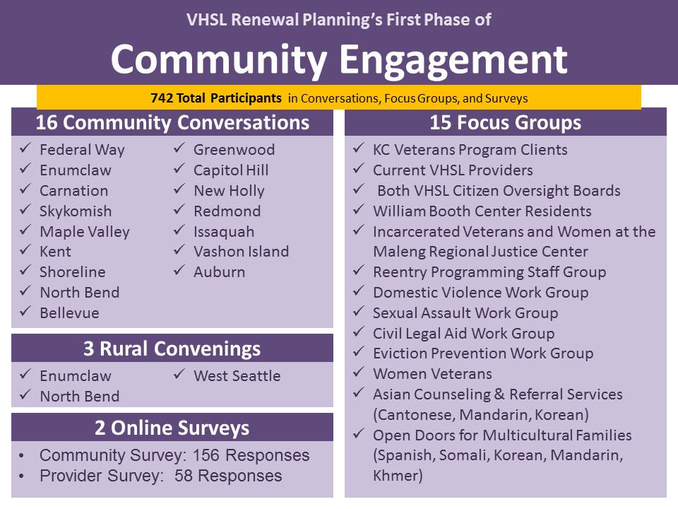
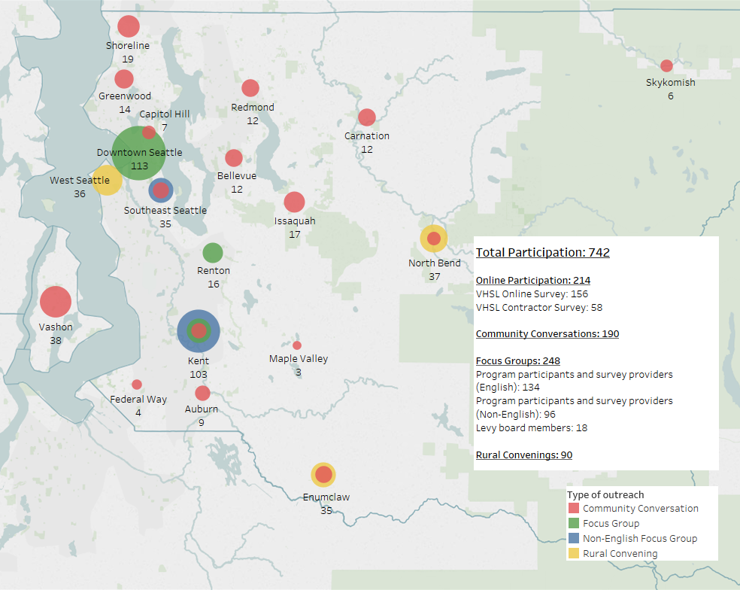
Within the variety of input provided, several common areas and themes emerged:
- Affordable Housing: Participants in in-person engagements and the online community survey identified a lack of affordable housing more frequently than any other human services system gap. Participants identified a variety of specific manifestations of affordable housing issues for different populations and regions within the county. The most prominent concerns were housing affordability and the instability that attends housing loss.

- Service System Awareness: Challenges relating to awareness of what services are available within a community, awareness of who is or is not eligible to receive those services, and awareness of how to connect effectively with services comprised the second most frequently mentioned gap from in-person engagements. Less than 10 percent of online community survey participants felt that members of their communities are very knowledgeable or knowledgeable about what veterans and human services are available to them.

- Service System Access: Transportation, service availability in rural communities and service accessibility for culturally specific communities were clearly identified in in-person engagements as gaps that inhibit access to veterans and human services. Participants also expressed a desire to have advocates or legal advice to help understand their options in potentially serious events like evictions, determining eligibility for programs and avoiding exploitation.

- Older Adults: Challenges to older adults and their caregivers emerged frequently as unmet needs. Older adults expressed particular concern over their ability to remain in their homes as rising costs and medical expenses outpace fixed incomes. Older adults consistently identified the central role of senior centers in their ability remain socially engaged, and many participants expressed concern over a trend towards divestment in services for older adults.

- Veterans: While veterans frequently praised the support that veterans’ services provide, they also consistently expressed frustration over the fragmentation of the veteran’s service system and specifically identified a shortage of trained Veterans Service Officers as a barrier to connecting to federal benefits that could otherwise provide important stability.

- Stigma and Dignity: Across all populations and communities, in-person participants frequently cited the essential role that professionally and compassionately provided veterans and human services play in combating the health-harming effects of social isolation. When asked to describe the characteristics of successful human services, participants consistently mentioned the stigma that accompanies accessing the human services system and the importance of promoting service recipient dignity in reducing stigma.

- Funding Specificity Leaves Gaps: Service providers frequently commented on issues having to do with the balance between funders’ movement towards specifically targeted funding and the funding control or flexibility that providers need to operate their organizations and serve clients as they are. In program administration, providers frequently discussed funders’ increased emphasis on data generation to measure performance without providing commensurate resources to hire staff and operate systems to generate the data itself. In client services, providers mentioned how program eligibility standards often require a client to enter crisis to become eligible for services. Examples of this issue included requirements of actual homelessness before receiving housing services and use of first responders to react to severe health and human service needs for lack of preventive programming.
Key Considerations in Community Engagement Design
In designing the first phase of community engagement for VHSL renewal planning, VHSL staff considered elements of process design and methodology that would set the conditions for a rigorous and useful data set to inform this report and follow-on renewal planning activities. These design considerations included being clear about the purpose of the first phase in the long-term process of community partnership, adopting best practices of other recently-run King County community engagement processes, conducting outreach, and designing a data recording system.
Community Partnership and the Multi-Phase VHSL Renewal Planning Process
VHSL staff identified early in the renewal planning process that community engagement was the most important initial task in preparing for possible renewal of the VHSL. Accordingly, each major phase of renewal planning will have a community engagement component. Although the ultimate form and timing of the renewal planning process will be driven by the decisions and priorities of the Executive and the County Council as they determine whether and in what form to seek renewal of the VHSL, this section briefly describes four phases of planned community engagement based on assumptions about what the renewal planning process could look like.
Phase I (June–December 2016). This now-completed phase is the subject of this analysis. The goals of Phase I were to inform King County residents about the VHSL and its possible renewal, seek community assessment of the current strengths and weaknesses of veterans and human services in their communities, and gather community input about the effectiveness of the current levy’s goals and systems. Community Conversations were optimized for geographic distribution across the county.
Phase II (January–March 2017). The next phase of planned community engagement will provide community members with a summary of renewal planning actions to-date and seek community input on possible results, indicators and strategy areas for inclusion in a potentially renewed VHSL. Further refinement of this phase’s purpose will occur based on ongoing guidance from the Executive and County Council. Phase II will consist of in-person and online engagement activities. Staff will optimize in-person engagement activities for exposure to key stakeholder groups and attendance at preexisting community meetings.
Phase III (April–June 2017). Should the County Council elect to pursue renewal of the VHSL, Phase III is designed to contribute to the development of a proposed Service Improvement Plan. The phase will consist of both in-person and online engagements. The community conversations will be optimized for receiving input from populations most likely to be affected by a renewed VHSL and subject matter experts in fields in which the VHSL is likely to invest.
Phase IV (August–September 2017). This would be the final phase of community engagement during the renewal planning process. The planned objective for this phase is to gain community input in the design of Requests for Proposal (RFPs) for a potentially renewed levy. This phase will focus on reconnection with residents and organizations who participated in previous engagement phases to provide updates on the integration of information learned in the community engagement process and to seek feedback about whether proposed RFP design and criteria reflect the guidance of the Executive, Council and participants of previous engagement phases.

Adopting Best Practices
King County’s recent processes to plan Best Starts for Kids (BSK), the Mental Illness and Drug Dependency (MIDD) sales tax, the July 2016 report of the Immigrant and Refugee Task Force (IRTF), the Limited English Proficiency Proviso Report (LEP), and the King County Equity and Social Justice (ESJ) Strategic Plan have all within the last two years undertaken extensive engagement processes in King County’s geographic, cultural, and experiential communities. VHSL staff benefitted extensively from studying those recently conducted processes and their results.
In addition to adopting best practices from recent community engagement efforts by other King County initiatives, VHSL staff recognized that from the community’s perspective, it was important to demonstrate awareness that some communities had very recently participated in similar processes. VHSL-specific community engagement without reference to King County’s recent and similar processes for BSK, MIDD, IRTF, and ESJ (among others) risked communicating to participants that their input was not going to inform King County planning beyond the specific VHSL purposes. To address this concern, VHSL staff included in all community conversations a summary paper of key conclusions drawn from the community engagement processes for BSK, MIDD, and the development of the King County Equity and Social Justice Strategic Plan. In addition to providing summaries, the document contained links to the final plans that previous community engagement processes informed.
Planning for Outreach
To promote awareness and participation in VHSL community conversations, staff accessed service provider and stakeholder networks, conducted extensive personal outreach to veterans and human services leaders and organizations, and researched pre-existing opportunities for engagement. Members of the VHSL citizen oversight boards contributed significantly by attending events themselves and advertising events through their networks. Human services coalitions, housing advocacy groups, veteran’s service organizations and preexisting networks of other divisions and sections within DCHS also contributed significantly to promoting both in-person engagement events and participation in online surveys. Throughout all stages of outreach, staff shared the online community survey to increase access for those who could not attend in-person events.
Data Recording System
With more than thirty in-person engagement events, it was essential to have a system to record and analyze participant feedback. Staff created a database to classify and sort comments recorded from every conversation and focus group. This system also incorporated the survey responses to provide a more complete picture of overall community comments and concerns.
After each event, staff compiled notes and classified responses based upon the substance of the comment recorded. Recorded comments were classified as one of the following: Strength, Gap, Barrier or Suggestion. Staff then entered each comment into the database so that it could be sorted by frequency of occurrence and location where the comment was made. This structure provided the ability to re-sort and surface comments relevant to specific populations or issues.
Results and Findings
This section highlights results and findings from in-person and online community engagement efforts. Findings are included within this section because they were raised frequently or by brought forward by a participant with perspective or experience that was underrepresented generally within the community engagement process.
In-Person Engagement
VHSL renewal planning staff conducted in-person engagement through three types of in-person engagement: Rural Convenings, Community Conversations, and focus groups. This section briefly summarizes each type of in-person engagement and then discusses in detail their results.
Rural Convenings
These community-based meetings were the first three community engagement events of the VHSL renewal planning process. The purpose of these meetings was to learn from residents and service providers from rural King County. Members of multiple rural communities were invited to each meeting to hear how experiences might differ among communities. Members of both unincorporated and incorporated rural communities were invited.
A total of ninety residents attended the three convenings in June and July 2016. Meetings were held in Enumclaw, North Bend and West Seattle. The West Seattle meeting was located to be accessible both to residents of Vashon Island and other rural communities in the eastern and southern regions of King County.
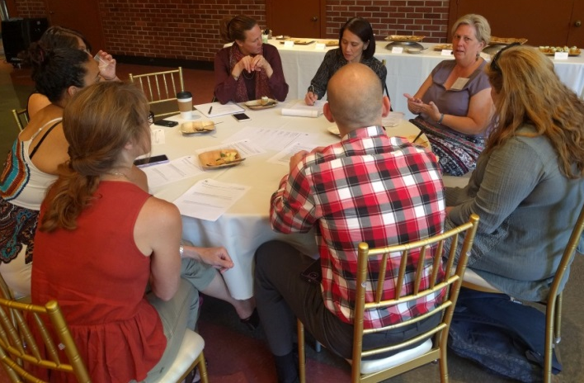 West Seattle Rural Convening (July 2016)
At each convening, participants received a brief introduction and orientation from VHSL renewal staff and then broke into working groups to answer four questions:
- What improvements would you like to see in the delivery of veterans and human services?
- Who (people, perspectives, or experiences) is missing from this conversation?
- How will we know if we’re getting closer to the result we seek?
- What are possible human services delivery improvements in rural communities that involve local partnerships, that involve transportation, that involve technology, that are expensive, that are low-cost or free, or that we haven’t otherwise discussed?

The Rural Convenings provided extensive insight into rural residents’ human services delivery concerns, values and aspirations. The meetings also served as an important proof of concept for the next set of in-person meetings in the VHSL renewal community engagement process, the Community Conversations.
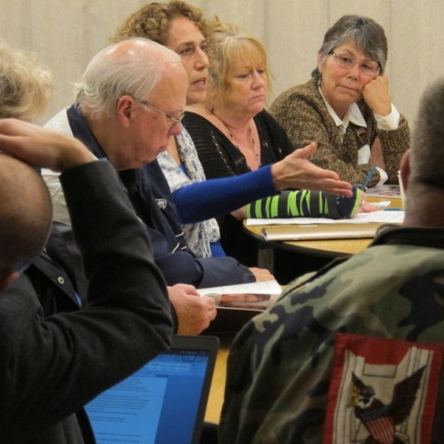
Community Conversations
Staff planned and hosted sixteen community conversations in September, October and November 2016. Community Conversations took place in senior centers, community centers, veteran’s service organizations and libraries across King County.
Based on lessons learned from the Rural Convenings and drawing upon the experiences of similar meetings from the recent MIDD and BSK community engagement processes, Community Conversations invited residents, service providers and persons with lived experience join VHSL staff in small group conversations to learn about the VHSL and then discuss answers and perspectives on four questions:
Auburn Community Conversation (November 2016)
- What veterans and human services are well provided in your community? Why do you believe they are well provided?
- What veterans and human services gaps do you experience within your community?
- What about the VHSL must we change or keep the same?
- Who else is missing from this conversation?

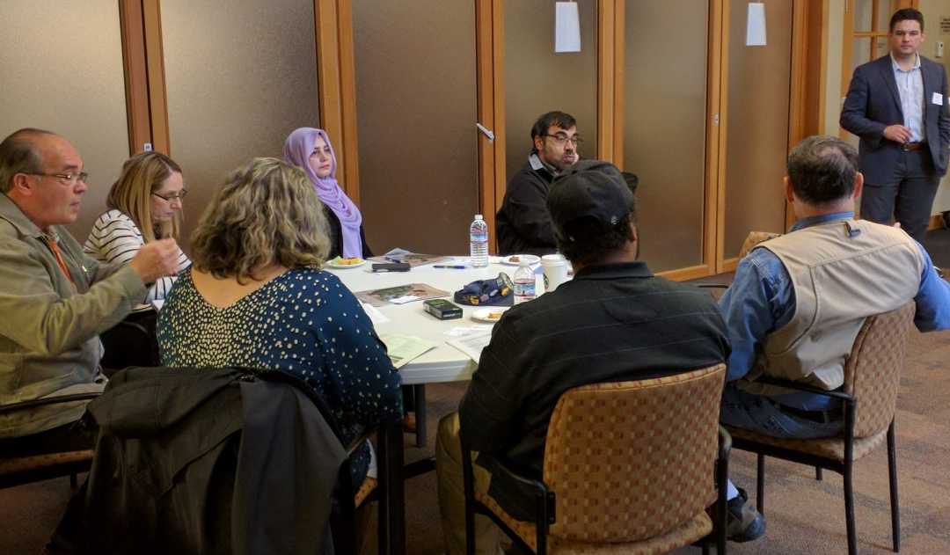
Issaquah Community Center Community Conversation (October 2016)

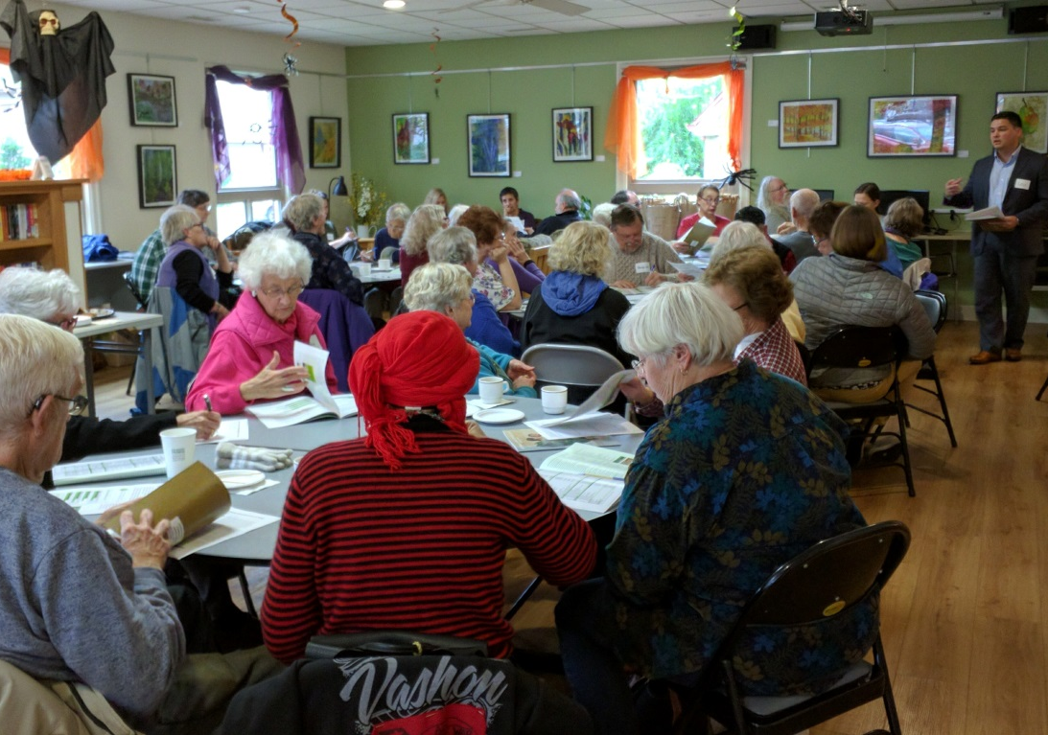
Vashon Senior Center Community Conversation (October 2016)

Focus Groups

To complement input from the convenings and conversations, staff convened 15 focus groups to learn about specific experiences and perspectives. Focus groups included civil legal aid providers, King County Veterans Program clients, VHSL contractors and program managers, women veterans, veterans residing in the William Booth Center, members of both VHSL citizen oversight boards, service providers for survivors of domestic violence and sexual assault, eviction prevention service providers, veterans and women incarcerated in the Maleng Regional Justice Center (MRJC), reentry programming providers at the MRJC, older adults of Club Bamboo (hosted and translated in three languages by Asian Counseling and Referral Services), and immigrant and refugee families with disabled children (hosted and translated in five languages by staff from Open Doors for Multicultural Families).
Multilingual Focus Groups
VHSL renewal staff partnered with King County’s Department of Natural Resources and Parks Community Services Area Program to host two focus groups in languages other than English. These events were facilitated by service providers who were able to recruit clients and staff for participation with a familiar individual.

The first focus group was facilitated by the Open Doors for Multicultural Families organization. This event gathered over 70 individuals, speaking five different languages (Khmer, Spanish, Korean, Somali and Chinese), all with family members that have a developmental disability. The second focus group was facilitated by Asian Counseling and Referral Services (ACRS). This event gathered 25 individuals, speaking three different languages (Vietnamese, Mandarin, Cantonese), from their Club Bamboo older adults program. Each of these groups was able to speak with a member of staff that had regular interaction with them and allowed for frank and nuanced discussion of their issues.

Combined Findings from In-Person Engagement
Each of the in-person engagement events varied widely in their locations, focus and composition. Despite this variety, several key themes emerged. After compiling feedback from over 30 in-person events, staff collated notes from each event to classify and record participants’ comments within a master list. Once comments were combined into a list, VHSL staff could group and sort participants’ comments to identify themes and trends. In addition to key themes mentioned elsewhere within this report, trends included:
- A Need for Affordable Housing/Help Preventing Inappropriate Housing Loss – Affordable housing was the most frequently cited human services system gap noted across all of the in-person gatherings. Whether voiced by older adults at a senior center, incarcerated women in the MRJC, veterans served by the King County Veterans Program, or participants at every one of the community conversations and rural convenings, the shortage of affordable housing and concerns about the ability to remain housed came up repeatedly. Older adults fear that their fixed incomes will not keep up with rapidly rising rents. They are also concerned that a lack of affordable in-home medical care will force them out of their homes and into institutions earlier than necessary. Service recipients in focus groups frequently discussed the central importance of housing to being able to succeed in other services like recovery, treatment and employment programs.

- Transportation as a Human Service – Older adults, rural communities, families of children with disabilities, homeless veterans and many others raised a lack of transportation as a significant gap and barrier to their ability to access services and remain connected and engaged in their communities. Rural residents in particular identified the time commitment required to find transportation to conduct necessary business.

- Access for Populations with Limited English Proficiency - Conversations hosted in other languages focused on access, knowledge, and coordination. Both focus groups spoke to the lack of translators, multilingual staff, and multilingual information for nearly every public agency. As with many other engagements, a lack of system awareness was heavily discussed in these groups. There was no clear vision of what was available and how it could improve their life. Many felt that if the staff at the respective agency was not aware of the service, the service would never reach the individual. Both groups discussed the need for better coordination in public agencies. Whenever participants were accessing services, there were consistent issues of the individual being expected to discover, translate, and engage the agency in an independent manner. These communities are interested in schools, senior centers, and other commonly accessed institutions to be hubs of information that can link the individual to the services most relevant for their household.

The following table depicts key findings in another way, organizing them into four categories: strengths, barriers, gaps and suggestions.

Community Conversation Feedback Themes
Strengths | Food banks & meal programs are accessible and very popular
Strengths | Food banks & meal programs connect clients to human services and resources
Strengths | Human services providers collaborate and communicate well
Strengths | Libraries are community hubs that increase access to services
Strengths | Low-barrier and easily accessed services are tend to be more effective
Strengths | Service providers that are networked with others are more effective
Strengths | Co-locating services is productive and effective for communities
Barriers | Limited transportation can be a significant barrier to accessing any services
Barriers | Fragmentation in the human services system makes it difficult to access services
Barriers | Funding for human services does not meet communities’ needs
Barriers | Current funding climate has shifted resources away from senior services
Barriers | There is a lack of knowledge about the services residents can access
Barriers | Funder and community-required data collection takes significant administrative capacity that is not covered by service-centric funder contracts
Barriers | Residents are not aware of the services available to control problems before they develop into crises
Barriers | There is a social stigma with the use of services which isolates those at-risk
Gaps | Affordable housing options for King County residents
Gaps | Transportation
Gaps | Affordable Dental Services
Gaps | Older Adult services and funding
Suggestions | Flexible funds are crucial to avert a crisis
Suggestions | The levy should focus on ending homelessness
Suggestions | The levy should look to apply a housing first model
Suggestions | Mobile and remote services should be expanded
Suggestions | VHSL goal 3 is not well-defined and may not be achievable for some populations who still deserve support

Results of Online Engagement
In addition to in-person engagement events, staff created and circulated two online surveys to gain additional information and input from community members. An online VHSL Community Survey received over 150 responses. A second survey specifically for VHSL provider program managers and contractors received over 50 responses.
Online Community Survey Responses
For those unable to attend a Community Conversation, a public online survey was created with similar questions containing quantitative and qualitative responses. It was accessible on the VHSL website, shared in all outreach communications, and required less than nine minutes to complete. The survey contained twelve questions and allowed respondents to provide additional details with their answers. Survey questions gauged the respondent’s knowledge of the available services, unmet needs in their community and the preferred methods for engaging with King County. The VHSL Community survey opened on Sept. 1, 2016 and closed on Dec. 1, 2016. Survey results are summarized below:
Current Services System Strengths and Issues
- Strengths: Veterans services (40%) and older adults services (29%) are regarded as being well supported.
  - Issues: Many (87%) respondents reported their community was “somewhat knowledgeable” or less on the services available in their community.
  - “Funding for human services as they exist now is not enough…It is critical that people are able to access the safety net and that services will be available to them when they need it” – Survey Respondent

Unmet Needs
  - Issue: 37 percent of respondents reported no services are provided well in their community.
  - Top Unmet Needs: affordable housing (87%), behavioral health and recovery services (62%) and older adults services (47%)

Preferred Methods of Community Engagement (This questions was included to inform future outreach and engagement efforts.)
  - Respondents most encouraged King County to engage in the following methods:
- Social media and blogs (58%)
- Attending a local pre-existing meeting (61%)
- Host an Open Community Meeting (63%)
Comments on what a fully functioning veterans and human services network would look like
  - Coordinated services, given that crises and needs are rarely restricted to one issue or one service need
  - Reduces homelessness
  - Affordable housing opportunities, including housing options for older adults and other fixed-income residents
  - Reduced stigma for behavioral health
  - “People would have access to services and know how to utilize them for what problems. They would not feel alone.” – Survey Respondent
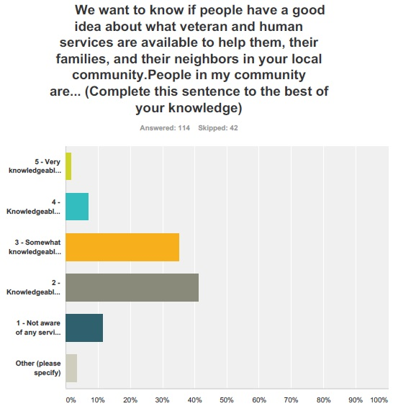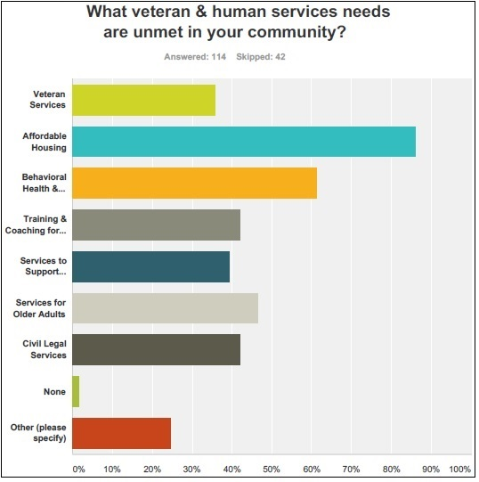
Results of the Online Provider Survey
The purpose of the Provider Survey was to identify the strengths, weaknesses, challenges and lessons learned in administration of the current VHSL. The online survey questions collected impressions and opinions on contract development and management, governance and oversight strategies, evaluation, performance measurement and reporting, and unintended consequences.

Because the provider survey focused almost exclusively on evaluating the current VHSL, survey results are discussed in greater detail within the section on evaluation of the current VHSL levy. Key findings and themes of the online Provider Survey include:

- Cost of Living: Providers expressed consistent desire for a cost of living adjustment in contracts for a renewed VHSL to assist in retaining skilled and effective staff in a high-turnover industry.

- Communication: Improved and increased communication between providers, VHSL staff and community members would help to share lessons learned across providers, keep providers informed of the levy work and its impact, and enable continuous improvement for providers.

- Systems Integration: Agencies that receive funding from multiple County sources would benefit from integrated contracting, contract management, performance measures and data reporting.

- Evaluation Framework: The current VHSL evaluation framework may benefit from an update that incorporates Results Based Accountability principles.

- Web-based Data Reporting: Current VHSL’s Excel-based information gathering system should be updated to a web-based system, similar to HMIS in order to achieve greater ease of data entry and to increase the ability beyond spreadsheet-based report to report complex or detailed performance data.

Analysis of potential strategy areas

The Veterans and Human Services Levy (VHSL) Guidance Motion directed analysis, in consultation with stakeholders, of eight potential new or enhanced strategy areas for investment in a renewed VHSL. The previous section described the community engagement process that the VHSL Renewal Team employed to gain the perspectives of a broad range of stakeholders, service providers, family members, clients and area residents about the veterans and human services systems gaps. This section summarizes several cross-cutting themes that emerged to across potential strategy areas and then provides detailed analysis for each potential new strategy area, as directed by Council Motion 14743.

Unifying Themes and Community Needs

Across the variety of populations and issues analyzed within this report several key, cross-cutting themes emerge:

Gaining and Maintaining Affordable Housing: Although treated with its own analysis within this report, affordable housing clearly emerged as a pressing community need unto itself, but also as a common theme from research and community engagement for every issue or population that this report analyzes. A person’s housing and the stability that comes with having a place to live provide an essential foundation for other types of services or investments to be effective.

System Awareness and Access: Just as with housing, system awareness and access are essential parts of any larger effort to serve people’s complex human service needs. King County residents across the county’s full geographic, cultural and experiential diversity expressed a desire to more easily know about all the services and programs that are available and to more easily access them. Residents identified insufficient transportation, unavailability of materials in languages other than English, difficult to use translation services, a lack of centralized information, program hours that match business days instead of people’s needs, complicated eligibility requirements, and rigid income thresholds as access barriers that impede people from receiving services and constrain the full effectiveness of public investments in health and human services.

Isolation: The feeling of being apart from families, communities and the prosperity of the larger county was also among the most common themes in community engagement and research. As is documented well within the section on older adults, the research process also revealed that isolation has profound community and health-harming effects. Older adults, veterans, residents returning from incarceration, survivors of human trafficking and domestic violence, and immigrants and refugees all report frequent feelings that their experiences or immutable characteristics separate them from their communities instead being sources of connection.

Veterans, Military Service members and Families

The VHSL Guidance Motion directs analysis to inform the Council’s decision about whether a renewed levy should retain some or all of the existing levy’s four strategies, which include a strategy to “support veterans and their families to build stable lives and strong relationships.” This section analyzes issues relevant to veterans and their families in six parts:

- Introduction
- Characteristics of King County’s Veterans
- Challenges and Trends for Veterans In King County
- Building Upon the Regional Veterans Initiative
- Amplifying the King County Veterans Program
- Opportunities to Improve Services and Systems for Veterans and their Families.

Introduction
Military service equips veterans to contribute powerfully to their communities. The leadership training and experience, ethos of shared sacrifice and common purpose, and exposure to people and cultures from across the country and across the globe imbue veterans with a blend of knowledge and perspectives that makes them community assets in King County and across the country.
For some veterans, however, the same experiences that equip them with the potential to contribute so much to their communities also erect barriers to unlocking that potential. While veterans are more civically engaged than non-veterans, veterans are also disproportionately represented among the homeless and exhibit elevated rates of suicide and post-traumatic stress.
The number of veterans is King County has fallen over the last ten years, but the number of veterans in poverty and the severity of their poverty increased over that same period. The number of veterans can also change significantly based on world events and federal policies.
Older veterans in King County present many of the same issues as the County’s overall population of older adults, and these can combine in complex ways with veteran-specific issues. Younger veterans are more economically and racially diverse than their older counterparts and present new opportunities and challenges.
Veterans of all ages are increasingly isolated within society as rates of military service decline. For veterans who experienced trauma in service, rejoining a society with little idea of those experiences can be traumatic. Social isolation poses risks to communities, which fail to fully benefit from the diversity within them and to individuals, for whom social isolation harms health and shortens lifespan.
The VHSL has recognized since its inception that investing in veterans not only serves veterans and their families, but King County as a whole, which has so much to gain by fully engaging veterans in their communities. This section analyzes King County veterans’ characteristics and issues.
Characteristics of King County’s Veterans
King County is home to an estimated 112,556 veterans. Of the 2014 American Community Survey (ACS)-estimated population of 112,556 veterans in King County, 100,834 are male and 11,722 are female. Veterans are 6.9 percent of the total County adult population. This represents a 14.6 percent decline from the 2009 estimate of 131,874. Looking forward, projecting the future number of veterans is a less stable calculation that projecting the size of other subpopulations. Federal policies and decisions about overall military size and whether to engage in armed conflict can rapidly alter the size of the population.
Service Eras of King County Veterans
The decades-long trend of reducing the size of the military and the end of the draft and conversion to an all-volunteer military in the 1970’s has substantially affected King County’s veteran population trends. Between 2009 and 2014, the number of younger veterans ages 18 to 54 dropped by an estimated 7,794 persons (-20 %). This is reflected in the distribution of veterans across eras of military service. As veterans of World War II and the Korean conflict pass away, Vietnam era veterans are now the largest group within the county’s veteran population. Veterans from subsequent eras are smaller in numbers, reflecting the trend toward a smaller military and longer average military service that came as more service members chose the military as a career rather than being drafted.
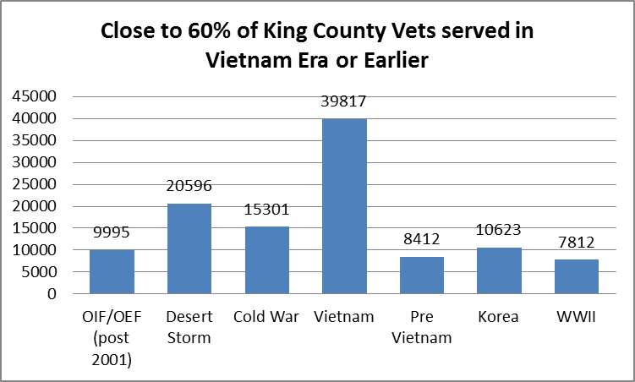

Age and Gender of King County Veterans Populations
There are more than 74,000 veterans over the age of 55, of which 21,620 are between 55 and 64 and not quite retirement age. Not surprisingly given the war era and draft, close to three out of five of the 112,000 King County veterans are over 55 years of age (60%). This represents a groundswell in need for aging health and human services as these veterans get older.
Health and human services providers are discovering that as these veterans age, a significant number are presenting service-related health and mental health problems that went previously undiagnosed, such as multiple sclerosis and cancers related to exposure to Agent Orange or chemical exposures during Desert Storm.
Over 9,200 King County veterans are 34 years of age and younger. Although small in numbers and proportion to the overall population, there are high rates of disability and mental health problems (30–40%) related to multiple deployments, increased rates of survival after injury, economically and socially-disrupting call-ups from civilian life for Reserve and National Guard members, and greater numbers and frequencies of deployment for all.
King County women veterans reflect the increasing role women have in the all-volunteer military. They are proportionally younger than their male counterparts. The role of women in the military has significantly grown and become more visible since the advent of the all-volunteer military. Importantly, however, women have always played important parts in military service. In King County there are over 1,600 women veterans who served in World War II and the Korean Conflict eras. Over half (52.7%) of all women veterans are under 54, with close to 2,065 actually under 34. Women represent 22.3 percent of veterans under 34.
Race/Ethnicity of King County Veterans Population
The proportion of King County veterans who are persons of color is approximately 20 percent.

Younger veteran populations are becoming more diverse. The proportion of veterans who are persons of color has increased among younger veterans, representing a gradual shift to a more diverse military. Veterans of Vietnam era and earlier are predominately white, with persons of color accounting for only 11 percent of the population. Approximately one in four veterans below 55 years of age is a person of color.
Younger male veterans in King County are more isolated from their peers as rates of military service have fallen. Among older men in King County (over 65), almost everyone is either a veteran or very likely to know a veteran: one in three men in King County between the age of 65 and 74 is a veteran (36.4%) or likely to know a veteran. Only eight percent of men in King County between the ages of 35 to 54 are veterans. One in 33 men below age 35 is a veteran (2.7%), representing what is likely the lowest rate of veteran status since the country’s founding.
Household Status of Active Military and Veterans: A majority of veterans and active duty military in King County are married, and their families feel the effects of their service. The VHSL has recognized this reality and increased attention to, and support for, the families and dependents of soldiers and veterans. Families of active military and veterans carry the daily burden of support and are impacted by the condition of the veterans who have returned from war. Family impacts include coping with and meeting the needs of aging disabled veterans, economic disruption during multiple deployments, and needing to provide long-term support for traumatized veterans. As veterans of contemporary conflicts experience increasing isolation in their communities, so too do their families.

Geographic Distribution
About two out of three veterans live outside the City of Seattle. According to the 2010-2014 ACS survey, 30.8 percent of all veterans live in South King County, 30.8 percent live in the City of Seattle, 29.7 percent live in East King County, and 8.7 percent live in North King County.
Veterans who are disabled or low-income live primarily in South King County, followed by Seattle. Data provided by the Veterans Benefits Administration shows the zip codes of recipients of VA Disability Compensation. Disability Compensation is awarded for service connected disabilities. The majority of veterans receiving compensation live in South King County with especially high concentrations in Kent, Auburn and Federal Way.
In 2015, the Veterans Health Administration’s Puget Sound Health Care Service System had over 28,544 enrollees with King County addresses, an increase of over 4,000 from 2012. These enrollees are predominately low-income, partially or fully disabled, and/or without other private health insurance options. Close to five out of ten VA enrollees are from South King County, and close to three out of ten are from Seattle. By region, the South had a 19.8 percent increase in VA enrollees living there.

Location of Veterans in King County
REGION | Veterans Receiving VA Disability Compensation |  | 2015 Enrollees VA Health System |  | Total Veterans King County
East Total | 2614 | 19.8% | 4,827 | 16.9% | 25,900 | 29.7%
North Total | 928 | 7.0% | 1,930 | 6.8% | 9,731 | 8.7%
Seattle Total | 3,346 | 25.3% | 8,315 | 29.1% | 32,748 | 30.8%
South Total | 6,322 | 47.9% | 13,471 | 47.2% | 50,330 | 30.8%
Grand Total | 13,210 |  | 28,411 |  | 118,710
Source: Veterans Administration Benefits Distributions (FY 2015) |  |  | Source: Veterans Administration Puget Sound Health Care System (FY 2015) |  | Source: 2010-2014 ACS Estimate

Income Status
Over 18,000 King County veterans are low-income (below 200% of poverty). The number of veterans below poverty grew from 5,867 to 8,299 – a 43 percent increase in five years. Between 2010 and 2015 the number of low-income veterans grew by six percent (while overall veterans declined by 12.4 percent). Most startling is that, within this number, the number of veterans actually living below poverty level itself (8,299) grew by 43 percent since 2010.
In 2015, 13,210 King County veterans were receiving VA Disability Compensation according to VA records. This was a decrease of 750 from 2011. Approximately 11.7 percent of the King County veterans population receives Disability Compensation. Compensation amounts are determined by the VA. Monthly checks range from a low of $127 per month for 10 percent disability and living alone, to a high of $3,285 for a 100 percent disabled veteran with a spouse and dependents.
The average compensation payment in 2015 for County veterans was $1,184. Close to half of all veterans receiving compensation are over the age of 60 (47%). Over 2,900 recipients are under the age of 40. In 2015, 1,272 King County veterans were receiving a VA Disability Pension, which differs from VA Disability Compensation in that it is “means tested” and available to wartime veterans who have limited or no income, age 65 or older, or under 65 and permanently and totally disabled.

Employment
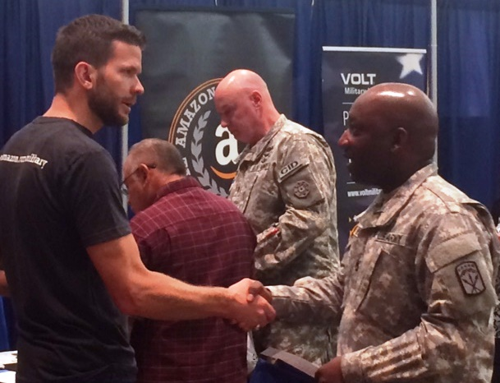
As with the overall job market, employment status has improved for veterans in the last five years. The prior veteran status report identified 5,865 unemployed veterans in King County from the 2010 ACS. The local unemployment rate was 8.4 percent for veterans in the job market; less than 9.2 percent rate for non-veteran population.
Amazon recruiters welcome jobseekers at VHSL-sponsored Veterans Career Expo at WA State Convention Center (July 2016)

The 2015 ACS estimated 1,776 unemployed veterans and 54,506 employed for a 3.2 percent unemployment rate. This was less than the 2015 non-veteran unemployment rate of 4.6 percent. Veterans of color had a higher unemployment rate of 6.1 percent compared to 2.8 percent for veterans who are white.
Challenges and Trends Facing Veterans in King County
Community Social Service Needs
There has been a significant increase in veterans seeking community assistance from 2011 to 2015. Statistics from the Community Information Line show a dramatic increase in requests by veterans for assistance referrals from 2011 to 2015. In 2011, 1,580 persons (duplicated) identifying themselves as veterans requested referral for financial assistance or housing. In 2015, this number grew to 3,489 calls (an increase of 121%). The largest numbers of callers were from South King County, followed by Seattle and the East Region. There were close to 1,000 calls to 211 for referral to civil legal assistance, running the gamut from consumer issues, family issues (often divorce) to housing issues. One-third of the calls were for housing-related issues, including eviction or landlord disputes. See also Civil Legal Services.
Service Related Trauma and Disabilities
The significant traumatic effects of military service affect many veterans and their families from all war eras. Between 19,500 to 28,000 King County veterans are experiencing debilitating mental health effects of combat or sexual trauma, including Post Traumatic Stress Disorder (PTSD), Traumatic Brain Injury (TBI) or Military Sexual Trauma (MST). As many as one in three women veterans experienced MST during their service. One study found that approximately 42 percent of women who had experienced a MST also had PTSD as a result of the MST.
American Indians/Hispanics/Blacks/Asians/Pacific Islander veterans have significantly higher rates of PTSD/mental health issues than white veterans, ranging from 37 to 57 percent compared to 24 percent for white veterans.
The VA Health System is struggling to meet the significant behavioral health needs of these affected veterans. Based on national trends, there may be as many as 12,000 King County veterans with PTSD or MST reluctant to seek treatment or support.
Estimated Occurrence of PTSD for King County Veterans
Veteran Group | Estimated King County Population | Estimated PTSD/MH issues | Rates Military Sexual Trauma | Potentially Affected in King County | Potentially reluctant to engage in treatment
Vietnam | 39,800 | 30% |  | 11,940 | 7,100+
Gulf War | 20,600 | 9-24% |  | 1,500- 4,000 | 960- 2,400
OEF/OIF | 9,995 | 20-30% |  | 1,500 – 4,000 | 900 – 2,400
Women of all races | 11,722 | 20% | 22-40% | 2,500 4,600 | 1,500 – 2,700
Men of all races | 110,834 |  | 2-3% | 2,200 3,300 | 1,300-1900

Iraq War and Afghanistan – The conflicts in Iraq and Afghanistan are ongoing. In April 2008, the RAND Corporation released the first comprehensive analysis of all branches of the military and experiences in the Iraq/Afghanistan wars. Nearly 20 percent of service members returned from Iraq and Afghanistan — 300,000 in all — report symptoms of PTSD or major depression, yet only slightly more than half of these have sought treatment. A July 2012 study published in the American Journal of Public Health found 37 percent of OIF/OEF veterans who sought treatment at U.S. health facilities from 2002 to 2008 were diagnosed with PTSD, depression, substance abuse or other mental concerns.
The Iraq War has been noticeably different from prior wars as soldiers are recalled for three and four deployments to war zones. The impact of multiple deployments is only now beginning to be understood, with anticipation of significant increases in PTSD rates. According to the 2014 ACS, King County has close to 10,000 veterans who served since 2001.
Service avoidance as a result of PTSD impacts ALL areas of life. Individuals with PTSD not only resist mental health treatment that could benefit them, they are also likely to be unengaged with other services as well, including medical care, rehabilitation, treatment for drug or alcohol abuse, financial benefits, employment support, housing assistance and family support. Untreated PTSD also contributes to high rates of chemical dependency, other behavioral and mental issues, divorce, domestic violence, criminal justice system involvement, homelessness and economic instability.

Suicides
Roughly 20 veterans a day commit suicide nationwide, according to data from the U.S. Department of Veterans Affairs. In recent years, the VA has hired 5,300 mental health providers and support personnel and upgraded its Veterans Crisis Line in response to the problem.
Findings on suicide counts and rates are based on analyses conducted at the VHA Office of Suicide Prevention, VISN 19 Mental Illness Research, Education and Clinical Care Center, and Post-Deployment Health Service. This report includes the years 2001–2014. Key findings from this report include:
- In 2014, an average of 20 veterans died by suicide each day. Six of the 20 were users of VHA services.
- In 2014, veterans accounted for 18 percent of all deaths by suicide among U.S. adults and constituted 8.5 percent of the U.S. adult population (ages 18+).
- In 2014, about 65 percent of all veterans who died by suicide were age 50 or older.
- After adjusting for differences in age and gender, risk for suicide was 21 percent higher among veterans when compared with U.S. civilian adults. (2014)
- After adjusting for differences in age, risk for suicide was 18 percent higher among male veterans when compared with U.S. civilian adult males. (2014)
- After adjusting for differences in age, risk for suicide was 2.4 times higher among female veterans when compared with U.S. civilian adult females. (2014)
- In 2014, rates of suicide were highest among younger veterans (ages 18–29) and lowest among older veterans (ages 60+).
Homelessness
Homeless veterans are disproportionally persons of color and homeless women veterans are significantly younger than their male counterparts. Local data from the Homeless Management Information System (HMIS), which now includes information about homeless veterans identified by the U.S. Department of Veterans Affairs, suggest that about 10 percent of homeless single adults are veterans.
In 2015, 3,722 veteran households were served by homeless housing and service providers in King County (excluding permanent supportive housing and other permanent housing programs). Of the 3,722 veteran households, 3,249 (87%) were single adults and 190 (5%) were families with children. There were 3,258 male veterans (88%) and 435 female veterans. Male veterans experiencing homelessness were older than female veterans; the average age for men was 51 years old compared to 45 years for women.
Persons of color were disproportionately represented; 51 percent of the veterans identified as white and 41 percent identified as a racial minority. Black or African-American veterans represented the largest minority group at 30 percent. Six percent of veterans identified as Hispanic/Latino.
Slightly more than half of the veterans (54%) self-identified as having a disability - 55 percent of men and 48 percent of women. Mental health conditions, physical disabilities and chronic health conditions were the most commonly reported.
Among the 209 women who reported a disability, almost 80 percent reported a mental health condition and 58 percent reported a chronic health condition. Among the 2,027 male veterans who reported a disability, 62 percent reported a mental health condition and 58 percent reported a physical disability. Men were more likely to report substance abuse than women.
Most veterans experiencing homelessness served in the Army (50%) or Navy (27%). The majority were honorably discharged (81%) or general under honorable conditions (12%). The most commonly reported Theaters of Operations were the Vietnam War (331 veterans) and Desert Storm (263 veterans). Of the 1,027 veterans with recorded service histories, 112 served in more than one Theater of Operations.
Newly Homeless Veterans
In 2016, our community, in partnership with the U.S. Department of Veterans Affairs, newly identified 749 homeless veterans between January and October, an average of 75 newly homeless veterans per month. The rate of identification was greatest in late summer and early fall. The demographics of the veterans who completed assessments in 2016 are similar to those who were enrolled in programs in 2015 in terms of age, gender and race.
Seventy-five of the 749 veterans (10%) were documented as chronically homeless within the HMIS data system. Chronically homeless veterans are more likely to be male (96%) and are slightly older (55 years old on average) than non-chronically homeless veterans. Chronically homeless veterans are also slightly more likely to be white and non-Hispanic/non-Latino compared to non-chronically homeless veterans.
Sixty-five of the 749 veterans (9%) were in families. Veterans in families tend to be younger than single adult veterans experiencing homelessness, 39 years vs. 55 years on average, respectively. Veteran families experiencing homelessness are more likely to identify as a racial minority (49%) compared to all homeless veterans. Veteran families are also more likely to have a female head of household (18%) and have higher vulnerability scores than single adult veterans.
King County Service System Challenges
There are currently over 180 programs serving veterans in King County. The 62 programs provided by the Federal Government are a combination of services provided by VA Health Services–Puget Sound (health, behavioral health and programs for homeless veterans), and the variety of benefits provided by the Veterans Benefits Administration (GI Bill education benefits, veterans disability compensation and pension).
The challenge to access VA health services and VA financial benefits through VA administration has become legendary. All of the programs have different and complex level eligibilities. Eligibility for most every program requires a review of such considerations as service era (Vietnam, Cold War, Gulf War pre or post 9/11, etc.); character of discharge (Honorable, Other Than Honorable, Dishonorable); level of disability and whether it is service connected or not; and in some cases, income eligibility.
The VA Puget Sound has participated in the nation-wide overhaul of VA health care and benefits processing. The VA has hired new staff in the last two years, in a push to increase access to mental health services. In August 2015, VA Puget Sound reported that the average wait time for a primary care appointment rose from just under 8 days to 11 days. Through improved access, they report that veterans can see a mental health provider with a little more than a one-day wait (national average is five days). The Seattle regional office of the Veterans Benefits Administration reports improved processing has led to a 90 percent decrease in the backlog of claims pending for more than 120 days.
In spite of improvements to VA access, significant numbers of King County veterans are still challenged to navigate this system of services and benefits. In addition to eligibility complexity, the benefits assessment processes are often cumbersome. Additional challenges include:
- Documentation process challenges
- Ineligibility due to discharge status or benefit restrictions
- Lack of VA system capacity, especially in behavioral health specialty care
- Over-reluctance to participate in the VA system
- Geographic and transportation challenges
- Lack of understanding or system and advocacy.

Building Upon the Regional Veterans Initiative
Recognizing the opportunity to identify regional solutions for veterans issues, King County Executive Dow Constantine launched the Regional Veterans Initiative (RVI) in February 2013. The RVI included an extensive community engagement process to hear directly from veterans what challenges they face in King County. The RVI members gathered information and published a report and recommendations for actions to transform the veterans service system.

A renewed VHSL will provide additional opportunities to continue to transform the regional veterans service system. The system fragmentation data mentioned within this section was drawn from the RVI’s innovative system mapping efforts. The RVI’s final report enumerated five values and three goals to guide future efforts to improve services for veterans and to improve communities’ ability to benefit from the contributions of their veterans.

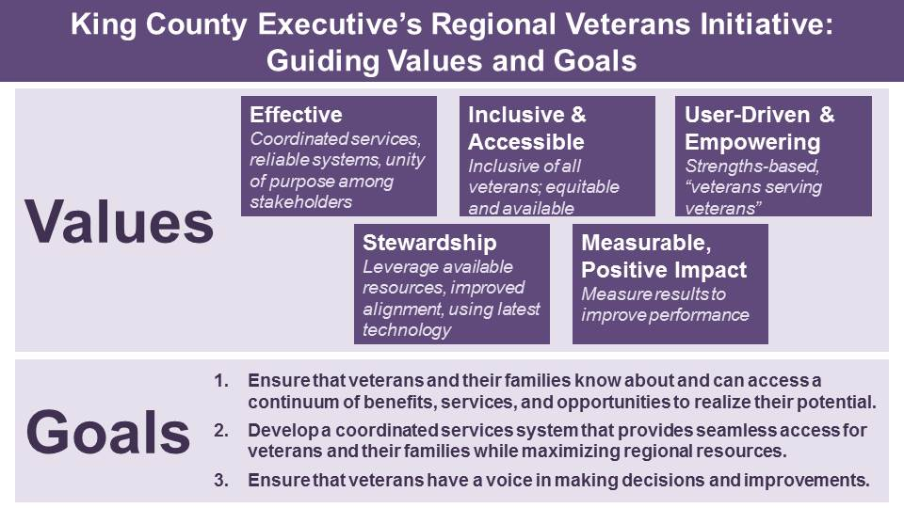

How VHSL Investments Amplify the King County Veterans Program
Since the 1950s, King County has funded and provided services to indigent, disabled, and/or homeless veterans with funds provided by RCW 73.08.010 – a dedicated property tax. Those services have been provided through the King County Veterans Program (KCVP). In November 2005, the King County Council, led by the Regional Policy Committee, sent to the voters a ballot measure to generate funding to support veterans, military personnel, their families and other individuals and families in need. The King County Veterans and Human Services Levy (VHSL) was approved by the voters, providing up to $6 million annually specifically for veterans services. The levy was renewed in 2011 for the years 2012–2017 with nearly 69 percent of the vote.

The VHSL makes it possible to significantly enhance the services previously available through the KCVP.
The infusion of funding provided by the VHS Levy made a difference in the scope of services KCVP could offer. It was able to hire social workers to provide individualized case management services to every veteran and veteran family, increase access to a range of services, and expand geographic access. Funds from the levy were dedicated to new programs, including efforts focused on helping veterans prepare for new careers at home following their discharge from service, helping them to turn the skills and experience they learned in the military into gainful employment in the community.

Summary of Service and System Opportunities for Veterans and Their Families
The following observations summarize from this section key needs and opportunities to improve services and systems for veterans, military service members, and their families in a renewed VHSL.
- System fragmentation within King County’s own programs for veterans is partially a result of incomplete integration between the King County Veterans Program and veterans services funded by the VHSL—full integration of the programs into one system offers an opportunity to continue pursuit of the goals of the Regional Veterans Initiative.

- Social isolation is a growing challenge for veterans—particularly young veterans—in a society where the share of the general population that serves in the military is shrinking over time.

- While King County’s efforts to house veterans have helped thousands of veterans find homes, veterans remain a significant portion of the homeless population, and their unique experiences as well as the specialized resources available to them require tailored approaches within the overall effort to make homelessness rare, brief and one-time.

- The subpopulation of veterans who are low-income is growing, as is the severity of their poverty.
- Women veterans are a growing part of the veteran population, and the veterans service system must continue to adjust so that all veterans—women and men—feel welcomed where veterans services are provided.
- Improved information sharing between federal, state and local agencies serving homeless veterans has enabled significant progress is housing veterans and understanding homeless veterans’ needs; similar improvement in the areas of veterans benefits, employment, and social engagement are possible if federal, state and local agencies can replicate information sharing arrangements in other contexts.
- PTSD, TBI, and depression remain significant issues for veterans, and an opportunity exists for VHSL-funded programs to standardize screening practices to help identify veterans who present symptoms and offer appropriate interventions that are coordinated with other services. The occurrence of PTSD, TBI, and mental health issues has historically been consistently underestimated and undiagnosed in the veteran health systems and in the community. This is true of all veterans across the board. Research is beginning to demonstrate the interconnectedness of war-related trauma and challenges related to long-term behavioral and economic stability. The impacts of PTSD and TBI on behavior in the community are seen in the numbers of chronically homeless veterans, and veterans with chemical dependency and mental illness served throughout a variety of service systems.
KCVP has already revised its assessment tool to better screen for PTSD and TBI. Where possible, other programs that are funded to meet the needs of veterans should implement consistent screening tools for these issues. This will increase understanding of the prevalence of PTSD/TBI and ensure appropriate service responses.
- Younger veterans value camaraderie with their older counterparts, but younger veterans’ increased diversity and decreased representativeness within the general population call for new approaches that promote social engagement.
- Veterans families remain an underserved population. The economic, social and mental health needs of veterans’ families and dependents are becoming more complex as they carry the support burden for both aging veterans and those just returning. Children are impacted in unique ways. If currently available veterans service systems are overwhelmed and/or unprepared, family members bear the brunt of unresolved needs.
The high deployment rates of the Reserves and National Guard since the Gulf War is disrupting King County families’ economic lives and social structures as never before. While in pre-deployment there is uncertainty. During deployment there is risk of isolation and increased family burdens. Upon return there is post deployment re-adjustment.
There are new VHSL-funded projects designed to improve connectedness to services for families. There may be a need to continue outreach and improving access to services for family members. New initiatives and enhanced services will be evaluated to see if the increased efforts are effective at engaging these populations.
- Suicide remains a devastating issue in the veterans population with an average of 20 veterans dying by suicide every day nationwide.

Older Adults

The VHSL Guidance Motion directs analysis to inform the Council’s decision about whether a renewed levy should include “a strategy or strategies to serve older adults.” An older adult workgroup convened to gather extensive information on the demographics, key issues, needs and service priorities specific to older adults. This section captures key themes of the workgroup’s research and study of older adults issues in King County.

Introduction
Nationally and locally, the number of older adults is dramatically increasing. By 2040, adults over 60 years of age are expected to comprise over 25 percent of the population in the United States. King County is experiencing a similarly dramatic rise in its older adult population. More than 232,000 residents in King County are 65+, and 334 of them are over age 100.

While the number of older adults has been increasing, funding for older adult services has been decreasing. Both locally and nationally, funding for older adult services has been steadily declining, even as the population grows.
Many older adults age their way into poverty. In 2013, half of all people on Medicare had incomes less than $23,500, which is equivalent to 200 percent of the poverty level in 2015.
The relationship between the lack of opportunities and poor health is increasingly clear. The areas of King County with lowest educational attainment and highest levels of poverty are also the areas with the most inadequate housing and greatest concentrations of obesity, diabetes and other health-harming conditions. Life expectancy varies across the County. In areas of East King County, adults can expect to live 10 years longer on average than their peers in areas of South King County.
Healthy living, financial security and social engagement are key contributors to a longer life. Compelling evidence indicates that living long and living well is most realistic for those who are socially engaged, who adopt healthy living behaviors and who are able to build financial security.
One of the biggest challenges is the lack of affordable housing for people who are low-income and people with disabilities, two groups that include older adults. Many older adults and people nearing retirement age fear they will not be able to afford a decent living situation.

A variety of supportive services can help an older adult age in their home, which is far less disruptive and far less expensive that a move to assisted living or a nursing home. Providing community-based services to help older adults age in place is a cheaper alternative.

The challenge is to keep older adults in their communities—as healthy, financially stable and socially engaged as possible. All of these factors are addressed in this section, along with possible investment areas for older adults in a renewed VHSL.

Older Adults Defined
“Older adults” is a relative term. It is often based on the age at which individuals are eligible for benefits or services available through a specific entity, such as Social Security at age 65, 66 or 67 depending on when a person was born. Other services such as some offered by the Seattle Mayor’s Office on Senior Citizens are available for those as young as 50.
The DCHS Older Adults Program currently defines older adults for the purpose of their program as those 55 and older. Should a renewed VHSL include an older adults strategy, defining an inclusive definition of “older adult” may maximize the levy’s ability to provide targeted services to populations whose circumstances cause variation in the onset of typical effects of old age. A broader definition would expand eligibility to persons otherwise ineligible for older adult services under a traditional definition. This includes populations that tend to age more quickly than the general populations, such as homeless older adults and those subject to race and place-based disparities that can cause earlier onset of age-based challenges. Persons with a developmental disability or other cognitive or intellectual disability also tend to age more rapidly than others.
Trends and Demographics
According to the 2010 Census, the proportion of people age 65 and older is higher than it has ever been: 40.3 million people or 13 percent of the total population. By 2040 projections estimate that people over age 65 will comprise over 21 percent of the population. This trend of increasing numbers of older adults will continue, and by 2050 the population ages 65 and over is projected to be 83.7 million – over double the number documented in 2012. The number of people in the oldest category of older adults, those 85 and older, is projected to grow from 5.9 million in 2012 to 8.9 million in 2030, rising to 18 million by 2050. Eventually, almost 11 percent of the population will be age 75 and older.
King County Older Adult Population by Age in 2010
Age | 60-64 | 65-69 | 70-74 | 75-79 | 80-84 | 85-89 | 90-94 | 95-94 | 100+
Population | 101,945 | 67,317 | 45,430 | 35,200 | 28,948 | 21,414 | 9,551 | 2,485 | 334

The rise in the older adult population is also being seen in King County. The population of King County’s adults 65 and over grew by over 57,000 between 2009 and 2014. Most notable is that in those five years, almost 50,000 residents were added to the 65-74 year old category, a 51 percent increase. In a few years these individuals will add to those 75 and older. As the population continues to age, King County may experience a tremendous drain on health, housing and social services as it attempts to respond to the growing needs of the aging population unless it begins planning for this dramatic increase.
King County Population by Age and Percent Change 2009-2014
Age | 2009 | 2014 | Increase | Percent Increase
0-17 | 408,366 | 439,568 | 27,602 | 6.8
18-34 | 472,195 | 532,417 | 60,222 | 12.8
34-54 | 585,093 | 600,388 | 15,295 | 2.6
55-64 | 202,272 | 255,002 | 52,730 | 26.1
65-74 | 97,748 | 147,615 | 49,867 | 51
75+ | 98,206 | 105,716 | 7,510 | 7.6
Total | 1,863,880 | 2,080,706 | 213,226 | 11.4

The rapid growth of the older population is a result of dramatic increases in longevity over the past 100 years. Nationwide, people born in 2000 can expect to live 30 years longer than their ancestors born in 1900.

Diversity
According to the 2010 U.S. Census, almost 680,000 people of color live in King County, making up 35.2 percent of the population. This is an increase from the 2000 census, when people of color represented 26.6 percent of the King County population. More than half of the recent growth is due to immigration. The majority of immigrants live in South King County.
Racial and ethnic diversity of the older adult population in King County mirrors that of the population at large. Data compiled by the City of Seattle’s Aging and Disability Services (ADS) illustrates that the 60+ population in King County is becoming increasingly diverse. Approximately 23 percent of King County residents age 60 and older are people of color, a four percent increase from 2011. Older people of color in King County include more than 76,000 foreign born elders. Major languages spoken among this population include Spanish, Chinese, Tagalog, Vietnamese, Korean and Japanese. In all, King County residents speak more than 170 different languages. Serving the needs of this diverse population requires an understanding of cultural differences and language barriers.
Funding Trends
The National Association of States United for Aging and Disabilities has documented the population of older adults and services dollars available to assist them. As the following table indicates, while the population of older adults has been steadily rising, and is projected to continue, the service dollars available to older adults have steadily declined.
Comparison of Population of Older Adults (OA) to Service Dollars
(Projections are based on historic inflation rates and projected population growth)
Year | Population in Millions | Millions of Service Dollars
1980 | 36 | 236
2010 | 57 | 155
2030 | 92 | ???

Locally, funds designated for older adult programming have dwindled over the years. The City of Seattle’s ADS is the Area Agency on Aging responsible for administering federal Older Americans Act (OAA) funding and partnering with community organizations to provide an array of services such as adult day services, caregiver support, case management, elder abuse prevention, health maintenance, health promotion, legal support, nutrition, senior center and transportation services. The ADS reports that their OAA funding has steadily declined since 2011, and in 2015 they received $548,131 fewer OAA dollars than in 2011. At the same time Medicaid funds increased, adding $3 million in revenue; however, these funds follow the individuals receiving services and as a dedicated fund source are not available for programming. In the last five years, the ADS lost additional federal and local funds. The net result is that in the last five years, their program funding declined by almost $3 million, while at the same time they served an additional 12,000 clients.
King County has also reduced funding for older adult services. Prior to 2001, about $800,000 in General Funds were available to support older adult services in King County. In 2008, King County’s Older Adult Program subcontracted over $750,000 to Adult Day Health and Senior Centers outside of the City of Seattle. In 2016, only about $140,000 was available, which was subcontracted to six area senior centers with a small additional amount to a transportation program. Adult day health received no funding.
Due to rising costs, a number of adult day care and adult day health programs overall have closed in recent years and currently only a half dozen adult day health programs still remain.
While the number of programs receiving King County funding for services declined, King County funded a number of capital projects for older adults, primarily senior center renovations and housing dedicated to older adults. From 1990 through 2014, almost $17 million in King County funding has been provided to capital housing projects for older adults.
Public Health-Seattle & King County’s Chronic Disease and Injury Prevention Section (CDIP) has a history of working on health-related issues with older adults. Until 2009, CDIP included a Chronic Disease Prevention and Healthy Aging unit, whose purpose was to prevent chronic disease, reduce health disparities and promote healthy aging across the life span of King County residents. One CDIP program, REACH, provided culturally tailored diabetes education and evidence-based chronic disease management classes and worked to improve systems to eliminate disparities in care for people living with diabetes. REACH ended in 2012 when the CDC grant supporting the program expired.
Another factor affecting funding is the varying nature of philanthropy, where charitable giving organizations can—and do—change what they fund. As older adult services are already underfunded locally, the loss of any philanthropic funding exacerbates the shortage.
Poverty
The poverty rate in King County for all ages is about 10 percent. However, poverty in King County among those 60 years of age and older is strongly related to race/ethnicity as shown in the following chart.
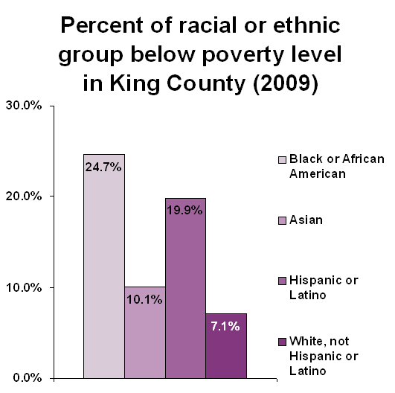
Supplemental Poverty Measure
The U.S. Census Bureau has two measures to determine poverty – the official poverty measure and the Supplemental Poverty Measure (SPM). The SPM subtracts medical expenses from income and considers variables such as home ownership and geographic location, resulting in a more accurate and higher estimate of poverty.
Using the SPM, 36 percent of those between 65-69 years of age live below 200 percent of the poverty level, versus 25 percent in the same age group using the official poverty measure. This percent rises with age. For example, of those 80 years old and older, 57 percent live at 200 percent of the SPM calculated poverty level. This pattern by age is similar under the official measure, but the poverty rates are about 12 percent lower using the official poverty measure. Older women are more likely to live in poverty than men under both poverty measures, as are older Hispanics and African Americans. Using the SPM, more than half (58 percent) of older adults who rated their health as fair or poor fell below 200 percent of the poverty level, compared to 40 percent of older adults who rated their health as excellent, very good or good.
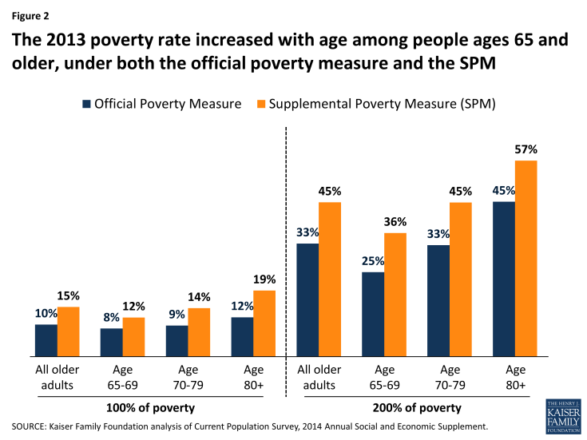
Income
In King County, as elsewhere, those with lower income are more likely to be in fair to poor health. Socioeconomic factors such as concentrated poverty correlate with disparate outcomes across health, life expectancy and disability measures. On average, communities of color fare considerably worse across these areas than white adults 60 years and older.

The household income of King County’s residents varies by race/ethnicity. As the following chart shows, while the median income (in 2009 dollars) is $67,250, the median income for Black/African American residents is $37,000 and for Native Americans only somewhat higher. Only Asian and Non-Hispanic white median household incomes are above $67,250.

King County Median Household Income by Race/Ethnicity in 2009 Dollars
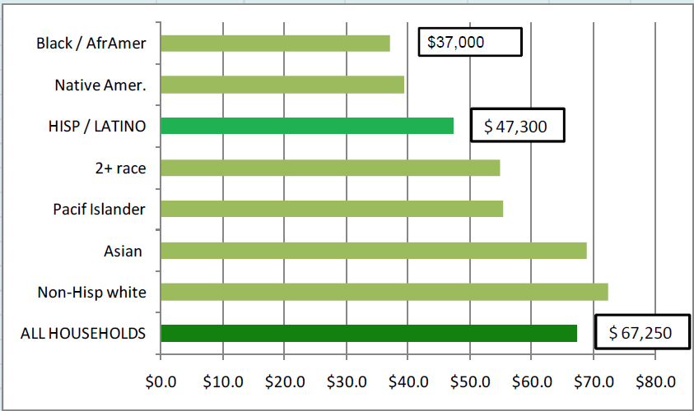

Financial Security
The King County Equity and Social Justice (ESJ) indicators of Equity determined income is the most powerful indicator of ESJ, having the ability to affect more determinants of equity than any other variable. As people live longer, life-long financial security is a growing challenge. This is particularly true for the least educated, who are more likely to live at or near the poverty level without emergency resources. National statistics indicate that 4.2 million older Americans live in poverty. For many older adults, retirement planning has been inadequate to prepare them for years of retirement, resulting in poverty in old-age for a broader group of older adults who may not have experienced poverty while working.
Input from the Seattle Housing Authority’s Senior Advisory Council indicated considerable concern about basic needs. Food insecurity was mentioned many times by residents, including the need to access food banks. One in six of these older adults are threatened by hunger. For older adults living on the edge with limited incomes, supplemental employment may be the key to remaining housed and fed.
Employment
Some older adults have been fortunate and finished their careers with a sufficient amount of savings so they can retire comfortably. Others may have retired with a pension. Many older adults, however, will have worked hard for an entire lifetime at poorly paid jobs that afforded no opportunity to save for the future, making ongoing employment into old age a necessity to afford basic needs.
Individuals 65 years of age and older represent just five percent of the King County labor force. Labor force participation is defined as the number of people of working age that are either employed or are actively seeking work. Labor force participation among people age 55+ tends to be lower than other age cohorts. Currently, the national labor force participation rate is 63 percent and for ages 55 and older it is 40.1 percent. This trend is particularly true in King County where there are more young employees and fewer older adults employed than the rest of Washington State.
After the 2008 economic downturn, many older adults continue to work as they anticipate outliving their savings. Forty-two percent report they are delaying retirement. Some have debt, while others need employment to pay for health insurance or housing.
Barriers to older adults being employed include:
- Lack of skills, including resume writing and interview skills
- Lack of confidence and self-esteem
- Lack of technology skills, such as email, texting and social media for job searches
- Age bias on behalf of employers
- The number of hours of work required and transportation.
Employers that hire older adults can benefit from their strengths, such as:
- Good work ethic and solid work behavior
- Employment history and work savviness
- Respect of employers and boundaries at work
- Work retention.
Older adults need assistance in assessing their skills and designing a plan that helps them find employment based on their individual needs and income requirements. Assistance with resume development, interviewing skills and self-esteem building are critical. Furthermore, older jobseekers need assistance in how to apply for work in an increasingly electronic age, far different from how many applied for work earlier in their professional lives. Employers are willing to hire older adults and create age-friendly work environments and employment specialists could help to connect these businesses to older jobseekers. This approach has helped veterans find employment and may be equally helpful in employing older adults.
Homelessness
The 2016 King County One Night Count found 4,505 individuals unsheltered homeless and surviving on the streets during the January “point in time” count. An additional 6,183 were counted in emergency shelter and transitional housing programs. Over 1,000 individuals over 55 years of age were among those in shelter and transitional housing. An unknown number of older adults are likely among those 4,505 counted as unsheltered.
Age | Emergency Shelter | Transitional Shelter | All
18-25 | 229 | 404 | 633
26-54 | 1,755 | 1,094 | 2,849
55-64 | 590 | 243 | 833
65+ | 152 | 44 | 196
Total | 3,200 | 2,983 | 6,183

In 2016, King County completed an analysis of the use of homeless services by older homeless adults as reported in the Homeless Management Information System during 2015. Of 16,672 unduplicated homeless individuals receiving services, 5,026 (30 percent) were 50 years of age or older.
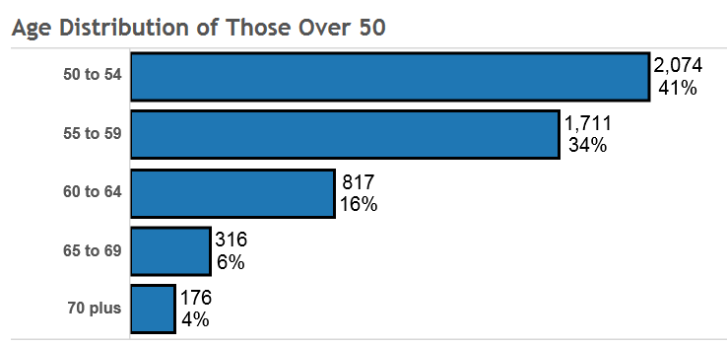
Analysis of the racial breakdown of those 50 years of age and older and homeless found that 49 percent were white and 32 percent were African American.
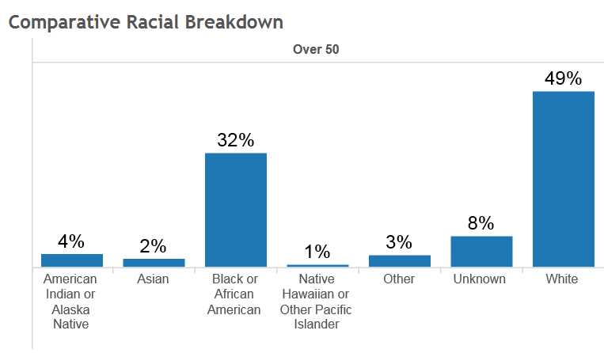
Housing
In 2009 a report, Quiet Crisis: Age Wave Maxes Out Affordable Housing, King County 2008-2025, outlined the need for affordable senior housing in light of the projected growth in King County’s older adult population. According to that report, in 2009 6,700 low income older adults were awaiting assistance from local housing authorities and nearly 1,000 were homeless. It estimated that by 2025, adults 65 and older would represent 23 percent of King County’s total population and 936 subsidized housing units would need to be created annually just to maintain the ratio of housing to older adults that existed in 2009.
The report estimated that 28,510 affordable housing units would be needed by 2025 to meet the needs of low-income older adults. The Quiet Crisis report is currently being updated, creating an opportunity for King County to collaborate in drafting the updated report.
Aging in Place
The Center for Disease Control and Prevention defines Aging in Place as “the ability to live in one’s own home and community safely, independently, and comfortably, regardless of age, income or ability level.” It focuses on increasing the livability of a community by responding to the needs of older adults related to housing, transportation, health services, cultural opportunities and the physical environment. Ninety percent of older adults want to stay in their homes and 80 percent believe their current home is where they will always live.
Disabilities increase with age and a number of supports are needed to assist older adults to age in place. Despite the costs associated with support services, aging in place has been shown to be cost effective.
Current statistics indicate almost 61 percent of adults 65 and older live with others, while almost 30 percent live alone. Just over 9 percent live in group settings. Thirty-five percent of older women live alone. Many of these older adults reside in low-income senior housing.
Low-income senior housing was designed for relatively healthy, independent seniors, and was not designed to provide services such as meals, health care or dementia support. The challenge for low-income senior housing is creating the supports that allow older adults to age in place. This has become a focus of some non-profit low-income housing agencies that provide permanent supportive housing to formerly homeless individuals, who have been meeting with Healthcare for the Homeless staff to explore how they might best meet the needs of their residents as they age. Recommended adaptations to the services model may include such things as:
- Patient assessment and nursing/care coordination, primary care, mental health and substance use disorder services
- Improved access to chore worker and home health aides
- Individualized treatment plans
- Multidisciplinary teams
- Expansion of the Harborview Medical Center’s Homeless Palliative Care program.
The Center for Outcomes Research and Education report on Health in Housing evaluated the impact on health care costs when low-income individuals move into affordable housing. Medicaid claims were used to measures changes in the use and cost of health care. A survey examined health care access and quality. The primary findings were:
- Costs to health care systems were lower after individuals moved into affordable housing – total Medicaid expenditures declined by 12 percent and were highest for those housing seniors and those with disabilities (16 percent).
- Primary care visits went up 20 percent and emergency visits went down 18 percent.
- Residents reported that access to care and quality of care improved after moving into housing.
- Properties with integrated health services were a key driver of health care outcomes –expenditures were $115/month lower per resident and emergency room visits down .43 visits per year.
The report suggests health care systems and affordable housing providers consider the potential benefits of stronger cross-sector collaboration.
Other older adults are in need of assisted living facilities and boarding homes that accept Medicaid eligible clients. These facilities are appropriate for clients not healthy enough to live independently but not appropriate for more intensive or institutional settings.
Another local resource available to assist individuals to age in place is the King County Housing Repair Program. The program provides funds for necessary repairs and modifications that help enable older adults to stay safely in their own homes. The Housing Repair Program reports that since 1990, an average of 80 percent of the repair projects they approved for funding were for residents age 55 and older. The funding for the program is predominantly from the Community Development Block Grant (CDBG) program, funding that has declined steadily over the years. While a similar number of home repair projects are approved each year (125-140,) the grant amounts available per project is less. Similar housing repair programs are available through the cities of Seattle and Bellevue.
Health Inequities
King County experiences geographic differences in the health of its residents. By using an index of health, housing and economic opportunities, the following map graphically depicts how various areas of the county rank on population measures, including health indicators such as frequent mental distress, smoking, obesity, diabetes, preventable hospitalizations, housing condition and economic opportunity indicators such as poverty rate and unemployment. The map indicates a number of areas of the South Region of the county experience low-incomes (below 200 percent of the poverty line), higher unemployment rates, high rates of frequent mental distress, smoking obesity, diabetes, and preventable hospitalizations—factors that impact healthy aging. Life expectancy in areas of South King County is 74 years of age, while higher ranked areas in East King County have an average life expectancy of 87.
According to the King County Hospitals for a Healthier Community report:
The relationship between lack of opportunities and poor health is clear: King County neighborhoods with the lowest educational attainment and highest levels of poverty are also the areas with the greatest concentrations of obesity, diabetes, and many other adverse health outcomes. Equal access to opportunities such as education, housing, and jobs is necessary for all people to thrive and achieve their full potential.

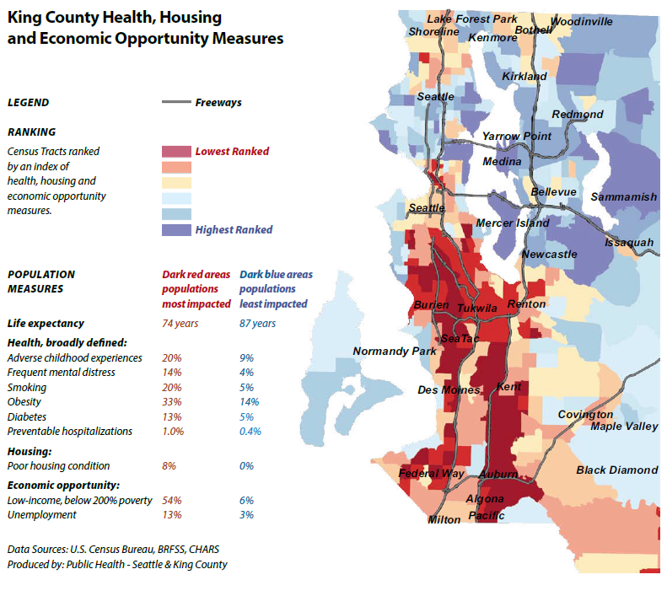
Rates and Severity of Disability
Disability is defined by the Americans with Disabilities Act as an individual’s physical or mental impairment that substantially limits one or more major life activities. Disability rates rise with age. The major underlying causes of physical disability are chronic diseases, including events such as stroke and slow progressive diseases such as arthritis and heart disease. Most older adults with a disability had more than one type of disability and were more likely to be women, age 85 and over with less than a high school education, widowed, living alone, or living in or near poverty.
As the number of older adults increases, the number of people with disabilities increases. These disabilities affect the ability to live independently.
King County rates of disability rise with age
Age | All 18-75+ | 55-64 | 65-74 | 75+
Percent with Disabilities | 21% | 30% | 32% | 43%

Healthy Living
Public Health–Seattle & King County (PHSKC) tracks a number of health measures that provide a snapshot of the health status of King County’s older adult population and point to some important health needs. These measures provide a baseline that could be useful later in measuring the progress made in improving lives of older adults in King County should older adults be included in a renewed VHSL. A review of selected PHSKC measures provides a high-level view of the status of older adults and their needs in King County.
Life expectancy
Life expectancy varies by location within King County. Years of potential life lost before age 85 is a measure of premature death. South King County has a premature death rate nearly 10 percent higher than the balance of County (9253.8 years per 100,000 people).
Falls
The rate of death from falls among adults age 65 and older was 7.4 times the county average and fall hospitalizations 5.7 times the average rate for the county.
Fall Deaths
Age | King County, 2008-2012 Average
0-64 | 0
65+ | 71

Fall Hospitalizations
Age | King County, 2008-2012 Average
<18 | 55.1
18-24 | 59.9
25-44 | 77.5
45-64 | 224.2
65+ | 1,676.3

Between 2008-2012 in King County, almost 80 percent of 2,093 hospitalizations due to falls were for adults ages 65 years or older. For 2015, King County Emergency Medical Service provided almost 43,996 responses to calls for those 65 years and older in the county (excluding Seattle). Of those, 6,829 (15.5 %) were falls.
Preventable Hospitalizations
Enormous hospital resources are used to care for preventable conditions among older adults. Adults ages 65 and older accounted for 60 percent of preventable hospitalizations.
Age | Count per year
18-24 | 256
25-39 | 786
40-64 | 3,638
65-74 | 1,916
75 and older | 5,170
Total | 11,766

Unmet Health Needs
The King County Hospital Health Needs Assessment 2015/2016 provides additional information on the unmet health needs of King County’s older residents.
Diabetes
Diabetes is a chronic disease that, if untreated, can cause numerous complications. Adults age 65 and older were nine times more likely than those ages 45-64 to have diabetes. American Indian/Alaska Native older adults were three times as likely as white, Asian and Hispanic older adults to have diabetes. The ten percent rate of diabetes in South King County is twice the rate in any other region of the county.
Proper management of diabetes helps prevent development of more serious health issues, such as amputations to lower extremities due to poor circulation. Feet need additional care and monitoring as circulation issues and neuropathy are associated with diabetes. Funding previously available for foot care clinics at senior centers and some residential housing facilities has been eliminated.

Dental Care
According to the Academy of General Dentistry, oral health is a key to general health. Poor oral health is linked with stroke, heart attack, diabetes and pneumonia, the number one cause of death in nursing homes. National statistics indicate that 42 percent of older adults below the federal poverty level have no remaining teeth, compared to 22 percent above the poverty level. Forty percent of those ages 65 and older haven’t visited a professional in the last year. Participation in the labor force is a strong predictor of dental coverage, but the picture is grim for retirees. About 10,000 people enter Medicare each day and only two percent of them have a dental benefit. Medicare has no dental coverage.

Leading causes of death by age
Cancer and heart disease rank among the top two causes of death for individuals ages 45 and older. Risk factors, including physical inactivity, obesity, unhealthy diet, and high blood pressure, are good targets for prevention-focused interventions.
Leading causes of death by age, King County, 2008-2012 average
Rank | Ages 45-64 | Ages 65-74 | Ages 75 & older
1. | Cancer | Cancer | Heart disease
2. | Heart disease | Heart disease | Cancer
3. | Unintentional injury | Chronic lower respiratory disease | Alzheimer’s disease
Average #/ year | 2,315 | 1,683 | 7,129

Elder Abuse
Elder abuse is defined by the National Center on Elder Abuse as an “intentional act or failure to act by a caregiver or another person in a relationship involving an expectation of trust that causes or creates a serious risk of harm to an older adult.” It can include physical, sexual or psychological abuse, neglect, abandonment and financial exploitation.
Crimes against vulnerable adults and elders are a growing problem in Washington State. In 2014, Washington State Adult Protective Services reported a 48 percent increase in crimes against older adults over a five-year span. In King County in 2015, APS received over 5,500 reports of abuse with three-quarters of the victims being over 60 years of age.
As with other forms of abuse, elder abuse is under-reported. A New York study estimated only one in 24 cases of elder abuse is reported and only one in 44 cases of financial exploitation. The National Center on Elder Abuse documents the risk factors, such as gender (women are more likely to be abused), low social support, dementia (close to 50% of people with dementia experience abuse), functional impairment and poor health.
Adults with intellectual, developmental and other disabilities are at greater risk of abuse, neglect and other violence against them than the general population. Institutionalized adult women with disabilities reported a 33 percent prevalence of experiencing interpersonal violence, verses 21 percent for institutionalized women without disabilities. Over their lifetime, men and women with disabilities experience disproportionate and elevated rates of interpersonal violence.
The impact of elder abuse is dramatic. Victims suffer a loss of independence, loss of life savings, abuse and neglect. Those who experience elder abuse have a 300 percent higher risk of death compared to those who have not been abused.
Behavioral Health
Older adults are distinct from other population groups in a variety of ways that may contribute to the development of behavioral health issues. These may include the following:
- Complex chronic health conditions - Older adults are more likely that any other age group to have complex chronic health conditions. About two-thirds of older adults have two or more chronic conditions.
- Drug use and abuse – Older adults often are prescribed long-term and multiple medications. Improper use is common and may be caused by cognitive decline, an attempt to save money by skipping doses, potentially addictive drugs being prescribed, or potential interactions of prescribed drugs.
- Experience of Loss – Many will experience the loss of spouses, friends, physical functioning, independence, and a sense of purpose.
- Elder Abuse – Many older adults experience financial, verbal, emotional or physical abuse. While 75 percent of hospital emergency departments have protocols for child abuse, it is estimated only 27 percent have elder abuse protocols.

It is estimated that 20 percent of older adults have behavioral health (mental health or substance abuse) conditions. Common diagnoses for older adults include anxiety, depression and severe cognitive disorders. Women age 65 and older experience symptoms of depression more often that older men - about 16 percent of women versus 11 percent of men. Depression is a key risk factor for suicide in older adults. While currently older adults make up about 13 percent of the populations, they account for 16 percent of all suicides, with the suicide rate for males 85 years of age and older being four times the nation’s overall rate. In King County, the rate of suicide deaths among those 65 years and older (17.1 per 100,000) is higher than the county rate for all age groups (11.5 per 100,000).

Other issues appear to be associated with behavioral health conditions. For example health care costs for older adults with depression are estimated to be 50 percent higher than for those without depression. Those with low incomes or significant care needs may also be at higher risk of behavioral health issues.

National data indicates a twelve-month prevalence of mental illness is estimated to occur among 19 -25 percent of all adults, but is estimated to be up to 49 percent for adult Medicaid recipients. According to a Kaiser Family Foundation article, more than six in ten (61 percent) of older adults with a Long-term Services and Supports (LTSS) needs report feeling depressed or having anxiety. In addition nearly one in three (32 percent) with a LTSS need has a cognitive impairment or possible or probable dementia. The article suggests that the high rates of behavioral health issues among groups with LTSS represents an opportunity for increased screening and integrated care that coordinates physical and behavioral health services.

Depression in older adults is treatable; it is not a normal part of aging. A number of evidence-based treatment options are available and given appropriate treatment, 60-80 percent of those treated will experience a reduction in symptoms. Adequate social support has been identified as a protective factor against developing behavioral health conditions.

Locally, the State of Washington contracts with King County DCHS Behavioral Health and Recovery Division (BHRD) to provide mental health and substance use disorder treatment services under a managed care model. A continuum of services in four service categories provide the structure of the delivery model, focusing on improving individual level of functioning, quality of life and community integration with the goal of fewer hospitalizations, incarcerations and emergency room visits.

Crisis Services
Crisis services include the Crisis Clinic 24-hour crisis line, Sobering Center, crisis diversion services, respite beds and detox beds. BHRD funds only one program that targets older adults specifically, the Geriatric Regional Assessment Team (GRAT). GRAT services, available for those 60 years of age and older, include comprehensive assessments, crisis intervention and stabilization, and referral to mental health, substance abuse and health care providers.

The BHRD Older Adult Plan points to the following crisis service needs:
- Specialized expertise and trained crisis response staff to properly diagnosis older adults and distinguish between dementia and other mental health or substance use disorders that sometimes result in inappropriate transfer of individuals to jails or emergency rooms
- Collaboration between service systems, specifically with State Department of Social and Health Services Home and Community Services to avert recurrent behavioral health crises
- Diversion or other facilities equipped and staffed to treat older adults with medical as well as behavioral health issues.

Voluntary / involuntary inpatient services
BHRD authorizes voluntary and involuntary inpatient psychiatric hospitalizations to stabilize the acute behavioral health crisis, restore functioning and return the individual to their home or a less restrictive level of care. There is an extreme shortage of hospital services that provide specialized care for older adults. King County has seen an increasing number of older adults who need involuntary treatment. Older adults with dementia or other organic disorders can have difficult-to-manage behaviors, making placement in community facilities like skilled nursing facility or adults family homes challenging. Eastern State Hospital (ESH) and Western State Hospital (WSH) are the only facilities in the state available for patients who need long-term psychiatric care. For those civilly committed to the hospital, finding the right residential placement in the community can be difficult, often resulting in an unnecessary and extended stay at a state hospital.

The BHRD Older Adult Plan identified the following need related to inpatient services:
- Increase the number of psychiatric hospital beds for those needing acute care and medical services when their medical needs are so complex that placement in a residential facility is inappropriate.

Residential / supportive housing
BHRD has a continuum of four residential and supportive housing services providing less intensive levels of care than the inpatient services described above. For all of the mental health residential/ housing programs, the resident must be independent in his/her personal care. They include:
- Enhanced mental health services
- Long-term rehabilitative care
- Supervised living
- Standard supportive housing.

While older adults may reside in any of the four types BHRD funds, one long-term rehabilitative and one standard supportive housing facility are specifically for those 55 years and older. Residential services for older adults needing residential substance use disorder services lack the type and amount of services available in the residential mental health facilities. Following hospitalizations, however, individuals may be unable to return to residential facilities.

Older adult residential treatment facilities needs include the following:
- Expand the number of residential facilities with skilled nursing services for those needing mental health or substance use disorder services.
- Expand the number of supportive housing facilities with an older adult focus.

Outpatient services
BHRD provides a continuum of outpatient behavioral health services in the following categories:
- Prevention
- Outreach, identification, access and engagement
- Medicaid State Plan Outpatient services
- Specialty and supportive services
- Criminal justice initiatives
- Intensive rehabilitative services.
BHRD provides services to about 6,800 older adults each year, equal to about 15 percent of those that receive services.
Though there are no prevention or outreach services that specifically target older adults, they may be served under these outpatient categories. Limited services may be available to older adults accessing supportive services. A number of agencies provide supportive services, such as the Washington State Aging and Long-Term Support Administration and Home and Community Services and Seattle’s Aging and Disability Services Division. BHRD through its Behavioral Health Organization funds Medicaid Personal Care for clients needing assistance with activities of daily living due solely to their psychiatric disability. Coordinating services among these agencies can be complex.
Medicaid requirements restrict the number of older adults that may receive services. Medicare insurance that covers older adults rarely provides adequate reimbursement rates for behavioral health services, including case management, coordination of services and psychosocial rehabilitation.
The BHRD Older Adult Plan identified six elements to provide an effective and comprehensive older adult system of care:
- Expanded service capacity to meet the growing number of older adults, including prevention, wellness, crisis intervention, outpatient treatment, caregiver support, residential services, and inpatient treatment
- Community-based services, including mobile services, in-home or in community settings such as senior centers
- Prevention, screening and early intervention strategies
- Evidence-supported services through evidenced-based models
- Coordinated and integrated care, both internally and with state and local agencies that fund services for older adults
- Workforce capacity and development, specifically developing the skills of general direct-care staff and increasing the number of geriatric specialists.
Among these recommendations, BHRD has identified as their top priority the development of a county-wide integrated mental health and substance use disorder (MH/SUD) geriatric crisis response team(s). The team(s) would maintain or enhance the GRAT team capacity, develop hospital alternatives or diversion for older adults experiencing a MH/SUD crisis. In addition, they would increase crisis response access for families and other caregivers that house and support older adults.
Dementia
According to the Alzheimer’s Association, dementia is a general term for loss of memory and other mental abilities severe enough to interfere with daily life that is caused by physical changes in the brain. Different types of dementia are associated with particular types of brain cell damage. Alzheimer’s disease represents 60-80 percent of all dementia diseases. It is a progressive brain disorder that develops slowly and damages brain cells, leading to memory loss, loss of brain functions and death.

An estimated 110,000 individuals have Alzheimer’s disease or dementia, a number that is projected to increase by 181 percent over the next 30 years for those 65 years of age and older. Alzheimer’s disease is the third leading age-adjusted cause of death in Washington State. In King County, deaths per year for women as a result of Alzheimer’s disease are almost double that for men.

National statistics indicate Alzheimer’s disease disproportionately impacts certain populations by race, ethnicity and gender:
- African Americans are about twice more likely than whites to have Alzheimer disease.
- Hispanics 60 years of age and older are about 1.5 times more likely than non-Hispanic white to have Alzheimer’s disease or other dementias.

Studies suggest that people ages 65 and over live on average four to eight years after a diagnosis of Alzheimer’s disease, but some survive as long as 20 years. The progressive nature of dementia and its duration places an emotional, physical and financial burden on caregivers, which are most often the families. There are an estimated 286,000 to 324,000 unpaid family caregivers of persons with dementia in Washington State. The duration and high costs of care commonly result in families depleting their resources and eventually turning to public assistance. The aging of baby boomers is expected to increase the proportion of middle-class families who will “spend down” their assets to Medicaid eligibility in the future. The State’s plan to address dementia calls for increased public awareness, early identification, provision of dementia primary care, and ensuring availability of dementia-capable long-term services and supports.

Social Engagement and Isolation
Research has pointed to the importance of remaining socially engaged as people age. The Sightlines Project: Seeing our way to living long, living well in 21st Century America documented many benefits to remaining engaged in community, including better physical health and resistance to illness and disease from common colds to heart disease; mental and cognitive health; a sense of purpose and control; and longevity.

By contrast, socially isolated individuals face significant health risks. A meta-analytic review of research on loneliness and social isolation found that actual and perceived social isolation are both associated with increased risk for early mortality.

Many residents experience or are at risk of social isolation because of lack of family, few social supports, or mobility issues that cause them to be home-bound. Some population groups or communities may be at particular risk of isolation such as immigrant communities, non- or limited English speakers, or rural communities that may be geographically isolated.

Senior Centers
Senior Centers have long served older adults in King County by providing a wide variety of activities and an inviting setting for older adults to gather, socialize and make friends. They offer opportunities for fitness, volunteerism, learning, transportation and a healthy meal. King County’s General Fund currently helps support six senior centers located in or near the unincorporated areas to provide the following services and programs:

Activities addressing social isolation | Legal counseling
Case management | Outreach
Community relations | Supervised exercise
Health promotion | Transportation to and from Senior Center
Information and Assistance | Volunteer opportunities

Core services, such as the nutrition program, are funded by the Area Agency on Aging.

In 2014 over 4,014 adults ages 55 and older were served through County-funded senior centers. Senior centers in King County will need additional financial support to respond to the continuing increase in adults coming for services, including those who seek the more intensive services previously available at adult day health programs that are increasingly not available.

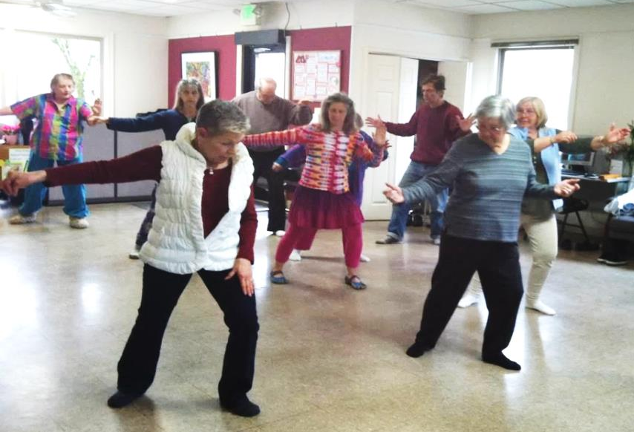 Vashon Senior Center

Adult Day Programs

These programs meet the needs of functionally and/or cognitively impaired adults in a community-based group setting. Programs are structured and provide a variety of health, social and support services so adults who need supervised care are in a safe place outside the home during the day. There are two types of adult day programs: Adult Day programs and Adult Day Health programs.

Adult Day programs include core services, such as personal care (eating, positioning, transferring, toileting, etc.), social services, routine health monitoring (vital signs, weight, etc.), general therapeutic activities (recreational activities, exercises, etc.), general health education (nutrition, disease management, etc.), a nutritious meal and snack, supervision, assistance with arranging transportation, and first aid as needed.

Adult Day Health programs include the core services mentioned above and also a skilled medical service such as skilled nursing, physical therapy, occupational therapy, speech therapy, or psychological or counseling services. The cost associated with operating these service-rich programs has resulted in the closure of some in recent years. Currently six are now operating in King County.

Over ten years ago, anyone eligible for Medicaid could use Adult Day Health services, which meant many individuals with an intellectual or developmental disability were eligible for adult day health programs. Now, clients must be eligible for the Washington State Medicaid Waiver, Community Options Program Entry System (COPES), to be eligible for these services. Agencies are losing clients because of the new eligibility requirements. The change has resulted in fewer social engagement options available for older adults with developmental disabilities.

Homebound

Older adults who are homebound by disabilities are at particular risk of isolation. Data available in 2010 indicated that possibly 3.6 million of more than 38.9 million people ages 65 and older in the United States were considered housebound and in need of home-based care. They experience a broad range of disability levels and a multitude of medical and psychiatric illnesses at higher rates than the general older population. In addition to medical and psychiatric care, homebound older adults have difficulties getting proper nutrition, and may become dependent on home delivery food services and similar programs.
Intellectual and Developmental Disabilities
Adults with intellectual and developmental disabilities are more likely to experience earlier age-related health changes, limited access to quality health care and have fewer financial resources. They are more likely to be living with parents into adulthood, and have more limited social supports and friendships outside the family. In King County, 5,835 adults are enrolled as clients of Washington State Developmental Disabilities Administration (DDA).
Living Arrangements of Older Adults with Developmental Disabilities in King County
Residence Type | Count | Percent
Own Home - Supported Living | 288 | 50%
Own Home - Independent Living | 61 | 11%
Adult Family Home | 59 | 10%
Group Home for DD | 60 | 10%
Parents Home | 33 | 6%

A total of 143 of the 1,981 eligible adults with developmental disabilities ages 50 and over participate in Community Access programs designed to increase social engagement and reduce isolation.
At the national level, more than 25 percent of family care providers are over 60 years of age. Most families receive few support services and face long residential services waiting lists. Aging parents of children with developmental disabilities experience challenges as unpaid caregivers similar to those caring for older adults. They also face the challenge of creating plans for the care of their child once they die or are no longer able to care for them. This planning often involves siblings, other family members, family friends and professionals such as financial planners, attorneys and social workers.
Key challenges for this population include:
- Improving the health of aging adults with developmental disabilities and their families
- Enhancing consumer directed and family-based care
- Increasing need for respite for caregivers
- Reducing barriers to health and community participation.

Guardianships and Supportive Decision Making
Socially isolated older adults without a close family member or extended support network nearby may need to establish a guardianship to assist with medical or other decisions that have become difficult for them to make on their own.

A guardian is a person or agency appointed by a court to manage the affairs of another, when an individual has been judged unable to manage his or her own affairs. It is a legal relationship between a competent adult and a person age 18 or older who has a disability that causes incapacity. The incapacity may be caused by mental deterioration, physical incapacity, mental illness or developmental disability. Low-income older adults often can't afford a guardianship and pro bono assistance is very limited.
Lesbian, Gay, Bisexual, Transgender, Queer (LGBTQ)
LGBTQ older adults represent about 2.4 percent of the older adult population in King County, and their numbers are likely to more than double by 2030. A local study, Aging with Pride, the first national federally-funded project to examine LGBTQ aging and health, has revealed significant social, economic and health disparities in King County. The key findings include:
- Elevated risk of disability, poor health and mental distress.
- High rates of victimization and discrimination – over two-thirds (68 percent) experienced three or more incidents of victimization and discrimination.
- Nearly one-quarter live below 200 percent of the federal poverty level.
- Almost half (over 45%) live alone and are at high risk of social isolation; more than half feel isolated from others; one in three has difficulty identifying someone in their lives to provide assistance if it was needed.
- They are less likely to be partnered or married and have fewer children and other cross-generational ties than their heterosexual peers.
- One in five served in the military yet only 15 percent are accessing veterans benefits.
- Most aging and health and human services agencies do not have training to effectively serve LGBTQ older adults – 16 percent have been denied services or provided inferior services due to actual or perceived sexual orientation and/or gender identity.
- LGBTQ older adults report not being able to obtain culturally relevant and appropriate services, with one in six in fear of obtaining services outside the LGBTQ community.
- Most are satisfied with their lives and 95 percent feel good about belonging to their community.
The Aging with Pride study recommends the development, piloting and evaluation of an evidence-based LGBTQ older adult and cross-generational support program to provide engagement, assistance, support, information, resources and referral for LGBTQ older adults.
Caregivers
Caregiving refers to assistance provided by family or friends rather than by a professional who is paid. Their services help older adults age in place rather than face premature institutionalization. Being in a caregiving role can be stressful and burdensome and take its toll on physical and psychological health and wellbeing. Research indicates it has all the features of a chronic stress experience due to the strain experienced over extended periods of time, accompanied by high levels of unpredictability and uncontrollability, and may also create secondary stress in multiple life domains such as work and family relationships, and often requiring high levels of vigilance.

Families often are a primary source of home care and support for older relatives, contributing services that nationally would cost hundreds of billions of dollars annually. Not only does supporting a family caregiver alleviate some of the cost burden of care, it increases the likelihood the older adult can age in place. In a study exploring the amount of respite care needed to be a therapeutic dose, researchers found that caregivers whose relative attended adult day services at least twice a week for three months had lower care-related strain levels than did a control group. The caregivers who received this intervention were also less angry and had fewer symptoms of depression.
Long-Term Support Services
The need for more caregivers as the older adult population continues to grow, as well as the challenges faced by individuals who are not eligible for or not using Medicaid funded long term support services (LTSS) is clear. The Medicaid Transformation 1115 Waiver attempts to address this issue. While the details of the agreement between the federal and state government are still under discussion, the intent is to use this opportunity to prepare for the “age wave” by testing new services that support unpaid family caregivers and provide targeted supports to people who may or may not qualify for Medicaid. Initiative 2 of the waiver calls for the establishment of two new benefits:

- Medicaid Alternative Care (MAC) will support unpaid caregivers, avoiding or delaying the need for more intensive Medicaid-funded services. This is a new benefit package for individuals who are eligible for Medicaid but not currently using Medicaid-funded LTSS.

- Targeted Supports for Older Adults (TSOA) will provide a limited set of services and supports to help individuals avoid or delay the need for Medicaid-funded services. This is a new eligibility category and benefit package for people “at risk” of future Medicaid LTSS use who do not meet Medicaid financial eligibility criteria.

King County can support these approaches by working collaboratively with Aging and Disability Services and community based organizations to educate caregivers and families of these benefits and encourage them to take advantage of the new opportunities. The County may also support its employees by exploring the possibility of paid caregiver leave that would be especially helpful to those in the “sandwich generation” – caring for both children and aging parents.

Kinship Caregivers
According to the 2000 U.S. Census, 4.5 million children are living in grandparent-headed homes, a 30 percent increase from 1990. Most grandparents raising grandchildren are between 55 and 64, with almost 25 percent over age 65. A growing number are far more likely to be persons of color who are living in poverty, adding to the challenge of being an older parent. In King County, 18,000 grandparents, aunts, uncles, siblings and others are raising younger family members.

The reasons for having to parent a grandchild often involve traumatic events. According to the American Association of Retired Persons (AARP), these may include the following:
Alcohol or drug problems | Child abuse and neglect
Mental illness | Teen pregnancy
Poverty | Parent(s) living with HIV/AIDS
Divorce or death of parent | Domestic violence
Parent(s) in jail | Military deployment of parent(s)

Grandmothers caring for or raising grandchildren suffer more stress and depression than grandmothers who aren't caregivers. They are more likely to experience obesity, weaker immune systems, and be at higher risk of chronic diseases. Their own health issues may be compounded by their grandchild who may have health problems, developmental challenges, or an increased need for care. They may also need legal assistance related to guardianship, custody or adoption issues.
Home Care Aides
As the population of older adults in King County increases, so will the need for Home Care Aides (HCA). According to a brief written by the University of Washington Center for Health Workforce Studies, assuming the number of people needing Medicaid services grows at the same rate as the general population, the number of HCAs needed to care for Medicaid clients will increase 56 percent in the next 20 years. By 2030, nearly 77,000 HCA may be needed. The policy brief suggests higher training standards will help stabilize the workforce and build career pathways for workers. This will be an area of increasing concern when need outstrips available aide.
Veterans
Veterans may experience service-connected and combat-related mental health and medical conditions that may lead to suffering and disability. These may interact with the aging process affecting veterans in different ways at different periods in their lives.
The population of aging veterans faces many of same issues as the general aging population. In response to a U.S. Department of Veterans Affairs (VA) survey on the needs of older veterans, over half of veterans 65 years of age and older reported difficulty functioning and rated their health status as fair or poor. Elderly African American and Hispanic veterans reported worse health than non-Hispanic white veterans on the majority of health indicators.
Some veterans experience PTSD more than 30 years after exposure to trauma, suggesting the need for continued outreach throughout their lifetime.
Transportation
The National Association of Area Agencies on Aging (n4a) reports that of calls placed to their Locator Hotline in 2015, 12 percent were related to transportation (for medical appointments, errands, etc.).
As individuals age, develop disabilities, or simply decide to stop driving, transportation becomes a challenge. Residents in rural areas of King County are in particular need of transportation services.
Besides Metro Transit, there are several transportation programs for King County’s older adults. Access Transportation, a shared-ride van service for people with disabilities is available. Americans with Disability Act (ADA) paratransit service has conditional eligibility and requires an evaluation at Harborview medical center to determine eligibility. Eligibility is stringent and many older adults are too healthy to be eligible, while others are too frail and need volunteer or other transportation services. Other transportation resources include neighborhood vans and shuttles that help residents access senior centers, groceries, medical appointments and other services in their neighborhoods. Unfortunately, not all areas of King County have shuttle services and some areas, such as Maple Valley, lost their shuttle program due to funding challenges. Funding for some senior transportation programs is uncertain, and even precarious.
The King County Mobility Coalition envisions a coordinated transportation network so residents can travel freely around King County and Puget Sound. They have developed an action plan to respond to transportation needs for all people in King County and in particular vulnerable residents with special needs. Their plan focuses on the following areas of need:
- Access to healthcare
- Veterans transportation
- Emergency management coordination for vulnerable populations
- Education and Outreach for underserved communities
- Suburban and rural access
- Livable communities
- Access to work and school.
Libraries
Seattle Public Library operates 27 branches across the city in addition to mobile library services. They sponsor older adult activities such as an Older Americans Month film series and coordinated volunteer opportunities. The King County Library system operates 49 libraries outside of the Seattle City limits. They are one of the few library systems in the country with dedicated staff focused on the older adults population. This investment has resulted in a broad array of programming.
Age Friendly Neighborhoods
The Aging and Disability Services Report, Quiet Crisis, included the following recommendation:
Create senior-friendly neighborhoods by targeting senior housing and infrastructure incentives in the neighborhoods that best support healthy aging. Create walking friendly neighborhoods with access to services, provide infrastructure incentives and promote transit-oriented development, incorporate sustainable design elements in housing.
This recommendation appears to be closely aligned with the Age Friendly Initiative sponsored by the World Health Organization and the American Association of Retired Persons (AARP). The broad focus of the initiative includes the domains of housing, transportation, outdoor spaces and building, civic participation and employment, and community support and health services.
Summary of Key Areas of Need
In light of the broad human services needs of King County’s growing older adult population, the following gaps in services and opportunities are noteworthy:
- Refunding previously effective programs in King County. Ongoing funding reductions in older adults programming have defunded effective programs. King County’s Older Adult Program has reduced funding for senior centers, adult day health and adult day care programs from $750,000 in 2008 to $120,000 today, and the number of local programs receiving funds was also dramatically reduced. PHSKC’s Healthy Aging Program that provided chronic disease management and fall prevention services was eliminated when the grant expired. Backfilling these lost services is an urgent need.

- A continuum of services. Older adulthood is a period of transition. Funding is needed for innovative and evidence-based programs for older adults that support all stages of aging. King County lacks a fully funded system of services to keep older adults healthy, housed, financially secure and socially engaged.

- Explore partnered programming opportunities like the Medicaid Waiver Initiative 2. Washington’s Medicaid Waiver request to the Centers for Medicare and Medicaid may provide opportunities to better serve older adults in need. Opportunities may arise to support creative programming not funded or not fully funded by Medicaid. King County’s older adults can benefit from efforts to leverage external fund sources to help serve this growing population.

Affordable Housing

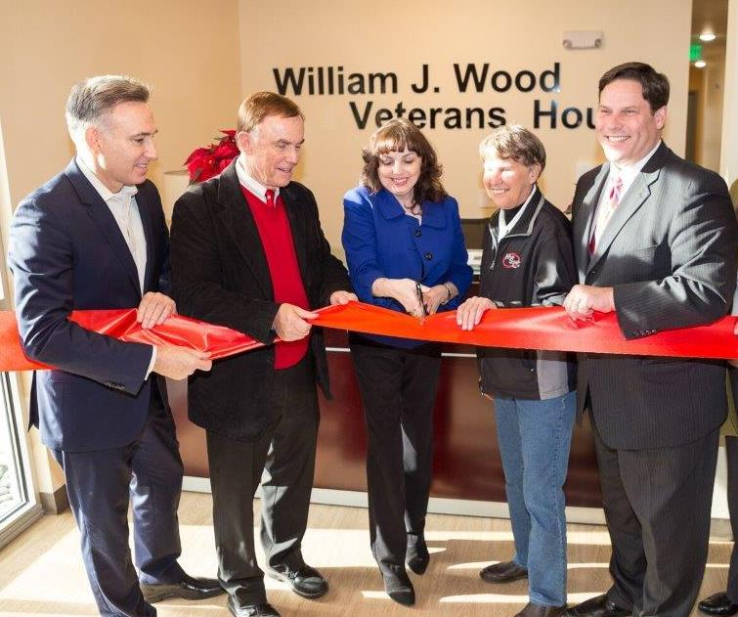
King County Executive Dow Constantine and King County Councilmember Pete Von Reichbauer join in the ribbon cutting to open the William J. Wood Veterans House, funded by the VHSL to provide housing for homeless veterans and their families (December 2017)

King County is a dynamic, diverse region. The County enjoys a low unemployment rate with a rapidly expanding technology sector, and real estate development working to produce the commercial and residential products demanded by the local economy. Unfortunately, this rapid growth also strains the region’s housing resources.

Since 2000, King County’s population has grown by over 16 percent, adding nearly 300,000 residents. As local businesses continue to expand, the populations will expand accordingly.

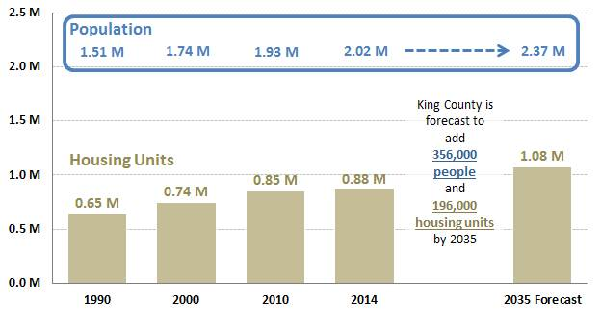

However, not all of King County’s residents are flourishing. In the face of a real estate and technology boom, many are finding themselves priced out of housing, especially those who are low and very low-income, seniors, veterans and people who are homeless. The housing needs of these groups are acute and demand specific strategies.

Low Income Households
Incomes in King County have increased by only seven percent since 2000. As of 2014, King County’s median household income was approximately $86,000. Area median income (AMI) for a family of four is as follows:

- 100%: $86,600
- 80%: $69,400
- 50%: $43,400
- 30%: $26,040

As the following table demonstrates, there are sub-regional differences in income, with more low-income households living in Seattle and South King County than in East King County.

Income Range by King County Subregion
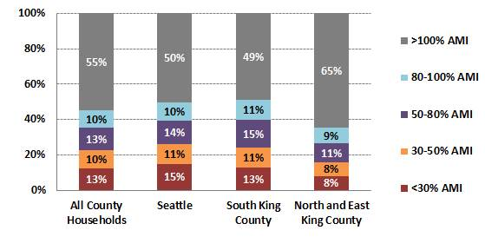

Rental Housing
Renter households make up approximately 40 percent of all households in King County, but represent nearly 70 percent of households earning less than 50 percent of AMI. With lower incomes and higher housing costs, renters are at higher risk of an adverse event negatively impacting housing security.

Income Range by Housing Type
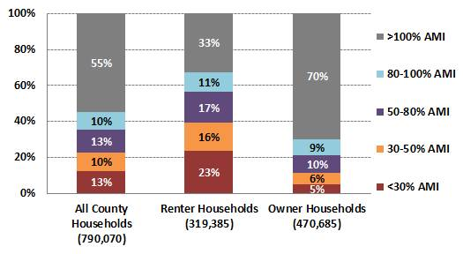
This situation is compounded by the rapid rise of rent experienced throughout our area. The following table shows how rents have increased in King County generally, by King County sub-region, and as compared to Pierce and Snohomish Counties.
Average Apartment Rent Trend

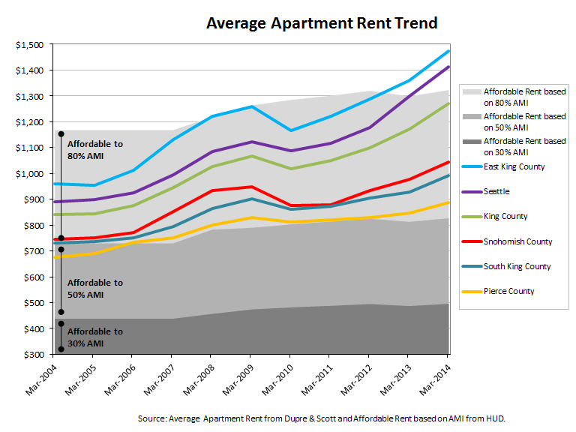

On average, households earning 80 percent of AMI can only afford to live in South King County unless the household is able to obtain subsidized housing in other parts of the County. For households earning 50 percent of AMI or below ($43,400), there is no region in King County that is affordable (based on the HUD principle that housing affordability is no more than 30% of income used for housing-related costs).

The following table compares affordable rent (30 percent of income) at various income levels to the median rent for a one-bedroom apartment in King County. The concept of affordable rent originated in the National Housing Act of 1937 and has increased over time to its current level of 30 percent (established in 1981). The amount of money that can be dedicated to housing costs increases as household income rises.

Affordable Rent and Wages
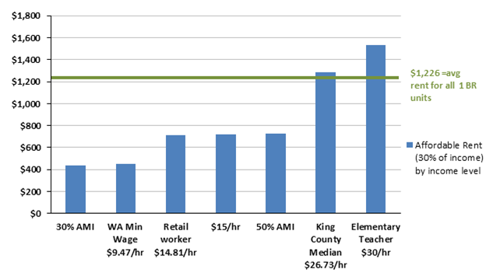

Clearly, the average one-bedroom apartment is out of reach for many households. Even for those benefitting from the recent increase in the minimum wage to $15/hour in SeaTac and Seattle, an affordable one-bedroom apartment is likely not attainable.

Most at Risk
Unsurprisingly, King County’s lowest income households face the greatest risk of housing instability. Nearly 50,000 households earning 30 percent of AMI (approximately Washington State’s minimum wage) are severely housing cost burdened (defined as paying more than 50% of income towards rent). An additional 14,500 households earning 50 percent of AMI are severely housing cost burdened.

Figures for cost burdened households also show sub-regional differences. Seattle has the highest number of severely cost burdened households, while South King County has the highest percentage.

Cost Burdened Renter Households by Sub-Region
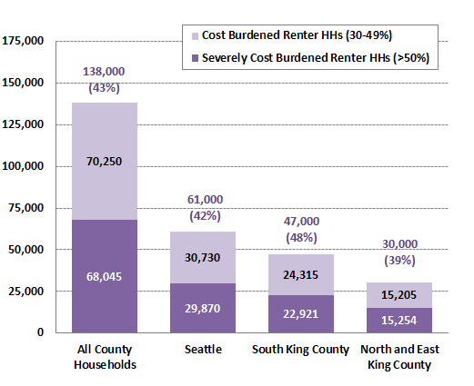

Cost Burdened Households by Income
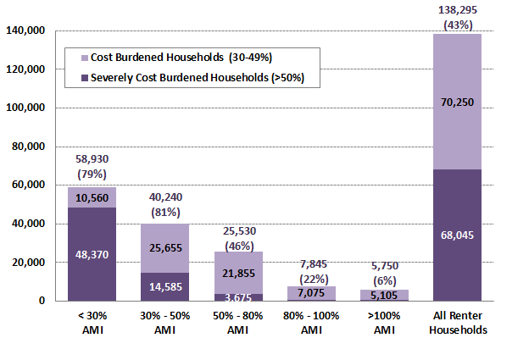

Taken together, there are nearly 65,000 households that are unstably housed. With one adverse event such as an illness, accident or reduced work hours, many of these households would be at severe risk of homelessness. In fact, a 2012 study in the Journal of Urban Affairs found that a $100 rise in rents leads to a 15 percent increase in homelessness. The impact of a rent increase is even higher in rural areas.

Subregional Differences
With over two million residents, King County communities have a broad range of housing needs. Seattle, East King County and South King County have experienced different changes in the rental market during the ten year span from 2005-2015. While rent has increased everywhere in King County, rents in South King County have increased less than in other parts of King County.
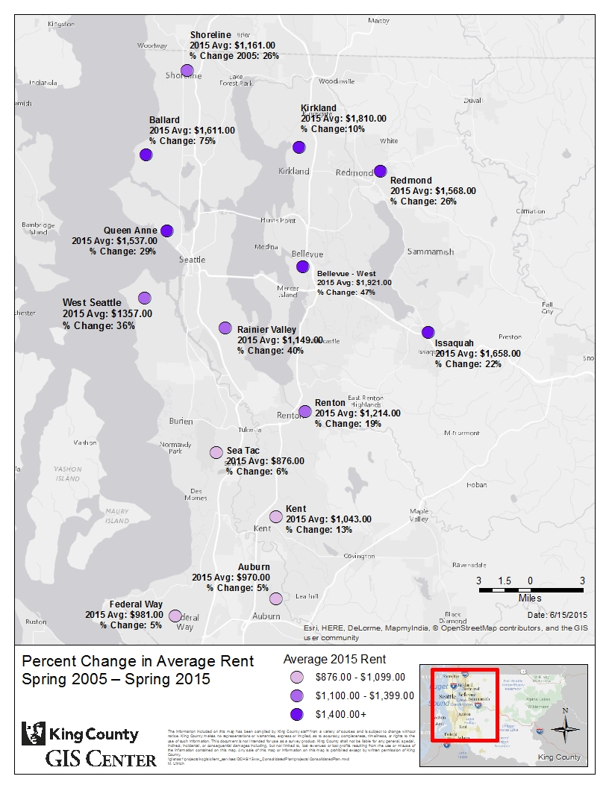

Growing Impact of Displacement

Low-income renters who have a federal Housing Choice voucher and are searching for housing are finding it increasingly difficult to locate landlords willing to accept the voucher payments. With the highly competitive rental market, many landlords who previously accepted voucher payments have stopped, displacing currently housed households. With the increasing value of land, owners of mobile home parks are selling the property to developers, displacing low-income park residents who, with the loss of their units, have few housing alternatives.

Special Populations

Beyond the general population, households with special needs require specialized housing. These include senior households, people who are exiting homelessness, and veterans.

Older Adults
This rise in the older adult population is being closely observed in King County. The population of King County’s adults ages 65 and over grew 12.8 percent between 2009 and 2014. Most notable is that in five years, almost 50,000 residents were added to the 65-74 year old category, a 51 percent increase. In a few years these individuals will add to those 75 and older.
As of July 2015, the population of King County was estimated to be 2,117,125. According to American Community Survey 2010-2014 estimates of King County’s population there are an estimated 232,417 King County residents 65 years and over and about an additional 100,000 ages 60 to 54.
King County Older Adult Population by Age
Age | 60-64 | 65-69 | 70-74 | 75-79 | 80-84 | 85-89 | 90-94 | 95-94 | 100+
Population | 101,945 | 67,317 | 45,430 | 35,200 | 28,948 | 21,414 | 9,551 | 2,485 | 334

Current statistics indicate almost 61 percent of adults 65 and older are living with others, while almost 30 percent are living alone and just over 9 percent live in group settings. Many of these older adults reside in low-income senior housing.

A 2009 report, Quiet Crisis: Age Wave Maxes Out Affordable Housing, King County 2008-2025 was released that outlined the need for affordable senior housing in light of the projected growth in King County’s older adult population. The report estimated that by 2025 adults 65 years of age and older would represent 23 percent of King County’s total population. Quiet Crisis emphasized the need for more affordable housing, estimating that 28,510 units of affordable housing units would need to be created by 2025 to meet the needs of low-income older adults. It identified a series of strategies to enable older adults to stay in their home, expand the supply of affordable housing units, and create senior-friendly neighborhoods.

Homelessness
As noted earlier in this report, the 2016 One Night Count of homeless people in King County found 4,505 individuals without shelter (a 19 percent increase from 2015) and another 6,183 homeless individuals in emergency shelters and transitional housing, for a total of 10,688 homeless persons throughout the County. The most striking thing about these figures is that homelessness in King County and other West Coast cities is rising while it is falling in other parts of the United States. Experts report that thriving U.S. cities such as Seattle are grappling with a surge in homelessness as incomes aren’t keeping pace with rising rents in a very-high price market. Among the reasons for the shortfall are the limited profit potentials for developers building low-cost housing, and declining federal appropriations for programs that subsidize construction of affordable units.

2015 King County Homeless Point In Time Count
Population | Unsheltered | Emergency Shelter | Transitional Housing | Total
Families | - | 983 | 2,063 | 3,046
Youth | 133 | 268 | 388 | 789
Single Adults | 3,179 | 1,307 | 243 | 4,729
- Veterans | 109 | 288 | 271 | 668
- Chronic | 351 | 436 | 28 | 815
TOTAL | 3,722 | 3,282 | 2,993 | 10,047

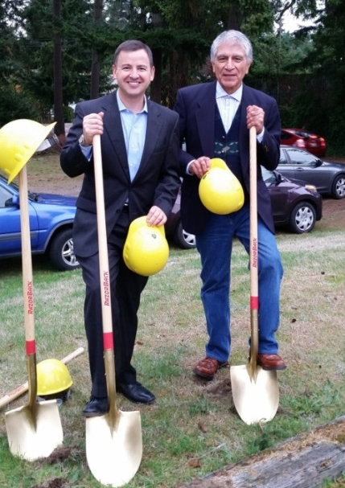
A separate report on veterans housing has been developed to identify both the need and potential strategies to address veterans homelessness, King County Veterans and Human Services Levy Report Two: Veterans Housing Assessment.

Affordable Housing Strategies for the Future
The VHSL Guidance Motion directs analysis to inform the Council’s decision about whether a renewed levy should include “a strategy or strategies to increase investments in affordable housing generally and reduction of homelessness specifically.”

In the face of the unprecedented need, the VHSL provides a welcome opportunity to expand current effective affordable housing solutions while supporting new, innovative approaches.
King County Councilmember Rod Dembowski and King County Veterans Oversight Board Chair Francisco Ivarra break ground for Compass Housing Alliance’s Ronald Commons with 50 units of housing for homeless families and veterans (Oct. 2015)

The strategies outlined below are organized based on the three high need populations previously discussed: extremely low-income renters, people who are homeless and older adults.
Extremely Low-Income Renters
Although the need for affordable housing in King County is high at all income levels, it is the extremely low-income, those earning less than 30 percent of the AMI that face the greatest need. These households are also the most likely to become unstably housed, potentially leading to homelessness. The VHSL can support these households in the following ways.
- Approach #1: Harness Existing Affordable Housing Production to Support Extremely Low Income Renters: Through existing programs and partnerships, including the Transit Oriented Development (TOD) bond program, King County is working to maximize capital investment in affordable housing. However, although affordable units are being created, existing resources are often not sufficient to make these units affordable to the lowest income. However, VHSL funds can be used for rent subsidy, decreasing the cost of already affordable units. This is a cost effective solution that is also flexible as it can be applied to both existing and new units throughout the county. Opportunities include partnering with the King County Housing Authority on its housing preservation efforts and providing additional rent subsidy to units being created through the TOD bond program.

- Approach #2: Leveraging the Private Sector Rental Market: Similar to Approach #1 above, King County is also working to harness the private rental market to meet the housing needs of extremely low income households. VHSL funds can be used to for rent support in private market apartments. When coupled with innovative housing solutions, such as micro-apartment units, the cost to support a household is reduced. Furthermore, residential development resulting from publicly supported projects, such as the proposed expansion of the Washington State Convention Center, provides the opportunity to create affordable housing in private, for profit developments.

- Approach #3: Expand Unit Support through VHSL: VHSL funds can be used for operating and maintenance purposes for extremely low-income units. Extremely low-income housing does not generate sufficient excess rent to cover the long-term operating and capital improvement expenses. By using funds for this purpose, the levy can ensure that existing low-income units remain a cornerstone of the King County affordable housing portfolio for the long term.

Homeless Households
With a growing homeless population in King County, the VHSL needs to support strategies that serve the continuum of homeless needs, from shelter to housing and including the creation of housing for specific populations. Rooted in the experience of our community and corroborated by recent analysis – including the Fall 2016 System Wide Analytics and Projection (SWAP) Report prepared for All Home, King County, United Way of King County and the City of Seattle – are four potential approaches to assist homeless households.
- Approach #1 - Shelter to Housing: Recent reports, including the SWAP, identify the need to expand shelter capacity and services and connect shelter to permanent housing resources. VHSL funds used for this approach could focus on two major areas, expanding and enhancing homeless shelter services and increasing the number of units available for homeless households exiting shelter.

  - Enhanced Shelter: Although King County funds over 1,900 shelter beds annually, the vast majority of these are emergency shelters open from 7 p.m. to 7 a.m. and are not designed or staffed to address housing barriers. VHSL funds could be used to create enhanced shelters, which are designed to operate 24-hours a day year round and offer the resources and services that can move a household from a shelter to housing. Funds could be used for both operating and services. VHSL resources could also be used to incentivize shelter operators to shift an emergency shelter to the enhanced model, enabling providers to feel confident they can provide the service necessary for shelter stayers to be successful.

  - Increased Homeless Housing: Once households address their housing barriers through the enhanced shelter, they need to move to permanent housing, both for their own sake and so there is through-put in the shelter system. VHSL funds could be used to quickly increase the number of dedicated homeless units. Uses of funds could include the acquisition or master leasing of hotel/motel units and the siting and purchase of low-cost modular units. In addition, dedicating VHSL funds to the homeless rental unit risk reduction pool would expand the number of private market units dedicated to formerly homeless households.

- Approach #2 - Expand Permanent Supportive Housing: Since June 2016, King County has operated the countywide coordinated entry system, providing a clearer picture of the shortfalls of the regional homeless system. Based on six months of assessment data, while the need for homeless services remains high at all levels, there is an acute need for Permanent Supportive Housing (PSH) designed to meet the needs of the chronically homeless. Although assessments are not complete for all homeless households, data show that the demand for PSH far outstrips supply. For example, there are presently 608 homeless families that have been assessed. Approximately 200 of these need permanent supportive housing; however, there are only 23 PSH units dedicated for homeless families in the system. To address this acute need, the VHSL could support expansion of PSH as outlined below.

  - Dedicated Capital for PSH: VHSL funds could be used to support the production of additional PSH units in South and East/North King County. PSH buildings are complex, involving both housing units and service space. Often, housing funds from other sources, such as the State of Washington or the federal government, cannot be used to support integral components of a PSH building. Having dedicated VHSL funds for PSH would allow for the production of additional units, particularly in light of declining federal resources and increased demand at the state level. In addition, if a proposal to increase the amount of low-income housing tax credits is successful, additional PSH resources would allow King County to create additional units that would not be possible if projects had to rely on non-King County sources to pair with tax credit funds.

  - Funding for Move-on Strategies: Beyond creating additional units, it is also important PSH units are prioritized for households with the greatest need. However, this may not always occur as a household originally placed in PSH stabilizes and no longer needs the intensive services, but does not leave the PSH unit. They often remain in PSH because there are no other, less intensive affordable housing units available. Presently, the turnover rate for PSH units is 10 percent. To address this issue, VHSL funds could be dedicated to rental assistance to support PSH households moving on to non-PSH units.

- Approach #3 - Develop Housing Models for Special Populations, including Recovery Housing. Through capital and service funding, DCHS supports hundreds of homeless housing units. However, due to federal and state funding requirements, the majority of these units use a restrictive definition of homeless. This limits King County’s ability to house specific populations that are likely to be homeless, such as formerly incarcerated individuals or those exiting mental health or substance use treatment. Homeless individuals who seek mental health or substance use treatment for 90 days or more are no longer considered homeless under the federal homeless definition and are not eligible for housing. People in jail are similarly affected.

To address these issues, VHSL funding could be used to create recovery and ex-offender-focused housing designed to support households leaving hospitals or jails. One specific concept includes an integrated housing model that accepts subacute patients into a healthcare environment and includes permanent housing on-site to support a recovery continuum.

- Approach #4 - Enhance Effective Support Services: A key component to an effective countywide homeless housing strategy is homeless support services. Entitlements such as Supplemental Security Income and Medicaid that provide income and health care, and existing programs that assist households in maintaining their housing are effective homeless strategies. However, access to these resources need to be expanded to support more individuals and families. Potential uses of VHSL funds to enhance these programs are outlined below.

  - Homeless Outreach: The first step in increasing access to homeless support services is connecting with individuals and families in need. For many years, King County has supported the work of outreach teams. As part of that effort, together with the City of Seattle and All Home, King County is evaluating the breadth and reach of the outreach providers. The analysis will identify geographic and expertise gaps in the homeless outreach team. VHSL funds could be used to augment existing outreach services. Outreach providers would then be able to more effectively identify homeless individuals and families, complete homeless assessments, and provide an improved level of service.

  - Entitlement Navigator: Entitlements are an important component of an effective homeless system. Supplemental Security Income (SSI) provides critical income to senior households and those with a disability. With the recently approved waiver allowing housing support services, Medicaid is also now an important support for homeless households. However, these programs are only effective for those who are enrolled. To increase the effectiveness of the homeless system and ensure that all households are accessing the programs they are entitled to, VHSL funds could be used to support entitlement navigator positions or civil legal aid attorneys to assist in claim submission or appeals. These navigators would work with homeless households to ensure they are registered for benefits and that these benefits are used to solve their homeless condition.

  - Housing Stability Program: Together with program partners, King County has operated the Housing Stability Program since 2008. The program provides households on the brink of homelessness access to a variety of services, including eviction prevention services. On an annual basis, the Housing Stability Program assists 550 households. However, the program generally runs out of funds prior to the end of the year, and over 200 families are turned away. In addition, among the services including in the Housing Stability Program, certain effective programs such as the Housing Justice Project and others are not funded to their effective capacity. Together with its program partners, DCHS intends to evaluate and redesign the Housing Stability Program, expanding the services that are particularly effective. VHSL funds could support this service expansion, expanding critically important services to homeless households.

- Approach #5: Develop Housing for Non-Literally Homeless Populations: Federal and some State of Washington capital funds must be used to create housing for “literally homeless” households. These are individuals and families that are living in a location not fit for human habitation. While this restriction helps to focus funding to the neediest, it also excludes certain households such as victims of domestic violence or youth under the age of 18 who may not be “literally homeless.” VHSL funds could be used to support units for these populations that cannot access housing funded with other sources.

Older Adults
Older adults are a cross-cutting population that is represented among extremely low-income renters, those who are homeless and veterans. However, seniors still demand tailored housing solutions. Strategies focused on aging in place, senior housing production and permanent supportive housing for older adults are discussed below.
- Approach #1 - Aging in Place: The Center for Disease Control defines aging in place as “the ability to live in one’s own home and community safely, independently, and comfortably, regardless of age, income or ability level.” It focuses on increasing the livability of a community by responding to the needs of older adults related to housing, transportation, health services, cultural opportunities and the physical environment. It aligns with older adult’s desire to remain in their communities as they age. It is estimated that 90 percent of older adults want to stay in their homes and 80 percent believe their current home is where they will always live.

Given that 80 percent of 85-year olds will have a disability, including about 45 percent with three or more disabilities, many older adults need or will need a number of supports to age in place. For example, 92 percent of home-delivered meal recipients said the meals allowed them to remain in their homes. A total of 53 percent of older adults rely on Older American Act transportation to remain in their communities. As adults age in place, caregiver and adult care services may also be required. Despite these costs, aging in place has been shown to be cost effective (see below). Though annual costs of assistance for individuals with developmental disabilities are higher than for older adults, community based services remain lower than residential care.
Comparison of Annual Facility Care and Annual Home and Community Care Costs
Care Type | Annual Costs
Private Pay Nursing Facility | $91,250
Medicaid Financed Nursing Facility | $53,593
Private Pay Assisted Living | $43,200
Homemaker & Adult Care Services | $17,904-$44,616
Home & Community Based Medicaid Services | $24,675

Specific strategies to support aging in place include housing repair services and multigenerational housing.
  - Housing Repair: King County has operated a Housing Repair Program for many years. For many seniors on fixed incomes, a necessary housing repair, even a minor one, is the first step towards housing instability, potentially leading to relocation from their community or even to homelessness. Conversely, a housing repair loan or grant, allowing for a new roof, plumbing repair, or even a home modification such as a bath tub grab bar, will allow a senior household to remain close to family, friends and their support network. VHSL funds in the amount of $1 million annually would allow the Housing Repair Program to expand services.

  - Multigenerational Housing: Multigenerational housing takes a variety of forms, but all share the common outcome of allowing multiple family generations to reside together. Similarly, VHSL support for multigenerational housing could take a variety of forms. At its simplest, funds could be used to modify an existing home, such as expanding a bathroom or finishing a basement, to allow a senior to reside with their adult children. Expanding from there, funds could be used to add an accessory dwelling unit to a home or property, providing for independent but co-located living. Finally, VHSL funds could support the creation of multigenerational homeownership opportunities. Under this model, a multigenerational family could move to a new home designed specifically to support aging in place.

- Approach #2 - Expand Senior Housing Production: The number of seniors in need of affordable housing is expected to increase dramatically as baby boomers age into retirement. This demands the production of hundreds of additional affordable senior units. Complicating this issue is the fact that the Department of Housing and Urban Development (HUD) has not designated new funding for the 202 program (senior affordable housing program) in several years. This places additional pressure on state and local resources to meet the need. However, with the recently approved Sound Transit 3 measure and the TOD Implementation Plan, King County has the opportunity to direct senior affordable housing development to locations that support healthy living. Senior affordable housing near transit supports both mobility and livability as high capacity locations grow into dynamic, transit focused communities. VHSL funds could support TOD investments at these locations (over $40 million is already targeted to high capacity transit) by incentivizing senior development through additional funding for senior affordable housing projects. Beyond capital funds, service funds from the VHSL could be used to support creation of low-income senior assisted living facilities.

- Approach #3: Develop Permanent Supportive Housing for Senior Populations: Similar to the population at large, the homeless population is aging as well. There is already a critical shortage of permanent supportive housing and that is expected to get worse as health care needs increase for older adults who have spent considerable time without housing or health care while homeless. Compounding the shortfall is that few units are designed specifically with a senior population in mind. VHSL funds could be used to support the creation of tailored units for older adults, including ADA accommodations, and support functions within larger PSH buildings.

Housing Innovation Fund
A final VHSL housing approach is the Housing Innovation Fund. King County’s affordable housing issues cannot be addressed solely with traditional resources and programs. Consequently, through the Housing Innovation Fund, King County could identify new affordable housing partnerships and explore new housing models. These partnerships, whether with other county departments, private landlords or market-rate developers, can expand options beyond what the county is able to do on its own. The VHSL could set aside $5 million annually, to be made available through a competitive process. Projects would be selected by an innovation committee, with selection criteria focused on impact, cost and replicability.

Regional Affordable Housing Strategy
Finally, as part of the 2017/2018 approved budget, the King County Council, in conjunction with the King County Executive, will convene a regional planning effort in 2017 to develop a regional plan for affordable housing. Many of the strategies identified above, together with those proposed in the Affordable Housing Strategy delivered to the King County Council in December 2015, will be considered as part of the regional affordable housing strategy planning effort.

Low-Income, Rural Residents

The VHSL Guidance Motion directs analysis to inform the Council’s decision about whether a renewed levy should include “a strategy or strategies to tailor services for particular populations whose circumstances warrant specialized approaches, including…low income residents living in rural communities.” This section looks at the demographics, health and wellbeing of rural residents.

King County’s Rural Population

Definition: Before examining the data on the rural population, it is important to first define the term “rural.” There is no single definition of “rural,” as shown below:

Agency | Geographic Unit | Definition of “Rural”
U.S. Census Bureau | Census blocks | Urban areas are defined as census blocks with at least 1,000 people per square mile that are surrounded by other census blocks with at least 500 people per square mile. All other census blocks are defined as rural.
Office of Management and Budget | County | A Metropolitan Statistical Area (MSA) is a county that contains at least one city with at least 50,000 and a total MSA population of at least 100,000 (or 75,000 in New England). If at least 25% of people in adjacent counties commute to or from the urban county then the adjacent counties are also included as part of the MSA. Counties that are not in an MSA are considered rural.
Economic Research Service, U.S. Department of Agriculture (USDA) | Zip codes and census tracts | USDA uses several definitions including Frontier and Remote (FAR) ZIP code areas and rural-urban community area codes (RUCA).  - FAR: Defines Frontier and Remote as ZIP codes with the majority of individuals living at least 60 minutes from urban areas with a population over 50,000.  - RUCA: Defines eleven types of urban-rural designations based on commuting patterns and the population of the census tract.
King County | Incorporated cities and unincorporated | Although there is no formal county definition, King County refers to the following incorporated towns and cities as rural:  - Black Diamond, Carnation, Duvall, Enumclaw, Fall City, Skykomish, Snoqualmie Valley and Vashon  King County also has rural unincorporated areas.

Formal definitions of rural may not reflect the actual geographic isolation of communities and individuals. For example, a ZIP code area or census block can be geographically adjacent to more dense areas, but not well-connected by roads or other forms of transportation.
This report defines “rural” as any ZIP code where at least 10 percent of the population lives in areas that meet the U.S. Census Bureau’s criteria for rural. This definition allows an analysis of publically available data by rural and urban ZIP codes. All of incorporated rural towns in King County are included in these regions as well as much of unincorporated King County.
Rural and Unincorporated Areas of King County
This definition has limitations. First, ZIP codes cross county boundaries. One of the ZIP codes defined as rural King County has sizeable geographic areas outside of the county boundary. However, most of the land in this ZIP code outside of King County is National Park and National Forest with sparse population. Including the entire ZIP code is, therefore, unlikely to change the assessment of needs in this region. Second, since the population in some ZIP codes is small it is impossible to report data from each ZIP code separately with a high degree of accuracy. Therefore, this report combines rural ZIP codes for the analysis. There may be variation in the needs within this larger analysis that may not be captured.

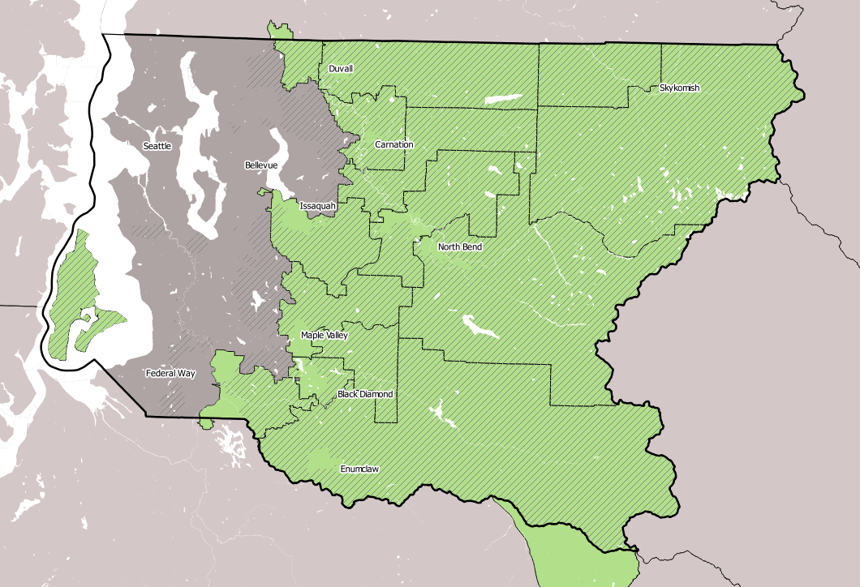
Legend
Rural
Unincorporated
Demographics
A total of 208,406 individuals (10.4 percent of the population) live in rural areas of King County. Compared to the entire county, a greater percentage of the rural population is white, a lower percentage is Hispanic/Latino, and a lower percentage speaks English less than “very well.”
There is less racial and ethnic diversity in rural King County compared to the county as a whole.
 | All of King County | Rural King County
Population, N (% of county) | 2,008,997 (100%) | 208,406 (10.4%)
Age, % of population
Under 5 years | 6.2% | 6.1%
5-19 years | 17.5% | 21.6%
20-24 years | 6.6% | 4.5%
25-64 years | 58.2% | 57.1%
65+ years | 11.6% | 10.8%
Race, % of population
White | 68.9% | 84.9%
Black | 6.2% | 2.1%
American Indian/Alaska Native | 0.7% | 1.1%
Asian | 15.2% | 5.8%
Hawaiian/Pacific Islander | 0.8% | 0.1%
Other | 2.6% | 1.3%
Two or more races | 5.6% | 4.6%
Hispanic/Latino ethnicity, % of population | 9.2% | 5.6%
Speaks English less than “very well”, N (% of population over age 5) | 10.7% | 3.7%
Source: U.S. Census Bureau, 2010-2014 American Community Survey 5-Year Estimates
Economic indicators
There are 15,155 people in rural King County whose income is below the federal poverty level ($24,300 for a family of four in 2016). A smaller percentage of individuals in rural King County have an income less than the federal poverty level compared to the county as a whole.
The percent of people in rural King County who are low-income is less than the county as a whole
 | All of King County | Rural King County
Income<100% federal poverty level, N (%) | 233,458  (11.8%) | 15,143  (7.3%)
Income<200% federal poverty level, N (%) | 483,335  (22.4%) | 33,325  (16.1%)
Educational attainment for those > 25 years, %
Less than a high school diploma | 7.9 % | 5.4%
High school diploma or equivalency | 16.7% | 20.9%
Some college | 20.1% | 25.1%
Associate’s degree | 8.2% | 8.8%
Bachelor’s degree | 29.2% | 26.5%
Graduate or professional degree | 17.8% | 13.3%
In the labor force, % of population >16 years | 69.6% | 69%
Unemployment, % of those >16 years in the labor force | 7.2% | 6.9%
Households that are owner occupied | 57.5% | 77.6%
Households with rent > 30% of their income (% of households in rental units) | 45.6% | 43.3%
In the past 12 months was “always” or “usually” worried or stressed about not having enough money to pay rent/ mortgage | 10.8% | 15%
In the past 12 months was “always” or “usually” worried or stressed about not having enough money to buy nutritious meals | 6.1% | 7.4%
Source: U.S. Census Bureau, 2010-2014 American Community Survey 5-Year Estimates and Center for Disease Control, 2014 Behavioral Risk Factor Surveillance System
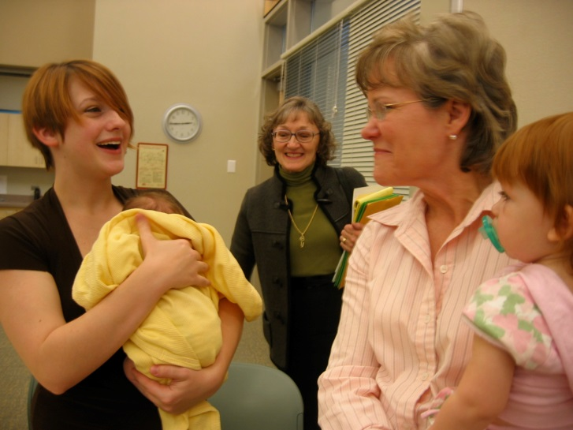
King County Councilmember Kathy Lambert attends the VHSL Joint Oversight Board meeting held in her district to learn more about levy-funded services for new mothers (April 2008). Here she gives one of those mothers a helping hand.
Wellbeing Services and Social Support
Indicators of wellbeing and social support from a large national survey suggest that overall, health and community support networks for people in rural areas are similar to if not better than the entire county.

 | All of King County | Rural King County
Self-reported health is “good”, “very good” or “excellent” % | 87.4% | 91.0%
Frequent mental distress (>14 poor physical health days in the past 30 days) | 9.1% | 8.5%
Frequent physical distress (>14 poor physical health days in the past 30 days) | 9.5% | 7.9%
Report having at least one person that they can count on for practical help, % | 93.3% | 94.5%
Report that people in their community do favors for each other “often” or “very often”, % | 39.1% | 45.6%
“Agree” or “strongly agree” that adults in the community watch out that children are safe and don’t get in trouble, % | 69.7% | 75.8%
Has trouble doing errands along because of a physical, mental, or emotional condition, % | 4.6% | 4.2%
Individuals at least 65 years living alone | 31.2% | 23.4%
Source: U.S. Census Bureau, 2010-2014 American Community Survey 5-Year Estimates and Center for Disease Control, 2014 Behavioral Risk Factor Surveillance System
Homelessness
King County tracks all unique individuals who are experiencing homelessness and who access services. In 2015, 23,166 individuals whose last permanent address was in King County experienced homelessness and accessed services. Approximately 374 of these individual’s last permanent zip code was in a rural area.

Community Services Needs
The Crisis Clinic operates King County 2-1-1, a call center staffed by information and referral specialists who can help direct callers to agencies that offer services. The 2-1-1 call logs provide an indication of the human services needs of individuals in King County who have called. In 2015, there were 99,078 calls for 137,297 human service needs. A total of 3,417 callers with 4,888 human service needs identified themselves as being from a rural zip code. Over 40 percent of calls from both rural King County and King County as a whole were related to housing, including immediate needs for shelter, financial assistance for housing and housing legal assistance. Rural King County had slightly higher needs for all legal aid, especially related to family legal issues.
Most 2-1-1 calls were related to housing needs
Need reported in 2-1-1 calls | Rural King County (N=4,888) | All of King County (N=127,297)
Abuse, assault and human trafficking | 0.2% | 0.2%
Animal services | 0.3% | 0.2%
Basic Assistance
Food | 3.5% | 4.0%
Housing | 23.3% | 27.7%
Other | 4.0% | 4.3%
Behavioral Health
Mental health | 2.2% | 1.5%
Substance abuse | 0.7% | 0.8%
Communications | 0.8% | 0.8%
Community resources | 3.7% | 1.6%
Dependent care (children and older adults) | 4.1% | 3.4%
Disaster assistance | 0.0% | 0.1%
Employment and education | 1.0% | 0.9%
Federal and state assistance and benefits programs | 2.3% | 1.5%
Financial
Housing | 12.2% | 12.0%
Other | 13.5% | 12.0%
Health and disability | 3.3% | 2.3%
Legal
Criminal | 0.2% | 0.2%
Family | 4.8% | 2.6%
Housing | 5.2% | 4.0%
Other civil legal | 5.0% | 4.4%
Other | 9.6% | 15.2%
Strategies for Meeting Human Services Needs of Rural Residents
Although rural areas in King County do not have the highest concentrations of vulnerable populations in the county, vulnerable populations in rural areas may face unique challenges due to their geographic location. There is little research that focuses on identifying evidenced-based practices for human services delivery in rural areas. More effort has focused on developing best practices for delivering health care in rural locations.
Increasingly this research points to the importance of integrating rural health and human service delivery for low-income families in rural areas. The Rural Health Information Hub’s Services Integration Toolkit describes eight evidence and promising models: co-location of services, one-stop shop, technology and telehealth, care coordination, school-based services integration, multigenerational approach and worksite model. Any of these tools might be explored as VHSL-funded enhancements for the rural areas. Observations from the community meetings support the need for greater coordination between services to reduce barriers for rural vulnerable populations in King County.

Diversion and Reentry for Criminal Justice-Involved or Incarcerated Persons

The VHSL Guidance Motion directs analysis to inform the Council’s decision about whether a renewed levy should include a strategy to “enhance reentry services for criminal justice system-involved and incarcerated persons.” In addition to analyzing what role reentry services might play in a renewed VHSL, this section also analyzes the potential role of criminal justice system diversion strategies in a renewed VHSL. This section discusses reentry and diversion in four parts:

- Introduction
- Who is in King County’s jails?
- Opportunities to enhance reentry services
- Opportunities to promote criminal justice system diversion.

Introduction
There are approximately 28,000 unique adults and 2,000 youth who are booked into King County jails or youth detention each year.

The current VHSL supports important parts of a continuum of services for justice-involved veterans and families. These levy-funded programs include mental health care in the County’s Regional Veterans Court, the Veterans Incarcerated Program and Passage Point. These programs focus on reentry and provide essential services to help veterans and families rejoin society after incarceration. When asked during community engagement and topical research, community members and criminal justice system stakeholders consistently acknowledged the value of reentry programming but then highlighted a clear emphasis on diversion.

The underlying idea of prioritizing diversion is that many of the traumatic effects and collateral consequences of justice-system involvement occur at the initial point of arrest and during pre-adjudicative procedures. When the criminal justice system is used to provide health, recovery and other interventions that could more effectively be provided by health and human services agencies, the result is that the person receives more expensive, less effective care that actually erects barriers to health and self-sufficiency. In cases where criminal justice system contact is more attributable to conditions of mental health, addiction or disproportionate practices of enforcement, the most effective strategy to prevent the fiscal and moral costs of using the criminal justice system to provide human services is to prioritize diversion away from the system rather than reentry to society after being part of the system.

Who is in King County’s Jails?
The King County adult jail population includes a wide range of individuals including,
- Individuals who have been arrested of a new crime by King County Sheriff’s department or police departments that contract with King County jails
- Individuals who have not complied with court requirements
- Individuals who have been convicted of crimes, normally with sentences of 364 days or less.

Approximately 28,000 unique individuals are booked into the King County Correctional Facility or the Regional Justice Center annually.

Black adults are overrepresented in King County jails
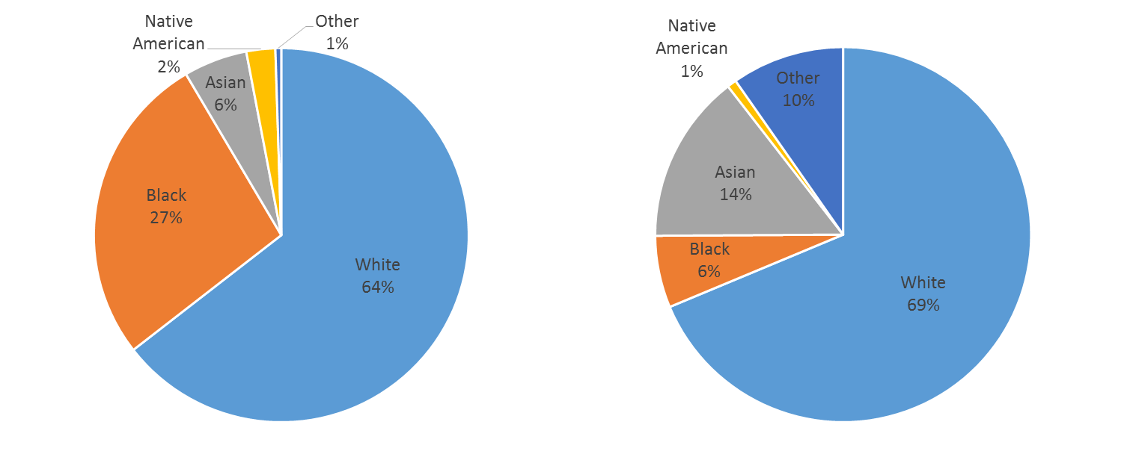
King County Jail Population (2009)
King County Population (2010 Census)

Based on a 2009 cohort analysis, individuals who identified their race as black or Native American are overrepresented in the King County jail population. One notable gap in this race data is the inability to identify the Latino and multiracial populations. These race/ethnicity categories are currently not available. Understanding of the disparities that exist in the criminal justice system is incomplete without information on Latino and multiracial individuals.

Non-compliance is the most common offense for individuals booked into the King County jails
Non-compliance is the most common offense associated with the index of King County jail bookings of the 2009 cohort that was studied. More detailed data describing the type of non-compliance is essential for understanding which incarcerations could have been avoided with greater flexibility in the court system or diversion programs. Detailed offense data is not currently linked to jail booking data. It is important to note that the data used to describe the general King County jail population is from 2009. Without more detailed information on the offense it is not possible to tell which individuals that were booked into the jail in 2009 would have qualified for current diversion programs.

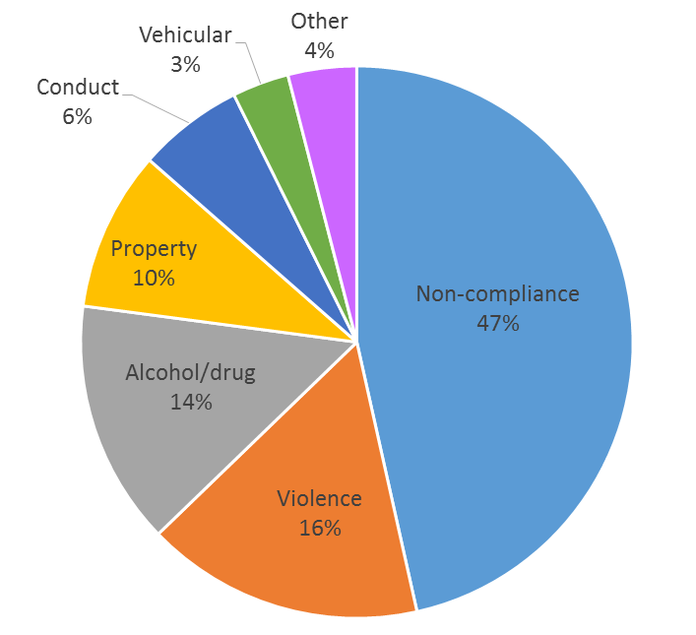

A large percentage of the King County jail population has a history of substance use disorder or a psychiatric condition
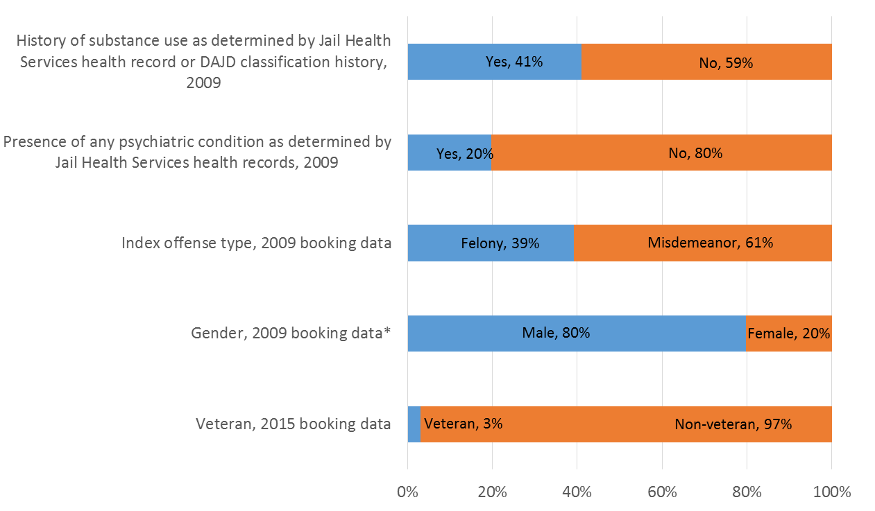
* Data is not collected on the number who identify as transgender

A large percentage of the jail population (41%) has a history of substance use noted in their Jail Health Services record or indicated by their Department of Adult and Juvenile Detention (DAJD) classification. Similarly, a large percentage (20%) of the jail population has a psychiatric condition determined by Jail Health.

Since there is no universal screening for mental health and substance use disorders, the estimates of substance use disorders and mental illness likely underestimates the total number of individuals with behavioral health challenges. These data do not reveal the number of individuals with co-occurring mental health and substance use disorders.

Individuals with behavioral health disorders are much more likely to return to the King County jails
Based on the same 2009 cohort study, 37 percent of the 2009 King County jail population was booked into a King County jail again within three years. Individuals with a psychiatric condition or substance use history are over 2.5 times more likely to return to King County jails within three years compared to those who do not.

Data Gaps
The biggest data gap is data about individuals’ risk of recidivism based on needs such as housing, employment, financial resources and social networks. DAJD will begin to use the Static Risk and Offender Needs Guide-Revised (STRONG-R), a validated risk assessment, in 2017.

Additionally data are unavailable to track an individual’s experience throughout the criminal justice system including law enforcement contact, charges filings, court outcomes and incarceration. The ability to link municipal law enforcement data, sheriff’s data, court data and jail data would enable examination of the detailed reasons that led to detention. These data systems are not yet linked.

High Utilizers
In 2014, high utilizers of the King County jails were selected as a focus population for the King County Health and Human Services Transformation Plan. “Familiar Faces” were defined as those with four or more King County jail bookings in a calendar year. A 2016 report examined the characteristics of the Familiar Faces populations in 2013 and 2014.

The 2016 Familiar Faces study examined the three months before and year following the initial booking for the 2013 Familiar Faces cohort. They found:
- Fifty-nine percent had an indicator for homelessness.
- The most common “most serious offense” in the study window was non-compliance (41%) followed by property (18%) and drug (13%) offenses.
- Most Familiar Faces had either four (51%) or five (23%) bookings in 2013.
- The length of stay for 52 percent of Familiar Faces was seven days or less.

Almost all Familiar Faces had either a psychiatric or chemical dependency diagnosis

Percent of 2013 and 2014 Familiar Faces combined*
N=1,273 for 2013
N=1,252 for 2014
Psychiatric or chemical dependency diagnosis | 94%
Age, years
18-24 | 21%
25-34 | 37%
35-44 | 22%
45-54 | 16%
5-64 | 4%
65+ | <1%
Gender
Male | 84%
Female | 16%
Race
White | 51%
Black | 40%
Native American | 4%
Asian | 5%
Other | 1%
Acute medical condition | 93%
Chronic medical condition | 51%
*An individual could be a Familiar Face in both 2013 and 2014

Opportunities to Enhance Reentry Services
The current VHSL focuses its reentry investments on serving incarcerated veterans and reentering families. Interviews with incarcerated focus group participants, stakeholder engagement with the King County Reentry Workgroup, and research identified several key service gaps that limit the effectiveness of current reentry efforts.

- Release planning should begin at booking, be coordinated to reentry resources and follow the Risk, Need Responsivity principle
A need frequently mentioned by the Reentry Workgroup and symposium participants was to begin reentry planning as early as possible when individuals are booked into King County jails. Reentry planning should be based on the Risk, Need, Responsivity principle which involves using a validated risk assessment and planning based on an individual’s specific needs and an individual’s risk of reoffending.

Incarcerated focus group participants frequently mentioned that reentry planning should span the entire period of incarceration through post-release reintegration. A Reentry Center that provided centralized services would help individuals follow through on reentry plans and remove barriers to accessing resources. Currently, many who are released from King County jails struggle to follow through with social service, medical and behavioral health referrals.

Another example of the need to start reentry services early and then continue them during and after release is around substance use disorders and the ability to begin medication-assisted treatment for opioid addiction in jail. Currently, Therapeutic Health Services or Evergreen Treatment Services will continue to serve clients who have already begun methadone treatment. However, Jail Health has not been able to qualify as a health clinic that can dispense methadone to individuals who would benefit from methadone treatment but have not yet begun. While jail is not an ideal therapeutic recovery environment, time spent in jail could be used to focus on recovery before release.
- Housing options are limited for those released from King County jails
Housing for those released from King County jails was the most frequently mentioned need in incarcerated focus groups. Many incarcerated persons are released from jail directly into homelessness, often at times outside of business hours for service organizations. Under these circumstances, newly released King County residents find themselves in an immediately unstable situation where previous investments in reentry can be quickly mooted as the recovery and good intentions give way to the difficulties of finding a place to sleep safely.

For those who secure short-term shelter immediately upon release, there are still many barriers to follow-on housing for individuals with a history of incarceration, including:

- Disqualification based on criminal history for some public housing options
- Preference of many landlords to individuals without a criminal history
- Lack of supportive housing options for those who need it
- High cost of housing.
Workgroup and Symposium participants point to the need for both immediate shelter after release from jail and long-term options that account for lasting barriers described above.
- There are many barriers to employment for those released from King County jails
The lack of employment is also risk factor for recidivism. Yet, individuals with a history of incarceration face many barriers to employment including:

- Employers preference to hire individuals without a criminal history
- Need for job training
  - Need for job settings where individuals have opportunities for success
- Instability in housing, healthcare and recovery making employment difficult.

Opportunities to Promote Criminal Justice System Diversion
Experts in the Reentry Workgroup expressed concern that many individuals are incarcerated due to underlying human service needs such as mental illness, substance used disorders and homelessness.
The Reentry Workgroup identified gaps that, if filled, could reduce incarceration rates for individuals who actually need human services. The need for these resources was also mentioned at many community meetings and at the Sequential Intercept Symposium.

- Behavioral health services are needed on demand before a crisis
Access to behavioral health resources 24 hours a day, seven days a week would better meet the needs of individuals with mental illness and substance use disorders. Most diversion services operate during business hours and cannot flexibly meet clients’ needs when they are in crisis. There are not sufficient flexible resources to meet clients’ needs to prevent behavioral health crises. Jails are run all day and night, but treatment resources rarely are.

- “Divert to What?” First responders need places to divert people to when they are in crisis and need training to use diversion resources
The Reentry Workgroup described that there is only one alternative location to take people who are experiencing a behavioral health crisis - the Crisis Solutions Center. The Crisis Solutions Center model needs to be expanded to become the default way that behavioral health crises are handled. First responders need training to accurately identify when behavioral health crises are primarily responsible for a person’s actions such that treatment would be more effective than jail. First responders who participated in the community engagement process agreed that diversion can be a better solution in many situations, and they instead focused on highlighting how few useful diversion facilities exist. A renewed VHSL may be able to invest in resources that can help answer the question, “divert to what?”

- Create opportunities for law enforcement to interact positively with community members
Raising awareness of implicit bias among law enforcement; building relationships between law enforcement and communities; giving all officers more opportunities to play a positive role such as participating in Law Enforcement Assisted Diversion (LEAD); and using a validated checklist rather than discretion to assess whether to arrest a suspect are all ways that police could begin to change practices. Creating additional opportunities for diversion and teaching officers when these strategies are appropriate could also contribute to reducing racial disproportionalities.

- Arrest, incarceration and criminal history have lasting effects; alternatives are needed
Arrest, incarceration and criminal history impact individuals’ psychological well-being and future housing and employment opportunities. The Reentry Workgroup highlighted the need for Restorative Justice as an alternative to filing charges for both adults and youth.

In King County, youth may be eligible for Restorative Justice for non-violent crimes. Through the Restorative Justice process a Community Accountability Board determine consequences for the behavior in partnership with the youth, victims, community members and family. No charges are filed unless the youth fails to comply with the consequences. However, there is no Restorative Justice option for individuals over 18 years old in King County despite the growing evidence that brain’s impulsivity control does not mature until approximately age 25.

survivors of Human Trafficking: Labor trafficking and commercially sexually exploited youth

There is limited local data about the extent of labor trafficking and commercial sexual exploitation of adults and children, and experts in this field identify improving data collection and analysis as a goal as work in this area progresses.
New Council Action: In an effort to address the lack of information about this problem, the County Council inserted a budget proviso in the recently enacted 2017-2018 Budget Ordinance, Ordinance 18409, Section 20, Proviso P1 directing the Executive to “transmit a report and a work plan on options to assess and address the systemic issue of labor trafficking and trafficking related exploitation in King County.” The Office of Equity and Social Justice will likely convene a work group of representatives from the Department of Community and Human Services, the King County Sheriff’s Office, the Prosecuting Attorney’s Office (PAO), Council staff and other appropriate community representatives to assist in the development of the report, due March 31, 2018.
Key Facts and Demographics
Human trafficking is the act of compelling a person into any form of labor against their will. Human trafficking can occur in any industry, including agriculture, construction, domestic service (e.g. housekeeper, child care), restaurants, salons, commercial sex work, massage parlors, and small businesses. Victims of human trafficking include children involved in the commercial sex trade, adults age eighteen or over who are forced, coerced or deceived into commercial sex acts, and anyone forced, coerced, or deceived into different forms of "labor or services." If the victim of the crime is under 18, force, fraud or coercion is not required to commit the crime of trafficking.
Human trafficking is commonly known as a form of modern-day slavery. According to the Federal Bureau of Investigation, human trafficking is the second most lucrative criminal industry worldwide, after drug trafficking, bringing in approximately $32 billion annually. The U.S. Department of State estimates that as many as 17,500 foreign nationals are trafficked into the U.S. every year, and the National Report on Domestic Minor Sex Trafficking suggests that between 100,000 and 300,000 domestic minors are trafficked within the borders of the United States.
Victims are often controlled physically, emotionally and financially. Escape is difficult because victims of human trafficking are often invisible. Some don't speak English. They are afraid to approach authorities because they fear threats of harm against their families or deportation. They may have no idea where they are or how to get help, and they may be ashamed. The trauma of human trafficking can be so great that many may not identify themselves as victims or ask for help, even in highly public settings.
Washington is considered to be a “hot spot” in an international human trafficking circuit between the United States, Mexico, Hawaii, Japan, Thailand and the Philippines.
Three common forms of human trafficking are the focus of this analysis – labor trafficking, commercial sexual exploitation of adults and commercial sexual exploitation of children.
- Labor Trafficking: Victims of human trafficking include anyone forced into different forms of "labor or services," such as domestic workers held in a home, or farm workers forced to labor against their will. Human trafficking is a crime under federal law. Washington State has been described as a focal point for the recruitment, transportation and sale of people for labor. In 2003, Washington was the first state to criminalize human trafficking. In 2012, the state adopted twelve human trafficking bills, making Washington State a model for comprehensive anti-human trafficking laws. Very little is known about the issue of human labor trafficking and exploitation in this region. Advocates state that they do not have good data on the extent of this hidden problem, but know it occurs and welcome a process to understand the nature of the problem in the County. Some advocates consider labor trafficking to be an overarching term that includes commercial sexual exploitation and trafficking. Others distinguish labor trafficking from commercial sex trafficking.
- Commercial Sexual Exploitation of Adults: Commercial Sexual Exploitation of adults includes prostitution, street or internet-based exploitation, pornography, stripping, phone sex, and other “businesses” in the sex industries that may be illegal or legal, and involve money transactions or other exchanges for sexual activity. King County experts state that because adult victims of commercial sexual exploitation were treated until recently as criminals in the justice system, there are significant gaps in understanding the scope of the adult survivor population and the services they need.
- Commercial Sexual Exploitation of Children (CSEC): The community’s response to commercial exploitation of children has been more robust since the 2008 publication of “Who Pays the Price?” Commercial sexual exploitation of children occurs in King County. Professionals from many disciplines across the state have identified and worked with child and youth victims. Trafficking and exploitation happen in both the County’s urban and rural areas. Approximately 300-500 youth are exploited each year in King County.
King County’s Response to Human Trafficking
King County government has actively sought to address human trafficking in various ways, including:
- The Prosecuting Attorney’s Office (PAO) works collaboratively across the region with law enforcement and other organizations to bring a coordinated response to human trafficking, especially as it relates to commercial sexual exploitation. The King County Sheriff’s Office Street Crimes Unit has made the reduction of child sexual exploitation a major emphasis and works throughout the County, especially in southern King County, targeting prostitution and pimps.

- The County Council initiated and supported countywide policies and activities aimed at addressing human trafficking. In 2011, King County recognized the link between runaway and vulnerable youth and transit by designating King County Metro buses as a National Safe Place partner. Safe Place is a community initiative that designates schools, fire stations, libraries and transit as Safe Place sites where youth can access help and supportive resources.

- In 2012, via Motion 13694, the Council called for the Executive and Metro to develop an anti-human trafficking transit public awareness campaign. The campaign, launched in January 2013 to coincide with International Human Trafficking Awareness Day, involved over 200 buses in King County reaching thousands of citizens. The public information campaign raised awareness of the signs of human trafficking, both labor and commercial sexual exploitation, leading to an increase in call volume to the National Human Trafficking Hotline.

- In 2013, the Council also adopted two human trafficking related provisos placed in the Sheriff’s Office and Public Health budgets. The reports established a comprehensive roadmap for the County in its efforts to end human trafficking and commercial sexual exploitation in the region.

- King County Superior Court, in partnership with the Center for Children and Youth Justice (CCYJ), has developed plans and programs to address CSE children. The King County Commercially Sexually Exploited Children (CSEC) Task Force convened on April 18, 2013 to develop and implement a coordinated, countywide response to childhood prostitution.

Common/Key Indicators, Metrics or Indices
Buyer Beware - A Partnership to End Commercial Sexual Exploitation, with its focus on carrying out a comprehensive strategy to reduce demand and facilitate exit from prostitution, provides the best source of information about the commercial sexual exploitation problem in King County.
More is known about the problem of commercial sexual exploitation of children in King County, primarily because of the work of Debra Boyer in “Who Pays the Price? Assessment of Youth Involvement in Prostitution in Seattle,” a 2008 report commissioned by the City of Seattle.
Victims of all forms of human trafficking, including adults and children, may live among us but are often linguistically and physically isolated within local communities. Populations that are often targeted are immigrants, people of color, low-income persons, the homeless, people with disabilities and children. This subordinate status and vulnerability that funnels members of marginalized groups into labor trafficking and commercial sexual exploitation raises issues of equity and social justice. Many people subjected to labor trafficking and commercial sexual exploitation would benefit from access to civil legal resources to address housing, labor, child support, public benefits and other legal needs. To the extent that the VHSL renewal process considers the equity and civil legal needs within the community, these populations should be included in this process.
Key Population Needs and/or Issues
Since 2009, King County and City of Seattle law enforcement agencies and prosecutors have pivoted away from enforcing commercial sexual exploitation laws against prostituted individuals and towards enforcement against buyers of commercial sex. The vast majority of buyers of commercial sex are white men and a disproportionate number of victims of commercial sexual exploitation are women of color. Addressing this reality promotes the County’s equity and social justice goals.
Since 2013, police and prosecutors have taken a much more aggressive approach with buyers who exploit victims, but additional resources are necessary to address demand through prevention, disruption, intervention and accountability. Needs of the adult CSE victim population includes:
- Lack of coordination of efforts
- Full assessment of the scope of the problem
- Training to work with CSE victims
- Service gaps
- System advocates
- Male accountability
- Insufficient shelter for victims
- Civil legal aid
- Employment resources.

Potential VHSL-Funded Programs, Activities or Strategies
The VHSL Guidance Motion directs analysis to inform the Council’s decision about whether a renewed levy should include “a strategy or strategies to tailor services for particular populations whose circumstances warrant specialized approaches, including sexually exploited youth [and] victims of human trafficking.”

The need for improved internal coordination remains a concern of human trafficking and CSE advocates, including better communication between separately elected officials. Beyond better coordination and cooperation, other possible programs, activities, or strategies in the areas of labor trafficking and commercial sexual exploitation of adults and children are as follows:
- A New Adult Survivor Collaborative: This collaborative funded by the City of Seattle Adult Victims Services funds $200,000 for case management and advocacy to serve 100 women per year within Seattle, but additional demand for outreach and services exists throughout the county and these services could be expanded and enhanced.
- Buyer Beware: A Partnership to End Commercial Sexual Exploitation: A King County initiative (endingexploitation.com) is a collaboration that brings together victims, community services organizations, businesses and local prosecuting authorities to carry out a comprehensive strategy to reduce demand and facilitate exit from prostitution.
- Stopping Sexual Exploitation (SSE) - A Program for Men: A program that addresses the demand for CSE and is based on principles of social justice and personal transformation designed to help men understand their behavior and promote their own decisions to not buy sex. Expanding approaches to deal with demand for CSE should be considered.
- Seattle Against Slavery (SAS): In partnership with SAS, King County launched an anti-human trafficking ad on buses and billboards in multiple languages. The “No One Should be Forced” ads continue to raise awareness. Ongoing support for these efforts should be considered.
- Trafficking Prevention for Schools (TPfS): The first curriculum of its kind that works to empower young people to become allies in the fight against human trafficking. TPfS aligns with violence prevention, health and safety curricula already being taught at the middle school level. SAS currently provides trafficking prevention in 13 schools involving 1,000 students. With additional funding, more training of this kind could occur.
This analysis was made possible by working with local experts, stakeholders and organizations that work with victims of human trafficking. All would be pleased to work with VHSL staff in the future. They include staff of the PAO and the Seattle City Attorney’s Office, Buyer Beware, Seattle Against Slavery, Businesses Ending Slavery and Trafficking (BEST), Organization of Prostitution Survivors, King County Council staff, DCHS staff, Commercially Sexually Exploited Children (CSEC) Task Force, Center for Children and Justice, YouthCare, StolenYouth, Coalition of Immigrants, Refugees and Communities of Color (CIRCC), Refugee Women’s Alliance (ReWA) and others.

Domestic Violence

This analysis explores demographics, needs, programs and services available for survivors of domestic violence and how the VHSL-supported programs could better serve those in need. The description of the needs of individuals who have experienced domestic violence is based on expert interviews with domestic violence service providers and staff from the King County Prosecuting Attorney’s Office (PAO).

Issues and Needs
At least 14,000 individuals experience domestic violence in King County each year. The most reported domestic violence incidents occurred in Seattle and South King County. An examination of King County data and subject matter expert interviews yielded three major themes:
- Domestic violence is an underlying cause of housing instability and homelessness for many.
- There are gaps in current services for individuals who have needs other than housing, older adults, those who have experienced sexual assault and those with civil legal needs. Services should be delivered in a culturally competent way in locations that are convenient for clients.
- The protection order process, law enforcement agencies and court system are not currently client-centered and additional resources are needed in order to conduct thorough investigations.
The number of individuals impacted by domestic violence is difficult to estimate since many incidents of domestic violence are not reported to law enforcement. In the context of this limitation, the following analysis of law enforcement is a conservative estimate of the number of incidents. In 2015, law enforcement responded to incidents that involved 14,233 victims of domestic violence in King County. In 2015, most victims of domestic violence incidents reported to law enforcement were female and most incidents occurred in South King County or Seattle.
Characteristic | Number (percentage) of victims
Gender
Female | 9,871 (69%)
Male | 4,287 (30%)
Unknown | 75 (1%)
Age, in years
0-18 | 1,782 (13%)
19-24 | 2,261 (16%)
25-34 | 3,748 (26%)
35-44 | 2,639 (19%)
45-54 | 2,123 (15%)
55-64 | 1,012 (7%)
65-74 | 396 (3%)
75+ | 136 (1%)
Unknown | 136 (1%)
Location
Unincorporated King County | 1,120 (8%)
Incorporated Urban North King County: Shoreline, Bothell, Woodinville | 637 (4%)
Incorporated Rural East King County: Duvall, Carnation, Snoqualmie | 108 (1%)
Incorporated Urban East King County: Kirkland, Bellevue, Redmond | 1,330 (9%)
Incorporated Urban South King County: Tukwila, Renton, Kent, Auburn | 6,146 (43%)
Incorporated Rural South King County: Maple Valley, Covington, Enumclaw | 319 (2%)
Seattle | 4,573 (32%)
Data source: Washington Association of Sheriffs and Police Chiefs and the King County Sheriff’s Office

Since race and ethnicity data was not collected consistently among law enforcement agencies, it is not possible to analyze race and ethnicity of victims for this report.
Injury and Death. In 2011, 16 percent of women and 1 percent of men at least age 18 years old report being injured by an intimate partner at some point in their life. In 2015 there were 54 domestic violence fatalities in Washington State. Four of these occurred in King County. A total of 4,195 individuals sought domestic violence protection orders as walk-in clients in 2015.
Homelessness. Domestic violence is often an underlying cause of homelessness or housing instability. In 2015, 5,023 people who were experiencing homelessness and seeking housing services were currently experiencing domestic violence or had experienced domestic violence in the past. Seventy nine percent of these individuals were female. Of those who had any domestic violence history, 372 were currently fleeing a domestic violence situation. Ninety three percent of these individuals were female.
Domestic Violence Strategies. The VHSL Guidance Motion directs analysis as to whether a renewed levy should include “a strategy or strategies to provide investments in services for survivors of domestic violence and people experiencing domestic violence.” The following service areas could be enhanced with VHSL investments.
Housing. Domestic violence is an underlying cause of housing instability and homelessness for many. As described in the previous section, over 5,000 individuals who sought housing assistance in 2015 had a history of domestic violence. Service providers described the immediate need for shelter and long-term housing options for domestic violence survivors. Eviction history and debt make it challenging for many survivors of domestic violence to hold a lease in their own name. Outreach to landlords and funding for community based organizations to provide six to twelve month rental guarantee is needed. A bright spot is the new Best Starts for Kids-funded Youth and Family Homelessness Prevention Initiative. Based on a very successful domestic violence pilot funded by the Bill and Melinda Gates Foundation, the new program will help families, including those fleeing domestic violence, and help save children from ever experiencing the trauma of homelessness. The program launched in December 2016.
Community Services. There is a lack of services for single adults and families who are not imminently at risk of homelessness. Services for individuals with children and those experiencing homelessness are prioritized among many funders. This leaves single adults and families who are not imminently at risk of homelessness with fewer resources. Providers were in agreement that services for children that are not housing-related, such as therapy, are another large unmet need.
Elder Abuse Services. Elder abuse services need to be part of domestic violence agencies. Services specific to elder abuse are not typically part of current community-based domestic violence services.
Sexual Assault Services. Many who have experienced domestic violence have experienced sexual violence. Providers described the high percentage of clients who experienced sexual assault as part of the domestic violence they experienced. These clients need to be connected to appropriate sexual assault resources as well as domestic violence services.
Legal Services. Domestic violence survivors often have many civil legal needs including assistance with protection orders, parenting plans, divorce, evictions, immigration and employer responses to an abuser disrupting the work setting. Navigating these legal needs is a challenge. Beginning in 2017, Legal Navigators will be available at King County courts to help clients with civil legal needs access appropriate legal services. This program is partially funded by Victims of Crime Act funds, but lacks full funding.
Even though domestic violence clients often have many legal needs, much of the civil legal aid available to domestic clients focuses on protection orders for those at highest risk of physical harm due to a lack of capacity. Each of these cases requires more resources since more respondents have representation. Protection order advocates through the Prosecuting Attorney’s Office also lack capacity. Advocates focus on assisting clients complete the protection order paperwork but often do not have the resources to conduct a comprehensive investigation. (See also the section on Civil Legal Services.)
Culturally Competent Services. Culturally competent services are needed to build client trust and enable service providers to effectively advocate for clients, including those who speak no or limited English and for those with cultural barriers to seeking help.
Co-located and Mobile Services. Providers described that when mental health and legal services are available at community-based domestic violence organizations clients are much more likely to follow up on a referral. More opportunities for these “warm hand offs” are needed. There is a particularly large disconnect between Prosecuting Attorney’s Office Protection Order Advocacy Program and services provided by community-based organizations. Similarly, mobile services are needed to meet the needs of clients and encourage follow-up on referrals. Currently, there are some mobile advocacy services but in almost all cases, individuals need to file for a protection order in person.
Effective Treatment for Batterers. As a result of a Washington State Institute for Public Policy meta-analysis, there is a general perception that treatment programs for batterers do not work. Providers described that only a few treatment programs available in King County are long enough and have sufficient behavior modification strategies to be effective. Judges do not often refer batterers to programs and many judges that do refer batterers to programs do not understand the differences between effective and ineffective programs.
Funding for Coordination of Services. Direct service providers and the Protection Order Advocacy Program both mentioned the importance of coordinating domestic violence efforts. Providers described the importance of an organization like the Coalition Enduring Gender-based Violence in coordinating efforts and advocating for system-based changes. One strategy that is not as well coordinated is the 24-hour hotlines. Providers described that resources are needed to streamline these services which are currently being provided by multiple community-based organizations. King County experts felt that the county’s domestic violence efforts across departments are not well coordinated due to a lack of funding for collaboration and communication across departments.
Prevention. Providers and protection order advocates described the lack of resources for prevention such as teaching about healthy relationships in the schools. Without upstream prevention efforts domestic violence will continue to impact many in King County.
Protection Order Barriers. The limited hours of the Protection Order Advocacy Program offices that assist individuals in filing protection orders presents a barrier for many who work. Offices are open 10 a.m.-noon and 1 p.m. to 4 p.m. due to limited staffing. Typically individuals can get a temporary protection order on the same day that they file, but must return for a full hearing in 14 days, creating another logistical challenge for many.
Additionally, the protection order filing process is adversarial. The principle of “innocent until proven guilty” means that the burden of proof is on the victim. The fear of not being believed is challenging for those who have been in abusive relationships. Training judges and commissioners on trauma-informed responses could help shift the tone of hearings.
Translation Barriers. Translation services are available, but the lack of a translator often leads to a hearing delay. This is particularly important since some victims stop pursuing a protection order when there are delays. Others with limited English proficiency are not accessing the protection order system at all.
Law enforcement and judicial training is needed to recognize patterns of domestic violence and provide trauma-informed responses. Many law enforcement officers, commissioners and judges who respond to incidents, administer protection order hearings and administer custody cases are not trained to understand the signs and patterns of domestic violence. Providers were in agreement that law enforcement, commissioners and judges who are not trained often fail to correctly identify domestic violence and do not provide trauma-informed responses.
Slow Court System. Providers noted that it can take up to two years for a domestic violence case to be processed in the court system. Many respondents (accused abusers) have representation, resulting in more hours spent per case by civil legal aid who have limited capacity.
Local Service System
The 2015 Domestic Violence and Child Maltreatment: Coordinated Response Guide provides a detailed analysis of the roles and responsibilities of agencies providing domestic violence and child maltreatment services. The roles of county-funded domestic violence services are described below.
Domestic violence services provided by King County
Service | Provided by
Community-based domestic violence services:  - Advocacy  - Counseling  - Accessing resources such as housing, financial assistance, employment training, legal assistance  - Support groups  - 24-hour crisis lines  - Outreach and professional trainings on domestic violence | Community-based organizations, some have some King County funding through the General Fund; others have funding through Victims of Crime Act (VOCA) or other sources
Domestic violence civil legal aid | Community-based organizations, some have County funding through the General Fund; others have funding through VOCA or other sources
System-based domestic violence advocates | Law enforcement, prosecuting attorney or municipalities
Protection Order Advocates | King County Prosecuting Attorney’s Office
Domestic violence shelter and transitional housing | Community-based organizations, some have some King County funding
Law enforcement | Municipal police and King County Sherriff’s Office
Prosecutor’s office – review cases that are referred from law enforcement and determine whether to file charges | Municipal government and King County
King County Superior Court, Family Court Services  - Domestic violence assessments  - Child abuse status reports  - Parenting plan evaluations  - Mediations  - Parent seminar | King County Superior Court

Programs and Strategies
Three main areas emerged, discussed above, as areas for program improvements and enhancements.
Housing
- Outreach to landlords
- Twelve month rental guarantee funding
Service System
- Additional resources for therapy, especially for children
- Onsite or connections to sexual assault resources
- Onsite civil legal services
- Services specific to older adults
- Mobile advocacy
- Culturally competent services
- Service system coordination
- Prevention programs
- Effective batterers treatment
Law Enforcement and Court
- Additional resources for the Protection Order Advocacy Program to investigate cases, offer services outside typical business hours and serve clients remotely
- Domestic violence training for law enforcement officers, commissioners and judges
- Enforcement and investigation for non-compliance on protection orders or relinquishing guns

Civil Legal Services

Civil Legal Services Defined
Civil legal services, also called civil legal aid, are legal and law-related services that assist low-income persons and communities to avoid, resolve or mitigate the effects of non-criminal legal problems. These services help low-income persons and communities in legal proceedings and situations where they may be at risk of losing access to important statuses, services or basic needs that contribute directly to a person’s ability to live healthily and happily within their community. These can include housing, healthcare, employment, disability benefits or the right to remain in the United States.

Key characteristics of civil legal services for the purpose of this report are that they are provided at no cost to low-income persons, they address legal and law-related problems in which a person is not legally entitled to representation, and they encompass a broad range of advice, alternative dispute resolution, and legal representation services. Examples of Civil Legal Services include an attorney guiding an asylum-seeker to allow a refugee to remain safe and present in King County, a mediator helping a low-income housing tenant and landlord resolve a habitability issue to keep the tenant healthy and housed, an accredited advocate or attorney helping a veteran appeal a denial of U.S. Veterans Administration benefits, an attorney representing domestic violence survivor in seeking a protection order, and a legal clinic that helps disabled older adults write wills and medical directives.

Washington’s Office of Civil Legal Aid (OCLA) published in 2015 a Civil Legal Needs Study Update that describes the current state of civil legal need in Washington. The study found that 70 percent of low-income households in Washington face at least one significant civil legal need each year, and that the average number of civil legal problems per household rose from 3.3 in 2003 to 9.3 in 2014. Compounding the issue, the study also found that many low-income people do not recognize when the problems they face have legal dimensions. In all, 76 percent of low-income people do not receive civil legal services to help them address their legal problems. The result is that low-income people too often engage in legal processes that could deprive them of housing, healthcare access, income or other important parts of their lives without the advice or representation that they need to withhold their rights.

Key Issues and Service Needs

King County provides General Fund support for limited civil legal services, one of four DCHS human services program areas that receive General Fund funding. The current VHSL’s activity 1.5.b supports limited civil legal services for low-income veterans. A portion of the County’s Housing Stability Program funds also support limited civil legal services.

The VHSL Guidance Motion directs analysis to inform the Council’s decision about whether a renewed levy should include “a strategy or strategies to increase integration of civil legal services for levy-funded programs or persons served by the levy.” This analysis responds by identifying and analyzing which current or potential levy-supported programs or persons could be better served through integration of Civil Legal Services.

Veterans, Military Service Members and their Families
The U.S. Department of Veterans Affairs annually conducts a national survey of homeless veterans and service providers. The survey consistently identifies that six of homeless veterans’ top ten unmet needs are legal: Legal assistance to prevent eviction or foreclosure, resolve outstanding warrants or fines, resolve child support disputes, reinstate drivers’ licenses, upgrade military discharge status, and authorize financial guardianships.

In addition to national data, VHSL Community Engagement activities identified a clear desire in King County’s veterans community for additional resources to help veterans apply for federal VA benefits. This category of services includes applying for Disability Compensation and related benefits for surviving spouses and dependents, Veterans Pensions, appealing inappropriate denials or reductions of benefits, negotiation of overpayment resolution, and appealing denials of medical care eligibility. Employees within the King County Veterans Program, a VHSL-funded activity that assists more than 2,000 veterans annually, also identified a need for additional assistance with applications and related issues involving VA benefits.

Older Adults
Both King County Bar Association’s Pro Bono Services and the Northwest Justice Project report that recent internal analyses of their caseloads for older adults show that legal issues for housing are the most common civil legal problem for older adults, comprising nearly 40 percent of all issues from both providers. Consumer Law issues such as disputed medical debt and debt collection and Family Law issues (including dissolution of marriage and adult guardianships) are the second and third most common legal issues. Both organizations also report that elder law issues (the group of civil legal issues that is specific to older adults, including issues around elder abuse and exploitation, advance directives, powers of attorney, wills, and estates) make up a smaller but significant portion of the older adult cases that they see.

Homeless Persons and Households at Risk of Inappropriate Housing Loss
Legal processes are often at work when a person or family loses a home or is evicted from a rental tenancy. Aging or disabled residents on fixed incomes and low-income households face a range potential civil legal challenges to their ability to remain housed. Challenges may include tax lien foreclosures or foreclosures for non-payment of utilities and home owners associations, housing loss brought on by code enforcement actions by landlords, displacement of manufactured housing communities (mobile home parks) when landowners sell the underlying land, eviction from rental housing or other issues of non-payment brought on by related civil legal issues such as inappropriate debt collection, inappropriate denial of government assistance, or simply by unforeseen expenses such as medical emergencies.

The same legal processes that contribute to housing loss often also contribute to difficulty being rehoused. Low-income persons face considerable civil legal difficulties in establishing the income stability needed to compete for housing in a high-demand rental market:
  - 43.4 percent of low-income persons face legal problems related to healthcare (in which the most common subissues are problems related to debt).
  - 37.6 percent of low-income persons experience civil legal issues with consumer debt, credit and financial services.
  - 33.6 percent experience civil legal problems in gaining or maintaining employment.
  - 29.6 percent experience difficulty in accessing government assistance.

For these reasons, All Home has identified civil legal services as a necessary component to its strategies to make homelessness rare, brief and one-time. All Home’s Strategic Plan call for an
[i]ncrease to civil legal aid in situations where legal advocacy will prevent homelessness (e.g. access to State and Federal benefit programs, SSI/SSDI, etc., foreclosure prevention, immigration, tenant representation, unemployment benefits, ABD, etc.).

The Strategic Plan identifies the role of civil legal aid making homelessness brief and one-time:
Improve access to civil legal aid to assist populations facing disproportionate levels of homelessness in King County in accessing state and federal benefit programs…. Identify civil legal organizations in King County that can partner with homeless housing providers to deliver civil legal aid to people facing civil legal barriers to obtaining or maintain access to housing.

Immigrants and Refugees
King County’s Immigrant and Refugee Task Force (IRTF) issued a report in 2016 that summarized the findings of an extensive community engagement process undertaken by the IRTF to understand and surface the concerns of immigrant and refugee populations within King County. The IRTF identified several service system gaps with civil legal dimensions, including:
  - Housing issues
    - Discrimination issues with landlords (undocumented people feel particularly vulnerable to abusive landlords), language barriers, lack of advocacy support and legal aid
    - Substandard housing and code violations—people don’t know where to turn for assistance and are afraid to report due to fear of landlord retaliation
  - Civil and criminal justice system issues, issues of youth engagement and community safety
  - Understanding rights and responsibilities in healthcare insurance and access, including healthcare-related civil legal issues involving denial of healthcare due to immigration status and healthcare-related civil legal issues involving denial of interpreter services by a healthcare provider
  - Remedies for discrimination in schools
  - Assistance in navigating issues related to immigration status, including difficulties in seeking housing, employment, healthcare and responding to job-related harassment.

Survivors of Domestic Violence or Sexual Assault
The Civil Legal Needs Study Update identifies survivors of domestic violence or sexual assault as the population that faces more civil legal problems than any other experiential, racial or ethnic group identified within the study. Survivors experience civil legal issues at higher rates, experience more civil legal issues, and require more intensive civil legal services relative to the general low-income population.

Common civil legal issues that survivors identified include obtaining protection orders to protect personal safety, obtaining or modifying parenting plans to keep survivors safe while co-parenting children, establishing or enforcing child support obligations to ensure both parents provide for children, and dealing with housing tenancy issues that may arise when survivors leave unsafe situations but retain legal responsibility for rent and tenancy fees.

Veterans Court Programs

What is a Veterans Treatment Court?
The terms “veterans treatment court” and “veterans court” encompass a variety of courts across the nation that recognize the value to veterans and communities of tailoring the criminal court experience for veterans. Beyond their common recognition that some veterans will respond better to therapeutic approaches, veterans courts vary widely in their approaches, underlying philosophies, resources and eligibility criteria.

Although specific characteristics vary among veterans courts, national organizations recognize key veterans court tenets while leaving particular methods of implementation to individual jurisdictions or courts. Most veterans courts:
- Integrate recovery and mental health treatment into the court process
- Adopt a non-adversarial approach between prosecution and defense that seeks to balance due process rights and public safety
- Provide a continuum of recovery and treatment services
- Monitor substance use abstinence through testing
- Employ a coordinated strategy amongst the court team to incent the veteran’s cooperation and respond to non-compliance
- Recognize the value of ongoing judicial interaction with the veteran
- Monitor and measure program outcomes
- Continuously train veterans court staff
- Cultivate partnerships with federal, state, and local resource providers and veterans organizations.

Beyond these similarities, areas where veterans courts employ differing models and philosophies include:
- Eligibility
In addition to courts’ variations about the types of charges over which they have jurisdiction, veterans courts vary as to which veterans are eligible to participate. Considerations include whether an eligible defendant can be a current service member, whether there should be a requirement of combat experience or service, whether certain types of military discharge should be excluded, whether eligibility to receive VA healthcare is necessary, whether there is a nexus between a charged offense and a mental health or addiction disorder, and whether mental health or addiction diagnosis is related to military service.

Courts also vary as to which types of charged offense are eligible for entry into a veterans court program. While all courts are inherently limited by their jurisdiction as to what types of charged offense they can adjudicate, some veterans courts choose to further limit eligible offenses. Some courts exclude violent offenses or particularly severe felony offenses.

- Post-Completion Disposition
Another consideration in veterans court design is whether successful completion of the program results in complete dismissal of a case, conviction to a lesser charge, or some form of deferred or contingent prosecution. These variations can be particularly complex as mandatory sentencing laws, mandatory jurisdiction durations, and individual case circumstances combine in many ways for particular defendants and their charges.

Veterans Courts in King County
King County is home to three veterans courts or dockets: King County District Court’s Regional Veterans Court (RVC), King County Superior Court’s Adult Drug Diversion Court Veterans Docket, and the Seattle Municipal Court Veterans Treatment Court (VTC).

Jurisdiction is an important point in distinguishing among the three courts. The Seattle VTC’s jurisdiction is limited by Seattle Municipal Court’s overall jurisdiction, focusing it on charged misdemeanors that occur within Seattle. The King County Drug Court’s Veterans Docket is limited to cases that are appropriate and accepted into the Drug Court. The County’s RVC has the broadest jurisdiction of the three, capable of handling misdemeanors within the District Court’s jurisdiction and also capable of having misdemeanor cases from any of the County’s municipalities referred to it. King County Superior Court can also refer a case into the RVC so long as the underlying charged offense is—or is adjusted to be—within the District Court’s jurisdiction. At the time of this report’s writing, RVC staff indicates that a majority of the RVC’s cases come as referrals to the RVC from municipalities within King County, as opposed to coming from unincorporated King County. This analysis of possible veterans treatment court expansion focuses on the County’s RVC because it is the largest and most flexible of the three veterans courts or dockets in King County.

King County’s Regional Veterans Court
King County’s RVC is part of the County’s Regional Mental Health Court. As a part of the Regional Mental Health Court, the RVC is funded by the MIDD. The current VHSL invests in several programs that support or complement the RVC. These include the veterans court clinician, a mental health professional who screens potential participants for the RVC; the Veterans Incarcerated Program, which includes within its services for incarcerated veterans notifying them about the RVC and assisting them in seeking documents to confirm their military service; and the King County Veterans Program, which can provide assistance and connection to local resources including housing for veterans. The RVC also depends upon a strong partnership with the U.S. Department of Veterans Affairs Veterans Justice Outreach (VJO) specialist team, who provides essential connections to medical care and behavioral health treatment at the VA hospital.

The RVC typically maintains 33-42 veterans within its caseload at any given time according to RVC staff. The RVC convenes a weekly calendar in the Downtown Seattle Courthouse.

In all RVC cases, the evidence is reviewed and assessed by the court clinician and prosecuting attorney to determine whether there is a nexus between the diagnosis and criminal act and to confirm that the veteran is willing and motivated to seek treatment and to be supervised by a probation officer for a period of up to two years.

As a part of the screening process, the veteran is assessed for the following:
- nature of the criminal behavior
- history of prior criminal conduct
- nexus between the criminal behavior and diagnostic criteria
- chemical dependency
- mental illness.

The court clinician coordinates with the U.S. Department of Veteran Affairs VJO specialist to link eligible veterans with treatment services at the Veterans Health Administration (VHA). The VJO acts as a liaison between the court, the veteran and the VHA throughout the veteran’s participation in the RVC.

In considering the question of possible expansion of veterans courts as directed by the Council’s guidance motion, this analysis focuses on whether the existing RVC—as the local VTC with the broadest potential jurisdiction—should expand its geographic reach or consider additional programming.

Expand geographic reach
The RVC is limited in its geographic reach by the District Court’s jurisdiction. The current RVC has in place a procedure that allows any municipality within King County to transfer an eligible case to the RVC. Superior Court may also refer some cases. This centralization of a county-wide veterans court function within the RVC allows the RVC’s multiple partners to focus resources.

Resourcing is a key consideration in analyzing whether to expand veterans courts in King County. Successful veterans courts require robust partnership with varied partners. The concentration of services and partnerships that makes veterans courts effective also makes them expensive. The RVC combines a team of assigned personnel from the County’s Prosecuting Attorney’s Office, the Department of Public Defense, Probation, U.S. Department of Veterans Affairs Veterans Justice Outreach Program, State Department of Veterans Affairs, and a network of local providers who can quickly align housing, financial, and non-VA treatment resources to assist an RVC veteran.

Because the existing RVC has the ability to hear cases from across King County and given the expense involved in creating a new veterans court within the County or its municipalities, expansion of veterans courts may be fastest, cheapest and most effectively accomplished by considering ways in which the existing RVC can best serve other areas of the county. If sufficient numbers of cases exist in other regions or cities, the RVC may consider holding an additional calendar in another part of the county. Another option may be to identify technology-based means to conduct some RVC business, although it would be essential to develop such proposals through the RVC’s participants because many of the model’s benefits rely on frequent, interpersonal relationships that technology-based solutions may interrupt or preclude.

Add Mentorship Programming. A possible means of expanding the RVC would be to add the capacity to provide mentorships for the veterans within the court. The National Association of Drug Court Professionals, Justice for Vets publication entitled “Ten Key Components of Veterans Treatment Court” established veteran mentor programs as an essential component of VTCs. A recent study published in the Community Mental Health Journal demonstrates that receiving mentoring as a part of VTC participation is correlated with positive clinical outcomes, in particular, improved social connections and reduced emotional limitations. RVC staff reported the lack of a mentorship program as a gap that, if filled, could elevate the RVC’s effectiveness for veterans.

Oversight Board Structure

BOARD STRUCTURE ANALYSIS AND RECOMMENDATIONS
The current Veterans and Human Services Levy (VHSL) maintains the original VHSL’s citizen oversight board structure. The voter-approved ballot measure for the original VHSL created two citizen oversight boards: the Veterans Citizen Oversight Board (VCOB) and the Regional Human Services Citizen Oversight Board (RHSCOB). The VCOB oversees VHSL funds for veterans, military personnel and their families. The RHSCOB oversees funds for “regional health and human services for a wide range of low-income people in need of such services.”

Key Characteristics of the Veterans Citizen Oversight Board:
- Twelve Members: One appointee from each Councilmember plus three Executive appointees
- The Executive must draw all three Executive appointees from the membership of the King County Veterans Advisory Board

Key Characteristics of the Regional Human Services Citizen Oversight Board:
- Twelve Members: One appointee from each Councilmember plus three Executive appointees
- The Executive appointees must be “poor or represent an organization that is composed of the poor, such as Welfare Rights, Retired Senior Citizens, Seattle Young People Project and others”
- Each of the three Executive appointees must also represent one of four geographic areas of King County: South King County, East King County, and Seattle and North King County.

Key Requirements for Both Boards:
- Members shall be King County residents.
- Members may not be elected or appointed officials of any unit of government.
- Members shall present a diverse, balanced representation of private and public sectors, veterans, community leaders, jurisdictions and human service representatives.
- On or before June 1 of each year, the boards must review and report on the expenditure of VHSL proceeds.

Analysis of Current Board Performance
Both the RHSCOB and VCOB have fulfilled their responsibilities under King County Ordinance 15279. In fulfilling their statutory duty, the VCOB and RHSCOB meet separately once per quarter with an additional joint meeting once per quarter. Boards meet with greater frequency as needed to make time-sensitive decisions. Together, they routinely devote as much as 300 hours of volunteer time annually.

Both boards played a key role in approving implementation plans for each levy activity in the beginning of the levy implementation period. The boards also recommend approval of VHSL annual reports, recommend how under-expended VHSL funds should be reallocated, and review and receive regular reports from VHSL staff and VHSL-funded service providers. In addition to satisfying their statutory responsibilities, board members regularly receive and accept invitations to assess potential capital projects, evaluate responses to Requests for Proposal, and sit as community-based panel members in hiring processes within King County. Both boards have been and continue to be successful.

Identifying Opportunities for Continuous Improvement
In preparation for this report, VHSL staff met with members of both boards to determine how they felt they might improve upon their current structures. Engagement efforts with the boards included a staff-prepared comparison of other King County citizen boards and a 90-minute focus group conducted with each board. Both boards noted that they often have two or more vacancies at a given time. They also agreed that an increased rate of attendance by all members would benefit board operations.

Both boards discussed possible changes of composition, including the inclusion of key institutional partners, increased input from service recipients and affected communities, and a shift away from the current emphasis on geographic distribution by Council district. Neither board expressed uniform endorsement for any fundamental changes to their structures. Both boards expressed a desire to keep close to the existing board size of twelve members each.

On the issue of board composition, the VCOB discussed the possible value of requiring representation on the board by spouses of veterans or service members. The VCOB also discussed the potential merits of promoting greater representation of veterans from more recent military conflicts.

Recommendations
In addition to considering the assessment of both boards, VHSL staff considered how broader opportunities for overall levy improvement might align with changes of citizen oversight boards in a renewed levy. Specifically, VHSL staff considered how board structure could reinforce efforts to increase integration of veterans and human services delivery systems, support increased emphasis on community engagement and partnership, and promote full integration of principles and practices of equity and social justice. VHSL staff also noted how the addition of a major new strategy area to a renewed VHSL might require modification of the existing board structures.

It is premature at this stage to recommend a specific structure for the citizen oversight boards in a potentially renewed VHSL because the County Council has not yet decided if the VHSL, if renewed, would substantially change. Rather than recommend specific structural changes, this report recommends principles to inform consideration of board structure changes after the County Council determines whether and in what form to seek renewal of the VHSL.

The citizen boards for a renewed VHSL should:
- Increase exposure and accountability to client and/or affected community perspectives

- Retain the current boards’ emphasis on citizen membership

- Retain or remain close to the current boards’ size

- Ensure VCOB composition includes perspectives of major populations served by the VHSL’s veteran-specific fund in a renewed VHSL. In the current VHSL, this would include positions for veterans, military service members and their families.

- Consider aligning the County’s state-mandated Veterans Advisory Board and the VCOB as a way to promote programmatic alignment between the County’s state-mandated Veterans Assistance Program (the King County Veterans Program) and VHSL-funded programs that serve veterans.

- Align RHSCOB composition to require perspectives of major population groups or service types served by the VHSL’s human services fund in a renewed VHSL. These may include members with expertise or experience in issues affecting older adults, homelessness, immigrants, refugees or populations reentering society after incarceration if those populations are included as major foci in a renewed VHSL.

- Consider the addition of non-voting members representing key governmental or institutional partners in order to promote veterans and human services system awareness, alignment and integration. Possible partners include the U.S. Department of Veterans Affairs (Hospital Administration and Benefits Administration), the U.S. Department of Housing and Urban Development, the Washington Department of Veterans Affairs, the Area Agency on Aging, or local Human Services Commissions.

Assessing Human Services Funding Trends and Alignment Opportunities

As was the case when the original Veterans and Human Services Levy (VHSL) came into being to provide funding for veterans and other vulnerable populations in King County, the VHSL’s potential renewal comes as a time of similar uncertainty. A new federal administration will come to office with largely unknown commitments to health, housing, human services and other safety net services. Federal actions most definitely impact state and local budgets. This uncertainty elevates the importance of local levies and flexible funding streams to react to needs in the County that would otherwise go unmet.

Background: The original VHSL was created shortly before the Great Recession. State and federal funds for mental health and substance use treatment had already experienced severe reductions, restricting access to care to serve only those enrolled in Medicaid. More and more people were crowding jails and juvenile detention, emergency rooms and detox because they could not access treatment services. King County, facing a new structural funding gap it still struggles with today, was forced to cut human services programs deeply in the early 2000s, including funding for child care services and programs for older adults. The veterans coming home from Iraq and Afghanistan after 9/11 were returning with significant needs, well publicized by the media.

In 2005, King County Executive Ron Sims convened the second of two citizen task forces charged with identifying the funding gaps for human services and recommending one or more ballot measures that might begin to fill the service gap. At the same time, fueled by several strong veterans advocates, the Regional Policy Committee (RPC) was studying the needs of local veterans, both for an aging veteran population and for returning service men and women. The RPC determined that the County needed to step up and provide a better level of care for those who had served and sacrificed. They proposed a Veterans Levy, but human services advocates rallied quickly to demand that a new fund source should not benefit only one population in need, however deserving, and called for an expanded levy that would help both veterans and other individuals and families in need. The Veterans and Human Services Levy went to the ballot in Fall 2005 – and passed.

The levy provided King County with a much needed flexible fund source to help many of the county’s most vulnerable and at-risk populations, filling in gaps where there was no state or county funding available and beginning to knit together what had become a tattered safety net.

The VHSL also came about at the time the County was developing new criminal justice initiatives as alternatives to incarceration as a means of reducing overcrowding at the jail and connecting people to treatment, rather than costly incarceration. It was also in 2005 that the County adopted the regional Ten Year Plan to End Homelessness in King County.

With all these factors in play, the levy became one of the tools to help address these newly established priority areas, including in its service plan priority services for veterans and their families, people who were homeless, people coming out of jail and prison, and families with young children most at risk. The first Service Improvement Plan set out programs and services to address the needs of these populations.
It was also in 2005 that the Washington State Legislature passed the Omnibus Mental Health and Substance Abuse Act that authorized counties to levy a one-tenth of one percent sales and use tax to fund new or enhanced mental health, chemical dependency or therapeutic courts services. The Executive’s Task Force recommended that the Council approve the sales tax and in 2007, it did, giving King County much needed additional funding for behavioral health services. The development of the service plan for the Mental Illness and Drug Dependency (MIDD) Fund was carefully crafted to augment but not duplicate service areas for the VHSL.

In 2015, with significant input from the community, King County Executive Dow Constantine developed a ballot measure to send to the people asking for support for our youngest residents. Best Starts for Kids was designed to provide the funding to help every child born and raised in King County to have their very best start in life and the supports to grow up healthy, motivated and able to achieve their highest potential. The voters said “yes.” The Implementation Plan developed for Best Starts was developed in concert with the development of the new Service Improvement Plan for the MIDD, renewed in 2015 for another nine years, and with an eye to be sure it supported but did not supplant the VHSL.

Looking ahead, there are both positive and challenging factors in play impacting human services in general and the VHSL specifically. Just as in 2005, the financial stability of funding for human services is again uncertain. Following are several issues in play that may impact human services in King County in the near and not too distant future and that could positively or negatively impact the VHSL.

Change Drivers and Funding Trends
- Human Services Funding Uncertainty: As was the case when the original VHSL began investing in services for veterans and vulnerable populations in King County, the VHSL’s potential renewal comes as a time of uncertainty about ongoing federal support for health and human services. Future County General Fund availability for human services is also not guaranteed, as revenue growth is limited by state law. This uncertainty elevates the importance of local human services levies to address the needs in our County that would otherwise go unmet.

- Changing priorities for philanthropies and other funders: Mission statements and priority areas for investments can change over time for philanthropies and other funders. An agency may make large scale investments in an area of social need, and choose to invest somewhere else at the end of that funding cycle, leaving a gap when the funding ends. Flexible funding streams can help to manage the volatility that can sometimes occur and offer temporary funding and time to re-stabilize the system.

- A new administration: Presidential elections occur every four years and the beginning of a new administration is always a time of some uncertainty. A new administration brings new priorities, ideas and approaches and those are passed down to state and local governments. However, it is hard to remember a time of greater anxiety as that which faces state and local governments currently. Targets for campaign and post-election rhetoric have included rollback of some or all of the Affordable Care Act, block-granting and/or reductions to Medicare and Medicaid, and reductions to welfare programs. Housing and homelessness commitments are unclear. This lack of clarity, and lack of comments showing a commitment to those most needing assistance in our communities is both worrisome, and makes it very difficult to know how to plan for the future.

- Affordable Care Act: Believed most vulnerable and the key target for rollbacks by the new administration is the Affordable Care Act (ACA), which has sought to make affordable health plans available for people across the country who had not been able to purchase coverage before. This is especially true of people who were low income or living with pre-existing conditions that made it difficult if not impossible to purchase health care. The ACA also brought about the option to expand eligibility for Medicaid coverage, which the State of Washington chose to exercise. Some 200,000 residents of King County are able to receive Medicaid-covered health and behavioral health services with the advent of the ACA, allowing them to achieve better health, recovery and more stable lives. If the administration follows through on threats to dismantle some or all of the ACA, thousands and thousands of people in King County and across the state may once again be without health coverage and will become physically ill, dependent on emergency rooms and emergency care, enter or re-enter homelessness, enter or re-enter detoxification, and enter or re-enter psychiatric hospitals. The greatest impact will likely be reduced funding for substance use disorder treatment services, which could very negatively impact the County’s efforts to address the heroin and opioid epidemic.

- Housing Policy and Funding: It is too soon to know what the future holds for housing, but the campaign speeches provide room for anxious speculation. In lean times, housing is often one of the first places an administration looks to cut. Community Development Block Grant, HOME and funding for housing authorities could all receive cuts from the U.S. Department of Housing and Urban Development (HUD).

- Homelessness State of Emergency: At a time when homelessness is already at crisis levels, and many more individuals are at risk for homelessness due to ever-increasing rental costs, any reductions to funding from the federal government for housing and homelessness would be damaging or even devastating. Large scale reductions to housing and homelessness services funds would cause homelessness numbers to escalate.

- Health Integration: King County completed the first phase of implementation of Senate Bill 6312, moving successfully to integrate mental health and substance use disorder treatment services in one managed care model. The law called for creation of Behavioral Health Organizations (BHOs) to purchase and administer Medicaid-funded mental health and substance use disorder services. BHOs are single entities that assume responsibility and financial risk for providing behavioral health services for people in need. The Behavioral Health and Recovery Division of the Department of Community and Human Services serves as the BHO for the King County region. The second phase of implementation is full integration of physical and behavioral health care by January 2020. This will bring about very great changes to how behavioral health services are provided in King County.

- Health and Human Services Transformation: The Transformation Plan approved by the County Council in 2013 calls for an accountable, integrated system of health, human services and community-based prevention for King County. The vision is that by 2020, the people of King County will experience significant gains in health and wellbeing because our community worked collectively to make the shift from a costly, crisis-oriented response to health and social problems, to one that focuses on prevention, embraces recovery and eliminates disparities by providing access to services that people need to realize their full potential.

- Equity and Social Justice Initiative: King County approved the Equity and Social Justice Initiative to address the historical and persistent patterns of inequities in our communities. It focuses on equity impacts on communities of color, low-income populations and limited-English speaking residents. True opportunity requires that every person have access to the benefits of our society regardless of race, ethnicity, gender, religion, sexual orientation, ability or other aspects of who we are, what we look like, where we come from, where we live or what we believe in. This initiative is at the heart of the work in health and human services, looking to recognize historic and structural inequities and disproportionalities and to invest in programs and services that eliminate barriers to health and success and create opportunities for all children, youth and families to succeed.

- Best Starts for Kids: In November of 2015, King County voters approved the Best Starts for Kids (BSK) property tax levy to create a new fund source to support children, youth and families. Best Starts is an initiative to improve the health and wellbeing of King County residents by investing in promotion, prevention and early intervention for children, youth, families and communities. The levy will invest early in programs for pre-natal to age 5 (50% of funds), sustain the gain by investing in programs for youth ages 5-24 that build resiliency and reduce risky behaviors and help youth transition successfully to adulthood (35% of funds), support our communities through the Communities of Opportunity initiative (10% of funds), and provide evaluation and performance measurement to ensure Best Starts is achieving the outcomes we want to see (5% of funds). BSK staff spent nearly a year working with the community and stakeholders to write the implementation plan. BSK will raise about $65 million per year for six years.

- Mental Illness and Drug Dependency (MIDD): The Washington State Legislature passed legislation in 2005 that allows counties to enact a one-tenth of one cent sales tax to generate funds for mental health and substance use disorder treatment services and therapeutic courts. The King County Council voted on Nov. 13, 2007 to enact this tax to fund the strategies and programs outlined in King County's Mental Illness and Drug Dependency Action Plan. The programs were designed to stabilize people suffering from mental illness and chemical dependency, diverting them from jails and emergency rooms into treatment. The MIDD was successful in reducing hospitalizations and jail days, and in improving health and stability for thousands of people served over a period of nine years. In 2016, the Council voted to renew the MIDD for nine more years and approved a new Service Improvement Plan. MIDD staff and oversight board members worked with service providers, consumers and hundreds of other stakeholders to draft the new plan. MIDD generates over $50 million per year.

- Divestment from Older Adult Programs: Even as the need grows, funding for services for older adults is shrinking. The Federal government has significantly reduced funding for services for this population. King County was forced to reduce its funding for older adult services during the recession. Philanthropic organizations have also divested from many older adult programs in favor of new priorities. Funding has not kept pace with the growth and needs of this population.

- Under-emphasis on the Importance of Human Capital: Nonprofit and community-based organizations frequently mention how prioritization of services and maintaining administrative cost caps has the unintended consequence of underinvesting in the people who provide services to clients. High rates of turnover brought on by stagnant salaries decrease provider expertise, efficiency and effectiveness. These workforce shortcomings become a barrier to overall system effectiveness and efficiency (and therefore can become a barrier to the effectiveness of County investments). Inexperienced provider staff lack the expertise and relationships to integrate services across organizations. Investing in nonprofit sector human capital (at least for organizations with which the County contracts) is essential to providing effective services.

- Data Requirements vs. Data Investments: Requests for contract provider performance data are not matched by investments in nonprofit and community-based organizations’ ability to generate that data. High quality data reports require investments. Generating and reporting reliable data about performance requires trained staff and up-to-date information systems.

- County Information System Integration as Public Resources Stewardship: An increasingly complex set of federal, state, local (county and city) and philanthropic funding sources is emerging to serve populations with King County. The fragmented funding gives way to fragmented performance measurement requirements and reporting duplication. County and community organizations often prepare multiple reports of similar but not identical information on the same population or services in order to meet the requirements of multiple funders. While unified funding amongst all levels of government and philanthropy is not likely, the County does have room to coordinate the performance measurement and data reporting requirements that it controls. For example, blended investments from the VHSL and BSK in Play and Learn Groups should not require the service provider to report performance twice. Similarly, a VHSL-funded shelter for homeless veterans should not have to input outcomes information into both HMIS and a VHSL-specific report.

Opportunities for Alignment
King County residents’ real life opportunities and challenges do not conform to the boundaries of federal, state and local funding. Efficient and effective health and human systems and services delivery require deliberate planning to leverage co-investment and programmatic coordination that meets the scale and complexity of residents’ needs without wasting resources or public trust through unnecessary duplication or inefficiency. In light of these realities, the VHSL Guidance Motion directs analysis of how a renewed VHSL would coordinate with Best Starts for Kids, the Mental Illness and Drug Dependency sales tax, and other federal, state, and local funding.
This analysis responds to the VHSL Guidance Motion in three subsections:
- Coordination between a renewed VHSL, Best Starts for Kids, and the Mental Illness and Drug Dependency sales tax
- Coordination with other local revenue sources and programs
- Coordination with the federal and state funding landscapes
Coordination with Best Starts for Kids (BSK) and the Mental Illness and Drug Dependency (MIDD)
The 2005 passage of the original VHSL predates the creation of both the MIDD and BSK. Since the 2011 renewal of the VHSL, King County has renewed the MIDD (in 2016) and initiated BSK. These three local revenue sources now provide a substantial portion of King County’s local investments in health and human services.
In planning for coordination of a renewed VHSL with MIDD and BSK, this report assesses where co-investment may be mandatory because of prohibitions against supplantation and where co-investment would be discretionary but advisable to promote coordinated health and human services system.
Staff from the VHSL, MIDD and BSK conducted in December 2016 a provisional investment overlap analysis as part of the process of identifying intersections between the three funds. Findings of potential co-investment included in this report are provisional at this stage in the VHSL renewal planning process. Identification of potential supplantation in this report is not a formal finding by the County.
A final, formal overlap analysis at the program level will be necessary to identify program-level co-investment that could implicate supplantation. A final analysis will require support from the Office of Performance, Strategy, and Budget. A final overlap analysis will not be possible until both MIDD and BSK have finalized implementation and RFP processes.
Supplantation: Areas of Mandatory Co-Investment
Supplantation is a concept in State law under which a government is or is not allowed to use new revenue to cover the costs of existing programs. The Legislature often adopts policies requiring new revenue to be used exclusively for new or expanded services. State law prohibits supplantation for some of the County’s major revenue sources:

- MIDD – revenue from the 0.1 percent Mental Illness and Drug Dependency (MIDD) sales tax authorized in RCW 82.14.460 is required to be spent on “new or expanded programs or services.”

- BSK and VHSL - Under current State law (RCW 84.55.050(2)(b)), revenue from levy lid lifts in King County, such as VHSL and BSK, cannot be used to supplant (i.e. replace) existing funding, with few exceptions.

The effect of the supplantation prohibition in the design of a potentially renewed VHSL is that a current VHSL-funded program must continue to receive the same amount of funding from King County before the renewed MIDD or BSK can fund the same program.

The above-mentioned overlap analysis of MIDD, BSK and VHSL programs identified areas of potentially overlapping BSK-VHSL investment in which supplantation would need to be avoided – the description of which is in the following paragraph – as well as areas of potential co-investments that do not implicate supplantation. The analysis did not identify likely MIDD-BSK supplantation but did identify areas of potential co-investment that do not appear to implicate supplantation.

The current VHSL Service Improvement Plan includes a mandatory allocation for VHSL investments in “early intervention and prevention programs that have demonstrated effectiveness in reducing dependency and criminal justice problems in the long run.” These include current VHSL investments in Nurse Family Partnership and Healthy Start (Activity 4.1), Maternal Depression Reduction (Activity 4.2), and Parent Education and Support (Activity 4.3). If BSK’s final investment portfolio includes investments in any of these programs, supplantation prohibitions on the BSK levy may have the effect of requiring the County to maintain investment in the same programs from existing resources (likely VHSL).
Advisable Co-Investment and Systems Integration
Discretionary co-investment and coordination between fund sources may be advisable in some cases to scale resources to requirements; to increase system stability through diversified funding; to create integrated systems of access, delivery, and measurement for residents accessing services from multiple County fund sources; or to align County investments with the County’s Strategic Plan and priorities. Coordination would be advisable within the following, selected potential investment intersections between VHSL, MIDD and BSK.
Aligning VHSL, MIDD and BSK Investments in Intergenerational Activities
In analyzing the possibility for a renewed VHSL to contain a substantial Older Adults strategy, research and community engagement indicated interest in intergenerational human services programming in areas including housing, promoting social inclusion and engagement and childcare.
Kinship care is a prominent example of an intergenerational approach at the intersection of BSK’s Invest Early strategy area and a potential VHSL Older Adult strategy area. Kinship care is the practice of having grandparents, great grandparents, or other family members care for young children of parents who cannot provide the care themselves because of work requirements or other circumstances. In this example, BSK’s investment in elevating the standard of childcare could be amplified by a VHSL investment to support older adults who provide childcare to their grandchildren or great grandchildren.
Aligning VHSL, MIDD and BSK Investments in Housing Capital and Making Homelessness Rare, Brief and One-Time
Housing capital is an area of County investment in which coordination of funds is already accomplished as funds are integrated through DCHS’s Housing and Community Development Section. In addition, All Home is a coordinating entity that can continue to promote alignment within homelessness investments by MIDD, BSK and VHSL.
Aligning VHSL and MIDD Investments in Therapeutic Courts
MIDD is a primary funder of King County’s therapeutic courts. VHSL does not directly fund any therapeutic courts, but the current VHSL does fund the mental health assessment contractors who provide initial assessments for the County Regional Veterans Court and Regional Mental Health Court. A renewed VHSL’s investments should remain aware of MIDD investments in the Regional Mental Health Court and its Regional Veterans Court.
Integrating Community Partnership
BSK, MIDD and VHSL are all moving toward models of continuous community partnership in designing, implementing and assessing the programming of each funding source. Episodic engagement by each funding source with the same general population of community-based providers and residents risks exhausting the capacity for local communities—geographic and cultural—and community-based providers to continue participating in these processes. Similarly, communities and community-based organizations may not be aware of how individual initiatives within King County are situated relative to each other—they perceive BSK, MIDD and VHSL all as parts of King County, and may be frustrated by repetitive engagement processes from multiple County initiatives.
A potential method to continue towards full community partnership without perpetuating an increasingly fragmented community engagement effort would be to integrate the community engagement efforts between MIDD, BSK and a renewed VHSL.
Integrating Contracting, Contract Management and Contractor Data Reporting
As with community partnership, contracting, contract management and contractor data reporting requirements present an important opportunity to integrate between BSK, MIDD and a renewed VHSL where more than one of these funding sources contracts with the same provider or organization. For example, if both a renewed VHSL and BSK contract with a provider for services under the Nurse Family Partnership model, the contracted provider should not have to conduct parallel contracting and reporting processes for both BSK and VHSL.
Aligning Performance Measurement Frameworks and Systems
Another potential point of coordination between MIDD, BSK, and a renewed VHSL is the opportunity to adopt common performance measurement frameworks and systems. Integrating contracting and data reporting would set the conditions for aligned performance measurement.
Aligning Frameworks: An aligned performance measurement framework would have BSK, MIDD and a renewed VHSL use similar language to describe strategic goals and programming to describe how to achieve strategic goals. The current VHSL uses a goals-strategies-activities framework. BSK and the recently renewed MIDD are both developing frameworks based on results, indicators and strategy areas (both the BSK and MIDD frameworks are based on upon the framework model of Results Based Accountability).
A renewed VHSL could align its performance measurement framework by transitioning from its current goals-strategies-activities framework to the same model used by BSK and MIDD. In this way, the County could consistently discuss and assess “results” and “strategy areas” across funding sources and implementation plans.
An aligned performance measurement framework would also allow for shared results and indicators among the fund sources. For example, the Department of Community and Human Services could measure at the department level how MIDD, BSK and VHSL investments combine to promote a common result that families in King County are healthy and connected to their communities.
Aligning Performance Management Systems: If MIDD, BSK and a renewed VHSL align their performance management frameworks, then the data systems that each uses to assess the performance of its programs could also become consistent.
Coordination with other local revenue sources and programs
A renewed VHSL would intersect with local funding sources and programs beyond BSK and MIDD. These include the state-mandated Veterans Assistance Program, County General Fund investments in human services, capital funding streams and Public Health-Seattle & King County.
State-Mandated Veterans Assistance Program: King County Veterans Program
A renewed VHSL elevates coordination with the King County Veterans Program (KCVP), moving from alignment to integration. RCW 73.08 requires each county in Washington to create a Veterans Assistance Program (VAP). King County’s is KCVP. Since its inception, the VHSL has invested resources to supplement the KCVP.
Alignment between KCVP and the VHSL allows the KCVP to go beyond its original model of providing periodic emergency funds, now providing a model of case management and system connection in which KCVP case managers assess or refer every client for healthcare enrollment (through the VA or non-veteran healthcare), employment readiness, housing, and income benefits as needed. Emergency funds provision remains a powerful tool, but it is now used in conjunction with VHSL-funded holistic client practices that promote veterans’ movement towards self-sufficiency, where possible.
A renewed VHSL has an important opportunity to further coordinate with KCVP. Whereas the KCVP and VHSL currently align, the two programs can move towards integration in which KCVP becomes a hub for all King County-funded investments in veterans services. Areas of potential KCVP-VHSL integration include citizen board structure, data system merger, contract oversight and management, performance measurement, community partnership, and policy development. The recommendations section of this report further describes these areas for potential integration.
General Fund Investments in Human Services
At the time of this report, King County’s General Fund provides approximately $7.5 million annually for domestic violence, sexual assault, civil legal and older adult services. Where both the VHSL and the General Fund invest in the same service areas, the VHSL should maintain general alignment. The VHSL should seek to move beyond alignment to achieve integration in the specific areas of contracting, contract monitoring, and performance measurement where an organization receives both VHSL and General Fund funding. The prohibition against supplantation is potentially at issue if the VHSL were to begin funding any human services programs that currently receive General Fund funding.
Coordination with federal and state funding landscapes
The recent change in federal administration may yield changes in the federal funding landscape for healthcare, human services and housing. Despite the current instability, the VHSL and County have formed key partnerships with federal and state entities that should continue despite an administration change. There are however, great uncertainties and the availability of flexible funds may be critical.

King County Council Motion 17743 requests a second report to describe the cost and time required to provide housing or shelter such that no veteran residing in King County who seeks housing or shelter shall remain unhoused. The report responding to that request is being transmitted separately.
As appropriate, this report employs “veterans” as an attributive noun, without an apostrophe, except for instances in which the possessive form of the noun is intended.
Recommendations in this section respond to the following Council requests in Motion 14743: - Whether the council should revise, eliminate, or retain the VHSL’s three goals (A.2.a) - Whether a renewed levy should incorporate any new goals (A.2.b) - Whether a renewed levy should retain some or all of the VHSL’s four strategies (A.2.d).
Recommendations within this section respond to Council requests in Motion 14743: - Whether a renewed levy should incorporate any new strategies (A.2.e) - The analysis and recommendations shall specifically address older adults, civil legal services, increased investments in affordable housing generally, reduction of homelessness specifically, enhanced reentry services for criminal justice system-involved and incarcerated persons, sexually exploited youth, victims of human trafficking, low-income residents living in rural communities, and survivors of domestic violence (A.2.e).
Recommendations within this section respond to Council’s request in Motion 14743: - How a renewed levy would align and coordinate with BSK, MIDD, and federal, state, and local funding sources (A.2.c).
Recommendations within this section respond to Council’s request in Motion 14743: - Whether a renewed levy should retain or revise the current levy’s citizen oversight board structure (A.2.f).
This recommendation responds to Council’s request in Motion 14743: - The report should include options and recommendations for use of renewed VHSL proceeds to fill gaps in the social safety net (A.3).
Veterans and Human Services Levy Service Improvement Plan (2012 -2017), Appendix A to King County Ordinance 17236 (adopting the service improvement plan). Available online at http://mkcclegisearch.kingcounty.gov/View.ashx?M=F&ID=1665986&GUID=9AC9583D-765A-41CB-B1BB-94724EA98376.
King County Strategic Plan approved in 2010 and updated in 2015; information is available online at http://www.kingcounty.gov/depts/executive/performance-strategy-budget/performance-strategy/strategic-plan.aspx
Approved by County Ordinance in 2007; Information is available online at http://www.kingcounty.gov/depts/community-human-services/about/FrameworkPolicies.aspx
The current VHSL’s target populations are: - Veterans, military personnel, and their families who are struggling with mental and physical health problems, unstable housing or homelessness, or unemployment and in need of supports that will help them build on their strengths and respond to the unique challenges they face. - Residents who are currently experiencing instability in their lives resulting from involvement in the homelessness, criminal justice, or emergency medical systems. - Families and individuals for whom prevention and early interventions will help lay the foundation for a successful future and prevent involvement in crisis systems. Current SIP at 21-22 of 55.
VHSL Annual Reports and Mid-Year Reports for 2012-2015 are available at http://kingcounty.gov/depts/community-human-services/initiatives/levy/reports.aspx.
Both the 2012-2017 Levy Evaluation Implementation Plan (2016 Update) and the 2012-2017 Addendum A (2016 Activity-Levy Evaluation Templates) are available online at http://kingcounty.gov/depts/community-human-services/initiatives/levy/evaluation.aspx.
Throughout the first phase of community engagement, staff utilized the ‘Community Café Model’ (BSKIP, p.31, 2016) as used by the Best Starts for Kids (BSK) levy renewal team. This model allowed for a mixture of residents, clients, service providers and subject matter experts to mix and converse over a series of questions. This model also enabled staff to receive detailed feedback from a smaller number of participants at each table and encouraged participants to speak with a member of King County DCHS staff.
Mental Illness and Drug Dependency (MIDD) outreach staff influenced the VHSL methodology for targeting specific populations and networks pertinent to the VHSL. This was demonstrated by reaching out to networks, community associations, nonprofits and professional organizations familiar with the current landscape of need. “The purpose of these engagement efforts was to hear ideas about services and programs…from those who need, use or engage with our county systems.” (MIDD SIP, p. 29, 2016)
King County’s Office of Equity & Social Justice (OESJ) produced the “Community Engagement Report” while drafting their OESJ Strategic Plan. The VHSL renewal team applied similar values to the first phase of community engagement as those found in this report: “Our process was designed to hear from people across sectors, geography, and populations throughout King County.” (KC-OESJ, p. 4, 2015).
Where appropriate, this report also supplements VHSL community engagement results with community input from the BSK, MIDD, IRTF and ESJ.
King County Motion 14743(A.2.e).
Got Your 6, 2016 Veterans Civic Health Index, available online at https://gotyour6.org/wp-content/uploads/2016/09/VCHI-Results-2016.pdf.
For an extensive, current analysis of the social isolation that veterans face upon leaving service, the trauma of reintegrating, and how cultivating belonging can address those issues, see Sebastian Junger’s Tribe: On Homecoming and Belonging (2016).
American Fact Finder, US Census Bureau 2010-2014 5 Year Estimates. August 2016
The 2014 ACS estimate of 112,556 veterans has a margin of error of 4,500+ either way. Throughout the status report, the ACS numbers cited are used to demonstrate findings, with the caveat that these are estimates, rather than a precise count.
At the lowest estimate 15.9 percent of all King County veterans are “non-white.” However we do not know to what degree Hispanic veterans may have overlapped and also declared their race as “white” 2015 ACS.
2014 one year ACS estimate of the demographics of the 112,800 veterans in King County. However zip code level data uses the 5 year average ACS, thus the geographic distribution is based on a five year average of 118,710.
Operation Enduring Freedom/Operation Iraqi Freedom (Afghanistan and Iraq deployments)
These numbers do not reflect women who experience PTSD absent MST. Women veterans experiencing PTSD alone are reflected among the population estimates by war era.
“New VA study finds 20 veterans commit suicide each day”. Military Times July 2016
“Wait times up last year according to Puget Sound VA” Hal Bernton, The Seattle Times August 7, 2015
For an in-depth description of the Regional Veterans Initiative and the reports and system maps that it produced, visit the RVI webpage at http://kingcounty.gov/depts/community-human-services/veterans/programs-services/about/regional-veterans-initiative.aspx.
King County Motion 14743(A.2.e).
Stanford Center on Longevity. The Sightlines Project: Seeing our way to living long, living well in 21st century America. Stanford University: February 2016.
Hahn, J.; Kushel, M.; Bangserg, D; Riley, E; Moss, A. et. al. A Brief Report: The Aging of the Homeless Population: Fourteen-year Trends in San Francisco. Journal of General Internal Medicine. 21:775. 2006.
Rothleutner, D. Personal Communication. 2016.
National Center on Elder Abuse (NCEA), Research: Statistics. Retrieved from: https://ncea.acl.gov/whatwedo/research/statistics.html
U.S. Department of Health and Human Services, Administration on Aging. Retrieved from: http://www.aoa.acl.gov/Aging_Statistics/future_growth/future_growth.aspx
U.S. Census Bureau. Census 2010, Table QT-P2. King County. King County Adults Age 60+ and People. 2010.
Centers for Disease Control and Prevention http://www.cdc.gov/nchs/data/hus/2011/022.pdf
King County, Performance, Strategy and Budget. Retrieved from: http://www.kingcounty.gov/~/media/depts/executive/performance-strategy-budget/regional-planning/Demographics/Cen2010RaceAgeKC.ashx?la=en . April 2010.
Felt, Chandler, King County Performance, Strategy and Budget. King County’s Changing Demographics: A View on our Increasing Diversity. Retrieved from: http://www.kingcounty.gov/~/media/exec/PSB/documents/AGR/KingCountyDemographics2012.ashx?la=en. 6/5/2013.
Ibid.
National Association of States United for Aging and Disabilities (NASUAD). Aging in America: We Can Do Better. www.nasuad.org. 2015.
Ibid.
Activities included Healthy Eating Healthy Aging for low-income, food stamp-eligible older adults; a physical activity initiative to decrease the number of residents living sedentary lifestyles; and a Racial and Ethnic Approaches to Community Health (REACH) coalition comprised of community-based organizations, community groups, clinics, government agencies and individuals working together to eliminate diabetes health-related inequities among African Americans, Asian Americans/Pacific Islanders and Hispanic/ Latinos.
King County. Retrieved from: http://www.kingcounty.gov/depts/executive/performance-strategy-budget/regional-planning/benchmark-program/Economy/EC03_Poverty.aspx. 2010.
Based on three times the subsistence food budget from 1963, adjusted annually for inflation, and further adjusted for family size and family member age.
Kaiser Family Foundation. Poverty Among Seniors: An updated Analysis of National and State Poverty Rates Under the Official and Supplemental Poverty Measures. Retrieved from: http://kff.org/medicare/issue-brief/poverty-among-seniors-an-updated-analysis-of-national-and-state-level-poverty-rates-under-the-official-and-supplemental-poverty-measures/. 6/10/16.
Ibid.
Ibid.
Stanford Center on Longevity. The Sightlines Project: Seeing our way to living long, living well in 21st century America. Stanford University: February 2016.
U.S. Census Bureau. Quarterly Workforce Indicators, King County and Washington State. 5/3/16.
Masters, Anne. WorkSource King County. Older worker LMI. Personal communication. 2016.
Dreeben, Art. Work Source. The Reality of What Older Workers Face in the Current Job Environment. May 2016.
Loverin, Nancy. King County Employment and Education Resources. Personal Communication. November 2016.
All Home King County. Understanding the Experience of Clients Over 50 in HMIS Programs. Retrieved from: https://public.tableau.com/profile/allhomekc#!/vizhome/Over50Analysis2016/Story1.
Aging and Disability Services. Quiet Crisis: Age Wave Maxes Out Affordable Housing, King County 2008-2025. Retrieved from: http://www.agingkingcounty.org/housing.htm. February, 2009.
Center for Disease Control. Retrieved from: http://www.cdc.gov/healthyplaces/terminology.htm . 8/14/2013.
National Association of States United for Aging and Disabilities (NASUAD). Aging in America: We Can Do Better. www.nasuad.org. 2015.
National Association of States United for Aging and Disabilities. Disability in America: Experiences Across the Lifespan. www.nasuad.org. 2015.
National Association of States United for Aging and Disabilities. Aging in America: We Can Do Better. www.nasuad.org. 2015.
Public Health-Seattle & King County, Health Care for the Homeless Network. Integrating Health and Housing Solutions for Older Homeless King County Residents: A Proposed Roadmap for Averting an Approaching Crisis. 4/29/16.
Center for Outcomes Research and Education (CORE). Health in Housing: Exploring the Intersection between Housing and Health Care. Enterprise Community Partners: 2016.
Ibid.
Fulmer, Clark. King County Housing Repair Program. Personal communication. 9/14/16.
King County Hospitals for a Healthier Community (KCHHC). King County Community Health Needs Assessment 2015/2016. Retrieved from PHSKC website: www.kingcounty.gov/health/indicators.
Ibid.
King County Hospitals for a Healthier Community (KCHHC). King County Community Health Needs Assessment 2015/2016. Retrieved from PHSKC website: www.kingcounty.gov/health/indicators.
Fried, L.P.; Guralnik, J.M. Disability in older adults: evidence regarding significance, etiology, and risk. Journal of American Geriatric Society. 45:1. January 1997.
U.S. Census Bureau. Older Americans with a Disability: 2008-2010. Retrieved from: http://www.census.gov/content/dam/Census/library/publications/2014/acs/acs-29.pdf. December 2014.
Washington State Behavioral Risk Factors Surveillance Survey (BRFSS). 2006-2010.
King County Hospitals for a Healthier Community (KCHHC). King County Community Health Needs Assessment 2015/2016. Retrieved from PHSKC website: www.kingcounty.gov/health/indicators. 2016.
Abe, Alan. King County Emergency Medical Services. Personal communication. 10/27/16.
Ibid.
WebMD, Diabetes Health Center. Foot Care for Diabetes. http://www.webmd.com/diabetes/guide/diabetes-better-foot-care.
Wortsell, Mary. Office of Women’s Health, US Department of Health and Human Services. Filling the Gap in the Oral Health of Older Adults: A Community Guide. Presented at the National Association of Area Agencies on Aging (n4a) 2015 Conference. July 2016.
Ibid.
Ibid.
National Center on Elder Abuse. What we Do: Research, Statistics/Data. Retrieved from: https://ncea.acl.gov/whatwedo/research/statistics.html.
Senior Services (Sound Generations). Seattle/King County Multi-Disciplinary Team: A Public–Private Response to Elder Abuse. Application to: The Harry and Jeanette Weinberg Foundation. December 18, 2015.
Ibid.
Heller, T. Stafford, P. Davis, L.S., Sedlezky, L. & Gaylord, V. (Eds.) Impact: Feature Issue on Aging and People with Intellectual and Developmental Disabilities. Retrieved from: https://ici.umn.edu/index.php?products/view/148. Winter 2010.
Ibid.
Ibid.
Ibid.
Substance Abuse and Mental Health Services Administration (SAMSHA) and Health Resources and Services Administration (HRSA). Growing Older: Providing Integrated Care for an Aging Population. HHS Publication No (SMA) 16-4982. 2016. Retrieved from: http://store.samhsa.gov/shin/content//SMA16-4982/SMA16-4982.pdf.
Ibid.
King County Behavioral Health and Recovery Division. Older Adult Plan. October 2016.
King County Hospitals for a Healthier Community (KCHHC). King County Community Health Needs Assessment 2015/2016. Retrieved from PHSKC website: www.kingcounty.gov/health/indicators.
Substance Abuse and Mental Health Services Administration. Depression and Older Adults: Key Issues. SAMSHA Publication No (SMA)-11-4631. 2011. Retrieved from: http://store.samhsa.gov/product/Treatment-of-Depression-in-Older-Adults-Evidence-Based-Practices-EBP-KIT/SMA11-4631CD-DVD.
Garfield, R.; et.al. The Henry J. Kaiser Family Foundation. Serving Low-income Seniors Where They Live: Medicaid’s Role in Providing Community-Based Long-term Services and Supports. September 2015. Retrieved from: http://files.kff.org/attachment/issue-brief-serving-low-income-seniors-where-they-live-medicaids-role-in-providing-community-based-long-term-services-and-supports.
Ibid.
Substance Abuse and Mental Health Services Administration. Depression and Older Adults: Key Issues. SAMSHA Publication No (SMA)-11-4631. 2011. Retrieved from: http://store.samhsa.gov/product/Treatment-of-Depression-in-Older-Adults-Evidence-Based-Practices-EBP-KIT/SMA11-4631CD-DVD.
Ibid.
Ibid.
Ibid.
Ibid.
Ibid.
Aging and Disability Services. Area Plan: Area Agency on Aging Seattle-King County, Washington 2016-2019. October 2015.
State of Washington. Washington State Plan to Address Alzheimer’s Disease and other Dementias. January 2016.
Ibid.
Aging and Disability Services. Area Plan: Area Agency on Aging Seattle-King County, Washington 2016-2019. October 2015.
Washington State. Washington State Plan to Address Alzheimer’s Disease and Other Dementias. January 2016.
Ibid.
Stanford Center on Longevity. The Sightlines Project: Seeing our way to living long, living well in 21st century America. Stanford University: February 2016.
Stanford Center on Longevity. The Sightlines Project: Seeing our way to living long, living well in 21st century America. Stanford University: February 2016.
Holt-Lunstad, Julianne; Smith, Timothy; Baker, Mark; Harris, Tyler; Stephenson, David. Loneliness and Social Isolation as Risk Factors for Mortality. Perspectives on Psychological Science. March 2015. 10:2.
City of Seattle, Aging and Disability Services. Area Plan Area Agency on Aging Seattle-King County, Washington, 2016-2019. Retrieved from: http://www.agingkingcounty.org/wp-content/uploads/sites/185/2016/07/AreaPlan2016_2019.pdf .
Qiu, Wei Quio , Physical and Mental Health of Homebound Older adults: An Overlooked Population. Journal of American Geriatrics. 58:1.1. November 2010.
Ibid.
Heller, Tamar. People with Intellectual and Developmental Disabilities Growing Old: An Overview.
Washington State Department of Social and Health Services, Developmental Disabilities Administration. 2016 Caseload and Cost Report. 2016.
Varnet, Theresa. Futures Planning for Families Supporting Adults with Life-long Disabilities. Impact. 23:1. Winter 2015.
Ibid.
Arc of Washington. Retrieved from: http://arcwa.org/library/guardianship#guardian. 10/28/16.
Gluck, Martha. Developmental Disabilities Administration. Personal communication. 10/28/16.
Fredriksen-Goldsen, Karen; Shiu, Chengshi; Kim, Hyun-Jun; Emlet, Charles; Goldsen, Jayn. At-Risk and Underserved: LGBTQ Older Adults in Seattle/King County: Findings from Aging with Pride. University of Washington. October 2015.
Ibid.
Ibid.
Shultz, Richard & Sherwood, Paula C. Physical and Mental Health Effects of Family Caregiving. Am J Nurs. 2008 Sep; 108(9 Suppl): 23–27. Improving caregiver well-being delays nursing home placement of patients with Alzheimer disease. 91 Mittelman, M.; Haley, W.; Clay, O.’ Roth, D. Improving caregiver well-being delays nursing home placement of patients with Alzheimer disease. Neurology November 14, 2006 vol. 67 no. 9 1592-1599.
Zarit, Steven; Femia, Elia. Behavioral and Psychosocial Interventions for Family Caregivers. American Journal of Nursing. Vol 108:9. 47–53. September 2008.
U.S. Department of Health and Human Services, Office of Women’s Health. Caregiver Fact Sheet. Retrieved from: www.womenshealth.gov.
Aging and Disability Services. Kinship Care. Retrieved from: www.kccaregiver.org/what-we-do/kinship-care/. 2016.
Ibid.
SEIU. UW Policy Brief Finds Dramatic Increase in Future Demand for Home Care Aides. Retrieved from: https://www.myseiubenefits.org/new-uw-policy-brief-finds-dramatic-increase-in-future-demand-for-home-care-aides/. 2/7/11.
Katz, Ira. Geriatric Psychiatry in the Department of Veterans Affairs: Serving the Needs of Aged and Aging Veterans. Geriatric Psychiatry. Vol 20:3. March 2012.
Villa, V; Harada, N.; Washington, D.; Damron-Rodriguez, J. The Health and Functional Status of US Veterans Aged 65+: Implications for VA Health Programs Serving an Elderly, diverse Veteran Population. American Journal of Medical Quality. Vol. 18:3. May/June 2003.
Goldberg, Jack, et. al. Prevalence of Post-Traumatic Stress Disorder in Aging Vietnam-Era Veterans. American Journal of Geriatric Psychiatry. Vol 24:3. March 2016.
Okazaki, Don; King County Transportation Planner. Personal communication. 10/20/16.
Aging and Disability Services. Quiet Crisis: Age Wave Maxes Out Affordable Housing, King County 2008-2025. Retrieved from: http://www.agingkingcounty.org/housing.htm. February, 2009.
AARP. AARP Network of Age-Friendly Communities. Retrieved from http://www.agingkingcounty.org/housing.htm. March 2015.
U.S. Census Bureau. Retrieved from: http://www.census.gov/quickfacts/table/RHI225215/53033. 2015.
King County. King County Adults Age 60+ and People with Disabilities: numbers, changes and risk factors by neighborhood.
National Association of States United for Aging and Disabilities. Disability in America: Experiences Across the Lifespan. www.nasuad.org. 2015.
Aging and Disability Services. Quiet Crisis: Age Wave Maxes Out Affordable Housing, King County 2008-2025. Retrieved from: http://www.agingkingcounty.org/housing.htm. February 2009.
The Wall Street Journal, Thriving U.S. Cities Grapple with Homelessness Surge, January 2016. Available online at http://www.wsj.com/articles/thriving-u-s-cities-grapple-with-homelessness-surge-1454063401
King County Motion 14743 (A.2.e).
SWAP Report
Center for Disease Control.
National Association of States United for Aging and Disabilities (NASUAD). Aging in America: We Can Do Better. www.nasuad.org. 2015.
National Association of States United for Aging and Disabilities. Disability in America: Experiences Across the Lifespan. www.nasuad.org. 2015
Ibid.
National Association of States United for Aging and Disabilities. Aging in America: We Can Do Better. www.nasuad.org. 2015.
King County Motion 14743(A.2.e).
King County Motion 14743(A.2.e).
www.fbi.gov/about-us/investigate/civilrights/human_trafficking/human_trafficking
Revised Code of Washington Section 9A.40.100
"Homeland Security." Definition of Human Trafficking. 22 December 2014., Web. 09 Feb. 2015.
“Education.” Seattle Against Slavery website. Viewed November 18, 2016. www.seattleagainstslavery.org/education/SAS website – education…
“Stop Human Trafficking.” Public Health – Seattle & King County. Viewed November 16, 2016. kingcounty.gov/depts/health/violence-injury-prevention/violence-prevention/human-trafficking.aspx
"Homeland Security." Definition of Human Trafficking. 22 December 2014. Web. 09 Feb. 2015.
Trafficking Victims Protection Act of 2000; Trafficking Victims Protection Reauthorization Act 2003, 2005, 2008.
Committee of the Whole, Staff Report, October 17, 2016.
Boyer, Who Pays the Price?
King County Motion 14743 (A.2.e).
Washington State Department of Public Health. Domestic Violence. Retrieved from http://www.doh.wa.gov/portals/1/documents/5500/iv-dv2013.pdf.
Washington State Coalition Against Domestic Violence. Domestic Violence Fatalities in Washington State – 2015. Retrieved from https://fatalityreview.files.wordpress.com/2016/04/2015-dv-fatalities-updated-4-8-16.pdf.
Data from the King County Domestic Violence Protection Order Advocacy Program, 2015.
Data from King County’s Homelessness Management and Information System, 2015.
King County Motion 14743 (A.2.e).
www.kingcounty.gov/~/media/courts/SuperiorCourt/Docs/DVResponseGuideline.ashx
Definition of Civil Legal Aid derived from the Washington Office for Civil Legal Aid’s “What is Civil Legal Aid?” website, available online at http://ocla.wa.gov/programs/civil-legal-aid/.
Washington State Supreme Court, Civil Legal Needs Study Update Committee, 2015 Washington State Civil Legal Needs Study Update (2015) 3. Available online at http://ocla.wa.gov/wp-content/uploads/2015/10/CivilLegalNeedsStudy_October2015_V21_Final10_14_15.pdf.
The 2012-2017 VHSL Service Improvement Plan allocates $20,000 annually for Veterans Civil Legal Services.
King County Motion 14743 (A.2.e).
U.S. Department of Veterans Affairs CHALENG survey results from 2011, 2013, 2014 and 2015.
Washington State Supreme Court, Civil Legal Needs Study Update Committee, 2015 Washington State Civil Legal Needs Study Update (2015) 7-8.
All Home, Strategic Plan (2015), Strategy 1.1.G, 16. Available online at http://allhomekc.org/wp-content/uploads/2015/09/All-Home-Strategic-Plan.pdf.
Ibid., Strategy 2.3.D, 21.
King County Immigrant and Refugee Task Force, Advancing Equity and Opportunity for King County Immigrants and Refugees (2016), 17. Available online at http://kingcounty.gov/~/media/Council/documents/Issues/IRTF/IRTF_July1.ashx?la=en.
Ibid.
Ibid., 19.
Ibid., 20.
Washington State Supreme Court, Civil Legal Needs Study Update Committee, 2015 Washington State Civil Legal Needs Study Update (2015) 8.
King County Immigrant and Refugee Task Force, Advancing Equity and Opportunity for King County Immigrants and Refugees (2016), 20.
Ibid., 24.
Washington State Supreme Court, Civil Legal Needs Study Update Committee, 2015 Washington State Civil Legal Needs Study Update (2015) 11.
Washington State Supreme Court, Civil Legal Needs Study Update Committee, 2015 Washington State Civil Legal Needs Study Update (2015) 13. Available online at http://ocla.wa.gov/wp-content/uploads/2015/10/CivilLegalNeedsStudy_October2015_V21_Final10_14_15.pdf: While 71% of all low-income Washington residents experience at least one civil legal problem, fully 100% of those who have been a victim of domestic violence and/or sexual assault … will experience important civil legal problems. Low-income Washingtonians who have suffered domestic violence or have been a victim of sexual assault experience an average of 19.7 legal problems per household, twice the average experienced by the general low-income population. They experience legal problems at substantially higher rates than the general low-income population across the entire spectrum of legal problem areas, including family relations, health care, consumer-finance, municipal services, rental housing and employment.
“Veterans Treatment Courts in Washington,” RepWaVets.org, Web, 18 Dec 2016.
For a detailed discussion of these ten tenets of a veterans court, see “The Ten Key Components of Veterans Treatment Court,” an online publication by Justice for Vets, a leading organization in the national movement to encourage the existence and elevate the practice of VTCs. Available online at http://justiceforvets.org/sites/default/files/files/Ten%20Key%20Components%20of%20Veterans%20Treatment%20Courts%20.pdf. In addition to Justice for Vets, the Uniform Law Commission in 2015 convened a panel of experts to draft a Model Veterans Court Act to guide states in creating VTCs. Although the Uniform Laws Commission has not finalized their effort at the time this report was written, the October 2016 working draft of the Model Act adopts the same ten characteristics of a VTC as does Justice for Vets. The Uniform Laws Commission’s work is available online at http://www.uniformlaws.org/Committee.aspx?title=Veterans%20Court%20Act.
This paragraph and the one that precedes it are taken from King County’s Regional Veterans Court Pilot Report (2014).
Although veterans courts require substantial resources to operate, one of the theories underlying veterans courts’ utility is that the coordinated investment of resources in the veterans court saves later expenditures in re-incarceration, recidivism and less effective treatment. Other types of court may be just as or even more expensive than veterans courts, but the total system costs are external to the court budget and can be difficult to capture.
Baldwin, Julie M. “Executive Summary: National Survey of Veterans Treatment Courts.” [2012].
Knudsen, K. & Wingenfeld, S. “A Specialized Treatment Court for Veterans with Truama Exposure: Implications for the Field.” Community Mental Health Journal. [2015].
King County Ordinance 17072 sets forth the ballot measure that voters approved to enact the current VHSL. 17072 §7 provides: “If the levy is reapproved by the voters, the oversight boards established by Ordinance 15279 shall be continued and the criteria for board membership shall be maintained.”
King County Ordinance 15279.
The King County Veterans Advisory Board (VAB) preexisted the VHSL. RCW 73.08 requires each Washington County to create a veterans assistance program and a VAB.
RCW 73.08 requires King County to maintain the King County Veterans Advisory Board (VAB). Alignment of the VCOB and VAB would likely entail supplementing the membership and duties of the VAB in order to satisfy the requirements of state law while satisfying additional requirements laid out in a ballot measure to renew the Veterans and Human Services Levy.
For clarity, this section uses the words “awareness,” “alignment” and “integration” to describe a continuum of coordination: Awareness is a form of coordination in which two or more programs serving the same population exist and operate separately. Each monitors the activities of the others, but none substantially alters its own actions based on the actions of the others. Awareness is the lowest level of coordination. Alignment is a form of coordination in which two or more programs serving the same population exist separately but operate with regard to the other programs. Aligned programs remain formally separate. Aligned programs will often substantially alter their own actions based on the actions of other aligned programs in order to avoid unintended duplication. Alignment is the intermediate level of coordination. Integration is a form of coordination in which two or more programs combine under unified command and control key aspects of their systems, resources, and operations. Integrated programs may remain formally separate, but they become functionally joint in their systems and the community results they seek. Integrated programs have formalized systems for joint governance and plan their actions together. Integration is the highest level of coordination. Integration may occur in the context of a time-limited project or may be ongoing. Increased coordination beyond integration would yield a full merger of the two or more programs into one entity or effort.
This summary does not reflect an official King County interpretation of the prohibition against supplantation. This report does not address interpretative questions about the restriction, and the purpose of this report’s supplantation analysis is to identify the issue and suggest at a high level its possible effects. Detailed interpretation and application of the supplantation restriction will require additional guidance and analysis.
King County Ordinance 17200 (2011) at Section (4.B.4); King County Ordinance 15406 (2006) at Section 7.f.

