East Lake Sammamish Trail Progress Report
Prepared in accordance with
Ordinance 18409, Section 132, Proviso P1

December 2017



Department of Natural Resources and Parks

Parks and Recreation Division

Introduction

The 2017-2018 Biennial Budget Ordinance, Ordinance 18409, Section 132, Proviso P1 requires the King County Executive to transmit three reports to the Council on East Lake Sammamish Trail progress, the second of which is due December 1, 2017.

Specifically, the Ordinance requires the report to:

- Describe the progress on budgeted work on South Sammamish Segments A and B;
- Share the status of coordination with the City of Sammamish; and
- Provide the status of money spent, quarterly and cumulatively during the 2017-2018 biennium, on work completed on South Sammamish Segments A and B.

Executive Summary

The East Lake Sammamish Trail (ELST) is an 11-mile trail and the missing link of the larger 44-mile “Locks to Lakes Corridor,” providing a trail from Seattle to the Cascade Mountains. The ELST trail follows an off-road corridor along Lake Sammamish and through the lakeside communities of Redmond, Sammamish and Issaquah. This report summarizes progress on South Sammamish segments A and B, and includes the status of funds spent on the project through the second quarter of 2017.

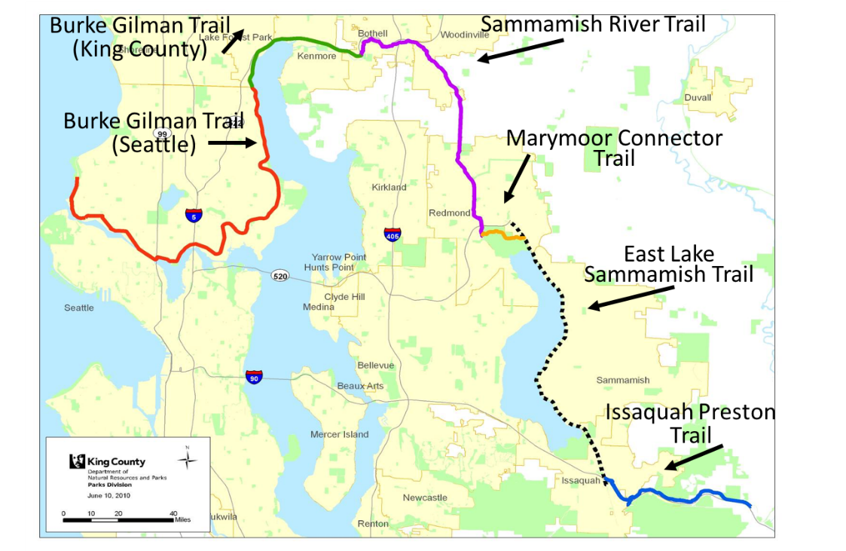

Project Summary

The East Lake Sammamish Trail follows a historic railroad route along the eastern shore of Lake Sammamish through the cities of Redmond, Sammamish and Issaquah. The ELST 11-mile segment is the missing link of the larger 44-mile “Locks to Lakes Corridor,” providing a trail from Seattle to the Cascade Mountains.

A trail 45 years in the making – For over 100 years, the East Lake Sammamish corridor existed as a railroad, used to move goods through the area. The King County Urban Trails Plan first identified the stretch of rail bed between Redmond and Issaquah as a critical future link in the Regional Trails System in 1971. The Burlington Northern Santa Fe Railway ceased operations on the track in 1996. The Cascade Land Conservancy acquired the corridor in April 1997 and King County purchased the property in September 1998. The following year, King County began a region-wide community engagement effort to guide development of the Trail Master Plan.

A trail for the community – At the end of an eight year planning and outreach process, a preferred alternative for the Trail Master Plan was identified and approved. King County began finalizing plans on the use, location, alignment, and width of the trail and by 2008, design of the 11-mile trail had begun. Trail design and construction have continued to adhere to the agreements made in the early planning phase to provide a safe, multi-use regional trail for bicyclists, pedestrians, joggers, skaters, strollers, wheelchairs, and users of all ages and abilities.

Progress on Budgeted Work on South Sammamish Segment A

Completed
- Installation of underground utilities
- Construction of retaining walls
- Construction of trail intersections
- Installation of chain link fencing
- Construction of rest stops
- Paving the trail
- Placing topsoil and mulch in landscape areas
- Placing topsoil and mulch in mitigation areas

In process
- Paving of driveway approaches
- Installation of trail signage
- Installation of bollards
- Installation of guardrail
- Installation of split rail fence
- Planting at landscape areas
- Planting at mitigation sites
- Construction of 33rd Street Plaza
- Striping at intersections
- Working on action item list
- Public Outreach

Progress on Budgeted Work on South Sammamish Segment B

Completed
- 60 percent design plans
- Submission of the Shoreline Substantial Development Permit (SSDP) Application
- Submission of the Grading Permit Application
- 30 Day Public Comment Period for SSDP

In process
- Review and preparation of responses to city and public comments received on the SSDP
- Continuation of trail design and drainage analysis
- Identification of encroachments that impact trail construction
- Preparation for an SSDP Hearing
- The City of Sammamish will construct the Zaccuse Creek fish culvert
- Public outreach

Status of Coordination with the City of Sammamish
on South Sammamish Segment A

City Inspector:
- Attends weekly construction meeting
- Visits the project site each day

City receives:
- Weekly project updates
- Project newsletters
- Gov Alerts – notifications and/or project updates
- Updated 3-week construction schedule every week
- Updated communications log once a month
- Notice of homeowners issues via email or phone, whichever is appropriate
- Notice of any shutdowns as a result of construction via email or phone, whichever is appropriate

Status of Coordination with the City of Sammamish
on South Sammamish Segment B

City receives:
- Updated communications log once a month
- Notice of homeowners issues via email or phone, whichever is appropriate
- Project newsletters
King County Parks:
- Holds a weekly conference call with the City to discuss Zaccuse Creek
- Has frequent discussions regarding permits, permit comments, and design issues with the City

Status of Money Spent, Quarterly and Cumulatively during the Biennium, on Work Completed on South Sammamish Segment A

ELST South A | Cumulative Expense for 2017 | Expense only for 2017 Q1 | Expense only for 2017 Q2
Planning | 70,544 | 34,320 | 36,224
Preliminary Design | 0 | 0 | 0
Final Design | 7,599 | 2,705 | 4,894
Construction/Implementation | 2,796,930 | 1,554,218 | 1,242,712
Acquisition | 0 | 0 | 0
 | $2,875,073 | $1,591,243 | $1,283,830

Status of Money Spent, Quarterly and Cumulatively during the Biennium, on Work Completed on South Sammamish Segment B

ELST South B | Cumulative Expense for 2017 | Expense only for 2017 Q1 | Expense only for 2017 Q2
Planning | 322,372 | 0 | 322,372
Preliminary Design | 97,987 | 59,664 | 38,323
Final Design | 143,090 | 105,637 | 37,453
Construction/Implementation | 112,194 | 77,624 | 34,570
 | $675,643 | $242,926 | $432,717

Designing or constructing 14 regional trail connections is a key component of the 2014-19 Parks, Trails and Open Space Replacement Levy. King County Parks looks forward to completing these last two segments of the East Lake Sammamish Trail and providing an important regional benefit.

