
Metropolitan King County Council
Cheryle A. Broom
King County Auditor
516 Third Avenue, Room W1033
Seattle, WA 98104-3272
(206) 296-1655
TTY 296-1024

Carolyn Edmonds, District 1
Bob Ferguson, District 2
Kathy Lambert, District 3
Larry Phillips, District 4
Dwight Pelz, District 5
Reagan Dunn, District 6
Pete von Reichbauer, District 7
Dow Constantine, District 8
Stephen Hammond, District 9
MANAGEMENT LETTER
Larry Gossett, District 10
Jane Hague, District 11
David W. Irons, District 12
Julia Patterson, District 13

DATE: April 12, 2005

TO: Metropolitan King County Councilmembers

FROM: Cheryle A. Broom, King County Auditor
Ron Perry, Principal Lead Auditor
Liz DuBois, Principal Management Auditor

SUBJECT: King County Auditor’s Office Review of Quantifiable Business
Case Project

Several years ago, King County developed a plan to replace its aging financial system, which was also incompatible with the financial system serving former Metro agencies in the county. This effort, entitled the Financial Systems Replacement Project (FSRP), encountered implementation problems and cost overruns and was terminated before completion.
Since then, the county has taken a different approach to the problem. It has transitioned from the earlier replacement project to a reconfiguration of how the county operates its business and personnel functions. As part of this process, the county council asked the executive to develop a business case for a new system, based on industry best practices. The council also requested the auditor’s office to review the costs and benefits associated with a new business approach. The auditor’s office engaged consulting expertise to review the work performed by the county’s consultants.
The county’s consultant, Dye Management Group, Inc, concluded that a single, integrated system would yield a high level of net benefits for the county. Our review resulted in these main conclusions:
- The project’s estimated return on investment is significantly lower than estimated by the consultant, but still positive;
- Some cost figures are three years old and need to be updated;
- Estimated benefits are based on general best practices, and their direct applicability to the county should be validated;
- The costs and benefits associated with the financial and personnel components of the project should be itemized separately so that the costs and benefits of each component are clear;
- The costs and benefits should be expressed in terms of net present value over the life of the project;
- The county should develop baseline costs, benchmarks, and performance measures so that the county can accurately track costs and evaluate whether the next phase, the Accountable Business Transformation (ABT) meets the county’s vision and goals for the project; and
- Non-quantified benefits also support ABT and should be tracked as well.

Some of these recommendations are consistent with Dye Management recommendations.

The executive concurs with the auditor’s recommendations. See Attachment A.

Summary

The Accountable Business Transformation (ABT) project represents a transition from the county’s earlier attempt to replace its financial computer system, Financial Systems Replacement Project (FSRP), to a reconfiguration of how the county operates its business and personnel functions. The goal of the original FSRP, begun in the late 1990’s, was to merge the separate financial management, payroll, and human resource systems of King County and the former Metro agencies. However, the project failed to achieve its objectives and was suspended in May 2000.

Since then, the county has been working to analyze the reasons for the project’s failure and to develop a revised plan for restarting it. As part of this process, the council asked the executive to develop a business case for a new system. The county selected a consultant, Dye Management Group, Inc., to develop a Quantifiable Business Case (QBC) based on an improved county Business Operations Model and on a cost-benefit analysis of the various options for proceeding. As part of the scope of this project, the county also asked the consultants to estimate the total amount the county spends on information technology, otherwise called the Total Cost of Ownership (TCO).

In its reports, Dye Management recommended that the county proceed with integrating its financial and payroll systems using Oracle Financials and PeopleSoft, implement changes to its business practices to support these operational changes and improve the efficiency of its operations, and to invest in a new budget system that meets the county’s needs. The reports identified a substantial amount of quantifiable benefits should the county proceed with its recommendation.

The council asked the auditor’s office to conduct an oversight review of the Dye Management’s studies as part of the adopted auditor’s work program for 2004. In brief, the council’s principal interests related to the validity of the various cost data and the viability of the methodologies and analyses used to calculate the benefits and costs of the Quantifiable Business Case. We engaged the services of independent consultants to assist our office in these efforts.

Main Findings
Our review of the QBC report and analysis found that the cost estimates appear to be reasonable. However, the primary implementation costs need to be updated and the county may wish to further verify the major operations costs that were self-reported by county departments. In addition, the technical approach used to quantify the costs and benefits and to calculate a return on investment for the project was generally appropriate, and the QBC employed a reasonable, although high-level, analytic approach.

The estimated economic benefits as reported in the QBC are based on a comparison of county operations to general best practices and external research. However, a detailed benefit cost study of specific county operations was not conducted. It is therefore unknown how comparable the county is to the organizations in the national studies, and without more detailed analysis it is not possible to determine if the county could realize the benefits and savings identified in the research. This is especially true with the human resource improvements, which use unverified benefit assumptions accounting for over 80 percent of the project’s economic value. In addition, the QBC’s financial analysis contained some technical calculation errors and questionable financial assumptions that overstate the project’s likely return on investment.

Our consultant’s analysis shows that using more conservative benefit assumptions and correcting for the technical errors in the QBC’s analysis substantially lowers the estimated value returned from the investment into the project, from $176 million to $17 million. Even after these adjustments are made, the financial analysis shows that the project as a whole could cover its own costs or potentially generate a positive return on investment, provided the cost, benefit, and project timeline estimates are correct. Implementing a single integrated financial system is also expected to produce non-economic benefits that support the option of moving forward with ABT in a phased manner.

Summary of Recommendations
This report recommends that in the next phase of ABT, the implementation costs be updated, the major costs and benefits included in the financial plan be more fully validated, and quantifiable cost savings be formally incorporated into the ABT project plan and schedule. For financial analysis purposes, we also recommend that the financial-related and human resource components be analyzed separately. In addition, baseline costs, benchmarks and performance measures should be developed so that the county can accurately track costs and evaluate whether ABT meets the county’s vision and goals for the project. The executive response (Attachment A) essentially concurs with these recommendations.

Background and Mandate

Council staff reports have provided extensive background information on the progress and evolution of this project (see excerpts in Attachment B). The county has transitioned from the replacement of its financial computer system (FSRP) to a reconfiguration of how it operates its business and personnel functions. The project also includes proposed alternatives for aligning its existing financial and personnel data systems with these newly configured operational models.

A vision and goals statement adopted by council Motion 11729 in June 2003 stated a twofold purpose:
- To make the county’s financial, human resource, and budget management functions fully integrated, efficient, and effective, and,
- To enhance the county’s ability to provide essential services to its customers.

The executive reported in July 2004 that the realization of this vision will require a transformation and standardization of business processes and a single core public sector financial system including budget management.

The Quantifiable Business Case (QBC) project was specifically authorized as a follow-up action to the adoption of the vision and goals statement. A QBC may be defined as follows:
A quantifiable business case is a study that measures costs, benefits and risks for a program proposal. A business case also sets up performance measures for a program that may be used as a yardstick to judge the success or failure of a program after it has been implemented. It also identifies implementation issues and risk mitigation strategies.

The county hired a consultant, Dye Management Group, Inc., to develop a QBC and a Business Operations Model (BOM) for the new business approach.

The Dye Management studies describe three basic approaches (alternatives) ranging from the status quo to moderate modifications of existing systems, to a single, countywide integrated system. Dye Management recommended the latter strategy, now called the Accountable Business Transformation (ABT), as the best fit for meeting the vision and goals developed by the county for transforming its business and personnel processes.

The QBC contains estimates of the costs and the benefits of improved business operations functions (such as payroll unification and an integrated financial system) under the ABT proposal. It also made recommendations to:
- Implement PeopleSoft software countywide, through a phased process.
- Align human resources policies and procedures countywide.
- Implement Oracle Financials countywide, through a phased process.
- Enhance a countywide budget solution.

Cost Reporting
Dye Management’s QBC reported on the estimated costs and benefits of implementing the various alternatives. The costs associated with the project were generally of two types: implementation costs and business operations costs. These costs cover four business areas of county government:
- Financials—the basic accounting needs of the county
- Human Resources—personnel management across all county agencies
- Payroll—a single payroll payment and monitoring system
- Budget—basic budget needs of the county; development, monitoring, and reporting

The QBC estimated costs within each of these functional business areas as well as several component projects within each area. For example, in the human resources area, there are options for improving employee performance, collective bargaining agreements, and management practices. The financial area includes integrating the county’s two financial systems, as well as proposed improvements in purchasing and asset management practices.

Implementation costs include the expenses needed to plan, develop, and implement the new data systems, purchase computer hardware and software, and retrain employees. To estimate the technical costs of project implementation, Dye Management relied primarily on figures prepared in 2001 and 2002 as the restart of FSRP was being evaluated, and was not asked to update these estimates.

Business operations costs are the ongoing expenses associated with operating and staffing the new business processes in areas such as accounting, personnel management, and procurement. To estimate the costs of current business operations, Dye Management surveyed county departments and divisions, asking them to self-report their cost and staffing data.

Estimation of Benefits
As part of the QBC scope of work, the county asked Dye Management to make generalized estimates of project benefits, based on available information and best practices. Providing detailed estimates of the fiscal benefit of each business improvement option was not part of the scope of work.

However, to illustrate the long-term benefits of each initiative over the life of the project, Dye Management calculated the net present value of the benefits over a 10-year period. Our analysis of these calculations is stated in the next section.

Total Cost of Ownership
Another study effort initiated by the county entailed the calculation of the Total Cost of Ownership (TCO) for the county’s current information technology. Pacific Technologies, Inc. (PTI) was engaged (as a subcontractor to Dye Management) to perform this work. The scope of the TCO involved the development of survey instruments (Excel templates) with which county departments would report information technology costs (staffing and all other costs) and the compilation and summary of that information into a final report. The date of that report is June 2004. Information from this report was used to supplement Dye Management’s cost data.

Scope of Work by Auditor and Its Consultants

The Metropolitan King County Council asked the auditor’s office to conduct an oversight review of both the QBC and the TCO, and this request became part of the adopted auditor’s work program for 2004. In brief, the council’s principal interests related to the validity of the various cost data and the viability of the methodologies and analyses used to calculate the benefits and costs in the Quantifiable Business Case.

To meet the council’s intent, we issued two separate, competitive solicitations for technical assistance. One involved the general validation of the cost data and benefit assumptions. The other included a detailed analysis of the costs, benefits, and underlying assumptions of the project.

Scope Limits
The auditor’s office limited its review to tasks generally described above. Thus, we did not intend to render a definitive opinion about the viability or feasibility of ABT. The project sponsors acknowledge that they are taking a phased approach to the development of ABT, so that all parties can review, analyze, and evaluate project components and updated costs as they are proposed by the executive. Our intent was to aid this process by providing supplemental analyses of the key project cost components and underlying assumptions of the final QBC recommendation.

Data Validation Efforts
Because resources available to us did not permit a comprehensive study, we decided to focus the validation of cost and benefit data on a limited sample of activities within the QBC. Working with the consultant, we identified those areas which involved the greatest amount of implementation (business process) costs and some potential for high payback opportunities. The areas selected for review were: Integrated Financial System – Accounts Payable, Integrated Financial System – Accounts Receivable and Collection, E-Procurement, and Payroll – Automate, Integrate, and Standardize.

With regard to reviewing TCO cost data, we selected two agencies, Finance and Business Operations Division (FBOD) and Human Resources Division (HRD), to perform detailed testing.

To assist us, we engaged Francis and Company, a local accounting and management consulting firm to conduct the following scope of work:
- Analyze the report by Dye Management Group, Inc. on the cost of business operations/processes for budget, financial, human resources, and payroll operations. The consultant conducted a limited assessment of the reliability of the cost data.
- Analyze the report by Pacific Technologies, Inc. (PTI) on the Total Cost of Ownership of information technology in the county, with an emphasis on the technology costs for budget, finance, human resources, and payroll operations. The consultant conducted a limited assessment of the methodology used to collect the cost data, the data’s reliability (i.e., completeness, reasonableness, and accuracy), and PTI’s benchmark analysis.

Francis and Company also previously performed a financial audit of the Financial Systems Replacement Project for the auditor’s office in 2001.

We want to reiterate that because this approach involved a limited sampling technique, the consultant’s findings do not apply to all cost areas, just the ones tested by the consultant.

Review of Analyses and Methods
The second part of our oversight involved a review of the analysis and methodologies included in the Quantifiable Business Case (QBC) and the Business Operations Model (BOM) prepared by Dye Management.

To assist us, we engaged Richard W. Hitch of RWH Consulting, a local firm that specializes in the financial and technical aspects of systems replacement to conduct the following scope of work:
- Analyze the Quantifiable Business Case report by Dye Management and Dye Management’s recommended Business Operations Model, with an emphasis on the following:
- The soundness of the methodology supporting Dye Management’s cost-benefit analysis.
- The adequacy of Dye Management’s research into best practices and comparability of the county to other similar organizations.
- The reasonableness of the approach used by Dye Management to evaluate alternative business operations models and develop a Quantifiable Business Case for a new model.
Mr. Hitch has direct knowledge of the county’s financial systems and has participated in the design and review of major public sector data systems.

Specifically, this consultant reviewed and assessed the primary assumptions and the methodologies involved in the development of the benefit-cost analyses for the QBC and the Business Operations Model. For example, he evaluated the process by which Dye Management calculated the estimated life-cycle net benefits of the proposals and alternatives in the QBC.

Major Findings and Conclusions

Costs
Dye Management’s QBC evaluated the county’s financial, budgeting, and human resources processes and identified a number of priority areas where the county could improve its business practices. It then estimated the implementation and operating costs of making improvements in these “high payback” areas and calculated the potential net benefits the county would realize over a 10-year period. The most significant areas of fiscal benefit included changes in the financial management and payroll processes, in the software systems that support these functions, and in the separate area of human resource management practices.

Overall, the high payback areas of the project can be grouped into two distinct categories: changes related to financial operations, such as payroll unification and consolidating the financial systems (ARMS and IBIS), and changes in human resource management practices, such as strengthening employee performance management and productivity.

Project Cost Verification
Our consultant’s high level review of technology and operational costs showed them to be reasonable estimates, with some relatively minor discrepancies. However, some costs proved difficult to verify. Also, county agencies, departments, and divisions self-reported the information and it was not validated as part of the QBC development. The cost figures should therefore be viewed as estimates.

In addition, the financial systems and payroll implementation cost estimates were not updated as part of the QBC scope and are now almost four years old. These costs are substantial, making up almost 80 percent ($37.7 million) of the entire project’s implementation costs. They are also based on a different set of software systems than are currently being proposed. If more precise cost estimates are desired, and if the county wishes to establish a baseline against which to track future project costs, these implementation costs should be updated. (This is also a QBC recommendation.) In addition, both of the auditor’s consultants recommend that the major operations costs be more rigorously validated to ensure they are reliable.

Project Cost-Benefit Analysis
The QBC and its supporting analysis expressed quantified benefits for the project in two ways: as net benefits and as the net present value of those benefits. The net benefits are the difference between total costs and total benefits. These are the figures included in the published QBC report. The net present value of the benefits calculates the value of the investment over a 10-year period, factoring in the time value of money. The latter figure is preferred, because it more truly represents the full value of the project to taxpayers. Dye Management calculated these values; however, they are not published in the QBC report.

The estimated quantifiable benefits identified in the QBC cost-benefit analysis are substantial; however, they should be used with some caution. A majority of the benefits are based on the results of national studies and general best practices, and detailed analyses have not been done to determine their direct applicability to King County. Because the assumptions on which these benefits are based are general in nature and cannot be verified, it is unknown to what extent these savings can actually be realized.

This is especially true for the benefits estimated for the human resource area, which make up over 90 percent ($85 million) of the project’s total net present benefits. In addition to being based on external studies, these benefits come largely from projected savings and efficiencies in labor costs, and dialog with organized labor will be a necessary part of achieving these benefits. One area in particular, improving “employee productivity,” is projected to result in a net savings of $73.6 million to the county. This item makes up over 72 percent of projected net present benefits, and is expected to be achieved through increased productivity and staffing reductions. However, the QBC did not identify examples of other public sector organizations that have achieved savings such as this by implementing these business practices, or analyze what the specific costs to the county would be if it implemented them.

Therefore, consistent with Dye Management’s recommendations, caution should be used in using these and other QBC figures that cite estimated savings based on general best practices unless further study is done to determine a more reliable dollar value. Such figures should therefore not be used as a major factor in justifying this investment unless a process for realizing these savings is formalized. In addition, the QBC uses the term “savings” to include both actual financial savings as well as to quantify process efficiencies or increases in productivity. Quantifying efficiencies is important; however, it should be kept in mind that they do not necessarily translate into budgetary savings.

The auditor’s consultants found that the technical approach to the cost-benefit analysis used in the QBC was largely correct, with costs and benefits spread over the life of the project using an analysis of net present value. However, they found that these net present values should have been included in the published QBC report, rather than the net benefits, because they more accurately reflect the project’s economic value. In addition, the consultants identified the need to make some corrections in computations, as well as adjustments in some assumptions, that ultimately have the effect of significantly lowering the estimated net economic benefit of the project.

Specifically, the consultants found some technical errors in the way the costs and benefits were calculated over the life of the project. They also question the choice of the relatively low discount rate used in the QBC and believe that it is not high enough to appropriately reflect the relative risk of the project and the cost of capital to the taxpayers. These modifications are consistent with recommendations we have made in recent capital planning and budgeting audits for such calculations.

Effects of These Adjustments
When the “employee productivity” benefit amount is removed from the analysis, and adjustments made to the financial assumptions, the results show a net financial return on the project of $17.3 million over 10 years. This is substantially lower than the QBC’s net present value estimate of $176 million (and the $237 million in net benefits published in the QBC report). However, it still indicates that the project as a whole could produce a positive financial investment, or come close to covering its own costs, provided the cost and benefit estimates are correct. The table below summarizes the impact of these adjustments on the QBC’s financial analysis.

Exhibit 1
Auditor’s Adjustments to Net Present Value Benefits of QBC

 | Financial-related areas | Human Resource-related areas | Total Project Value
QBC’s Net Present Value (NPV) Benefits | $34.3 million | $141.8 million | $176.1 million
Revised NPV benefits after auditor’s technical adjustments | $6.3 million | $84.6 million | $90.9 million
Revised NPV benefits after auditor’s technical adjustments and after removing employee productivity benefit | $6.3 million | $11 million | $17.3 million
Overall conclusion | Operating costs appear to be reasonable estimates, but the majority of implementation costs need updating. | Estimated benefits are overstated, and some major assumptions not validated. Conservative adjustments result in far lower benefits. | Project shows potential to pay for itself.
Source: QBC report (Dye Management Group, Inc.) and RWH Consulting/Auditor’s Office analysis.

This table illustrates how the net present value benefit of the project lowers as technical adjustments are made and the employee productivity benefit is excluded. When the financial-related components (e.g., financial systems, payroll and budgeting) are viewed separately from the human resource efforts, they demonstrate how the financial returns on each portion of the project differ from each other.

The county may be able to realize efficiencies and benefits in the human resource management area, and these changes could be worthwhile. However, we believe the county should be conservative when it comes to translating general study findings into quantified fiscal savings. This is especially true given the magnitude and impact the human resource “productivity” benefits have on the project’s overall economic value.

Aggregating project costs and benefits into an overall figure obscures the differences in costs and benefits of the separate project areas. We conclude that for the purposes of cost-benefit analysis, the human resources management area should be considered separately from the financial, payroll, and budget aspects of ABT. This conclusion is based on two factors:

- The implementation of improvements in human resource management are distinctly separate from the financial changes, and
- Including human resource benefits in overall ABT economic analysis could potentially mask the costs and benefits of the financial areas.

It is also important to point out that the relatively high initial costs of ABT will be incurred during the project’s first few years, with the estimated, somewhat uncertain benefits accumulated over 10 years. Changes in the project’s timeline (implementation schedule and project lifetime) and economic assumptions (such as interest rates and rates of return), can easily change these estimates from an economic gain to a loss.

Non-Economic Benefits Exist
Despite concerns raised by our consultants about the benefit assumptions and the technical corrections that greatly reduced the projected net benefits of the project, our consultants concluded that other non-economic reasons exist for the county to move forward with the integration of its financial and payroll systems. They added that confirmable economic benefits should not necessarily be the only reasons for the upgrades, because some improvements will most likely bring economic benefits even though they are very difficult or impractical to quantify. The auditor’s consultants support the QBC recommendation that the county proceed in this direction.

Some of the non-economic benefits of the project mentioned by our consultants include:
- Implementing and maintaining consistent, sound financial practices across all county agencies that are now served by IBIS, ARMS, or both.
- Using current vendor-supported technology (versus in-house systems) to help ensure financial systems are routinely upgraded.
- Having one consistent and reliable source of countywide financial and staffing information.

QBC Approach Reasonable, but Broad
As discussed earlier, the QBC’s analytical approach was based on a detailed evaluation of county operating practices; a comparison of these practices to industry standards, best practices, and general external research; and an identification of key areas where process improvements could produce a “high payback” for the county. This approach is reasonable considering the breadth of the undertaking and the number of county business areas covered. Nevertheless, it has limitations that warrant some discussion.

The QBC’s benefit estimates should be considered with caution because additional analysis was not performed to determine:
- If King County is comparable to the organizations that were the subject of cited national research studies,
- How the county’s operations differ from identified best practices, and
- How the recommended changes in systems and business practices will address the problems identified during the assessment phase.

While the QBC analysis did use more conservative assumptions to estimate efficiencies and savings than those cited in the research, these assumptions remain rough estimates and were not validated. In addition, the QBC did not specifically address how the functions performed by the county’s “side systems” will be impacted by the new systems, and what the potential costs would be should the new systems need any modifications. Further study would be therefore needed to confirm the accuracy of the cost and benefit estimates reported in the QBC.

It is important to keep in mind that Dye Management was not asked to study or detail the implementation effects of the improvements or the new technology and solutions, and that the county required that the benefits identified in the QBC be quantified whenever possible. We concur with and want to emphasize the point made by Dye Management that the quantified financial benefits were only targeted estimates based on national standards and best practices, and that there should be “vigorous debate” about if and how the county can achieve them.

Conclusions
Our limited review shows that project cost estimates appear reasonably accurate, and that even after significant adjustments are made to correct the economic analysis technique and to apply more conservative benefit assumptions, the project still shows a potential to produce a modest financial benefit, or break even.

As noted in this review, these costs and benefits are estimates, and some are more reliable than others. Our consultants emphasized the following points:
- The majority of implementation costs are out of date. Operating costs are self-reported and have undergone a limited amount of validation.
- Many benefit estimates are based on external practices and benchmarks and have not been validated. More conservative financial return assumptions (or even no returns in some areas) should be applied unless more detailed analysis is performed.
- For financial analysis purposes, the human resource efforts should be kept separate from the finance/payroll/budget improvements.
- If the county wants a firmer/more reliable baseline for project costs, additional verification of costs should be performed.
- Compelling business reasons exist for proceeding with payroll unification and the integration of county financial systems, and economic cost-benefit analysis should not be the sole basis for proceeding forward with this project.
- An alternative method for calculating the net present value of benefits is recommended.

To reduce some of the cost uncertainties, and to develop a sound financial plan, the outdated implementation costs for the project’s major components (financial integration and payroll unification) should be updated. Further verification of other major costs and benefits would help the county establish a more accurate baseline budget to manage and monitor project costs. This verification will be of even more importance to the cost and benefit assumptions used to develop the financial plan for funding ABT.

In addition, it is important that the county have the ability to evaluate whether ABT successfully meets the county’s vision and goals for the project. As required by the adopted vision and goals statement, and as Dye Management discussed in the BOM and QBC reports, performance measures and benchmarks are needed to identify and track cost savings, efficiencies, and other process improvements in order to evaluate whether the county’s goals are being met.

Recommendations

We propose these suggestions for consideration in the development of the next phase of ABT.
- Update the implementation cost estimates for the new finance and payroll systems. (Note: This is consistent with a QBC recommendation.)
- When the financial plan for funding the ABT project is developed, the major costs and benefits included in this plan should be more fully validated. In addition, the quantifiable cost savings should be formally incorporated into the ABT project plan and schedule.
- For clarity of financial analysis, the costs and benefits of ABT should be expressed in terms of net present value, rather than net benefits. In addition, the finance, budget and payroll analysis improvements should be considered separately from those of the human resources management practices.
- Develop valid baseline costs to track ABT project costs, and develop benchmarks and performance measures for each phase of the project to evaluate the impact and success of ABT. (Note: This is consistent with a QBC recommendation.) These should be developed in the following areas:
- Project management (costs, timelines, scope)
- Quantifiable cost savings and efficiencies
- Improved performance, information availability, decision making ability, non-quantifiable efficiencies

Executive Response

The King County Executive responded to the auditor’s report, and essentially with the recommendations. The text of the executive’s comments is included as Attachment A.

Future Review by Auditor’s Office

Per budget proviso, the auditor’s office will be continuing its oversight of the ABT project in 2005 by reviewing the executive’s recommendation, cost data, and the planning and implementation aspect of the next phase of ABT.

CB:RP:LD:yr
Attachments: Executive Response – Attachment A
Background information on the development of the Quantifiable Business Case excerpted from council staff reports – Attachment B

Attachment A
Executive Response to Management Letter

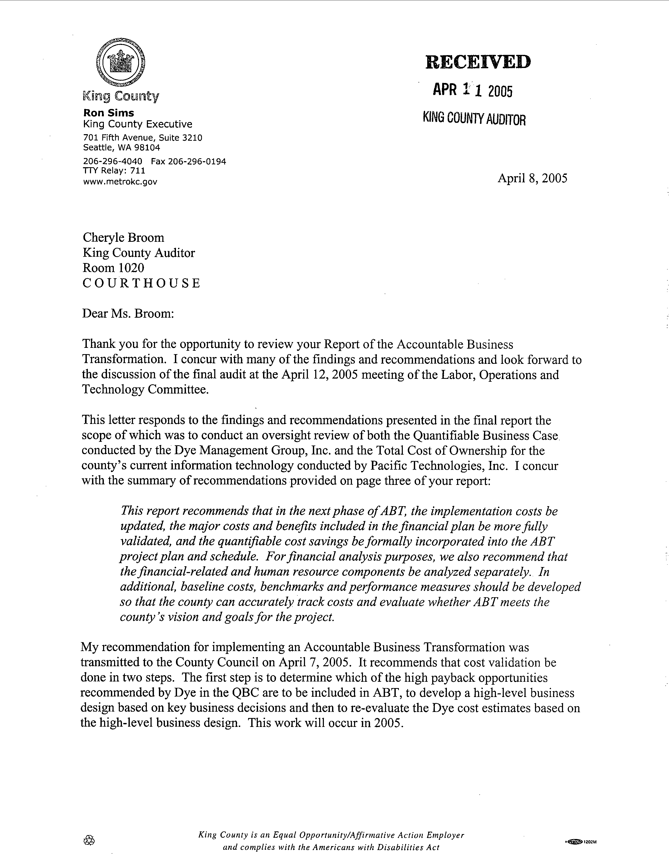
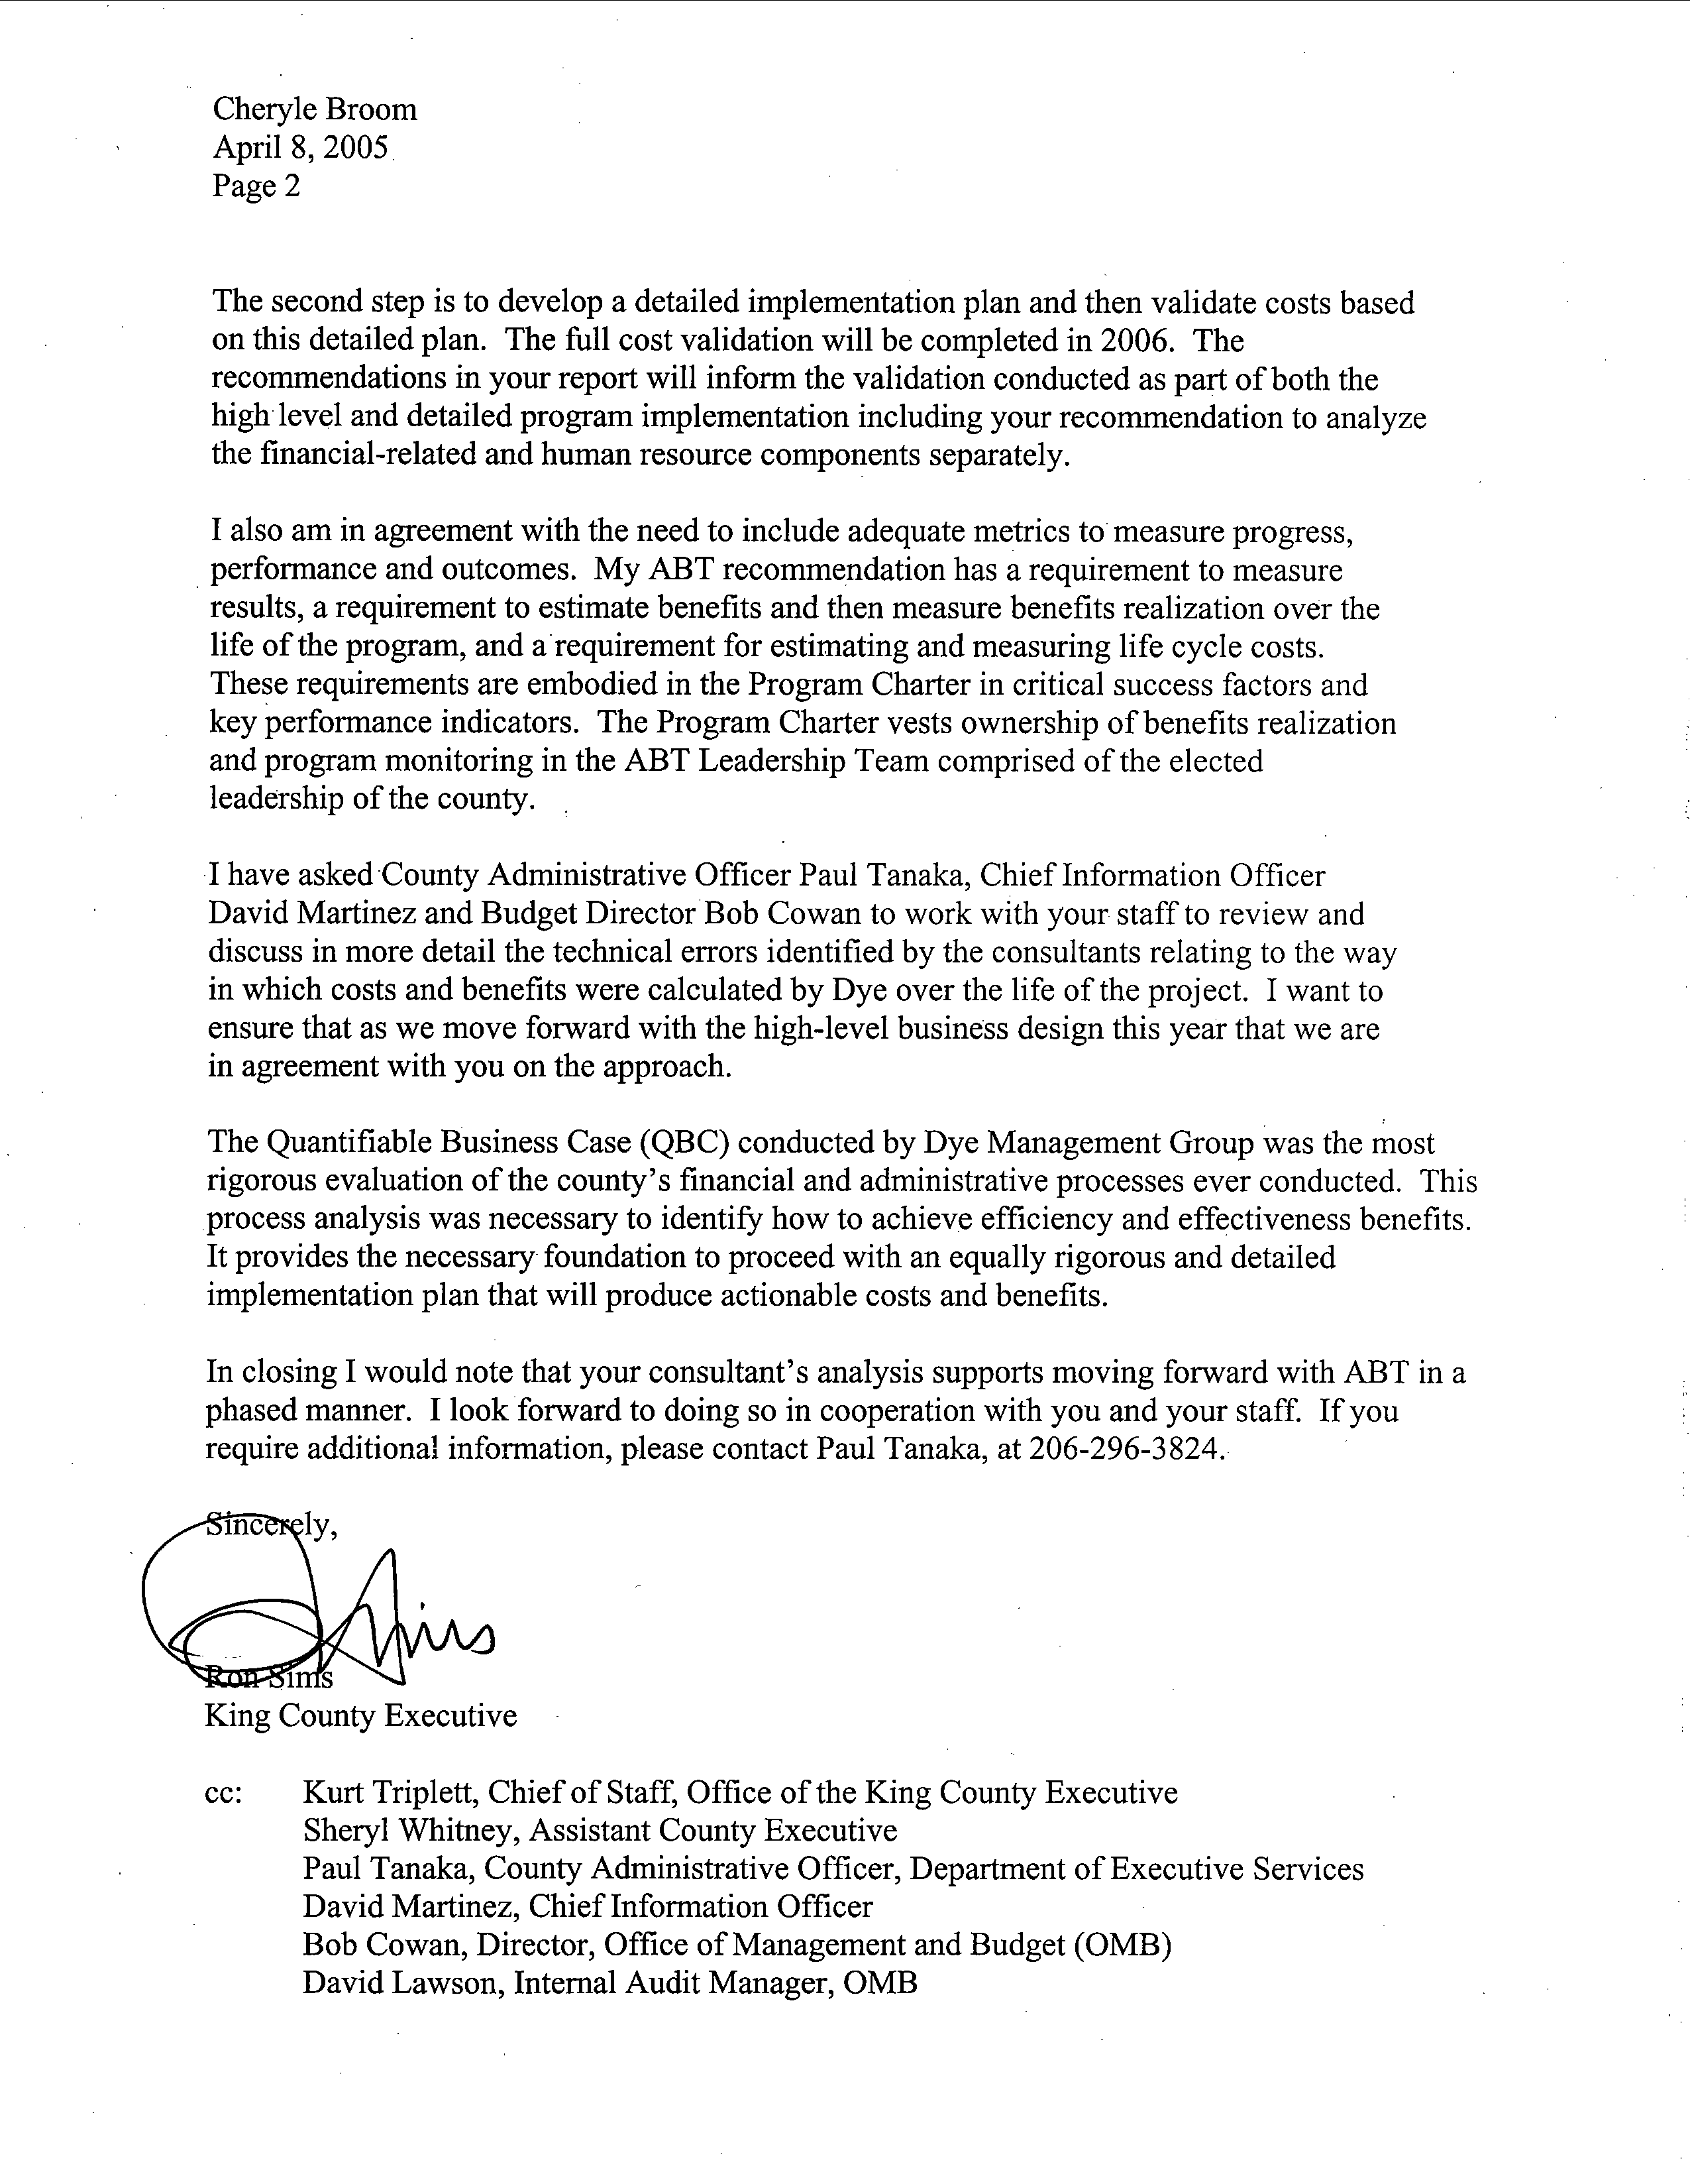
Attachment B
Background information on the development of the Quantifiable Business Case
excerpted from council staff reports

Financial Systems Replacement Project (FSRP) Background

Historically, the county has had two major financial, payroll and human resource systems because King County and Metro were separate governments with separate ways of doing business and computer systems. When King County and Metro merged, it was expected that their business practices would be aligned and their computer systems would be consolidated to increase efficiencies and enable enterprise-wide business operations. This consolidation has not successfully occurred; therefore, King County and the former Metro agencies still operate with independent financial, payroll and human resource systems; a modern budget management system is not in place. Due to reorganization, some departments are “straddle” agencies that use both payroll and financial systems, creating additional management challenges.

FSRP was a complex enterprise-wide capital project that was intended to replace the county’s multiple financial, payroll and human resource systems with one integrated financial, payroll and human resource system. FSRP was also intended to implement a modern budgeting system. Total direct FSRP costs were $43 million. The project received about $38.9 million in funding in 1997 and was to have been completed by May 2000. The project failed to achieve its objective and the project was suspended in May 2000. An additional $3.7 million was appropriated to stabilize the payroll portion of the project and an additional $300,000 was appropriated to retain consultants to conduct an independent assessment and present a plan to restart FSRP.
FSRP Assessment
The county hired consultants (Dye Management and IBM Global Services, Inc.) to conduct a critical assessment of the suspended project, a high-level business case for re-starting the project and an implementation plan to recommend project direction for a possible project restart. (Collectively these documents are known as the Dye IBM Management Report.)

The Dye IBM Management Report stated that the primary reasons FSRP failed were due to lack of:

- Leadership. “Lack of leadership may be the single most important factor leading to the program’s failure.”
- Accountable management. “Adequate project management was not ensured.” And “program ownership does not appear to have been assumed.”
- Shared vision. “…the county failed to understand the business justification for the program…”
- Change management. Organizational resistance to standardizing business practices.
The Dye IBM Implementation Plan recommended:

- Develop an information technology (IT) governance process;
- Establish and validate the vision for the program;
- Create a business case to justify the required funding;
- Develop a detailed implementation plan;
- Implement PeopleSoft software for Payroll and Human Resource operations in phases;
- Re-evaluate software selection for core financials; and
- Hire an integration consulting firm to help lead the implementation effort.
Change in Project Direction
With council leadership, the county has moved forward on some of these recommendations.
First, in 2001 the council and executive developed an IT governance process. A countywide IT strategic planning office was created (Office of Information Resources Management). A Chief Information Officer position was created to lead this office who reports directly to the executive. As part of the IT governance process, the Strategic Advisory Council (SAC) was created that consists of elected officials from all county agencies and private sector executives. The SAC acts in an advisory capacity to the Chief Information Officer (CIO) in developing long-term strategic objectives for IT deployment countywide.
Second, in June 2003 the county established and validated a vision and goals statement for the program. Council adopted the vision and goals statement that had been thoroughly reviewed and endorsed through the IT governance process. This statement was endorsed by elected leaders of the Strategic Advisory Council (SAC) and by their business and technology managers.
Third, a detailed business case (as described in the body of this memorandum) has been completed by a consultant. The four recommendations made in the business case are:

- Implement PeopleSoft software countywide, through a phased process.
- Align human resources policies and procedures countywide.
- Implement Oracle Financials countywide, through a phased process.
- Enhance a countywide budget solution.

The proposed policies linked to the above recommendations are:

- Pay all employees on a common, bi-weekly pay cycle from a single payroll system by migrating all employees to the PeopleSoft system. Council has already endorsed this policy (Motion 11729).
- Align all county human resource practices and procedures to ensure that business needs are met through legally defensible human resource practices.
- Process core county financial transactions from a single integrated system by implementing Oracle Financials software countywide.
- Standardize and streamline operating and capital budgeting by implementing a public sector operating and capital budget countywide solution.

This task was subcontracted by Dye Management Group, Inc. to Pacific Technologies, Inc. (PTI).
The Business Operations Model includes an assessment of current practices, systems, alternatives for improvement, recommendations, and an implementation plan in the key areas of finance, payroll, budget, and human resources.
Critical Assessment and Implementation Planning Report (Dye Management Group, Inc., 2001) and Strategic Technology Plan (Moss Adams, 2002).
Also known as “business process costs” in the QBC and Business Operations Model reports.
Cost data, benchmark information, and best practices were collected by surveys developed by Dye Management and PTI, respectively.
ARMS is the primary financial management system for most Current Expense (CX) agencies. IBIS is the system used mostly for non-CX agencies such as the former Metro agencies, Transit and Wastewater Treatment.
This is consistent with OIRM’s requirements for business case development.
“Financial-related” includes integrated financial systems, payroll, and budget changes.
Assumes a 15 percent discount rate (10 percent real rate of return plus 5 percent inflation). A less conservative 10 percent discount rate (5 percent real rate of return plus 5 percent inflation) would yield an overall NPV of $34.5 million.
“Side systems” refer to the computer systems that, over time, have been set up to provide analytical capabilities not provided by ARMS and the county’s other budget and financial systems.
Quantifiable Business Case report, p. 12.
Our consultant’s verification of costs was not a statistically significant sample and therefore cannot be extrapolated to all aspects of the project.

