Lease Property Summary
Depiction of Property

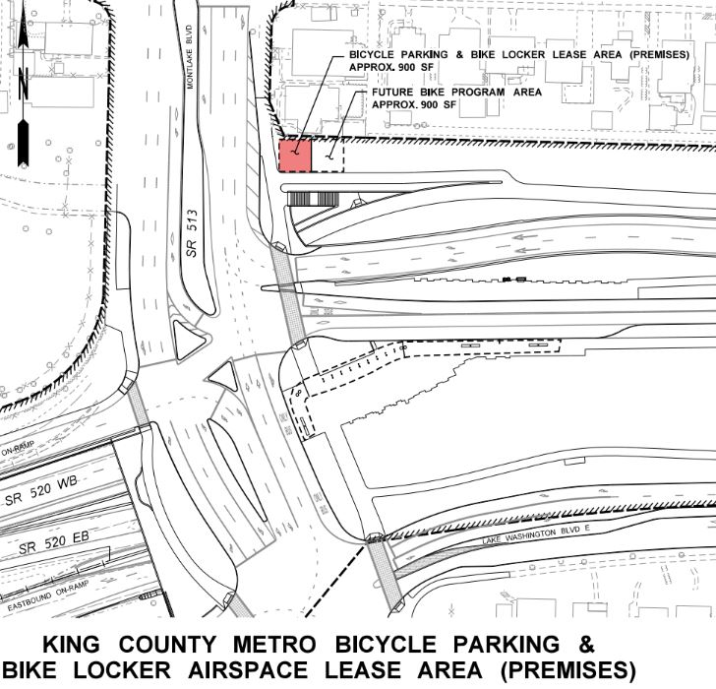

Property Owner: ​Washington State Department of Transportation
Address: A portion of the highway right of way of SR 520 in the vicinity of the Montlake Lid
Rent: $3,393 per year offset by Metro’s operation and maintenance of the Northgate North Lot Park and Ride
Operating Costs: No costs; Metro will provide maintenance of the facility excluding fences
Term: Initial 20-year term with two additional 20-year options to extend
Use Dimension: 900 square feet
Council District: 2
Funding Source: Public Transportation Operating Fund
Previous Location: N/A
Offer Timeline: Previous airspace lease approved by Ordinance 19182 in 2020 contemplated entering into two subsequent agreements: Northgate North Lot executed in 2022, and the subject airspace lease. Both parties agreed in principle at the time Ordinance 19182 was passed, and execution of this airspace lease concludes this transaction.

Lease Synopsis:
This lease is for Metro’s use of WSDOT’s property at Montlake for bike facilities. It includes Metro’s maintenance of those bike facilities. While the lease will be at no cost to Metro, Metro will incur costs to maintain the new bike facilities.

Context
Rationale for transaction: Since 1975, Metro has been operating bus stops on the highway entrance ramps at the SR520/Montlake interchange. WSDOT has now constructed the SR 520/Montlake to Lake Washington – Interchange and Bridge Replacement Project (Project) on real property owned by the State of Washington, which included a lid and ramp improvements at the Montlake Boulevard interchange with SR 520, construction of a westbound in-line transit stop, an eastbound pull out transit stop, a northbound SR 513 transit stop, and Metro’s related transit facilities in the vicinity of the lid.

At completion of construction, King County Metro arranged to lease a portion of the SR 520 right of way from WSDOT to continue to provide public transportation services and facilities at this location, along with the provision of a new bicycle facility. That lease was approved via Ordinance 19182 in 2020. In that agreement, WSDOT and Metro agreed to negotiate and enter into a second airspace lease for the bicycle facilities – this present lease – along with an operating and maintenance agreement for Metro to take responsibility for the Northgate North Lot Park and Ride, located at 10001 1st Ave. NE in Seattle, WA, in 2022, to provide for Metro’s use of WSDOT property under both airspace leases. Metro and WSDOT executed the operating and maintenance agreement for the Northgate North Lot in 2023.

The 2020 airspace lease enacted by Ordinance 19182 is for the bus stop improvements. Ordinance 19182 contemplated Metro and WSDOT entering into a second airspace lease for the provision of the new bicycle facilities, as well as for Metro to agree to maintain the Northgate North Lot Park and Ride as consideration for both leases. This present lease is the third of the three agreements outlined in the 2020 airspace lease and approved by Ordinance 19182.

Policy considerations: This project supports bus service and bicycle facilities, which takes single occupancy vehicles (SOV’s) off the road and provides attractive and convenient facilities that will encourage transit use. The project area includes energy efficient lighting and an open concept area that supports natural light and enhances security through clear lines of sight. The previous transit facilities in this area were on the lower level of the freeway with stairs that were not very convenient to Metro customers. These new facilities are much more inviting and create an overall better customer service experience.

Political considerations: County WSDOT partners anticipate the execution of this lease to conclude the series of agreements between Metro and WSDOT related to the SR 520 Montlake Bridge project.

Community considerations: Supports transit use for communities.

Fiscal considerations: The fair market lease value of the property used for this facility is offset by Metro’s maintenance and operations responsibilities of the Northgate North Lot, so no actual money will be exchanged between the agencies.

Other Considerations: None.

CIP/operation impacts: Adds a facility for Metro’s Facilities Maintenance Division to maintain, which is estimated to cost no more than $5,000 per year.

SEPA Review Required: No.

King County Strategic Plan impact: N/A

Equity and Social Justice Impact: In accordance with Real Property Asset Management Plan (RAMP) Strategy 2.0 and 24.0, FMD and Metro reviewed this legislation for equity and social justice (ESJ) impacts. By continuing service on the new 520 lid, transit-dependent residents living or transferring in this area will have access to job, recreational, and educational opportunities, as well as access to the neighborhood open space being constructed on the lid.

Energy Efficiency impact: Not Applicable.

Lease Alternatives Analysis
Summary: N/A – not relevant for this particular transaction.

Vicinity View Map

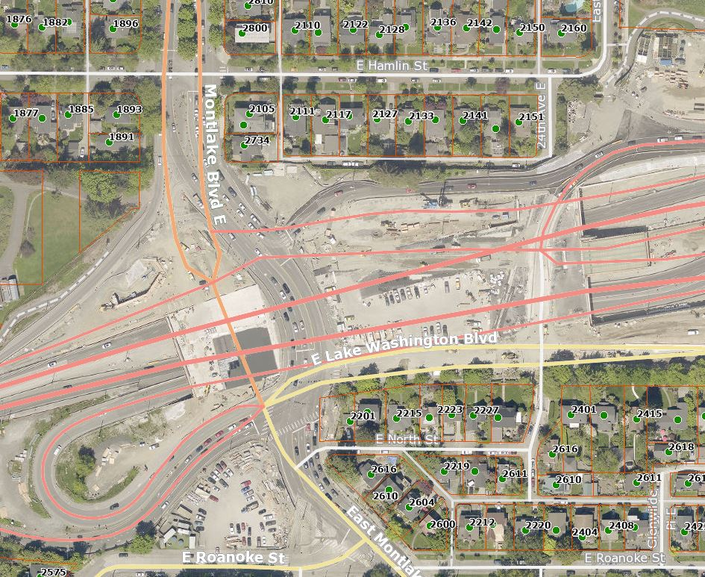

Site Map

